Annex VI

MINISTRY OF TRANSPORT AND PUBLIC WORKS

SOUTHERN AFRICA TRADE AND CONNECTIVITY PROJECT

**BUSINESS PLAN COMPETITION GRANTS PROPOSAL TEMPLATE FOR APPLICANTS**

**PLEASE TAKE NOTE OF THE FOLLOWING:**

* **SATCP consists of 4 Components. The proposal should fit within Component 3 only.**
* **Component 3 aims to improve the productivity and market opportunities for the private sector, smallholders, and cross-border traders along specific value chains through a regional integration approach.**
* **SATCP is among others prioritising these specific value chains namely** **soya, poultry, sugar, pulses, groundnuts, coffee, tea, macadamia, cotton, cashew, and fruits and vegetables, the proposal should fit within any one or across two or all the value chains.**
* The proposal must be written in English as clearly as possible to facilitate its assessment.
* This template should not be altered e.g. by changing the order of sections or deleting the section titles, notes and guidelines. Complete each section in the ***boxes provided at the end of each section***.
* Please adhere to the stipulated lengths (Stated Maximum number of pages). ***When completed the proposal should be no more than 10 PAGES (excluding Annexes).***
* Failure to adhere to the given instructions and guidelines will result in disqualification.

**DETAILS OF THE LOCAL APPLICANT**

| Full name of the Group / Individual /Business |  |
| --- | --- |
| Total Number of Employees/Membership by gender (if a group) | **Total:** **F: M** |
| Location & Physical Address |  |
| Key Contact Person(s) and Contact Numbers (*at least two members)* |  |
| Focus of Enterprise Business (A concise overview of the project, including objectives, activities, expected outcomes, and budget.) |  |
| Details of Enterprise Registration in Malawi (if enterprise has been formalized).  If not formalised, provide the National ID and demonstrated proof of willingness to register the entity.  For individual applicants provide the ID number of the applicant. |  |
| Stage of Enterprise (tick) | 1. **START UP STAGE** (A startup stage business is a new venture focused on developing initial products or services, establishing a market presence, and securing funding.) 2. **GROWTH STAGE** (A growth stage business is characterized by increasing revenue, market expansion, hiring additional staff, and investing in growth initiatives. 3. **EXPANSION STAGE**(An expansion stage business focuses on significant growth, diversification, strategic partnerships, and increased profitability. ) |

**PROPOSAL SUMMARY**

| SATCP Value Chains covered by proposal |  | |
| --- | --- | --- |
| Proposed Title of Project |  | |
| Objectives of the proposed Project |  | |
| Summary of activities to be performed under the Project intervention |  | |
| Expected results from the Project intervention (e.g. *proposed number of farmers reached,Employment Generated, income generated by the project, quantities traded*) |  | |
| Proposed Start & Finish dates of the Project actions *(Latest finish-18 months period)* | Start date: March, 2025  Finish date: TBA | |
| Proposed  Budget (USD) | *Requested from SATCP* | USD: |
| *Other funding Sources* | USD: |
| ***Total Budget*** | **USD:** |

**PROPOSAL DETAILS**

1. **EXECUTIVE SUMMARY-INNOVATION AND LOCAL ECONOMIC DEVELOPMENT *(Maximum 1 page)* (5 MARKS)**

*Provide a brief description of the type of business. If operational, state the current commercial activities that are undertaken by the enterprise indicating the current services or products provided in the market, community, outreach, turn over, etc (state if it’s still a business idea), where the business is located, growth potential of current business in the market. Describe how the proposed project and actions will will bring economic benefits such as employment creation, provide required products and services, contributing to market development (including inclusion of women and youth in economic development activities).* *Highlight the project activities and results to be achieved*

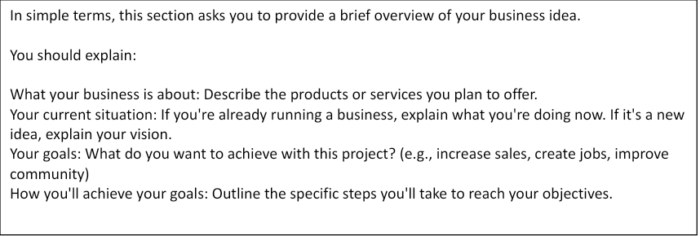

## MARKET POTENTIAL ANALYSIS – COMPETITION AND POTENTIAL FOR COMMERCIALISTATION *(Maximum 1 page) (5 MARKS)*

*Is there a market or key use or market for the proposed innovation or project? Provide a summary of the findings of the market potential analysis, or potential utilisation and benefit of the innovation to farmers who are linked to the SATCP private sector . In connection to the product/service that will be the focus in your project, please refer to the market size, market growth or scalability, competition (if applicable), profitability or resilience imparted to farmers/communities, and consumer and product/service type. Forecast total opportunity in terms of number of customers or users and revenue potential (if innovation leads to a commercial product/use) and estimate your market share in the district.*

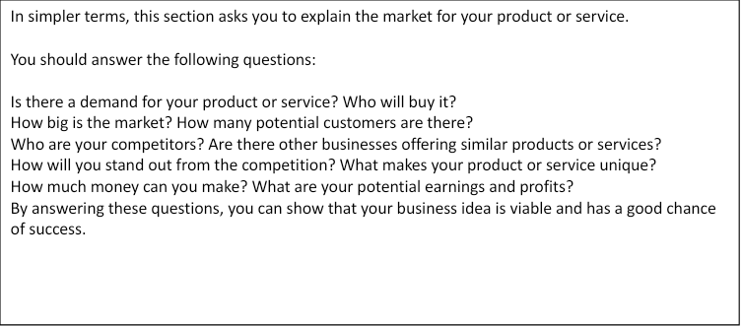

1. **CONTEXT ANALYSIS AND PROBLEM STATEMENT *(Maximum 1 page)* 10 MARKS**

*State and describe the significant value chain problems / blockages and/or opportunities, the context and underlying factors in the proposed areas of operation. Minimally include the Need – what need/problem does the project address/solve? the Response – what actions/steps/initiatives do you plan to take to address/solve the need/problem? what products and/or services will you offer and what are the economic and business surroundings do you operating in- SWOT Analysis (Strengths, Weaknesses, Opportunities and Threats)* 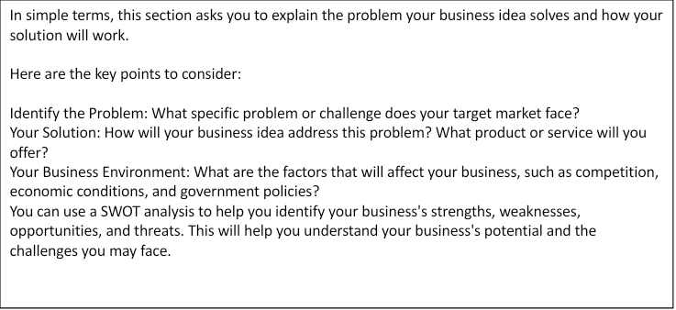

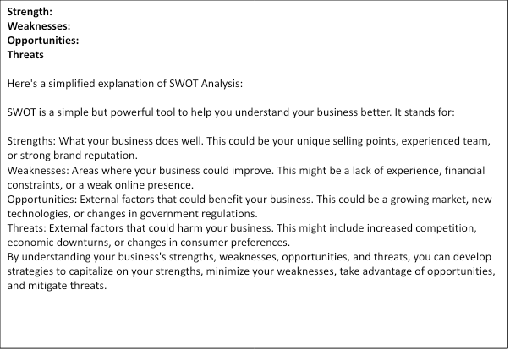

1. **OBJECTIVES AND EXPECTED RESULTS (Maximum 1/2 page) 10 MARKS**

## *Articulate clearly why is the project needed. Project objective (outcome) i.e. What needs or problems are solved and for what target group(s)?*

***Specific Objectives****-What does the project aim to achieve in the medium/long term?*

*.*

| **In simpler terms, this section asks you to clearly state what you want to achieve with your project.**  **Here's what you need to include:**  **Why is your project important? Explain the problem or need your project will address.**  **What is your main goal? What do you want to accomplish overall?**  **What are your specific goals? Break down your main goal into smaller, more specific goals. For example, if your main goal is to increase sales, specific goals could be to:**  **Increase customer base by 20%**  **Launch a new product line**  **Improve marketing efforts**  **By clearly defining your objectives, you'll be able to track your progress and measure your success.** |
| --- |

1. **PROPOSED INTERVENTION(S) *(Maximum 1 page)* 15 MARKS**

*Describe the technical solution, describing the proposed actions that you wish to perform to address the problems identified. Describe the innovation aspects of the process/product/service . The solution should clearly show the degree of innovation- business model should be technically sound and market oriented, should be climate friendly technology and should address specific market or social needs of the targeted community. Vision for the commercialization and viability should be articulated- applicants need to provide financial projections of the venture to show revenue streams and profitability*

*Scalability- can the innovation be adapted and up scaled to benefit more people*

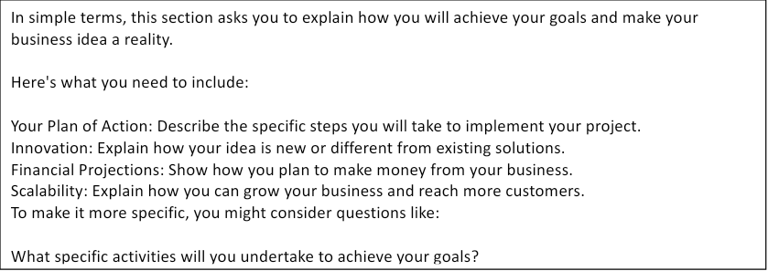

1. **SUSTAINABILITY AND SCALABILITY (Maximum 1 Page) 10 MARKS**

* *How will your proposed project activities remain commercially viable when World Bank funding ceases?*
* *How will Small holder farmers continue to benefit from the improved or developed markets or proposed services when SATCP funding ceases?*
* *Describe how your proposed activities can be scaled up or replicated profitably.*
* *How will your proposed activities stimulate growth in the value chain(s) and in the market?*
* *How is your approach likely to extend opportunities for other market players in this or other value chains?*

Explain how you see your business develop in 5 years?

| **In simpler terms, this section asks you to explain how your business will continue to thrive after the SATCP funding ends.**  Here are the key questions to consider:   1. **Long-Term Viability:** How will your business continue to make money after the funding ends? 2. **Benefits for Smallholder Farmers:** How will your project continue to benefit farmers even after the funding stops? 3. **Growth Potential:** How can you expand your business and reach more customers? 4. **Impact on the Market:** How will your business contribute to the overall growth of the market and value chain? 5. **Future Vision:** What does your business look like in 5 years?   By addressing these questions, you can demonstrate the sustainability and scalability of your business idea. |
| --- |

1. **Social Impact Indicators(Maximum 1 Page)**

*Describe the social impact indicators*

* *Number of new jobs created*
* *Number of low-income SHFs and private businesses as producers, suppliers and distributors*
* *Number of new low-income SHFs gaining access to basic goods and services*
* *Ration of male and female beneficiaries*

| In simple terms, this section asks you to explain how your business will benefit the community.  Here are some questions to help you:  Job Creation: How many jobs will your business create?  Economic Impact: How will your business improve the livelihoods of people in your community?  Social Impact: Will your business help people access essential goods and services?  Gender Equality: How will you ensure that both men and women benefit from your business?  By addressing these questions, you can demonstrate the positive impact of your business on society. |
| --- |

1. **Gender Equality and Women empowerment and Youth Empowerment (Maximum 1 Page)**

*Describe how the proposed business will contribute to gender and women empowerment*

| In simple terms, this section asks you to explain how your business will empower women and promote gender equality.  Consider the following questions:  Women's Involvement: How will women be involved in your business, whether as owners, employees, or customers?  Women's Empowerment: How will your business help women become more independent and financially secure?  Gender-Fair Practices: How will you ensure fair treatment and equal opportunities for all genders?  By addressing these questions, you can show how your business contributes to a more equitable society. |
| --- |

1. **Environmental sustainability(Maximum 1 Page)**

*Describe the potential negative and opportunity impacts that your business will have to the environment especially climate change.*

| In simple terms, this section asks you to explain how your business will impact the environment.  Consider these questions:  Environmental Impact: What are the potential negative effects of your business on the environment (e.g., pollution, waste)?  Sustainability: How will you minimize your business's negative impact on the environment?  Climate Change: How can your business contribute to climate change mitigation or adaptation?  By addressing these questions, you can demonstrate your commitment to sustainable business practices. |
| --- |

1. **CAPACITY AND SKILLS TO MANAGE THE PROPOSED ENTERPRISE (Maximum 1 pages) 10 MARKS**

*Describe your capacity and relevant experience that demonstrates your willingness and long-term commitment to the enterprise activities. Does the group/entrepreneur have the required capacity (skills) required to deliver the proposed intervention? Please indicate any capacity gaps and the support that may be required.*

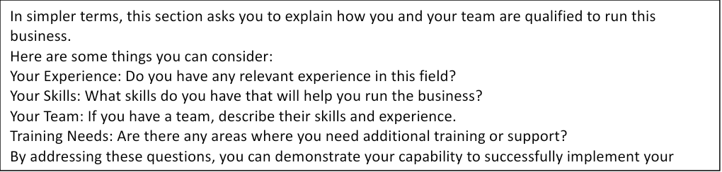

1. **RISK MANAGEMENT *(Maximum 1/2 page)***  **10 MARKS**

*State and describe any specific risks/hazards that you identify as posing threat(s) to the long-term performance, viability and sustainability of the enterprise that you are proposing. Please indicate the mitigation actions that you will implement to manage the identified risks. (Please be open and objective on all possible risks –* ***laying out potential risks does not mean project proposal failure*** *)*

| **Risk and Likely Consequence** | **Probability of occurrence** | **Impact on enterprise activities** | **Mitigation Actions** |
| --- | --- | --- | --- |
|  |  |  |  |
|  |  |  |  |
|  |  |  |  |
|  |  |  |  |
|  |  |  |  |
|  |  |  |  |

**In simpler terms, this section asks you to identify potential problems that could affect your business and explain how you will deal with them.**

Here are some questions to help you:

1. **What are the potential challenges your business might face?** Think about things like economic downturns, competition, or natural disasters.
2. **How likely are these challenges to happen?** Assess the probability of each risk.
3. **What could be the impact of these challenges on your business?** How might they affect your sales, profits, or reputation?
4. **What will you do to prevent or minimize these risks?** Develop a plan to address each potential risk.

For example, if you're worried about competition, you might develop a unique marketing strategy or focus on building strong customer relationships. If you're concerned about economic downturns, you might create a financial cushion or diversify your product offerings.

1. **BUDGET or FINANCIAL PLAN *(Maximum 1/2 page)***  **20 MARKS**

*State and describe the financial resources that are required to implement the proposed project that you have described above.*

***NB: Your application will score higher if your contribution to the proposed project is at least 30%, of the total budget.***

| Proposed  Budget (USD) | Funds requested from SATCP | USD: |
| --- | --- | --- |
| Funds from other sources (**specify**) | USD: |
| Total Funds for Project intervention | **USD**: |

**REQUIRED ANNEXES**

1. Detailed itemised breakdown for the total project budget - Refer to Excel Sheet



1. Simple cash flow statement and Gross margin Analysis if applicable- Refer to Excel Sheet



1. Detailed 18 months Work Plan of proposed project- Refer to Excel Sheet



1. If applicable, copy of business registration document

**DECLARATION BY THE APPLICANT**

***Please read the declaration statement below, tick all the boxes and fill in the table below as confirmation of the declaration statement made by the applicant.***

The applicant, represented by the undersigned, being the authorized signatory for the applicant, in the context of the present application and representing the enterprise in the proposed activities, hereby declares that:

**the applicant understands that submission of this proposal and any other additional information and documentation is not an entitlement to award of the grant.** 

the applicant understands that not adhering to the provided guidelines may result in their proposal being disqualified.

the applicant has the sources of financing as detailed in section 8 above and will allow an independent body as appointed by SATCP to verify this (if the applicant’s proposal is successful). 

the applicant is directly responsible for the preparation, management and implementation of the proposed activities and is not acting as an intermediary / agent;

the applicant will comply with all the WorldBank due diligence processes prior to the award of any contract.

the applicant is able to deliver immediately, upon request, any additional relevant supporting documents.

***Signed on behalf of the applicant.***

| **Authorized Representative’s Name** |  |
| --- | --- |
| **Signature and date** |  |

**SATCP BUSINESS PLAN PROPOSAL SUBMISSION CHECKLIST AND ADMINSTRATIVE EVALUATION**

**.(For SATCP official use only)**

| **Checking list** | **YES** | **NO** |
| --- | --- | --- |
| 1. Application submission deadline has been respected. |  |  |
| 1. Business Proposal in line with SATCP priority value chains |  |  |
| 1. A complete (including all annexes) Business Proposal form is submitted in hard copy. |  |  |
| 1. A complete (including all annexes) Business Proposal form is submitted in soft copy (via email) |  |  |
| 1. Individual Entrepreneurs and/or Farmer Group Enterprise members is/are resident in the SATCP operational districts where the proposed business activities will be undertaken. |  |  |
| 1. The proposed business operations will be conducted within the chosen 15 SATCP operational district. |  |  |
| 1. Declaration statement on the proposal template completed and signed. |  |  |

Name:……………………………………….. Designation:…………………………….……

Signature:…………………………………… Date:………………………………………….

*For official use only*

Submission meets the above criteria: **recommend proceeding to technical and financial evaluation**.

Submission does not meet above criteria (hard and soft copy): – **disqualify the proposal**

Name:…………………………… Designation:…………………….. Date:………………………