
Government of Malawi
Ministry of Transport & Public Works

ENVIRONMENTAL AND SOCIAL MANAGEMENT PLAN (ESMP) FOR THE PROPOSED UPGRADING OF KHOLONI - SITOLO ROAD TO GRAVEL STANDARD IN MCHINJI DISTRICT

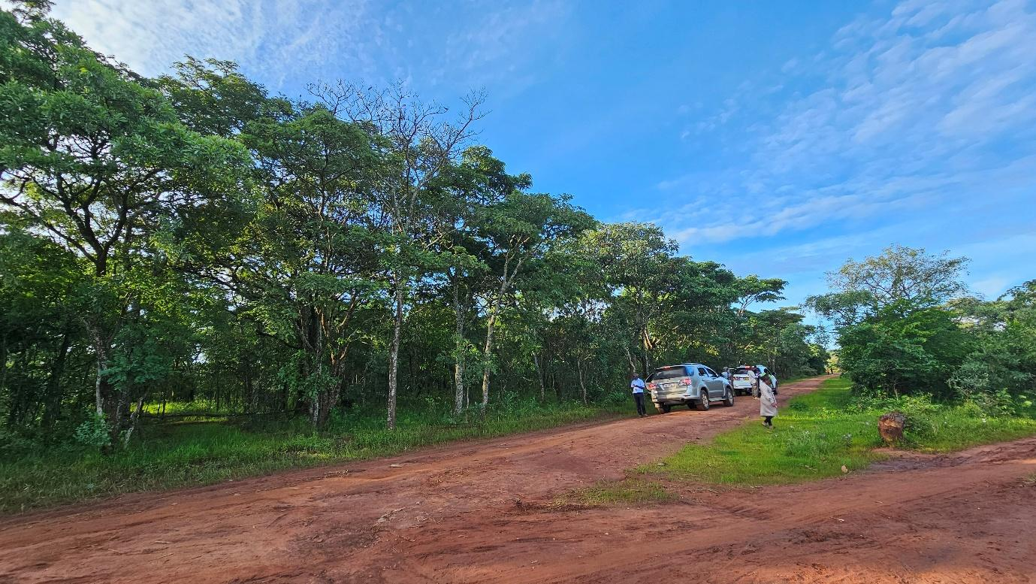

Ministry of Transport and Public Works
Southern Africa Trade and Connectivity Project
Private Bag 322
Lilongwe 3

18 June, 2026

EXECUTIVE SUMMARY
1.0 Project Background
The proposed rehabilitation of the Kholoni–Sitolo Road is a priority rural transport intervention under the Southern Africa Trade and Connectivity Project, financed by the World Bank and implemented by the Ministry of Transport and Public Works through the Roads Authority under the Last Mile Infrastructure (LMI) programme. The subproject is intended to improve rural accessibility, strengthen agricultural market connectivity, and enhance mobility for communities located along feeder road networks that connect productive rural areas to strategic trade corridors.
The road is located in Mchinji District and extends for approximately 10 km from Kholoni, immediately after the railway crossing, to Sitolo within Traditional Authority Mlonyeni. The road serves dispersed rural settlements, agricultural production zones, schools, trading points, health service users, and bicycle and motorcycle traffic, while also linking communities to the M12 Road, an important national and cross-border trade corridor.
The proposed works are scheduled for implementation over approximately nine months, with an indicative budget of USD 500,000.
At present, the road exists as an earth/gravel rural access road affected by severe drainage deficiencies, silted side drains, localized erosion, blocked culverts, weak subgrade sections, and seasonal flooding in low-lying areas. During the rainy season, sections become impassable due to ponding and overtopping, while dry-season traffic generates dust affecting nearby households, schools, and roadside activities.
The proposed rehabilitation will improve road functionality through regravelling, reshaping, culvert upgrading, drainage rehabilitation, embankment strengthening, and road safety improvements while retaining the existing alignment and minimizing land disturbance.
An Environmental and Social Management Plan (ESMP) has therefore been prepared in accordance with the Environment Management Act (2017), MEPA Environmental and Social Impact Assessment Guidelines (2025), and the World Bank Operational Policies, to ensure environmental and social risks are effectively prevented, minimized, and monitored.
2.0 Nature and Scope of the Proposed Project
The project involves rehabilitation of the existing Kholoni–Sitolo feeder road to improved gravel standard for enhanced all-weather access and drainage resilience.
Key works include:
- Reshaping of approximately 10 km of roadway
- Spot gravelling of weak sections
- Localized embankment formation in flood-prone areas
- Installation of new culverts including single-cell and multi-cell box culverts
- Rehabilitation of existing culverts, headwalls, mitre drains and outlet drains
- Scour protection and drainage outlet stabilization
- Installation of road safety signs and speed calming measures near settlements
- Controlled sourcing of borrow materials from approved sites
- Rehabilitation of borrow pits after material extraction
3.0 Rationale of the Proposed Project
The road serves farming communities dependent on smallholder agriculture, petty trade, and local transport services. Poor road conditions currently increase transport costs, reduce agricultural competitiveness, constrain access to social services, and expose communities to seasonal isolation.
Rehabilitation is necessary to:
- Improve year-round road accessibility
- Reduce travel time and vehicle operating costs
- Improve evacuation of agricultural produce including maize, tobacco, and groundnuts
- Improve access to schools, health centres, and trading centres
- Reduce seasonal washouts and erosion damage
- Improve resilience to climate-related rainfall events
5.0 Justification of the Study
Preparation of this ESMP is required because the road rehabilitation traverses settled rural communities, cultivated land, graveyard-sensitive areas, drainage crossings, and socially active settlement clusters where construction activities may generate site-specific environmental and social impacts.
The impacts are expected to be localized, temporary, and manageable through practical mitigation measures, making a stand-alone ESMP the appropriate safeguard instrument.
6.0 Objectives of the ESMP
The ESMP seeks to:
- Identify environmental and social risks across all project phases
- Define mitigation and enhancement measures
- Ensure legal and safeguard compliance
- Protect workers, communities, water resources, soils, and cultural sites
- Establish monitoring and reporting arrangements
- Strengthen grievance redress and stakeholder accountability
7.0 Methodology Used to Prepare the ESMP
The ESMP was prepared through:
- Review of engineering designs and project documentation
- Field reconnaissance along the road corridor
- Baseline environmental and socio-economic assessment
- Stakeholder consultations with communities, local leaders, schools, district institutions, and DESC members
- Identification of phase-based impacts and preparation of mitigation measures
8.0 Summary of Key Positive Impacts and Enhancement Measures
8.1 Improved Flood Resilience and Drainage Efficiency
Road rehabilitation will improve hydraulic performance and reduce localized flooding.
Enhancement Measures
- Climate-resilient culvert sizing
- Scour protection
- Improved cross-drainage design
- Regular drainage maintenance
8.2 Improved Community Participation and Transparency
The project strengthens accountability through consultations and grievance systems.
Enhancement Measures
- Functional GRM
- Inclusive consultations
- Representation of women and vulnerable groups
8.3 Improved Road Safety
Safety improvements are expected near schools and settlements.
Enhancement Measures
- Road signage
- Speed calming measures
- Pedestrian crossing awareness
8.4 Local Employment and Income Generation
Construction will create short-term labour opportunities.
Enhancement Measures
- Local labour recruitment
- Gender-sensitive hiring
- Transparent employment records
8.5 Improved Market Access and Economic Mobility
Road improvement will reduce transport barriers.
Enhancement Measures
- Periodic maintenance
- Functional drainage preservation
9.0 Summary of Key Negative Impacts and Mitigation Measures
9.1 Dust, Noise and Temporary Access Disruption
Construction may affect settlements and sensitive receptors.
Mitigation Measures
- Water spraying
- Speed control
- Controlled work scheduling
- Temporary access maintenance
9.2 Risk to Graveyards and Cultural Sites
Sensitive graveyard sections require protection.
Mitigation Measures
- Corridor verification
- Buffer zones
- Chance-find procedure
9.3 Soil Erosion and Sedimentation
Earthworks may accelerate runoff.
Mitigation Measures
- Silt barriers
- Slope stabilization
- Vegetative restoration
9.4 Borrow Pit Degradation
Borrow areas may create erosion and stagnant water.
Mitigation Measures
- Approved borrow sites only
- Topsoil storage
- Progressive rehabilitation
9.5 Fuel and Oil Contamination
Machinery handling may contaminate soils and runoff.
Mitigation Measures
- No on-site fuel storage
- Procure fuel directly from nearby service stations
- Spill kits
- Controlled refueling
9.6 Traffic and Community Safety Risks
Construction traffic may increase accidents.
Mitigation Measures
- Traffic Management Plan
- Flaggers
- Warning signage
9.7 GBV/SEA/SH Risks and Worker Misconduct
Labour influx may create social risks.
Mitigation Measures
- Contractor Code of Conduct
- GBV awareness training
- Confidential reporting mechanism
- Referral linkage
- Worker discipline enforcement
- Zero child labour
- HIV/AIDS awareness
10.0 Conclusion and Recommendations
10.1 Conclusion
The proposed rehabilitation of Kholoni–Sitolo Road is expected to deliver major socio-economic benefits through improved rural access, drainage efficiency, road safety, and stronger agricultural connectivity. Environmental and social risks identified are localized and manageable if mitigation measures are fully implemented.
10.2 Recommendations
- Integrate all ESMP obligations into contractor contracts
- Approve all site-specific management plans before mobilization
- Operationalize community and worker grievance systems
- Deploy environmental, social, GBV, and OHS personnel on site
- Obtain all statutory approvals before works commence
- Ensure regular supervision by Roads Authority, Supervising Consultant, and District Council

ACRONYMS AND ABBREVIATIONS
AIDS | Acquired Immune Deficiency Syndrome
DED | Detailed Engineering Design
DESC | District Environment Sub-Committee
EHS | Environmental, Health and Safety
EMA | Environment Management Act
ESHS | Environmental, Social, Health and Safety
ESIA | Environmental and Social Impact Assessment
ESMMP | Environmental and Social Mitigation and Monitoring Plan
ESMP | Environmental and Social Management Plan
FGD | Focus Group Discussion
GBV | Gender-Based Violence
GIIP | Good International Industry Practice
GRM | Grievance Redress Mechanism
HIV | Human Immunodeficiency Virus
IEC | Information, Education and Communication
IUCN | International Union for Conservation of Nature
LC | Local Council
LMI | Last Mile Infrastructure
MEPA | Malawi Environment Protection Authority
OHS | Occupational Health and Safety
OP/BP | Operational Policy / Bank Procedure (World Bank)
PPE | Personal Protective Equipment
RA | Roads Authority
RHS | Right-Hand Side
SATCP | Southern Africa Trade and Connectivity Project
SEA | Sexual Exploitation and Abuse
SEA/SH | Sexual Exploitation and Abuse / Sexual Harassment
SEP | Stakeholder Engagement Plan
SH | Sexual Harassment
STA | Sub-Traditional Authority
WMP | Waste Management Plan

TABLE OF CONTENTS
1. CHAPTER 1: INTRODUCTION AND BACKGROUND 1
1.1 Introduction 1
1.2 Project Background 1
1.3 Developer Details 2
1.4 Nature and Scope of the Project 2
1.5 Project Objectives 3
1.6 Justification of the Project 3
1.7 Objectives of the ESMP 3
1.8 Rationale of the ESMP 3
1.9 Methodology 4
1.10 Project Location 5
1.11 Land Tenure and Land Requirement for the Project 10
1.12 Potential Users of the ESMMP 10
2 CHAPTER 2: PROJECT DESCRIPTION 11
2.1 Introduction 11
2.2 Project Components and Activities 11
2.3 Labour Requirement 12
2.4 Land Requirement 14
2.5 Material Requirements and Sources 14
2.5.1 Gravel Material 15
2.5.2 Sand 15
2.5.3 Aggregates and Cement 15
2.5.4 Water for Construction 15
2.5.5 Material Transport 16
2.6 Waste Generation and Management 16
2.6.1 Anticipated Waste Streams 17
2.6.2 Spoil Management 17
2.6.3 Hazardous Waste Management 17
2.6.4 Domestic Waste 18
2.6.5 Borrow Pit Rehabilitation 18
3 CHAPTER 3: POLICY AND LEGAL FRAMEWORK 20
3.1 Introduction 20
3.2 National Policies and Strategies 20
3.2.1 Policy Framework 20
3.2.2 Legislative Framework 21
3.3 World Bank Safeguard Policies and Procedures 24
3.3.1 World Bank Operational Policy OP/BP 4.01: Environmental Assessment 24
3.3.2 Environmental, Health and Safety (EHS) Guidelines 25
3.3.3 World Bank Requirements on Sexual Exploitation and Abuse (SEA) and Sexual Harassment (SH) 26
3.4 Institutional Framework 27
3.4.1 Malawi Environment Protection Authority (MEPA) 27
3.4.2 Ministry of Natural Resources, Energy and Mining 27
3.4.3 Ministry of Lands 28
3.4.4 Ministry of Transport and Public Works 28
3.4.5 Roads Authority (RA) 28
3.4.6 Ministry of Local Government and Rural Development / District Council 28
3.4.7 Ministry of Labour and Construction Industry Regulatory Authority (CIRA) 29
3.4.8 Institutional Coordination for ESMP Implementation 29
3.5 Summary of Main Statutory Approvals/Licenses to be obtained for the project 29
4 CHAPTER 4: ENVIRONMENTAL AND SOCIAL SETTING 31
4.1 Introduction 31
4.2 Biophysical Environment 31
4.2.1 Topography 31
4.2.2 Geology 32
4.2.3 Soils 34
4.2.4 Climate and Climate Change Risks 36
4.2.5 Water Resources 39
4.2.6 Flora and Fauna (Biological Environment) 41
4.3 Socio-economic environment 45
4.3.1 Demography 45
4.3.2 Education and Literacy 46
4.3.3 Health 47
4.3.4 Cultural Heritage 47
4.3.5 Agriculture 48
4.3.6 Economic Activities and Livelihoods 49
4.3.7 Transport 49
4.3.8 Security 49
4.3.9 Land Use 50
4.3.10 Vulnerable and Marginalized Groups 50
4.3.11 Communication 50
4.3.12 Energy Sources 50
4.3.13 Implications for the Project 51
5 CHAPTER 5: ENVIRONMENTAL AND SOCIAL MANAGEMENT PLAN 52
5.1 Introduction 52
5.2 Environmental and Social Mitigation and Monitoring Plan 53
5.3 Institutional Arrangements and Implementation Capacity 56
5.3.1 ESMMP Implementation Responsibilities 56
5.3.2 Monitoring and Oversight Framework 56
5.3.3 Institutional Coordination Mechanisms 56
5.3.4 Implementation Capacity 57
5.3.5 Adequacy of Institutional Arrangements 57
REFERENCES 58

LIST OF FIGURES
Figure 1-1: Consultation with Mchinji DESC members 5
Figure 1-2: Project location map 6
Figure 1-3: Aerial view of the Kholoni–Sitolo corridor 7
Figure 1-4: Detailed view of Chainage 0+000 of the road corridor 8
Figure 1-5: Detailed view of End of the Road Corridor 9
Figure 4-1: Geological Map of the Kholoni – Sitolo Road 33
Figure 4-2: Soils along the Kholoni – Sitolo Road Corridor 35
Figure 4-3: Mean monthly maximum and minimum temperature pattern for the Kholoni–Sitolo Road Corridor. 37
Figure 4-4: Average monthly rainfall distribution for the Kholoni–Sitolo Road Corridor. 38
Figure 4-5: Hydrological map of the proposed project area 40
Figure 4-6: Typical miombo woodland vegetation along the Kholoni–Sitolo Road corridor. 41
Figure 4-7: Terminalia sericea recorded within the project corridor. 42
Figure 4-8: Invasive species (Lantana camara and Gmelina arborea) observed along the alignment. 43
Figure 4-9: Vegetation preserved within graveyard sites along the corridor. 43
Figure 4-10: Tiwonge Primary School along the road corridor 47
Figure 4-11: A graveyard near Chainage 0+000 km 48
Figure 4-12: Mixed cropping- maize and potatoes along the corridor 49
Figure 4-13: Grid electricity supplied to homes along the corridor 51

LIST OF TABLES
Table 2-1: Summary of Project Components and Activities for the Kholomoni–Sitolo Road 12
Table 2-2: Expected Number of People to be Employed (Indicative Peak Workforce) 13
Table 2-3: Summary of Construction Materials and Sources 16
Table 2-4: Anticipated Waste Streams and Management Measures 18
Table 3-1: Key National Policies Guiding the Project 20
Table 3-2: Key National Legislation Guiding the Project 22
Table 3-3: World Bank Environmental and Social Safeguard Policies Applicable to the Project 25
Table 3-4: Summary of Statutory Approvals and Licences Required 30
Table 4-1: Composite Flora Species Recorded in the Kholoni–Sitolo Road Corridor 42
Table 4-2: Composite Fauna Species Recorded in the Kholoni–Sitolo Road Corridor 44

List of annexes

Annex 1. Feedback Letter from MEPA

Annex 2. Terms of Reference from MEPA

Annex 3a. List of Stakeholders Consulted

Annex 3b. Issues raised by Stakeholders and how they have been addressed in ESMP

Annex 4. Sample Code of Conduct for Contractors

Annex 5. Barrow Pit Rehabilitation Framework

Annex 6. Traffic Management Framework

Annex 7. Chance Find Procedure for Last Mile Infrastructure under SATCP

Annex 8: Labour Management Guidelines for Contractor Compliance and Preparation of Labour Management Plans (LMPs)

Annex 13. Flora and Animal Species of Kholoni-Sitolo Corridor

Annex 14-B. Animal Species

Annex 14. SATCP LMI Grievance Redress Mechanism (GRM) Protocol

Annex 15. Spatial distribution of Works

Annex 16. Project Drawings

CHAPTER 1: INTRODUCTION AND BACKGROUND

Introduction
This Environmental and Social Management Plan (ESMP) has been prepared for the Proposed Upgrading of the Kholoni–Sitolo Feeder Road in Mchinji District, Malawi. The subproject forms part of the Last Mile Infrastructure (LMI) Roads Rehabilitation Initiative under the Southern Africa Trade and Connectivity Project (SATCP), which seeks to improve rural accessibility, strengthen local and regional connectivity, and enhance the climate resilience of feeder and undesignated roads.
The proposed intervention covers approximately 10 km of existing road alignment between Kholoni and Sitolo within EPA Chiosya / GVH Kholoni. Based on the approved design, the works comprise regravelling, reshaping of the existing formation, drainage improvement, culvert installation and rehabilitation, and localized earthworks to improve all-weather passability and reduce recurrent deterioration. The road serves as an important local access corridor linking Kholoni, Chisenga, Molosiyo, Sitolo, and surrounding agricultural communities, while also providing onward connectivity to the M12 (Lilongwe–Mwami Border) corridor and associated cross-border trade routes.
The ESMP has been prepared in accordance with the Environment Management Act (2017), the Malawi Environment Protection Authority (MEPA) Guidelines for Environmental Assessment (2025), and applicable World Bank safeguard requirements under SATCP. Given that the works are confined to an existing alignment and the anticipated impacts are site-specific and manageable, the subproject is treated as a Category B / List B activity requiring a stand-alone ESMP.
This chapter introduces the project and provides the contextual basis for the ESMP. It presents the project background, developer details, nature and scope of works, objectives, justification, methodology, location, land requirements, and intended users of the ESMP. These elements establish the foundation for the baseline analysis, impact assessment, and mitigation and monitoring framework set out in the subsequent chapters.

Project Background
In Mchinji District, the Kholoni–Sitolo corridor serves predominantly rural farming communities by linking settlements to local markets and providing onward access to the M12 corridor and the Mwami border post, thereby supporting agricultural transport and cross-border trade.
Over time, the road has deteriorated due to inadequate drainage, damaged culverts, erosion, and seasonal runoff, resulting in difficult travel conditions during the rainy season and dust generation during the dry season. These issues have increased transport costs, reduced accessibility, and created safety risks for local road users. The subproject has an indicative budget of USD 500,000 and is expected to be implemented between May 2026 and January 2027.

Developer Details
Name of Developer: | Ministry of Transport and Public Works
Physical Address: | The Project Manager  Southern Africa Trade and Connectivity Project  Private Bag 322  Lilongwe 3
Contact Person: | The Project Manager  Southern Africa Trade and Connectivity Project  Ministry of Transport and Public Works  Private Bag 322  Lilongwe 3.  Cell: 0999088044  Email: hastingsngoma@gmail.com

Nature and Scope of the Project
The proposed works involve upgrading and rehabilitation of the existing Kholoni–Sitolo road corridor to improve surface condition, drainage performance, and all-weather accessibility. The intervention is based on the approved Detailed Engineering Design and is confined to the existing road alignment and road reserve.
The scope of works includes regravelling of the carriageway, reshaping of the road formation, cleaning and rehabilitation of existing culverts, installation of selected new culverts, improvement of side drains and mitre drains, localized embankment formation, and spot improvements at erosion-prone or poorly drained sections. The design also includes rehabilitation of drainage discharge points and associated erosion protection where required.
The road is an existing feeder road rather than a new alignment. Accordingly, the project does not involve realignment, broad widening outside the established corridor, or substantial permanent land acquisition..

Project Objectives
The Kholoni–Sitolo Feeder Road aims to improve all-weather accessibility through rehabilitation of the road surface and drainage infrastructure; strengthen connectivity between Kholoni, Chisenga, Molosiyo, Sitolo, and surrounding agricultural communities; reduce travel constraints during the rainy season; improve safety for pedestrians, cyclists, and other road users; and support movement of agricultural inputs, produce, and goods to markets and service centres.

Justification of the Project
The project is justified on technical, socio-economic, and climate resilience grounds. Technically, the road has deteriorated due to insufficient drainage, culvert failure, erosion, and recurrent wet-season damage, resulting in poor passability and high maintenance needs. Socio-economically, the road is essential for local mobility, agricultural transport, access to markets, and access to education and health services. Poor road conditions currently constrain income generation, service access, and movement of goods and people.
From a resilience perspective, the corridor is vulnerable to seasonal runoff, localized flooding, and road surface deterioration associated with intense rainfall events. Improving drainage, restoring the gravel wearing course, and strengthening weak sections will reduce recurrent damage and improve long-term reliability.

Objectives of the ESMP
The primary objective of this ESMP is to provide a practical, site-specific framework for management of environmental and social risks and impacts associated with the proposed upgrading of the Kholoni–Sitolo Feeder Road.
Specifically, the ESMP is intended to identify and assess likely environmental and social impacts during construction and operation; define mitigation and enhancement measures in line with the mitigation hierarchy; assign institutional responsibilities for implementation, supervision, and reporting; provide a monitoring framework with measurable indicators; ensure compliance with the Environment Management Act (2017), MEPA Guidelines (2025), and applicable World Bank requirements; and integrate occupational health and safety, community health and safety, labour management, and GBV/SEA/SH prevention measures into project implementation. The ESMP also provides a structured basis for stakeholder engagement and operation of the Grievance Redress Mechanism (GRM).

Rationale of the ESMP
Preparation of this ESMP is a statutory requirement arising from the MEPA determination letter dated 22 August 2024, issued following review of the Project Brief for the upgrading of the Kholoni–Sitolo Road to gravel standard in Mchinji District. In accordance with the Environment Management Act (2017), MEPA directed that a stand-alone Environmental and Social Management Plan (ESMP) be prepared prior to commencement of project activities and provided specific Terms of Reference to guide its preparation (Annexes 1 & 2).
Although the project involves rehabilitation of an existing road alignment, the proposed works—such as earthworks, drainage improvement, culvert installation, borrow material extraction, and construction traffic movements—have the potential to generate localized environmental and social impacts if not properly managed. These may include soil erosion, drainage alteration, dust emissions, waste generation, occupational and community safety risks, and potential social conflicts associated with construction activities.

Methodology
The ESMP for the Kholoni–Sitolo Feeder Road was prepared using a structured methodology combining desk review, field investigations, spatial analysis, and stakeholder consultation.
The study commenced with a review of relevant project documentation, including the Detailed Engineering Design, inventory of proposed interventions, maps, road alignment data, traffic survey information, and available baseline references. Relevant legislation, policies, and regulatory guidelines were also reviewed to establish the applicable compliance framework.
Field investigations were undertaken along the Kholoni–Sitolo corridor to verify baseline physical, biological, and socio-economic conditions, ground-truth the design proposals, and identify site-specific environmental and social sensitivities. Particular attention was given to drainage crossings, low-lying sections, settlement interfaces, schools, community facilities, wetlands, and erosion-prone locations.
Stakeholder consultations were undertaken with district-level institutions and local communities along the corridor, including local leadership structures and service institutions. These consultations helped identify concerns relating to road condition, drainage, safety, access, livelihoods, and social risks.
The ESMP was prepared through three linked stages comprising baseline characterization, identification of environmental and social risks and impacts, and development of mitigation, monitoring, and institutional management measures for implementation.

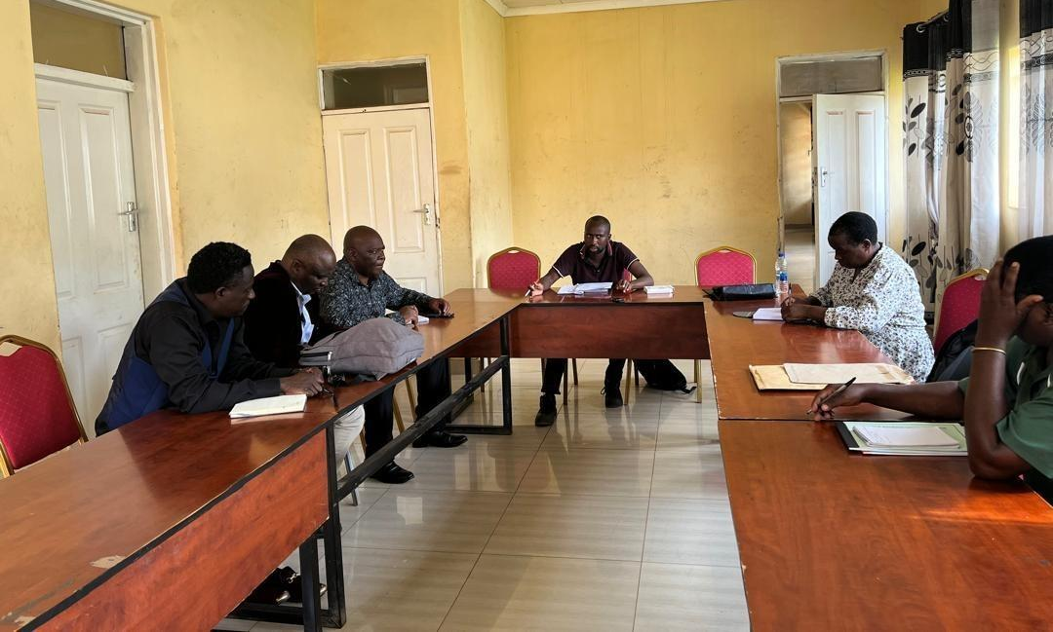
Figure 1-1: Consultation with Mchinji DESC members
Note: All photographs included in this report were taken during stakeholder consultations and field activities with the informed consent of the individuals concerned.

Project Location
The Kholoni–Sitolo Feeder Road is located in Mchinji District in the Central Region of Malawi. The road extends from Kholoni to Sitolo and serves rural agricultural communities within EPA Chiosya / GVH Kholoni, including Kholoni, Chisenga, Molosiyo, and Sitolo.
Based on the project spatial data, the road has a mapped length of 9.36 km. The alignment commences at 483163.77 mE, 8480148.64 mN and terminates at 480805.63 mE, 8487734.32 mN in UTM coordinates. The corridor traverses predominantly rural landscapes comprising cultivated land, settlement clusters, drainage paths, and community facilities. The location of the road is shown in the project maps in figures 1-2 to 1-5 below.
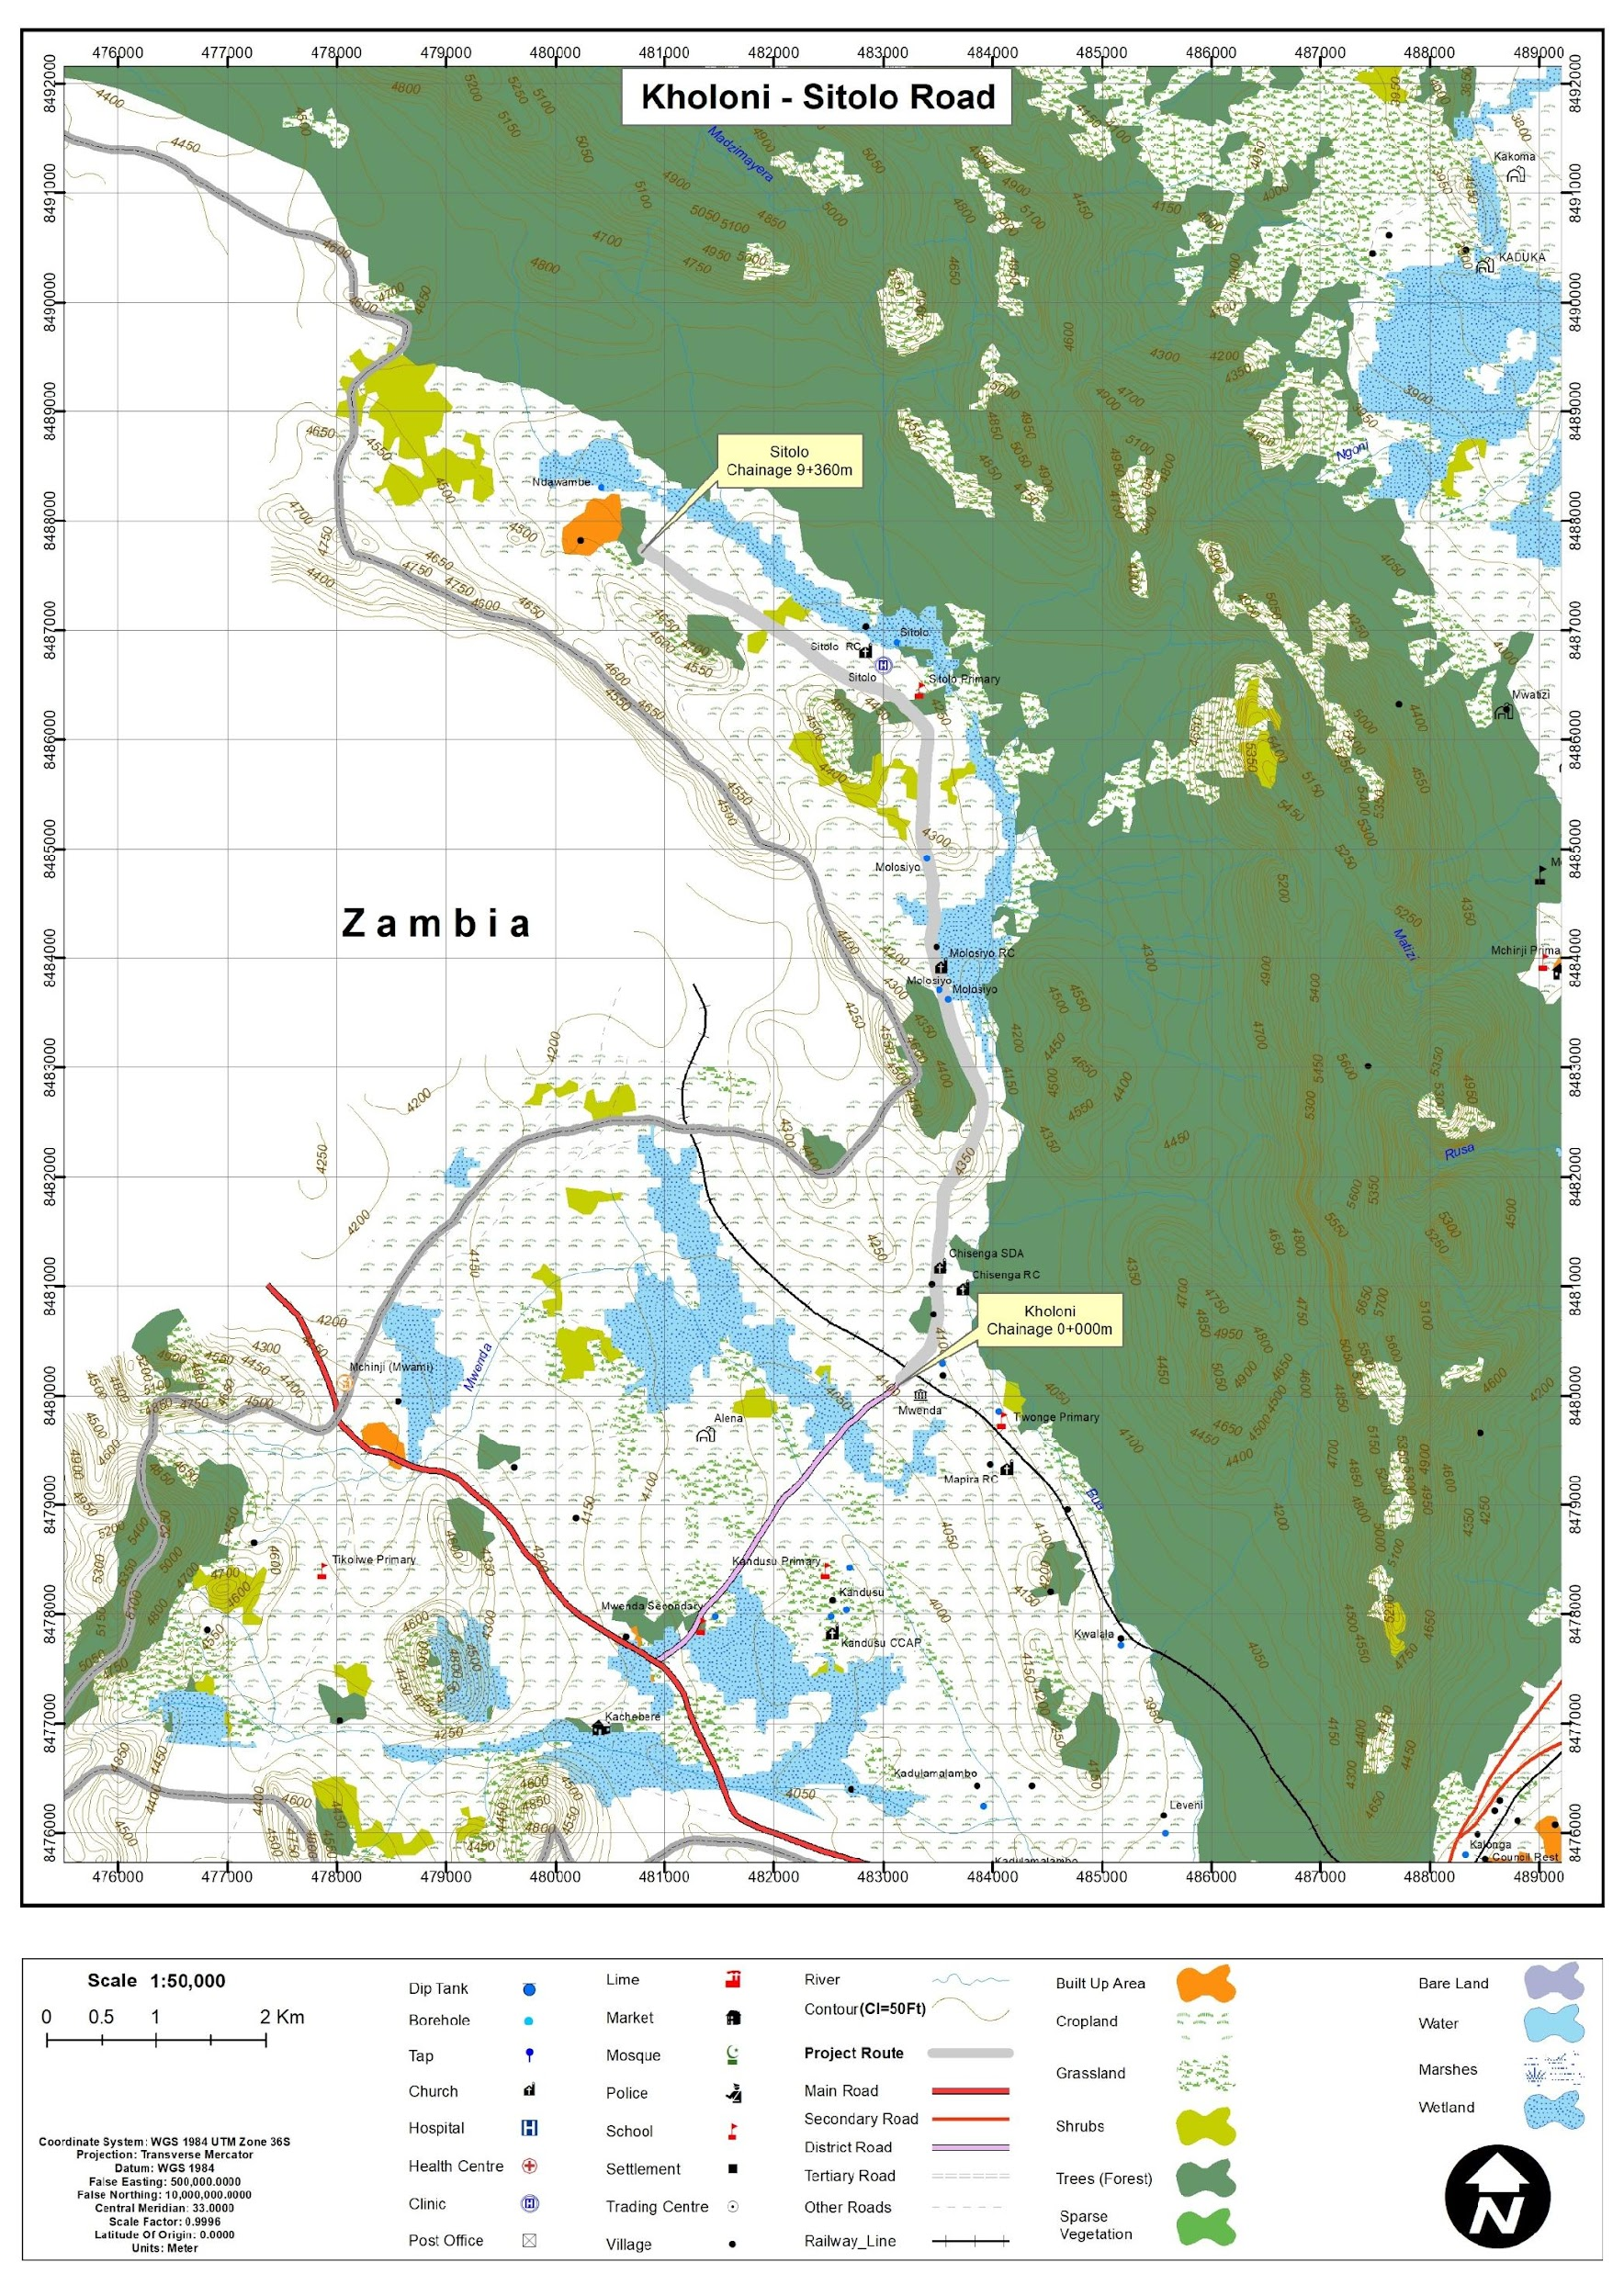
Figure 1-2: Project location map
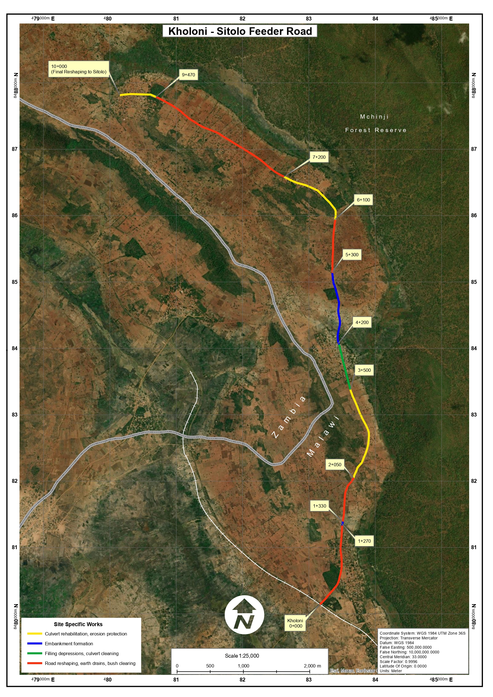
Figure 1-3: Aerial view of the Kholoni–Sitolo corridor
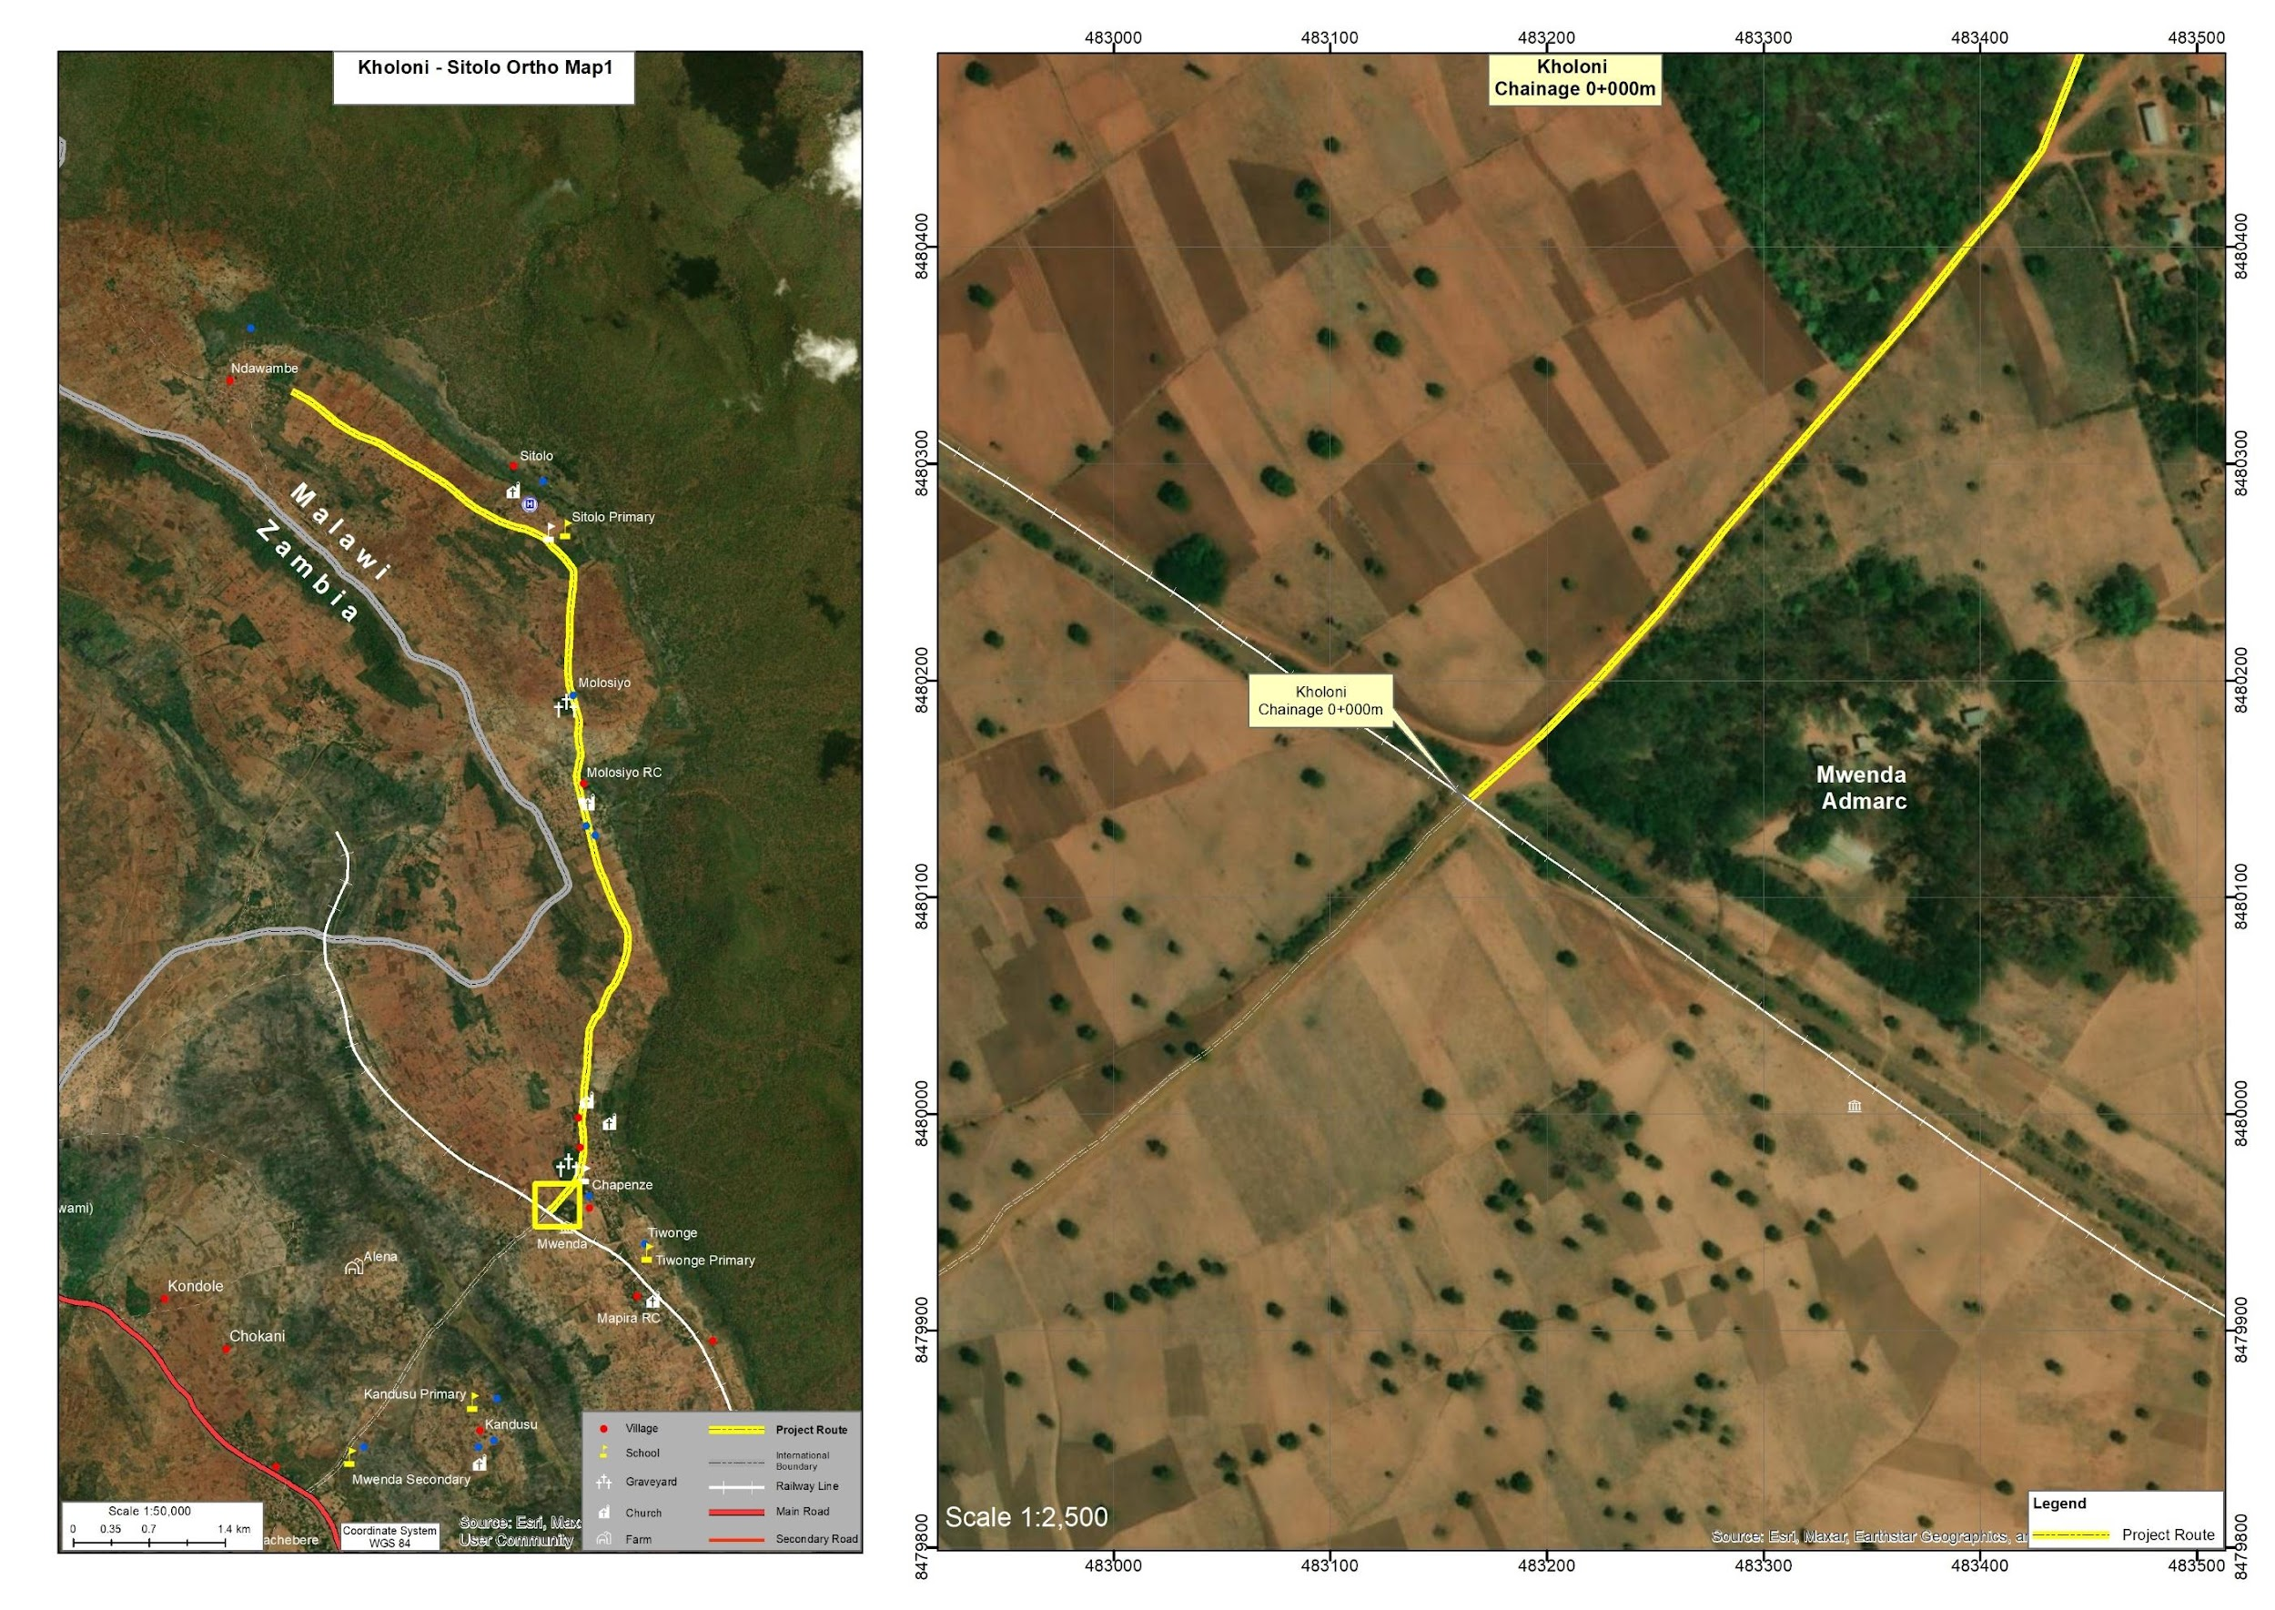
Figure 1-4: Detailed view of Chainage 0+000 of the road corridor
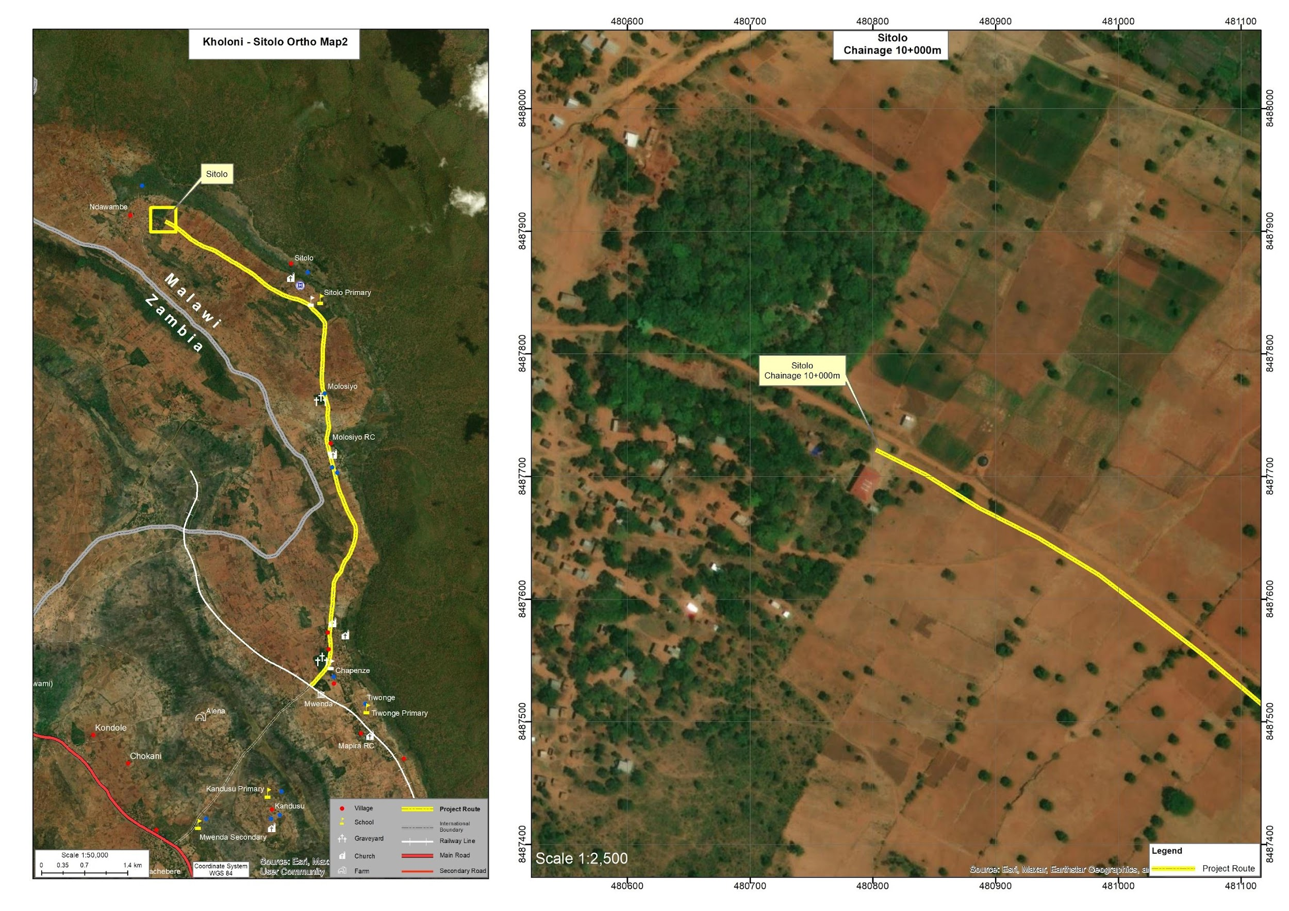
Figure 1-5: Detailed view of End of the Road Corridor

Land Tenure and Land Requirement for the Project
The Kholoni–Sitolo corridor lies in an area where land is predominantly held under customary tenure and administered through established traditional leadership structures. Residential plots, cultivated fields and community facilities adjacent to the road are generally occupied and used under customary rights.
The proposed intervention is limited to rehabilitation and spot improvements within the existing road corridor and road reserve, as detailed in Annex 15 (Spatial Distribution of Works). The works comprise targeted activities such as spot gravelling, reshaping, earth drains, scour checks, culvert rehabilitation and replacement, concrete pads, a small number of new box culverts, and localized embankment formation between chainage 0+000 (Kholoni) and 9+420, with no works extending beyond the established reserve. Within these chainages, the bill of quantities and strip maps show that activities are concentrated at discrete locations (e.g. existing drainage crossings and eroded sections) rather than along the full length of the alignment, and that all interventions remain inside the available road reserve width.
Field verification and mapping confirm that, although some houses, water points, churches and a community graveyard occur close to the road, the spot-check design allows all planned works to be accommodated on the carriageway and the unused portions of the reserve without affecting these assets. In particular, sections involving new or upgraded culverts and embankment improvements (for example at approximately 1+275–1+330, 3+400–4+360 and other listed chainages) have been checked against the orthophotos to ensure that no residential or business structures, and no part of the graveyard, fall within the construction footprint. On this basis, no permanent land acquisition, physical displacement or loss of primary residential or commercial structures is anticipated, and the subproject does not involve land take beyond the existing road reserve.
Agricultural activities and settlement occur close to certain sections of the road, particularly near community nodes, but the rehabilitation design explicitly avoids unnecessary widening or realignment. Any short-term disturbance (for example, temporary access constraints or minor edge trimming within the reserve) will be addressed through good construction practices, access management and the project-level grievance redress mechanism rather than through formal land acquisition.
Any temporary land requirements associated with contractor operations, material stockpiles or borrow areas will be managed in line with applicable legal and safeguard requirements, including prior consultation and agreement with customary landholders and local leadership, written consent where appropriate, and full rehabilitation of sites upon completion of use.

Potential Users of the ESMP
This Environmental and Social Management Plan (ESMP) provides guidance for managing environmental and social risks associated with the rehabilitation of the Kholoni–Sitolo Access Road. The document serves as a practical tool for institutions responsible for project implementation, supervision, compliance monitoring, and stakeholder engagement throughout the project lifecycle.
Table 1-1 outlines the key institutions and stakeholders expected to use this ESMP and their respective roles in environmental and social management.
Table 1-1. Potential Users of the ESMP and Their Roles
Potential User | Potential Usage of the ESMP
Malawi Environment Protection Authority (MEPA) | Regulatory review, environmental compliance monitoring, and verification that project implementation aligns with the Environmental Management Act (2017) and MEPA requirements.
Ministry of Transport and Public Works (MoTPW) and PIU | Project owner and implementing authority responsible for overall coordination of the road rehabilitation works and ensuring that environmental and social safeguards are integrated into project implementation under the SATCP Last Mile Infrastructure component.
Mchinji District Council (including DESC) | Local-level monitoring and coordination of environmental and social management measures, as well as facilitation of engagement with local communities.
Ministry of Labour and National Construction Industry Council (NCIC) | Oversight of labour standards, occupational health and safety compliance, and contractor adherence to national labour regulations.
Project Engineers and Supervising Consultants | Integration of environmental and social requirements into construction supervision, site inspections, and monitoring of mitigation measures during project implementation.
Contractors and Subcontractors | Implementation of ESMP mitigation measures, occupational health and safety provisions, labour management procedures, community health and safety measures, and GBV/SEA/SH prevention requirements during construction.
Local Communities and Road-Corridor Users | Awareness of project activities, potential impacts, mitigation measures, employment opportunities, and access to the project Grievance Redress Mechanism (GRM).
World Bank and Other Oversight Institutions | Safeguards due diligence, implementation supervision, and monitoring of compliance with applicable environmental and social safeguard policies.

CHAPTER 2: PROJECT DESCRIPTION

Introduction
This chapter describes the technical scope and physical components of the proposed upgrading of the Kholoni–Sitolo Road (UD) to gravel standard in Mchinji District. The road currently exists as an earth track with sections that become difficult or impassable during the rainy season, thereby constraining movement of agricultural produce and access to markets and essential services for surrounding communities.
The proposed intervention involves upgrading approximately 10 km of the existing Kholoni–Sitolo Road to gravel standard using Low Volume Road (LVR) design principles, while maintaining the current alignment and road reserve. The works are intended to improve the road formation, drainage capacity, and stability of weak and flood-prone sections in order to provide safer and more reliable all-weather access.

Overview of Engineering Works
The proposed works comprise targeted upgrading measures along the full 10 km alignment, addressing sections affected by drainage failure, localised erosion, deteriorated cross-drainage structures, and road formation deficiencies. The main interventions include gravelling of the carriageway, reshaping and grading of the road formation, rehabilitation and replacement of drainage structures, embankment improvement in low-lying sections, and spot improvement works at locations affected by erosion or poor drainage.
The engineering design also includes rehabilitation of existing concrete pipe culverts, construction of new reinforced concrete box culverts at selected locations, provision of headwalls and lined outlet drains, construction of earth drains, mitre drains and lined drains, and installation of scour checks and erosion protection works. Presenting these works clearly at project description stage is consistent with ESMP good practice, which requires technical description of the activities and institutional linkages needed for subsequent mitigation and monitoring provisions.mepa+1
The spatial distribution of these interventions along the Kholoni–Sitolo Road, from chainage 0+000 at Kholoni to chainage 10+000 at Sitolo, is presented in Annex 15 (Spatial Distribution of Works), which provides the detailed chainage-specific schedule of works.

Key Engineering Focus Areas
Review of the Detailed Engineering Design indicates that gravelling, reshaping and provision of side drains extend along most of the 0+000 to 9+420 corridor, while more intensive interventions are concentrated at specific chainages where culverts, drifts, embankments and outlet conditions are deficient. These include multiple existing 600 mm diameter concrete pipe culverts that require cleaning, provision or replacement of headwalls, excavation and lining of outlet drains, and in some cases demolition and replacement with reinforced concrete box culverts.
Additional critical interventions are proposed at low-lying and erosion-prone sections where embankment formation, retaining structures, lined drains, scour checks and outlet protection works are required to stabilise the road prism and improve drainage performance. This chainage-based presentation provides a practical basis for linking specific engineering interventions to the environmental and social risks, mitigation measures, monitoring requirements and institutional responsibilities set out in subsequent chapters of this ESMP.

Project Implementation Phases
The upgrading of the Kholoni–Sitolo Road will be implemented through four main phases: planning and design, construction, demobilisation and operation. Each phase comprises specific activities that must be undertaken in a manner that manages environmental and social risks in accordance with national requirements and applicable World Bank safeguard and ESMF principles, and the ESMP should specify the roles of responsible parties for implementation and monitoring across these phases. The implementation phases are presented in table 2-1.
Table 2-1: Main Activities for Kholoni–Sitolo Road at each Phase
Phase | Main activities
Planning and Design | Engineering surveys and topographical mapping of the 10 km corridor; inventory and condition assessment of existing drainage structures and erosion-prone sections; hydrological analysis to determine culvert capacities and drainage requirements; preparation of the Detailed Engineering Design (DED), including road geometry, gravel layer thicknesses, culvert rehabilitation/replacement, erosion control structures and embankment design; environmental and social screening, preparation of the ESMP and integration of safeguards into design and bidding documents; stakeholder consultations with district authorities, traditional leaders and affected communities.
Construction | Site establishment, including contractor camps, equipment yards and material storage areas; clearing of vegetation and obstructions within the road reserve, limited to the footprint required for works; earthworks including excavation, grading and reshaping of the road formation, and embankment construction in flood-prone or low-lying sections; placement and compaction of the gravel wearing course to the specified thickness and cross-fall; rehabilitation of existing concrete pipe culverts, including cleaning, replacement of damaged pipes where required, provision of new headwalls, and excavation and lining of outlet drains; construction of new cross-drainage structures, including reinforced concrete box culverts at selected locations and additional pipe culverts to meet design flows; construction and improvement of side drains, mitre drains and lined drains, together with scour checks and erosion protection works at culvert outlets and embankments; implementation of traffic management measures and temporary access arrangements during construction; implementation of environmental and social mitigation measures as set out in this ESMP.
Demobilisation | Removal of contractor camps, equipment yards, temporary storage areas and temporary diversions; collection and proper disposal of construction waste, surplus materials and dismantled structures; rehabilitation of borrow areas and temporary work sites in accordance with agreed restoration plans; reinstatement and stabilisation of disturbed surfaces and drainage channels to prevent erosion.
Operation and Maintenance | Routine grading of the gravel surface to maintain ride quality and drainage function; periodic regravelling of the carriageway; regular cleaning of side drains, mitre drains and culvert inlets/outlets to maintain drainage capacity; inspection and maintenance of culverts, headwalls, erosion protection works and embankments, including repair of erosion or structural damage; vegetation management within the road reserve to maintain sight distance and protect drainage features; ongoing monitoring of road condition, drainage performance and safety features by the District Council and the Project Team, with findings integrated into routine and periodic maintenance planning.

Project Components and Activities
The project involves the upgrading of approximately 10 km of an existing undesignated (UD) earth road to gravel standard, incorporating improvements to road geometry, drainage infrastructure, and safety features. Engineering investigations identified several drainage deficiencies and deteriorated cross-drainage structures along the alignment, which contribute to seasonal flooding, erosion of the road formation, and limited accessibility during the rainy season.
The design therefore prioritises rehabilitation and installation of drainage structures, including concrete pipe culverts, box culverts, headwalls, lined drains, and erosion protection works at outlets. The project also includes strengthening of the road formation, gravelling of the carriageway, and construction of embankments in low-lying sections to improve climate resilience and year-round accessibility.

Labour Requirement
Construction activities will require a combination of skilled, semi-skilled, and unskilled labour, reflecting the diversity of works such as gravel surfacing, culvert installation, drainage construction, earthworks, and embankment improvement.
At peak construction periods, the contractor is expected to employ approximately 70–100 workers, depending on the level of mechanization and sequencing of works. The highest workforce levels occurring during peak construction activities such as drainage installation, excavation, and gravel placement.
In line with Government of Malawi development objectives and World Bank safeguard principles, priority will be given to recruiting local labour from communities along the project corridor. Local employment will mainly cover labour-intensive tasks such as vegetation clearing, excavation, drainage construction, traffic control, and general site labour. This approach promotes local economic benefits while minimising labour influx risks.
Specialised technical personnel—including engineers, surveyors, materials technicians, equipment operators, and personnel responsible for environmental, social and occupational health and safety compliance—may be recruited externally where local skills are unavailable. These personnel will support construction supervision, quality assurance, environmental and social compliance, and occupational health and safety oversight.
The contractor will also promote gender-inclusive employment practices, encouraging the participation of women in appropriate labour-based activities and ensuring equitable working conditions.
Table 2-2: Expected Number of People to be Employed (Indicative Peak Workforce)
SN | Employee Category | Local | External* | Total
1 | Civil Engineering and Supervision | 3 | 3 | 6
2 | Surveying and Setting Out | 2 | 2 | 4
3 | Masonry and Concrete Works | 8 | 0 | 8
4 | Carpentry and Formwork | 5 | 0 | 5
5 | Mechanical / Equipment Operators | 5 | 3 | 8
6 | Drainage Construction | 12 | 0 | 12
7 | Excavation and Earthworks | 15 | 0 | 15
8 | Manual Material Handling | 10 | 0 | 10
9 | Site Clearing and Preparation | 8 | 0 | 8
10 | Traffic Control and Safety | 5 | 0 | 5
11 | General Site Maintenance | 4 | 0 | 4
12 | Catering and Welfare Services | 2 | 0 | 2
13 | Security Services | 4 | 0 | 4
14 | Health and Safety Compliance | 2 | 0 | 2
15 | Environmental and Social Compliance (combined) | 2 | 0 | 2
*External staff refers to specialised personnel engaged on a short-term basis.

Land Requirement
The upgrading of the Kholoni–Sitolo Road will be implemented within the existing road alignment and established road reserve. The project design does not involve widening beyond the current road corridor and therefore does not require permanent land acquisition.
All proposed activities, including road formation improvement, gravel surfacing, drainage construction, and embankment formation, will be undertaken within the existing road footprint. Where informal temporary structures such as vending booths or groceries placed by their occupants occur within the road reserve along the alignment, the corresponding sections have been deliberately excluded from the spot-based rehabilitation scheme during design, so that construction works avoid them altogether; any residual coordination needs around the immediate working area will be handled under the stakeholder engagement and GRM provisions of this ESMP.
Field assessments conducted during ESMP preparation indicate that some sections of the road reserve are currently used for:
- small-scale cultivation;
- pedestrian footpaths;
- informal access tracks to farms and homesteads.
Consultations with the farmers indicated that communities are aware that their cultivation activities are within the road reserve. The land along the road reserve is very minimum and will not have any significant livelihood impact except temporary disturbance during construction activities. No asset loose is anticipated. Where temporary adjustments are required during construction activities, particularly for culvert installation or embankment reconstruction, these will be addressed through consultation with affected land users and local leadership structures.
Temporary land may be required for short-term construction activities such as material stockpiling; equipment parking and contractor site facilities. Such temporary use will only occur following agreement with relevant landowners or community leaders and affected areas will be restored after construction.
Based on the defined scope and use of the existing alignment, the project is not expected to cause physical displacement or permanent land loss. Any minor land-related concerns arising during implementation will be managed through the project grievance redress mechanism and applicable national procedures.

Material Requirements and Sources
Construction of the proposed Kholoni–Sitolo Road rehabilitation project will require a range of materials for pavement construction, drainage structures, embankment formation, and erosion protection works. These materials include gravel for the road wearing course, sand and aggregates for concrete works, cement, and water for construction activities.
Potential sources of construction materials were identified during preparation of the Detailed Engineering Design (DED) and confirmed through preliminary field verification. The contractor will obtain all materials from approved and environmentally compliant sources and will ensure that extraction and transportation activities comply with national environmental regulations and the requirements of this Environmental and Social Management Plan (ESMP).
All material extraction sites and supply points will be subject to appropriate environmental management measures, and any borrow areas used during construction will be rehabilitated upon completion of extraction.

Gravel Material
Gravel will be the primary material required for construction of the road wearing course and for strengthening of the road formation in sections requiring embankment improvement.
Suitable gravel sources have been identified from nearby borrow pits during the materials investigations undertaken as part of the engineering design. Laboratory testing of the sampled materials confirmed that they meet the required technical specifications for gravel wearing courses under low-volume rural road standards.
The estimated volume of gravel required for the project is expected to be in the range of 8,000–10,000 cubic metres, depending on final design quantities, layer thickness, and compaction factors.
Gravel extraction will only be undertaken from approved borrow pits, and all borrow areas will be rehabilitated after completion of extraction in accordance with the borrow pit rehabilitation measures outlined in this ESMP.

Sand
Sand will be required for a range of construction activities, including:
- concrete works associated with culverts and drainage structures;
- masonry works such as culvert headwalls and wing walls;
- minor drainage lining and structural works where necessary.
Sand will be sourced from licensed suppliers or approved riverine extraction sites within Mchinji District, subject to compliance with relevant regulatory requirements.
Extraction of sand from natural watercourses will comply with the provisions of the Water Resources Act (2013) and other applicable environmental regulations to ensure that river ecosystems and downstream water users are not adversely affected. These primary suppliers will comply with labor regulations including prohibiting child or forced.

Aggregates and Cement
Coarse aggregates required for concrete works will be obtained from licensed quarry operators within the region. Aggregates will be transported to the construction site using covered trucks to minimise material loss and dust generation.
Cement required for concrete works will be procured from authorised commercial suppliers and transported to site in sealed bags to prevent moisture contamination and reduce dust emissions during handling.
Proper storage of cement will be ensured through the use of covered storage areas to maintain product quality and prevent environmental contamination.

Water for Construction
Water will be required during construction for several purposes, including:
- compaction of gravel layers during road formation works;
- mixing of concrete and mortar;
- dust suppression along the construction corridor;
- general construction and site management activities.
Water will be sourced from approved and legally accessible water sources, which may include nearby rivers or streams where authorised, boreholes, or commercial water supply points.
The contractor will ensure that water abstraction does not negatively affect community water supply systems, livestock watering points, or downstream water users. Any abstraction from natural water sources will comply with relevant regulatory requirements and will be conducted in consultation with local authorities where necessary.

Material Transport
Construction materials will be transported to the project site using tipper trucks, haulage trucks, and water bowsers. Existing access roads and sections of the project corridor will be used as haul routes for the delivery of materials and movement of construction equipment.
Transport operations will be carefully managed to minimise environmental and social impacts, including dust generation, traffic disruption, and safety risks to nearby communities.
Where necessary, the contractor will implement appropriate traffic management and road safety measures, including speed control, warning signage, and coordination with local communities to ensure safe movement of construction vehicles and road users.

Table 2-3: Summary of Construction Materials and Sources
Material | Purpose | Potential Source | Key Environmental Considerations
Gravel | Wearing course for the road surface and strengthening of road formation | Approved borrow pits identified during engineering design | Borrow pits must be approved by relevant authorities; extraction areas must be rehabilitated after use to prevent erosion and water stagnation
Sand | Concrete works for culverts, masonry structures (headwalls and wing walls), and drainage works | Licensed suppliers or approved riverine extraction sites within Mchinji District | River sand extraction must comply with the Water Resources Act (2013) and avoid disturbance of riverbanks and aquatic ecosystems
Aggregates (Coarse) | Concrete works for culverts and drainage structures | Licensed quarry operators within the region | Quarry operations must hold valid licenses and comply with environmental regulations
Cement | Structural concrete works and masonry construction | Authorised commercial suppliers | Proper storage in covered areas to prevent contamination, moisture damage, and dust emissions
Water | Gravel compaction, concrete mixing, dust suppression, and general construction activities | Approved water sources such as nearby rivers, boreholes, or commercial supply points | Water abstraction must not interfere with community water supply or downstream users

Waste Generation and Management
Construction activities associated with the upgrading of the Kholoni–Sitolo Road will generate several types of waste materials. Although the scale of works is moderate and largely confined to rehabilitation of an existing road corridor, appropriate waste management practices will be implemented to prevent environmental pollution, protect community health, and minimise nuisance to surrounding communities.
Waste generated during the construction phase will be managed in accordance with the Environment Management Act (2017), relevant local authority regulations, and good international industry practice for construction waste management. The contractor will implement a waste management system that prioritises waste minimisation, reuse, recycling, and safe disposal.
Waste management measures will include proper segregation of waste streams, safe storage of hazardous materials, and disposal of non-reusable waste at approved disposal sites.

Anticipated Waste Streams
The main waste streams expected during the construction phase include:
- excavated soil and spoil generated from drainage construction and earthworks;
- vegetation cleared from the road corridor;
- broken concrete or masonry debris resulting from culvert repair or replacement;
- packaging materials such as cement bags, plastic wrapping, and containers;
- used oils, lubricants, and oily rags from machinery maintenance;
- scrap metal from equipment repairs or construction works;
- domestic waste generated by construction workers;
- wastewater generated from equipment washing and concrete works.
These waste streams will be managed through appropriate waste handling procedures to minimize environmental impacts.

Spoil Management
Excavation works for road formation, culverts, and drainage structures will generate soil and spoil materials. Wherever feasible, suitable excavated materials will be reused within the project site for activities such as:
- embankment construction;
- backfilling of culvert trenches;
- landscaping and stabilization of disturbed areas.
Spoil that is unsuitable for reuse will be transported to designated disposal sites approved by the Mchinji District Council or other relevant authorities.
Disposal sites will be carefully selected to avoid environmentally sensitive areas, including:
- rivers and streams;
- wetlands;
- agricultural land;
- residential areas and community facilities.
Spoil disposal will be carried out in a controlled manner to prevent erosion, sedimentation, and obstruction of natural drainage systems.

Hazardous Waste Management
Construction activities involving machinery and vehicles may generate small quantities of hazardous waste such as used oils, lubricants, grease, oil filters, and fuel residues.
These materials will be managed through the following measures:
- storage in sealed and clearly labelled containers;
- placement of containers in designated storage areas with secondary containment;
- prevention of spills and leaks during storage and transport;
- disposal through licensed hazardous waste handlers or recycling facilities where available.
Spill response materials will be maintained at construction sites to enable rapid containment and clean-up of accidental spills.

Domestic Waste
Domestic waste will be generated from construction workers operating along the road corridor or at temporary work sites.
Domestic waste will include:
- food waste;
- plastic bottles and packaging;
- paper waste;
- general refuse.
This waste will be collected in designated waste bins placed at construction work areas and site offices. The contractor will arrange for regular collection and transportation of domestic waste to approved disposal sites identified by the District Council.
Open burning of waste within the project site will not be permitted, except where specifically authorised by relevant authorities.

Borrow Pit Rehabilitation
Borrow pits used for extraction of gravel materials will be rehabilitated following completion of material extraction in order to prevent long-term environmental degradation and reduce safety risks to surrounding communities.
Borrow pit rehabilitation measures may include:
- reshaping pit slopes to stable gradients;
- backfilling or contouring of excavated areas where appropriate;
- improving drainage to prevent formation of stagnant water;
- re-vegetation of disturbed areas using natural regeneration or planting.
Proper rehabilitation of borrow pits will reduce erosion risks, improve landscape stability, and minimise hazards such as accidental falls or mosquito breeding.

Table 2-4: Anticipated Waste Streams and Management Measures
Waste Stream | Possible Sources |  | Proposed Waste Management Measures
Excavated Soil and Spoil | Drainage construction, culvert installation, road formation works |  | Reuse for embankment construction or backfilling where suitable; dispose of excess spoil at approved disposal sites
Cleared Vegetation | Vegetation clearing within road reserve |  | Reuse as mulch where appropriate; allow community use where safe; dispose of excess vegetation at approved locations
Concrete Waste | Culvert installation or rehabilitation works |  | Reuse as fill material where feasible; dispose of unusable debris at approved council disposal sites
Scrap Metal | Equipment repairs or structural works |  | Collect and recycle through licensed scrap metal dealers
Used Oils and Lubricants | Machinery servicing and maintenance |  | Store in sealed containers; dispose of through licensed hazardous waste handlers or recycling facilities
Packaging Waste (Cement Bags, Plastics) | Construction materials packaging |  | Segregate and recycle where possible; dispose of non-recyclables at approved waste disposal sites
Domestic Waste | Worker camps and site offices |  | Provide waste bins; collect and transport waste to approved disposal sites; prohibit open burning
Wastewater | Equipment washing and concrete works |  | Dispose in designated soak pits or controlled areas to avoid contamination of watercourses

CHAPTER 3: POLICY AND LEGAL FRAMEWORK

Introduction
This chapter outlines the policy, legal, and institutional framework governing the proposed Rehabilitation of the Kholoni–Sitolo Road in Mchinji District, Malawi. It reviews the key national policies, laws, guidelines, and required approvals relevant to Environmental and Social (E&S) risk management, ensuring compliance with Malawi’s environmental governance system and World Bank Operational Policy OP/BP 4.01 on Environmental Assessment. The chapter also defines the roles and responsibilities of institutions responsible for regulating, implementing, supervising, and monitoring E&S performance throughout the project lifecycle. Overall, it provides the legal and institutional foundation for ensuring that the road rehabilitation is environmentally sustainable, legally compliant, and socially responsible.

National Policies and Strategies

Policy Framework
Table 3-1 presents key national policies and strategies that provide the strategic and regulatory framework for planning, implementation, and monitoring of the proposed project. These policies reflect Malawi’s development priorities and establish obligations relating to environmental protection, land administration, water resources management, climate resilience, gender inclusion, labour standards, waste management, and transport sector governance.
Table 3-1: Key National Policies Guiding the Project
Policy / Strategy | Brief Description | Implications for the Project
Malawi 2063 (MW2063) and First 10-Year Implementation Plan (MIP-1, 2021–2030) | Malawi’s long-term national development vision and medium-term implementation plan prioritising economic infrastructure, rural connectivity, trade facilitation, and climate resilience. | Rehabilitation of the proposed Road contributes to MW2063 and MIP-1 by improving rural connectivity, enhancing access to markets and social services, and strengthening climate-resilient transport infrastructure.
National Environmental Policy (2004) | Provides the overarching framework for integrating environmental sustainability into development planning and decision-making. | Requires integration of environmental safeguards, pollution prevention measures, and adherence to environmental assessment requirements administered by MEPA.
National Land Policy (2002) | Promotes orderly land administration, secure land tenure, and sustainable land use management. | Requires respect for the legal road reserve while ensuring that surrounding customary land rights are safeguarded.
National Water Policy (2005) | Promotes sustainable water resources management, protection of water bodies, and equitable access to water resources. | Requires protection of nearby rivers and streams during construction and responsible water abstraction for construction purposes, including prevention of erosion and siltation from earthworks and drainage works.
National Gender Policy (2015) | Promotes gender equality and equitable participation of women and men in development processes. | Requires gender-inclusive stakeholder engagement, equal employment opportunities, and integration of Gender-Based Violence (GBV) and Sexual Exploitation and Abuse (SEA) risk prevention measures during project implementation.
National Climate Change Management Policy (2016) | Provides guidance for climate change adaptation and mitigation across sectors. | Requires integration of climate-resilient design features such as adequate drainage systems, erosion control, and improved road formation to withstand extreme rainfall events.
National Sanitation Policy (2008) | Provides a framework for improving sanitation and hygiene standards and safe management of waste. | Requires appropriate management of solid and liquid waste generated during construction activities, including safe storage and disposal practices.
National HIV and AIDS Policy (2022–2027) | Aims to reduce HIV transmission and strengthen workplace HIV prevention and non-discrimination measures. | Requires implementation of HIV and AIDS awareness programmes for construction workers and communities and promotion of non-discriminatory workplace practices. Contractor to develop CoC in accordance with annex 4
National Transport Policy (2015) | Aims to develop a safe, efficient, and sustainable transport system in Malawi. | Supports rehabilitation of rural roads to improve access and connectivity, and requires incorporation of road safety considerations and safe traffic management during construction.
National Labour and Employment Policy (2017) | Promotes decent work, fair labour practices, and protection of workers’ rights. | Requires fair recruitment practices, decent working conditions, prohibition of child labour, and compliance with occupational health and safety standards. Contractor to develop a plan following annex 8
National Forest Policy (2016) | Promotes sustainable forest management and restoration of degraded landscapes. | Requires minimisation of vegetation clearing within the road reserve and implementation of erosion control and site rehabilitation measures after construction.
National Decentralisation Policy (1998) | Provides the framework for devolved governance and planning at district level. | Requires engagement with the District Council and the District Environmental Sub-Committee (DESC) for environmental oversight, monitoring, and alignment with district development priorities and by-laws.

Legislative Framework
Table 3-2 outlines the principal national legislation governing implementation of the Proposed Rehabilitation of the Kholoni–Sitolo Road in Mchinji District. These statutes provide the legal basis for environmental protection, land administration, labour standards, occupational health and safety, public health, water resources management, and road infrastructure development in Malawi.
Compliance with these laws is mandatory and informs the design, construction, and operation of the project, as well as the mitigation and monitoring measures outlined in this Environmental and Social Management Plan (ESMP).

Table 3-2: Key National Legislation Guiding the Project
Act | Brief Description | Implications for the Project
Constitution of the Republic of Malawi (1995) | The supreme law of Malawi guaranteeing environmental protection, human rights, gender equality, and sustainable development (Sections 5, 12(e), and 13(d)). | Requires environmentally sound project implementation and protection of community rights through application of approved environmental and social safeguards instruments.
Environment Management Act (2017) | Principal legislation governing environmental protection, environmental assessment, pollution control, and sustainable natural resource management in Malawi. | Requires preparation and implementation of an ESMP and compliance with environmental requirements administered by MEPA prior to and during project implementation.
Public Roads Act (2023) | Provides the legal framework for classification, development, rehabilitation, and maintenance of public roads and associated infrastructure. | Requires that rehabilitation works be undertaken within the legally designated road reserve and that appropriate drainage, safety, and access management standards are applied.
Land Act (2016) and Customary Land Act (2016) | Establish the legal framework governing land tenure systems, land administration, acquisition of land for public purposes, and compensation. | Confirms the legal status of the public road reserve and requires that surrounding customary land rights are respected. No land acquisition is anticipated as works are confined within the existing road corridor.
Water Resources Act (2013) | Provides for sustainable management, allocation, and protection of water resources in Malawi. | Requires permits for water abstraction where necessary and implementation of measures to prevent pollution, erosion, and sedimentation of nearby water bodies during construction.
Occupational Safety, Health and Welfare Act (1997) | Establishes requirements for safe and healthy workplaces and regulates plant, machinery, and hazardous working conditions. | Requires implementation of Occupational Health and Safety (OHS) measures including provision of PPE, site safety procedures, and safe operation of construction equipment. Plans will be developed by contractor in line with annex 6 and 8
Employment Act (2000) | Provides minimum employment standards and prohibits forced labour, discrimination, and child labour. | Requires fair recruitment procedures, compliance with labour standards, and prohibition of child labour in project activities.
Gender Equality Act (2013) | Promotes gender equality and prohibits discrimination, harassment, and exploitation in workplaces and society. | Requires gender-inclusive employment practices and enforcement of measures to prevent Gender-Based Violence (GBV), Sexual Exploitation and Abuse (SEA), and Sexual Harassment (SH).
Data Protection Act (2024) | Regulates the collection, processing, storage, use, and protection of personal data in Malawi, including obligations relating to confidentiality, lawful processing, and protection of personal information. | Requires that stakeholder information collected through consultations, attendance registers, interviews, grievance redress, and project monitoring activities be used strictly for project purposes, securely stored, and handled in a manner that protects confidentiality and privacy.
Child Care, Protection and Justice Act (2011) | Protects the rights, welfare, and development of children in Malawi and provides legal mechanisms to prevent abuse, neglect, exploitation, and harmful practices affecting children. | Requires the proposed project to enforce zero child labour, ensure child safety around construction sites, and implement reporting and response mechanisms for child protection risks in accordance with Sections 3, 79, and 80–82 of the Act.
HIV and AIDS (Prevention and Management) Act (2018) | Protects rights of people living with HIV and AIDS and promotes workplace awareness and prevention programmes. | Requires non-discriminatory practices and implementation of HIV awareness programmes among construction workers and surrounding communities.
Public Health Act (1948) | Provides legal provisions for safeguarding public health, sanitation, drainage, and disease prevention. | Requires provision of sanitation facilities at construction sites and proper waste management to prevent public health risks.
Environment Management (Waste Management and Sanitation) Regulations (2008) | Regulates management of solid and liquid waste, including hazardous waste handling and disposal. | Requires segregation, safe storage, transportation, and disposal of waste generated during construction activities.
Environment Management (Chemicals and Toxic Substances) Regulations (2008) | Regulates the handling, storage, transportation, and disposal of chemicals and hazardous substances. | Requires proper storage and handling of fuels, lubricants, and chemicals used in construction operations.
Forestry Act (2020) | Provides for conservation, sustainable management, and protection of forest resources. | Requires minimisation of vegetation clearing within the road reserve and rehabilitation of disturbed areas after construction.
National Parks and Wildlife Act (2017) | Provides for conservation and management of wildlife resources and biodiversity. | Requires that project activities avoid disturbance to wildlife habitats and prohibits hunting or exploitation of wildlife by project workers.
Local Government Act (1998) | Empowers district councils to manage development planning, environmental management, and service delivery. | Requires coordination with the District Council and the District Environmental Sub-Committee (DESC) for project consultations, monitoring, and compliance with district by-laws.
Physical Planning Act (2016) and Physical Planning (Amendment) Act (2022) | Regulates land use planning and requires development permission for infrastructure projects. | Requires obtaining Development Permission from the District Council prior to commencement of works.
Liquid Fuels and Gas (Production and Supply) Act (2004), Chapter 50:03 | Regulates the production, storage, transportation, distribution and supply of liquid fuels and gas in Malawi. The Act establishes licensing requirements and safety standards to ensure proper handling and management of petroleum products and gas within the country. | Where project activities involve the storage or use of petroleum products (e.g., diesel for construction equipment or generators), fuel handling must comply with national safety and licensing requirements. Contractors must ensure safe storage, transport and use of fuels to prevent spills, fire hazards and environmental contamination, and must comply with regulatory requirements governing fuel supply chains.
Construction Industry Act No. 28 of 2025 (CIRA Act) | Establishes the Construction Industry Regulatory Authority (CIRA) to regulate, develop, and promote the construction industry in Malawi. The Authority oversees registration and licensing of contractors, consultants, material manufacturers and suppliers, enforces professional and ethical standards, promotes training and capacity development, and standardizes construction practices and procedures across the industry. | Requires that all contractors, consultants, and suppliers engaged in the proposed Road rehabilitation project be registered and licensed by CIRA, and that construction activities comply with approved industry standards, codes of ethics, and professional conduct requirements. The project must therefore ensure engagement of CIRA-registered entities, adherence to quality and safety standards, and compliance with regulatory oversight for construction works.

World Bank Safeguard Policies and Procedures

World Bank Operational Policy OP/BP 4.01: Environmental Assessment
The proposed Rehabilitation of the Kholoni–Sitolo Road in Mchinji District is financed with support from the World Bank. As such, the project is subject to the World Bank’s environmental and social safeguard requirements. Operational Policy OP/BP 4.01 on Environmental Assessment, which governs the identification, assessment, and management of environmental and social risks associated with Bank-financed projects.
Table 3-3: World Bank Environmental and Social Safeguard Policies Applicable to the Project
Safeguard Policy | Key Requirements and Application to the Project
Environmental Assessment (OP/BP 4.01) | Requires environmental assessment of projects financed by the World Bank to ensure environmental sustainability and informed decision-making. For the Kholoni–Sitolo Road project, an ESMP has been prepared to identify potential impacts and define mitigation, monitoring, and institutional measures.
Forests (OP/BP 4.36) | Vegetation disturbance is limited to roadside clearing within the existing road reserve. The ESMP includes vegetation control and rehabilitation measures to minimise disturbance.
Physical Cultural Resources (OP/BP 4.11) | No known cultural heritage resources were identified within the project area. A Chance Finds Procedure is included in the ESMP to guide response if archaeological or cultural materials are encountered during construction.

Environmental, Health and Safety (EHS) Guidelines
The World Bank Group Environmental, Health and Safety (EHS) Guidelines represent Good International Industry Practice (GIIP) and provide technical guidance for managing environmental, occupational health, and community safety risks associated with infrastructure development projects. For the Kholoni–Sitolo Road rehabilitation project, the applicable guidance includes the General EHS Guidelines and relevant construction-related provisions for road rehabilitation works, particularly for earthworks, drainage construction, operation of construction machinery, haulage of materials, occupational safety, traffic safety, and community protection.
Key EHS risk areas addressed under this project include:
- Air Quality and Dust Control: regular water spraying, covering of haulage trucks, speed control, and equipment maintenance. Noise and Vibration Management: maintenance of machinery, restriction of noisy activities near sensitive receptors, and controlled working hours. Wastewater and Stormwater Management: runoff control, protection of roadside drains, and prevention of sediment discharge into nearby watercourses.
- Solid and Hazardous Waste Management: segregation, secure storage, licensed disposal, and spill prevention for oils and fuels.
- Occupational Health and Safety (OHS): hazard identification, PPE provision, toolbox talks, first aid readiness, and incident reporting.
- Community Health and Safety: traffic control, warning signage, pedestrian safety, controlled access to work areas, and prevention of construction-related accidents.
To ensure compliance with the World Bank Group EHS Guidelines, the contractor will prepare and implement site-specific management instruments including (Full list in Annexes):
- an Occupational Health and Safety (OHS) Management Plan;
- a Traffic Management Plan;
- a Waste Management Plan;
- a Spill Prevention and Response Plan; and
- Emergency Preparedness and Response Procedures.
- Demobilization/Reinstatement Plan
- Traffic Management Plan / Road Safety Plan:
- Borrow Pit and Quarry Management/Rehabilitation Plan
- GBV/SEA/SH Prevention and Response Action Plan:
- Workers Camp Management Plan:
- Grievance Redress Mechanism (GRM) Procedure: for communities and workers.
- Stakeholder Engagement Plan (SEP)
Implementation of these instruments will be supervised by the Supervising Engineer, the Roads Authority, the SATCP Project Implementation Unit, and relevant district authorities.

World Bank Requirements on Sexual Exploitation and Abuse (SEA) and Sexual Harassment (SH)
In line with World Bank requirements and Good International Industry Practice, all projects financed by the Bank must assess and manage risks related to Sexual Exploitation and Abuse (SEA) and Sexual Harassment (SH). These risks may arise in infrastructure projects involving mobilisation of a construction workforce and interactions between project workers and surrounding communities. The World Bank applies a zero-tolerance approach to SEA/SH, requiring borrowers and contractors to implement preventive, enforceable, and survivor-centred measures.
Under this ESMP, the contractor responsible for rehabilitation of the Kholoni–Sitolo Road will implement the following measures:
- development and enforcement of a Worker Code of Conduct prohibiting SEA/SH and gender-based violence;
- mandatory induction training for all workers on acceptable conduct and reporting obligations;
- establishment of clear disciplinary procedures for violations of the Code of Conduct;
- community awareness and sensitisation activities to inform communities of expected worker behaviour and available reporting channels; and
- operation of a confidential and survivor-centred grievance mechanism capable of handling SEA/SH complaints.
Any violations of these provisions will result in immediate disciplinary action, including removal of workers from site and referral to competent authorities where necessary.
These measures align with the World Bank Good Practice Note on Addressing SEA/SH in Investment Project Financing involving Civil Works and ensure that project implementation upholds the highest standards of professional conduct and community protection.

Institutional Framework
Implementation of this ESMP requires coordination among national and local institutions responsible for environmental regulation, transport infrastructure oversight, land administration, labour management, construction regulation, and local governance. These institutions provide regulatory oversight, technical guidance, monitoring, and enforcement to ensure that the project is implemented in compliance with national legislation and applicable World Bank safeguard requirements. The key institutions and their mandates related to ESMP implementation are summarised in Table 3-5.
Table 3-5. Key Safeguard Institutions and their Mandates
SN | Institution | Mandate Related to ESMP
1 | Malawi Environment Protection Authority (MEPA) | Principal environmental regulator under the Environment Management Act (2017). Responsible for reviewing and approving the ESMP, issuing environmental clearance, conducting compliance monitoring and inspections, and enforcing corrective actions where non-compliance occurs.
2 | Ministry of Transport and Public Works (MoTPW) | Project owner under the SATCP Last Mile Infrastructure component. Responsible for overall project coordination, ensuring compliance with environmental and social safeguards, integrating ESMP provisions into project implementation, and reporting safeguard performance to MEPA and the World Bank.
3 | Roads Authority (RA) | Provides technical support for road sector implementation, including engineering oversight, supervision of works, and ensuring contractor compliance with technical and safeguard requirements during construction.
4 | Ministry of Lands, Housing and Urban Development | Provides policy guidance on land administration, spatial planning, and protection of road reserves, ensuring infrastructure development aligns with national land use planning regulations and physical planning standards.
5 | Ministry of Local Government and Rural Development (through Dedza District Council and DESC) | Facilitates stakeholder engagement and community consultations, supports coordination between project actors, monitors compliance with district by-laws and environmental health standards, and assists with grievance management and local oversight during project implementation.
6 | Ministry of Labour | Responsible for enforcement of labour laws, occupational health and safety standards, and workplace registration under the Occupational Safety, Health and Welfare Act (1997).
7 | Construction Industry Regulatory Authority (CIRA) | Regulates, develops, and promotes the construction industry in Malawi under the Construction Industry Act No. 28 of 2025. CIRA registers and grades contractors and consultants, enforces construction standards and codes of ethics, and monitors compliance to ensure quality, safety, and professionalism in infrastructure delivery.

Together, these institutions ensure that the ESMP is effectively reviewed, implemented, monitored, and enforced, with MEPA providing environmental regulatory oversight, MoTPW coordinating project implementation, and sector ministries and the District Council supporting planning, community engagement, labour compliance, and local-level monitoring.

Summary of Main Statutory Approvals/Licenses to be obtained for the project
Implementation of the Kholoni Section of the Zomba–Kachulu Road rehabilitation requires compliance with several statutory approval and licensing requirements in accordance with Malawi’s environmental, construction, labour, land use, and natural resource management regulations. Table 3-4 summarises the principal statutory approvals and licences required for the implementation of the Kholoni road rehabilitation works, together with the responsible institutions and indicative timeframes for processing.

Table 3-4: Summary of Statutory Approvals and Licences Required
SN | Approval / Licence Required | Applicable Legal / Regulatory Framework | Issuing Institution | Responsible Party | Indicative Timeframe
1 | ESMP Approval / Environmental Clearance | Environment Management Act (2017) | Malawi Environment Protection Authority (MEPA) | MoTPW | Up to 3 months
2 | Construction Project Registration | Construction Industry Act (2025) | Construction Industry Regulatory Authority (CIRA) | MoTPW | ~2–4 weeks
3 | Approval for Waste Disposal | Environment Management Act (2017); Local Government Act (1998) | MEPA; Relevant District Council | MoTPW | ~2 weeks
4 | Approval for Sand Extraction (where applicable) | Local Government Act (1998) | Relevant District Council | MoTPW | ~2 weeks
5 | Quarrying / Borrow Pit Approval (if required) | Mines and Minerals Act (2018) | Department of Mines | MoTPW | Up to 3 months
6 | Workplace Registration Certificate | Occupational Safety, Health and Welfare Act (1997) | Ministry of Labour | MoTPW | ~2 weeks
7 | Water Abstraction Permit (if required) | Water Resources Act (2013) | National Water Resources Authority | MoTPW | ~2 weeks
8 | Development Permission (where applicable) | Physical Planning Act (2016, as amended 2022); Local Government Act (1998) | Relevant District Council | MoTPW | ~2 weeks
9 | Fuel Storage Registration / Licence (for on-site storage capacity > 400 litres) | Liquid Fuels and Gas (Production and Supply) Act (2004) and subsidiary Regulations; MERA Notice on mandatory registration and licensing of private storage exceeding 400 litres | Malawi Energy Regulatory Authority (MERA) | Contractor | Up to 3 months

Obtaining and maintaining these statutory approvals will form an important component of ESMP compliance during project implementation. The contractor, under supervision of the Roads Authority, will be responsible for securing operational licences related to construction activities, while the Roads Authority will ensure overall regulatory compliance and coordination with relevant authorities.

CHAPTER 4: ENVIRONMENTAL AND SOCIAL SETTING

Introduction
This chapter describes the environmental and social baseline conditions for the Kholoni–Sitolo road corridor in Mchinji District, Central Malawi. The baseline provides the reference conditions against which potential environmental and social impacts of the proposed road rehabilitation are assessed.
The baseline description is based on site reconnaissance, engineering design information, stakeholder consultations, and relevant secondary data sources. It focuses on conditions within and around the project corridor that may influence implementation of the proposed works.

Biophysical Environment

Topography
The Kholoni–Sitolo Road corridor (approximately 10 km) traverses moderately undulating terrain transitioning from upland hills near Kholoni to gently sloping agricultural plains toward Sitolo along the Malawi–Zambia border in Mchinji. Elevation ranges between approximately 1,310 m and 1,430 m above sea level, with a gradual north-westward decline of about 105–120 m along the road alignment.
The Mchinji Forest Reserve lies to the east of the corridor and consists of steep forested hills, but its runoff does not directly influence the road because intervening ridges separate it from the alignment. Instead, drainage affecting the corridor originates from hills on the Zambia side, with runoff flowing eastwards toward the Bua River catchment.
Several seasonal drainage lines and localized wetland depressions, particularly near Molosiya and Sitolo, collect runoff during the rainy season and may cause temporary water accumulation and saturated soils. Although the terrain is generally stable with no landslide risk, localized ponding and erosion occur where drainage infrastructure is inadequate.
The topographic setting requires effective drainage design, including culverts, cross-drainage structures, and side drains, to manage runoff and reduce localized erosion and water accumulation along the rehabilitated road. The spatial distribution of these features is illustrated in Figure 1-2 (Topographic Map of the Kholoni–Sitolo Road Corridor) in Section 1.10 of the Introduction.

Geology
The Kholoni–Sitolo Road corridor (approximately 9.36 km) lies within the Precambrian Malawi Basement Complex, characterized mainly by weathered crystalline rocks overlain by lateritic and sandy residual soils. The dominant geological materials along most of the alignment consist of lateritic sandy and clayey soils, which form the existing road subgrade and are typical of tropical weathered basement terrains. These soils are generally suitable for road construction but may lose strength under high moisture conditions, particularly in poorly drained areas.
Localized geological variations occur along the corridor. Biotite gneiss formations appear between Chainage 3+000–4+000, while quartz-schist and siliceous granulite units occur between Chainage 7+000–8+000. Weathering of these rocks produces gravelly sandy soils that may provide relatively stable subgrade materials and potential borrow sources. In lower valley areas, especially near Molosiya, alluvial and dambo deposits consisting of silts, clays, and organic soils may occur, which generally have lower bearing capacity and higher moisture retention. No major faults or tectonic instability are mapped within the corridor, indicating that the area is geologically stable.

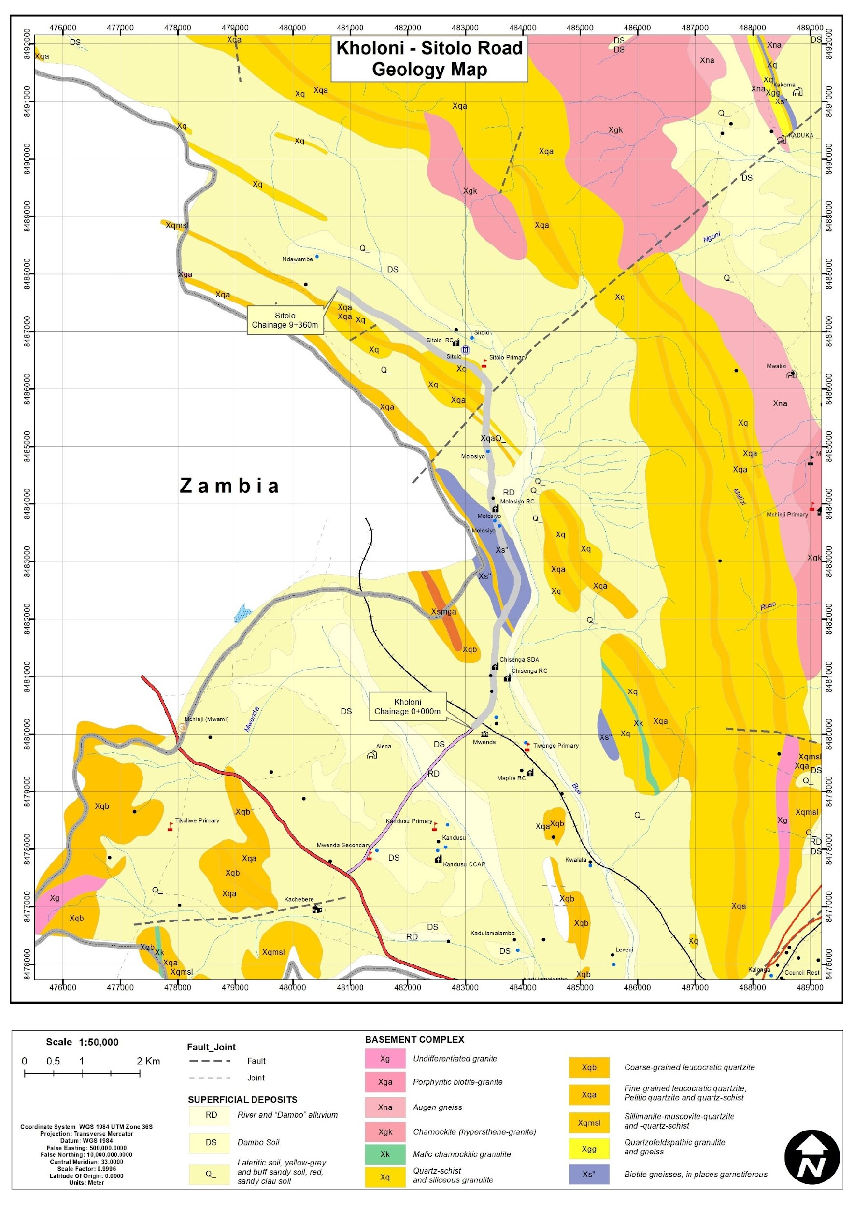
Figure 4-1: Geological Map of the Kholoni – Sitolo Road

Soils
The Kholoni–Sitolo Road corridor (Chainage 0+000–9+360) is predominantly underlain by sandy clay loam soils, derived from the weathering of metamorphic basement rocks. These soils cover approximately 80–85% of the alignment and generally provide moderate drainage and reasonable bearing capacity, making them suitable for road foundations when properly compacted. However, they are moderately moisture-sensitive and may soften during prolonged rainfall if drainage is inadequate.
Localized rock outcrops occur mainly in the central and northern sections toward Sitolo, where shallow soils expose underlying crystalline basement rocks. These areas may influence excavation and grading but can also provide relatively stable foundations.
In low-lying valley areas near Molosiya, soils tend to retain more moisture due to seasonal drainage and wetland influences, which may lead to localized water accumulation and reduced permeability during the rainy season.
The soils along the corridor are structurally stable under normal conditions, with potential risks including subgrade softening, localized ponding, and erosion on sloping sections.

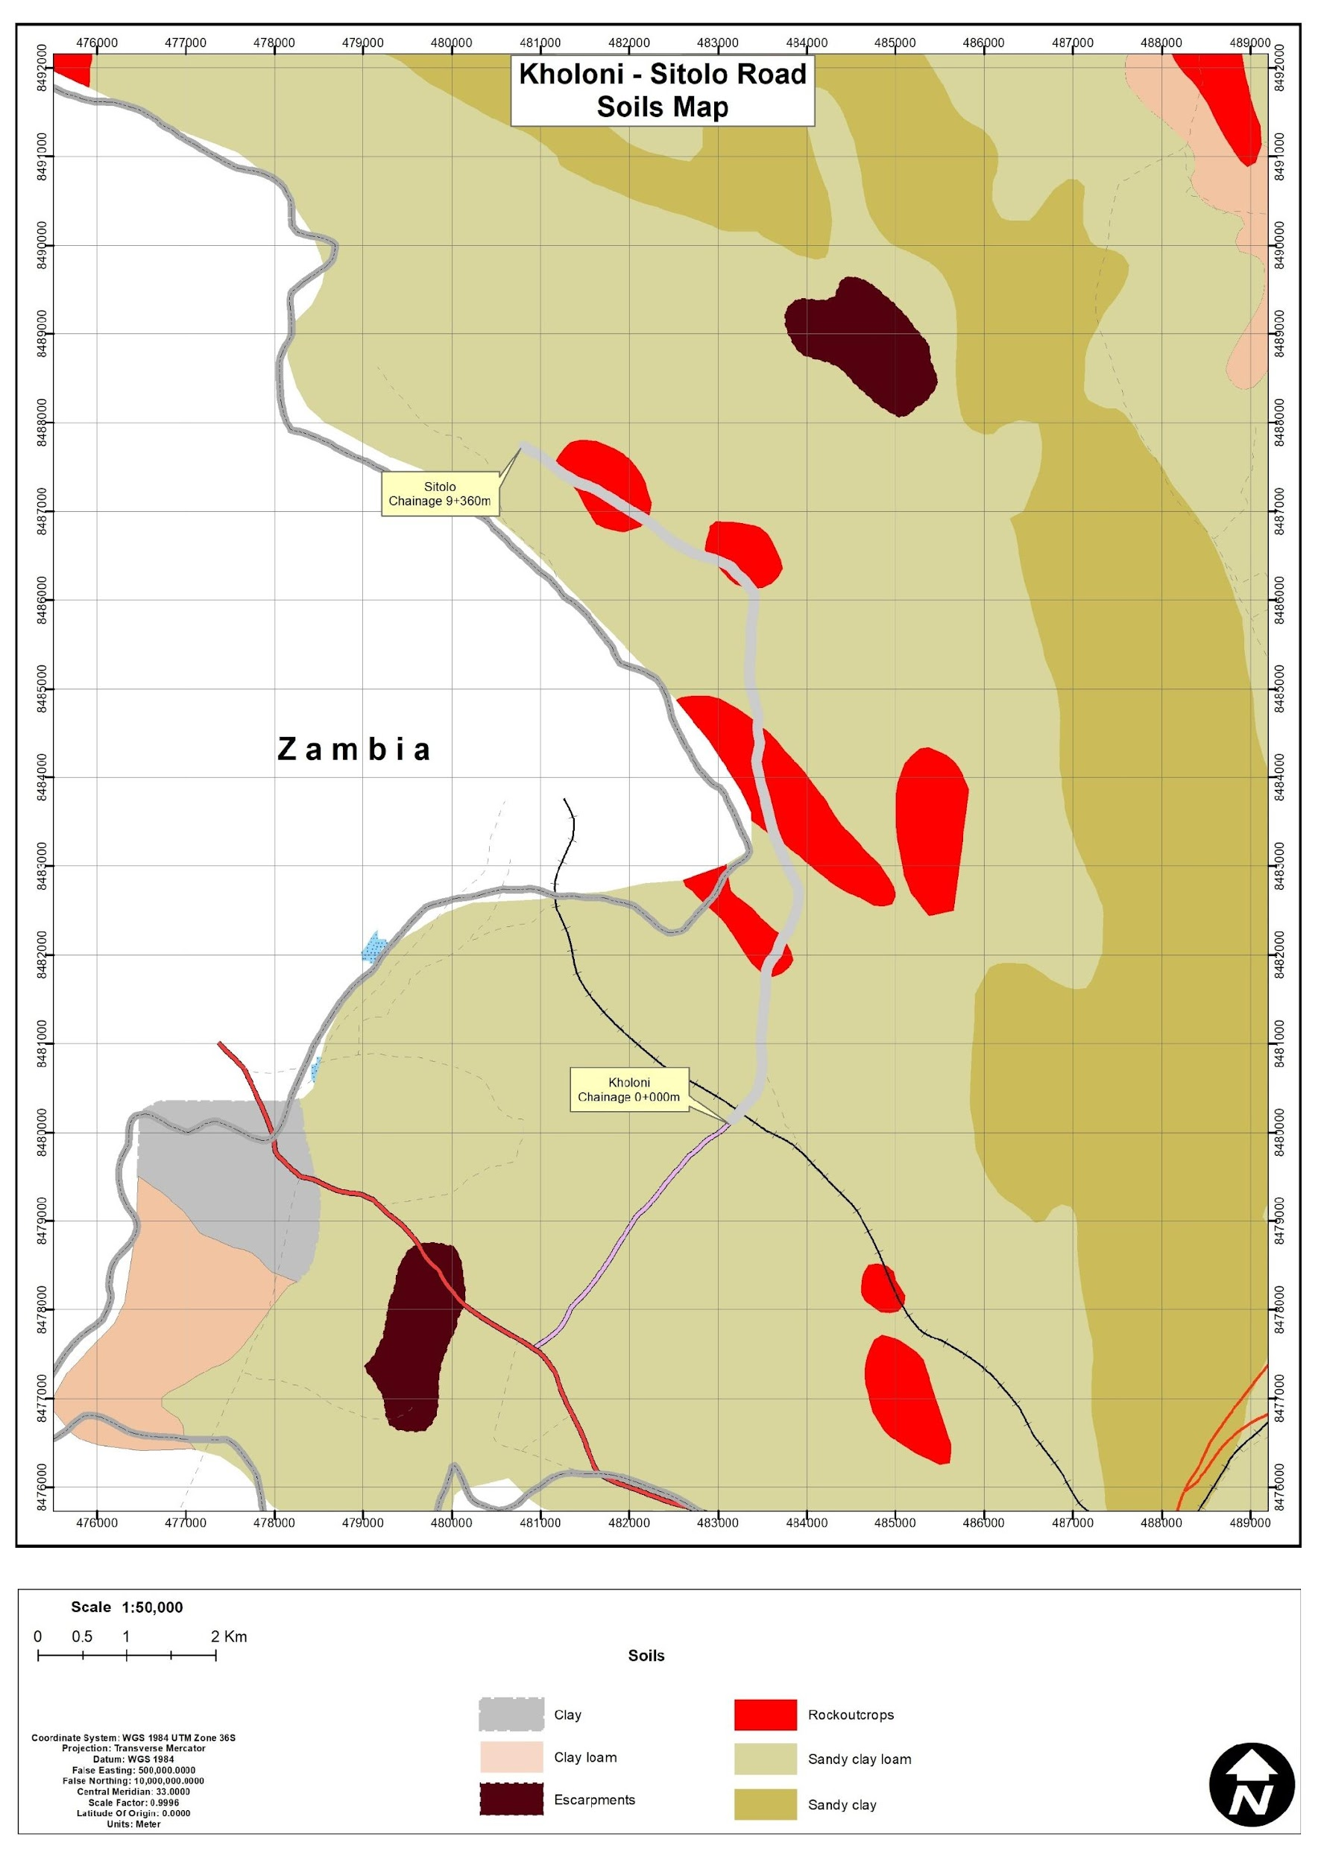
Figure 4-2: Soils along the Kholoni – Sitolo Road Corridor

Climate and Climate Change Risks

General Climate Conditions
The Kholoni–Sitolo Road corridor in Mchinji District lies within the central Malawi plateau climatic zone, characterized by a subtropical climate with two distinct seasons consisting of the rainy season (November to April) and the dry season: (May to October).
Rainfall during the wet season is often convective and intense, generating significant surface runoff. Seasonal rainfall strongly influences road surface performance, erosion potential, subgrade moisture conditions, and drainage loading, particularly in low-lying sections of the corridor.
Seasonal climate variability is a key determinant of gravel road performance. During high rainfall months, roads may experience rutting, shoulder erosion, and overtopping of drainage structures, while prolonged dry periods can lead to dust generation and surface loosening.
Where site-specific station data were limited, representative climate datasets for the Mchinji climatic zone were used, consistent with MEPA (2025) Environmental Assessment Guidelines, which allow the use of the nearest representative climate datasets when local observations are unavailable.

Temperature Pattern
The temperature regime along the Kholoni–Sitolo corridor reflects the moderate subtropical conditions typical of central Malawi, with relatively stable temperatures throughout the year.
Mean monthly maximum temperatures range between approximately 23°C and 30°C, while minimum temperatures vary between about 10°C and 19°C. The cool dry season (May–July) represents the coldest period, with lower night-time temperatures around 10–11°C. Temperatures begin to increase from August, reaching peak levels during the hot dry season (October–November) when maximum temperatures approach 29–30°C.
During the rainy season (November–April), temperatures remain warm but are moderated by cloud cover and rainfall.
Seasonal temperature variation has practical implications for road works. The hot dry season may increase dust emissions and worker heat exposure, while the cooler dry season generally provides favourable construction conditions.
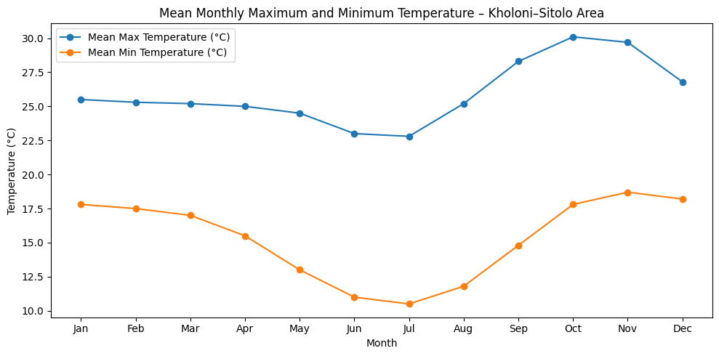
Figure 4-3: Mean monthly maximum and minimum temperature pattern for the Kholoni–Sitolo Road Corridor.

Data Source: ERA5 Reanalysis Temperature Dataset (1951–2022), ECMWF Copernicus Climate Data Store.

Rainfall Pattern
The Kholoni–Sitolo corridor experiences a unimodal rainfall regime, with the majority of rainfall occurring between November and April, while May to October remains largely dry.
Peak rainfall occurs between December and February, with January receiving the highest average monthly rainfall (approximately 250 mm). Rainfall gradually decreases through March and April before reaching minimal levels during the dry season months.
Rainfall begins to increase again in October, marking the onset of the next rainy season.
This seasonal rainfall pattern has direct implications for road infrastructure. High rainfall intensity during the rainy season may increase the risk of soil erosion, sedimentation of drainage structures, and temporary flooding of low-lying road sections. Proper design and maintenance of culverts, side drains, and erosion protection structures are therefore critical for ensuring long-term road resilience.
Conversely, the dry season provides favourable conditions for construction, although dry conditions may contribute to dust generation along gravel surfaces.
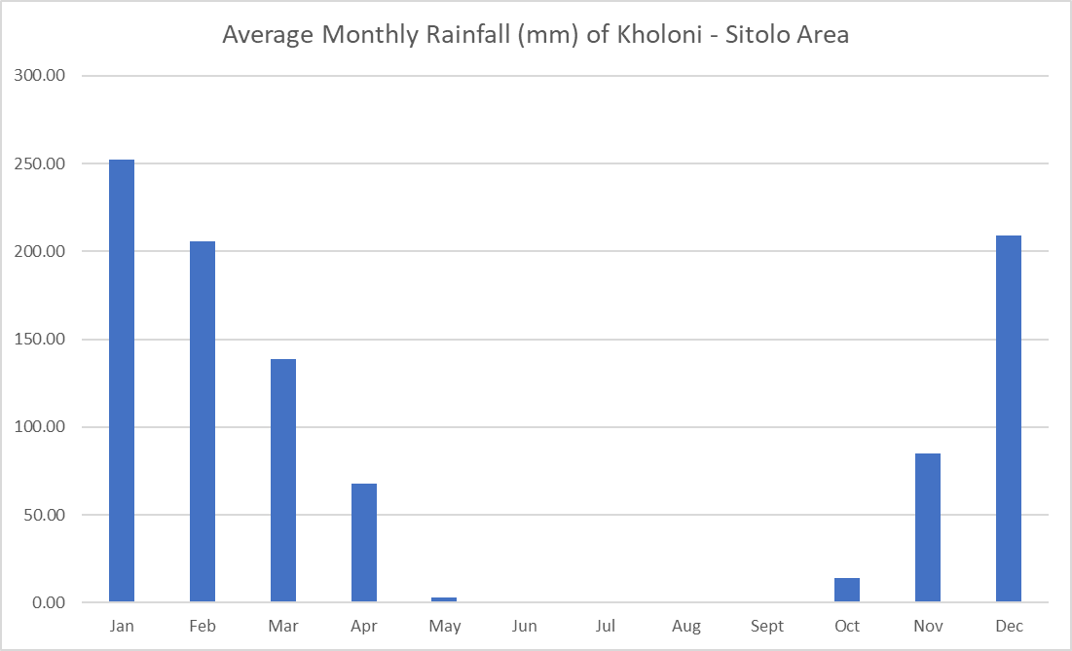
Figure 4-4: Average monthly rainfall distribution for the Kholoni–Sitolo Road Corridor.

Data Source: CHIRPS Rainfall Dataset (1981–2024), Climate Hazards Center, University of California Santa Barbara.

Sunshine, Humidity, and Wind Conditions
Seasonal climate patterns indicate clear differences between the wet and dry seasons. The dry season is associated with higher sunshine duration and lower humidity, while the rainy season experiences higher humidity and increased cloud cover.
Relative humidity is generally highest between December and March, while June to September represents the driest and least humid period. Moderate wind conditions are typical of the region, with slightly stronger winds during the late dry season, which may increase dust dispersion during construction activities.

Climate Change Risks
Climate projections for Malawi indicate increasing rainfall variability and gradual temperature increases, which may influence the long-term resilience of rural road infrastructure.
Key climate-related risks for the Kholoni–Sitolo corridor include:
- More intense short-duration rainfall events, leading to increased surface runoff;
- Higher erosion risk and drain overtopping during heavy storms;
- Potential weakening of road subgrade materials in low-lying areas;
- Accelerated deterioration of gravel surfaces, increasing maintenance requirements.
Drainage crossings and low-lying sections of the corridor are particularly vulnerable during extreme rainfall events.

Water Resources
The Kholoni–Sitolo Road corridor (Chainage 0+000–9+360) lies within the upper Bua River catchment, part of the broader Luangwa River–Zambezi River basin. The hydrology of the area is dominated by seasonal rainfall-driven drainage systems, shallow valley streams, and localized dambo wetlands, reflecting the gently undulating terrain and basement complex geology typical of the Malawi–Zambia border region.
The corridor does not intersect major perennial rivers. Instead, surface drainage is primarily through small seasonal streams and wetland depressions that respond directly to rainfall during the November–April rainy season. These drainage channels convey runoff eastward toward tributaries feeding the Bua River basin (Figure 4-6).
Hydrologically sensitive zones occur near Kholoni, Molosiya, and Sitolo, where the road passes close to seasonal wetlands and valley-bottom dambos. These wetlands function as natural runoff collection and groundwater recharge areas during periods of intense rainfall. Several minor seasonal streams are also mapped east of the corridor, exhibiting peak flows during the rainy season and becoming intermittent or dry during the May–October dry season.
Community water supply infrastructure, including boreholes, dip tanks, and communal water points, is present around settlements such as Molosiya, Sitolo, and Chisenga, indicating the importance of shallow groundwater resources associated with dambo landscapes.
Key hydrological characteristics observed along the corridor include:
- Localised water ponding in low-lying areas;
- Temporary overtopping of drainage channels during heavy rainfall;
- Side drain erosion along sloping sections; and
- Subgrade saturation near wetland areas.
No major river crossings occur along the corridor, and drainage conditions are associated mainly with seasonal runoff pathways and wetland depressions within the catchment system.
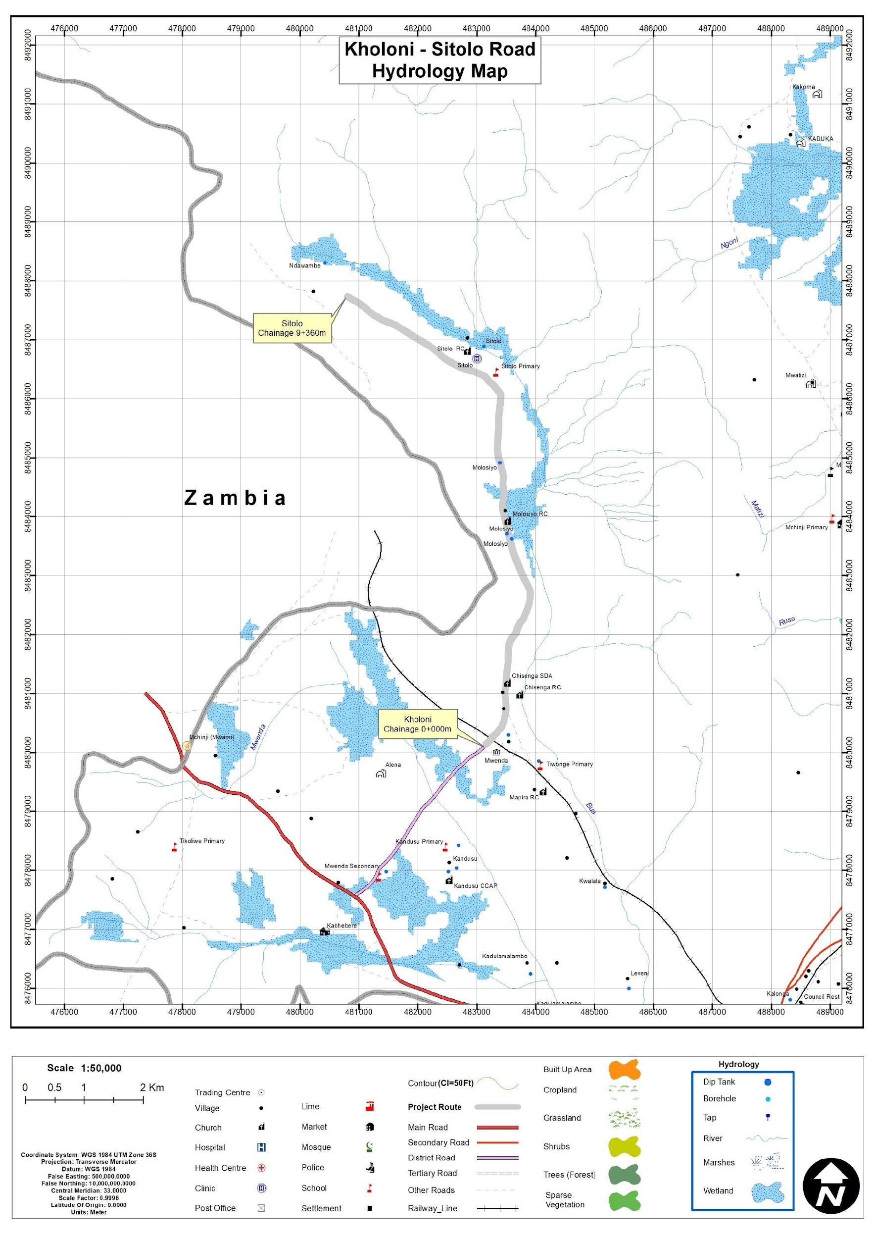
Figure 4-5: Hydrological map of the proposed project area

Flora and Fauna (Biological Environment)

Flora (Vegetation)
Vegetation along the Kholoni–Sitolo Road corridor (Chainage 0+000–9+360) occurs within the miombo woodland ecosystem of central Malawi at an elevation of approximately 1,258 m above sea level. The landscape consists of mixed woodland interspersed with cultivated agricultural land and scattered rural settlements, reflecting long-term human settlement and farming activities.
Dominant vegetation includes Brachystegia species, Combretum species, and Gmelina arborea, which form the woodland canopy typical of the miombo ecosystem. Additional plant life comprises shrubs, herbs, grasses, and cultivated crops such as maize (Zea mays), cassava (Manihot esculenta), and Irish potato (Solanum tuberosum).
Natural vegetation within the road reserve has been moderately modified by agricultural expansion, although relatively intact vegetation patches remain in culturally protected areas such as graveyards, which function as informal biodiversity refuges.

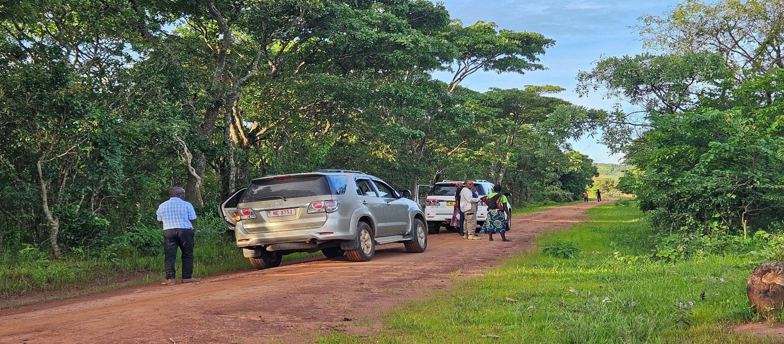
Figure 4-6: Typical miombo woodland vegetation along the Kholoni–Sitolo Road corridor.
A total of 28 plant species representing trees, shrubs, herbs, vines, and grasses were recorded during the ecological survey.

Table 4-1: Composite Flora Species Recorded in the Kholoni–Sitolo Road Corridor
Scientific Name | English Name | Habit | IUCN Status | Remarks
Brachystegia spiciformis | Zebrawood | Tree | Least Concern | Dominant miombo species
Brachystegia boehmii | Prince of Wales Feathers | Tree | Least Concern | Woodland species
Brachystegia taxifolia | African Mahogany | Tree | Least Concern | Miombo woodland species
Combretum adenogonium | Three-leaved Combretum | Tree | Least Concern | Miombo associate
Annona senegalensis | African Custard Apple | Shrub | Least Concern | Common savannah shrub
Flacourtia indica | Governor's Plum | Shrub | Least Concern | Common shrub
Uapaca kirkiana | Sugar Plum | Tree | Least Concern | Indigenous fruit tree
Terminalia sericea | Silver Cluster Leaf | Tree | Least Concern | Protected under Forestry Act
Mangifera indica | Mango | Tree | Least Concern | Cultivated species
Lantana camara | Common Lantana | Shrub | Least Concern | Invasive species
Gmelina arborea | White Teak | Tree | Least Concern | Exotic invasive species
Zea mays | Maize | Grass | Least Concern | Cultivated crop
Sida acuta | Broom Weed | Herb | Least Concern | Disturbance indicator
Cissampelos mucronata | Heart-leaved Vine | Vine | Least Concern | Woodland climber
Vernonia glabra | Mauve Paintbrush | Herb | Least Concern | Herbaceous species
(Full species inventory provided in Annex 14)

No endemic plant species were recorded. However, Terminalia sericea is protected under the Forestry Act (Cap 63:01) and may require authorization for removal if affected by road works.
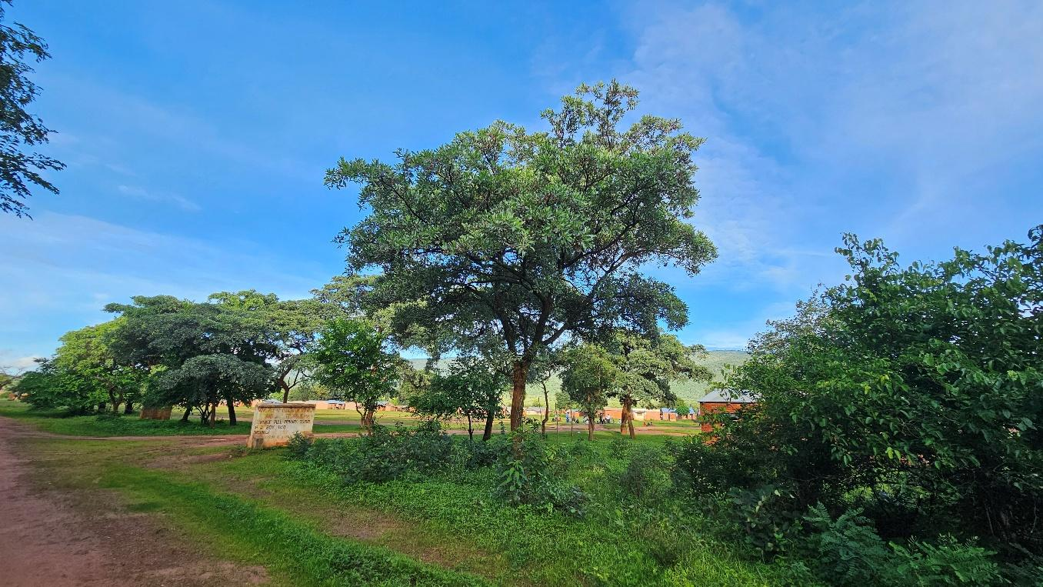
Figure 4-7: Terminalia sericea recorded within the project corridor.

Two invasive plant species (Lantana camara and Gmelina arborea) were also identified, indicating areas of ecological disturbance along the road corridor.
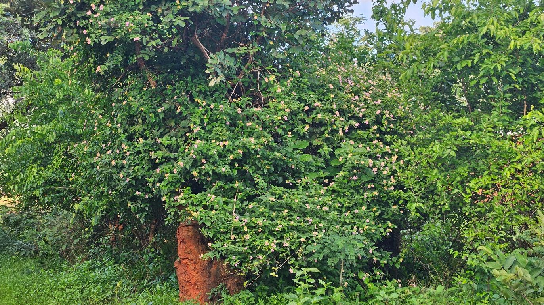
Figure 4-8: Invasive species (Lantana camara and Gmelina arborea) observed along the alignment.
Sensitive habitats identified include two graveyard sites, where vegetation remains relatively intact due to cultural protection. These areas will require strict avoidance and protective buffer zones during construction.
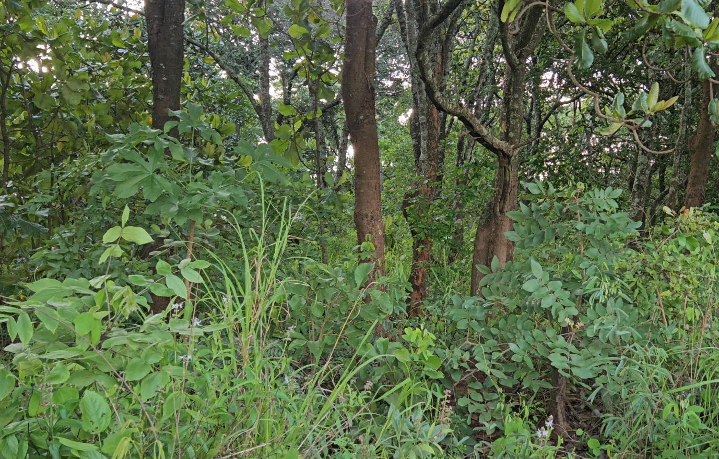
Figure 4-9: Vegetation preserved within graveyard sites along the corridor.

Fauna (Wildlife)
Faunal diversity within the Kholoni–Sitolo corridor reflects typical rural agricultural landscapes and fragmented woodland habitats. The survey recorded species belonging to five taxonomic groups:
- Mammals
- Birds
- Reptiles
- Amphibians
- Macro-invertebrates
Most species observed are widely distributed across the miombo woodland ecosystem and are classified as Least Concern under the IUCN Red List.

Table 4-2: Composite Fauna Species Recorded in the Kholoni–Sitolo Road Corridor
Animal Group | Scientific Name | Common Name | IUCN Status | Remarks
Mammal | Crocuta crocuta | Spotted Hyena | Least Concern | Occasional sightings
Mammal | Papio cynocephalus | Yellow Baboon | Least Concern | Woodland habitat
Mammal | Chlorocebus pygerythrus | Vervet Monkey | Least Concern | Common primate
Mammal | Lepus saxatilis | Scrub Hare | Least Concern | Agricultural landscapes
Mammal | Sylvicapra grimmia | Bush Duiker | Least Concern | Woodland edges
Bird | Pycnonotus barbatus | Common Bulbul | Least Concern | Common resident
Bird | Streptopelia semitorquata | Red-eyed Dove | Least Concern | Woodland species
Bird | Merops pusillus | Little Bee-eater | Least Concern | Insectivore
Bird | Pogoniulus chrysoconus | Yellow-fronted Tinkerbird | Least Concern | Woodland species
Reptile | Bitis arietans | Puff Adder | Least Concern | Terrestrial snake
Reptile | Naja mossambica | Mozambique Spitting Cobra | Least Concern | Venomous species
Reptile | Dendroaspis polylepis | Black Mamba | Least Concern | Woodland snake
Amphibian | Xenopus laevis | African Clawed Frog | Least Concern | Wetland habitats
Amphibian | Sclerophrys gutturalis | Guttural Toad | Least Concern | Seasonal wetlands
Invertebrate | Apis mellifera | Honey Bee | Least Concern | Important pollinator
Invertebrate | Nomadacris septemfasciata | Red Locust | Least Concern | Agricultural pest
(Full faunal inventory provided in Annex 14)
No endemic or globally threatened fauna species were recorded within the project corridor.

Implications for the Project
The ecological assessment indicates that the Kholoni–Sitolo corridor occurs within a moderately disturbed rural ecosystem dominated by agriculture and fragmented woodland habitats. Biodiversity sensitivity within the immediate road reserve is therefore relatively low.
Key ecological findings include:
- No endemic or globally threatened species recorded.
- Most species are classified as Least Concern under the IUCN Red List.
- Presence of Terminalia sericea, a protected tree species.
- Occurrence of invasive plant species (Lantana camara and Gmelina arborea).
- Graveyard sites functioning as localized biodiversity refuges.
Potential ecological impacts from road rehabilitation may include localized vegetation clearance and temporary disturbance to wildlife habitats.
To minimize impacts, mitigation measures will include:
- Minimizing vegetation clearing within the road reserve;
- Protecting culturally sensitive sites and graveyards;
- Managing invasive plant species where feasible;
- Obtaining permits before removing protected tree species;
- Implementing post-construction revegetation and habitat rehabilitation.
These measures will ensure compliance with Malawi environmental legislation and biodiversity conservation requirements while maintaining ecological integrity along the Kholoni–Sitolo corridor.

Socio-economic environment

Demography

Population Characteristics
T/A Mlonyeni has an estimated population of 57,408 people, comprising approximately 27,968 males (48.7%) and 29,440 females (51.3%), distributed across about 13,047 households based on the district average household size of 4.4 persons. For the purposes of this ESMP, the Project Influence Area (PIA) is defined as the 10 km corridor of settlements and livelihood activities that fall within roughly 5 km on either side of the Kholoni–Sitolo road alignment, including villages, social services and agricultural land that rely on the road for access, as illustrated in Figure 1-3.
Within this 10 km PIA, an estimated 2,986 households (about 13,138 people) reside along or near the Kholoni–Sitolo corridor, representing roughly 22.8% of the Traditional Authority’s total population. Settlement patterns are uneven: denser, more nucleated villages and trading centres occur around the Chisenga–Molosiyo section and near Sitolo, while the central portions of the alignment traverse more dispersed homesteads within agricultural land. Population density is therefore higher around trading centres and community facilities, where houses and small businesses are often located within about 10–15 metres of the road, increasing potential exposure to construction-phase disturbances such as dust, noise and vibration.
The population structure in the PIA is predominantly youthful, with about 50.2% under 18 years, 45.3% within the working-age group (18–64 years), and 4.5% aged 65 years and above, resulting in a dependency ratio of approximately 110 dependents per 100 working-age individuals. Females form a slight majority and female-headed households account for about 30.2% of households, with women primarily engaged in subsistence agriculture, domestic work and small-scale trading, while men more frequently participate in seasonal and migratory labour.

Household Size and Composition
With an average household size of 4.4 persons, households within the corridor typically consist of extended family units comprising parents, children, and occasionally grandparents or other relatives. Housing typologies reflect typical rural construction practices and include burnt brick or mud-block wall construction. Iron-sheet roofing is more common in settlement centres such as Chisenga and Sitolo, while thatched roofing remains prevalent in peripheral rural areas.

Migration and Mobility Patterns
Migration in the project area includes seasonal and longer-term labour movement to Zambia and urban centres in Malawi, mainly for work in agriculture, informal trade, and construction. Daily mobility along the corridor is driven by agricultural activities, school attendance, access to milling services, and travel to Mchinji Boma for administrative and health services. The road’s proximity to the M12 (Lilongwe–Mwami Border) corridor and the Sitolo Solar Grid strengthens cross-border trade and local economic activity, making reliable road access essential. During seasonal flooding, communities sometimes use alternative routes that are 2–5 km longer and may pass through private farmland, increasing travel time and limiting emergency access, reinforcing the Kholoni–Sitolo road’s importance as the main mobility route for surrounding communities.

Education and Literacy

Education
Sitolo Primary School is the main education facility in the corridor, enrolling 1,198 learners (593 boys and 605 girls) with a relatively balanced gender distribution. The school has 19 teachers, resulting in a pupil–teacher ratio of about 63:1, which exceeds national and optimal classroom benchmarks and indicates classroom congestion and increased teacher workload. School records show a dropout rate of about 33.5% (401 learners), with girls mainly leaving due to early marriage and teenage pregnancy, and boys due to financial pressures and involvement in farming or income-generating activities. Additional schools serving the area include Tiwonge Primary School and Kholoni Community Day Secondary School. Learner movement along the road corridor is frequent, particularly during morning arrival, break periods, and afternoon departure times.
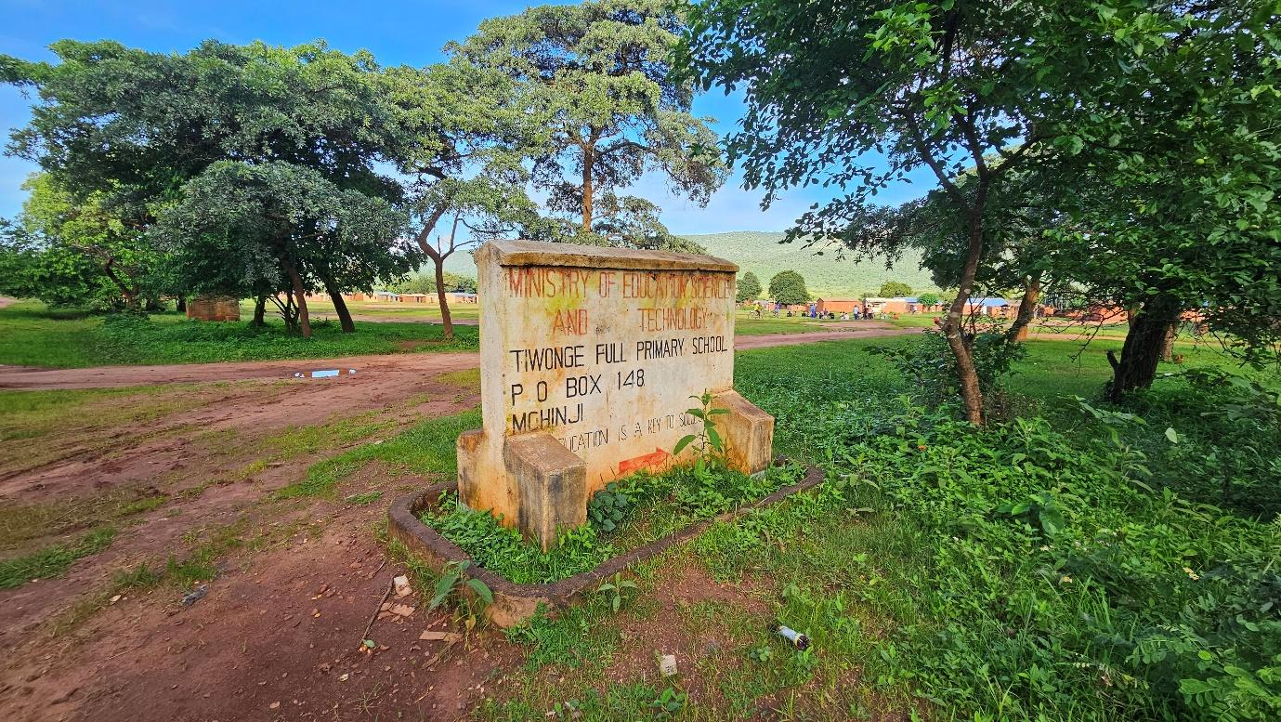
Figure 4-10: Tiwonge Primary School along the road corridor

Literacy
Literacy levels in the Central Region of Malawi average approximately 67% among persons aged five years and above. Literacy rates are generally lower among women compared to men, reflecting historical disparities in educational access. This pattern was confirmed during corridor consultations.
Moderate literacy levels were observed within the project area, with both written and oral forms of communication commonly used in community interactions and local administrative processes.

Health
There are no health facilities directly along the Kholoni–Sitolo Road corridor, and most communities rely on Mchinji District Hospital, located about 15 km away along the M12 (Lilongwe–Mwami Border) corridor. Access to healthcare therefore depends heavily on the condition of the feeder road connecting the corridor to the M12. During the rainy season, sections of the road become difficult to pass, increasing travel time and delaying routine and emergency medical access. The hospital provides key services including outpatient care, maternal and child health, immunisation, ART, surgery, and ambulance referrals. About 13,138 people live within or rely on the corridor for access to health services.

Cultural Heritage
No formally recognised heritage monuments or archaeological sites were identified within the footprint of the proposed road rehabilitation works. Community consultations and field verification confirmed the presence of community graveyards adjacent to sections of the road alignment, particularly near the settlements of Ndawambe and Sitolo.
The spatial distribution of works (Annex 15) and the chainage-specific design show that all proposed activities are confined to the existing road reserve and limited to spot improvements at discrete locations (e.g. culvert upgrades, scour protection and localized embankment formation). Within these sections, the construction footprint has been checked against the mapped positions of the graveyards, confirming that the graves lie outside the area required for works and that no excavation, storage or access routes will extend onto them. As a result, the proposed rehabilitation will not disturb these culturally significant sites and will not result in any disturbance to physical or cultural heritage features.
The graveyards are nevertheless recognised as important community cultural assets, and they will be treated as no-go areas for construction activities, with appropriate demarcation, toolbox talks and Chance Find Procedures (Annex 7) applied should any previously unknown cultural materials be encountered.
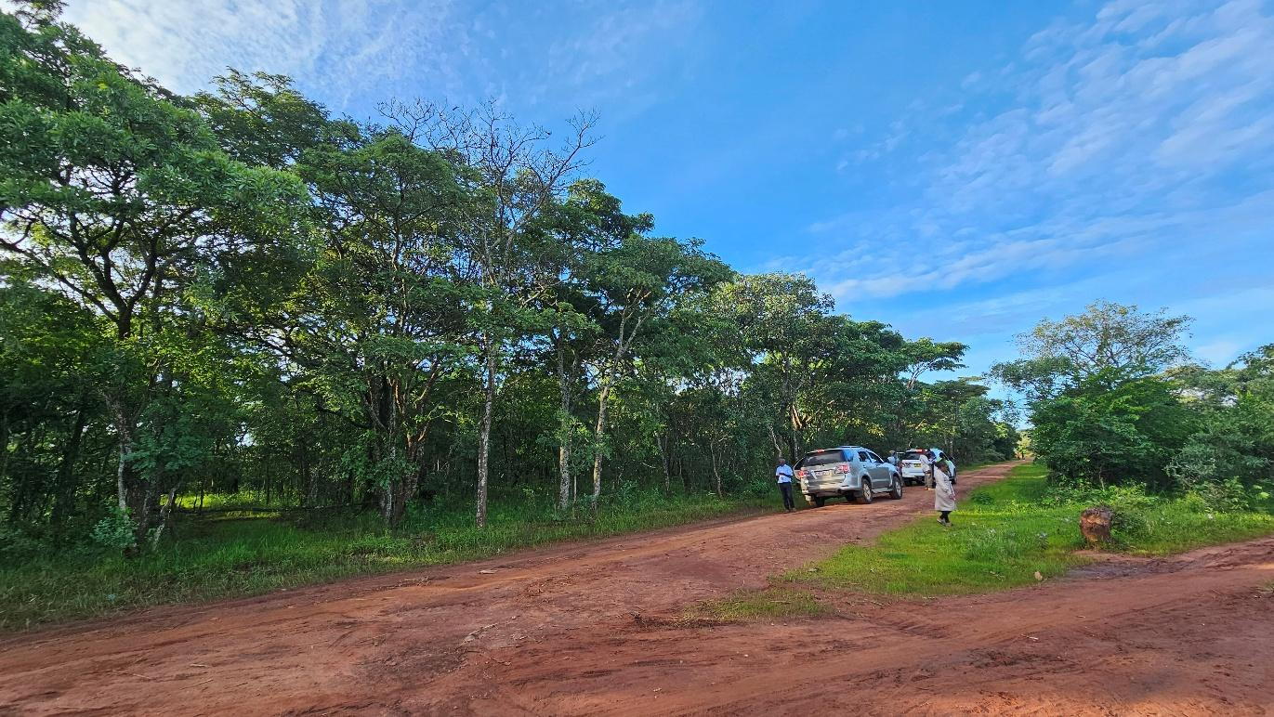
Figure 4-11: A graveyard near Chainage 0+000 km

These sites are culturally significant and require careful protection during project implementation.

Agriculture
Agriculture is the primary livelihood within the project corridor, with most households engaged in smallholder farming for subsistence and local market sales. The main crops grown include maize, Irish potato, and beans, produced mainly under rain-fed conditions with limited small-scale irrigation. Farming is labour-intensive and highly dependent on seasonal rainfall, making it central to household food security and income generation. In addition to crop production, households keep small livestock such as goats, poultry, and cattle, while proximity to the Zambia border supports some informal cross-border trade. Economic activity typically increases during harvest periods as farmers sell produce in nearby trading centres. Consequently, road conditions significantly influence market access, transport costs, and post-harvest trade. Improvements to the road are therefore expected to enhance agricultural market connectivity and strengthen rural livelihoods in the corridor. Evidence of the mixed cropping systems practiced along the corridor is provided in Figure 4-7.
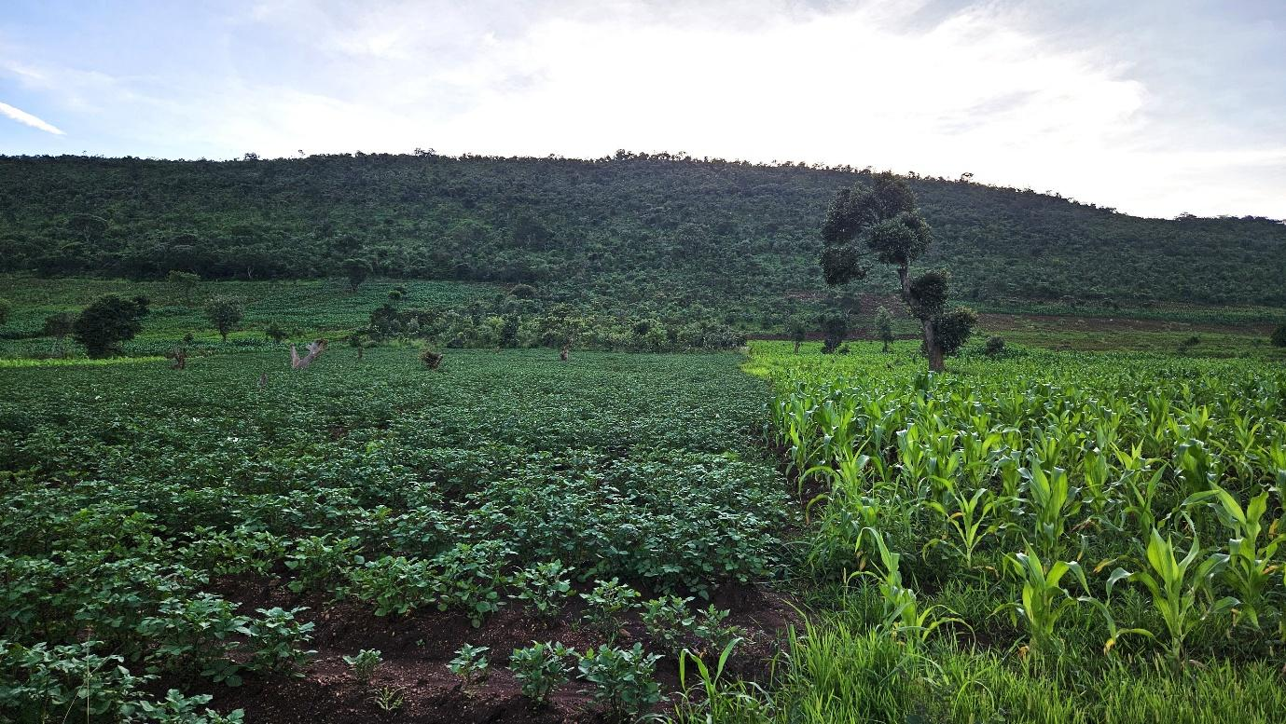
Figure 4-12: Mixed cropping- maize and potatoes along the corridor

Economic Activities and Livelihoods
Approximately 68% of people in Mchinji leave below the poverty line (Mchinji SEP 2022_2030). Livelihoods in the corridor are mainly based on smallholder agriculture, complemented by petty trading, casual labour (ganyu), bicycle transport services, and informal cross-border trade. About 22.8% of T/A Mlonyeni’s population lives within the corridor, and with 30.2% of households being female-headed, socio-economic vulnerability is moderate. Community consultations noted that poorly sequenced construction could temporarily disrupt transport and access to markets, affecting incomes and commodity prices. Trading centres and milling facilities are important economic nodes serving surrounding communities.

Transport
The Kholoni–Sitolo corridor is used by pedestrians, bicycles, motorcycles, and light vehicles, with pedestrians forming a large share of daily traffic, especially near schools, churches, and trading centres. Traffic peaks occur during morning and afternoon periods linked to school and market activities. Community consultations identified accident-prone areas on steep slopes, particularly where motorcycles are common and road surfaces become slippery in wet conditions. Seasonal road deterioration has also limited mobility and increased travel time, but planned rehabilitation is expected to improve year-round connectivity, reduce transport costs, and enhance safety for vulnerable road users.

Security
Security along the corridor is generally stable, with community governance managed by traditional authorities and formal policing provided by the Malawi Police Service in Mchinji Boma. Community Policing Forums also support crime prevention and dispute mediation at the local level. Local security concerns reported during consultations include petty theft and community disputes, which are commonly addressed through existing local leadership and policing structures.

Land Use
Land use along the Kholoni–Sitolo corridor is mainly agricultural and governed under customary tenure systems, with land allocated through traditional leadership and used for farming and settlement. Some cultivated fields extend close to the road edge, but since rehabilitation will follow the existing alignment, significant land acquisition is not expected. Any land-related disputes are typically resolved through Traditional Authorities, Village Development Committees, and Area Development Committees.

Vulnerable and Marginalized Groups
Vulnerable groups within the corridor include female-headed households (30.2%), school-age children (about 50.2% of the population), elderly persons (4.5%), persons with disabilities, and low-income farming households. These groups are particularly sensitive to mobility disruptions, road safety risks, and seasonal economic shocks. During consultations, women also expressed concerns about unequal employment opportunities and wage disparities during construction, highlighting the need for inclusive labour practices and transparent recruitment procedures during project implementation.

Communication
Communication within the project area relies on a combination of traditional leadership structures, churches, Village Development Committees, mobile phone networks, and community meetings. Moderate literacy levels within the corridor require that project communication strategies incorporate both written notices and oral communication methods, including public meetings and announcements delivered through community leadership structures.

Energy Sources
Households in the corridor mainly rely on firewood for cooking, reflecting the continued dependence on biomass energy typical of rural Malawi. However, some households have access to grid electricity, with appliances such as televisions and satellite dishes indicating active use. The corridor also passes through the Sitolo Solar Grid area, which supplies renewable electricity to parts of the trading centre and nearby settlements, supporting small businesses and services. Despite these improvements, biomass remains the dominant cooking fuel, indicating a transitional rural energy profile, while improved road connectivity may support further expansion and maintenance of energy infrastructure.
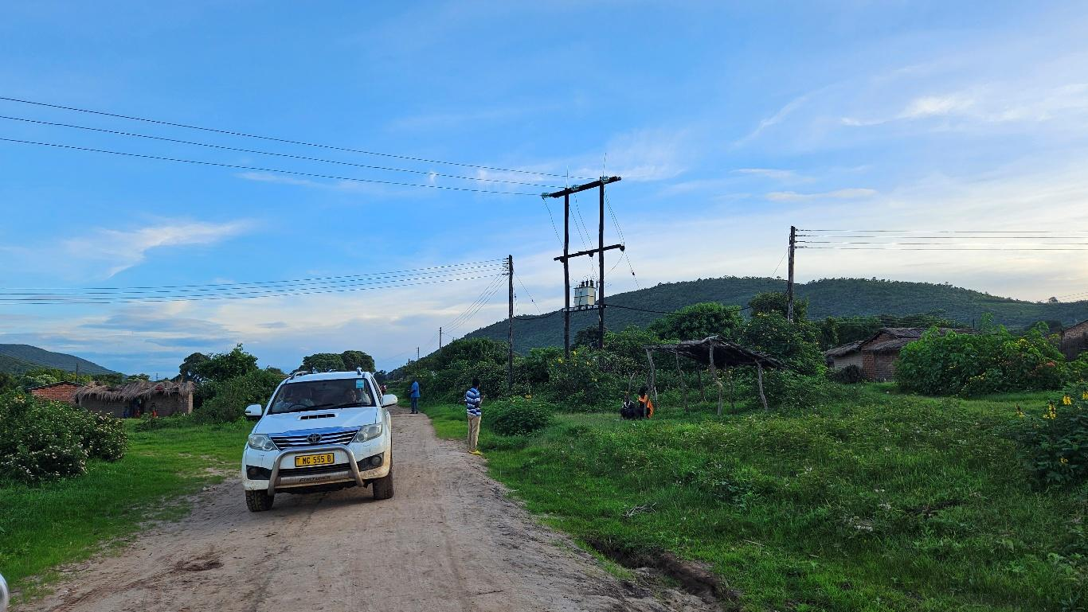
Figure 4-13: Grid electricity supplied to homes along the corridor

Implications for the Project
The Kholoni–Sitolo Road serves about 13,138 people (22.8% of T/A Mlonyeni’s population), most of whom depend on agriculture. With over half the population under 18, significant school enrolment, and a pupil–teacher ratio of 63:1, safe and reliable road access is important for education and daily mobility. The road also provides key access to Mchinji District Hospital (about 15 km away), local markets, maize mills, schools, and cross-border trade routes. Rehabilitation is expected to reduce travel time, improve market access, strengthen climate resilience, and enhance access to social services. However, due to high pedestrian activity, nearby schools and trading centres, cultural sites such as graveyards, seasonal flooding, and existing vulnerabilities, implementation should prioritize pedestrian safety, protection of sensitive sites, continued community access during construction, and inclusive employment practices to ensure positive socio-economic outcomes.

CHAPTER 5: ENVIRONMENTAL AND SOCIAL MITIGATION AND MONITORING PLAN

Introduction
Environmental and social management measures for the rehabilitation of the Kholoni–Sitolo Road have been developed to guide and outline the mitigation measures, monitoring requirements, implementation responsibilities, and reporting arrangements for managing environmental and social impacts identified during project planning, construction, demobilisation, and operation.
The ESMMP provides the framework for implementing environmental and social safeguards in accordance with applicable national legislation and relevant World Bank requirements, and forms part of the obligations to be implemented by the contractor, supervising engineer, and responsible authorities during project execution.
Monitoring provisions are included to enable the Roads Authority, supervising engineers, district authorities, and MEPA to systematically track environmental and social performance, verify the effectiveness of mitigation measures, and ensure continuous improvement throughout project implementation.
Reports of monitoring activities will be prepared by the contractor and submitted on a Monthly basis to the PIU and the Environmental District Officer because the project will be implemented in nine months.

Environmental and Social Mitigation and Monitoring Plan
REF | Impacts & Risks | Enhancement / Mitigation Measures | Schedule of Implementation | Responsible Institution | Implementation Cost (USD) | Performance Indicator | Means of Verification | Frequency | Responsible (Monitoring) | Annual Monitoring Budget (USD)
5.2.1 | Planning & Design: Positive
5.2.1.1 | Improved flood resilience and drainage efficiency | Size culverts using peak flow modelling; integrate climate-resilient hydraulic design; provide scour protection at outlets; include adequate cross-drainage structures in flood-prone sections. | Design Stage (Pre-Construction) | MoTPW/ Design Engineer | Included in Design | Culvert capacity meets hydrological design standards | Approved design drawings; hydrological report | Once (Design Approval) | MoTPW / SC | N/A
5.2.1.2 | Improved transparency and community ownership | Conduct structured stakeholder consultations; establish a functioning GRM; document consultations; ensure community representation including women and vulnerable groups. | Pre-Construction | MoTPW/ District Council | 900 | Functional GRM established; consultations disaggregated by gender and vulnerable group participation | GRM logbook; consultation minutes | Quarterly | MoTPW / DC | 400
5.2.1.3 | Improved pedestrian safety | Integrate road safety design features (speed calming near schools and trading centres, signage, pedestrian crossings). | Design Stage | MoTPW / Design Engineer | Included in Design | Road safety measures included in design | Approved design drawings | Once | MoTPW / SC | N/A
5.2.2 Planning & Design: Negative
5.2.2.1 | Dust, noise, and construction movement affecting nearby households, schools, and trading centres | Map sensitive receptors (schools, settlements, markets); design buffer zones; restrict construction footprint; Plan and implement dust suppression measures. | Design & Construction | MoTPW / Contractor | 600 | Reduced complaints from nearby communities | GRM records; supervision reports | Monthly | SC / DC | 300
5.2.2.2 | Risk to graveyards and cultural sites | Conduct site verification of cultural heritage areas; establish buffer zones; implement chance-find procedures. | Design Stage | MoTPW / Design Engineer | 400 | Cultural sites protected and documented | Site inspection reports | Quarterly | MoTPW / DC | 200
5.2.2.3 | Excess vegetation clearing and risk to access routes within road reserve | Optimize road alignment within existing road reserve; use existing access tracks as first preferenceminimize vegetation clearance; mark trees to be retained prior to works, limit construction traffic to approved routes only, and utilise existing footpaths, farm entrances, service roads and established tracks within the reserve; | Design Stage | MoTPW / Design Engineer | Included in Design | Area cleared within approved footprint | Environmental inspection reports | Once before clearing | SC / MoTPW | N/A
5.2.2.4 | Inadequate capacity of contractors to identify and manage the potential environmental and social risks | Contractor to include an Environmental, Social, Health and Safety (ESHS) Officer in their staffing to be based at site.  Develop and implement Contractor-ESMP (C-ESMP) and associated management plans in line with the frameworks, Malawi regulations and WB EHS guidelines and policies covering  - Waste Management Plan  - Code of Conduct  - Borrow Pit Rehabilitation  - Stakeholder Engagement Plan  - Traffic Management Plan  Chance Finds Procedure | Design & Construction | Contractor | Contractor Cost | ESHS Officer on site  C-ESMP and associated plans developed and implemented | Site Inspections | Monthly | MoTPW / DC | N/A
5.2.3 | Construction: Positive
5.2.3.1 | Local employment and income generation | Prioritize recruitment of local labour; advertise employment opportunities locally; maintain employment records disaggregated by gender. | Construction Phase | Contractor / MoTPW | 600 | % of workforce recruited locally | Employment records; payroll | Monthly | SC / MoTPW | 400
5.2.3.2 | Local economic stimulation | Procure construction materials and services locally where feasible; support small local suppliers and traders. | Construction Phase | Contractor | 600 | Value of contracts awarded to local suppliers | Procurement records | Quarterly | SC / MoTPW | 300
5.2.3.3 | Skills transfer to local workers | Provide on-site skills training in construction, equipment handling, and safety practices. | Construction Phase | Contractor | 400 | Number of workers trained | Training attendance sheets | Quarterly | SC / MoTPW | 400
5.2.4 | Construction: Negative
5.2.4.1 | Vegetation clearing causing habitat disturbance and loss of roadside plant cover | Minimize vegetation clearing; confine works within road reserve; replant disturbed areas with indigenous vegetation after construction. | Construction Phase | Contractor | 600 | Area of disturbed roadside vegetation restored after construction | Environmental inspection reports; restoration records | Monthly | SC / MoTPW | 800
5.2.4.2 | Restricting access to routes within road reserve | Use existing access tracks as first preference, limit construction traffic to approved routes only, and utilise existing footpaths, farm entrances, service roads and established tracks within the reserve, avoid opening unnecessary new access strips; | Construction Phase | Contractor | 100 | No new access tracks | Environmental inspection reports; restoration records | Monthly | SC / MoTPW | Included
5.2.4.3 | Land degradation from borrow pits and unregulated material extraction | Obtain approval for borrow pits; strip and store topsoil; rehabilitate pits progressively; contour pits to prevent water stagnation; obtain materials only from licensed and approved sources and prohibit riverbank extraction | Construction Phase | Contractor | Included in BOQ | Percentage of approved material sources verified | Borrow pit inspection reports; permits | Weekly | SC / MoTPW | Included
5.2.4.4 | Land degradation from borrow pits | Obtain approval for borrow pits; strip and store topsoil; rehabilitate pits progressively; contour pits to prevent water stagnation. | Construction Phase | Contractor | Included in BOQ | Percentage of borrow pits rehabilitated before contract closure | Borrow pit inspection reports; closure certificate | Monthly | SC / DC | Included
5.2.4.5 | Soil and water contamination from fuel and oils | Store fuel in bunded areas; implement spill prevention and response plan; prohibit refuelling near water bodies; train workers in spill management. | Construction Phase | Contractor | 600 | Number of hydrocarbon spill incidents recorded per month | Spill logs; inspection reports | Weekly | SC / MoTPW | 600
5.2.4.6 | Dust emissions affecting communities | Water exposed surfaces regularly using water bowsers; cover haul trucks; enforce speed limits; schedule works to minimize disturbance near settlements. | Construction Phase | Contractor | Included in BOQ | Number of dust-related complaints recorded per month near settlements | GRM logs; inspection reports | Weekly | SC / MoTPW | Included
5.2.4.7 | Construction traffic and machinery movement increasing accident risk for pedestrians and road users | Implement Traffic Management Plan; install warning signs; deploy flaggers near schools and trading centres; provide safe pedestrian passageways. | Construction Phase | Contractor | 500 | Number of traffic incidents recorded near active work zones per month | Traffic incident log; supervision reports | Monthly | MoTPW / Police | 900
5.2.4.8 | GBV/SEA/SH risks, communicable disease transmission, and worker misconduct | Implement Contractor Code of Conduct; conduct GBV awareness training; establish confidential reporting mechanisms; collaborate with local authorities; conduct HIV/AIDS awareness sessions; enforce zero-tolerance alcohol abuse rules during working hours | Construction Phase | Contractor / MoTPW | 500 | Number of workers trained; HIV sessions conducted; unresolved complaints | Training attendance sheets; GRM records | Quarterly | MoTPW / DC | 700
5.2.4.9 | Abusive Labor and Working Conditions (labour exploitation, forced labour, under aged and discriminatory working conditions) | - Explain to all workers’ conditions of service, labor exploitation and contract duration  - Ensure all workers have a signed contract and given a acopy  - Implement age verification system using national identification to employ only those that are 18 years old and above and undertake due diligence of primary suppliers to ensure they are not using child labor  - Establish and maintain a Worker Grievance Redress Mechanism that is SEA/SH responsive | Construction Phase | Contractor / MoTPW | 400 | Number of labour grievances unresolved | Payroll records; grievance register | Monthly | SC / Ministry of Labour | 400
5.2.4.10 | Construction equipment noise affecting nearby households, schools, and trading centres | Restrict noisy activities to daytime hours; maintain equipment; notify communities before high-noise activities. | Construction Phase | Contractor | 500 | Number of noise complaints recorded during construction period | Community complaint records; inspection reports | Monthly | SC / MoTPW | 250
5.2.4.11 | Spread of invasive plant species | Avoid transporting contaminated soil; remove invasive plants; rehabilitate disturbed areas with native vegetation. | Construction Phase | Contractor | 400 | Number of disturbed sites rehabilitated without invasive species occurrence | Environmental inspection reports | Quarterly | SC / MoTPW | 200
5.2.4.12 | Temporary disruption of access to homes, farms, schools, and trading centres during culvert installation and earthworks | Maintain access to farms, social services etc as part of the Traffic Management Plan including signage, temporary crossings use of flag people, one way traffic, temporary diversions and pedestrian access route  Establish a grievance redress mechanism  Payment of compensation for any losses/ damage to assets inadvertently caused as a result of contractor activities at replacement value | Construction Phase | Contractor / MoTPW | 800 | Temporary crossings maintained and access restored | Site inspection reports; GRM records | Weekly | SC / DC | 400
5.2.4.13 | Damage to community water points, borehole access paths, irrigation channels, or local utility connections during excavation works | Identify nearby utilities and irrigation channels before excavation; avoid damage during works; maintain uninterrupted water flow; restore disturbed access immediately where affected | Construction Phase | Contractor / MoTPW | 600 | Number of unresolved water or irrigation complaints | Community complaints register; site inspection reports | Site inspection reports; community feedback | SC / DC | 300
5.2.4.14 | Damage to graveyards and cultural sites | Establish graveyard as “NO-GO ZONE” establish buffer zones, restrict and avoid construction footprint near graveyard; implement chance-find procedures. | Construction Phase | Contractor / MoTPW
5.2.5 | Demobilisation: Negative
5.2.5.1 | Residual contamination or construction waste | Remove all equipment and waste; remediate contaminated soils; restore temporary camp sites; conduct final environmental inspection. | Post-Construction | Contractor / MoTPW | 500 | Site clearance certificate issued | Final environmental audit | Once | MoTPW / SC | 500
5.2.5.2 | Abandoned borrow pits and hazards | Fully rehabilitate borrow pits; stabilize slopes; convert pits into safe landforms or water harvesting structures where appropriate. | Post-Construction | Contractor | 500 | Borrow pits restored and safe | Post-construction inspection | Once | MoTPW / DC | 800
5.2.6 | Operation & Maintenance: Positive
5.2.6.1 | Improved market access and economic mobility | Maintain road surface through periodic grading; maintain drainage structures to ensure year-round access. | Operation & Maintenance | MoTPW | 500 | Reduced travel time and transport cost | User surveys; maintenance logs | Bi-annual | MoTPW | 600
5.2.6.2 | Improved access to health and education services | Maintain reliable road connectivity; conduct routine inspections to ensure safe access to service centres. | Operation & Maintenance | MoTPW | 500 | Increased accessibility to social services | Community surveys | Annual | MoTPW / DC | 800
5.2.6.3 | Improved transport efficiency | Maintain road signage and traffic control infrastructure. | Operation & Maintenance | MoTPW | 500 | Functional traffic signage | Maintenance records | Annual | MoTPW | 500
5.2.7 | Operation & Maintenance: Negative
5.2.7.1 | Higher post-rehabilitation vehicle speeds increasing accident risk near settlements and schools | Install speed calming measures near settlements and schools; enforce speed limits; conduct community road safety awareness campaigns. | Operation & Maintenance | MoTPW / District Council | 200 | Number of road accidents recorded | Police reports | Annual | MoTPW / Police | 600
5.2.7.2 | Drainage failure during extreme rainfall | Conduct regular inspection of culverts and drains; reinforce embankments; remove sediment before rainy season. | Operation & Maintenance | MoTPW | 500 | Number of erosion incidents recorded | Inspection reports | After major storms | MoTPW | 800
5.2.7.3 | Dust generation during dry season | Periodically water road sections near settlements; plant roadside vegetation barriers to reduce dust spread. | Operation & Maintenance | MoTPW | 500 | Reduced dust complaints | Community feedback | Seasonal | MoTPW | 500
 | Total |  |  |  | 8,300 |  |  |  |  | 7.950
Notes:
- Engineering mitigation measures such as erosion control, borrow pit rehabilitation, drainage stabilization, and dust suppression are included in the Contractor’s BOQ.
- The ESMMP budget will support community engagement, monitoring, safety measures, environmental restoration, and institutional capacity.
- Implementation will be led by Ministry of Transport and Public Works with oversight from the Supervising Consultant and Mchinji District Council.
- Monitoring will be coordinated by MoTPW Environmental and Social Safeguards Team.
- Environmental monitoring during construction will be integrated into the Contractor’s Environmental, Health and Safety (EHS) reporting system.
- The Supervising Consultant will conduct routine field inspections and compliance verification.
- District Council and community structures will support grievance monitoring and stakeholder engagement.

Institutional Arrangements and Implementation Capacity
This section outlines the institutional framework for implementing, monitoring, and coordinating the ESMP for the Kholoni–Sitolo Road in Mchinji District. It clarifies the roles, responsibilities, and coordination mechanisms among institutions involved in ensuring effective ESMP implementation throughout the project lifecycle. Detailed activity-level responsibilities are provided in the ESMP Implementation and Monitoring Matrix.

ESMP Implementation Responsibilities
The Contractor has primary responsibility for implementing ESMP mitigation and enhancement measures in accordance with contractual environmental and social requirements. The Contractor must appoint a qualified Environmental, Health and Safety (EHS) Officer, prepare site-specific management plans (e.g., waste management, occupational health and safety, traffic management, and GBV/SEA/SH action plans), implement environmental protection measures, maintain compliance records, and submit periodic reports.
The Ministry of Transport and Public Works (MoTPW), through the Southern Africa Trade and Connectivity Project (SATCP) Project Implementation Unit (PIU), serves as the executing agency and is responsible for overall oversight. MoTPW ensures ESMP provisions are integrated into contracts, supervises contractor compliance, reviews monitoring reports, and ensures corrective actions are implemented where necessary.
The Supervising Consultant (SC) provides day-to-day technical supervision of the works and verifies contractor compliance through routine site inspections. The SC ensures that environmental protection measures, drainage structures, safety provisions, and other mitigation measures are implemented according to design specifications.

Monitoring and Oversight Framework
Monitoring of ESMP implementation will occur at multiple levels to ensure compliance and transparency. At the site level, the Supervising Consultant and MoTPW will conduct routine inspections to verify implementation of environmental and social safeguards, including erosion control, dust suppression, traffic safety, waste management, and occupational health and safety.
At the regulatory level, the Malawi Environment Protection Authority (MEPA) will provide statutory oversight and may conduct compliance inspections in accordance with the Environment Management Act (2017).
At the district level, the Mchinji District Council, through the District Environment Sub-Committee (DESC), will support local monitoring, community engagement, and grievance handling.

Institutional Coordination Mechanisms
Effective implementation requires coordination among national, district, and site-level institutions. Regular coordination meetings and joint site inspections involving MoTPW, the Supervising Consultant, the Contractor, and District Council representatives will be conducted to review compliance, address emerging issues, and monitor progress.
A Grievance Redress Mechanism (GRM) will operate at project and district levels to ensure that community concerns are recorded, investigated, and resolved within established timelines.

Implementation Capacity
The SATCP PIU within MoTPW provides technical oversight for environmental and social safeguards, including monitoring compliance, coordinating inspections, and liaising with MEPA and the District Council. The Mchinji District Environment Sub-Committee provides an important interface between communities and project authorities, although logistical constraints may limit frequent inspections.
The Contractor is required to maintain adequate environmental and safety capacity on site, including qualified personnel and resources necessary to implement mitigation measures such as dust suppression, erosion control, spill response, and traffic safety management.

Adequacy of Institutional Arrangements
The institutional framework combines contractor-led implementation, supervision by the Supervising Consultant, oversight by MoTPW through the SATCP PIU, regulatory oversight by MEPA, and district-level monitoring support from Mchinji District Council.
This multi-tiered structure provides adequate capacity to ensure effective, transparent, and accountable ESMP implementation while safeguarding environmental resources, community wellbeing, and compliance with national and international environmental and social standards.

REFERENCES
1. Policies and Strategies
Government of Malawi. (1994). National environmental action plan. Ministry of Natural Resources.
Government of Malawi. (2002). Malawi national land policy. Ministry of Lands, Housing and Urban Development.
Government of Malawi. (2004). National environmental policy. Ministry of Natural Resources.
Government of Malawi. (2015). National transport policy. Ministry of Transport and Public Works.
Government of Malawi. (2016). National climate change management policy. Ministry of Natural Resources, Energy and Mining.
Government of Malawi. (2016). National forest policy. Ministry of Natural Resources, Energy and Mining.
Government of Malawi. (2018). Malawi 2063: An inclusively wealthy and self-reliant nation. National Planning Commission.
Government of Malawi. (2022). National water policy. Ministry of Agriculture, Irrigation and Water Development.
Government of Malawi. (2025). National gender policy. Ministry of Gender, Community Development and Social Welfare.

2. Legislation and Regulations
Government of Malawi. (1995). Constitution of the Republic of Malawi. Government Printer.
Government of Malawi. (1948). Public Health Act. Government Printer.
Government of Malawi. (1997). Occupational Safety, Health and Welfare Act. Government Printer.
Government of Malawi. (1998). Local Government Act. Government Printer.
Government of Malawi. (2000, as amended). Employment Act. Government Printer.
Government of Malawi. (2010). Child Care, Protection and Justice Act. Government Printer.
Government of Malawi. (2013). Water Resources Act. Government Printer.
Government of Malawi. (2017). Environment Management Act. Government Printer.
Government of Malawi. (2017). Gender Equality Act. Government Printer.
Government of Malawi. (2017). Trafficking in Persons Act. Government Printer.
Government of Malawi. (2018). HIV and AIDS (Prevention and Management) Act. Government Printer.
Government of Malawi. (2020). Forestry Act. Government Printer.
Government of Malawi. (2017). National Parks and Wildlife Act. Government Printer.
Government of Malawi. (2019). Mines and Minerals Act. Government Printer.
Government of Malawi. (2022). Land Act. Government Printer.
Government of Malawi. (2023). Public Roads Act. Government Printer.

3. Guidelines, Standards, and Institutional Frameworks
Malawi Environment Protection Authority (MEPA). (2025). Guidelines for Environmental assessment (2nd ed.). Government of Malawi.
Malawi Environment Protection Authority (MEPA). (2008). environmental management (waste management and sanitation) regulations. Government of Malawi.
Government of Malawi. (2020). Chemicals and toxic substances management guidelines. Ministry of Natural Resources.
World Bank. (2004). Operational Policy OP/BP 4.01: Environmental Assessment. World Bank Group.
World Bank. (2018). Good practice note: Addressing gender-based violence in investment project financing. World Bank Group.

4. Project and Technical Documents
Suida & Partners. (2025). Detailed engineering design report (draft) for accelerated last-mile infrastructure in Blantyre, Neno, Zomba, Balaka, Ntcheu, Dedza, Lilongwe and Mchinji districts, Malawi (Contract No. MW-MTPW-454201-CS-QCBS). Ministry of Transport and Public Works, Government of Malawi; Southern Africa Trade and Connectivity Project (SATCP).
Government of Malawi, Ministry of Transport and Public Works. (2026). Inception report: Consultancy services for preparation of Environmental and social management plans for proposed last-mile infrastructure under the Southern Africa Trade and Connectivity Project (SATCP). Project Implementation Unit.

5. Statistical Reports and Other Literature
National Statistical Office (NSO). (2018). 2018 Malawi population and housing census report. Government of Malawi.
National Statistical Office (NSO). (2018). 2018 Malawi population and housing census: District analytical report – Mchinji. Government of Malawi.
National Statistical Office (NSO). (2018). 2018 Malawi population and housing census: District analytical report – Mchinji. Government of Malawi.
National Statistical Office (NSO). (2018). 2018 Malawi population and housing census: District analytical report – Mchinji. Government of Malawi.
National Statistical Office (NSO). (2024). Malawi labour force survey report. Government of Malawi.

ANNEXES

Annex 1. Feedback Letter from MEPA
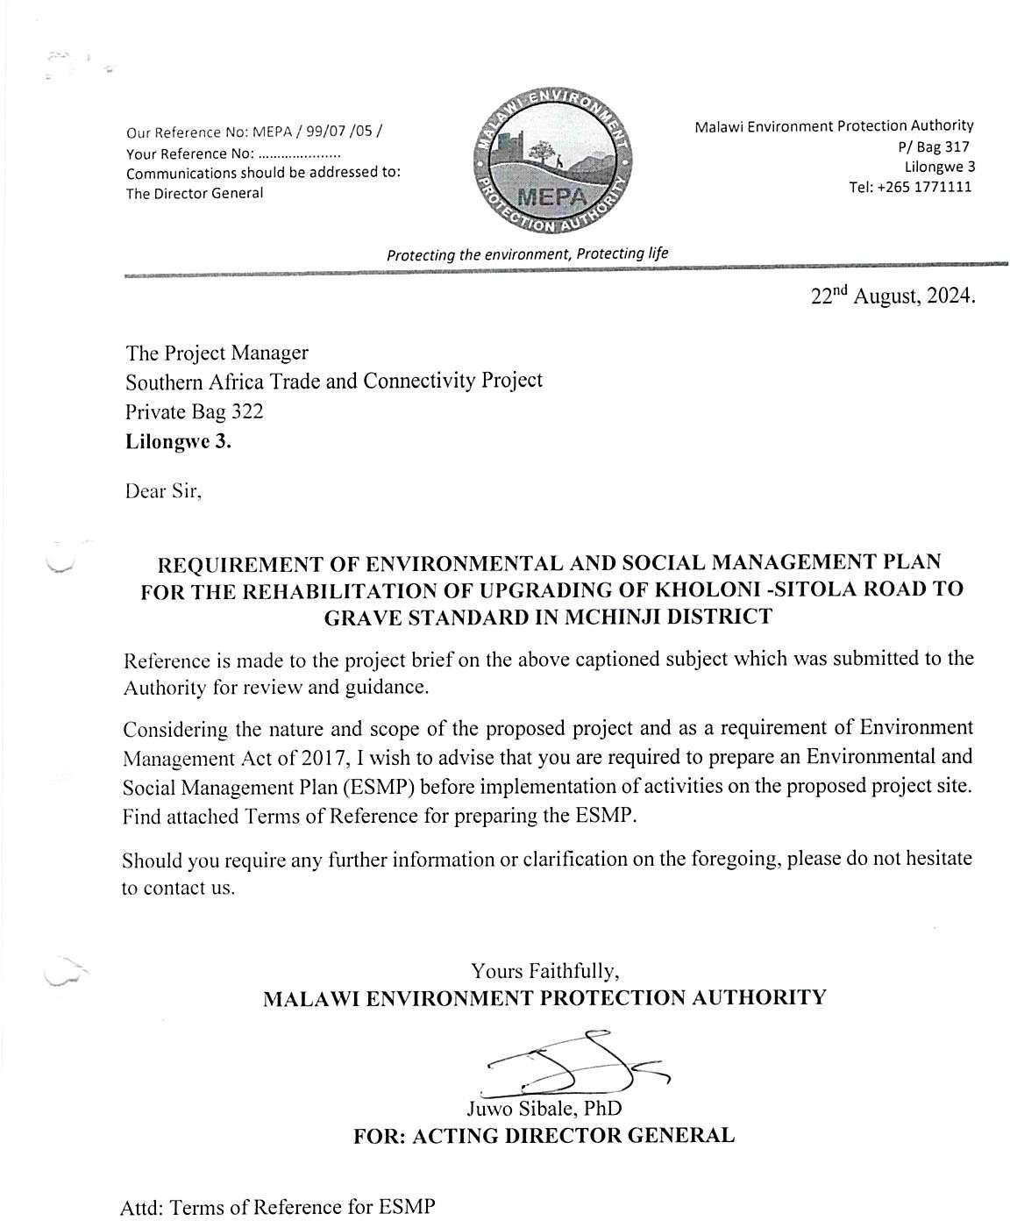

Annex 2. Terms of Reference from MEPA
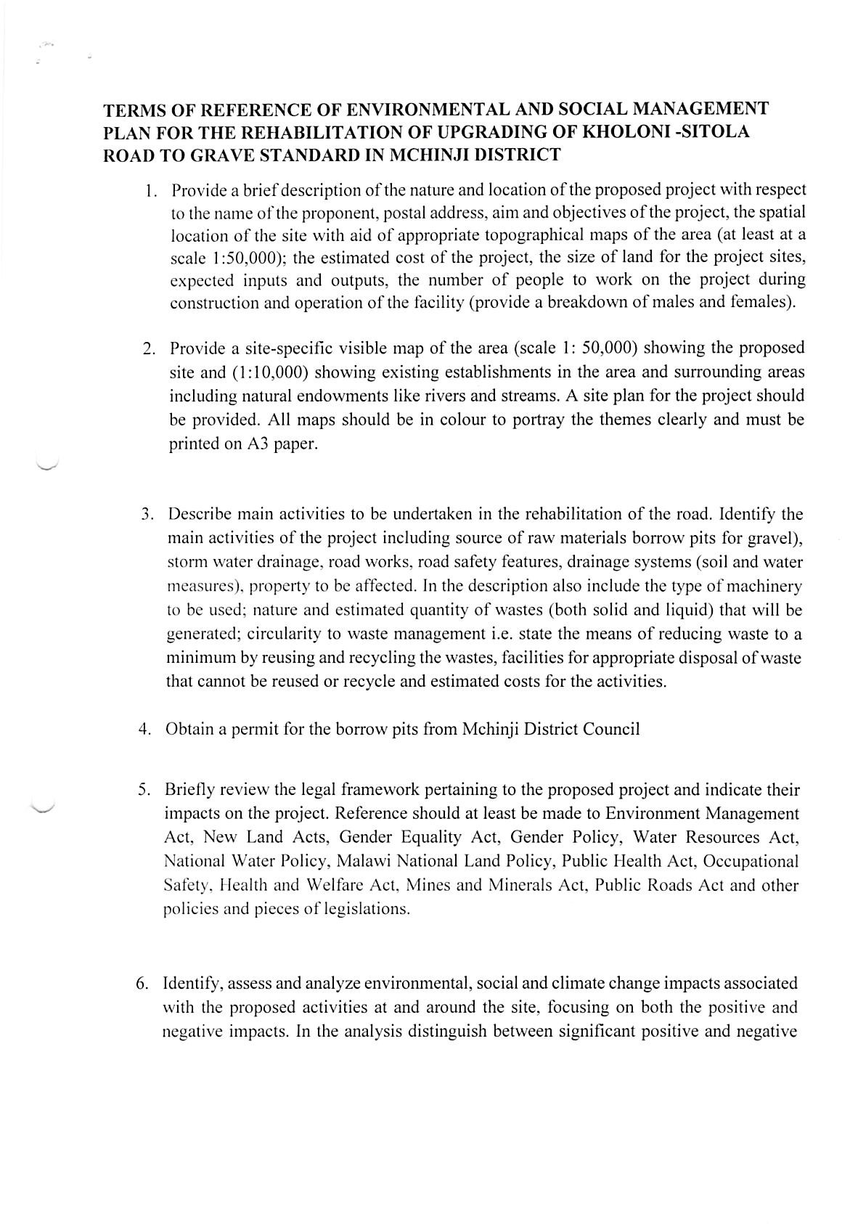

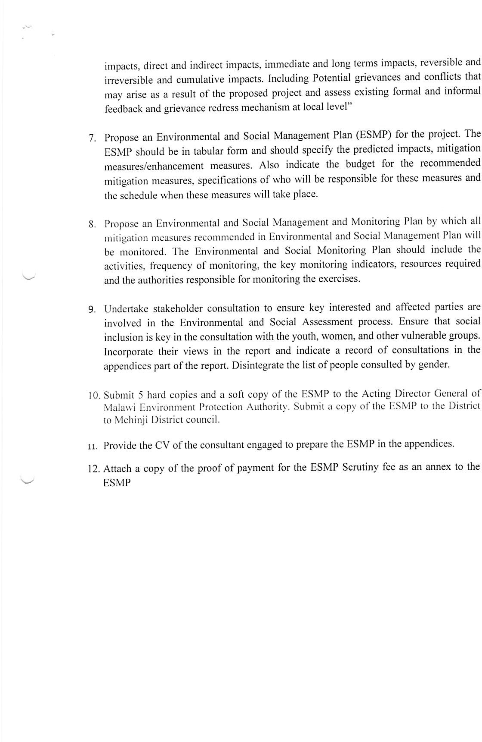

Annex 3a. List of Stakeholders Consulted
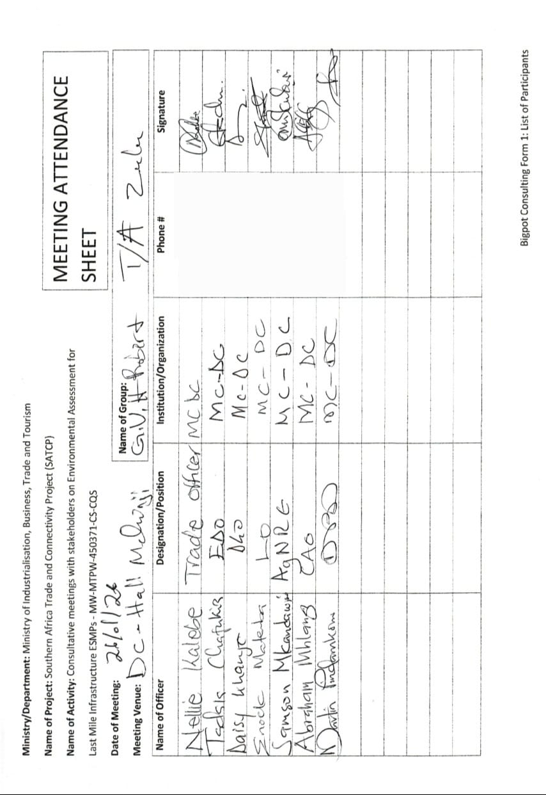
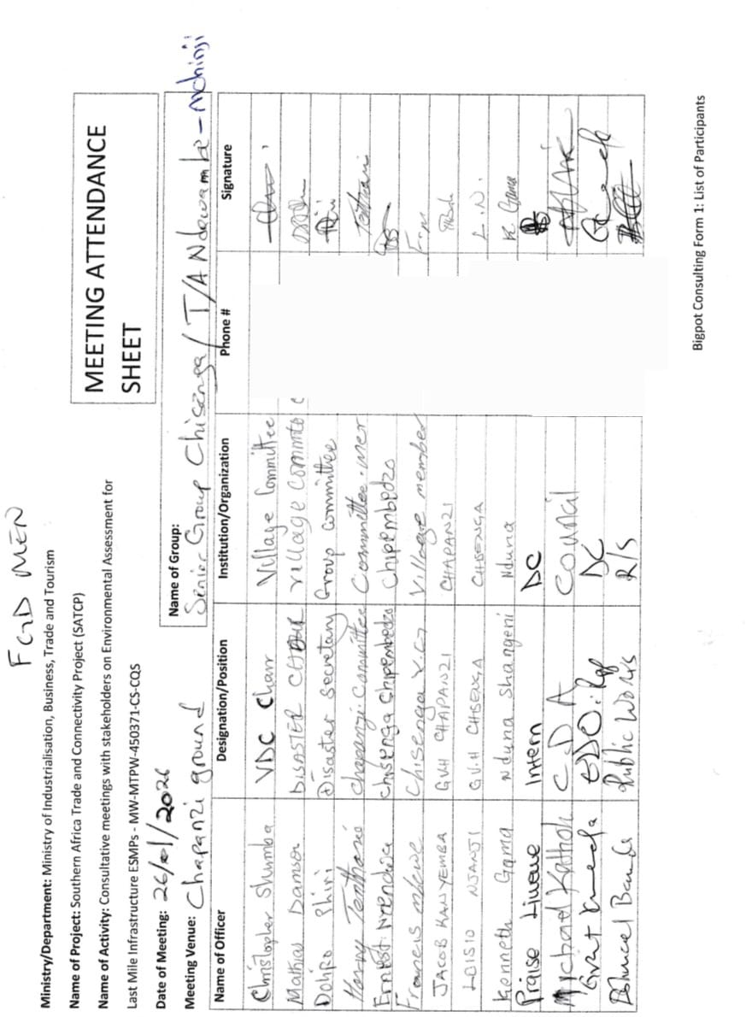

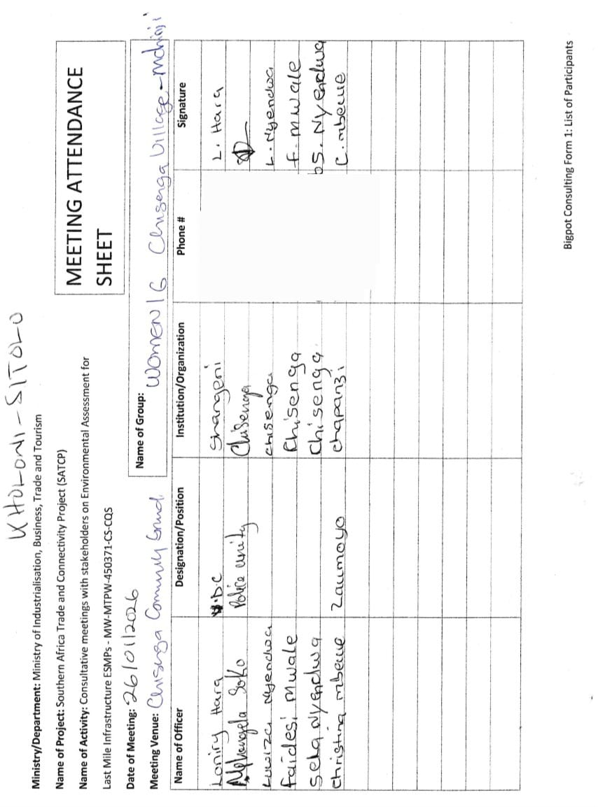

Annex 3b. Issues raised by Stakeholders and how they have been addressed in ESMP
SN | Issue Raised | Raised By | ESMP Response / Intervention | ESMP Reference (Section / Table / Annex)
1 | Limited formal communication and disclosure of project information to district authorities and communities prior to consultations | DESC, Men FGD, Women FGD | The ESMP provides for structured stakeholder consultations, continued engagement during implementation, and operation of grievance redress mechanisms for communities and workers. | Section 1.9 Methodology; Section 5.2; Annex 4 List of Stakeholders Consulted; Annex 10 Stakeholder Engagement Framework
2 | Seasonal flooding and overtopping of the road in low-lying areas, especially near Sitolo bridge crossings | DESC | The ESMP addresses this through hydrological design, climate-resilient culvert sizing, scour protection, cross-drainage structures, and maintenance of drainage infrastructure. | Sections 4.2.4 Climate and Climate Change Risks; 4.2.5 Water Resources; Section 5.2. ESMP
3 | Presence of wetlands near Ndawambe area requiring protection during construction | DESC | The ESMP recognizes wetland sections as hydrologically sensitive and requires controlled runoff, spoil control, avoidance of stockpiling or disposal in wetland margins, and protection of natural drainage. | Section 4.2.5 Water Resources; Section 2.6 Waste Generation and Management; Section 5.2.
4 | Sandy and loose soils along the corridor increasing the risk of erosion, washouts, and embankment instability | DESC | The ESMP addresses this through erosion and sediment control, slope stabilization, controlled earthworks, compaction, and drainage improvement in moisture-sensitive sections. | Sections 4.2.2 Geology; 4.2.3 Soils; Section 5.2
5 | Existing culverts are blocked, broken, or inadequate, leading to poor drainage and disruption of farmland and access paths | DESC | The ESMP provides for culvert sizing, installation of new culverts, rehabilitation of existing culverts, side drains, and drainage maintenance to restore flow and road passability. | Section 2.2 Project Components and Activities; Section 5.2
6 | Risk of siltation and contamination of nearby water sources such as boreholes, springs, and shallow wells during construction | DESC | The ESMP addresses this through sediment control, spoil management, spill prevention, fuel to be procured directly from nearby service stations, prohibition of refuelling near water bodies, and controlled wastewater management. | Sections 2.5.4 Water for Construction; 2.6.2 Spoil Management; 2.6.3 Hazardous Waste Management; 4.2.5 Water Resources; Section 5.2 ESMP
7 | Presence of irrigation infrastructure such as the Pandawani weir requiring protection | DESC | The ESMP addresses this through identification and protection of irrigation channels and related community water infrastructure during excavation, maintenance of uninterrupted flow, and restoration where disturbed. | Section 4.2.5 Water Resources; Section 5.2.4.12
8 | Borrow pits may pose safety risks to children and create mosquito breeding sites if left open | DESC | The ESMP requires approval of borrow pits, topsoil stripping, progressive rehabilitation, contouring to prevent water stagnation, and full closure and stabilization after use. | Section 2.6.5 Borrow Pit Rehabilitation; Section 5.2 Annex 9 Borrow Pit Rehabilitation Framework
9 | Illegal sand mining in riverbanks, roadsides, Tikoliwe area, and forest reserves must be avoided | DESC | The ESMP requires that materials be sourced only from licensed and approved sources and prohibits extraction from riverbanks and other environmentally sensitive areas. | Section 2.5.2 Sand; Table 2-3 Summary of Construction Materials and Sources; Section 5.2; Chapter 3 Legislative Framework
10 | Construction waste such as spoil, cement bags, plastics, oil residues, and human waste requires proper management and disposal | DESC, Men FGD, Women FGD | The ESMP provides for spoil reuse and controlled disposal, hazardous waste handling, domestic waste collection, segregation, storage, and disposal at approved sites. | Section 2.6 Waste Generation and Management; Table 2-4 Anticipated Waste Streams and Management Measures; Section 5.2 ESMP; Annex 6 Waste Management Framework
11 | Villages, houses, churches, markets, and community assets are located close to the road and may be affected during construction | DESC, Men FGD, Women FGD | The ESMP addresses this through sensitive receptor mapping, controlled construction footprint, dust suppression, traffic control, and maintenance of safe community access. | Sections 4.3 Socio-economic Environment; Section 5.2 ESMP
12 | Temporary disruption of crops, roadside businesses, and community access routes during construction | DESC, Women FGD | The ESMP provides for phased construction, temporary crossings, notification before temporary closures, and restoration of access immediately after works. | Sections 2.2.2 Construction Phase; 2.4 Land Requirement; 4.3.7 Economic Activities and Livelihoods; Section 5.2 ESMP
13 | Dominant livelihoods include farming, cross-border trade, informal vending, and piece work that depend on road access | DESC, Men FGD, Women FGD | The ESMP recognizes these livelihood systems in the baseline and reflects improved market access, local economic stimulation, and employment generation as key positive project outcomes. | Sections 4.3.5 Agriculture; 4.3.7 Economic Activities and Livelihoods; Section 5.2 ESMP
14 | Construction may disrupt access to markets, hospitals, schools, and maize mills if diversions are not properly managed | Men FGD | The ESMP provides for phased works, temporary crossings, notification of communities, and restoration of access to social and economic service points. | Sections 4.3.2 Education; 4.3.3 Health; Section 5.2.4.11
15 | Accident risks from motorcycles, construction vehicles, and heavy machinery near villages and schools | DESC, Men FGD, Women FGD | The ESMP addresses this through traffic management planning, warning signs, flaggers, safe pedestrian passageways, speed calming, and post-construction road safety measures. | Section 5.2.1.3; Section 5.2 ESMP; Annex 11 Traffic Management Framework
16 | Need for traffic control measures such as warning signs, flag persons, speed controls, and clear demarcation of work zones | DESC, Men FGD, Women FGD | The ESMP directly includes these measures under traffic safety mitigation and monitoring for both construction and operation phases. | Section 5.2 ESMP; Annex 11 Traffic Management Framework
17 | Dust emissions and noise pollution during construction may affect nearby communities | DESC, Men FGD, Women FGD | The ESMP addresses this through water spraying, covering haul trucks, speed limits, work scheduling, equipment maintenance, and restriction of noisy works to daytime hours. | Section 5.2 EMMP
18 | Risk of children approaching construction machinery and hazardous areas | Men FGD, Women FGD | The ESMP addresses this through community safety measures, warning signs, flaggers, safe pedestrian passageways, and road safety design features near schools and trading centres. | Section 5.2 ESMP; Annex 11 Traffic Management Framework
19 | Presence of graveyards along the corridor that must be protected from disturbance | DESC, Men FGD, Women FGD | The ESMP recognizes graveyards as culturally sensitive sites and requires site verification, buffer zones, avoidance during works, and implementation of a chance-find procedure. | Sections 4.2.6 Flora and Fauna; 4.3.4 Cultural Heritage; Section 5.2 ESMP; Annex 12 Chance Find Procedure
20 | Protection of community assets such as boreholes, schools, churches, footpaths, irrigation channels, and a football ground near the road | DESC | The ESMP provides for identification of community assets, controlled work footprint, access protection, and avoidance or restoration where assets are affected. | Sections 4.3 Socio-economic Environment; Section 5.2 ESMP
21 | Need to prioritize local labour for unskilled work opportunities during construction | DESC, Men FGD, Women FGD | The ESMP prioritizes local labour recruitment and requires employment records disaggregated by gender. | Section 2.3 Labour Requirement; Table 2-2 Expected Number of People to be Employed; Section 5.2 ESMP
22 | Past contractor-related issues including delayed wages, unpaid labour, and poor working conditions | DESC | The ESMP addresses this through written labour contracts, timely wage payment, worker grievance registers, labour welfare inspections, and Ministry of Labour oversight. | Section 2.3 Labour Requirement; Section 5.2 ESMP; Chapter 3 Legislative and Institutional Framework; Annex 13 Labour Management Guidelines
23 | Risk of GBV, SEA/SH, and early pregnancies associated with labour influx and interactions with community members | DESC, Men FGD, Women FGD | The ESMP addresses this through a contractor Code of Conduct, GBV/SEA/SH awareness training, confidential reporting channels, collaboration with local authorities, and survivor-centred response measures. | Chapter 3.3.3 World Bank Requirements on SEA/SH; Section 5.2 ESMP; Annex 7 Code of Conduct; Annex 8 Summary of GBV Measures
24 | Risk of HIV/AIDS transmission and family conflicts linked to relationships between workers and community members | Men FGD, Women FGD | The ESMP addresses this through HIV/AIDS awareness sessions, worker conduct rules, community sensitization, and labour management controls during construction. | Section 2.3 Labour Requirement; Chapter 3 Legislative Framework; Section 5.2 ESMP; Annex 13 Labour Management Guidelines
25 | Alcohol abuse and youth behavioural risks that may be aggravated during construction | DESC, Men FGD | The ESMP addresses this through worker conduct requirements, zero-tolerance alcohol abuse rules during working hours, labour supervision, and grievance procedures. | Section 5.2 ESMP; Annex 7 Code of Conduct
26 | Vulnerable groups requiring special consideration including women, youth, elderly persons, and persons with disabilities | DESC, Men FGD, Women FGD | The ESMP addresses this through inclusive consultation, GRM participation, gender-sensitive recruitment, and explicit consideration of vulnerable groups in engagement processes. | Sections 4.3.10 Vulnerable and Marginalized Groups; Section 5.2 ESMP; Annex 10 Stakeholder Engagement Framework
27 | Need for functional grievance redress mechanisms involving VDCs, Traditional Authorities, and district structures | DESC, Men FGD, Women FGD | The ESMP provides for project-level grievance redress mechanisms for both communities and workers, linked to stakeholder engagement and district-level coordination structures. | Section 1.7 Objectives of the ESMP; Section 5.2.1.2; Section 5 Institutional Coordination Mechanisms; Annex 10 Stakeholder Engagement Framework
28 | Limited logistical capacity (transport and fuel) for DESC to conduct monitoring and ESMP enforcement | DESC | The ESMP acknowledges district-level implementation capacity constraints and assigns joint monitoring and oversight functions under the institutional framework. | Section 5 Implementation Capacity; Section 6.2.1 Recommendations for MoTPW / SATCP PIU; Section 6.2.5 Recommendations for Mchinji District Council and DESC
29 | Need for joint inspections, safeguards training, and simplified monitoring tools for district staff | DESC | The ESMP provides for joint monitoring involving MoTPW, the Supervising Consultant, MEPA, and District Council structures under the monitoring and institutional coordination framework. | Section 5 Monitoring and Oversight Framework; Section 5.3.3 Institutional Coordination Mechanisms; Section 5.3.4 Implementation Capacity
30 | Risk that contractors may abandon works before completion if not properly supervised | Men FGD, Women FGD | The ESMP addresses this through contractor obligations, supervision by the Supervising Consultant, oversight by MoTPW, demobilisation requirements, and mandatory pre-mobilisation site-specific plans. | Section 5.2 ESMP Implementation Responsibilities
31 | Need for strong drainage design, use of concrete slabs in waterlogged areas, and climate-resilient road construction | DESC, Men FGD, Women FGD | The ESMP addresses this through hydrological modelling, climate-resilient culvert sizing, drainage rehabilitation, embankment improvement, scour protection, and maintenance of drainage structures under operation. | Sections 2.2 Planning and Design / Construction; 4.2.4 Climate and Climate Change Risks; 4.2.5 Water Resources; Section 5.2 ESMP

Annex 4. Sample Code of Conduct for Contractors
1. Purpose and Scope
This Sample Code of Conduct (CoC) provides the minimum mandatory standards of behaviour for all personnel engaged in implementation of SATCP Last Mile Infrastructure (LMI) subprojects, including contractors, sub‑contractors, supervising consultants, suppliers, and all categories of workers (permanent, temporary and day workers). The annex serves as a framework and template for preparation of a project‑specific Contractor’s Code of Conduct, which shall be adapted by each Contractor to reflect the scope, risks, workforce composition and community context of the subproject, and submitted to the Supervising Consultant and the PIU for review and approval prior to mobilisation.
The project‑specific CoC shall apply to all personnel working on or in connection with the subproject and shall be communicated in a language and format that workers understand. Each worker shall sign the approved Code of Conduct as a condition of employment and shall receive induction and periodic refresher training on its requirements, including sanctions for non‑compliance.
The Code addresses risks associated with the following:
- Environmental and social management.
- Occupational health and safety (OHS).
- Labour influx and labour relations.
- Spread of communicable diseases, including HIV and AIDS.
- Sexual harassment (SH), sexual exploitation and abuse (SEA), and gender‑based violence (GBV).
- Child labour and child protection.
- Illicit behaviour, crime and corruption.
- Community health, safety and road safety.
Compliance with the approved Code of Conduct is a contractual obligation for the Contractor and all associated personnel, and a condition of employment on the project. The Contractor shall be responsible for enforcement of the Code at worksites, worker accommodation areas, haul routes and all other project‑related locations, while the Supervising Consultant and PIU shall monitor compliance as part of ESMP and contract implementation.
2. General Obligations
The Supervising Consultant shall ensure that the Contractor and all associated personnel:
a) Legal Compliance
Comply at all times with the laws, regulations, and standards of the Republic of Malawi, including the Environment Management Act (2017), labour laws, occupational safety legislation, and applicable World Bank safeguard requirements.
b) ESHS Planning Instruments
Prepare, implement, and maintain site-specific instruments prior to commencement of works, including:
- Environmental and Social Management Plan (ESMP);
- Health and Safety Management Plan (HSMP);
- HIV and AIDS Awareness Programme;
- Occupational Health and Safety Awareness Programme;
- Road Safety and Traffic Management Plan.
c) Occupational Health and Safety
Provide a safe and healthy working environment, including:
- Provision and compulsory use of appropriate Personal Protective Equipment (PPE);
- Prevention of avoidable accidents and injuries;
- Immediate reporting and correction of unsafe acts or hazardous conditions.
d) Traffic and Road Safety
Implement traffic safety measures, including:
- Temporary speed calming devices and speed-limit signage;
- Warning signs in villages, trading centres, schools, health facilities, and construction zones;
- Enforcement of safe driving practices by all project drivers.
e) Environmental Protection
Avoid unnecessary clearance of trees and vegetation, prevent conflicts over water resources, and ensure sustainable use of natural resources in consultation with local communities.
f) Pollution Prevention
Take all reasonable measures to prevent pollution of air, water, and soil, land degradation, and environmental damage, and ensure compliance with good international industry practice.
g) Worker and Public Safety
Install standard safety signs, barricades, and road markings during construction and after completion to protect workers, communities, and road users.
h) Sanitation and Welfare Facilities
Provide adequate sanitation facilities, including:
- Safe drinking water;
- Decent toilets and washing facilities at worksites and camps;
- Prohibition of open defecation.
i) Site Rehabilitation and Restoration
Restore all disturbed areas after construction, including borrow pits, quarries, stockpiles, camps, access roads, batching plants, fuel storage areas, and waste disposal sites, through landscaping, tree planting, and erosion-control measures.
3. Labour, Ethics, and Social Conduct
j) Non-Discrimination
Prohibit all forms of discrimination in recruitment, employment, and working conditions on the basis of gender, age, ethnicity, disability, religion, marital status, political affiliation, or other protected characteristics.
k) Fair Labour Practices
Adhere to Malawi labour laws by issuing written contracts to skilled and unskilled workers, respecting working hours, wages, and conditions of employment.
l) Prevention of Sexual Harassment
Strictly prohibit sexual harassment, including abusive language, inappropriate gestures, sexually suggestive behaviour, or culturally offensive conduct, particularly towards women and children.
m) Prevention of SEA/GBV
Prohibit any form of sexual exploitation, abuse, or violence, including:
- Exchange of money, goods, services, or employment for sex;
- Exploitative or degrading behaviour;
- Any sexual activity with minors (persons under 18), regardless of consent.
n) Child Protection and Child Labour
Prohibit child labour and all forms of child abuse, exploitation, or endangerment, and ensure children’s safety in and around project areas.
o) Conflict of Interest and Corruption
Avoid conflicts of interest and prohibit bribery, favouritism, or preferential treatment based on personal, financial, or family relationships.
p) Protection of Property and Assets
Safeguard project equipment, materials, and property; prohibit theft, vandalism, misuse, or waste of resources.
q) Grievance Reporting and Non-Retaliation
Ensure that workers and community members can report violations of this Code through established grievance mechanisms without fear of retaliation, provided the report is made in good faith.
4. Enforcement and Accountability
r) Acknowledgement and Sanctions
All workers and contractor personnel shall:
- Read, understand, accept, and sign this Code of Conduct as a condition of employment;
- Attend mandatory induction and refresher training on ESHS and SEA/GBV prevention.
Any violation of this Code of Conduct may result in disciplinary action, including:
- Verbal or written warnings;
- Suspension or dismissal;
- Termination of contract; and/or
- Referral to relevant legal authorities.
5. Contractor Certification
I, the undersigned, confirm that I have read and understood this Code of Conduct and commit to ensuring full compliance by all personnel engaged under this contract.
I Agree /
Name of Authorized Representative: ____________________________
Signature: ____________________________
Name of Company: ____________________________
Physical Address: ____________________________
Company Stamp: ____________________________
Date: ____________________________

Annex 5. Barrow Pit Rehabilitation Framework
(SATCP Last Mile Infrastructure Projects)
1. Introduction and Purpose
This Borrow Pit Rehabilitation Framework applies to all borrow pits identified and utilised under the SATCP Last Mile Infrastructure (LMI) projects. It sets out mandatory procedures for environmentally sound material extraction, operation, rehabilitation and closure of borrow pits so that material sourcing does not result in permanent land degradation, public safety hazards, or adverse impacts on surrounding communities and ecosystems.
The Framework provides the standard requirements that Contractors must follow when preparing site-specific Borrow Pit Management and Rehabilitation Plans for each borrow source they intend to use. These site-specific plans shall form part of the Contractor’s Environmental and Social Management Plan (C-ESMP) and shall be submitted to the Supervising Consultant and the PIU for review and approval prior to opening or using any borrow pit. The Framework shall also be applied within the site-specific ESMP to guide oversight, monitoring and verification of borrow-pit performance throughout construction and post-closure.
2. Project Context
Borrow pits are identified during the design and pre-construction phases of LMI subprojects based on geotechnical investigations undertaken under the Detailed Engineering Design (DED). These borrow pits may supply lateritic gravel, fill material, or other construction materials required for road rehabilitation, drainage works, and ancillary infrastructure.
At the planning stage, borrow pits are considered indicative material sources. Final selection, approval, and use shall be subject to field verification, landowner consent, Environmental and social screening, and approval by relevant authorities.
3. Regulatory and Safeguards Framework
Borrow pit development, operation, and rehabilitation under SATCP LMI projects shall comply with:
- Environment Management Act (2017)
- MEPA Guidelines for Environmental Assessment (2025)
- SATCP ESMF
- World Bank OP/BP 4.01 and OP/BP 4.04 (where applicable)
- Approved ESMPs and DEDs for each LMI subproject
4. Borrow Pit Planning and Site Controls
Before opening or using any borrow pit, the Contractor shall:
- Obtain written approval from the Supervising Consultant and the relevant District Council.
- Secure documented landowner consent and confirmation from the appropriate Traditional Authority.
- Verify land tenure status and agree on access, use, rehabilitation, and handover conditions.
- Clearly demarcate the borrow pit footprint and access routes.
- Strip and stockpile topsoil separately for use during rehabilitation.
- Install warning signage and temporary fencing, particularly where borrow pits are located near settlements, agricultural land, footpaths, or grazing areas.
5. Key Environmental and Social Risks
Typical risks associated with borrow pits under LMI projects include:
- Loss of productive agricultural land
- Open excavations posing injury risks to people and livestock
- Standing water leading to mosquito breeding
- Soil erosion and sediment runoff into nearby streams or wetlands
- Visual scarring of the landscape
- Community dissatisfaction where land is not adequately restored
6. Rehabilitation Objectives
Borrow pit rehabilitation under SATCP LMI projects shall aim to:
- Restore land to a safe, stable, and productive condition
- Prevent erosion, standing water, and slope instability
- Reintegrate rehabilitated sites into agricultural or community land use
- Eliminate public health and safety hazards
- Meet landowner, community, and District Council expectations
7. Rehabilitation Measures
7.1 Progressive Rehabilitation
- Implement rehabilitation progressively, commencing immediately after material extraction in each section.
- Phase excavation activities to minimise the total open area at any given time.
7.2 Backfilling and Reshaping
- Reuse overburden and unsuitable material for backfilling.
- Reshape excavated areas to stable slopes (maximum 1:3).
- Partially backfill deep excavations to eliminate water accumulation.
7.3 Topsoil Replacement
- Evenly spread stockpiled topsoil over rehabilitated surfaces.
- Ensure sufficient topsoil depth to support revegetation or agricultural reuse.
7.4 Drainage and Erosion Control
- Restore surface drainage to natural flow patterns.
- Apply erosion control measures such as contour shaping, grass strips, or stone pitching where required.
7.5 Revegetation
- Revegetate rehabilitated sites using indigenous grass species and locally appropriate tree species, subject to landowner preference.
- Prioritise vegetation that supports soil stabilisation, shade provision, and community utility.
8. Safety and Community Protection
- Secure active borrow pits using fencing, barriers, or warning tape.
- Install clear warning signage in English and local languages.
- Eliminate vertical faces and open pits upon closure.
- Formally hand back rehabilitated sites to landowners after completion.
9. Post-Use Land Options
Subject to agreement with landowners and District Councils, rehabilitated borrow pits may be converted into:
- Agricultural land
- Community woodlots
- Grazing areas
- Controlled water retention areas (only where approved, engineered, and safe)
10. Roles and Responsibilities
Actor | Responsibility
Contractor | Implement borrow pit management and rehabilitation
Supervising Consultant | Approve, supervise, and certify rehabilitation works
District Council / DESC | Community liaison and site verification
Landowners / Traditional Authorities | Accept rehabilitated land

11. Monitoring and Reporting
- Report borrow pit status in monthly ESMP compliance reports.
- Monitor indicators including number of rehabilitated sites, erosion evidence, water ponding, and vegetation establishment.
- Conduct final inspections prior to issuance of completion certificates.
12. Budgeting
- Fully include borrow pit rehabilitation costs in the Contractor’s BoQs and C-ESMP.
- Prohibit approval of any borrow pit without a costed and approved rehabilitation provision.
13. Completion and Handover
Consider borrow pits closed only when rehabilitation is complete, sites are safe and stable, and formal handover documentation is signed by relevant parties.
14. Conclusion
This Borrow Pit Rehabilitation Framework provides a consistent and enforceable approach for managing borrow pits across all SATCP Last Mile Infrastructure projects, ensuring Environmentally responsible material sourcing, protection of community interests, and full compliance with MEPA (2025) and World Bank safeguards.

Annex 6. Traffic Management Framework
1. Introduction
This Traffic and Access Management Framework (TAMF) has been prepared for the Southern Africa Trade and Connectivity Project (SATCP) – Last Mile Infrastructure (LMI) subprojects, including feeder road rehabilitation, drainage improvements, bridge/culvert works and associated construction activities. The Framework sets out the minimum requirements for planning, operating and monitoring construction-related traffic so that works are carried out safely and with limited disruption to local communities and road users.
The Framework provides mandatory guidance for the preparation and implementation of site-specific Traffic and Access Management Plans (TAMPs) by Contractors. For each subproject, the Contractor shall prepare a TAMP consistent with this Framework and submit it to the Supervising Consultant and the SATCP PIU/State Agency for Transport and Construction Projects for review and approval prior to commencement of construction works.
The TAMF aims to ensure that all construction-related traffic—vehicles, equipment and personnel—is managed safely, efficiently and in an environmentally and socially responsible manner, while minimising risks and disruptions to communities, vulnerable road users, businesses, and existing transport infrastructure.
2. Purpose and Objectives
Construction activities will increase vehicular and machinery traffic within worksites and along existing regional and community roads. Without effective management, such traffic may:
- Interfere with normal traffic and pedestrian movements;
- Increase risks of accidents and injuries to workers and the public;
- Damage existing road infrastructure;
- Generate dust, noise, congestion, and community nuisance.
The objectives of this Framework are to:
- Promote safe interaction between construction traffic, pedestrians, and local road users;
- Minimize Environmental and social risks associated with construction traffic;
- Guide the planning, use, and rehabilitation of access roads and haul routes;
- Ensure site-specific traffic impacts are addressed through appropriate design, scheduling, signage, and controls.
3. Access Roads and Haul Routes
a) Planning and Approval
The Contractor shall prepare detailed layout plans for all proposed access roads and haul routes. These plans shall:
- Be submitted to the Supervising Consultant for approval;
- Be accompanied by written consent from affected landowners, Traditional Authorities, or village leadership where applicable.
b) Use of Existing Infrastructure
Existing roads shall be used wherever feasible. Construction of temporary access roads shall only be permitted where unavoidable and upon approval by the Site Manager and relevant stakeholders. Construction of temporary diversions, if required, will require approval of the District and the World Bank.
c) Environmental Considerations
Planning of haul routes shall consider:
- Vegetation and sensitive habitats;
- Watercourses and drainage patterns;
- Existing land use;
- Proximity to households, schools, markets, and health facilities.
d) Construction, Maintenance, and Rehabilitation
The Contractor shall be responsible for:
- Construction and routine maintenance of access and haul roads;
- Installation of drainage infrastructure at early stages to prevent erosion;
- Decommissioning and rehabilitation of temporary roads upon completion of works.
Topsoil shall be stripped and stockpiled prior to construction and reused during rehabilitation. Disturbed areas shall be revegetated using indigenous species where applicable.
e) Dust Suppression
Dust control measures shall be implemented, including:
- Regular watering of access and haul roads;
- Enforcement of speed limits (maximum 30 km/h near settlements);
- Use of dust palliatives where necessary.
Dust suppression activities shall be recorded and reported as part of Environmental compliance monitoring.
4. Traffic Management and Safety Measures
Each site-specific Traffic and Access Management Plan shall include, at minimum, the following components:
4.1 Traffic Control and Signage
- Clearly defined access routes within and around worksites;
- Advance warning signage along haul routes and near construction zones;
- Temporary traffic signs, barriers, and flag persons where required;
- Establishment and enforcement of speed limits and control points.
Where bridge or culvert works require road occupation, temporary bypasses or diversions shall be constructed prior to commencement of works to avoid full road closures.
5. Transport of Materials
The Contractor shall ensure that:
- Vehicles transporting fine or granular materials are fully covered with tarpaulins to prevent dust and spillage;
- Any spillage or pollution along transport routes is cleaned immediately at the Contractor’s cost;
- Delivery schedules are aligned with off-peak hours to reduce congestion and disturbance to communities.
6. Driver Requirements and Conduct
All project drivers and equipment operators shall:
- Hold valid licenses appropriate to the vehicles or machinery operated;
- Be trained and certified in defensive driving and road safety;
- Receive training in eco-driving to reduce fuel consumption and emissions;
- Undergo project induction covering pedestrian safety, fatigue management, and substance abuse prevention.
Driver working hours shall be managed to prevent fatigue, ensuring adequate rest periods. The Contractor shall maintain up-to-date driver registers and dust suppression logs.
7. Interaction with Communities and Sensitive Areas
High-risk interaction areas such as schools, markets, trading centres, and health facilities shall be identified and mapped. Site-specific mitigation measures shall be implemented, including:
- Temporary pedestrian crossings;
- Traffic calming devices (speed bumps, rumble strips);
- Warning lights, reflectors, and signage;
- Temporary bypasses where necessary.
Community engagement shall be coordinated with the Stakeholder Engagement Framework (Annex 11) to ensure awareness of traffic changes and safety measures.
8. Monitoring, Enforcement, and Reporting
The Contractor’s Traffic and Access Management Plan shall include:
- An accident and incident register with clear reporting procedures;
- Random alcohol and drug testing protocols for drivers;
- A penalty and disciplinary structure for non-compliance with traffic safety requirements;
- Regular monitoring of road conditions and prompt repair of damage caused by construction traffic;
- Monthly traffic management reports detailing:
  - Traffic incidents and near misses;
  - Dust and noise control performance;
  - Community complaints related to traffic;
  - Corrective actions undertaken.
The Supervising Consultant shall verify compliance and recommend corrective measures where deficiencies are identified.
9. Institutional Responsibilities
Actor | Key Responsibilities
Contractor | Prepare and implement site-specific TAMPs, ensure compliance
Supervising Consultant | Review, approve, and monitor TAMP implementation
SATCP / PIU | Oversight and enforcement
District Authorities | Local coordination and support
Traffic Police (where applicable) | Enforcement and incident response
10. Conclusion
This Traffic and Access Management Framework establishes mandatory requirements for safe, efficient, and Environmentally responsible management of construction traffic under the SATCP Last Mile Infrastructure subprojects. Effective implementation of this Framework will reduce accident risks, protect communities, and ensure compliance with national legislation and World Bank safeguard requirements.
Site-specific Traffic and Access Management Plans shall be developed and approved prior to commencement of construction works and updated as necessary throughout project implementation.

Annex 7. Chance Find Procedure for Last Mile Infrastructure under SATCP

1. Introduction
This Chance Find Procedure sets out the protocol to be followed if previously unidentified cultural heritage is discovered during implementation of the SATCP Last Mile Infrastructure (LMI) subprojects. Cultural heritage may include, but is not limited to, archaeological materials, graves and burial sites, religious artefacts, sacred or ritual sites, and historical objects that were not identified during the initial environmental and social assessment. The procedure is to be applied by Contractors and Supervising Consultants on all worksites and along all associated project footprints, and ensures that any chance finds are managed in accordance with the Monuments and Relics Act (Cap 29:01) of Malawi and the World Bank’s OP/BP 4.11 on Physical Cultural Resources.
2. Purpose
The purpose of this procedure is to safeguard Malawi’s tangible cultural heritage by ensuring that any unexpected discoveries are handled with care and in accordance with legal and safeguard requirements. The procedure seeks to prevent unauthorized interference, preserve historical and cultural assets, and maintain respect for community traditions and sensitivities.
3. Scope
This procedure applies to all personnel involved in the project, including contractors, subcontractors, consultants, field workers, and any party engaged in construction, material sourcing, excavation, or related site activities. It is applicable to all locations along the project corridor, including campsites, borrow pits, material stockpiles, access roads, and working zones.
4. Definition of a Chance Find
A chance find is defined as any artifact, feature, structure, or site of cultural, historical, or religious significance that is discovered unexpectedly during the execution of project activities. Examples may include human remains, pottery fragments, stone tools, religious objects, altars, burial grounds, historical ruins, or sacred trees. These are typically items or sites not previously recorded or anticipated in the ESMP documentation.
5. Procedure to Follow in the Event of a Chance Find
If a chance find is encountered, the following steps must be followed:
- All work in the immediate vicinity must stop immediately. The affected area must be secured with a buffer zone of no less than 20 to 50 meters to prevent disturbance or looting.
- The Contractor must promptly inform the Supervision Consultant, the Project Implementation Unit (PIU) of the SATP, and the Department of Antiquities (DoA) within 24 hours.
- The DoA will dispatch a qualified cultural heritage or archaeological specialist to assess the nature, significance, and appropriate treatment of the discovery.
- Based on the expert assessment and consultations with relevant stakeholders, the cultural material may be preserved in situ, documented and relocated, or managed in accordance with traditional practices—such as holding customary ceremonies prior to relocating graves or sacred objects.
- No work should resume in the vicinity until the DoA has provided written clearance authorizing continuation. All findings must be properly recorded, photographed, and geotagged for documentation and reporting purposes.

6. Roles and Responsibilities
The Contractor is responsible for ensuring that all site personnel are trained in this procedure and for immediately halting work and protecting the area in the event of a discovery. The Supervision Consultant must verify contractor compliance and support the coordination of response efforts. The PIU is responsible for notifying the Department of Antiquities, facilitating expert engagement, and ensuring adherence to this procedure. The Department of Antiquities will lead assessments, determine the heritage value of the find, and authorize appropriate measures or clearance to resume work.
7. Training and Awareness
To ensure that all relevant personnel are aware of and can implement this procedure, pre-construction induction training will be provided to all workers and supervisors. This will include awareness of local cultural sensitivities and the importance of cultural heritage protection. Refresher training will be conducted every six months or upon the onboarding of new workers. On-site communication materials such as posters and briefing cards will be used to reinforce awareness.
8. Legal and Policy Basis
This procedure is grounded in the Monuments and Relics Act (Cap 29:01) of Malawi, which mandates the protection and reporting of archaeological discoveries and prohibits unauthorized disturbance of cultural resources. It is also aligned with the World Bank’s OP/BP 4.11 (Physical Cultural Resources), which requires Borrowers to avoid, minimize, or mitigate impacts on cultural heritage and to engage relevant communities and authorities in the process of managing heritage resources.
9. Reporting and Documentation
All chance finds must be documented in a standardized reporting format that includes the date and time of discovery, location coordinates (GPS), a physical description of the find, photographic records, and the actions taken. These reports must be submitted to the PIU, the Department of Antiquities, and included in the Contractor’s monthly E&S compliance reporting. Records of follow-up actions, assessments, and final clearance must also be retained.
10. Budget and Resources
A dedicated budget line will be included in the project’s Environmental and Social Management Plan (ESMP) to support implementation of the chance find procedure. This will cover costs associated with expert assessments, protective measures (e.g., fencing), documentation, stakeholder engagement, and cultural or ceremonial activities where required for the proper treatment of sacred or religious sites.

Annex 8: Labour Management Guidelines for Contractor Compliance and Preparation of Labour Management Plans (LMPs)

1. Purpose of these Guidelines
These Labour Management Guidelines are issued to guide Contractors in the preparation and implementation of project‑specific Labour Management Plans (LMPs) for SATCP Last Mile Infrastructure (LMI) road projects. They are not a standalone LMP; rather, they operationalise the project‑level Labour Management Procedures and relevant Malawi labour legislation for application at subproject and contract level.
Specifically, the Guidelines:
- Establish minimum labour and working‑conditions requirements that Contractors must meet on all SATCP LMI contracts.
- Clarify statutory obligations under applicable Malawi labour legislation (including the Employment Act, Occupational Safety, Health and Welfare Act, Gender Equality Act, Child Care, Protection and Justice Act, and Trafficking in Persons Act).
- Define the scope, structure and content expected in Contractor LMPs, including provisions on terms and conditions of employment, OHS, worker accommodation, Code of Conduct, SEA/SH and GBV, child labour, and grievance mechanisms.
- Provide direction on labour‑risk identification, mitigation and monitoring consistent with national law and World Bank requirements for managing social risks (OP/BP 4.01 and the Labour Management Procedures for SATCP).
All Contractors engaged under SATCP shall prepare a site‑specific Labour Management Plan (LMP) consistent with these Guidelines and the project‑level Labour Management Procedures, and submit it to the Supervising Consultant and PIU for review and approval prior to mobilisation. The approved LMP will form part of the Contractor’s C‑ESMP and will be monitored throughout implementation.
2. Legal and Policy Framework
Contractors must ensure their LMPs demonstrate compliance with:
- Employment Act (2000, as amended)
- Occupational Safety, Health and Welfare Act (1997)
- Gender Equality Act (2013)
- Child Care, Protection and Justice Act (2010)
- HIV and AIDS (Prevention and Management) Act (2018)
- Trafficking in Persons Act (2017)
- Public Health Act (1948)
- Applicable minimum wage regulations
- Relevant World Bank safeguards (OP/BP 4.01)
The LMP must clearly reference these instruments and describe how compliance will be operationalised.
3. Categories of Workers to be Covered
The Contractor’s LMP shall cover all categories of project workers, including:
- Direct workers (Contractor employees)
- Subcontracted workers
- Security personnel
- Primary supplier workers
The LMP must describe how labour standards will be applied to subcontractors and suppliers.
4. Minimum Content Requirements for Contractor LMPs
Each Contractor’s LMP must include, at a minimum, the following components:
4.1 Workforce Planning and Recruitment Procedures
The LMP must describe:
- Anticipated labour numbers by category and phase;
- Recruitment procedures;
- Local hiring strategies;
- Non-discrimination measures;
- Age verification procedures;
- Prohibition of forced labour and child labour;
- Record-keeping systems for employees.
Recruitment must comply with Sections 4, 5, 21, and 23 of the Employment Act.
4.2 Employment Conditions
The LMP shall demonstrate how the Contractor will ensure:
- Written contracts for all workers;
- Clear specification of wages, hours, and benefits;
- Compliance with statutory working hours and rest days;
- Provision of annual, sick, and maternity leave;
- Equal pay for equal work;
- Proper termination procedures and severance entitlements.
4.3 Occupational Health and Safety (OHS)
The LMP must include:
- Site-specific OHS risk assessment;
- Hazard identification and control measures;
- PPE provision policy;
- Toolbox talks and safety training plan;
- Accident and incident reporting procedures;
- Emergency response plan;
- First aid and medical arrangements;
- Special protection for young workers (14–18 years).
OHS provisions must comply with the Occupational Safety, Health and Welfare Act (1997).
4.4 Worker Welfare Facilities
The LMP must outline provision of:
- Adequate sanitation facilities (segregated by gender);
- Potable water;
- Waste management systems;
- Rest areas and shelters;
- Medical and first aid facilities;
- Safe worker accommodation (where applicable).
4.5 Gender, GBV, SEA/SH and Child Protection
The LMP shall include:
- A mandatory Code of Conduct;
- GBV/SEA/SH awareness training programme;
- Zero tolerance policy;
- Confidential reporting pathways;
- Sanctions for misconduct;
- Measures to prevent exploitation of minors.
The LMP must align with the project’s GBV Management Framework.
4.7 Workers Grievance Redress Mechanism (WGRM)
The Contractor’s LMP must establish a Workers Grievance Redress Mechanism that:
- Is free and accessible;
- Protects confidentiality;
- Prohibits retaliation;
- Provides defined timelines for resolution;
- Maintains grievance records;
- Allows escalation procedures.
4.8 Monitoring and Reporting
The LMP must describe:
- Internal compliance monitoring procedures;
- Monthly labour reporting requirements;
- OHS statistics reporting;
- Training records;
- Grievance reporting;
- Supervision Consultant oversight arrangements.
5. Key Labour Risks in LMI Road Projects
Contractors shall assess and manage risks including:
- Workplace injuries and accidents;
- Exposure to dust, noise, and hazardous materials;
- Spread of communicable diseases;
- Child labour and forced labour risks;
- Gender-based violence;
- Labour disputes;
- Discrimination and exclusion of vulnerable groups;
- Resource competition due to labour influx.
Mitigation measures must be integrated into the Contractor’s ESMP and Construction Environmental and Social Management Plan (C-ESMP).
6. Review and Approval
No Contractor shall mobilise to site until:
- A project-specific Labour Management Plan has been prepared;
- The LMP has been reviewed and approved by the Supervision Consultant and Roads Authority/SATCP;
- The Code of Conduct has been signed by all personnel;
- Induction training on labour standards and GBV has been conducted.
7. Enforcement
Failure to comply with these Guidelines and approved LMP provisions may result in:
- Suspension of works;
- Withholding of payment;
- Contractual penalties;
- Termination of contract.

Annex 13. Flora and Animal Species of Kholoni-Sitolo Corridor
Annex 14-1. Flora Species
Scientific Name | English Name | Habit | National Plant Red Data List Status | IUCN Red List Status | Remarks
Cissampelos mucronata | Heart-leaved vine | Vine | Least Concern | Least Concern | Common woodland climber
Annona senegalensis | African Custard Apple | Shrub | Least Concern | Least Concern | Common savannah shrub
Argemone mexicana | Mexican Poppy | Herb | Not Evaluated | Least Concern | Disturbance indicator
Bauhinia petersiana | Kalahari White Bauhinia | Tree | Least Concern | Least Concern | Miombo associate species
Brachystegia spiciformis | Zebrawood | Tree | Least Concern | Least Concern | Dominant miombo species
Brachystegia taxifolia | African Mahogany | Tree | Least Concern | Least Concern | Miombo woodland species
Brachystegia boehmii | Prince of Wales Feathers | Tree | Least Concern | Least Concern | Common woodland species
Bridelia cathartica | Knobby Bridelia | Shrub | Least Concern | Least Concern | Woodland shrub
Combretum adenogonium | Three-leaved Combretum | Tree | Least Concern | Least Concern | Miombo associate
Euclea lanceolata | Blue Guarri | Shrub | Least Concern | Least Concern | Woodland shrub
Ficus natalensis | Natal Fig | Tree | Least Concern | Least Concern | Riparian/woodland tree
Flacourtia indica | Governor's Plum | Shrub | Least Concern | Least Concern | Common shrub
Gmelina arborea | White Teak | Tree | Least Concern | Least Concern | Invasive exotic species
Lantana camara | Common Lantana | Shrub | Least Concern | Least Concern | Invasive species
Mangifera indica | Mango | Tree | Least Concern | Least Concern | Cultivated species
Piliostigma thonningii | Camel’s Foot Tree | Tree | Least Concern | Least Concern | Common woodland species
Senna siamea | Siamese Cassia | Tree | Least Concern | Least Concern | Introduced ornamental tree
Senna spectabilis | Spectacular Cassia | Tree | Least Concern | Least Concern | Exotic species
Sida acuta | Broom Weed | Herb | Least Concern | Least Concern | Disturbed habitat species
Solanum panduriforme | Bitter Apple | Herb | Least Concern | Least Concern | Herbaceous plant
Solanum tuberosum | Irish Potato | Herb | Least Concern | Least Concern | Cultivated crop
Steganotaenia araliacea | African Carrot Tree | Shrub | Least Concern | Least Concern | Woodland shrub
Strychnos spinosa | Spiny Monkey Orange | Shrub | Least Concern | Least Concern | Edible fruit species
Terminalia sericea | Silver Cluster Leaf | Tree | Protected | Least Concern | Protected under Forestry Act
Uapaca kirkiana | Sugar Plum | Tree | Least Concern | Least Concern | Important indigenous fruit tree
Vernonia glabra | Mauve Paintbrush | Herb | Least Concern | Least Concern | Herbaceous species
Vitex mombassae | Smelly Berry Fingerleaf | Shrub | Least Concern | Least Concern | Woodland shrub
Zea mays | Maize | Grass | Least Concern | Least Concern | Dominant cultivated crop

Annex 14-B. Animal Species
Animal Group | Scientific Name | Local Name | National Red Data List Conservation Status | IUCN/Global Conservation Status
Reptile | Agama armata | Peter’s Ground Agama | Least Concern | Least Concern
Reptile | Agama mossambica | Mozambique agama | Least Concern | Least Concern
Reptile | Atheris rungweensis | Rungwe Sedge-Viper | Least Concern | Least Concern
Reptile | Bitis arietans | Puff-Adder | Least Concern | Least Concern
Reptile | Chamaeleo africanus | African chameleon | Least Concern | Least Concern
Reptile | Chamaeleo dilepis | Flap-necked chameleon | Least Concern | Least Concern
Reptile | Dendroaspis intermedius | Eastern Green Mamba | Least Concern | Least Concern
Reptile | Dendroaspis polylepis | Black Mamba | Least Concern | Least Concern
Reptile | Naja mossambica | Mozambique Spitting Cobra | Least Concern | Least Concern
Amphibian | Breviceps poweri | Power's Rain Frog | Least Concern | Least Concern
Amphibian | Ptychadena schillukorum | Schilluk Ridged Frog | Least Concern | Least Concern
Amphibian | Sclerophrys gutturalis | Guttural Toad | Least Concern | Least Concern
Amphibian | Xenopus laevis | African Clawed Frog | Least Concern | Least Concern
Invertebrate | Acanthacris ruficornis | Garden locust | Least Concern | Not Evaluated
Invertebrate | Acraea natalica | Natal Acraea | Least Concern | Least Concern
Invertebrate | Acrida acuminata | Common Stick Grasshopper | Least Concern | Not Evaluated
Invertebrate | Amauris niavius | Friar | Least Concern | Least Concern
Invertebrate | Apis mellifera | Western honey bee | Least Concern | Data Deficient
Invertebrate | Nomadacris septemfasciata | Red Locust | Least Concern | Least Concern
Invertebrate | Orthetrum chrysostigma | Epaulet skimmer | Least Concern | Least Concern
Mammal | Epomophorus paraxerus cepapi | Tree squirrel | Least Concern | Least Concern
Mammal | Crocuta crocuta | Spotted hyena | Least Concern | Least Concern
Mammal | Papio cynocephalus | Yellow baboon | Least Concern | Least Concern
Mammal | Chlorocebus pygerythrus | Vervet monkey | Least Concern | Least Concern
Mammal | Saccostomus capensis | Pouched mouse | Least Concern | Least Concern
Mammal | Lepus saxatilis | Scrub hare | Least Concern | Least Concern
Mammal | Sylvicapra grimmia | Bush duiker | Least Concern | Least Concern
Bird | Euplectes capensis | Yellow Bishop | Least Concern | Least Concern
Bird | Pycnonotus barbatus | Common Bulbul | Least Concern | Least Concern
Bird | Streptopelia semitorquata | Red-eyed Dove | Least Concern | Least Concern
Bird | Centropus burchellii | Burchell’s Coucal | Least Concern | Least Concern
Bird | Chrysococcyx caprius | Dideric Cuckoo | Least Concern | Least Concern
Bird | Colius striatus | Speckled Mousebird | Least Concern | Least Concern
Bird | Laniarius major | Tropical Boubou | Least Concern | Least Concern

Annex 14. SATCP LMI Grievance Redress Mechanism (GRM) Protocol
1. Introduction
This Grievance Redress Mechanism (GRM) Protocol has been developed for the Southern Africa Trade and Connectivity Project (SATCP) – Last Mile Infrastructure (LMI) subprojects, including feeder road rehabilitation, drainage improvements, culvert/bridge works and associated construction activities. The GRM provides a structured, project-wide system for receiving, recording, assessing and resolving concerns, queries and complaints from communities, workers and other stakeholders.
The GRM serves as the first line of response to stakeholder concerns, complementing statutory and other grievance channels (e.g. courts, police, labour authorities). It aims to resolve issues as close as possible to the point of impact, using dialogue and collaborative problem-solving, and thereby maintain constructive relations between the project, affected communities and workers.
Construction activities under SATCP LMI are expected to generate grievances related to, among others, land and assets, labour and working conditions, occupational and community health and safety, environmental impacts, and gender-based violence / sexual exploitation and abuse / sexual harassment (GBV/SEA/SH) and trafficking in persons (TIP). Contractors are required to develop and implement site-specific GRM Management Plans consistent with this Protocol.
The GRM will use two complementary modes of recording grievances:
- Manual submission (e.g. verbal, paper forms, grievance boxes, community meetings); and
- Electronic recording in a central database to allow tracking, escalation, and consolidated reporting across SATCP LMI.
Electronic recording will be promoted to support timely management oversight, automatic flagging of overdue cases, and real-time analysis of grievance trends.
2. Categories and Types of Grievances
The GRM will receive and register all grievances related to SATCP LMI activities, whether from project-affected community members, workers or institutions. Grievances may be submitted:
- In person to GRM committee members or project staff.
- By phone, SMS, WhatsApp or project-designated hotlines.
- Via grievance boxes at key locations.
- Through written letters or emails to the PIU, Supervising Consultant or Contractor.
The following categories and examples guide classification (non-exhaustive):
2.1 Construction-related Community Concerns and Livelihood Continuity
- Reinstatement disputes – Disputes about reinstatement of inadvertently damaged crops, structures or roadside assets during construction.
- Access disruption – Concerns about temporary loss of access to homes, services, schools or markets during construction.
- Livelihood continuity – Alleged disruption to roadside businesses or inadvertent crop damage during construction.
2.2 Health and Safety (Workers and Community)
- Safety violations – Inconsistent handling of safety breaches, inadequate enforcement of rules.
- Accidents and injuries – Workplace or traffic accidents, concerns about the response, or perceived unfair dismissal following an accident.
- Health and safety hazards – Exposure to hazardous materials or unsafe conditions, lack or poor quality of PPE.
- Community safety complaints – Dust, noise, blocked accesses to schools/health centres/markets, speeding construction vehicles, unsafe detours, open borrow pits or excavations.
2.3 Labour / Contractor Issues
- Payment disputes – Delayed payment, underpayment or non-payment.
- Working conditions – Poor accommodation, sanitation, unsafe or unhealthy work environments.
- Wage disputes – Wage rates, overtime, non-payment of benefits.
- Discrimination and harassment – Workplace discrimination, bullying, harassment.
- Contract interpretation – Disagreements about terms, duration, or conditions of contracts.
2.4 Gender and Social Inclusion (GSI)
- Gender discrimination – Unequal treatment of women and men in recruitment, pay or opportunities.
- Social exclusion – Exclusion of youth, persons with disabilities or vulnerable groups from employment or consultations.
- Cultural insensitivity – Disrespect for local customs, norms or religious practices.
2.5 Environmental
- Pollution and waste management – Improper waste disposal, dust, noise, spills, or other pollution.
- Community environmental impacts – Perceived damage to water sources, agricultural land, forests or communal resources.
- Natural resource damage – Deforestation, degradation of wetlands, unsustainable material extraction.
2.6 General Project Issues
- Project delays and disruptions – Concerns about prolonged construction or schedule slippage affecting access.
- Communication gaps – Lack of information, unclear messages about project scope, timing and impacts.
- Stakeholder engagement – Inadequate consultation, lack of feedback, or perceptions of exclusion.
2.7 GBV / SEA/SH and TIP (Special Handling)
GBV/SEA/SH and TIP-related grievances require special, survivor-centred handling. These cases will:
- Be received through any GRM entry point, but not investigated by community or project committees.
- Be immediately and confidentially referred (with consent) to trained focal points and survivor service providers/police, in line with the project’s GBV/SEA/SH Action Plan and referral protocol.
- Not be discussed in open committee meetings; only anonymised statistics may be reported.
3. Objectives of the GRM
The GRM seeks to:
- Provide accessible, responsive and demonstrably fair channels through which communities and workers can raise grievances and complaints and obtain timely resolution.
- Maintain open, two-way communication between the project and stakeholders and serve as an early-warning system for emerging risks.
- Resolve most grievances locally and amicably at site or community level, reducing escalation to courts or disruptive conflict.
- Manage expectations and reduce negative perceptions by offering clear information on what the project can and cannot do.
- Prevent accumulation of unresolved grievances that could lead to protests, work stoppages, sabotage or reputational damage.
- Ensure that the rights, dignity and safety of all complainants are respected, including vulnerable and marginalised groups.
- Generate lessons on recurrent issues to support continuous improvement of ESMP and C-ESMP implementation.
4. Principles of the GRM
The SATCP LMI GRM is guided by the following principles:
- Human dignity and rights – All complainants are treated with respect, without discrimination.
- Equity and gender equality – Processes recognise different barriers faced by women, men, youth and vulnerable groups and proactively promote equitable access.
- Accessibility – Multiple, free-of-charge uptake channels (verbal, written, phone, SMS/WhatsApp, boxes, community meetings) are provided in local languages; illiterate complainants can lodge complaints verbally.
- Fairness and impartiality – Grievances are assessed objectively; members with conflicts of interest recuse themselves; complainants may appeal decisions.
- Transparency – Procedures, timelines and possible outcomes are clearly communicated; complainants are informed of progress and decisions.
- Accountability and responsiveness – Clear responsibilities for receiving, logging, processing and closing grievances; time-bound response standards; monitoring of overdue cases.
- Confidentiality and safety – Identity of complainants is protected where requested; anonymous grievances are accepted; special measures protect GBV/SEA/SH survivors.
- Predictability – Sequential steps (receipt, acknowledgement, assessment, resolution, appeal, closure) and associated timeframes are defined and publicised.
- Inclusivity and participation – GRM committees are gender-balanced and include community representatives; stakeholders participate in developing and reviewing solutions.
- Systematic record-keeping – All grievances are logged, tracked and reported (including anonymous ones), with capacity to attach supporting evidence.
- Right to appeal – Complainants can request reconsideration and, if unsatisfied, escalate to higher levels and/or formal legal systems.
- Rule of law – Outcomes are consistent with the Constitution and laws of Malawi and applicable international standards.
5. GRM Structure and Implementation Levels
The GRM operates at three main levels, plus specialised handling for GBV/SEA/SH and TIP:
- Community Level GRM Committee (CGRC) – For community grievances.
- Contractor / Workers’ GRM Committee (WGRC) – For worker-related grievances.
- District Grievance Redress Committee (DGRC) – For escalated and complex cases and oversight.
- Project-Level GRM Focal Point (PIU) – For further escalation, supervision and reporting to SATCP and the World Bank.
5.1 Community Level GRM Committee (CGRC)
Composition (6–10 members, ≥40% women):
- Community representatives (including women and youth).
- Community member(s) from affected villages.
- Community Development Assistant / case worker.
- Representative of community policing or community-based structures.
- Local NGO/CBO representative where available.
Chiefs and political leaders are not formal members, but are kept informed and may support outreach to ensure independence.
Key roles:
- Conduct community sensitisation on GRM procedures and rights.
- Receive grievances (verbal or written), assist complainants to record them, and log all cases.
- Screen and, where within mandate, investigate and facilitate resolution through dialogue with involved parties.
- Refer complex cases or those beyond community mandate (including all GBV/SEA/SH and criminal cases) to the Supervising Consultant and/or DGRC.
- Provide feedback to complainants and record outcomes.
- Submit monthly summaries to the DGRC and Supervising Consultant.
5.2 Contractor / Workers’ GRM Committee (WGRC)
Composition (6–10 members, ≥40% women):
- Worker representatives (skilled and unskilled, including women).
- Contractor’s ESHS/HR representative (secretariat).
- Supervising Consultant representative.
- Where relevant, service provider/GBV focal person.
Key roles:
- Sensitise workers on GRM, Code of Conduct and rights.
- Receive and log grievances from workers (including anonymously).
- Screen and address labour-related complaints within the Contractor’s mandate (wages, conditions, OHS, etc.).
- Refer unresolved or serious cases (e.g. GBV, criminal acts, systemic labour violations) to the DGRC and/or regulatory authorities.
- Provide feedback to complainants and ensure documentation of actions taken.
5.3 District Grievance Redress Committee (DGRC)
Typical composition (with ≥40% women):
- District Environmental Officer.
- Director of Public Works.
- District Social Welfare / Protection Officer.
- District Gender Officer.
- District Labour Officer.
- District Lands Officer.
- HIV and AIDS Coordinator.
- Police representatives (Victim Support Unit and Community Policing).
- District Education Officer (as needed).
- NGO / CSO representative.
- SATCP PIU representative.
- Supervising Consultant and Contractor representatives (as observers/resource persons).
Key roles:
- Receive cases escalated from CGRCs, WGRCs and Supervising Consultant.
- Verify facts (including site visits), mediate and decide on appropriate resolutions.
- Refer GBV/SEA/SH, TIP and other criminal matters to appropriate services/police while ensuring survivor-centred handling.
- Provide guidance, training and backstopping to CGRCs and WGRCs.
- Consolidate and submit quarterly GRM reports to the District Executive Committee and PIU.
- Monitor overall functioning of the GRM and recommend improvements.
5.4 Project-Level GRM Focal Point (PIU)
- Maintain the central GRM database and track status of all cases.
- Provide oversight and quality control of GRM implementation across LMI sites.
- Support resolution of cases escalated from the DGRC where necessary.
- Report GRM performance to SATCP management and the World Bank.
6. GRM Process and Timeframes
The standard process applies to all grievances except GBV/SEA/SH and other sensitive cases, which follow separate confidential protocols.
- Receipt and Registration (Day 0–2)
  - Grievance received via any channel (verbal, written, phone, box, etc.).
  - Logged in the GRM register (paper and/or electronic) with unique ID, date, category, location, and brief description.
  - Complainant receives acknowledgement (receipt, SMS or verbal confirmation).
- Screening and Assignment (Day 2–5)
  - CGRC or WGRC reviews the grievance to confirm whether it falls within their mandate.
  - If yes, they handle it at their level; if not, it is referred to DGRC or appropriate authority (e.g. police, labour office) with documentation.
- Investigation and Proposed Resolution (Day 5–21)
  - Committee gathers information from relevant parties, may conduct site visits, review documents or consult experts.
  - A proposed resolution is formulated (e.g. corrective action, compensation within project rules, explanation, and/or referral).
- Communication of Decision (By Day 21)
  - Decision communicated to the complainant in a language and format they understand.
  - If accepted, the case is implemented and closed.
  - If not accepted, the complainant may appeal to the next GRM level (e.g. from CGRC/WGRC to DGRC, from DGRC to PIU or formal legal system).
- Implementation and Closure (Within agreed timeframe, typically 30–45 days total)
  - Responsible party implements agreed actions.
  - Committee verifies completion and records closure details in the register/database.
- Appeal
  - If unsatisfied, complainants can escalate sequentially (CGRC/WGRC → DGRC → PIU → courts/other formal mechanisms).
  - Appeals and outcomes are logged and reported.
7. Special Protocol for GBV / SEA/SH and TIP
- Any GRM entry point may receive a GBV/SEA/SH/TIP disclosure.
- The receiver must prioritise survivor safety, confidentiality and consent, thank the survivor, avoid probing questions, and not attempt to investigate.
- With the survivor’s consent, the case is referred within 24 hours to a designated GBV Focal Point (e.g. Social Welfare Officer or specialised NGO) and, where appropriate, the police.
- The case is recorded without personal identifiers in the GRM system for statistical and monitoring purposes only.
- No details are discussed in GRM committee meetings; only anonymised numbers and types of cases are reported.
8. Information, Training and Monitoring
- GRM information (process, contacts, timelines, anonymity options) will be disclosed through community meetings, posters, radio spots and worker inductions in accessible languages.
- All GRM committee members receive initial and refresher training on GRM procedures, record-keeping, conflict resolution and GBV-sensitive handling.
- The PIU consolidates monthly/quarterly GRM reports (number of cases, categories, resolution rates, average closure time, outstanding cases) and uses this information to improve ESMP and C-ESMP implementation.

Annex 15. Spatial distribution of Works

Chainage |  | DESCRIPTION OF WORKS
FROM | TO | DESCRIPTION OF WORKS
0+000 |  | KHOLOMONI
0+000 | 9+420 | Spot gravelling
0+000 | 9+420 | Reshaping and Earth drains - LHS & RHS
0+370 |  | Existing concrete pipe culvert (600mm Dia - 1line) - Cleaning and Excavation of outlet drain
0+370 | 0+600 | Provide Earth drains
0+700 |  | Existing concrete pipe culvert (600mm Dia - 1line) - Requires 2No. Head walls and cleaning
1+220 |  | Provide mitre drain - RHS
1+275 |  | Existing concrete pipe culvert (600mm Dia - 2lines) - Provide retaining walls & lined drains, Embankment formation
1+310 |  | Existing Concrete drift - Demolish and construct a box culvert 2m x 1m, fill approaches
1+275 | 1+330 | Embankment Formation, provide earth drains and Scour checks - RHS & LHS
1+330 | 1+900 | Provide Scour Checks - RHS & LHS
1+810 |  | Existing concrete pipe culvert (600mm Dia - 1lines) - Demolish and construct a Box culvert 1.5m x 1m
1+900 |  | Provide mitre drain - RHS
1+900 | 2+050 | Provide Concrete pad
2+050 | 2+280 | Provide Scour checks - LHS
2+270 |  | Existing concrete pipe culvert (600mm Dia - 1line) - requires 2No. Head walls, cleaning and Excavation of outlet drain
2+400 |  | Existing concrete pipe culvert (600mm Dia - 1line) - Demolish, construct a Box culvert 1.5m x 1m and Excavate outlet drain
2+600 |  | Existing concrete pipe culvert (600mm Dia - 1lines) - Requires 2No. Head walls, Cleaning and Excavation of outlet drain
2+700 |  | Existing concrete pipe culvert (600mm Dia - 1line) - Requires 1No. Head walls and Cleaning
2+890 |  | Existing concrete pipe culvert (600mm Dia - 1line) - Requires 1No. Head walls and Cleaning
3+060 |  | Existing concrete pipe culvert (600mm Dia - 1line) - Requires 1No. Head walls
3+200 |  | Existing concrete pipe culvert (600mm Dia - 1line) - Requires 2No. Head walls, Cleaning and provide lined outlet drain
3+300 | 3+370 | Existing concrete pipe culvert (600mm Dia - 1line) - Requires Cleaning
3+400 |  | Reshape road to Molosiyo and fill scoured section Provide lined drains drain - LHS (to the culvert at Km 3+440)
3+440 |  | Existing concrete pipe culvert (600mm Dia - 1line) - Requires cleaning and Excavation of outlet drain
3+500 |  | Existing concrete pipe culvert (600mm Dia - 1line) - Requires cleaning, 2No. Head walls and Excavation of outlet drain
4+200 | 4+500 | Embankment Formation, provide retaining wall (RHS & LHS) and lined drain(LHS)
4+360 |  | Provide a Box Culvert 2m x 1m 3 cells
4+500 | 5+300 | Provide Scour Checks - RHS & LHS
5+700 |  | Existing concrete pipe culvert (600mm Dia - 1line) - Requires cleaning, excavation of outlet drain
6+100 |  | Existing concrete pipe culvert (600mm Dia - 1lines) - Requires 2No. Head walls and Erosion protection works at the outlet structure.
6+100 |  | Anti treatment
6+400 |  | Existing concrete pipe culvert (600mm Dia - 1lines) - Requires 2No. Head walls and Cleaning.
7+400 |  | Existing concrete pipe culvert (600mm Dia - 1line) - Requires 2No. Head walls
7+600 |  | Existing concrete pipe culvert (600mm Dia - 1line) - Requires 2No. Head walls
7+720 |  | Existing concrete pipe culvert (600mm Dia - 1line) - Requires 1No. Head wall, Cleaning and Excavation of Outlet drain
7+830 |  | Existing concrete pipe culvert (600mm Dia - 1line) - Requires 1No. Head walls, Cleaning and Excavation of Outlet drain
8+000 |  | Existing concrete pipe culvert (600mm Dia - 1line) - Requires 2No. Head walls, Cleaning and Excavation of Outlet drain
8+080 |  | Provide mitre drain - RHS
8+200 |  | Existing concrete pipe culvert (600mm Dia - 1line) - Requires 2No. Head walls, Cleaning and Excavation of Outlet drain
8+300 |  | Existing concrete pipe culvert (600mm Dia - 1line) - Excavation of Outlet drain
8+400 |  | Existing concrete pipe culvert (600mm Dia - 1line) - Requires 2No. Head walls, Erosion Protection works and Excavation of Outlet drain
8+550 |  | Existing concrete pipe culvert (600mm Dia - 1line) - Requires 2No. Head walls
8+610 |  | Existing concrete pipe culvert (600mm Dia - 1line) - Requires 2No. Head walls, Remove and replace 2 No. concrete pipes and Excavation of Outlet drain
8+650 |  | Existing concrete pipe culvert (600mm Dia - 1line) - Requires 2No. Head walls, Remove and Replace broken pipe and Excavation of Outlet drain
8+970 |  | Existing concrete pipe culvert (600mm Dia - 1line) - Requires cleaning and Excavation of Outlet drain
9+020 |  | Existing concrete pipe culvert (600mm Dia - 1line) - Requires 2No. Head walls, erosion protection works (outlet structure) and Excavation of Outlet drain
9+100 |  | Provide mitre drain - RHS
9+150 |  | Existing concrete pipe culvert (600mm Dia - 1line) - Requires 2No. Head walls, Cleaning and Excavation of Outlet drain
9+300 |  | Existing concrete pipe culvert (600mm Dia - 1line) - Requires 2No. Head walls, Cleaning and Excavation of Outlet drain
9+420 |  | Existing concrete pipe culvert (600mm Dia - 1line) - Requires 2No. Head walls, Cleaning and Excavation of Outlet drain
10+000 |  | SITOLO

Annex 16. Project Drawings
