
Government of Malawi
Ministry of Transport & Public Works

ENVIRONMENTAL AND SOCIAL MANAGEMENT PLAN (ESMP) FOR THE PROPOSED REHABILITATION OF KANYENDA - MWENDAYEKHA IRRIGATION SCHEME ACCESS ROAD IN KANYAMA EPA, GVH KASUMBU, DEDZA DISTRICT

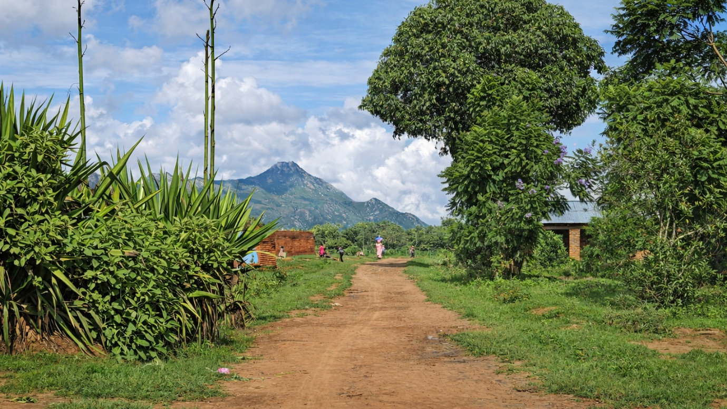

Ministry of Transport and Public Works
Southern Africa Trade and Connectivity Project
Private Bag 322
Lilongwe 3

18 June, 2026

EXECUTIVE SUMMARY
1.0 Project Background
The proposed rehabilitation of the Kanyenda - Mwendayekha Irrigation Scheme (UD) Access Road financed under the Southern Africa Trade and Connectivity Project (SATCP), which is a World Bank project and is being implemented by Ministry of Transport and Public Works. The road plays a critical role in supporting local agricultural production, irrigation scheme–based livelihoods, and the movement of goods and people between settlements, cultivated areas, and nearby service centres. However, the current condition of the road is characterised by poor drainage, erosion-prone sections, low-lying segments, and deteriorated running surfaces, which significantly constrain year-round accessibility—particularly during the rainy season.
To address the environmental and social considerations associated with the proposed rehabilitation works, an Environmental and Social Management Plan (ESMP) has been prepared.
The proposed works for this subproject involve rehabilitation of an existing road within an established road reserve. The scope of works includes drainage improvements, sectional re-gravelling, embankment formation, selected spot improvements, and rehabilitation or construction of drainage structures, all aimed at restoring all-weather access and improving resilience to climatic stresses.
Construction activities are anticipated to be implemented over an estimated period of 3 to 4 months, with peak labour demand during earthworks, drainage construction, and surfacing operations. The workforce will be predominantly locally sourced, providing short-term employment opportunities for skilled and unskilled labour, including women and youth.
2.0 Nature and Scope of the Proposed Project
The proposed project involves the rehabilitation and upgrading of the existing Kanyenda–Mwendayekha Irrigation Scheme Access Road to improve accessibility, safety, and all-weather reliability. Key components of the project include:
- Improvement of the road formation and running surface;
- Construction and rehabilitation of drainage structures, including side drains, mitre drains, culverts, and flood-relief structures;
- Localised realignment and shaping to improve road safety and drainage;
- Rehabilitation of existing structures and installation of road safety features, including signage and traffic calming measures near settlements and areas of high pedestrian activity;
- Sourcing of construction materials such as gravel, laterite, sand, and aggregates from approved sites; and
- Rehabilitation of borrow pits and material sources after use.
3.0 Rationale of the Proposed Project
The proposed road is a critical access route for predominantly rural communities whose livelihoods depend on rain-fed and irrigation-supported agriculture, petty trading, and casual labour. Poor road conditions—especially during the rainy season—currently constrain access to markets, health facilities, schools, and emergency services, and increase transport costs for farmers and traders.
Rehabilitation of the road is therefore essential to:
- Improve year-round connectivity and resilience to seasonal flooding;
- Reduce travel time and vehicle operating costs;
- Strengthen agricultural value chains and irrigation scheme productivity; and
- Enhance access to social services and economic opportunities.
4.0 Justification of the Study
The preparation of this Environmental and Social Management Plan (ESMP) is a statutory requirement under the Environment Management Act (2017) and the MEPA Guidelines for Environmental Assessment (2025). Following review of the Project Brief, the Malawi Environment Protection Authority (MEPA) issued a formal Determination Letter requiring the preparation of an ESMP and provided specific Terms of Reference to guide its development prior to commencement of works.
The project involves rehabilitation of an existing access road and associated drainage improvements within a settled and agriculturally productive area. The anticipated impacts are site-specific, largely temporary, and reversible, and can be effectively managed through an ESMP, without requiring a full Environmental and Social Impact Assessment (ESIA).
In line with national regulatory requirements and World Bank OP/BP 4.01, the ESMP functions as a binding implementation tool to ensure that environmental, social, occupational health and safety, labour, and gender-related risks are systematically identified, mitigated, monitored, and reported throughout the project lifecycle.
5.0 Objectives of the ESMP
The objectives of the ESMP are to:
- Identify potential environmental and social impacts and risks associated with the project;
- Define practical mitigation and enhancement measures for all project phases;
- Ensure compliance with national legislation, MEPA requirements, and World Bank safeguards;
- Protect the health and safety of workers and local communities;
- Establish monitoring, reporting, and corrective action mechanisms; and
- Promote stakeholder engagement, transparency, and accountability.
6.0 Methodology Used to Prepare the ESMP
The ESMP was prepared using a structured approach consistent with MEPA requirements and international good practice. The methodology included:
- Desk review of relevant national policies, legislation, MEPA guidelines, project design documents, and World Bank safeguard requirements;
- Field assessments along the Kanyenda–Mwendayekha Road corridor to document baseline biophysical and socio-economic conditions;
- Stakeholder consultations with District Council officials, traditional leaders, community representatives, and institutional stakeholders;
- Identification and analysis of key environmental and social risks related to drainage sensitivity, material sourcing, road safety, labour, and community health; and
- Development of mitigation, enhancement, and monitoring measures tailored to site-specific conditions.
7.0 Summary of Key Positive Impacts and Enhancement Measures
7.1 Improved Irrigation Access and Agricultural Productivity
The project will significantly improve access to irrigation scheme blocks and enhance hydraulic performance of canal crossings, thereby supporting agricultural productivity and long-term food security within the scheme command area.
Enhancement Measures
• Integrate properly designed irrigation canal crossings into detailed engineering design.
• Validate alignment with irrigation committees and farmers.
• Maintain uninterrupted access to scheme blocks during and after construction.
• Conduct routine drainage and culvert maintenance during operation.
• Coordinate with irrigation management structures to ensure sustainable water flow management.
7.2 Enhanced Market Connectivity and Reduced Travel Time
Improved road conditions and optimized alignment will enhance connectivity between farming areas and trading centres, reducing transport costs and improving market access.
Enhancement Measures
• Optimize alignment to reduce travel distance and improve safety.
• Incorporate safe loading bays where feasible.
• Maintain adequate gravel thickness and undertake periodic grading during operation.
• Facilitate roadside enterprise development in designated safe areas.
• Support improved mobility for traders and transporters.
7.3 Improved Flood Resilience and Drainage Performance
Appropriate culvert sizing and drainage design will reduce overtopping, erosion, and localized flooding, strengthening climate resilience of the access road.
Enhancement Measures
• Apply hydrological modelling for culvert sizing.
• Map flood-prone areas prior to final design.
• Inspect and clear culverts routinely during operation.
• Monitor embankments for erosion or failure.
• Strengthen drainage systems in response to extreme rainfall events.
7.4 Creation of Local Employment and Skills Development
Construction activities will generate short-term employment opportunities and technical skill transfer for local communities.
Enhancement Measures
• Prioritize recruitment of local labour (including women and youth).
• Implement transparent and inclusive recruitment procedures.
• Provide skills training in equipment operation and occupational health and safety.
• Promote fair working conditions and compliance with labour standards.
• Encourage collaboration with local authorities for labour sourcing.
7.5 Local Economic Stimulation and Income Circulation
Procurement of materials and services locally will stimulate small and medium enterprises (SMEs) and support local income circulation.
Enhancement Measures
• Source materials from licensed and compliant local suppliers.
• Support small-scale local enterprises.
• Promote efficient and sustainable material use.
• Ensure timely and fair payment systems.
• Monitor procurement practices to maximize local participation.
8.0 Summary of Key Negative Impacts and Mitigation Measures
8.1 Inadequate Consideration of Irrigation Canal Crossings
Poorly designed crossings may obstruct water flow and restrict access to irrigation plots.
Mitigation Measures
• Conduct detailed canal mapping and hydraulic assessments.
• Adjust alignment to avoid interference where feasible.
• Design reinforced crossings where unavoidable.
• Obtain validation from irrigation committees prior to final design.
8.2 Increased Soil Erosion and Sedimentation
Earthworks may increase erosion risk and sedimentation of irrigation canals and the Mwendayekha River.
Mitigation Measures
• Install silt fences and sediment traps in erosion-prone areas.
• Stabilize exposed slopes through compaction and vegetation.
• Maintain effective stormwater drainage systems.
• Rehabilitate disturbed areas promptly.
8.3 Increased Water Pollution Risks
Fuel spills, improper storage, or equipment washing may contaminate surface water resources.
Mitigation Measures
• Prohibit washing of equipment in rivers.
• Store fuels and lubricants in bunded, impermeable areas.
• Implement and maintain a spill prevention and response plan.
• Conduct soil testing and remediation if contamination occurs.
8.4 Dust, Noise, and Traffic Safety Risks
Construction activities may generate dust, noise, and increased accident risks affecting nearby communities.
Mitigation Measures
• Implement dust suppression through regular watering.
• Restrict noisy works to daytime hours.
• Maintain machinery to reduce emissions and noise.
• Develop and implement a Traffic Management Plan.
• Install signage for speed limit
Construct speed humps very 100 meters
8.5 Occupational Health and Safety Risks
Workers may be exposed to physical hazards during construction.
Mitigation Measures
• Provide and enforce use of appropriate PPE.
• Conduct regular toolbox talks and safety briefings.
• Establish functional first aid facilities.
• Monitor and record incidents and corrective actions.
8.6 GBV/SEA/SH and Social Risks
Labour influx and worker-community interactions may increase risks of misconduct and social tension.
Mitigation Measures
• Enforce a signed Code of Conduct.
• Conduct mandatory GBV/SEA/SH awareness training.
• Establish confidential and accessible reporting channels.
• Strengthen community engagement and grievance mechanisms.
8.7 Climate Vulnerability and Operational Safety Risks
Extreme rainfall events and increased traffic volumes may affect road integrity and safety.
Mitigation Measures
• Monitor embankments and drainage structures regularly.
• Strengthen drainage systems where weaknesses are identified.
• Maintain road signage and conduct safety awareness campaigns.
• Implement routine road maintenance and grading.
9.0 Conclusion and Recommendations
9.1 Conclusion
The rehabilitation of the Kanyenda–Mwendayekha Irrigation Scheme Access Road will deliver significant socio-economic and agricultural benefits, including improved irrigation access, enhanced market connectivity, employment generation, and strengthened flood resilience. While the project presents identifiable environmental and social risks, these impacts are site-specific and manageable through implementation of the ESMP.
All identified impacts—both positive and negative—are addressed through clearly articulated enhancement and mitigation measures supported by defined institutional responsibilities and monitoring mechanisms. With effective implementation, supervision, and regulatory oversight, the project is considered environmentally and socially acceptable.
9.2 Recommendations
To ensure full compliance with MEPA requirements and effective ESMP implementation, the following actions are recommended:
- Allocate adequate financial, technical, and human resources for ESMP implementation and monitoring.
- Integrate all mitigation and enhancement measures into contractual obligations for the Contractor and Supervising Engineer.
- Require submission and approval of site-specific management plans prior to mobilization.
- Establish functional Grievance Redress Mechanisms (GRMs) at community and worker levels.
- Ensure all statutory approvals are obtained prior to commencement of works.
- Deploy qualified Environmental and Social personnel for supervision and monitoring.
- Strengthen coordination between MoTPW (SATCP PIU), Dedza District Council, irrigation management structures, and MEPA to ensure effective oversight and adaptive management.

ACRONYMS AND ABBREVIATIONS

AIDS | Acquired Immune Deficiency Syndrome
DED | Detailed Engineering Design
DESC | District Environment Sub-Committee
EHS | Environmental, Health and Safety
EMA | Environment Management Act
ESF | Environmental and Social Framework (World Bank)
ESHS | Environmental, Social, Health and Safety
ESIA | Environmental and Social Impact Assessment
ESMMP | Environmental and Social Mitigation and Monitoring Plan
ESMP | Environmental and Social Management Plan
FGD | Focus Group Discussion
GBV | Gender-Based Violence
GIIP | Good International Industry Practice
GRM | Grievance Redress Mechanism
HIV | Human Immunodeficiency Virus
IEC | Information, Education and Communication
IUCN | International Union for Conservation of Nature
LC | Local Council
LMI | Last Mile Infrastructure
MEPA | Malawi Environment Protection Authority
OHS | Occupational Health and Safety
OP/BP | Operational Policy / Bank Procedure (World Bank)
PPE | Personal Protective Equipment
RHS | Right-Hand Side
SATCP | Southern Africa Trade and Connectivity Project
SEA | Sexual Exploitation and Abuse
SEA/SH | Sexual Exploitation and Abuse / Sexual Harassment
SEP | Stakeholder Engagement Plan
SH | Sexual Harassment
STA | Sub-Traditional Authority
WMP | Waste Management Plan

TABLE OF CONTENTS

EXECUTIVE SUMMARY i
1 CHAPTER 1: INTRODUCTION AND BACKGROUND 1
1.1 Introduction 1
1.2 Developer Details 1
1.3 Nature and Scope of the Project 1
1.4 Project Objectives 2
1.5 Justification of the Project 3
1.6 Objectives of the ESMP 3
1.7 Rationale of the ESMP 4
1.8 Methodology 4
1.9 Project Location 6
1.10 Land Tenure and Land Requirement for the Project 12
1.11 Potential Users of the ESMP 12
2 CHAPTER 2: PROJECT DESCRIPTION 14
2.1 Introduction 14
2.2 Project Components and Activities 14
2.3 Summary of Engineering Works 14
2.4 Project Phases 15
2.5 Labour Requirements 15
2.6 Material Requirements and Sources 16
2.7 Worker Accommodation 17
2.8 Waste and Waste Management 18
2.9 Rehabilitation of Temporary Sites 19
3 CHAPTER 3: POLICY AND LEGAL FRAMEWORK 20
3.1 Introduction 20
3.2 National Policies and Strategies 20
3.2.1 Policy Framework 20
3.2.2 Legislative Framework 22
3.3 World Bank Safeguard Policies and Procedures 24
3.3.1 World Bank Operational Policy OP/BP 4.01: Environmental Assessment 24
3.3.2 EHS, SEAH and Other World Bank Safeguards 25
3.4 Institutional Framework 26
3.5 Summary of Main Statutory Approvals/Licenses to be obtained for the project 27
4 CHAPTER 4: ENVIRONMENTAL AND SOCIAL SETTING 29
4.1 Introduction 29
4.2 Biophysical Environment 29
4.2.1 Topography 29
4.2.2 Geology 31
4.2.3 Soils 33
4.2.4 Climate and Climate Change Risks 35
4.2.5 Water Resources 37
4.2.6 Flora 40
4.2.7 Fauna (Animal Life) 42
4.2.8 Human–Fauna Interaction 43
4.2.9 Sanitation and Waste Management 43
4.2.10 Implications for the Project 43
4.3 Socio-economic Environment 43
4.3.1 Population and Demographic Structure 44
4.3.2 Education and Literacy 44
4.4 Overall Implications of the baseline conditions on the Project 45
5 CHAPTER 5: ENVIRONMENTAL AND SOCIAL MANAGEMENT PLAN 47
5.1 Introduction 47
5.2 Environmental and Social Mitigation and Monitoring Plan for Kanyenda Mwendayekha Road 49
5.3 Institutional Arrangements and Implementation Capacity 53
REFERENCES 54
ANNEXES 56
Annex 1. Feedback Letter from MEPA 56
Annex 2. Terms of Reference from MEPA 57
Annex 3a. List of Stakeholders Consulted 59
Annex 3b. Issues raised by stakeholders and how they have been addressed in the ESMP 62
Annex 4. Sample Code of Conduct for Contractors 68
Annex 5. Barrow Pit Rehabilitation Framework 72
Annex 6. Traffic Management Framework 76
Annex 7. Chance Find Procedure for Last Mile Infrastructure under SATCP 80
Annex 8: Labour Management Guidelines for Contractor Compliance and Preparation of Labour Management Plans (LMPs) 82
Annex 9. Contractor Environmental and Social Management Plan (C-ESMP) Framework 86
Annex 10. Waste Management Framework 89
Annex 11. Stakeholder Engagement Framework 93
Annex 12. Details of the Consultants (Names, Qualification and Roles of Team Members) 98
Annex 13. SATCP LMI Grievance Redress Mechanism (GRM) Protocol 99
Annex 14. Project Design Drawings 106

LIST OF FIGURES

Figure 1-1. Consultation Kanyenda - Community representatives 6
Figure 1-2. Location of Kanyenda-Mwendayekha Irrigation Scheme Access Road 7
Figure 1-3. Arial view of the Kanyenda – Mwendayekha Irrigation Scheme Access Road 8
Figure 1-4. Detailed view of Chainage 0+000 at Kanyenda 9
Figure 1-5. Detailed view of the graveyard section of the road (approx. Chainage 0+700 -1000 m) 10
Figure 1-6. Detailed view of the Mwendayekha Irrigation Scheme/Mwendayekha River section 11
Figure 4-1. Topographic Map of the Kanyenda - Mwendayekha Irrigation Scheme Access Road corridor 30
Figure 4-2. Geological Map of the Kanyenda - Mwendayekha Irrigation Scheme Access Road 32
Figure 4-3. Soil distribution map of the area 34
Figure 4-4. Soils along the road corridor 35
Figure 4-5. Mean monthly rainfall pattern for Kanyenda – Mwendayekha Road Corridor (1981–2024) 36
Figure 4-6. Mean monthly temperature pattern for Kanyenda – Mwendayekha Road Corridor 36
Figure 4-9. Hydrological map of the area 38
Figure 4-8. Livestock grazing at the end of the 3 km road section (Mwendayehka River) 40
Figure 4-9. Agricultural dominance (maize cultivation) adjacent to the graveyard section of the road 40

LIST OF TABLES

Table 1-1. Potential Users of the ESMP and Their Roles 12
Table 2-1. Project Implementation Phases 15
Table 2-2. Expected Number of People to be Employed (Peak Workforce) 16
Table 2-3. Material Requirements, Estimated Quantities, and Potential Sources 17
Table 2-4. Expected Waste Streams and Management Measures 18
Table 3-1. Policies Guiding the Project\ 20
Table 3-2: Legislation Guiding the Project 22
Table 3-3. World Bank Environmental and Social Operational Policies Triggered by the Project 25
Table 3-4. Other World Bank and International Safeguards Applicable to the Project 25
Table 3-5. Key Safeguard Institutions and their Mandates 26
Table 3-6.. Summary of Statutory Approvals and Licences Required 28
Table 4-1. Baseline Surface Water Quality of the Mwendayekha River (Rainy Season – January 2026) 39
Table 4-2. Sample of Plant Species Recorded in the Project Area 41
Table 4-3. Consolidated Fauna Species Recorded in the Project Area 42
Table 6-1. Institutional Responsibilities for ESMP Implementation and Oversight 53

List of Annexes
Figure 1-1 Consultation with Balaka DESC 4
Figure 1-2: Location of the proposed Balaka – Mbela – Kachenga Road (S133/381) Road 6
Figure 1-3 : Location of the proposed road in Balaka 7
Figure 1-4: Balaka section of the road 8
Figure 1-5: Toleza Farm section of the road 9
Figure 1-6: Mbela Trading Centre, on the far end of the road 10
Figure 4-1: Geological Map of the Kachenga - Mbela Road section 31
Figure 4-2: Soils of the proposed project area 33
Figure 4-3: Soils within the wetland section and Dark sandy-loam soils within the Toleza Farm Section 34
Figure 4-4: Average Monthly Temperature Pattern (1951–2022) for the Balaka–Mbela–Kachenga Road Section 34
Figure 4-5: Monthly Rainfall Distribution for Balaka District 35
Figure 4-6: Average Monthly Sunshine Duration for Balaka District 35
Figure 4-7: Hydrological map of the area 38
Figure 4-8: Pictorial view of Senna siamea species observed in Balaka- Mbela proposed road project area. 39
Figure 4-9Grasses are a major vegetative composition of the road section 40
Figure 4-10: Flora Species Sampled from the Balaka- Mbela Project Area and their Conservation Status 41
Figure 4-11: Protected species; Pericopsis angolensis in Balaka- Mbela proposed road project area 43
Figure 4-12: Lantana camara an inasive species grown as ornamental at Tepu Trading Centre 43
Figure 4-13: Pictorial view of the vegetation community in Toleza farm 44
Figure 4-14: Mammal Species Recorded in the Balaka–Mbela Road Project Area and Their Conservation Status 45
Figure 4-15: Bird Species Recorded in the Balaka–Mbela Road Project Area and Their Conservation Status 45
Figure 4-17: Reptile Species Recorded in the Balaka–Mbela Road Project Area and Their Conservation Status 46
Figure 4-18: Amphibian Species Recorded in the Balaka–Mbela Road Project Area and Their Conservation Status 46
Figure 4-19: Macro-Invertebrate Species Recorded in the Balaka–Mbela Road Project Area and Their Conservation Status 46
Figure 4-20: Elegant grasshopper (Zonocerus elegans) Recorded within the Project Area 47
Figure 4-21: Mbela Trading Centre 48
Figure 4-22: A clinic towards the Balaka Town approach 51
Figure 4-23: Mixed farming along the corridor 52
Figure 4-24: Lime factory operations along the corridor road 53
Figure 4-25: A pick-up transporting passenger along the proposed route 54
Figure 4-27: Cyclists transporting charcoal to the market along the corridor 56

List of annexes

Annex 1. Feedback Letter from MEPA

Annex 2. Terms of Reference from MEPA

Annex 3a. List of Stakeholders Consulted

Annex 3b. Issues raised by Stakeholders and how they have been addressed in ESMP

Annex 4. Sample Code of Conduct for Contractors

Annex 5. Barrow Pit Rehabilitation Framework

Annex 6. Traffic Management Framework

Annex 7. Chance Find Procedure for Last Mile Infrastructure under SATCP

Annex 8: Labour Management Guidelines for Contractor Compliance and Preparation of Labour Management Plans (LMPs)

Annex 13. Flora and Animal Species of Kanyenda-Mwendayekha Corridor

Annex 14-B. Animal Species

Annex 14. SATCP LMI Grievance Redress Mechanism (GRM) Protocol

Annex 15. Spatial distribution of Works

Annex 16. Project Drawings

CHAPTER 1: INTRODUCTION AND BACKGROUND

Introduction
This Environmental and Social Management Plan (ESMP) has been prepared for the Proposed Rehabilitation of Kanyenda - Mwendayekha Irrigation Scheme Road in Dedza District, Malawi. The proposed works involve the rehabilitation of an existing road corridor and associated drainage infrastructure, including drainage improvements, culvert rehabilitation and construction, embankment formation, and selected spot improvements.
This ESMP has been prepared in accordance with the Environment Management Act (2017), the Malawi Environment Protection Authority (MEPA) Guidelines for Environmental Assessment (2025), and the World Bank Operational Policy OsP/BP 4.01 on Environmental Assessment, under which the project is classified as a Category B / List B activity. The purpose of the ESMP is to ensure that potential adverse environmental and social impacts associated with the rehabilitation works are avoided where feasible, minimised, mitigated, and managed in a manner that is technically sound, socially acceptable, and environmentally sustainable, while enhancing the project’s positive impacts.

Developer Details
Name of Developer: | Ministry of Transport and Public Works
Physical Address: | The Project Manager  Southern Africa Trade and Connectivity Project  Private Bag 322  Lilongwe 3
Contact Person: | The Project Manager  Southern Africa Trade and Connectivity Project  Ministry of Transport and Public Works  Private Bag 322  Lilongwe 3.  Cell: 0999088044  Email: hastingsngoma@gmail.com

Nature and Scope of the Project
The proposed project involves rehabilitation of the existing Kanyenda–Mwendayekha Irrigation Scheme Access Road in Dedza District through targeted engineering interventions along approximately 3 km of the existing road alignment. The works are designed to restore road functionality, improve drainage performance, and enhance resilience to seasonal flooding and erosion while maintaining the existing road footprint and reserve.
The rehabilitation works will focus on spot improvements and localized structural interventions to address sections affected by poor drainage, erosion, and waterlogging. No major realignment or widening of the road is proposed.
The key activities under the project include:
- Drainage improvement works, including cleaning, reshaping, and rehabilitation of roadside drains, construction of earth drains, and installation of mitre drains to safely discharge runoff from the road surface.
- Culvert rehabilitation and installation, including repair of existing culverts, reconstruction of damaged headwalls, and construction of new culverts where required to improve cross-drainage capacity.
- Construction of concrete drifts and drainage protection works at selected crossing points to improve water flow management and reduce erosion.
- Embankment formation and stabilization in low-lying and erosion-prone sections to improve road profile and reduce overtopping during heavy rainfall.
- Reshaping and regrading of the road surface, including reinstatement of shoulders and treatment of side slopes to improve surface drainage, riding quality, and road safety.
- Localized spot improvements, including road stabilization in severely degraded sections identified during the Detailed Engineering Design.
Ancillary activities will include temporary traffic management, protection of adjacent properties and access points, sourcing of construction materials, waste management, and rehabilitation of temporary work areas and borrow pits after construction.
All works will be implemented within the existing road reserve, and the project is not expected to require permanent land acquisition or physical displacement of households. The interventions are linear and site-specific, distributed along the road corridor at locations identified in the Detailed Engineering Design.

Project Objectives
The overall objective of the project is to rehabilitate the Kanyenda–Mwendayekha Irrigation Scheme Access Road in Dedza District in order to improve reliable all-season access for surrounding communities and enhance connectivity between agricultural production areas, irrigation schemes, and local markets.
The specific objectives of the project are to:
- Restore road functionality along approximately 3 km of the existing Kanyenda–Mwendayekha access road through targeted rehabilitation works.
- Improve road drainage and flood resilience through installation and rehabilitation of culverts, concrete drifts, and drainage structures.
- Enhance accessibility to the Mwendayekha Irrigation Scheme and surrounding communities, enabling reliable transport of agricultural produce and farm inputs.
- Improve access to essential social and economic services, including markets, schools, and health facilities.
- Reduce travel time, vehicle operating costs, and seasonal transport disruptions currently experienced during the rainy season.
- Support local economic activities and agricultural value chains through improved rural transport connectivity.

Justification of the Project
The rehabilitation of the Kanyenda–Mwendayekha Irrigation Scheme Access Road in Kanyama EPA, Dedza District is justified by the need to improve transport connectivity for farming communities served by the Mwendayekha Irrigation Scheme and surrounding agricultural areas.
Agriculture is the primary livelihood in the project area, with farmers producing maize, beans, and other crops that supply local markets and trading centres. However, the poor condition of the existing road, particularly during the rainy season, limits reliable transportation of agricultural inputs and produce, increasing transport costs and contributing to post-harvest losses.
Rehabilitation of approximately 3 km of the access road, including installation of culverts, construction of concrete drifts, and localized stabilization works, will improve year-round accessibility to the irrigation scheme and surrounding communities. This will facilitate movement of farm inputs and agricultural produce, strengthen local agricultural value chains, and improve market access for smallholder farmers.

Objectives of the ESMP
The purpose of this Environmental and Social Management Plan (ESMP) is to ensure that potential environmental and social impacts associated with the rehabilitation of the Kanyenda–Mwendayekha Irrigation Scheme Access Road are effectively identified, mitigated, and monitored throughout the project lifecycle.
The specific objectives of the ESMP are to:
- Identify and assess potential environmental and social impacts associated with the planning, construction, demobilization, and operational phases of the project.
- Propose practical mitigation measures to avoid, minimize, or manage adverse environmental and social impacts arising from project activities.
- Enhance positive impacts associated with improved road access and local economic opportunities.
- Establish environmental and social monitoring measures to ensure effective implementation of mitigation actions during project implementation.
- Define institutional roles and responsibilities for environmental and social management during the project lifecycle.
- Ensure compliance with the Environmental Management Act (2017), MEPA requirements, and World Bank Operational Policies applicable to this project. This ESMP has been prepared in accordance with the Terms of Reference issued by the Malawi Environment Protection Authority (MEPA) following review of the project brief (see Annex 2) and the World Bank Operational Policies.

Rationale of the ESMP
Preparation of this Environmental and Social Management Plan (ESMP) is necessary to ensure that potential environmental and social impacts associated with the rehabilitation of the Kanyenda–Mwendayekha Irrigation Scheme Access Road are identified, mitigated, and monitored during project implementation and operation stages.
In addition, the project forms part of the Southern Africa Trade and Connectivity Project (SATCP) financed by the World Bank, and therefore requires alignment with the Bank’s environmental safeguard provisions, particularly Operational Policy OP/BP 4.01 on Environmental Assessment, which requires that potential environmental and social risks of infrastructure projects be assessed and managed through appropriate safeguard instruments.

Methodology
Preparation of this Environmental and Social Management Plan (ESMP) followed a combination of literature review, field investigations, stakeholder consultations, water quality assessment, and spatial analysis to establish baseline environmental and social conditions and identify potential impacts associated with the rehabilitation of the Kanyenda–Mwendayekha Irrigation Scheme Access Road.
Relevant project documentation and regulatory frameworks were reviewed to guide the assessment. Key documents included the Detailed Engineering Design (DED) for the access road, national environmental legislation, and applicable sector policies, as well as environmental safeguard requirements under the World Bank Operational Policy OP/BP 4.01 on Environmental Assessment. The Terms of Reference issued by the Malawi Environment Protection Authority (MEPA) (Annex 2) guided the scope and structure of the ESMP.
A field visit to the project area was conducted on 22 January 2026 to verify environmental and social baseline conditions along the approximately 3 km road corridor. The field assessment focused on identifying key environmental features and potential receptors along the road alignment. Observations covered:
- existing road condition and drainage structures;
- surrounding agricultural land use and irrigation activities;
- nearby settlements and community infrastructure;
- river crossings and surface water features, particularly the Mwendayekha River at the end of the working section; and
- areas vulnerable to erosion or seasonal flooding.
These observations informed the identification of potential environmental and social impacts associated with the proposed rehabilitation works.
A baseline water quality assessment of the Mwendayekha River was undertaken to understand existing water conditions prior to implementation of the road rehabilitation works. Water samples were collected from three sampling locations along the river:
- Upstream sampling point – approximately 500 m upstream of the road crossing;
- Crossing point – at the road–river crossing location; and
- Downstream sampling point – approximately 500 m downstream of the crossing.
The sampling approach was designed to assess potential differences in water quality above and below the crossing area. Laboratory analysis of the collected samples was conducted at the Chancellor College Chemistry Laboratory, and the detailed results are presented in Annex 6.
Stakeholder consultations were undertaken to gather local knowledge and perspectives on environmental and social conditions in the project area. These consultations were conducted during the field visit on 22 January 2026 and included discussions with the District Environment Sub-Committee (DESC) and community representatives within the project area (Attendance list in Annex 3). The consultations provided information on local livelihoods, agricultural activities, road usage patterns, seasonal access challenges, and community expectations regarding the proposed rehabilitation works.
Geographic Information System (GIS) and remote sensing techniques were used to support spatial analysis and preparation of maps for the project area. Satellite imagery and spatial datasets were analysed to identify key environmental features, including:
- the road alignment and surrounding land uses;
- settlement patterns and agricultural areas;
- drainage systems and river crossings; and
- other environmentally sensitive features.
The spatial analysis informed mapping of the project location and environmental setting, which is presented in the relevant sections of this report.
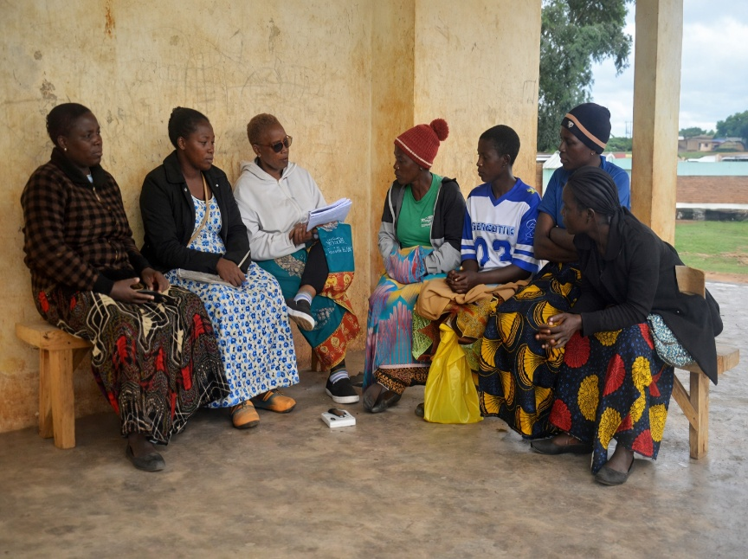
Figure 1-1. Consultation Kanyenda - Community representatives

Project Location
The Kanyenda–Mwendayekha Irrigation Scheme Access Road is located in Dedza District in the Central Region of Malawi and forms part of the undesignated feeder road network under the Southern Africa Trade and Connectivity Project (SATCP) – Last Mile Infrastructure (LMI) component.
The road project has an approximate length of 3 km, extending from Kanyenda towards the Mwendayekha irrigation area. Based on surveyed spatial data, the road alignment starts at:
Start Point (Kanyenda)
642,881.16 mE; 8,424,512.81 mN
and ends at:
End Point (Mwendayekha Area)
645,157.59 mE; 8,425,339.22 mN
(Coordinates referenced in the UTM coordinate system, meters).
The road traverses a predominantly rural agricultural landscape characterised by irrigated and rain-fed farming, dispersed settlements, and local access tracks associated with the irrigation scheme. The spatial context of the project, including the road alignment and surrounding features, is presented in the Location Map, Aerial View, and Chainage Maps (Figures 1-2 to 1-6) in this report.
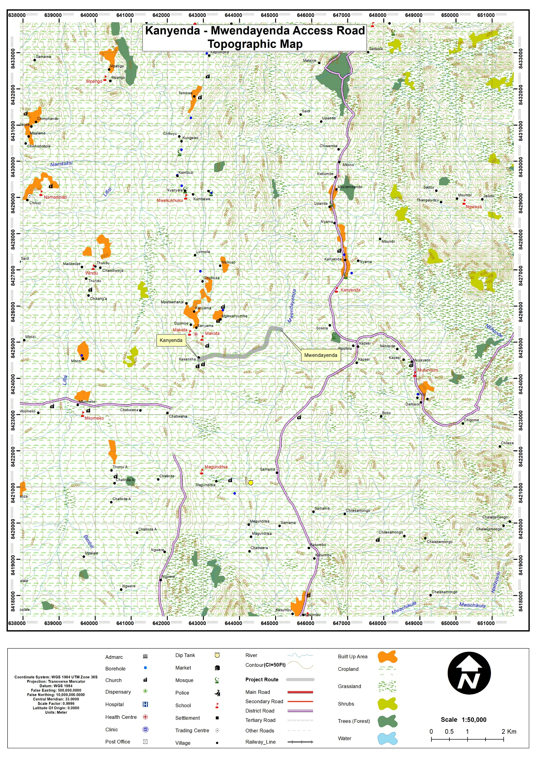
Figure 1-2. Location of Kanyenda-Mwendayekha Irrigation Scheme Access Road

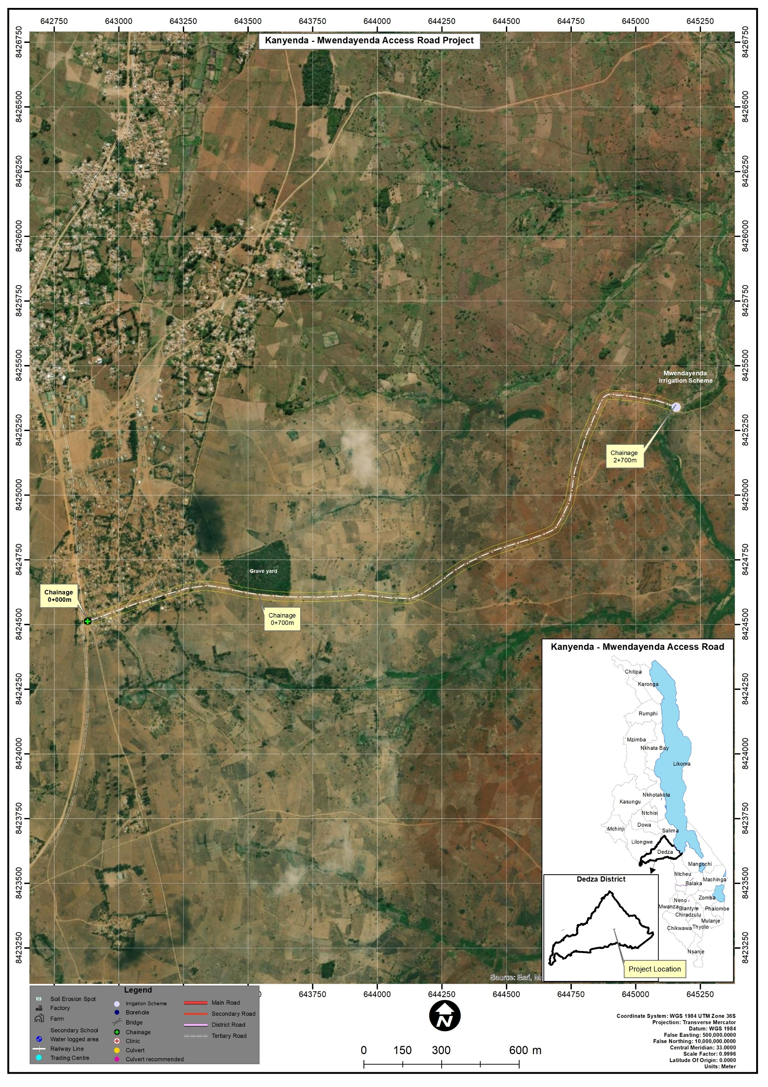
Figure 1-3. Arial view of the Kanyenda – Mwendayekha Irrigation Scheme Access Road
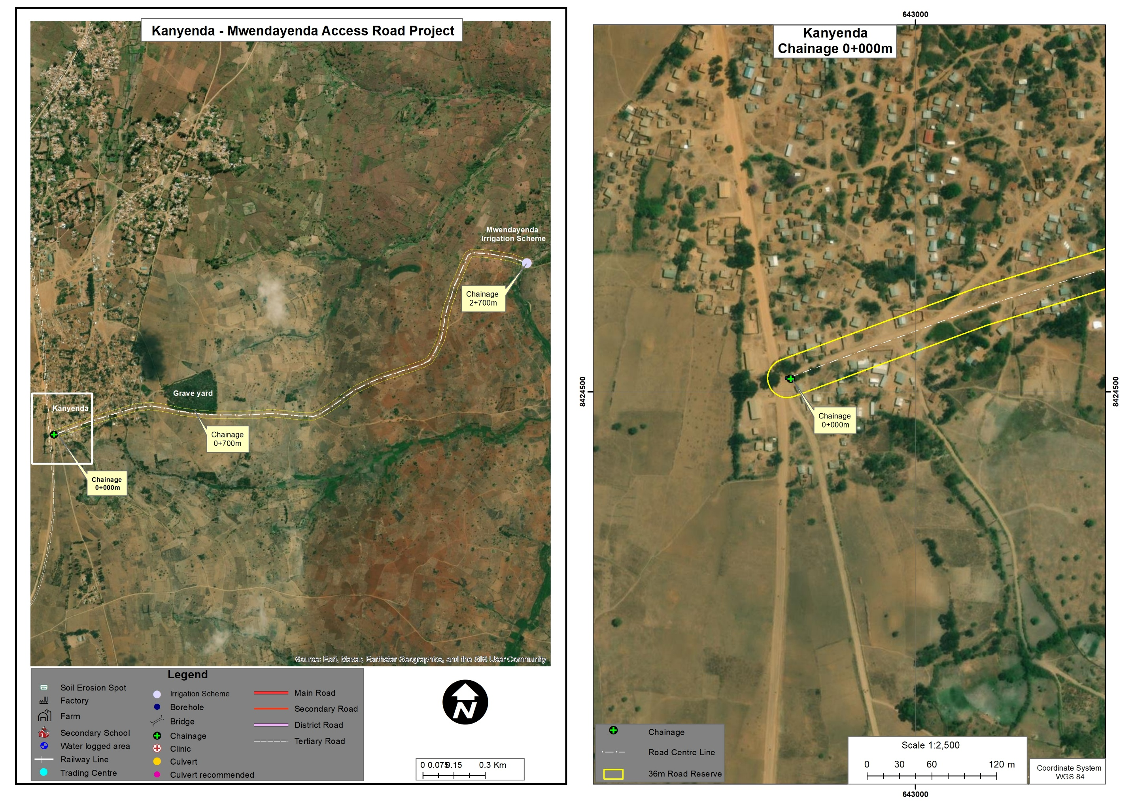
Figure 1-4. Detailed view of Chainage 0+000 at Kanyenda

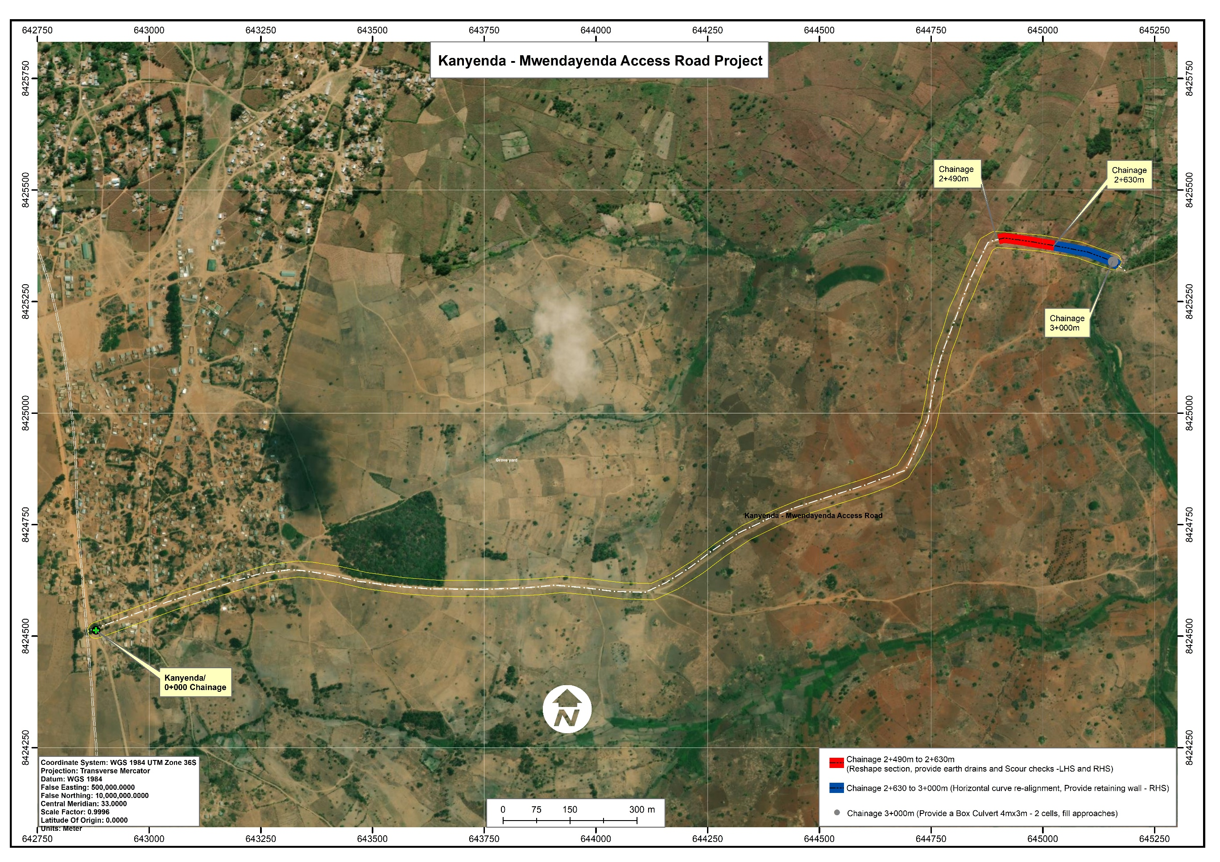
Figure 1-5. Detailed view of the graveyard section of the road (approx. Chainage 0+700 -1000 m)

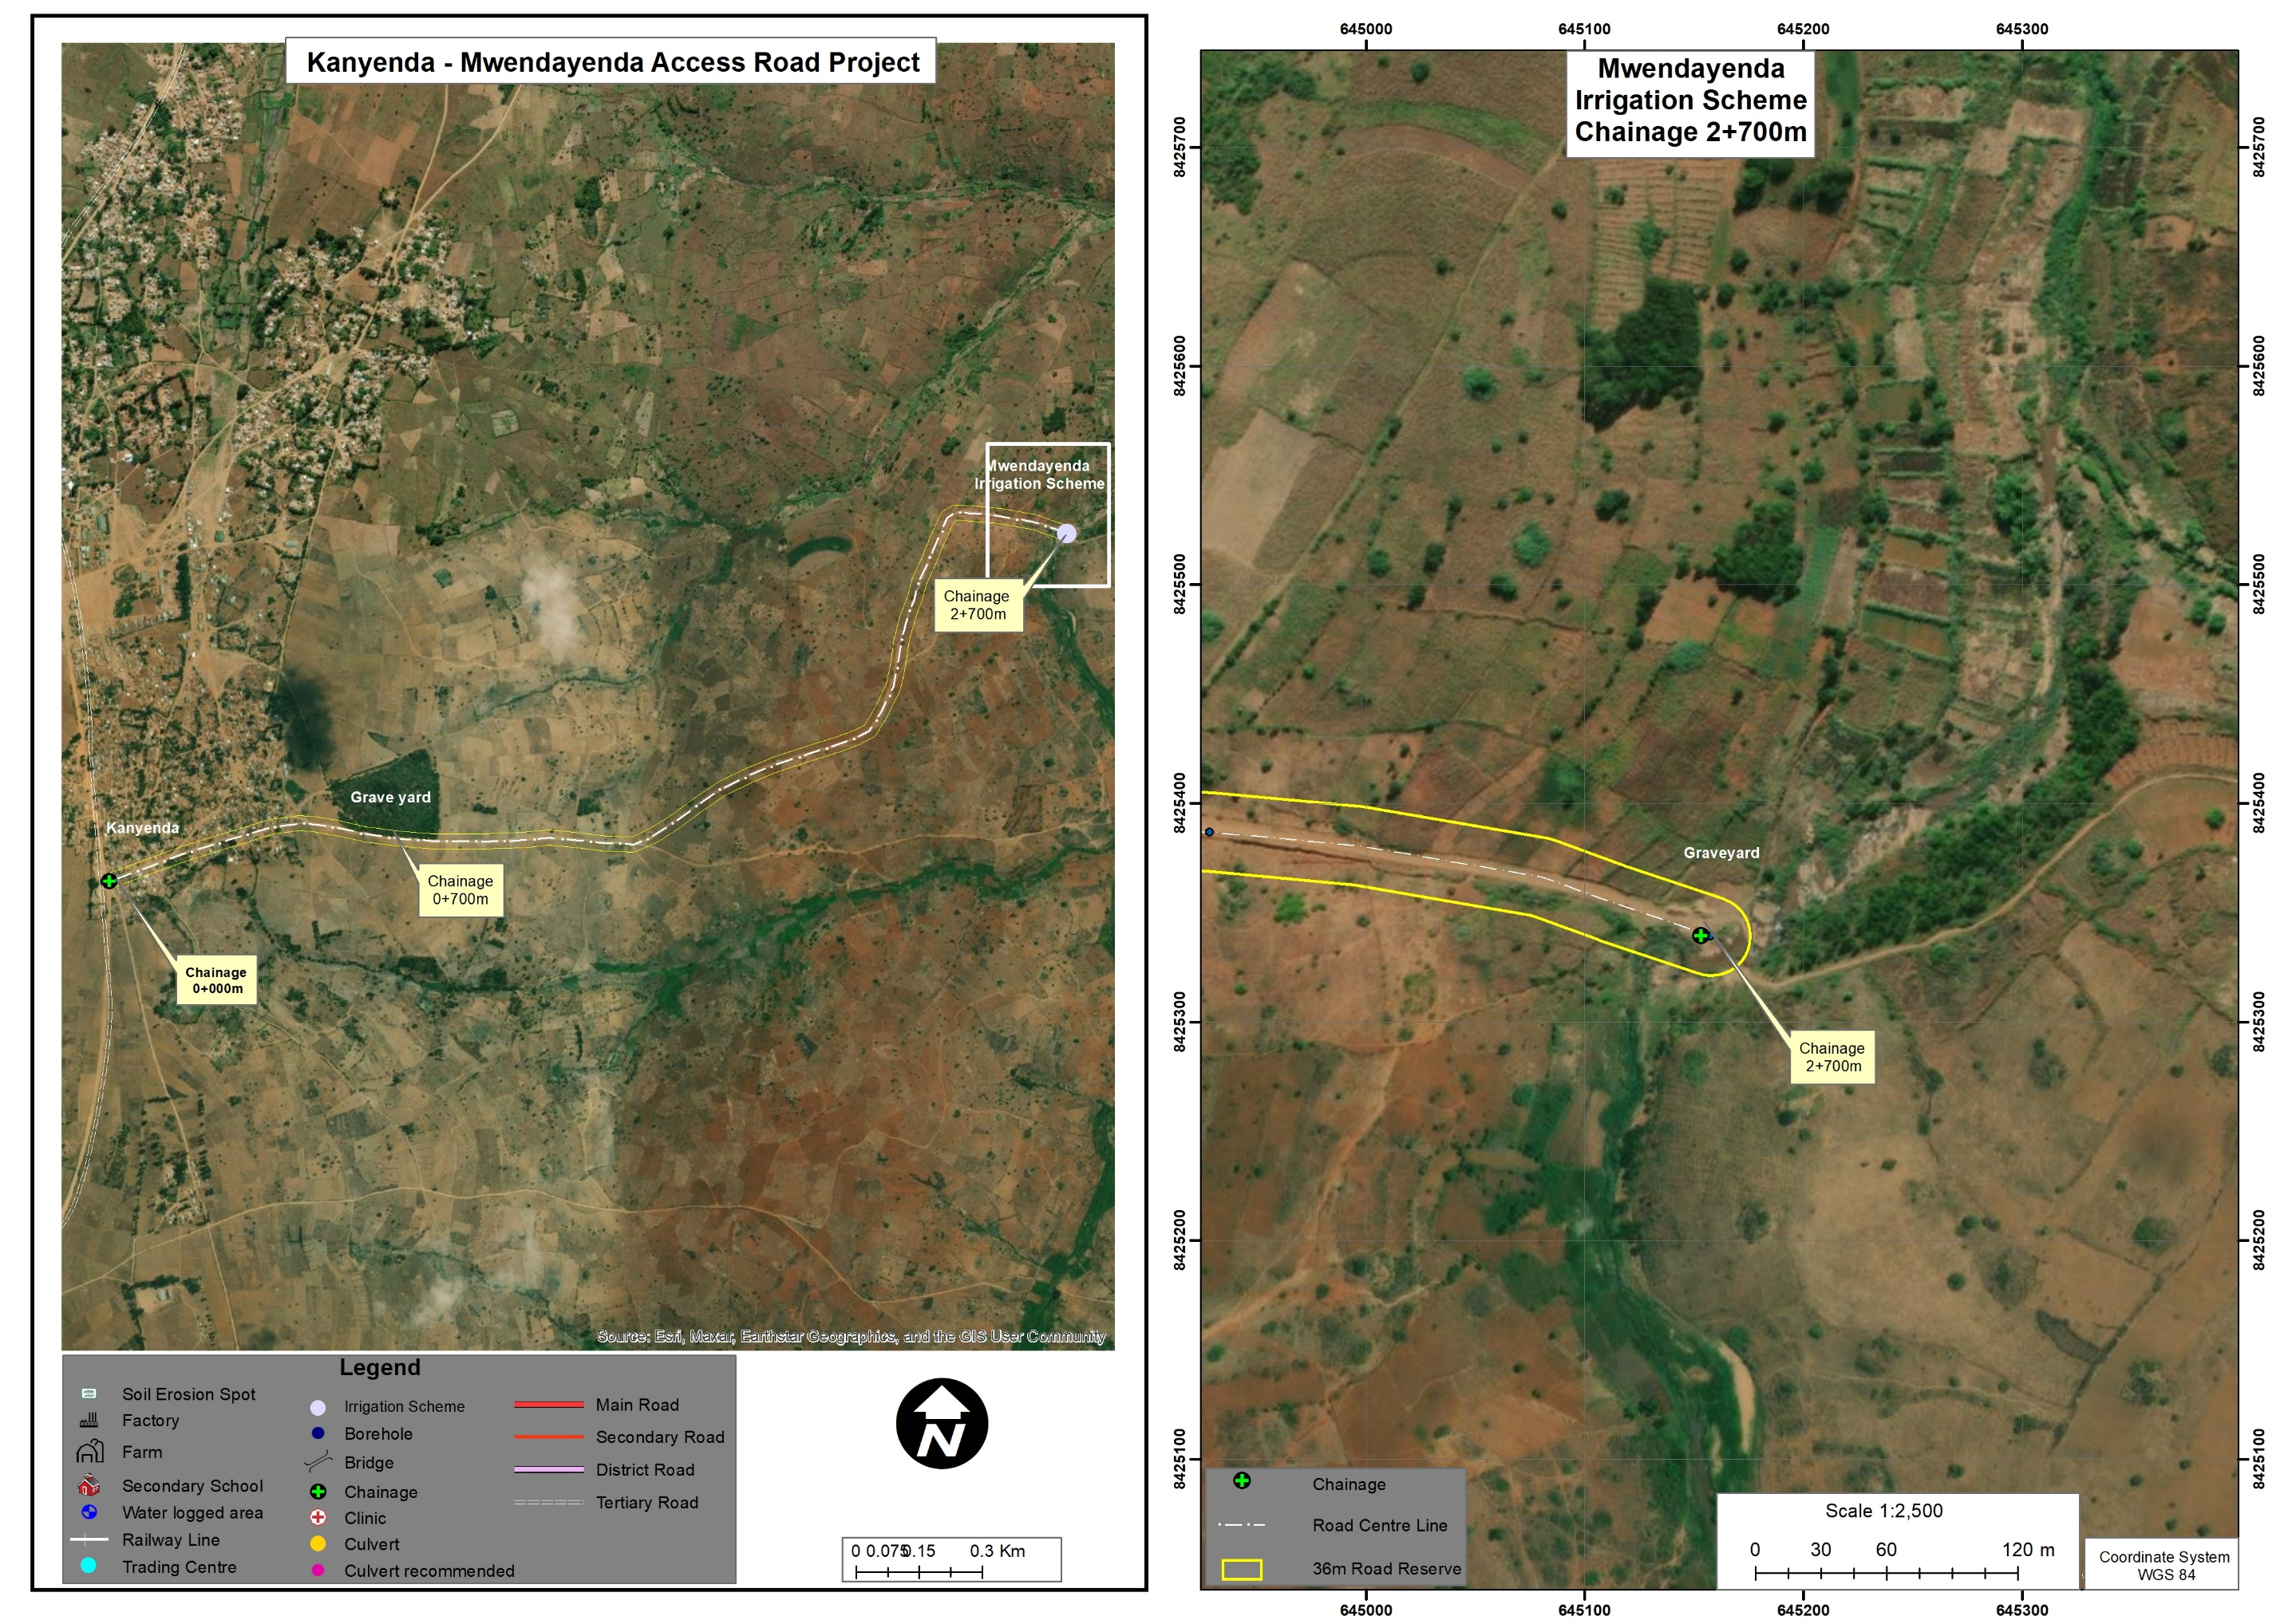
Figure 1-6. Detailed view of the Mwendayekha Irrigation Scheme/Mwendayekha River section

Land Tenure and Land Requirement for the Project
Land along the Kanyenda–Mwendayekha access road is predominantly held under customary land tenure, which is the prevailing land administration system in rural areas of Dedza District. The land is traditionally managed under the authority of local traditional leadership, with individual households cultivating plots for rain-fed and irrigated agriculture associated with the Mwendayekha Irrigation Scheme.
Sensitive receptors identified near the road corridor include a graveyard located adjacent to the road reserve shortly after Kanyenda village, and residential structures situated at the edge of the road reserve within the first 500 m from chainage 0+000. These features lie outside the zone of active construction works (chainage 2+490 to 3+000) and will not be affected by project activities.
The proposed rehabilitation works will be implemented entirely within the existing road reserve and alignment. No acquisition of additional land is required. The scope of works comprises road reshaping, installation of drainage infrastructure (earth drains and scour checks), horizontal curve realignment with slope stabilization (retaining wall), and construction of a box culvert with approach fills, all concentrated between chainage 2+490 and 3+000. Where informal temporary structures such as vending booths or groceries placed by their occupants occur within the road reserve along the alignment, the corresponding sections have been deliberately excluded from the spot-based rehabilitation scheme during design, so that construction works avoid them altogether; any residual coordination needs around the immediate working area will be handled under the stakeholder engagement and GRM provisions of this ESMP.

Potential Users of the ESMP
This Environmental and Social Management Plan (ESMP) provides guidance for managing environmental and social risks associated with the rehabilitation of the Kanyenda–Mwendayekha Irrigation Scheme Access Road. The document serves as a practical tool for institutions responsible for project implementation, supervision, compliance monitoring, and stakeholder engagement throughout the project lifecycle.
Table 1-1 outlines the key institutions and stakeholders expected to use this ESMP and their respective roles in environmental and social management.
Table 1-1. Potential Users of the ESMP and Their Roles
Potential User | Potential Usage of the ESMP
Malawi Environment Protection Authority (MEPA) | Regulatory review, environmental compliance monitoring, and verification that project implementation aligns with the Environmental Management Act (2017) and MEPA requirements.
Ministry of Transport and Public Works (MoTPW) and PIU | Project owner and implementing authority responsible for overall coordination of the road rehabilitation works and ensuring that environmental and social safeguards are integrated into project implementation under the SATCP Last Mile Infrastructure component.
Dedza District Council (including DESC) | Local-level monitoring and coordination of environmental and social management measures, as well as facilitation of engagement with local communities.
Ministry of Labour and National Construction Industry Council (NCIC) | Oversight of labour standards, occupational health and safety compliance, and contractor adherence to national labour regulations.
Project Engineers and Supervising Consultants | Integration of environmental and social requirements into construction supervision, site inspections, and monitoring of mitigation measures during project implementation.
Contractors and Subcontractors | Implementation of ESMP mitigation measures, occupational health and safety provisions, labour management procedures, community health and safety measures, and GBV/SEA/SH prevention requirements during construction.
Local Communities and Road-Corridor Users | Awareness of project activities, potential impacts, mitigation measures, employment opportunities, and access to the project Grievance Redress Mechanism (GRM).
World Bank and Other Oversight Institutions | Safeguards due diligence, implementation supervision, and monitoring of compliance with applicable environmental and social safeguard policies.

CHAPTER 2: PROJECT DESCRIPTION

Introduction
This chapter describes the scope and principal activities for the rehabilitation of the Kanyenda–Mwendayekha Irrigation Scheme Access Road in Dedza District under the Southern Africa Trade and Connectivity Project (SATCP) – Last Mile Infrastructure component, implemented by the Ministry of Transport and Public Works (MoTPW). The subproject involves spot rehabilitation of an existing approximately 3 km feeder road to restore all-weather functionality, improve drainage performance, stabilise erosion-prone sections, and improve safe access for surrounding communities and agricultural users. Works will be undertaken within the existing road alignment and road reserve in accordance with the Detailed Engineering Design (Annex 14)

Overall Scope of Rehabilitation
The proposed works comprise targeted rehabilitation measures focused on sections affected by drainage failure, localised erosion, geometric deficiencies, and road surface deterioration. The interventions include road reshaping, provision of drainage structures, curve realignment, slope stabilisation, and installation of a new drainage crossing structure at the road terminus.

Chainage-Specific Engineering Works
Table 2.1 presents the chainage-specific scope of works for the Kanyenda–Mwendayekha Road.
Table 2-1. Chainage Works Details for Kanyenda–Mwendayekha Road
From chainage | To chainage | Description of works
0+000 | 2+490 | Existing road section from Kanyenda; no major rehabilitation works proposed under this package
2+490 | 2+630 | Reshape road section; provide earth drains and scour checks on the left-hand side (LHS) and right-hand side (RHS)
2+630 | 3+000 | Horizontal curve realignment; construct retaining wall on the RHS
3+000 | 3+000 | Construct 4 m × 3 m double-cell box culvert and fill approaches
3+000 | End | End of project road section

Key Engineering Focus Areas
The DED indicates that the principal rehabilitation works are concentrated between chainage 2+490 and 3+000, covering approximately 510 m of the road corridor. Within this section, the works focus on restoring the road profile, improving surface water management through side drains and scour checks, stabilising vulnerable slopes using a retaining wall, and providing a permanent drainage crossing at the road terminus via a new double‑cell box culvert. This chainage‑based presentation provides a clear linkage between specific project activities, their locations, and the environmental and social risks and impacts that are assessed and managed in subsequent chapters of this ESMMP.

Project Phases
The rehabilitation of the of the proposed Road will be implemented through four main phases: planning and design, construction, demobilisation, and operation. Each phase involves specific activities aimed at ensuring that the road rehabilitation works are implemented efficiently while managing environmental and social risks in accordance with national regulations and applicable World Bank safeguard requirements. The key activities associated with each phase are summarised in Table 2-2.
Table 2-2. Project Implementation Phases
Phase | Main Activities
Planning & Design | Preparation of Detailed Engineering Design (DED); topographic surveys and field verification; identification of drainage deficiencies and erosion-prone sections; stakeholder consultations; environmental and social screening; preparation of ESMP and integration of environmental and social safeguards into project design.
Construction | Site establishment and mobilisation; vegetation clearing within the road reserve; filling depressions and reshaping road formation; construction of earth drains and scour checks; repair of existing culvert at chainage 2+450; installation of new box culvert (4 m × 3 m, 2 cells) at chainage 3+000; construction of retaining wall and curve realignment; material transport and handling; traffic management and implementation of environmental and social mitigation measures.
Demobilisation | Removal of construction equipment and temporary facilities; clearing of stockpiles and construction debris; proper waste disposal; reinstatement of temporary work areas; regrading and stabilisation of disturbed surfaces; restoration of drainage and affected land areas.
Operation | Use of rehabilitated road by local communities and agricultural users; routine inspection and maintenance including drainage clearing, minor repairs, and culvert maintenance; monitoring of road safety conditions and performance of drainage structures.

Labour Requirements
The rehabilitation works will be implemented by a contractor employing a mix of skilled, semi-skilled, and unskilled labour, with priority given to local recruitment from communities within Dedza District. The workforce is expected to be temporary, with an estimated peak workforce of approximately 60–70 workers (with gender balance consideration of 40%/60% M/F) during labour-intensive activities such as drainage works, culvert installation, and road reshaping.
A limited number of specialised personnel (e.g., engineers, surveyors, and equipment operators) may be sourced externally for technical supervision and quality control. In line with national labour legislation and World Bank requirements, the contractor will promote gender inclusion with a target of at least 40% participation of either gender where feasible, particularly in unskilled and semi-skilled roles.
The expected peak workforce composition is summarised in Table 2-3.
Table 2-3. Expected Number of People to be Employed (Peak Workforce)
SN | Employee Category | Local | External* | Total
1 | Civil Engineering and Supervision | 2 | 2 | 4
2 | Surveying and Setting Out | 2 | 1 | 3
3 | Masonry and Concrete Works | 6 | 0 | 6
4 | Carpentry and Formwork | 4 | 0 | 4
5 | Mechanical / Equipment Operators | 5 | 2 | 7
6 | Drainage Construction | 8 | 0 | 8
7 | Excavation and Earthworks | 10 | 0 | 10
8 | Manual Material Handling | 8 | 0 | 8
9 | Site Clearing and Preparation | 6 | 0 | 6
10 | Traffic Control and Safety | 4 | 0 | 4
11 | General Site Maintenance | 4 | 0 | 4
12 | Catering and Welfare Services | 1 | 0 | 1
13 | Security Services | 3 | 0 | 3
14 | Health and Safety Compliance | 2 | 0 | 2
15 | Environmental & Social Management | 2 | 0 | 2
* External staff refers to specialized non-local personnel engaged on a short-term or intermittent basis.

Material Requirements and Sources
Construction of the Kanyenda–Mwendayekha Irrigation Scheme Access Road will require a range of materials for earthworks, drainage improvements, culvert installation, and minor structural works. Quantities are derived from the Detailed Engineering Design (DED) (Annex 14). Wherever feasible, materials will be sourced from licensed suppliers and approved borrow areas within Dedza District to reduce haulage distances and environmental impacts. All material sourcing will be subject to environmental screening, landowner consent where applicable, and compliance with MEPA guidelines and World Bank safeguard requirements.
The key material requirements, indicative quantities, and potential sources are summarised in Table 2-4.

Table 2-4. Material Requirements, Estimated Quantities, and Potential Sources
SN | Material Required | Unit | Estimated Quantity | Potential Sources | Remarks (Intended Use)
1 | Selected fill / lateritic gravel | m³ | To be confirmed from DED | Approved borrow pits within Dedza District | Road formation reshaping and embankment stabilisation
2 | Sand | m³ | Low–Moderate | Licensed sand suppliers | Concrete and mortar works
3 | Aggregates | m³ | Moderate | Approved quarries | Culvert works, drainage structures, concrete works
4 | Boulders / rock | m³ | Low | Licensed quarries / approved sources | Erosion protection and drainage stabilisation
5 | Water | m³/day | Moderate | Approved boreholes, licensed water suppliers, authorised surface sources | Concrete works, compaction, dust suppression
6 | Diesel | Litres | Moderate | Licensed fuel suppliers | Construction machinery and vehicles
7 | Petrol | Litres | Low | Licensed fuel suppliers | Light vehicles and equipment
8 | Electricity / Solar | kWh | Low | Public grid / solar systems | Site offices and welfare facilities

All material extraction and sourcing activities will comply with the Environmental Management Act (2017), MEPA environmental guidelines, and applicable World Bank safeguards, with measures to prevent pollution, regulate extraction, and ensure rehabilitation of borrow areas after use.

Worker Accommodation
The project will not require large or permanent worker camps. Most workers will be locally recruited and will commute daily from nearby communities. A small number of specialised personnel may be accommodated in existing guesthouses or rented accommodation in nearby trading centres, rather than in purpose-built camps.
Temporary site facilities will include site offices, potable water points, sanitation facilities, rest areas, first-aid equipment, and designated areas for equipment parking and material storage.
All facilities will comply with national labour legislation, occupational health and safety standards, and relevant World Bank guidelines. Adequate sanitation (with gender-separated facilities where appropriate) and safe drinking water will be provided. The contractor will enforce a Worker Code of Conduct to manage interactions with surrounding communities. All temporary facilities will be dismantled and sites restored after completion of works.

Waste and Waste Management
The rehabilitation of the Kanyenda–Mwendayekha Irrigation Scheme Access Road is expected to generate limited quantities of waste, mainly during the construction phase. Waste will arise primarily from earthworks, culvert installation, equipment maintenance, and routine site activities. Given the small scale and short duration of works, waste generation is anticipated to be low to moderate compared with major road construction projects.
The contractor will use the mitigation and monitoring measures included in the ESMP
The main waste streams anticipated during construction and the corresponding management measures are summarised in Table 2-5.
Table 2-5. Expected Waste Streams and Management Measures
Waste Category | Waste Stream | Possible Sources |  | Proposed Waste Management Measures
Non-hazardous (construction) | Excavated soil and spoil | Drainage works, culvert installation, earthworks |  | Reuse on site for backfilling and shaping; excess disposed of at approved sites
Non-hazardous (construction) | Construction rubble | Culvert rehabilitation, minor concrete works |  | Reuse as fill where suitable; dispose at council-approved sites
Non-hazardous (construction) | Concrete waste | Minor concrete works |  | Minimise wastage; allow curing and reuse as hardcore or dispose at approved sites
Recyclable | Scrap metal | Equipment maintenance, minor fabrication |  | Collect and sell to licensed scrap metal recyclers
Non-hazardous (packaging) | Packaging waste (cement bags, plastics) | Construction materials |  | Segregate; reuse where possible; dispose through licensed waste handlers
Hazardous | Used oils and lubricants | Equipment and vehicle maintenance |  | Store in sealed containers; dispose through licensed hazardous waste handlers
Hazardous | Used batteries | Construction equipment |  | Store safely and return to licensed recyclers
Non-hazardous (domestic) | Domestic waste | Site offices and workers |  | Segregate; collect regularly and dispose at approved municipal facilities
Liquid / sanitary | Sewage | Temporary welfare facilities |  | Use portable toilets or septic systems; regular emptying by licensed operators

Rehabilitation of Temporary Sites
Temporary construction sites such as material stockpiles, equipment parking areas, site offices, welfare facilities, and temporary access points will be used only during the construction period and located within the existing road reserve or through short-term agreements with land users.
Upon completion of the works, all temporary sites will be rehabilitated and restored to their original or agreed condition. This will include removal of temporary structures and waste, regrading of disturbed surfaces, restoration of drainage, and stabilisation of exposed soils. Disturbed vegetation will be allowed to regenerate naturally or replanted with appropriate local species.
Borrow areas or stockpiling locations will be reshaped and made safe, and rehabilitation of all temporary sites will be verified by the Supervising Engineer prior to project handover.

CHAPTER 3: POLICY AND LEGAL FRAMEWORK

Introduction
This chapter reviews the policy, legal, and institutional framework applicable to the Proposed Rehabilitation of Kanyenda - Mwendayekha Irrigation Scheme (UD) in Dedza District, Malawi. It highlights the key national policies, legislation, and guidelines that govern environmental and social risk management for the project and summarises the regulatory approvals, permits, and licenses required to ensure compliance with Malawi’s environmental governance framework and the World Bank Operational Policy OP/BP 4.01 on Mwendayekha Assessment.
The chapter also outlines the roles and responsibilities of relevant institutions involved in the regulation, implementation, supervision, and oversight of Environmental and social performance during the planning, construction, and operational phases of the project. These include national regulatory authorities, sector ministries, district-level institutions, and project implementing agencies. Together, this framework provides the institutional and legal basis for integrating environmental and social considerations into project decision-making and for ensuring that the rehabilitation of the proposed road is implemented in a manner that is legally compliant environmentally sound, and socially responsible.

National Policies and Strategies

Policy Framework
Table 3-1 presents key national policies and strategies that provide the strategic and regulatory framework for planning, implementation, and monitoring of the proposed project. These policies reflect Malawi’s development priorities and establish obligations relating to environmental protection, land administration, water resources management, climate resilience, gender inclusion, labour standards, waste management, and transport sector governance.
Table 3-1. Policies Guiding the Project
Policy / Strategy | Brief Description | Implications for the Project
Malawi 2063 (MW2063) and First 10-Year Implementation Plan (MIP-1, 2021–2030) | Malawi’s long-term national development vision and medium-term implementation plan prioritising economic infrastructure, rural connectivity, trade facilitation, and climate resilience. | Rehabilitation of the proposed Road contributes to MW2063 and MIP-1 by improving rural connectivity, enhancing access to markets and social services, and strengthening climate-resilient transport infrastructure.
National Environmental Policy (2004) | Provides the overarching framework for integrating environmental sustainability into development planning and decision-making. | Requires integration of environmental safeguards, pollution prevention measures, and adherence to environmental assessment requirements administered by MEPA.
National Land Policy (2002) | Promotes orderly land administration, secure land tenure, and sustainable land use management. | Requires respect for the legal road reserve while ensuring that surrounding customary land rights are safeguarded.
National Water Policy (2005) | Promotes sustainable water resources management, protection of water bodies, and equitable access to water resources. | Requires protection of nearby rivers and streams during construction and responsible water abstraction for construction purposes, including prevention of erosion and siltation from earthworks and drainage works.
National Gender Policy (2015) | Promotes gender equality and equitable participation of women and men in development processes. | Requires gender-inclusive stakeholder engagement, equal employment opportunities, and integration of Gender-Based Violence (GBV) and Sexual Exploitation and Abuse (SEA) risk prevention measures during project implementation.
National Climate Change Management Policy (2016) | Provides guidance for climate change adaptation and mitigation across sectors. | Requires integration of climate-resilient design features such as adequate drainage systems, erosion control, and improved road formation to withstand extreme rainfall events.
National Sanitation Policy (2008) | Provides a framework for improving sanitation and hygiene standards and safe management of waste. | Requires appropriate management of solid and liquid waste generated during construction activities, including safe storage and disposal practices.
National HIV and AIDS Policy (2022–2027) | Aims to reduce HIV transmission and strengthen workplace HIV prevention and non-discrimination measures. | Requires implementation of HIV and AIDS awareness programmes for construction workers and communities and promotion of non-discriminatory workplace practices.
National Transport Policy (2015) | Aims to develop a safe, efficient, and sustainable transport system in Malawi. | Supports rehabilitation of rural roads to improve access and connectivity, and requires incorporation of road safety considerations and safe traffic management during construction.
National Labour and Employment Policy (2017) | Promotes decent work, fair labour practices, and protection of workers’ rights. | Requires fair recruitment practices, decent working conditions, prohibition of child labour, and compliance with occupational health and safety standards.
National Forest Policy (2016) | Promotes sustainable forest management and restoration of degraded landscapes. | Requires minimisation of vegetation clearing within the road reserve and implementation of erosion control and site rehabilitation measures after construction.
National Decentralization Policy (1998) | Provides the framework for devolved governance and planning at district level. | Requires engagement with the District Council and the District Environmental Sub-Committee (DESC) for environmental oversight, monitoring, and alignment with district development priorities and by-laws.

Legislative Framework
Table 3-2 outlines the principal national legislation governing the implementation of the Proposed Rehabilitation of the Kanyenda - Mwendayekha Irrigation Scheme Road. These statutes provide the legal basis for environmental protection, land administration, labour standards, occupational health and safety, public health, water resources management, and road infrastructure development in Malawi. Compliance with these laws is mandatory and informs the design, construction, and operation of the project, as well as the mitigation and monitoring measures set out in this ESMP.
Table 3-2: Legislation Guiding the Project
Act | Brief Description | Implications for the Project
Constitution of the Republic of Malawi (1995) | The supreme law of Malawi guaranteeing environmental protection, human rights, gender equality, and sustainable development (Sections 5, 12(e), and 13(d)). | Requires environmentally sound project implementation and protection of community rights through application of approved environmental and social safeguards instruments.
Environment Management Act (2017) | Principal legislation governing environmental protection, environmental assessment, pollution control, and sustainable natural resource management in Malawi. | Requires preparation and implementation of an ESMP and compliance with environmental requirements administered by MEPA prior to and during project implementation.
Public Roads Act (2023) | Provides the legal framework for classification, development, rehabilitation, and maintenance of public roads and associated infrastructure. | Requires that rehabilitation works be undertaken within the legally designated road reserve and that appropriate drainage, safety, and access management standards are applied.
Land Act (2016) and Customary Land Act (2016) | Establish the legal framework governing land tenure systems, land administration, acquisition of land for public purposes, and compensation. | Confirms the legal status of the public road reserve and requires that surrounding customary land rights are respected. No land acquisition is anticipated as works are confined within the existing road corridor.
Water Resources Act (2013) | Provides for sustainable management, allocation, and protection of water resources in Malawi. | Requires permits for water abstraction where necessary and implementation of measures to prevent pollution, erosion, and sedimentation of nearby water bodies during construction.
Occupational Safety, Health and Welfare Act (1997) | Establishes requirements for safe and healthy workplaces and regulates plant, machinery, and hazardous working conditions. | Requires implementation of Occupational Health and Safety (OHS) measures including provision of PPE, site safety procedures, and safe operation of construction equipment. The contractor will develop plans in accordance with the frameworks in Annexes 6 and 8
Employment Act (2000) | Provides minimum employment standards and prohibits forced labour, discrimination, and child labour. | Requires fair recruitment procedures, compliance with labour standards, and prohibition of child labour in project activities.
Gender Equality Act (2013) | Promotes gender equality and prohibits discrimination, harassment, and exploitation in workplaces and society. | Requires gender-inclusive employment practices and enforcement of measures to prevent Gender-Based Violence (GBV), Sexual Exploitation and Abuse (SEA), and Sexual Harassment (SH).
Data Protection Act (2024) | Regulates the collection, processing, storage, use, and protection of personal data in Malawi, including obligations relating to confidentiality, lawful processing, and protection of personal information. | Requires that stakeholder information collected through consultations, attendance registers, interviews, grievance redress, and project monitoring activities be used strictly for project purposes, securely stored, and handled in a manner that protects confidentiality and privacy.
Child Care, Protection and Justice Act (2011) | Protects the rights, welfare, and development of children in Malawi and provides legal mechanisms to prevent abuse, neglect, exploitation, and harmful practices affecting children. | Requires the proposed project to enforce zero child labour, ensure child safety around construction sites, and implement reporting and response mechanisms for child protection risks in accordance with Sections 3, 79, and 80–82 of the Act.
HIV and AIDS (Prevention and Management) Act (2018) | Protects rights of people living with HIV and AIDS and promotes workplace awareness and prevention programmes. | Requires non-discriminatory practices and implementation of HIV awareness programmes among construction workers and surrounding communities. The contractor will develop CoC following annex 4.
Public Health Act (1948) | Provides legal provisions for safeguarding public health, sanitation, drainage, and disease prevention. | Requires provision of sanitation facilities at construction sites and proper waste management to prevent public health risks.
Environment Management (Waste Management and Sanitation) Regulations (2008) | Regulates management of solid and liquid waste, including hazardous waste handling and disposal. | Requires segregation, safe storage, transportation, and disposal of waste generated during construction activities.
Environment Management (Chemicals and Toxic Substances) Regulations (2008) | Regulates the handling, storage, transportation, and disposal of chemicals and hazardous substances. | Requires proper storage and handling of fuels, lubricants, and chemicals used in construction operations.
Forestry Act (2020) | Provides for conservation, sustainable management, and protection of forest resources. | Requires minimisation of vegetation clearing within the road reserve and rehabilitation of disturbed areas after construction.
National Parks and Wildlife Act (2017) | Provides for conservation and management of wildlife resources and biodiversity. | Requires that project activities avoid disturbance to wildlife habitats and prohibits hunting or exploitation of wildlife by project workers.
Local Government Act (1998) | Empowers district councils to manage development planning, environmental management, and service delivery. | Requires coordination with the District Council and the District Environmental Sub-Committee (DESC) for project consultations, monitoring, and compliance with district by-laws.
Physical Planning Act (2016) and Physical Planning (Amendment) Act (2022) | Regulates land use planning and requires development permission for infrastructure projects. | Requires obtaining Development Permission from the District Council prior to commencement of works.
Liquid Fuels and Gas (Production and Supply) Act (2004), Chapter 50:03 | Regulates the production, storage, transportation, distribution and supply of liquid fuels and gas in Malawi. The Act establishes licensing requirements and safety standards to ensure proper handling and management of petroleum products and gas within the country. | Where project activities involve the storage or use of petroleum products (e.g., diesel for construction equipment or generators), fuel handling must comply with national safety and licensing requirements. Contractors must ensure safe storage, transport and use of fuels to prevent spills, fire hazards and environmental contamination, and must comply with regulatory requirements governing fuel supply chains.
Construction Industry Act No. 28 of 2025 (CIRA Act) | Establishes the Construction Industry Regulatory Authority (CIRA) to regulate, develop, and promote the construction industry in Malawi. The Authority oversees registration and licensing of contractors, consultants, material manufacturers and suppliers, enforces professional and ethical standards, promotes training and capacity development, and standardizes construction practices and procedures across the industry. | Requires that all contractors, consultants, and suppliers engaged in the proposed Road rehabilitation project be registered and licensed by CIRA, and that construction activities comply with approved industry standards, codes of ethics, and professional conduct requirements. The project must therefore ensure engagement of CIRA-registered entities, adherence to quality and safety standards, and compliance with regulatory oversight for construction works.

World Bank Safeguard Policies and Procedures

World Bank Operational Policy OP/BP 4.01: Environmental Assessment
The Proposed Rehabilitation of Kanyenda - Mwendayekha Irrigation Scheme (UD) is financed under a World Bank–supported programme and is therefore subject to the World Bank’s environmental and social safeguard requirements. In accordance with World Bank Operational Policy OP/BP 4.01 on Environmental Assessment, the project has been classified as a Category B intervention requiring the preparation of a stand-alone Environmental and Social Management Plan (ESMP).
The scope of the project does not require permanent land acquisition, physical displacement, or involuntary land take beyond the existing scheme footprint, and no sensitive or critical natural habitats are expected to be significantly affected.
Table 3-3. World Bank Environmental and Social Operational Policies Triggered by the Project
Safeguard Policy | Key Requirements and Application to the Project
Environmental Assessment (OP/BP 4.01) | This policy requires an environmental assessment of projects proposed for Bank financing to ensure environmental sustainability and informed decision-making. The assessment considers impacts on the natural environment (air, water, land), human health and safety, and social aspects. For this project, an environmental and Social Management Plan (ESMP) has been prepared to identify potential impacts associated with road rehabilitation works and to define appropriate mitigation, monitoring, and institutional measures.
Physical Cultural Resources (OP/BP 4.11) | This policy addresses the protection of cultural heritage, including archaeological, historical, and religious sites. No known physical cultural resources were identified within the project footprint during consultations and field assessments. A Chance Finds Procedure has nonetheless been incorporated into the ESMP to guide appropriate action should any cultural resources be encountered during construction.

EHS, SEAH and Other World Bank Safeguards
In addition to WB OP/BP safeguards listed above, implementation of the proposed Project will be guided by relevant World Bank good practice instruments and international environmental and social standards. These include the World Bank Group Environmental, Health and Safety (EHS) Guidelines, guidance on incorporating social dimensions into Bank-supported projects, and requirements for prevention and management of Sexual Exploitation and Abuse and Sexual Harassment (SEA/SH) in civil works projects.
These instruments provide Good International Industry Practice (GIIP) for managing environmental, occupational health and safety, labour, and community risks during infrastructure development. The implications of these safeguards for the proposed project are summarised in Table 3-4.

Table 3-4. Other World Bank and International Safeguards Applicable to the Project
Safeguard / Guideline | Key E&S Requirement | Implications for the Proposed Intervention
World Bank Group Environmental, Health and Safety (EHS) Guidelines | Provide Good International Industry Practice for managing environmental pollution, occupational health and safety, and community safety risks during construction activities. | Requires implementation of measures for dust suppression, noise control, safe equipment operation, wastewater and stormwater management, and safe handling of hazardous materials during road rehabilitation works.
World Bank Good Practice Note on SEA/SH Prevention | Requires proactive prevention and response measures to address risks of Sexual Exploitation and Abuse (SEA) and Sexual Harassment (SH) in projects involving civil works. | Requires enforcement of worker Codes of Conduct, worker training on SEA/SH prevention, community awareness activities, and establishment of confidential grievance mechanisms with survivor-centred response procedures.
World Bank Labour and Working Conditions Good Practice | Promotion of safe working conditions, fair labour practices, worker grievance mechanisms, and prevention of child and forced labour. | Requires implementation of labour management procedures, provision of PPE, worker induction training, occupational health and safety measures, and supervision of contractor workforce practices.
World Bank Community Health and Safety Principles | Protection of communities from risks associated with construction activities, including traffic hazards, construction safety, and access disruptions. | Requires implementation of traffic management measures, maintenance of safe pedestrian access, communication with communities regarding construction schedules, and management of construction hazards near settlements.

Institutional Framework
Implementation of this ESMP requires coordination among national and local institutions responsible for environmental regulation, transport infrastructure oversight, land administration, labour management, construction regulation, and local governance. These institutions provide regulatory oversight, technical guidance, monitoring, and enforcement to ensure that the project is implemented in compliance with national legislation and applicable World Bank safeguard requirements. The key institutions and their mandates related to ESMP implementation are summarised in Table 3-5.
Table 3-5. Key Safeguard Institutions and their Mandates
SN | Institution | Mandate Related to ESMP
1 | Malawi Environment Protection Authority (MEPA) | Principal environmental regulator under the Environment Management Act (2017). Responsible for reviewing and approving the ESMP, issuing environmental clearance, conducting compliance monitoring and inspections, and enforcing corrective actions where non-compliance occurs.
2 | Ministry of Transport and Public Works (MoTPW) | Project owner under the SATCP Last Mile Infrastructure component. Responsible for overall project coordination, ensuring compliance with environmental and social safeguards, integrating ESMP provisions into project implementation, and reporting safeguard performance to MEPA and the World Bank.
3 | Ministry of Lands, Housing and Urban Development | Provides policy guidance on land administration, spatial planning, and protection of road reserves, ensuring infrastructure development aligns with national land use planning regulations and physical planning standards.
4 | Ministry of Local Government and Rural Development (through Dedza District Council and DESC) | Facilitates stakeholder engagement and community consultations, supports coordination between project actors, monitors compliance with district by-laws and environmental health standards, and assists with grievance management and local oversight during project implementation.
5 | Ministry of Labour | Responsible for enforcement of labour laws, occupational health and safety standards, and workplace registration under the Occupational Safety, Health and Welfare Act (1997).
6 | Construction Industry Regulatory Authority (CIRA) | Regulates, develops, and promotes the construction industry in Malawi under the Construction Industry Act No. 28 of 2025. CIRA registers and grades contractors and consultants, enforces construction standards and codes of ethics, and monitors compliance to ensure quality, safety, and professionalism in infrastructure delivery.

Together, these institutions ensure that the ESMP is effectively reviewed, implemented, monitored, and enforced, with MEPA providing environmental regulatory oversight, MoTPW coordinating project implementation, and sector ministries and the District Council supporting planning, community engagement, labour compliance, and local-level monitoring.

Summary of Main Statutory Approvals/Licenses to be obtained for the project
The implementation of the Kanyenda - Mwendayekha Irrigation Scheme Access Road Rehabilitation Project requires compliance with several statutory approval and licensing requirements to ensure adherence to Malawi’s environmental, labour, land use, and safety regulations. These approvals must be obtained prior to, or during, project implementation as applicable. Refer to Table 3-6.

Table 3-6.. Summary of Statutory Approvals and Licences Required
SN | Approval / Licence Required | Applicable Legal / Regulatory Framework | Issuing Institution | Responsible Party | Indicative Timeframe
1 | ESMP Approval / Environmental Clearance | Environment Management Act (2017) | Malawi Environment Protection Authority (MEPA) | MoTPW | Up to 3 Weeks
2 | Approval for Waste Disposal | Environment Management Act (2017); Local Government Act (1998) | MEPA; Dedza District Council | MoTPW | ~2 weeks
3 | Approval for Sand Extraction (where applicable) | Local Government Act (1998) | Dedza District Council | MoTPW | ~2 weeks
4 | Quarrying / Borrow Pit Approval (if required) | Mines and Minerals Act (2018) | Department of Mines | MoTPW | Up to 3 months
5 | Workplace Registration Certificate | Occupational Safety, Health and Welfare Act (1997) | Ministry of Labour | MoTPW | ~2 weeks
6 | Water Abstraction Permit (if required) | Water Resources Act (2013) | National Water Resources Authority | MoTPW | ~2 weeks
7 | Development Permission (where applicable) | Physical Planning Act (2016, as amended 2022); Local Government Act (1998) | Dedza District Council | MoTPW | ~2 weeks
8 | Fuel Storage Registration / Licence (for on-site storage capacity > 400 litres) | Liquid Fuels and Gas (Production and Supply) Act (2004) and subsidiary Regulations; MERA Notice on mandatory registration and licensing of private storage exceeding 400 litres | Malawi Energy Regulatory Authority (MERA) | Contractor | Up to 3 months

CHAPTER 4: ENVIRONMENTAL AND SOCIAL SETTING

Introduction
This chapter describes the existing environmental and socio-economic conditions within the project area for the Kanyenda–Mwendayekha Irrigation Scheme Access Road in Dedza District. The baseline information provides an understanding of the physical, biological, and socio-economic environment likely to interact with the proposed road rehabilitation activities.
Baseline data was obtained through field visits, stakeholder consultations with the Dedza District Environment Sub-Committee (DESC) and local communities, GIS and remote sensing analysis, and review of secondary sources including district reports and national datasets.

Biophysical Environment

Topography
The project area lies within the Dedza highland plateau, characterised by gently undulating terrain with moderate slopes and elevations generally above 1,500 m above sea level. The landscape consists mainly of agricultural plains interspersed with shallow drainage lines associated with the Mwendayekha River system and irrigation scheme infrastructure.
The relatively gentle terrain generally favours road rehabilitation works; however, localized low-lying sections and drainage convergence zones near the irrigation scheme experience seasonal water accumulation and surface runoff. These conditions contribute to road surface deterioration, shoulder erosion, and localized waterlogging, particularly during the rainy season.
A key topographic feature occurs near the Mwendayekha River crossing (around Chainage ~3+000 m) where the rehabilitation works end and where there is a shallow drainage depression linked to the irrigation scheme and natural runoff channels. The combination of low gradients and clay-rich soils reduces natural drainage efficiency and increases susceptibility to ponding and seasonal flooding.
Overall, the road is characterised by gently undulating agricultural terrain with localized depressions, requiring effective drainage measures including road camber, side drains, mitre drains, culverts, and flood-relief structures to maintain road stability.

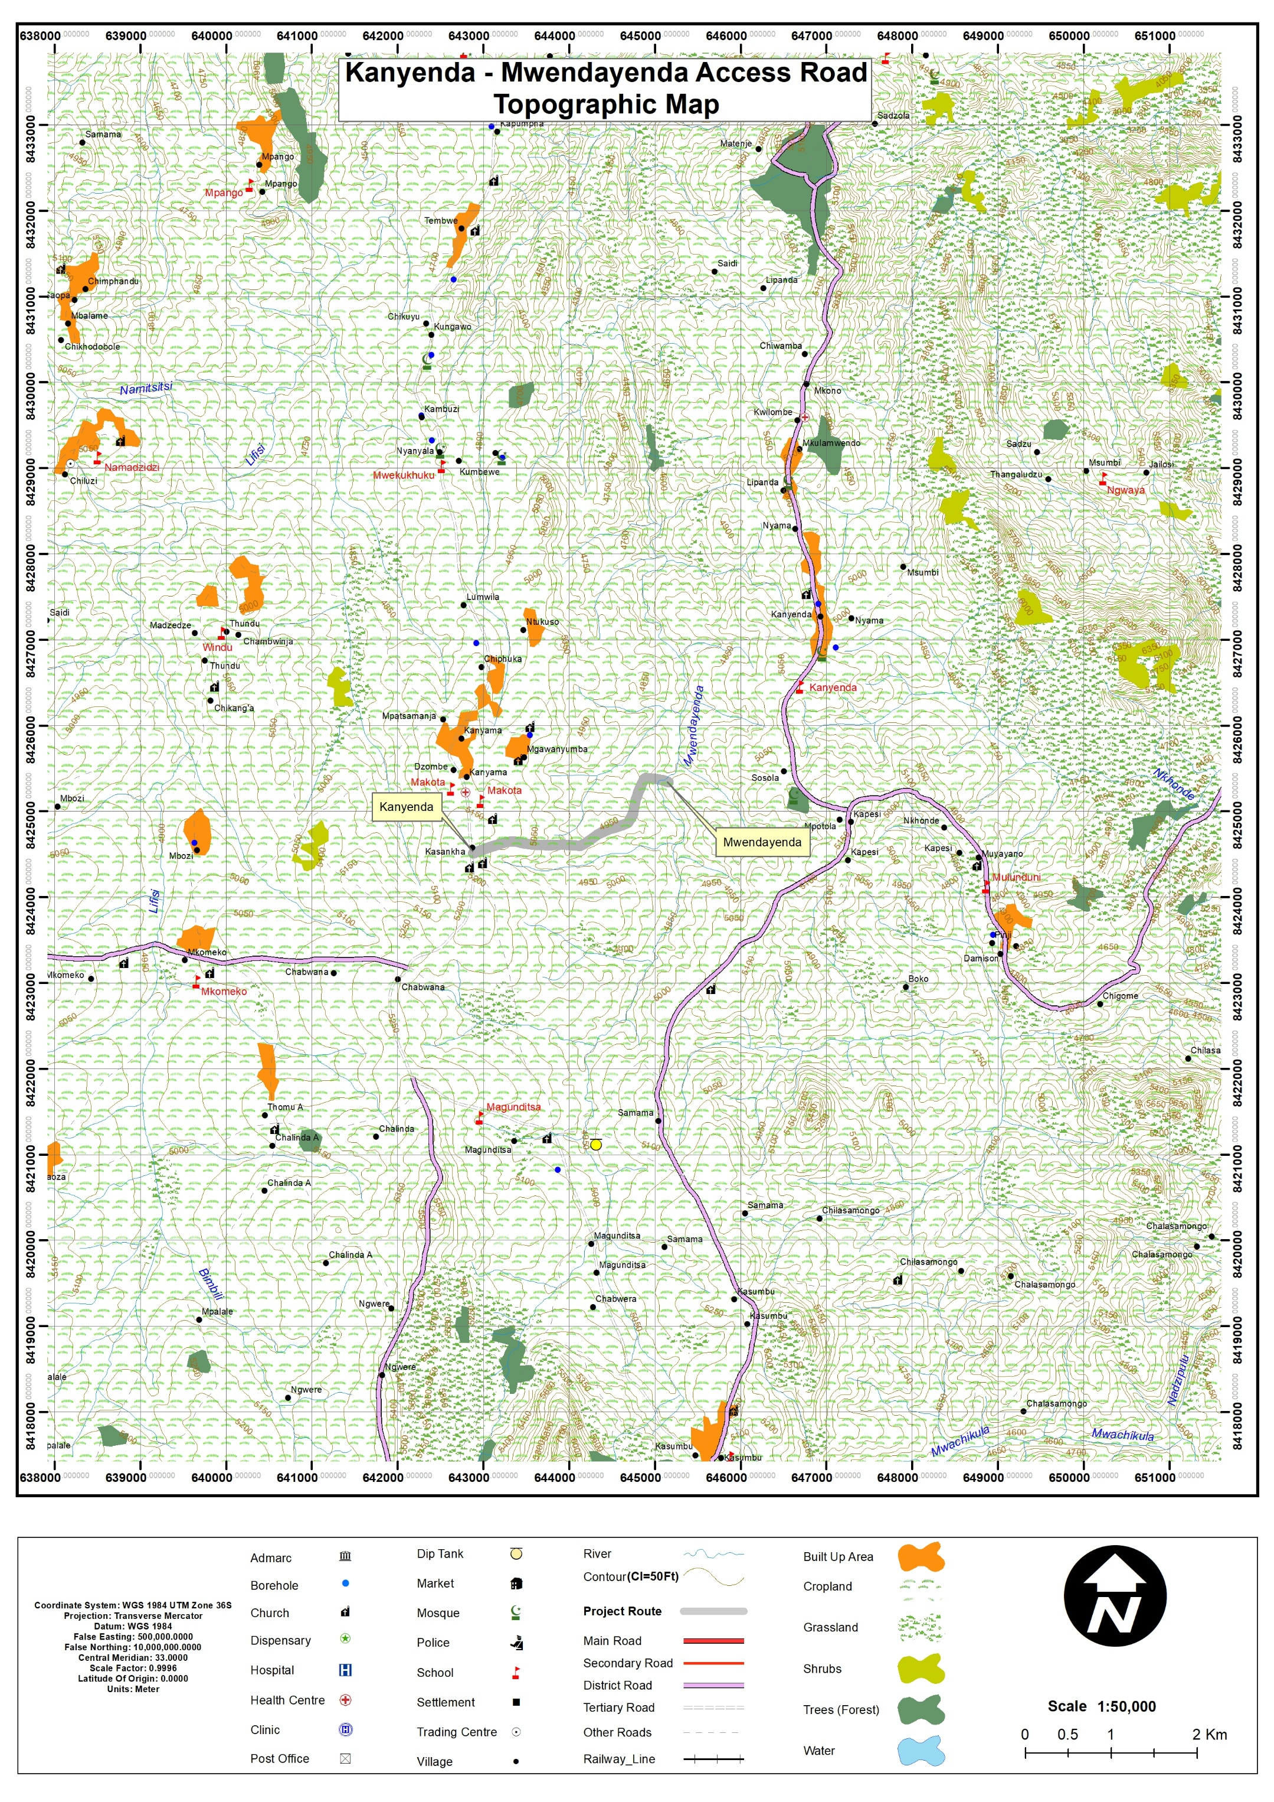
Figure 4-1. Topographic Map of the Kanyenda - Mwendayekha Irrigation Scheme Access Road corridor

Geology
The project area lies within the Precambrian Basement Complex of central Malawi, part of the Mozambique Belt geological formation. The geology is dominated by high-grade metamorphic rocks, including biotite gneiss, hornblende gneiss, and granulitic formations.
These rocks form a stable geological foundation but are typically covered by deeply weathered regolith derived from long-term tropical weathering processes. As a result, direct bedrock exposures are limited along the road corridor.
In low-lying areas near drainage lines and irrigation channels, the subsurface contains Quaternary alluvial deposits composed of silts, sands, and clayey sediments. These materials often exhibit lower bearing capacity and higher moisture sensitivity, which may lead to subgrade weakening and rutting during the rainy season.
Overall, geological conditions are considered favourable for road rehabilitation, provided that design measures address the behaviour of weathered soils and saturated alluvial deposits, particularly through proper drainage and compaction of road materials.

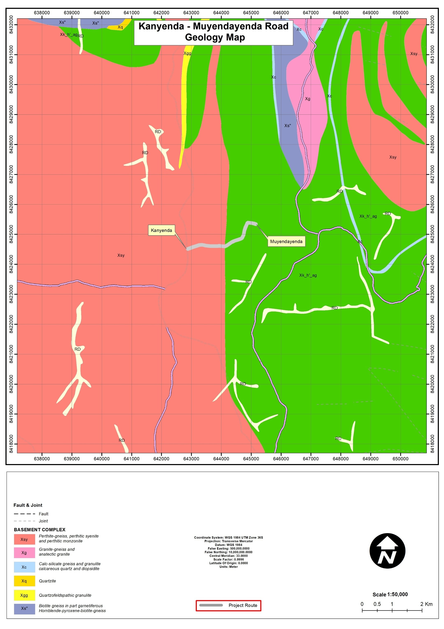
Figure 4-2. Geological Map of the Kanyenda - Mwendayekha Irrigation Scheme Access Road

Soils
Soils along the project corridor consist mainly of residual soils derived from weathered basement rocks, with localized alluvial deposits in low-lying drainage areas associated with the Mwendayekha River system.
The dominant soil types include:
- Sandy clay loam soils, moderately drained and common across cultivated farmland;
- Clay loam soils in low-lying sections, which are prone to water retention and seasonal saturation; and
- Loamy sands in slightly elevated areas, which drain well but are susceptible to erosion when exposed.
These soils are generally suitable for agricultural production but are moisture-sensitive when used as road formation material. During the rainy season, poorly drained sections may experience surface deformation, rutting, and reduced load-bearing capacity. Effective road rehabilitation will therefore require adequate subgrade preparation, improved drainage systems, and stabilization or replacement of weak clayey soils in susceptible sections.

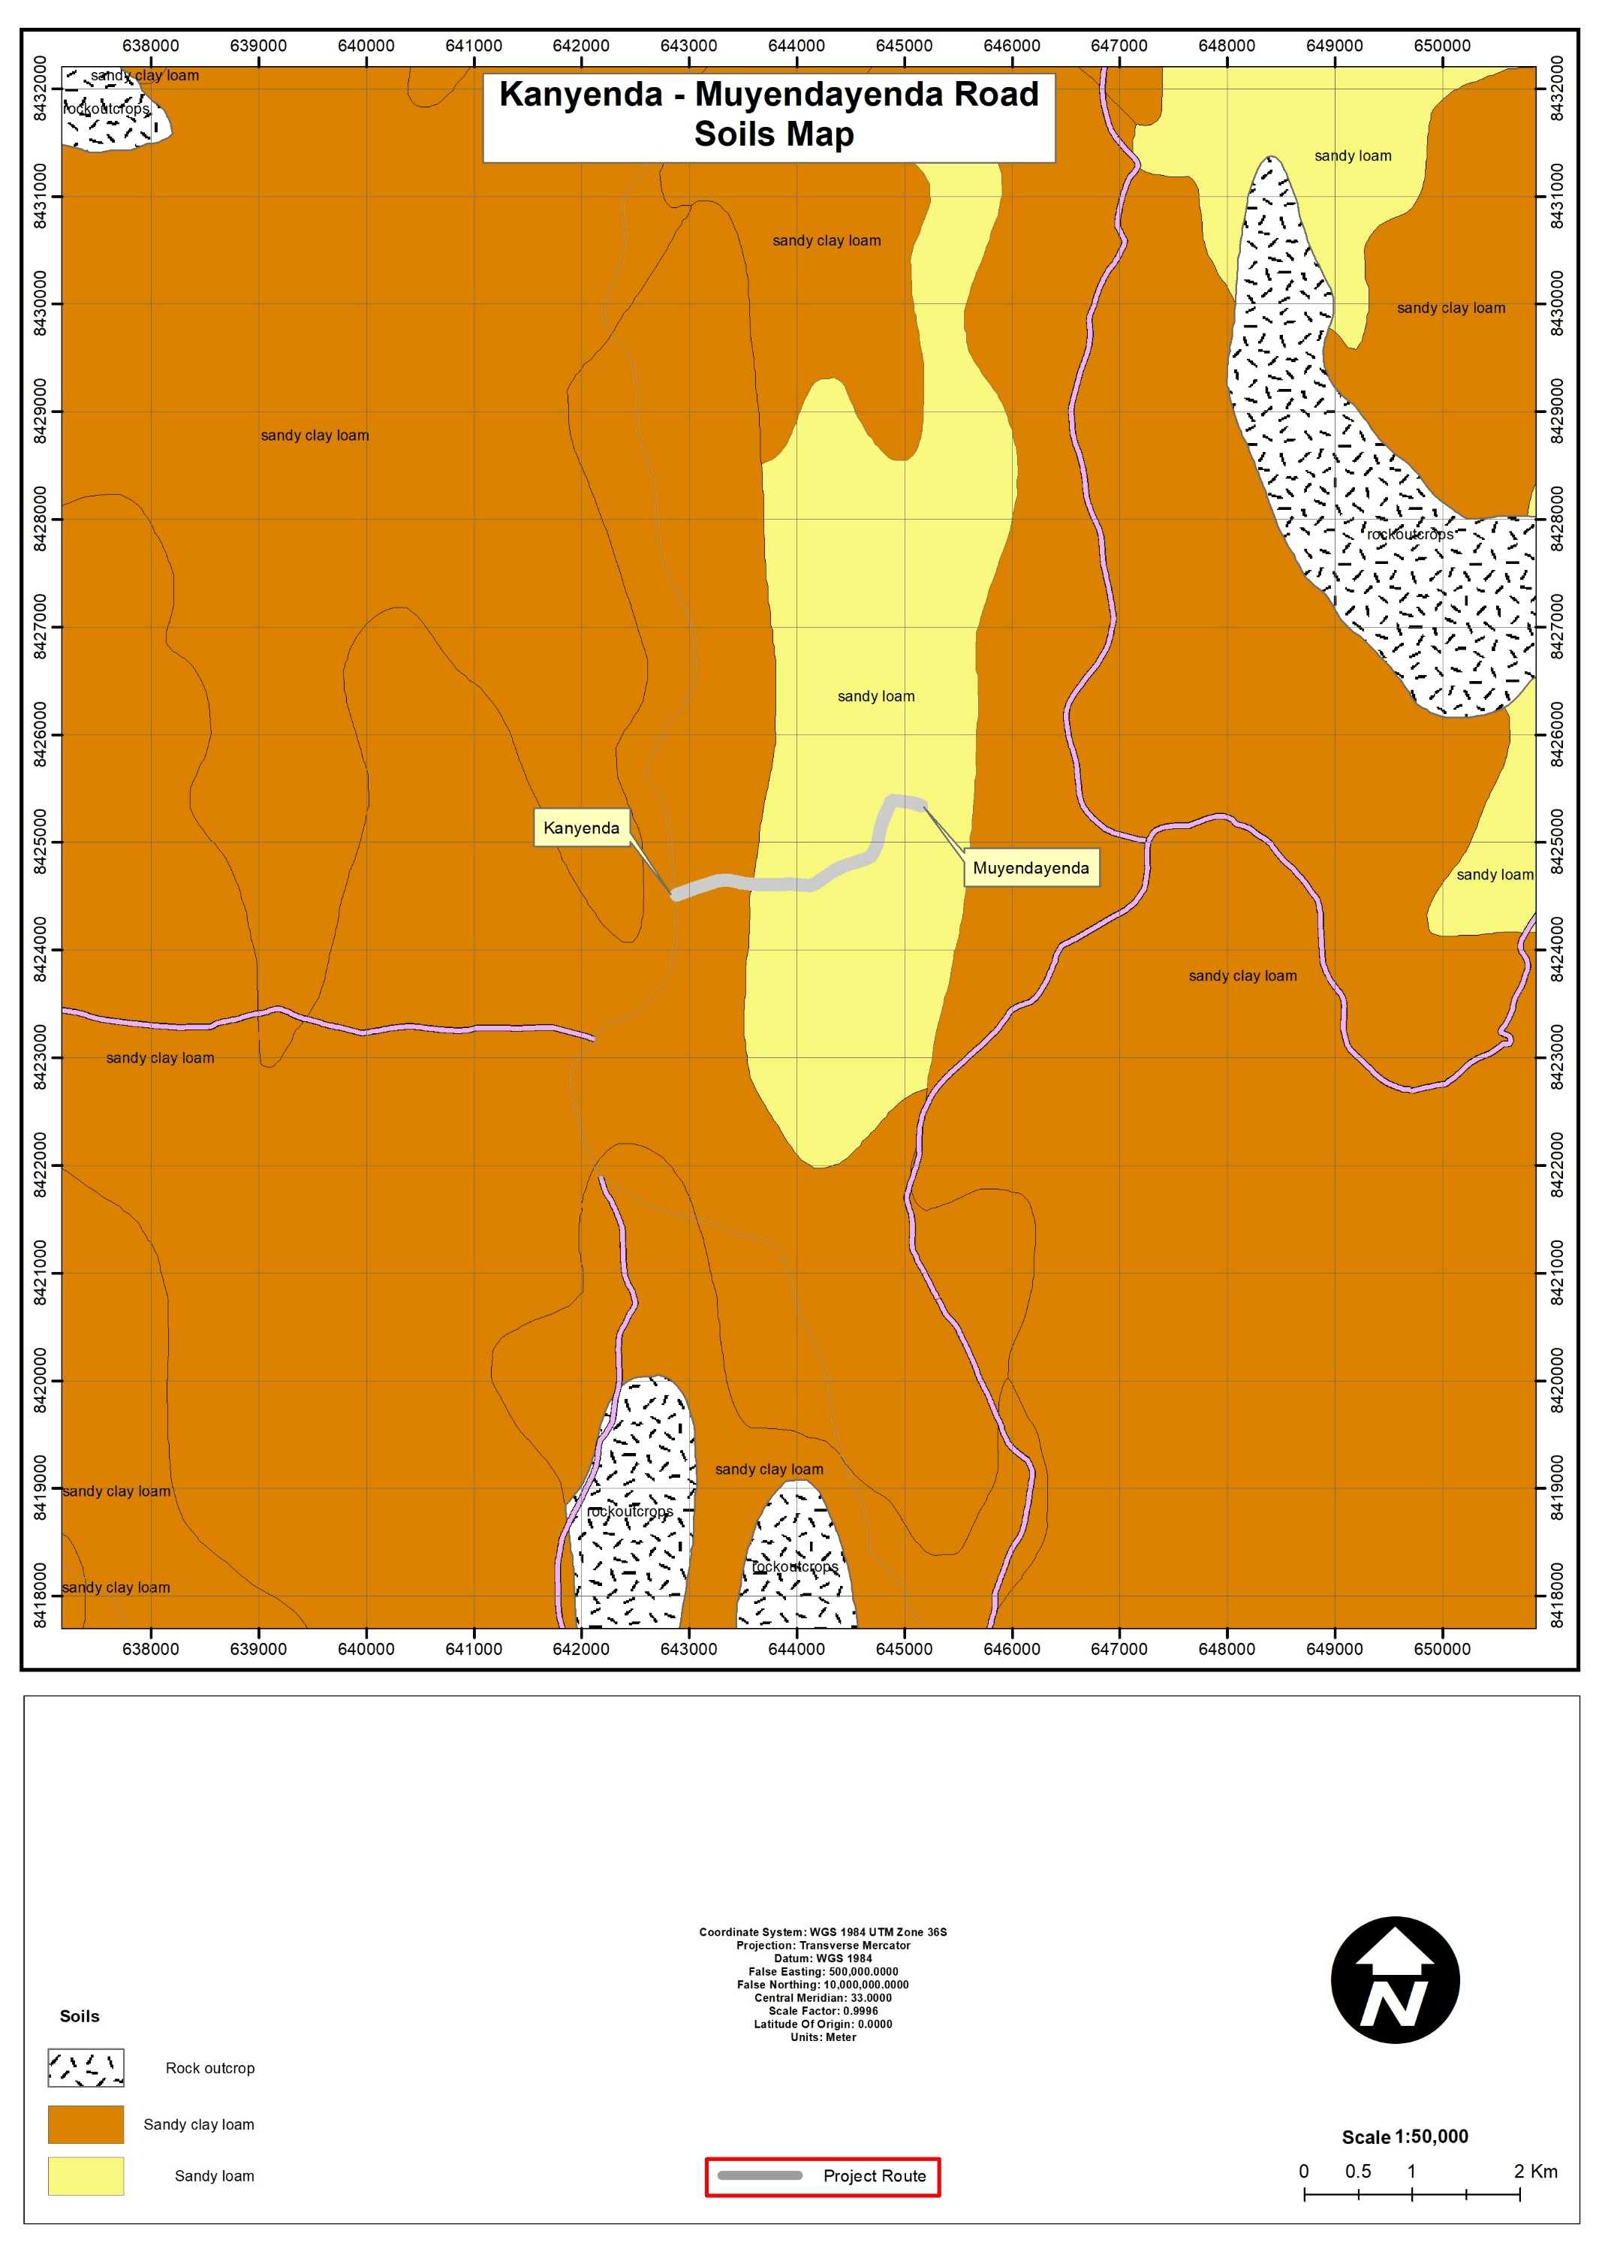
Figure 4-3. Soil distribution map of the area
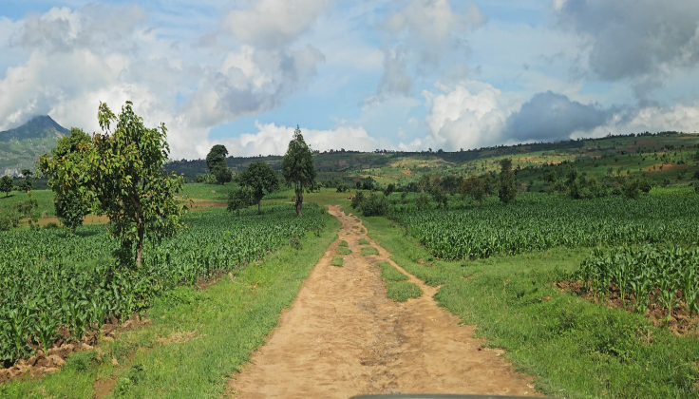
Figure 4-4. Soils along the road corridor

Climate and Climate Change Risks
The project area experiences a subtropical highland climate, characterised by two distinct seasons a rainy season (November – April) and a dry season (May – October). Average annual rainfall in Dedza District ranges between 900 mm and 1,200 mm, with peak rainfall typically occurring between December and February. Mean annual temperatures generally range from 15°C to 25°C, moderated by the district’s high elevation.
Rainfall patterns strongly influence surface runoff, erosion potential, and road performance, particularly in sections near irrigation infrastructure and drainage lines.
Climate projections for central Malawi indicate increasing risks associated with:
- Rainfall variability and intense storm events
- Flooding and erosion in low-lying agricultural areas
- Accelerated deterioration of gravel and earth roads
- Increased vector-borne disease risks where standing water occurs
These conditions highlight the importance of climate-resilient road rehabilitation, including improved drainage infrastructure and erosion control measures.
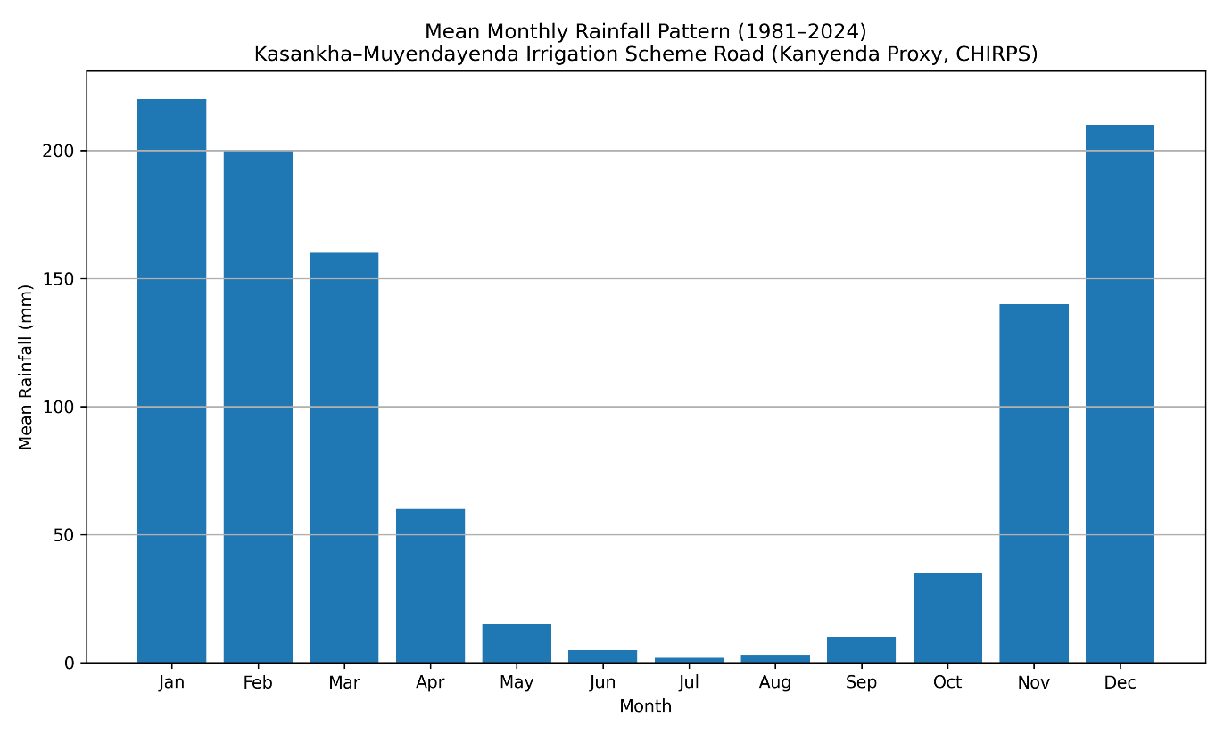
Figure 4-5. Mean monthly rainfall pattern for Kanyenda – Mwendayekha Road Corridor (1981–2024)
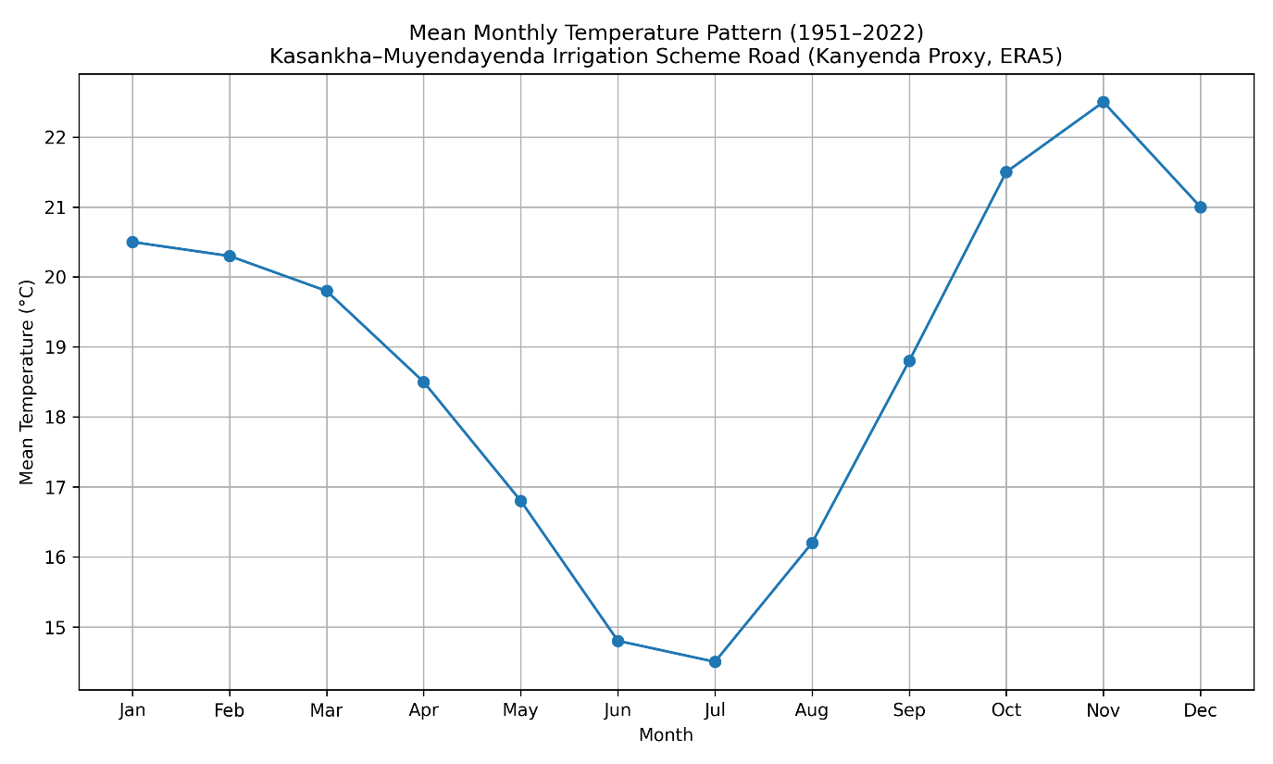
Figure 4-6. Mean monthly temperature pattern for Kanyenda – Mwendayekha Road Corridor

Water Resources

Water sources
The road corridor lies within the Mwendayekha River catchment. Surface hydrology is strongly influenced by seasonal rainfall patterns and irrigation scheme water management.
The Mwendayekha River provides water for the Mwendayekha Irrigation Scheme, which supports agricultural production in the surrounding communities. Several seasonal drainage channels and irrigation canals intersect or run adjacent to the proposed road
During the rainy season, increased runoff may lead to soil erosion and gully formation along the 3 kilometers section to be rehabilitated. as well as sediment transportation into the Mwendayekha river which is at the end of this section,

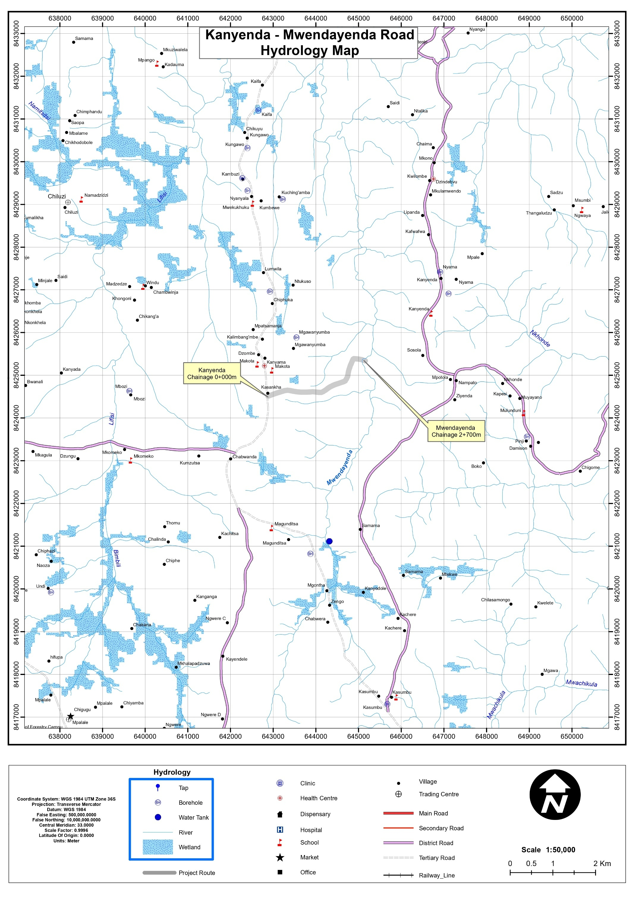
Figure 4-9. Hydrological map of the area

Water Quality
Surface water quality assessment was undertaken to establish baseline conditions of the Mwendayekha River, which is the main watercourse at the end of the section to be rehabilitated and supports the Mwendayekha Irrigation Scheme and surrounding agricultural activities. The assessment was conducted during the rainy season (January 2026) when runoff from cultivated fields and livestock activities is most likely to influence water quality.
Water samples were collected at three monitoring points: upstream (500 m upstream of the crossing), at the river crossing point, and downstream (500 m downstream). Laboratory analysis was conducted at the Chancellor College Chemistry Laboratory, and the detailed analytical results are presented in Annex 6.
The results indicate that physico-chemical parameters are generally within the Malawi Standard (MS 691:2005) limits, although slightly elevated turbidity, suspended solids, iron, and nutrients were observed during the rainy season. These variations are consistent with soil erosion, surface runoff from cultivated land, and livestock activity within the catchment. However, microbiological indicators (faecal coliforms, E. coli, and faecal streptococci) were elevated, reflecting typical rural sanitation conditions and livestock presence near the river.
Table 4-1. Baseline Surface Water Quality of the Mwendayekha River (Rainy Season – January 2026)
Parameter | MS 691:2005 Standard | Upstream | Crossing Point | Downstream | Remarks
pH | 6.0–9.5 | 6.32 | 6.78 | 7.10 | Within acceptable range
Temperature (°C) | Not specified | 22.8 | 23.1 | 23.4 | Normal for tropical surface waters
Electrical Conductivity (µS/cm at 25°C) | 3500 | 35 | 58 | 72 | Slight increase due to runoff but very low overall
Total Dissolved Solids (mg/L) | 2000 | 22 | 41 | 56 | Low and within acceptable limits
Chloride (mg/L) | 750 | 0.3 | 0.5 | 0.6 | Slight increase from surface runoff
Sulphate (mg/L) | 800 | 0.9 | 1.3 | 1.7 | Slight increase due to soil erosion
Nitrate (mg/L) | 1 | 0.2 | 0.3 | 0.4 | Slight increase associated with agricultural runoff
Iron (mg/L) | 3 | 0.18 | 0.36 | 0.58 | Increased slightly due to sediment disturbance
Turbidity (NTU) | 25 | 4.5 | 7.8 | 9.6 | Higher during rainy season due to sediment transport
Suspended Solids (mg/L) | Not specified | 6.2 | 9.4 | 11.7 | Increased due to runoff from cultivated fields
Faecal Coliform (/100 ml) | 50 | 85 | 210 | >300 | Elevated due to livestock and surface runoff
E. coli (/100 ml) | Not specified | 74 | 180 | >300 | Indicates faecal contamination risk
Faecal Streptococci (/100 ml) | 0 | 12 | 95 | >300 | Elevated during rainy season runoff
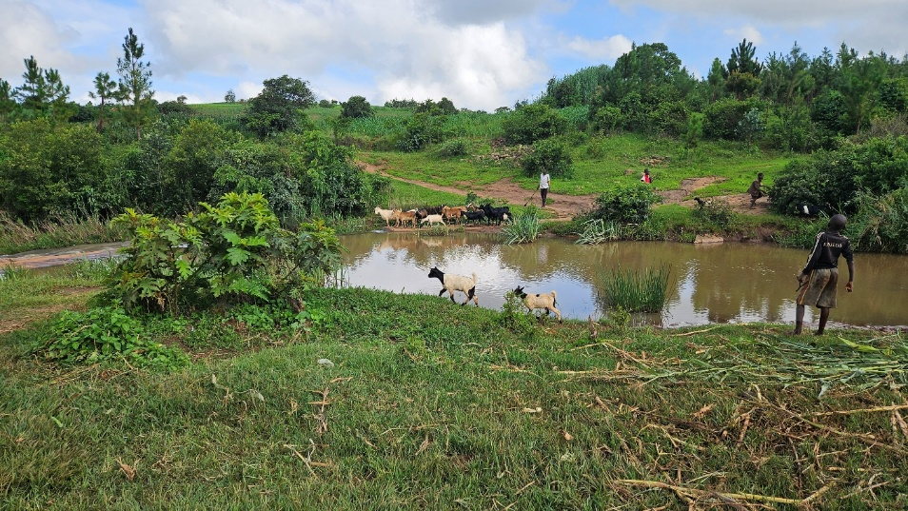
Figure 4-8. Livestock grazing at the end of the 3 km road section (Mwendayehka River)

Flora
Vegetation within the project area is largely made of shrubs and exotic tree species. Natural vegetation has been significantly modified due to cultivation, grazing, and settlement development. Common vegetation types observed along the corridor include:
- Cultivated crops, particularly maize, beans, and vegetables;
- Scattered trees and shrubs around homesteads and field boundaries;
- Grasses and herbaceous vegetation along road edges and fallow land.
Some indigenous tree species occur sporadically, including Acacia species and other agroforestry trees (Table 4-2). No protected forests or ecologically sensitive habitats were identified within the immediate road section of rehabilitation.
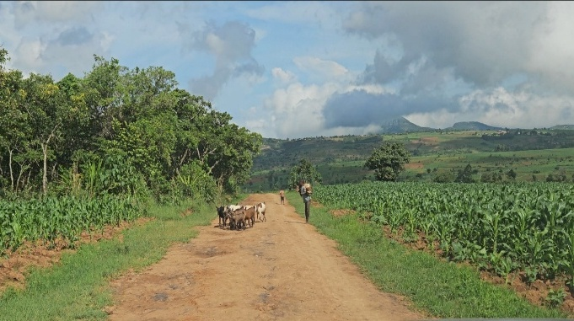
Figure 4-9. Agricultural dominance (maize cultivation) adjacent to the graveyard section of the road

Table 4-2. Sample of Plant Species Recorded in the Project Area
Species | Family | Form | English Name | National Plant Red Data List Conservation Status | IUCN Status
Faidherbia albida | Fabaceae | Tree | Apple-ring acacia | Least Concern/Protected | Least Concern
Agave americana | Asparagaceae | Herb | Century plant | Not Evaluated | Least Concern
Agave sisalana | Asparagaceae | Herb | Sisal | Not Evaluated | Not Evaluated
Azanza garckeana | Malvaceae | Shrub | African Chewing Gum | Not Evaluated | Not Evaluated
Mangifera indica | Anacardiaceae | Tree | Mango | Not Evaluated | Data deficient
Psidium guajava | Myrtaceae | Herb | Guava | Not Evaluated | Least Concern
Syzygium Cordatum | Myrtaceae | Tree | Water Berry | Least Concern | Least Concern

Fauna (Animal Life)
Faunal assemblages recorded within the project area are typical of disturbed agro-rural landscapes associated with irrigated agriculture, scattered settlements, and roadside vegetation. Field surveys, transect observations, and community consultations identified species from five taxonomic groups: mammals, birds, reptiles, amphibians, and macro-invertebrates. Most species recorded are common and adaptable taxa associated with farmland mosaics, wetlands, and settlement edges.
Across all groups, no endemic, threatened, or globally endangered species were identified, and the majority are classified as Least Concern under the IUCN Red List. Faunal activity was generally low and dispersed, reflecting the long history of cultivation, livestock grazing, and settlement within the project corridor. Species presence is slightly higher near wetlands, irrigation areas, and vegetated farmland sections, which provide limited feeding and refuge habitat.
A consolidated summary of the fauna recorded within the project area is presented in Table 4-3.
Table 4-3. Consolidated Fauna Species Recorded in the Project Area
Group /Scientific Name | Common / Local Name | National Conservation Status | IUCN Status
Mammals
Saccostomus capensis | Pouched Mouse | Least Concern | Least Concern
Epomophorus paraxerus cepapi | Tree Squirrel | Least Concern | Least Concern
Paraxerus palliatus | Red Bush Squirrel | Least Concern | Least Concern
Birds
Passer diffusus | Southern Grey-headed Sparrow | Least Concern | Least Concern
Corvus albus | Pied Crow | Least Concern | Least Concern
Pycnonotus barbatus | Common Bulbul | Least Concern | Least Concern
Streptopelia semitorquata | Red-eyed Dove | Least Concern | Least Concern
Ploceus velatus | Southern Masked Weaver | Least Concern | Least Concern
Tchagra senegalus | Black-crowned Tchagra | Least Concern | Least Concern
Reptiles
Agama mossambica | Mozambique Agama | Not Evaluated / Least Concern | Least Concern
Chamaeleo africanus | African Chameleon | Not Evaluated / Least Concern | Least Concern
Amphibians
Xenopus laevis | African Clawed Frog | Least Concern | Least Concern
Breviceps poweri | Power’s Rain Frog | Least Concern | Least Concern
Xenopus muelleri | Clawed Frog | Least Concern | Least Concern
Sclerophrys gutturalis | Guttural Toad | Least Concern | Least Concern
Amietophrynus garmani | Eastern Olive Toad | Least Concern | Least Concern
Macro-invertebrates
Apis mellifera | Western Honey Bee | Not Evaluated / Least Concern | Data Deficient
Zonocerus elegans | Elegant Grasshopper | Least Concern | Least Concern
Acraea natalica | Natal Acraea Butterfly | Least Concern | Least Concern
Acanthacris ruficornis | Garden Locust | Not Evaluated / Least Concern | Least Concern
Catopsilia florella | African Migrant Butterfly | Least Concern | Least Concern
Orthetrum chrysostigma | Epaulet Skimmer (Dragonfly) | Least Concern | Least Concern
Nomadacris septemfasciata | Red Locust | Least Concern | Least Concern

Human–Fauna Interaction
No evidence of human–wildlife conflict, wildlife migration corridors, or regular wildlife crossing points was observed during field surveys. The existing road is already operational, and fauna present appear habituated to human activity and agricultural land use.

Sanitation and Waste Management
Field observations and community consultations indicate that sanitation and waste management practices within the project area are predominantly household-based and informal, reflecting the rural character of the corridor. Most households rely on traditional pit latrines for sanitation, which are typically constructed and maintained at household level.
Solid waste management is largely undertaken through on-site disposal practices, including the use of household waste pits, open dumping, and occasional burning of combustible waste. These practices are common in rural areas where organised waste management services are limited.
There are no commercial or municipal waste management facilities within the immediate project area, and formal waste collection services are generally absent along the rural sections of the corridor. However, small trading centres and market areas generate modest amounts of commercial and domestic waste, which are often disposed of in nearby open spaces or informal dumping areas.

Implications for the Project
The baseline assessment indicates that the Kanyenda–Mwendayekha road is generally suitable for rehabilitation due to its stable geology and relatively flat terrain. However, several environmental characteristics require consideration during design and construction.
The low-gradient terrain and presence of wetlands and seasonal drainage lines increase the risk of erosion. In addition, moisture-sensitive soils in some sections may reduce subgrade strength under saturated conditions, requiring proper subgrade preparation, stabilization, and compaction.
Seasonal rainfall and increasing climate variability may further increase erosion and drainage challenges, making effective drainage systems and erosion control measures essential. The proximity of the road corridor to irrigation infrastructure and surface water resources also requires careful management of runoff, sediments, and construction-related pollutants.

Socio-economic Environment
The socio-economic baseline indicates that the Kanyenda–Mwendayekha Irrigation Scheme Road serves a predominantly rural and agriculture-dependent population with settlements concentrated near Kanyenda/Kanyama Trading Centre and more dispersed households toward the Mwendayekha Irrigation Scheme.

Population and Demographic Structure
For this ESMP, the area of influence (AoI) is defined as the continuous settlement band extending approximately 1 km on either side of the Kanyenda–Mwendayekha access road alignment, including all villages, social facilities and productive land that interact directly with the road, plus associated ancillary sites (borrow areas, access tracks and temporary construction facilities) within Traditional Authority (TA) Kanyenda. In practice, this corresponds to the group village areas bisected by the 3 km road section shown in the orthophoto in section 1.9, which are expected to experience the direct, indirect and cumulative environmental and social impacts of the project (e.g. traffic, dust, drainage changes, access improvement).
Using 2018 Population and Housing Census data for Nkhotakota District and TA Kanyenda, adjusted by the reported intercensal growth rate for the district, the AoI is estimated to contain about 2,350–2,400 households, representing an estimated population of roughly 10,300–10,500 people, based on the prevailing rural average household size of around 4.4 persons. The population structure is youthful, with children and adolescents (0–17 years) accounting for close to half of residents, about 45 percent in the economically active age group (18–64 years), and a small elderly cohort (65+ years). Sex distribution is slightly female biased (approximately 51–52 percent female and 48–49 percent male), and census-based projections and local records indicate a high proportion of female headed households due to male labour migration, alongside a small number of child headed households. These characteristics point to the presence of vulnerable groups within the AoI that require targeted consideration in the design of road safety, employment, stakeholder engagement and grievance redress measures.

Education and Literacy
No schools are located directly within the road corridor; however, Makota Primary School and Makota Community Day Secondary School serve communities in the project area. Makota Primary School enrolment is approximately 1,990 learners (923 boys, 1,067 girls), while Makota CDSS enrolment is 286 learners (137 boys, 149 girls). Literacy levels reflect regional trends, with an estimated 67% literacy rate in the Central Region, generally lower among women than men.

Health Services
Healthcare services are primarily provided by Kanyama Health Centre, located approximately 1 km from the road origin, offering outpatient care, maternal and child health services, HIV testing, and basic treatment. More complex medical cases are referred to Dedza District Hospital, located about 17 km from the project area.

Livelihoods and Economic Activities
Over 70 percent of the people in the area leave below the poverty line which is pegged at $1 per day. The local economy is dominated by smallholder agriculture and irrigation farming, with crops such as maize, Irish potatoes, onions, tomatoes, and beans widely cultivated. Supplementary livelihoods include petty trading, casual labour (ganyu), transport services, brick moulding, and small-scale vending, with women predominantly engaged in petty trade and subsistence farming, while men often participate in produce marketing, livestock activities, and transport services.

Transport and Mobility
Traffic on this road is dominated by motorcycles (30.6%), bicycles (27.8%), and animal carts (26.5%), reflecting the rural character of the corridor. Heavy vehicles constitute less than 1% of traffic, confirming that the road carries very light structural loading (Traffic Class LE 0.01).

Land Use and Infrastructure
Land use along the Kanyenda–Mwendayekha access road is predominantly rural, transitioning from denser residential and trading activities around Kanyenda trading centre to mainly agricultural land and irrigated fields towards Mwendayekha. Existing infrastructure is limited to scattered homesteads, local access tracks, small drainage crossings, and community-use areas within or adjacent to the road reserve, including a community graveyard on the left-hand side of the corridor (Figure 1-3). There are no major industrial or commercial facilities along the route, and grid electricity coverage is low, with most households relying on biomass (mainly firewood) for energy.

Vulnerability and Social Considerations
The population includes several vulnerable groups, notably female-headed households, elderly persons, persons with disabilities, and child-headed households. Limited income sources, dependence on agriculture, and seasonal road access constraints increase vulnerability to economic and environmental shocks.

Implications
Overall, the corridor supports a low-income, agriculture-dependent rural population with strong reliance on road access for livelihoods, markets, education, and health services. Given the high proportion of women and vulnerable households, maintaining safe access, minimizing disruption during construction, and ensuring gender-responsive engagement will be essential during project implementation.

Overall Implications of the baseline conditions on the Project
The baseline assessment indicates that the Kanyenda–Mwendayekha road rehabilitation will occur in a rural agricultural area with generally suitable physical conditions but some environmental and social sensitivities. The terrain and geology favour rehabilitation; however, low-gradient landscapes, moisture-sensitive soils, increase risks of erosion, requiring careful drainage and protection of river systems. Socio-economically, the road supports about 2,357 households reliant on agriculture and small trade, with high use by pedestrians and non-motorised transport. Overall, potential impacts are expected to be localized and manageable through appropriate engineering design, environmental safeguards, and community engagement implemented under the ESMP.

CHAPTER 5: ENVIRONMENTAL AND SOCIAL MANAGEMENT AND MONITORING PLAN

Introduction
This chapter presents the Environmental and Social Mitigation and Monitoring Plan (ESMMP) for the proposed Kanyenda - Mwendayekha Irrigation Scheme Road Rehabilitation Project. It outlines the mitigation measures, monitoring requirements, implementation responsibilities, and reporting arrangements for managing environmental and social impacts identified during project planning, construction, demobilisation, and operation.
The ESMMP provides the framework for implementing environmental and social safeguards in accordance with applicable national legislation and relevant World Bank requirements, and forms part of the obligations to be implemented by the contractor, supervising engineer, and responsible authorities during project execution.
Monitoring provisions are included to enable the MoTPW, supervising engineers, district authorities, and MEPA to systematically track environmental and social performance, verify the effectiveness of mitigation measures, and ensure continuous improvement throughout project implementation.
Reports of monitoring activities will be prepared by the contractor and submitted on a Monthly basis to the PIU and the Environmental District Officer because the project will be implemented in three - four months.
Framework Instruments for Contractor Implementation
To support effective implementation of the environmental and social management measures outlined in Section 5.2, this ESMP includes framework instruments provided in the Annexes that establish minimum requirements, procedures, and standards for contractor compliance. The Contractor is required to prepare site-specific management plans based on these frameworks prior to commencement of works, including:
- Barrow Pit Rehabilitation Plan (Annex 5)
- Traffic Management Plan (Annex 6)
- Labour Management Plan (Annex 8)
- Contractor Environmental and Social Management Plan - CESMP (Annex 9)
- Waste Management Plan (Annex 10)
- Stakeholder Engagement Plan (Annex 11)
These plans must be submitted to the Supervising Engineer and MoTPW Environmental District Officer for review and approval before the respective activities commence. The Contractor must also implement the Code of Conduct (Annex 4), Chance Find Procedure (Annex 7), and Grievance Redress Mechanism Protocol (Annex 13) as mandatory requirements throughout construction.

All contractor-prepared plans must demonstrate alignment with Malawi environmental legislation, MEPA Guidelines for Environmental Assessment (2025), World Bank Environmental and Social Framework requirements, and the mitigation measures specified in Section 5.2.

Environmental and Social Mitigation and Monitoring Plan for Kanyenda Mwendayekha Road
REF | Impacts & Risks | Enhancement / Mitigation Measures | Responsible Institution | Implementation Cost (USD) | Performance/Monitoring Indicator | Frequency | Monitoring Cost (USD)
5.2.1 Planning Phase – Positive Impacts and Enhancement Measures
5.2.1.1 | Improved drainage and reduced flooding | Design culverts based on hydrological analysis; include adequate sizing, freeboard, and scour protection | MoTPW / Design Engineer | project cost | Approved hydrological design | Once | N/A
5.2.1.2 | Improved stakeholder acceptance | Conduct stakeholder consultations and disclose ESMP  Ensure inclusion of women and vulnerable groups in consultations  Establish and operationalize a Grievance Redress Mechanism (GRM) | District Council | 1000 | Number of consultations conducted  Representation of vulnerable people in consultation groups and GRCs  Availability of functioning GRC | Monthly | 500
5.2.1.3 | Early planning of local employment opportunities. | - Include local labour provisions in procurement documents;  - Establish transparent recruitment procedures;  - Promote gender-inclusive employment to achieve 40% female employment | - MoTPW  - Contractor  - Contractor | 200 | Presence of labour and gender clauses in bidding documents | Once | 800
52.2 Planning Phase – Negative Impacts and Mitigation Measures
5.2.2.1 | Inadequate capacity of contractors to identify and manage the potential environmental and social risks | Contractor to include an Environmental, Social, Health and Safety (ESHS) Officer in their staffing to be based at site.  Develop and implement Contractor-ESMP (C-ESMP) and associated management plans in line with the frameworks, Malawi regulations and WB EHS guidelines and policies covering  - Waste Management Plan  - Code of Conduct  - Borrow Pit Rehabilitation  - Stakeholder Engagement Plan  - Traffic Management Plan  - Chance Finds Procedure | Contractor | Contractor cost | ESHS Officer on site  C-ESMP and associated plans developed and implemented | Monthly | N/A
5.2.2.2 | Anxiety to loss of land and assets | Sensitize communities on the Project and activities at each chainage  No land take outside of the project area / agreements  Establish a grievance mechanism | PIU and Design Engineer | 200 | Number of sensitization sessions done | Twice | 50
5.2.2.3 | Poor early decisions on borrow pits and material sources. | Verify land ownership; obtain landowner consent; integrate borrow pit management obligations in contracts. | MoTPW, DCs | 1000 | Number of approved material sites with documented consent | Once | 100
5.2.3 Construction Phase – Positive Impacts and Enhancement Measures
5.2.3.1 | Short-term employment creation for local communities | Establish and implement transparent recruitment procedures;  Promote gender-inclusive employment to achieve 40% female employment. | Contractor | 500 | Recruitment procedure in place  40% of employees are female | 1.Once  2. Monthly | 200
5.2.3.2 | Local procurements leading to increased circulation of income in local economies. | Engagement of local vendors and service providers where possible;  Maintain access to trading centres as part of the Traffic Management plan including signage, temporary crossings, diversions, use of flag people etc. | Contractor | 500 | % locally sourced goods/services  Number of grievances received related to access | Monthly | 100
5.2.3.3 | Skills transfer | Provide on-the-job training to workers | Contractor | 100 | Number of workers trained | Monthly | N/A
5.2..4 Construction Phase – Negative Impacts and Mitigation Measures
5.2.4.1 | Vegetation loss | Limit clearing to construction footprint;  Restore vegetation after works, including borrow pits. Where possible, rehabilitate borrow pits progressively.  Replant trees at a ratio of 1:10 | Contractor | 500 | Area cleared against planned area for works  Area rehabilitated  Number of trees planted | Monthly | 500
5.2.4.2 | Soil erosion and sedimentation | Install erosion control measures (silt traps, drainage channels, slope stabilization) to manage impact during construction, while permanent measures are being constructed as per design | Contractor | 500 | Control measures (silt traps, drainage channels, slope stabilization) in place during construction | Every two months | 1000
5.2.4.3 | Disruption of water flow | Provide temporary diversion channels during culvert installation and maintain environmental flows | Contractor | 500 | Diversion channels in place and records of flows (inspections) | Monthly | 500
5.2.4.4 | Soil and water contamination | Establish designated fueling areas;  Provide spill kits; ensure proper storage of fuels | Contractor | 500 | Availability of spill kits and designated areas for fuelling and fuel storage areas | Monthly | 500
5.2.4.4 | Soil and water contamination | Provision of sanitation facilities for workers, | Contractor | 500 | Number of facilities provided | once | 200
5.2.4.4 | Soil and water contamination | Provide waste bins | Contractor | 200 | Number of bins being used on site | Every two months | 100
5.2.4.4 | Soil and water contamination | Train workers on waste management as part of inductions | Contractor | 200 | Number of workers trained (training records) | Monthly | 100
5.2.4.5 | Dust emissions | Apply water spraying; implement speed control measures; cover transported materials | Contractor | 500 | Records of dust suppression activities  Number of grievances related to dust | Monthly | 500
5.2.4.6 | Occupational Health and Safety risks | Provide ESHS Personnel  Implement measures indicated in SATCP’s OHS Management Framework  Carry out risk assessment and implement measures accordingly  Induct all workers on the OHS Plan and conduct toolbox talks on at least a weekly basis  Provide PPE to all workers and enforce its use.  Implement emergency preparedness procedures included in the OHS Management Framework | Contractor | 1000 | Accident, near miss and incident records  Risk assessment records  Training records for workers on OHS plan available on site | Monthly | 500
5.2.4.7 | Climate-related risks: increased surface runoff, flash flooding, and accelerated soil erosion, particularly during high-intensity rainfall events | Store loose soil material, waste, concrete mix and fuel away from the river banks | Contractor | 500 | Designated sites for waste, fuels and concrete mixing away from riverbank  Provide shelter/rest areas for workers | Monthly | 500
5.2.4.8 | Noise and vibration | Restrict working hours to daylight hours  Regular servicing of equipment | Contractor | N/A | Number of dust, noise, or traffic-related complaints recorded | Monthly | 500
5.2.4.9 | Disruption of aquatic ecology from extraction of sand | Sand mining will only be carried out in areas permitted by authorities  Procure sand from licensed suppliers | Contractor | 500 | Permits available on site  % of disturbed sand mining areas rehabilitated | once | N/A
5.2.4.10 | Community Health and Safety risks | Implement dust suppression  Conduct awareness campaigns on HIV/AIDS, Cholera and other communicable diseases  Provide safe diversion for safe movement of traffic (including signage, barriers and passable diversion) | Contractor | 500 | Traffic management plan developed and available on site | Monthly | 400
5.2.4.11 | Temporary loss of access to land due to use for ancillary facilities including diversions and storage area | Maintain access to farms, social services etc as part of the Traffic Management Plan including signage, temporary crossings use of flag people, one-way traffic, temporary diversions and pedestrian access route  Establish a grievance redress mechanism  Payment of compensation for any losses/ damage to assets inadvertently caused as a result of contractor activities at replacement value | Contractor | Project cost | Signed sale/lease agreements shared with PIU | Once | N/A
5.2.4.12 | Temporary disruption of access to farms and social services. | Maintain access to farms, social services etc as part of the Traffic Management Plan including signage, temporary crossings use of flag people etc. | Contractor | Costed above | Number of grievances related to issues with access | Monthly | N/A
5.2.4.13 | Labour influx risks including communicable diseases, SEA/SH and social tensions. | Ensure all workers are trained on and sign Worker Code of Conduct  Conduct HIV/AIDS and SEA/SH awareness training;  Establish and maintain a Community Grievance Redress Mechanism that is SEA/SH responsive | Contractor | 1000 | % of workers signed the CoC against number employed  % of workers who received training on CoC against number employed  % of workers who received training on HIV/AIDS, SEA/SH against number employed  Number of Grievances received  % of grievances received against resolved within indicated timelines | Monthly | 200
5.2.4.14 | Labor exploitation, abuse (forced or underage), and discriminatory working conditions | Explain to all workers conditions of service, labour expectations and contract duration  Ensure all workers have a signed contract and given a copy  Implement age verification system using national identification to employ only those that are 18 years old and above  Establish and maintain a Worker Grievance Redress Mechanism that is SEA/SH responsive | Contractor | 500 | % of workers with signed contract against number employed  No of underage workers reported  Availability of functioning WGRC  % of grievances resolved against received within indicated timelines | Monthly | 200
5.2.4.15 | Impacts to Cultural Heritage | Implement a Chance Finds Procedure including the training of workers | Contractor | 200 | % of workers trained on chance finds procedure | Monthly | 200
5.2.4.16 | Damage to assets including crops and trees as a result of works | Establish a grievance redress mechanism  Payment of compensation for any losses/ damage to assets inadvertently caused as a result of contractor activities at replacement value | Contractor | Cost as per unintended damage. | Number of grievances related to lost assets received  % of grievances related to lost assets resolved in agreed timelines | Monthly | N/A
5.2.4.17 | Environmental degradation from uncontrolled material extraction. | Acquire permits for material extraction or procure from licensed suppliers  Restrict extraction to approved sites; prohibit riverbed and wetland extraction; demarcate borrow pits.  Rehabilitate Borrow pits and sand mining areas. Progressive rehabilitation should be implemented where possible. | Contractor | Include in contract | Permits available on site  Number of demarcated borrow pits  % area of borrow pit rehabilitated | Once  Monthly  Monthly and prior to site handover by Contractor | 500
45.25 Contractor Demobilization Phase – Negative Impacts
5.2.5.1 | Residual waste and disturbed land | Remove all waste; dispose at approved sites; clean-up / restore site  Restore temporary storage area to pre project conditions. | Contractor | 500 | 100% waste removed and disposed at disposal site approved by District Council  100% of disturbed land restored to the satisfaction of the client and District in line with agreed plans | Once | 600
5.2.5.1 | Residual waste and disturbed land | Regrade and stabilise disturbed areas; restore drainage | Contractor | 500 | 100% of disturbed land restored to the satisfaction of the client and District in line with agreed plans | Once | 600
5.2.5.2 | Sudden loss of income for local workers. | Provide advance notice (a month), ensure payment of dues and issue work references where possible. | Contractor | 400 | N/A | N/A | N/A
5.2.6 Operation and Maintenance Phase – Positive Impacts and Enhancement Measures
5.2.6.1 | Improved accessibility | Maintain culverts and road surface regularly  Maintain signage, road safety measures and traffic calming devices near settlements. | MoTPW / District Council | 5,000/year | Number of maintenance activities carried out | As per District Council routine | N/A
5.2.62 | Reduced erosion and waterlogging at drainage infrastructure locations | Routine inspection and clearing of drainage structures | District Council | 3,000/year | Number of inspections carried out | As per District Council routine | N/A
5.2.7 | Operation and Maintenance Phase – Negative Impacts and Mitigation Measures
5.2.7.1 | Culvert blockage and flooding | Regular desilting and removal of debris | District Council | N/A | Number of maintenance activities carried out | As per District Council routine | N/A
5.2.7.2 | Downstream erosion | Install and maintain energy dissipation structures | MoTPW / District Council | NA | Energy dissipation structures installed | N/A | N/A
5.2.7.3 | Extreme rainfall impacts | Conduct periodic structural inspections and maintenance | MoTPW | Subject to damage assessment | Number of inspections carried out | As per District Council routine | N/A

Institutional Arrangements and Implementation Capacity
This section outlines the institutional framework for implementing, coordinating, and monitoring the Environmental and Social Management Plan (ESMP) for the Kanyenda–Mwendayekha Irrigation Scheme Road in Dedza District. The framework clarifies the roles and responsibilities of institutions involved in environmental and social safeguard management throughout the planning, construction, and operation phases of the project.
Implementation of the ESMP will require coordination among national, district, and site-level institutions through routine supervision, reporting, and consultation mechanisms. Detailed responsibilities for specific mitigation and monitoring actions are presented in the ESMP Implementation and Monitoring Matrices.
Table 5-1. Institutional Responsibilities for ESMP Implementation and Oversight
Institution | Role in ESMP Implementation
Ministry of Transport and Public Works (MoTPW) and PIU | Executing agency responsible for overall ESMP oversight; integrates ESMP requirements into project contracts, supervises compliance, reviews monitoring reports, and ensures corrective actions are implemented.
Contractor | Primary responsibility for implementing ESMP mitigation measures during construction; appoints an Environmental, Health and Safety (EHS) Officer, prepares site-specific management plans, implements environmental safeguards, and maintains compliance records.
Supervising Consultant (SC) | Provides day-to-day supervision of construction activities and verifies contractor compliance with ESMP requirements through regular inspections and technical reporting.
Malawi Environment Protection Authority (MEPA) | Provides statutory environmental oversight and conducts compliance inspections in accordance with the Environment Management Act (2017).
Dedza District Council / District Environment Sub-Committee (DESC) | Supports local monitoring, facilitates community engagement, and assists with environmental awareness and grievance handling at the district level.

REFERENCES
1. Policies and Strategies
Government of Malawi. (1994). National environmental action plan. Ministry of Natural Resources.
Government of Malawi. (2002). Malawi national land policy. Ministry of Lands, Housing and Urban Development.
Government of Malawi. (2004). National environmental policy. Ministry of Natural Resources.
Government of Malawi. (2015). National transport policy. Ministry of Transport and Public Works.
Government of Malawi. (2016). National climate change management policy. Ministry of Natural Resources, Energy and Mining.
Government of Malawi. (2016). National forest policy. Ministry of Natural Resources, Energy and Mining.
Government of Malawi. (2018). Malawi 2063: An inclusively wealthy and self-reliant nation. National Planning Commission.
Government of Malawi. (2022). National water policy. Ministry of Agriculture, Irrigation and Water Development.
Government of Malawi. (2025). National gender policy. Ministry of Gender, Community Development and Social Welfare.

2. Legislation and Regulations
Government of Malawi. (1995). Constitution of the Republic of Malawi. Government Printer.
Government of Malawi. (1948). Public Health Act. Government Printer.
Government of Malawi. (1997). Occupational Safety, Health and Welfare Act. Government Printer.
Government of Malawi. (1998). Local Government Act. Government Printer.
Government of Malawi. (2000, as amended). Employment Act. Government Printer.
Government of Malawi. (2010). Child Care, Protection and Justice Act. Government Printer.
Government of Malawi. (2013). Water Resources Act. Government Printer.
Government of Malawi. (2017). Environment Management Act. Government Printer.
Government of Malawi. (2017). Gender Equality Act. Government Printer.
Government of Malawi. (2017). Trafficking in Persons Act. Government Printer.
Government of Malawi. (2018). HIV and AIDS (Prevention and Management) Act. Government Printer.
Government of Malawi. (2020). Forestry Act. Government Printer.
Government of Malawi. (2017). National Parks and Wildlife Act. Government Printer.
Government of Malawi. (2019). Mines and Minerals Act. Government Printer.
Government of Malawi. (2022). Land Act. Government Printer.
Government of Malawi. (2023). Public Roads Act. Government Printer.

3. Guidelines, Standards, and Institutional Frameworks
Malawi Environment Protection Authority (MEPA). (2025). Guidelines for Mwendayekha assessment (2nd ed.). Government of Malawi.
Malawi Environment Protection Authority (MEPA). (2008). environmental management (waste management and sanitation) regulations. Government of Malawi.
Government of Malawi. (2020). Chemicals and toxic substances management guidelines. Ministry of Natural Resources.
World Bank. (2004). Operational Policy OP/BP 4.01: Environmental Assessment. World Bank Group.
World Bank. (2018). Good practice note: Addressing gender-based violence in investment project financing. World Bank Group.

4. Project and Technical Documents
Suida & Partners. (2025). Detailed engineering design report (draft) for accelerated last-mile infrastructure in Blantyre, Neno, Zomba, Balaka, Ntcheu, Dedza, Lilongwe and Mchinji districts, Malawi (Contract No. MW-MTPW-454201-CS-QCBS). Ministry of Transport and Public Works, Government of Malawi; Southern Africa Trade and Connectivity Project (SATCP).
Government of Malawi, Ministry of Transport and Public Works. (2026). Inception report: Consultancy services for preparation of environmental and social management plans for proposed last-mile infrastructure under the Southern Africa Trade and Connectivity Project (SATCP). Project Implementation Unit.

5. Statistical Reports and Other Literature
National Statistical Office (NSO). (2018). 2018 Malawi population and housing census report. Government of Malawi.
National Statistical Office (NSO). (2018). 2018 Malawi population and housing census: District analytical report – Dedza. Government of Malawi.
National Statistical Office (NSO). (2018). 2018 Malawi population and housing census: District analytical report – Dedza. Government of Malawi.
National Statistical Office (NSO). (2018). 2018 Malawi population and housing census: District analytical report – Dedza. Government of Malawi.
National Statistical Office (NSO). (2024). Malawi labour force survey report. Government of Malawi.

ANNEXES

Annex 1. Feedback Letter from MEPA
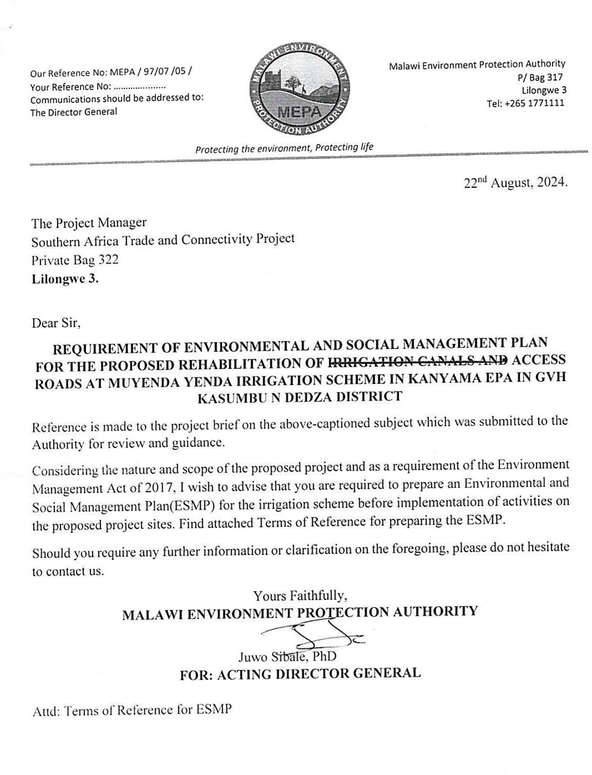

Annex 2. Terms of Reference from MEPA

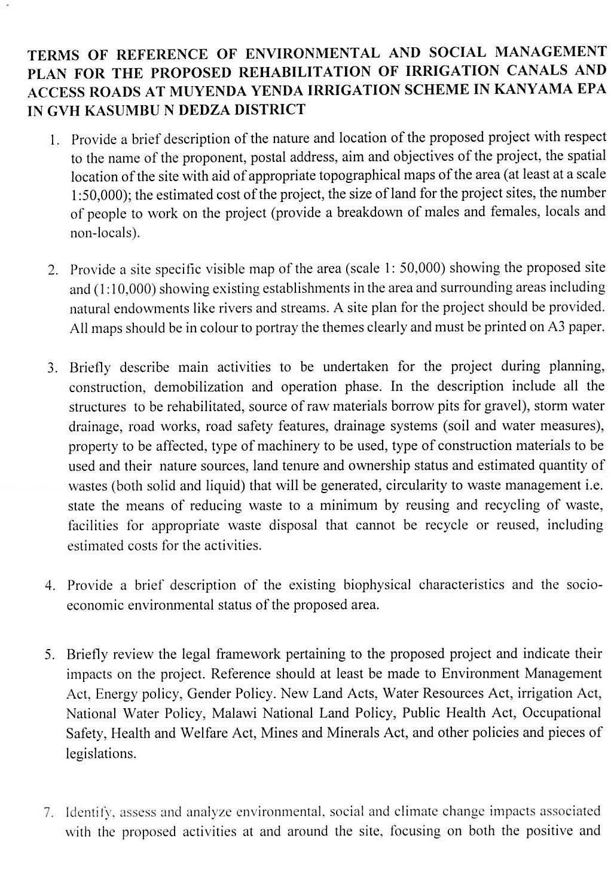
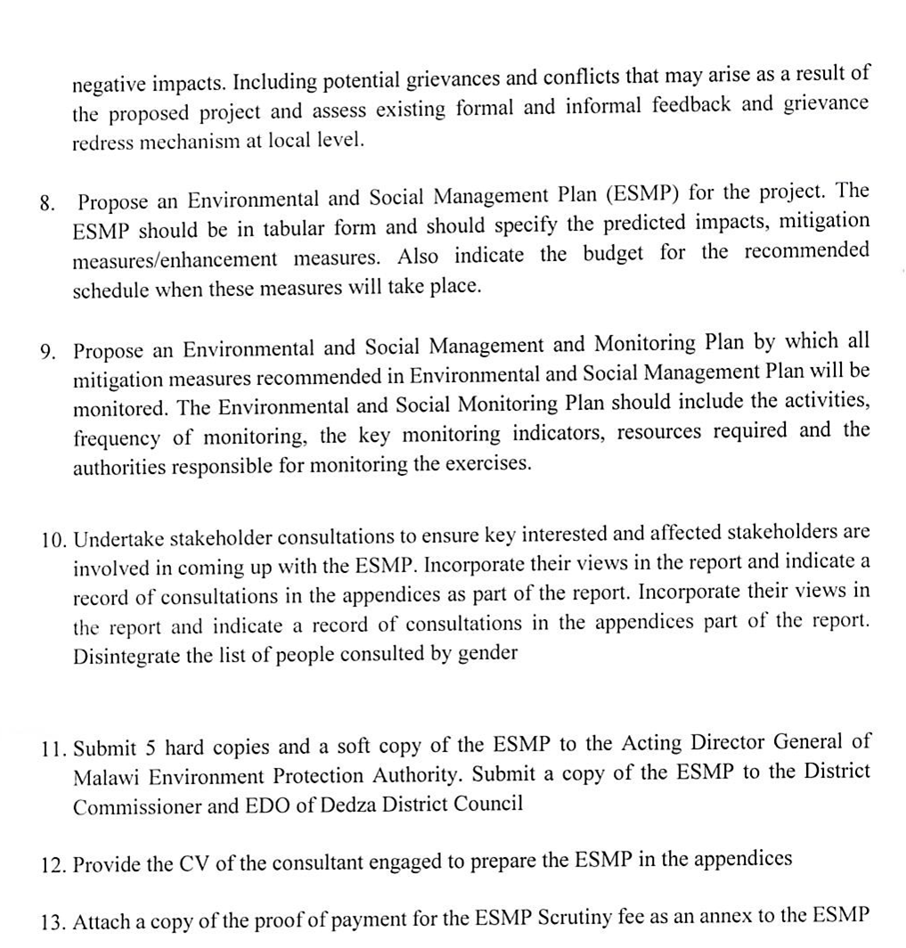

Annex 3a. List of Stakeholders Consulted
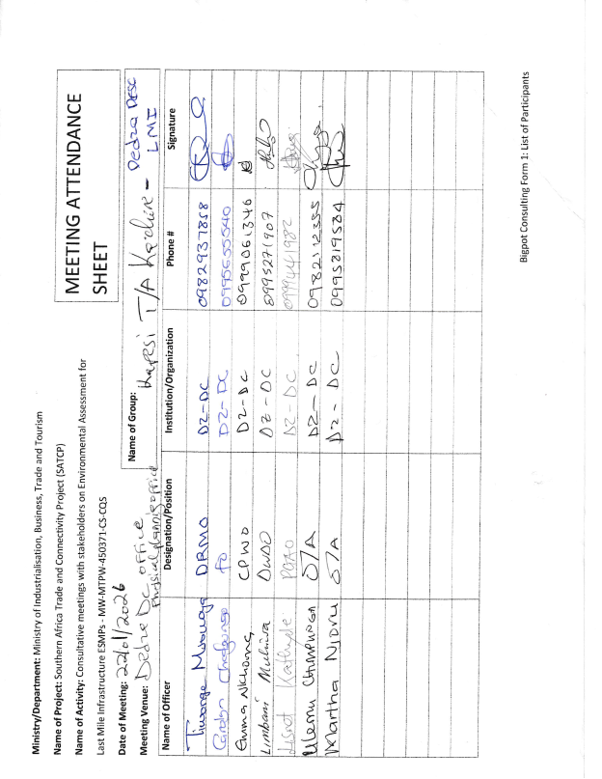

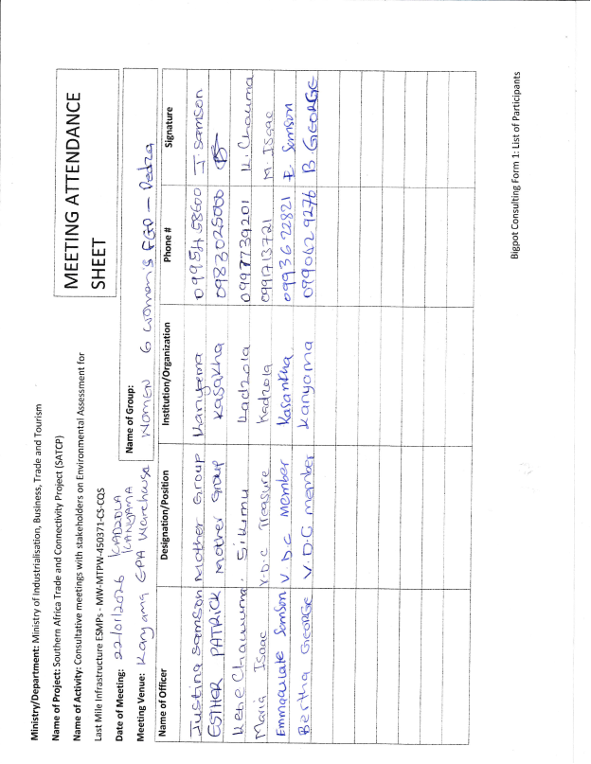

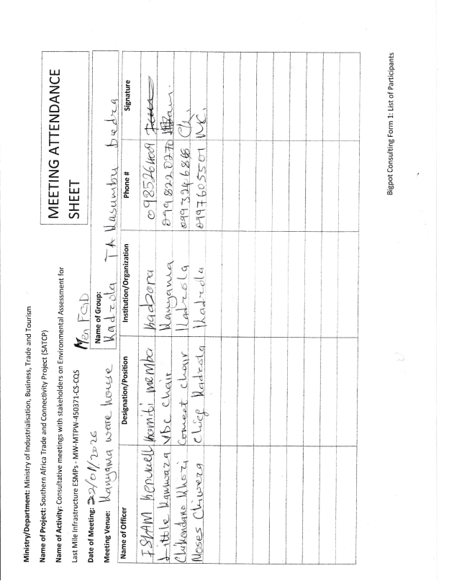

Annex 3b. Issues raised by stakeholders and how they have been addressed in the ESMP

SN | Raised By | Issue Raised | Response Based on the ESMP | Relevant ESMP Section(s)
1 | DESC | Need for clarity on project scope, especially whether the road will be widened or tarmacked. | The ESMP clarifies that the project involves rehabilitation of the existing access road within the current alignment and road reserve, with spot improvements, culverts, drainage works, concrete drifts and localized stabilization. It does not involve tarmacking or expansion into a new road corridor. | Chapter 1: Introduction and Background (Sections 1.3, 1.6, 1.7); Chapter 2: Project Description (Sections 2.2, 2.3)
2 | DESC | Concern that budget may be inadequate to manage E&S risks. | The ESMP includes a costed mitigation and monitoring plan, together with institutional responsibilities for implementation, supervision and regulatory oversight, providing a framework for resourcing environmental and social safeguards throughout the project. | Chapter 5: Environmental and Social Management Plan (Section 5.2 – ESMMP; Section 5.3 – Institutional Arrangements and Implementation Capacity)
3 | DESC | Lack of early disclosure of screening reports, briefs and designs. | The ESMP incorporates a Stakeholder Engagement Framework that identifies MoTPW, District Council/DESC and communities as key stakeholders and sets out procedures for disclosure, consultation and feedback during implementation. | Section 1.11 Potential Users of the ESMP; Chapter 5 (Section 5.3 – Institutional Arrangements); Annex 11: Stakeholder Engagement Framework
4 | DESC | Irrigation canal and irrigation scheme are sensitive features requiring protection. | The ESMP recognises the irrigation scheme, canals, agricultural fields and the river crossing as sensitive receptors and provides mitigation for drainage protection, access continuity and prevention of sedimentation and pollution. | Section 1.10 Land Tenure and Land Requirement; Section 4.2.5 Water Resources; Section 4.2.10 Implications for the Project; Chapter 5 (Section 5.2 – ESMMP rows on water resources and livelihoods)
5 | DESC | Graveyard close to the road is a strict no-go area. | The ESMP identifies the community graveyard as a sensitive cultural receptor and requires that it be avoided during works. A Chance Find Procedure and cultural heritage protection measures guide contractors if any remains or artefacts are encountered. | Section 1.10 Land Tenure and Land Requirement; Section 4.3.1 Population and Demographic Structure / settlement pattern; Chapter 3: Policy and Legal Framework (World Bank OP/BP 4.11 / Physical Cultural Resources); Annex 7: Chance Find Procedure; Chapter 5 (Section 5.2 – ESMMP cultural heritage rows)
6 | DESC | Wetland/dambo and downslope livestock-use area may be affected. | The ESMP identifies wetlands, seasonal drainage lines, low-lying areas and the Mwendayekha River system as environmentally sensitive features and includes drainage design, erosion control and pollution-prevention measures tailored to these areas. | Section 4.2.1 Topography; Section 4.2.4 Climate and Climate Change Risks; Section 4.2.5 Water Resources; Section 4.2.10 Implications for the Project; Chapter 5 (Section 5.2 – ESMMP rows on erosion and water resources)
7 | DESC | Existing drainage structures may be blocked, damaged or undersized. | The ESMP and detailed design provide for rehabilitation of existing culverts, new culvert and box-culvert construction, earth drains and scour checks to improve stormwater conveyance and reduce flood and erosion risks. | Chapter 2: Project Description (Sections 2.2 and 2.3 – Summary of Engineering Works); Chapter 5 (Section 5.2 – drainage/erosion mitigation)
8 | DESC | Risk of contractors abstracting irrigation or domestic water and causing conflict. | The ESMP stipulates that construction water should be sourced from approved boreholes, licensed suppliers or authorised sources, subject to applicable permits, and includes measures to protect river and irrigation water resources from over-abstraction and pollution. | Section 2.6 Material Requirements and Sources; Section 4.2.5 Water Resources; Chapter 3 (Statutory Approvals / Table of Licences); Chapter 5 (Section 5.2 – water abstraction and pollution prevention)
9 | DESC | Risk of cement runoff, sedimentation and water contamination during concrete works. | The ESMP identifies water pollution and sedimentation as key risks and includes mitigation such as controlled batching, containment of wash-water, bunded fuel and chemical storage, proper waste handling and protection of watercourses. | Chapter 5: Environmental and Social Management Plan (Section 5.2 – ESMMP rows on water pollution and erosion); Annex 10: Waste Management Framework
10 | DESC | Works programme should consider rainfall and farming seasons. | The ESMP discusses seasonal rainfall, climate variability and agricultural calendars, and emphasises scheduling of works, drainage control and access management to minimise disruption to farming and reduce erosion risks. | Section 4.2.4 Climate and Climate Change Risks; Section 4.3.2 Education and Livelihoods (agriculture); Section 4.4 Overall Implications; Chapter 5 (Section 5.2 – timing and access mitigation)
11 | DESC | Borrow pits and spoil disposal could create dangerous pits and long-term degradation. | The ESMP includes a Borrow Pit Rehabilitation Framework that requires approvals, landowner consent, topsoil management, safety measures, progressive rehabilitation and formal handover of restored sites. | Chapter 2 (Section 2.6 Material Requirements and Sources); Chapter 5 (Section 5.2 – borrow pits/spoil rows); Annex 5: Borrow Pit Rehabilitation Framework
12 | DESC | Need for a clear waste management plan, especially if camps are established. | The ESMP requires a site-specific Waste Management Plan as part of the C-ESMP, identifies expected waste streams and sets out segregation, storage, transport and disposal requirements for hazardous and non-hazardous waste. | Chapter 2 (Section 2.8 Waste and Waste Management; Section 2.7 Worker Accommodation, if applicable); Chapter 5 (Section 5.2 – waste management rows); Annex 10: Waste Management Framework
13 | DESC | Houses close to the road, borehole near alignment, and access to schools/health facilities create social sensitivity. | The ESMP baseline documents settlement concentration near Kanyenda/Kanyama, nearby boreholes and social services, and community reliance on the road. Mitigation includes access management, traffic control, dust suppression and community safety measures. | Section 4.3.1 Population and Demographic Structure; Section 4.3.2 Education and Literacy / access to services; Section 4.2.5 Water Resources; Section 4.2.10 Implications; Chapter 5 (Section 5.2 – traffic, dust and access mitigation)
14 | DESC | High proportion of female-headed households and vulnerable people requires inclusion. | The ESMP notes a youthful and slightly female-majority population, a high proportion of female-headed households and vulnerable groups, and calls for gender-responsive engagement, protection of vulnerable people and inclusive GRM access. | Section 4.3 Socio-economic Environment (especially 4.3.1); Section 4.4 Implications; Chapter 5 (Section 5.2 – social/GBV rows; Section 5.3 – stakeholder engagement and GRM)
15 | DESC | Need to maintain access for farmers and produce buyers during construction. | The ESMP identifies temporary access disruption as a key impact and requires temporary access routes/crossings, advance notice to users, and prompt restoration of access for irrigation users, farmers and other road users. | Chapter 5 (Section 5.2 – ESMMP rows on access disruption and livelihoods)
16 | DESC | GBV/SEA/SH risks due to proximity of homes and contractor presence. | The ESMP includes SEA/SH-sensitive measures: Codes of Conduct, worker training, a GBV Action Plan, confidential reporting pathways and GRM linkages for sensitive cases, in coordination with local service providers. | Chapter 3: Policy and Legal Framework (World Bank GBV/SEA/SH requirements); Chapter 5 (Section 5.2 – GBV/SEA/SH rows); Annex 4: Sample Code of Conduct; Annex 8: Labour Management Guidelines; Annex 13: SATCP LMI GRM Protocol
17 | DESC | Community health and safety risks from excavations, borrow pits, standing water, slippery concrete, traffic. | The ESMP sets out mitigation for traffic safety, excavation and borrow-pit safety, OHS and public health, including signage, barriers, controlled access, PPE, first aid and traffic management around works. | Chapter 5 (Section 5.2 – community health, traffic and OHS rows); Annex 11: Traffic Management Framework; Annex 5: Borrow Pit Rehabilitation Framework
18 | DESC | Local labour should be prioritised, with gender inclusion and no child labour. | The ESMP states that most labour will be locally recruited, promotes gender inclusion and requires compliance with labour legislation, written contracts, PPE provision, Codes of Conduct and strict prohibition of child labour. | Chapter 2 (Section 2.5 Labour Requirements); Chapter 3 (Employment Act, Child Care, Protection and Justice Act); Chapter 5 (Section 5.2 – labour and working conditions rows); Annex 8: Labour Management Guidelines; Annex 4: Code of Conduct
19 | DESC | Wage disputes, lack of contracts, and need for grievance handling for workers. | The ESMP provides for labour management through contractor obligations, written contracts, worker induction and access to a dedicated worker GRM channel linked to the overall project GRM and overseen by the Ministry of Labour. | Chapter 3: Policy and Legal Framework (labour); Chapter 5 (Section 5.2 – labour/GRM rows; Section 5.3 – institutional roles); Annex 13: SATCP LMI GRM Protocol
20 | DESC | DESC wants an active monitoring role, but has fuel/logistics constraints. | The ESMP assigns monitoring and coordination roles to the District Council/DESC alongside MoTPW, the Supervising Consultant and MEPA, and acknowledges the need for joint inspections, GRM support and logistical facilitation through the project. | Chapter 3 (Section 3.4 Institutional Framework); Chapter 5 (Section 5.3 – Institutional Arrangements and Implementation Capacity); Table of statutory approvals in Chapter 3
21 | Women’s FGD | Uncertainty over whether the road will be tarmac or gravel and what exactly will be built. | The ESMP clarifies that the intervention is rehabilitation of an existing gravel feeder/access road with culverts, concrete drifts, drainage works and localised stabilisation, not upgrading to a paved/tarmac standard. | Chapter 1 (Sections 1.3, 1.6, 1.7); Chapter 2 (Sections 2.2, 2.3)
22 | Women’s FGD | Crop fields, boreholes and roadside businesses may be affected. | The ESMP recognises fields, boreholes/wells and roadside businesses as sensitive receptors and provides for maintaining works within the existing corridor, managing temporary disturbances and protecting water points and livelihoods. | Section 1.10 Land Tenure and Land Requirement; Section 4.2.5 Water Resources; Section 4.3.1–4.3.3; Chapter 5 (Section 5.2 – land/livelihoods and water rows)
23 | Women’s FGD | Dust, noise, traffic and risks to children during construction. | The ESMP identifies dust, noise and traffic hazards as key construction impacts and includes dust suppression, working-hours controls, signage, flaggers and community awareness, with particular attention to schools and residential areas. | Chapter 4 (Section 4.2.4 Climate and Section 4.2.10 Implications); Chapter 5 (Section 5.2 – air quality/noise/traffic safety rows); Annex 11: Traffic Management Framework
24 | Women’s FGD | Boreholes and wells should be protected during construction. | The ESMP identifies household water points as sensitive features and requires pollution prevention, safe siting of works and waste areas, controlled abstraction and immediate repair of any accidental damage. | Section 4.2.5 Water Resources; Section 4.2.9 Sanitation and Waste Management; Chapter 5 (Section 5.2 – water protection rows); Annex 10: Waste Management Framework
25 | Women’s FGD | Need for designated waste disposal and proper construction waste handling. | The ESMP includes a waste management matrix and Waste Management Framework requiring on-site segregation, safe storage, transport to approved facilities and a ban on open dumping or burning. | Chapter 2 (Section 2.8 Waste and Waste Management); Chapter 5 (Section 5.2 – waste rows); Annex 10: Waste Management Framework
26 | Women’s FGD | GBV risks, early marriage and need for community-led awareness. | The ESMP provides GBV/SEA/SH prevention and response measures, including CoCs, awareness campaigns, collaboration with service providers and a GRM pathway for sensitive cases, with emphasis on engaging women and community structures. | Chapter 3 (World Bank GBV/SEA/SH requirements); Chapter 5 (Section 5.2 – GBV/SEA/SH rows); Annex 4: Code of Conduct; Annex 8: Labour Management Guidelines; Annex 13: GRM Protocol; Annex 11: Stakeholder Engagement Framework
27 | Women’s FGD | Need for GRM committee with chiefs, women, VDC/ADC and mother groups. | The ESMP establishes a multi-tier GRM that builds on community structures and allows representation from women, youth, VDC/ADC and other groups on community-level GRM committees, while maintaining independence and clear referral pathways. | Chapter 5 (Section 5.3 – GRM/Institutional Arrangements); Annex 13: SATCP LMI GRM Protocol; Annex 11: Stakeholder Engagement Framework
28 | Women’s FGD | The graveyard must not be encroached upon. | The ESMP explicitly identifies the graveyard as a no-go area and includes cultural heritage protection and Chance Find procedures to ensure no disturbance of graves or sacred sites. | Section 1.10 Land Tenure and Land Requirement; Section 4.3.1 / 4.3.2 (settlement and cultural features); Annex 7: Chance Find Procedure; Chapter 5 (Section 5.2 – cultural heritage rows)
29 | Women’s FGD | Women want inclusion in employment opportunities. | The ESMP promotes local recruitment with specific encouragement for hiring women in suitable unskilled and semi-skilled roles and requires non-discrimination in recruitment and employment practices. | Section 2.5 Labour Requirements; Section 4.3 Socio-economic Environment; Chapter 5 (Section 5.2 – employment and gender rows); Annex 8: Labour Management Guidelines
30 | Women’s FGD | Fear of crop loss or land disputes despite statement that no land acquisition is planned. | The ESMP confirms that works are confined to the existing road corridor and that no land acquisition or displacement is envisaged, while acknowledging potential temporary crop or access disturbance and providing mitigation and GRM procedures to address any such cases. | Section 1.10 Land Tenure and Land Requirement; Section 4.2.10 Implications; Chapter 5 (Section 5.2 – land/livelihoods and GRM rows)
31 | Men’s FGD | The community wants better road access because the missing crossing/poor road raises transport costs. | The ESMP justifies the subproject in terms of improved access to the irrigation scheme, reduced transport costs, enhanced market connectivity and better access to services. | Chapter 1 (Section 1.5 Justification of the Project; Section 1.6 Objectives); Chapter 7 (if present – Project Benefits) / Executive Summary
32 | Men’s FGD | Concern that some community members expected a bridge or stronger structure at the river crossing. | The ESMP and DED specify a new engineered crossing (box culvert and related works) at the river crossing, combined with drainage and slope stabilisation to improve reliability, and clarify this in the project description. | Chapter 2 (Sections 2.2 and 2.3 – Summary of Engineering Works); Annex 14: Project Design Drawings
33 | Men’s FGD | Forest patches and trees may be affected by works. | The ESMP notes remaining vegetation and forest patches and requires limiting clearance to the defined footprint, avoiding unnecessary tree removal and implementing re-vegetation or tree planting where disturbance occurs. | Section 4.2.6 Flora; Section 4.2.10 Implications; Chapter 5 (Section 5.2 – biodiversity/vegetation rows)
34 | Men’s FGD | Borrow pits and road safety are major concerns. | The ESMP addresses borrow pit siting and rehabilitation and road safety through the Borrow Pit Rehabilitation Framework and Traffic Management Framework, including signage, speed control and safe detours. | Chapter 2 (Section 2.6 Material Requirements); Chapter 5 (Section 5.2 – borrow pits and traffic safety rows); Annex 5: Borrow Pit Rehabilitation Framework; Annex 11: Traffic Management Framework
35 | Men’s FGD | Need for safe water and sanitation during construction. | The ESMP requires provision of safe drinking water, sanitation and hygiene facilities for workers and proper management of effluent and solid waste at any camps or work sites. | Chapter 2 (Section 2.7 Worker Accommodation; Section 2.8 Waste and Waste Management); Chapter 5 (Section 5.2 – worker health and sanitation rows)
36 | Men’s FGD | Contractors should avoid intoxication, follow rules and work through chiefs to reduce GBV and social tension. | The ESMP mandates Codes of Conduct, worker induction on community norms and GBV/SEA/SH, enforcement of misconduct sanctions and structured engagement with local leadership through the Stakeholder Engagement Plan and GRM. | Annex 4: Code of Conduct; Annex 11: Stakeholder Engagement Framework; Annex 13: GRM Protocol; Chapter 5 (Section 5.2 – GBV/behaviour rows)
37 | Men’s FGD | Employment should prioritise locals and be fair to both men and women. | The ESMP supports local labour recruitment and gender-balanced opportunities and notes positive socio-economic impacts from fair, inclusive short-term employment. | Section 2.5 Labour Requirements; Section 4.3 Socio-economic Environment; Chapter 5 (Section 5.2 – employment and gender rows)
38 | Men’s FGD | Need for humps/signage and clear alternative routes during construction. | The ESMP includes a Traffic Management Framework and mitigation for access disruption, specifying signage, temporary traffic calming measures, flaggers and safe detours where necessary. | Chapter 5 (Section 5.2 – traffic safety/access rows); Annex 11: Traffic Management Framework
39 | DESC; Women’s FGD; Men’s FGD | Need for strong drainage, climate resilience and protection from erosion/flooding. | The ESMP consistently identifies drainage failure, erosion, flooding and climate risk as key issues and embeds culverts, earth drains, scour protection, slope stabilisation and climate-sensitive design and maintenance measures. | Chapter 2 (engineering works); Chapter 4 (Section 4.2.4 Climate; Section 4.2.5 Water Resources; Section 4.2.10 Implications); Chapter 5 (Section 5.2 – erosion/drainage rows)
40 | DESC; Women’s FGD; Men’s FGD | Need for continued coordination and enforcement during implementation. | The ESMP defines a multi-level implementation and oversight structure involving MoTPW, Contractor, Supervising Consultant, MEPA and Dedza District Council/DESC, supported by monitoring, reporting and GRM arrangements. | Chapter 3 (Section 3.4 Institutional Framework; Section 3.5 Summary of Approvals); Chapter 5 (Section 5.3 – Institutional Arrangements and Implementation Capacity)

Annex 4. Sample Code of Conduct for Contractors
1. Purpose and Scope
This Sample Code of Conduct (CoC) provides the minimum mandatory standards of behaviour for all personnel engaged in implementation of SATCP Last Mile Infrastructure (LMI) subprojects, including contractors, sub‑contractors, supervising consultants, suppliers, and all categories of workers (permanent, temporary and day workers). The annex serves as a framework and template for preparation of a project‑specific Contractor’s Code of Conduct, which shall be adapted by each Contractor to reflect the scope, risks, workforce composition and community context of the subproject, and submitted to the Supervising Consultant and the PIU for review and approval prior to mobilisation.
The project‑specific CoC shall apply to all personnel working on or in connection with the subproject and shall be communicated in a language and format that workers understand. Each worker shall sign the approved Code of Conduct as a condition of employment and shall receive induction and periodic refresher training on its requirements, including sanctions for non‑compliance.
The Code addresses risks associated with the following:
- Environmental and social management.
- Occupational health and safety (OHS).
- Labour influx and labour relations.
- Spread of communicable diseases, including HIV and AIDS.
- Sexual harassment (SH), sexual exploitation and abuse (SEA), and gender‑based violence (GBV).
- Child labour and child protection.
- Illicit behaviour, crime and corruption.
- Community health, safety and road safety.
Compliance with the approved Code of Conduct is a contractual obligation for the Contractor and all associated personnel, and a condition of employment on the project. The Contractor shall be responsible for enforcement of the Code at worksites, worker accommodation areas, haul routes and all other project‑related locations, while the Supervising Consultant and PIU shall monitor compliance as part of ESMP and contract implementation.
2. General Obligations
The Supervising Consultant shall ensure that the Contractor and all associated personnel:
a) Legal Compliance
Comply at all times with the laws, regulations, and standards of the Republic of Malawi, including the Environment Management Act (2017), labour laws, occupational safety legislation, and applicable World Bank safeguard requirements.
b) ESHS Planning Instruments
Prepare, implement, and maintain site-specific instruments prior to commencement of works, including:
- Environmental and Social Management Plan (ESMP);
- Health and Safety Management Plan (HSMP);
- HIV and AIDS Awareness Programme;
- Occupational Health and Safety Awareness Programme;
- Road Safety and Traffic Management Plan.
c) Occupational Health and Safety
Provide a safe and healthy working environment, including:
- Provision and compulsory use of appropriate Personal Protective Equipment (PPE);
- Prevention of avoidable accidents and injuries;
- Immediate reporting and correction of unsafe acts or hazardous conditions.
d) Traffic and Road Safety
Implement traffic safety measures, including:
- Temporary speed calming devices and speed-limit signage;
- Warning signs in villages, trading centres, schools, health facilities, and construction zones;
- Enforcement of safe driving practices by all project drivers.
e) Environmental Protection
Avoid unnecessary clearance of trees and vegetation, prevent conflicts over water resources, and ensure sustainable use of natural resources in consultation with local communities.
f) Pollution Prevention
Take all reasonable measures to prevent pollution of air, water, and soil, land degradation, and environmental damage, and ensure compliance with good international industry practice.
g) Worker and Public Safety
Install standard safety signs, barricades, and road markings during construction and after completion to protect workers, communities, and road users.
h) Sanitation and Welfare Facilities
Provide adequate sanitation facilities, including:
- Safe drinking water;
- Decent toilets and washing facilities at worksites and camps;
- Prohibition of open defecation.
i) Site Rehabilitation and Restoration
Restore all disturbed areas after construction, including borrow pits, quarries, stockpiles, camps, access roads, batching plants, fuel storage areas, and waste disposal sites, through landscaping, tree planting, and erosion-control measures.
3. Labour, Ethics, and Social Conduct
j) Non-Discrimination
Prohibit all forms of discrimination in recruitment, employment, and working conditions on the basis of gender, age, ethnicity, disability, religion, marital status, political affiliation, or other protected characteristics.
k) Fair Labour Practices
Adhere to Malawi labour laws by issuing written contracts to skilled and unskilled workers, respecting working hours, wages, and conditions of employment.
l) Prevention of Sexual Harassment
Strictly prohibit sexual harassment, including abusive language, inappropriate gestures, sexually suggestive behaviour, or culturally offensive conduct, particularly towards women and children.
m) Prevention of SEA/GBV
Prohibit any form of sexual exploitation, abuse, or violence, including:
- Exchange of money, goods, services, or employment for sex;
- Exploitative or degrading behaviour;
- Any sexual activity with minors (persons under 18), regardless of consent.
n) Child Protection and Child Labour
Prohibit child labour and all forms of child abuse, exploitation, or endangerment, and ensure children’s safety in and around project areas.
o) Conflict of Interest and Corruption
Avoid conflicts of interest and prohibit bribery, favouritism, or preferential treatment based on personal, financial, or family relationships.
p) Protection of Property and Assets
Safeguard project equipment, materials, and property; prohibit theft, vandalism, misuse, or waste of resources.
q) Grievance Reporting and Non-Retaliation
Ensure that workers and community members can report violations of this Code through established grievance mechanisms without fear of retaliation, provided the report is made in good faith.
4. Enforcement and Accountability
r) Acknowledgement and Sanctions
All workers and contractor personnel shall:
- Read, understand, accept, and sign this Code of Conduct as a condition of employment;
- Attend mandatory induction and refresher training on ESHS and SEA/GBV prevention.
Any violation of this Code of Conduct may result in disciplinary action, including:
- Verbal or written warnings;
- Suspension or dismissal;
- Termination of contract; and/or
- Referral to relevant legal authorities.
5. Contractor Certification
I, the undersigned, confirm that I have read and understood this Code of Conduct and commit to ensuring full compliance by all personnel engaged under this contract.
I Agree /
Name of Authorized Representative: ____________________________
Signature: ____________________________
Name of Company: ____________________________
Physical Address: ____________________________
Company Stamp: ____________________________
Date: ____________________________

Annex 5. Barrow Pit Rehabilitation Framework
(SATCP Last Mile Infrastructure Projects)
1. Introduction and Purpose
This Borrow Pit Rehabilitation Framework applies to all borrow pits identified and utilised under the SATCP Last Mile Infrastructure (LMI) projects. It sets out mandatory procedures for environmentally sound material extraction, operation, rehabilitation and closure of borrow pits so that material sourcing does not result in permanent land degradation, public safety hazards, or adverse impacts on surrounding communities and ecosystems.
The Framework provides the standard requirements that Contractors must follow when preparing site-specific Borrow Pit Management and Rehabilitation Plans for each borrow source they intend to use. These site-specific plans shall form part of the Contractor’s Environmental and Social Management Plan (C-ESMP) and shall be submitted to the Supervising Consultant and the PIU for review and approval prior to opening or using any borrow pit. The Framework shall also be applied within the site-specific ESMP to guide oversight, monitoring and verification of borrow-pit performance throughout construction and post-closure.
2. Project Context
Borrow pits are identified during the design and pre-construction phases of LMI subprojects based on geotechnical investigations undertaken under the Detailed Engineering Design (DED). These borrow pits may supply lateritic gravel, fill material, or other construction materials required for road rehabilitation, drainage works, and ancillary infrastructure.
At the planning stage, borrow pits are considered indicative material sources. Final selection, approval, and use shall be subject to field verification, landowner consent, environmental and social screening, and approval by relevant authorities.
3. Regulatory and Safeguards Framework
Borrow pit development, operation, and rehabilitation under SATCP LMI projects shall comply with:
- Environment Management Act (2017)
- MEPA Guidelines for Environmental Assessment (2025)
- SATCP ESMF
- World Bank OP/BP 4.01 and OP/BP 4.04 (where applicable)
- Approved ESMPs and DEDs for each LMI subproject
4. Borrow Pit Planning and Site Controls
Before opening or using any borrow pit, the Contractor shall:
- Obtain written approval from the Supervising Consultant and the relevant District Council.
- Secure documented landowner consent and confirmation from the appropriate Traditional Authority.
- Verify land tenure status and agree on access, use, rehabilitation, and handover conditions.
- Clearly demarcate the borrow pit footprint and access routes.
- Strip and stockpile topsoil separately for use during rehabilitation.
- Install warning signage and temporary fencing, particularly where borrow pits are located near settlements, agricultural land, footpaths, or grazing areas.
5. Key Environmental and Social Risks
Typical risks associated with borrow pits under LMI projects include:
- Loss of productive agricultural land
- Open excavations posing injury risks to people and livestock
- Standing water leading to mosquito breeding
- Soil erosion and sediment runoff into nearby streams or wetlands
- Visual scarring of the landscape
- Community dissatisfaction where land is not adequately restored
6. Rehabilitation Objectives
Borrow pit rehabilitation under SATCP LMI projects shall aim to:
- Restore land to a safe, stable, and productive condition
- Prevent erosion, standing water, and slope instability
- Reintegrate rehabilitated sites into agricultural or community land use
- Eliminate public health and safety hazards
- Meet landowner, community, and District Council expectations
7. Rehabilitation Measures
7.1 Progressive Rehabilitation
- Implement rehabilitation progressively, commencing immediately after material extraction in each section.
- Phase excavation activities to minimise the total open area at any given time.
7.2 Backfilling and Reshaping
- Reuse overburden and unsuitable material for backfilling.
- Reshape excavated areas to stable slopes (maximum 1:3).
- Partially backfill deep excavations to eliminate water accumulation.
7.3 Topsoil Replacement
- Evenly spread stockpiled topsoil over rehabilitated surfaces.
- Ensure sufficient topsoil depth to support revegetation or agricultural reuse.
7.4 Drainage and Erosion Control
- Restore surface drainage to natural flow patterns.
- Apply erosion control measures such as contour shaping, grass strips, or stone pitching where required.
7.5 Revegetation
- Revegetate rehabilitated sites using indigenous grass species and locally appropriate tree species, subject to landowner preference.
- Prioritise vegetation that supports soil stabilisation, shade provision, and community utility.
8. Safety and Community Protection
- Secure active borrow pits using fencing, barriers, or warning tape.
- Install clear warning signage in English and local languages.
- Eliminate vertical faces and open pits upon closure.
- Formally hand back rehabilitated sites to landowners after completion.
9. Post-Use Land Options
Subject to agreement with landowners and District Councils, rehabilitated borrow pits may be converted into:
- Agricultural land
- Community woodlots
- Grazing areas
- Controlled water retention areas (only where approved, engineered, and safe)
10. Roles and Responsibilities
Actor | Responsibility
Contractor | Implement borrow pit management and rehabilitation
Supervising Consultant | Approve, supervise, and certify rehabilitation works
District Council / DESC | Community liaison and site verification
Landowners / Traditional Authorities | Accept rehabilitated land

11. Monitoring and Reporting
- Report borrow pit status in monthly ESMP compliance reports.
- Monitor indicators including number of rehabilitated sites, erosion evidence, water ponding, and vegetation establishment.
- Conduct final inspections prior to issuance of completion certificates.
12. Budgeting
- Fully include borrow pit rehabilitation costs in the Contractor’s BoQs and C-ESMP.
- Prohibit approval of any borrow pit without a costed and approved rehabilitation provision.
13. Completion and Handover
Consider borrow pits closed only when rehabilitation is complete, sites are safe and stable, and formal handover documentation is signed by relevant parties.
14. Conclusion
This Borrow Pit Rehabilitation Framework provides a consistent and enforceable approach for managing borrow pits across all SATCP Last Mile Infrastructure projects, ensuring Environmentally responsible material sourcing, protection of community interests, and full compliance with MEPA (2025) and World Bank safeguards.

Annex 6. Traffic Management Framework
1. Introduction
This Traffic and Access Management Framework (TAMF) has been prepared for the Southern Africa Trade and Connectivity Project (SATCP) – Last Mile Infrastructure (LMI) subprojects, including feeder road rehabilitation, drainage improvements, bridge/culvert works and associated construction activities. The Framework sets out the minimum requirements for planning, operating and monitoring construction-related traffic so that works are carried out safely and with limited disruption to local communities and road users.
The Framework provides mandatory guidance for the preparation and implementation of site-specific Traffic and Access Management Plans (TAMPs) by Contractors. For each subproject, the Contractor shall prepare a TAMP consistent with this Framework and submit it to the Supervising Consultant and the SATCP PIU/State Agency for Transport and Construction Projects for review and approval prior to commencement of construction works.
The TAMF aims to ensure that all construction-related traffic—vehicles, equipment and personnel—is managed safely, efficiently and in an environmentally and socially responsible manner, while minimising risks and disruptions to communities, vulnerable road users, businesses, and existing transport infrastructure.
2. Purpose and Objectives
Construction activities will increase vehicular and machinery traffic within worksites and along existing regional and community roads. Without effective management, such traffic may:
- Interfere with normal traffic and pedestrian movements;
- Increase risks of accidents and injuries to workers and the public;
- Damage existing road infrastructure;
- Generate dust, noise, congestion, and community nuisance.
The objectives of this Framework are to:
- Promote safe interaction between construction traffic, pedestrians, and local road users;
- Minimize Environmental and social risks associated with construction traffic;
- Guide the planning, use, and rehabilitation of access roads and haul routes;
- Ensure site-specific traffic impacts are addressed through appropriate design, scheduling, signage, and controls.
3. Access Roads and Haul Routes
a) Planning and Approval
The Contractor shall prepare detailed layout plans for all proposed access roads and haul routes. These plans shall:
- Be submitted to the Supervising Consultant for approval;
- Be accompanied by written consent from affected landowners, Traditional Authorities, or village leadership where applicable.
b) Use of Existing Infrastructure
Existing roads shall be used wherever feasible. Construction of temporary access roads shall only be permitted where unavoidable and upon approval by the Site Manager and relevant stakeholders. Construction of temporary diversions, if required, will require approval of the District and the World Bank.
c) Environmental Considerations
Planning of haul routes shall consider:
- Vegetation and sensitive habitats;
- Watercourses and drainage patterns;
- Existing land use;
- Proximity to households, schools, markets, and health facilities.
d) Construction, Maintenance, and Rehabilitation
The Contractor shall be responsible for:
- Construction and routine maintenance of access and haul roads;
- Installation of drainage infrastructure at early stages to prevent erosion;
- Decommissioning and rehabilitation of temporary roads upon completion of works.
Topsoil shall be stripped and stockpiled prior to construction and reused during rehabilitation. Disturbed areas shall be revegetated using indigenous species where applicable.
e) Dust Suppression
Dust control measures shall be implemented, including:
- Regular watering of access and haul roads;
- Enforcement of speed limits (maximum 30 km/h near settlements);
- Use of dust palliatives where necessary.
Dust suppression activities shall be recorded and reported as part of environmental compliance monitoring.
4. Traffic Management and Safety Measures
Each site-specific Traffic and Access Management Plan shall include, at minimum, the following components:
4.1 Traffic Control and Signage
- Clearly defined access routes within and around worksites;
- Advance warning signage along haul routes and near construction zones;
- Temporary traffic signs, barriers, and flag persons where required;
- Establishment and enforcement of speed limits and control points.
Where bridge or culvert works require road occupation, temporary bypasses or diversions shall be constructed prior to commencement of works to avoid full road closures.
5. Transport of Materials
The Contractor shall ensure that:
- Vehicles transporting fine or granular materials are fully covered with tarpaulins to prevent dust and spillage;
- Any spillage or pollution along transport routes is cleaned immediately at the Contractor’s cost;
- Delivery schedules are aligned with off-peak hours to reduce congestion and disturbance to communities.
6. Driver Requirements and Conduct
All project drivers and equipment operators shall:
- Hold valid licenses appropriate to the vehicles or machinery operated;
- Be trained and certified in defensive driving and road safety;
- Receive training in eco-driving to reduce fuel consumption and emissions;
- Undergo project induction covering pedestrian safety, fatigue management, and substance abuse prevention.
Driver working hours shall be managed to prevent fatigue, ensuring adequate rest periods. The Contractor shall maintain up-to-date driver registers and dust suppression logs.
7. Interaction with Communities and Sensitive Areas
High-risk interaction areas such as schools, markets, trading centres, and health facilities shall be identified and mapped. Site-specific mitigation measures shall be implemented, including:
- Temporary pedestrian crossings;
- Traffic calming devices (speed bumps, rumble strips);
- Warning lights, reflectors, and signage;
- Temporary bypasses where necessary.
Community engagement shall be coordinated with the Stakeholder Engagement Framework (Annex 11) to ensure awareness of traffic changes and safety measures.
8. Monitoring, Enforcement, and Reporting
The Contractor’s Traffic and Access Management Plan shall include:
- An accident and incident register with clear reporting procedures;
- Random alcohol and drug testing protocols for drivers;
- A penalty and disciplinary structure for non-compliance with traffic safety requirements;
- Regular monitoring of road conditions and prompt repair of damage caused by construction traffic;
- Monthly traffic management reports detailing:
  - Traffic incidents and near misses;
  - Dust and noise control performance;
  - Community complaints related to traffic;
  - Corrective actions undertaken.
The Supervising Consultant shall verify compliance and recommend corrective measures where deficiencies are identified.
9. Institutional Responsibilities
Actor | Key Responsibilities
Contractor | Prepare and implement site-specific TAMPs, ensure compliance
Supervising Consultant | Review, approve, and monitor TAMP implementation
SATCP / PIU | Oversight and enforcement
District Authorities | Local coordination and support
Traffic Police (where applicable) | Enforcement and incident response
10. Conclusion
This Traffic and Access Management Framework establishes mandatory requirements for safe, efficient, and environmentally responsible management of construction traffic under the SATCP Last Mile Infrastructure subprojects. Effective implementation of this Framework will reduce accident risks, protect communities, and ensure compliance with national legislation and World Bank safeguard requirements.
Site-specific Traffic and Access Management Plans shall be developed and approved prior to commencement of construction works and updated as necessary throughout project implementation.

Annex 7. Chance Find Procedure for Last Mile Infrastructure under SATCP

1. Introduction
This Chance Find Procedure sets out the protocol to be followed if previously unidentified cultural heritage is discovered during implementation of the SATCP Last Mile Infrastructure (LMI) subprojects. Cultural heritage may include, but is not limited to, archaeological materials, graves and burial sites, religious artefacts, sacred or ritual sites, and historical objects that were not identified during the initial environmental and social assessment. The procedure is to be applied by Contractors and Supervising Consultants on all worksites and along all associated project footprints, and ensures that any chance finds are managed in accordance with the Monuments and Relics Act (Cap 29:01) of Malawi and the World Bank’s OP/BP 4.11 on Physical Cultural Resources.
2. Purpose
The purpose of this procedure is to safeguard Malawi’s tangible cultural heritage by ensuring that any unexpected discoveries are handled with care and in accordance with legal and safeguard requirements. The procedure seeks to prevent unauthorized interference, preserve historical and cultural assets, and maintain respect for community traditions and sensitivities.
3. Scope
This procedure applies to all personnel involved in the project, including contractors, subcontractors, consultants, field workers, and any party engaged in construction, material sourcing, excavation, or related site activities. It is applicable to all locations along the project corridor, including campsites, borrow pits, material stockpiles, access roads, and working zones.
4. Definition of a Chance Find
A chance find is defined as any artifact, feature, structure, or site of cultural, historical, or religious significance that is discovered unexpectedly during the execution of project activities. Examples may include human remains, pottery fragments, stone tools, religious objects, altars, burial grounds, historical ruins, or sacred trees. These are typically items or sites not previously recorded or anticipated in the ESMP documentation.
5. Procedure to Follow in the Event of a Chance Find
If a chance find is encountered, the following steps must be followed:
- All work in the immediate vicinity must stop immediately. The affected area must be secured with a buffer zone of no less than 20 to 50 meters to prevent disturbance or looting.
- The Contractor must promptly inform the Supervision Consultant, the Project Implementation Unit (PIU) of the SATP, and the Department of Antiquities (DoA) within 24 hours.
- The DoA will dispatch a qualified cultural heritage or archaeological specialist to assess the nature, significance, and appropriate treatment of the discovery.
- Based on the expert assessment and consultations with relevant stakeholders, the cultural material may be preserved in situ, documented and relocated, or managed in accordance with traditional practices—such as holding customary ceremonies prior to relocating graves or sacred objects.
- No work should resume in the vicinity until the DoA has provided written clearance authorizing continuation. All findings must be properly recorded, photographed, and geotagged for documentation and reporting purposes.

6. Roles and Responsibilities
The Contractor is responsible for ensuring that all site personnel are trained in this procedure and for immediately halting work and protecting the area in the event of a discovery. The Supervision Consultant must verify contractor compliance and support the coordination of response efforts. The PIU is responsible for notifying the Department of Antiquities, facilitating expert engagement, and ensuring adherence to this procedure. The Department of Antiquities will lead assessments, determine the heritage value of the find, and authorize appropriate measures or clearance to resume work.
7. Training and Awareness
To ensure that all relevant personnel are aware of and can implement this procedure, pre-construction induction training will be provided to all workers and supervisors. This will include awareness of local cultural sensitivities and the importance of cultural heritage protection. Refresher training will be conducted every six months or upon the onboarding of new workers. On-site communication materials such as posters and briefing cards will be used to reinforce awareness.
8. Legal and Policy Basis
This procedure is grounded in the Monuments and Relics Act (Cap 29:01) of Malawi, which mandates the protection and reporting of archaeological discoveries and prohibits unauthorized disturbance of cultural resources. It is also aligned with the World Bank’s OP/BP 4.11 (Physical Cultural Resources), which requires Borrowers to avoid, minimize, or mitigate impacts on cultural heritage and to engage relevant communities and authorities in the process of managing heritage resources.
9. Reporting and Documentation
All chance finds must be documented in a standardized reporting format that includes the date and time of discovery, location coordinates (GPS), a physical description of the find, photographic records, and the actions taken. These reports must be submitted to the PIU, the Department of Antiquities, and included in the Contractor’s monthly E&S compliance reporting. Records of follow-up actions, assessments, and final clearance must also be retained.
10. Budget and Resources
A dedicated budget line will be included in the project’s Environmental and Social Management Plan (ESMP) to support implementation of the chance find procedure. This will cover costs associated with expert assessments, protective measures (e.g., fencing), documentation, stakeholder engagement, and cultural or ceremonial activities where required for the proper treatment of sacred or religious sites.

Annex 8: Labour Management Guidelines for Contractor Compliance and Preparation of Labour Management Plans (LMPs)

1. Purpose of these Guidelines
These Labour Management Guidelines are issued to guide Contractors in the preparation and implementation of project‑specific Labour Management Plans (LMPs) for SATCP Last Mile Infrastructure (LMI) road projects. They are not a standalone LMP; rather, they operationalise the project‑level Labour Management Procedures and relevant Malawi labour legislation for application at subproject and contract level.
Specifically, the Guidelines:
- Establish minimum labour and working‑conditions requirements that Contractors must meet on all SATCP LMI contracts.
- Clarify statutory obligations under applicable Malawi labour legislation (including the Employment Act, Occupational Safety, Health and Welfare Act, Gender Equality Act, Child Care, Protection and Justice Act, and Trafficking in Persons Act).
- Define the scope, structure and content expected in Contractor LMPs, including provisions on terms and conditions of employment, OHS, worker accommodation, Code of Conduct, SEA/SH and GBV, child labour, and grievance mechanisms.
- Provide direction on labour‑risk identification, mitigation and monitoring consistent with national law and World Bank requirements for managing social risks (OP/BP 4.01 and the Labour Management Procedures for SATCP).
All Contractors engaged under SATCP shall prepare a site‑specific Labour Management Plan (LMP) consistent with these Guidelines and the project‑level Labour Management Procedures, and submit it to the Supervising Consultant and PIU for review and approval prior to mobilisation. The approved LMP will form part of the Contractor’s C‑ESMP and will be monitored throughout implementation.
2. Legal and Policy Framework
Contractors must ensure their LMPs demonstrate compliance with:
- Employment Act (2000, as amended)
- Occupational Safety, Health and Welfare Act (1997)
- Gender Equality Act (2013)
- Child Care, Protection and Justice Act (2010)
- HIV and AIDS (Prevention and Management) Act (2018)
- Trafficking in Persons Act (2017)
- Public Health Act (1948)
- Applicable minimum wage regulations
- Relevant World Bank safeguards (OP/BP 4.01)
The LMP must clearly reference these instruments and describe how compliance will be operationalised.
3. Categories of Workers to be Covered
The Contractor’s LMP shall cover all categories of project workers, including:
- Direct workers (Contractor employees)
- Subcontracted workers
- Security personnel
- Primary supplier workers
The LMP must describe how labour standards will be applied to subcontractors and suppliers.
4. Minimum Content Requirements for Contractor LMPs
Each Contractor’s LMP must include, at a minimum, the following components:
4.1 Workforce Planning and Recruitment Procedures
The LMP must describe:
- Anticipated labour numbers by category and phase;
- Recruitment procedures;
- Local hiring strategies;
- Non-discrimination measures;
- Age verification procedures;
- Prohibition of forced labour and child labour;
- Record-keeping systems for employees.
Recruitment must comply with Sections 4, 5, 21, and 23 of the Employment Act.
4.2 Employment Conditions
The LMP shall demonstrate how the Contractor will ensure:
- Written contracts for all workers;
- Clear specification of wages, hours, and benefits;
- Compliance with statutory working hours and rest days;
- Provision of annual, sick, and maternity leave;
- Equal pay for equal work;
- Proper termination procedures and severance entitlements.
4.3 Occupational Health and Safety (OHS)
The LMP must include:
- Site-specific OHS risk assessment;
- Hazard identification and control measures;
- PPE provision policy;
- Toolbox talks and safety training plan;
- Accident and incident reporting procedures;
- Emergency response plan;
- First aid and medical arrangements;
- Special protection for young workers (14–18 years).
OHS provisions must comply with the Occupational Safety, Health and Welfare Act (1997).
4.4 Worker Welfare Facilities
The LMP must outline provision of:
- Adequate sanitation facilities (segregated by gender);
- Potable water;
- Waste management systems;
- Rest areas and shelters;
- Medical and first aid facilities;
- Safe worker accommodation (where applicable).
4.5 Gender, GBV, SEA/SH and Child Protection
The LMP shall include:
- A mandatory Code of Conduct;
- GBV/SEA/SH awareness training programme;
- Zero tolerance policy;
- Confidential reporting pathways;
- Sanctions for misconduct;
- Measures to prevent exploitation of minors.
The LMP must align with the project’s GBV Management Framework.
4.7 Workers Grievance Redress Mechanism (WGRM)
The Contractor’s LMP must establish a Workers Grievance Redress Mechanism that:
- Is free and accessible;
- Protects confidentiality;
- Prohibits retaliation;
- Provides defined timelines for resolution;
- Maintains grievance records;
- Allows escalation procedures.
4.8 Monitoring and Reporting
The LMP must describe:
- Internal compliance monitoring procedures;
- Monthly labour reporting requirements;
- OHS statistics reporting;
- Training records;
- Grievance reporting;
- Supervision Consultant oversight arrangements.
5. Key Labour Risks in LMI Road Projects
Contractors shall assess and manage risks including:
- Workplace injuries and accidents;
- Exposure to dust, noise, and hazardous materials;
- Spread of communicable diseases;
- Child labour and forced labour risks;
- Gender-based violence;
- Labour disputes;
- Discrimination and exclusion of vulnerable groups;
- Resource competition due to labour influx.
6. Review and Approval
No Contractor shall mobilise to site until:
- A project-specific Labour Management Plan has been prepared;
- The LMP has been reviewed and approved by the Supervision Consultant and SATCP;
- The Code of Conduct has been signed by all personnel;
- Induction training on labour standards and GBV has been conducted.
7. Enforcement
Failure to comply with these Guidelines and approved LMP provisions may result in:
- Suspension of works;
- Withholding of payment;
- Contractual penalties;
- Termination of contract.

Annex 13. SATCP LMI Grievance Redress Mechanism (GRM) Protocol
1. Introduction
This Grievance Redress Mechanism (GRM) Protocol has been developed for the Southern Africa Trade and Connectivity Project (SATCP) – Last Mile Infrastructure (LMI) subprojects, including feeder road rehabilitation, drainage improvements, culvert/bridge works and associated construction activities. The GRM provides a structured, project-wide system for receiving, recording, assessing and resolving concerns, queries and complaints from communities, workers and other stakeholders.
The GRM serves as the first line of response to stakeholder concerns, complementing statutory and other grievance channels (e.g. courts, police, labour authorities). It aims to resolve issues as close as possible to the point of impact, using dialogue and collaborative problem-solving, and thereby maintain constructive relations between the project, affected communities and workers.
Construction activities under SATCP LMI are expected to generate grievances related to, among others, land and assets, labour and working conditions, occupational and community health and safety, environmental impacts, and gender-based violence / sexual exploitation and abuse / sexual harassment (GBV/SEA/SH) and trafficking in persons (TIP). Contractors are required to develop and implement site-specific GRM Management Plans consistent with this Protocol.
The GRM will use two complementary modes of recording grievances:
- Manual submission (e.g. verbal, paper forms, grievance boxes, community meetings); and
- Electronic recording in a central database to allow tracking, escalation, and consolidated reporting across SATCP LMI.
Electronic recording will be promoted to support timely management oversight, automatic flagging of overdue cases, and real-time analysis of grievance trends.
2. Categories and Types of Grievances
The GRM will receive and register all grievances related to SATCP LMI activities, whether from project-affected community members, workers or institutions. Grievances may be submitted:
- In person to GRM committee members or project staff.
- By phone, SMS, WhatsApp or project-designated hotlines.
- Via grievance boxes at key locations.
- Through written letters or emails to the PIU, Supervising Consultant or Contractor.
The following categories and examples guide classification (non-exhaustive):
2.1 Construction-related Community Concerns and Livelihood Continuity
- Reinstatement disputes – Disputes about reinstatement of inadvertently damaged crops, structures or roadside assets during construction.
- Access disruption – Concerns about temporary loss of access to homes, services, schools or markets during construction.
- Livelihood continuity – Alleged disruption to roadside businesses or inadvertent crop damage during construction.
2.2 Health and Safety (Workers and Community)
- Safety violations – Inconsistent handling of safety breaches, inadequate enforcement of rules.
- Accidents and injuries – Workplace or traffic accidents, concerns about the response, or perceived unfair dismissal following an accident.
- Health and safety hazards – Exposure to hazardous materials or unsafe conditions, lack or poor quality of PPE.
- Community safety complaints – Dust, noise, blocked accesses to schools/health centres/markets, speeding construction vehicles, unsafe detours, open borrow pits or excavations.
2.3 Labour / Contractor Issues
- Payment disputes – Delayed payment, underpayment or non-payment.
- Working conditions – Poor accommodation, sanitation, unsafe or unhealthy work environments.
- Wage disputes – Wage rates, overtime, non-payment of benefits.
- Discrimination and harassment – Workplace discrimination, bullying, harassment.
- Contract interpretation – Disagreements about terms, duration, or conditions of contracts.
2.4 Gender and Social Inclusion (GSI)
- Gender discrimination – Unequal treatment of women and men in recruitment, pay or opportunities.
- Social exclusion – Exclusion of youth, persons with disabilities or vulnerable groups from employment or consultations.
- Cultural insensitivity – Disrespect for local customs, norms or religious practices.
2.5 Environmental
- Pollution and waste management – Improper waste disposal, dust, noise, spills, or other pollution.
- Community environmental impacts – Perceived damage to water sources, agricultural land, forests or communal resources.
- Natural resource damage – Deforestation, degradation of wetlands, unsustainable material extraction.
2.6 General Project Issues
- Project delays and disruptions – Concerns about prolonged construction or schedule slippage affecting access.
- Communication gaps – Lack of information, unclear messages about project scope, timing and impacts.
- Stakeholder engagement – Inadequate consultation, lack of feedback, or perceptions of exclusion.
2.7 GBV / SEA/SH and TIP (Special Handling)
GBV/SEA/SH and TIP-related grievances require special, survivor-centred handling. These cases will:
- Be received through any GRM entry point, but not investigated by community or project committees.
- Be immediately and confidentially referred (with consent) to trained focal points and survivor service providers/police, in line with the project’s GBV/SEA/SH Action Plan and referral protocol.
- Not be discussed in open committee meetings; only anonymised statistics may be reported.
3. Objectives of the GRM
The GRM seeks to:
- Provide accessible, responsive and demonstrably fair channels through which communities and workers can raise grievances and complaints and obtain timely resolution.
- Maintain open, two-way communication between the project and stakeholders and serve as an early-warning system for emerging risks.
- Resolve most grievances locally and amicably at site or community level, reducing escalation to courts or disruptive conflict.
- Manage expectations and reduce negative perceptions by offering clear information on what the project can and cannot do.
- Prevent accumulation of unresolved grievances that could lead to protests, work stoppages, sabotage or reputational damage.
- Ensure that the rights, dignity and safety of all complainants are respected, including vulnerable and marginalised groups.
- Generate lessons on recurrent issues to support continuous improvement of ESMP and C-ESMP implementation.
4. Principles of the GRM
The SATCP LMI GRM is guided by the following principles:
- Human dignity and rights – All complainants are treated with respect, without discrimination.
- Equity and gender equality – Processes recognise different barriers faced by women, men, youth and vulnerable groups and proactively promote equitable access.
- Accessibility – Multiple, free-of-charge uptake channels (verbal, written, phone, SMS/WhatsApp, boxes, community meetings) are provided in local languages; illiterate complainants can lodge complaints verbally.
- Fairness and impartiality – Grievances are assessed objectively; members with conflicts of interest recuse themselves; complainants may appeal decisions.
- Transparency – Procedures, timelines and possible outcomes are clearly communicated; complainants are informed of progress and decisions.
- Accountability and responsiveness – Clear responsibilities for receiving, logging, processing and closing grievances; time-bound response standards; monitoring of overdue cases.
- Confidentiality and safety – Identity of complainants is protected where requested; anonymous grievances are accepted; special measures protect GBV/SEA/SH survivors.
- Predictability – Sequential steps (receipt, acknowledgement, assessment, resolution, appeal, closure) and associated timeframes are defined and publicised.
- Inclusivity and participation – GRM committees are gender-balanced and include community representatives; stakeholders participate in developing and reviewing solutions.
- Systematic record-keeping – All grievances are logged, tracked and reported (including anonymous ones), with capacity to attach supporting evidence.
- Right to appeal – Complainants can request reconsideration and, if unsatisfied, escalate to higher levels and/or formal legal systems.
- Rule of law – Outcomes are consistent with the Constitution and laws of Malawi and applicable international standards.
5. GRM Structure and Implementation Levels
The GRM operates at three main levels, plus specialised handling for GBV/SEA/SH and TIP:
- Community Level GRM Committee (CGRC) – For community grievances.
- Contractor / Workers’ GRM Committee (WGRC) – For worker-related grievances.
- District Grievance Redress Committee (DGRC) – For escalated and complex cases and oversight.
- Project-Level GRM Focal Point (PIU) – For further escalation, supervision and reporting to SATCP and the World Bank.
5.1 Community Level GRM Committee (CGRC)
Composition (6–10 members, ≥40% women):
- Community representatives (including women and youth).
- Community member(s) from affected villages.
- Community Development Assistant / case worker.
- Representative of community policing or community-based structures.
- Local NGO/CBO representative where available.
Chiefs and political leaders are not formal members, but are kept informed and may support outreach to ensure independence.
Key roles:
- Conduct community sensitisation on GRM procedures and rights.
- Receive grievances (verbal or written), assist complainants to record them, and log all cases.
- Screen and, where within mandate, investigate and facilitate resolution through dialogue with involved parties.
- Refer complex cases or those beyond community mandate (including all GBV/SEA/SH and criminal cases) to the Supervising Consultant and/or DGRC.
- Provide feedback to complainants and record outcomes.
- Submit monthly summaries to the DGRC and Supervising Consultant.
5.2 Contractor / Workers’ GRM Committee (WGRC)
Composition (6–10 members, ≥40% women):
- Worker representatives (skilled and unskilled, including women).
- Contractor’s ESHS/HR representative (secretariat).
- Supervising Consultant representative.
- Where relevant, service provider/GBV focal person.
Key roles:
- Sensitise workers on GRM, Code of Conduct and rights.
- Receive and log grievances from workers (including anonymously).
- Screen and address labour-related complaints within the Contractor’s mandate (wages, conditions, OHS, etc.).
- Refer unresolved or serious cases (e.g. GBV, criminal acts, systemic labour violations) to the DGRC and/or regulatory authorities.
- Provide feedback to complainants and ensure documentation of actions taken.
5.3 District Grievance Redress Committee (DGRC)
Typical composition (with ≥40% women):
- District Environmental Officer.
- Director of Public Works.
- District Social Welfare / Protection Officer.
- District Gender Officer.
- District Labour Officer.
- District Lands Officer.
- HIV and AIDS Coordinator.
- Police representatives (Victim Support Unit and Community Policing).
- District Education Officer (as needed).
- NGO / CSO representative.
- SATCP PIU representative.
- Supervising Consultant and Contractor representatives (as observers/resource persons).
Key roles:
- Receive cases escalated from CGRCs, WGRCs and Supervising Consultant.
- Verify facts (including site visits), mediate and decide on appropriate resolutions.
- Refer GBV/SEA/SH, TIP and other criminal matters to appropriate services/police while ensuring survivor-centred handling.
- Provide guidance, training and backstopping to CGRCs and WGRCs.
- Consolidate and submit quarterly GRM reports to the District Executive Committee and PIU.
- Monitor overall functioning of the GRM and recommend improvements.
5.4 Project-Level GRM Focal Point (PIU)
- Maintain the central GRM database and track status of all cases.
- Provide oversight and quality control of GRM implementation across LMI sites.
- Support resolution of cases escalated from the DGRC where necessary.
- Report GRM performance to SATCP management and the World Bank.
6. GRM Process and Timeframes
The standard process applies to all grievances except GBV/SEA/SH and other sensitive cases, which follow separate confidential protocols.
- Receipt and Registration (Day 0–2)
  - Grievance received via any channel (verbal, written, phone, box, etc.).
  - Logged in the GRM register (paper and/or electronic) with unique ID, date, category, location, and brief description.
  - Complainant receives acknowledgement (receipt, SMS or verbal confirmation).
- Screening and Assignment (Day 2–5)
  - CGRC or WGRC reviews the grievance to confirm whether it falls within their mandate.
  - If yes, they handle it at their level; if not, it is referred to DGRC or appropriate authority (e.g. police, labour office) with documentation.
- Investigation and Proposed Resolution (Day 5–21)
  - Committee gathers information from relevant parties, may conduct site visits, review documents or consult experts.
  - A proposed resolution is formulated (e.g. corrective action, compensation within project rules, explanation, and/or referral).
- Communication of Decision (By Day 21)
  - Decision communicated to the complainant in a language and format they understand.
  - If accepted, the case is implemented and closed.
  - If not accepted, the complainant may appeal to the next GRM level (e.g. from CGRC/WGRC to DGRC, from DGRC to PIU or formal legal system).
- Implementation and Closure (Within agreed timeframe, typically 30–45 days total)
  - Responsible party implements agreed actions.
  - Committee verifies completion and records closure details in the register/database.
- Appeal
  - If unsatisfied, complainants can escalate sequentially (CGRC/WGRC → DGRC → PIU → courts/other formal mechanisms).
  - Appeals and outcomes are logged and reported.
7. Special Protocol for GBV / SEA/SH and TIP
- Any GRM entry point may receive a GBV/SEA/SH/TIP disclosure.
- The receiver must prioritise survivor safety, confidentiality and consent, thank the survivor, avoid probing questions, and not attempt to investigate.
- With the survivor’s consent, the case is referred within 24 hours to a designated GBV Focal Point (e.g. Social Welfare Officer or specialised NGO) and, where appropriate, the police.
- The case is recorded without personal identifiers in the GRM system for statistical and monitoring purposes only.
- No details are discussed in GRM committee meetings; only anonymised numbers and types of cases are reported.
8. Information, Training and Monitoring
- GRM information (process, contacts, timelines, anonymity options) will be disclosed through community meetings, posters, radio spots and worker inductions in accessible languages.
- All GRM committee members receive initial and refresher training on GRM procedures, record-keeping, conflict resolution and GBV-sensitive handling.
- The PIU consolidates monthly/quarterly GRM reports (number of cases, categories, resolution rates, average closure time, outstanding cases) and uses this information to improve ESMP and C-ESMP implementation.

Annex 14. Project Design Drawings

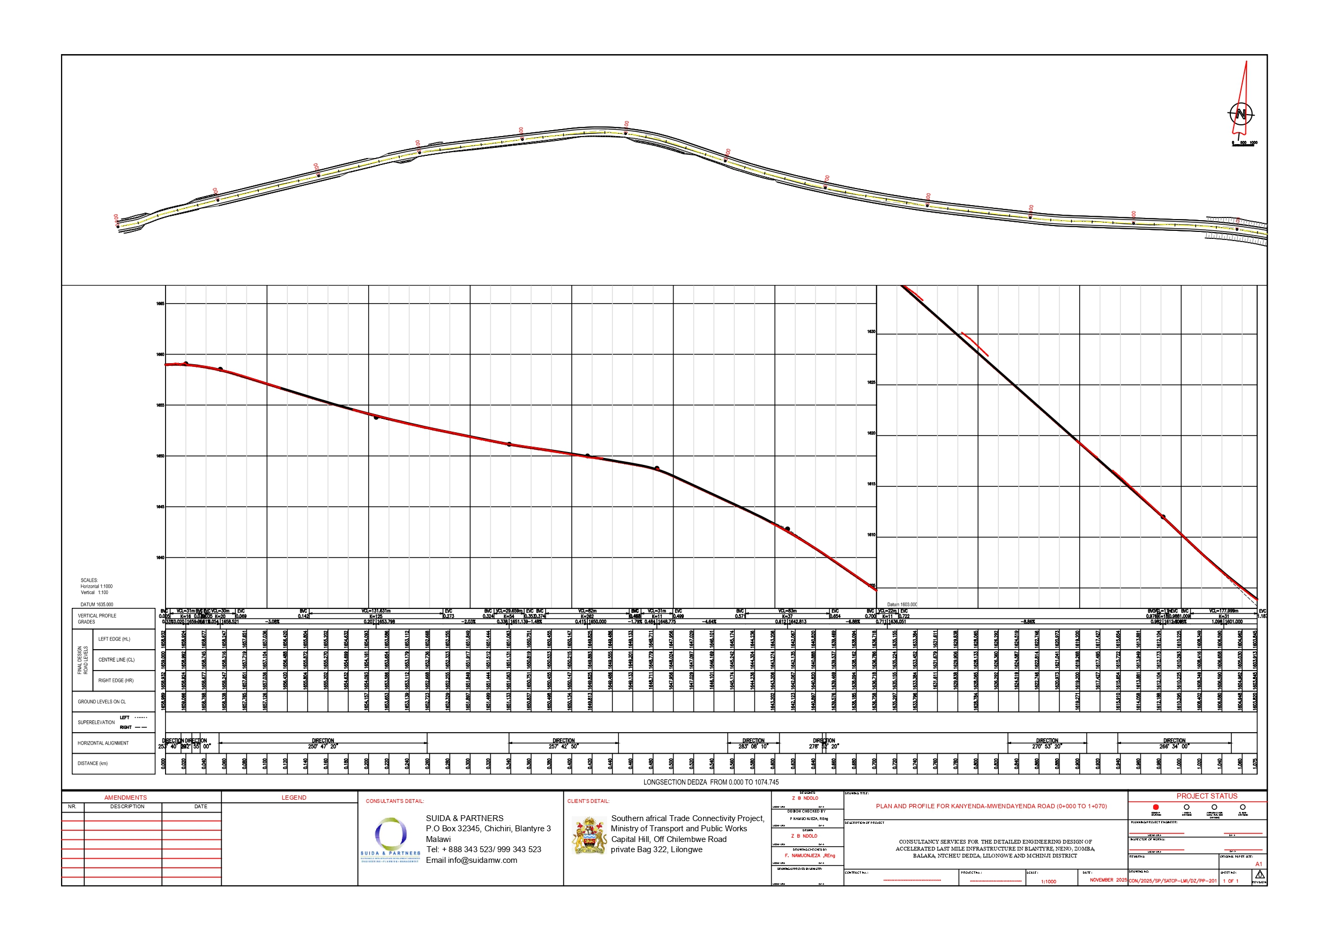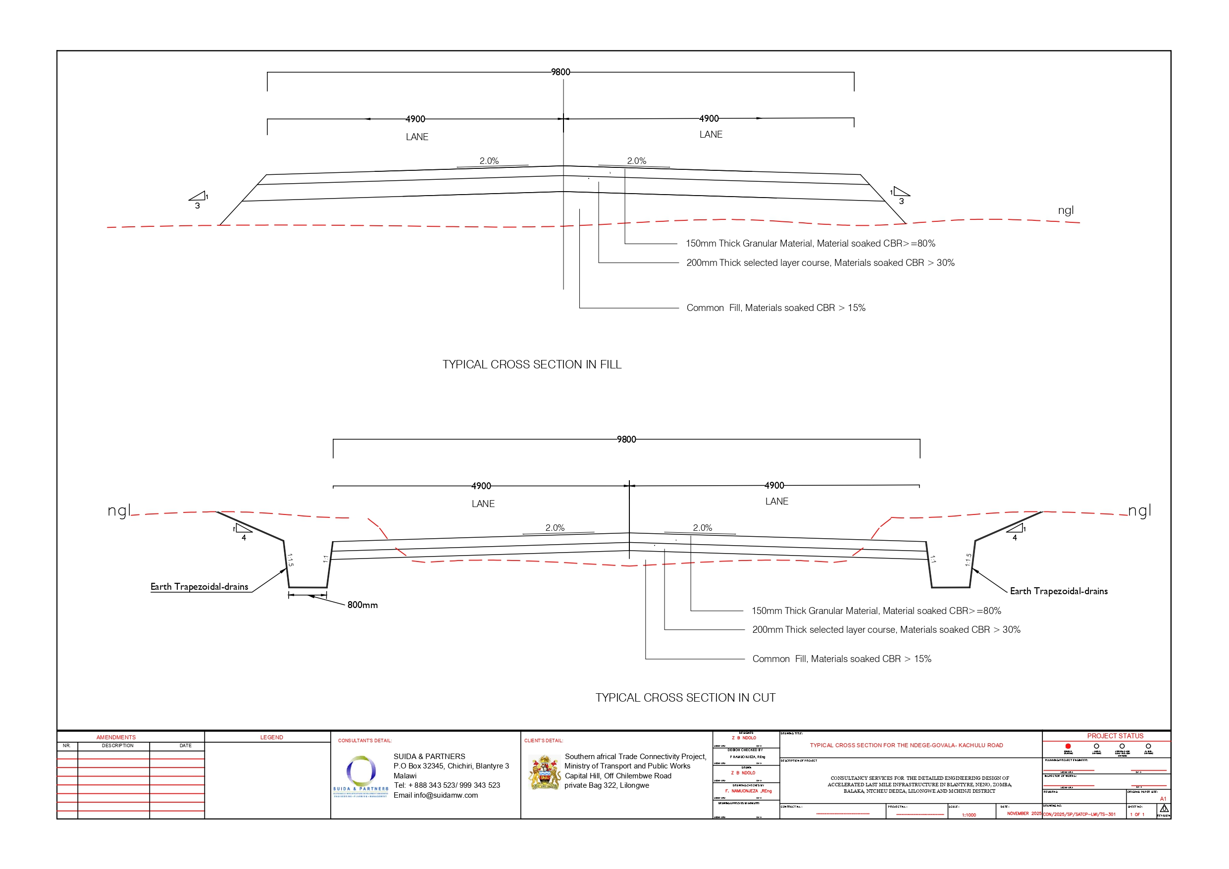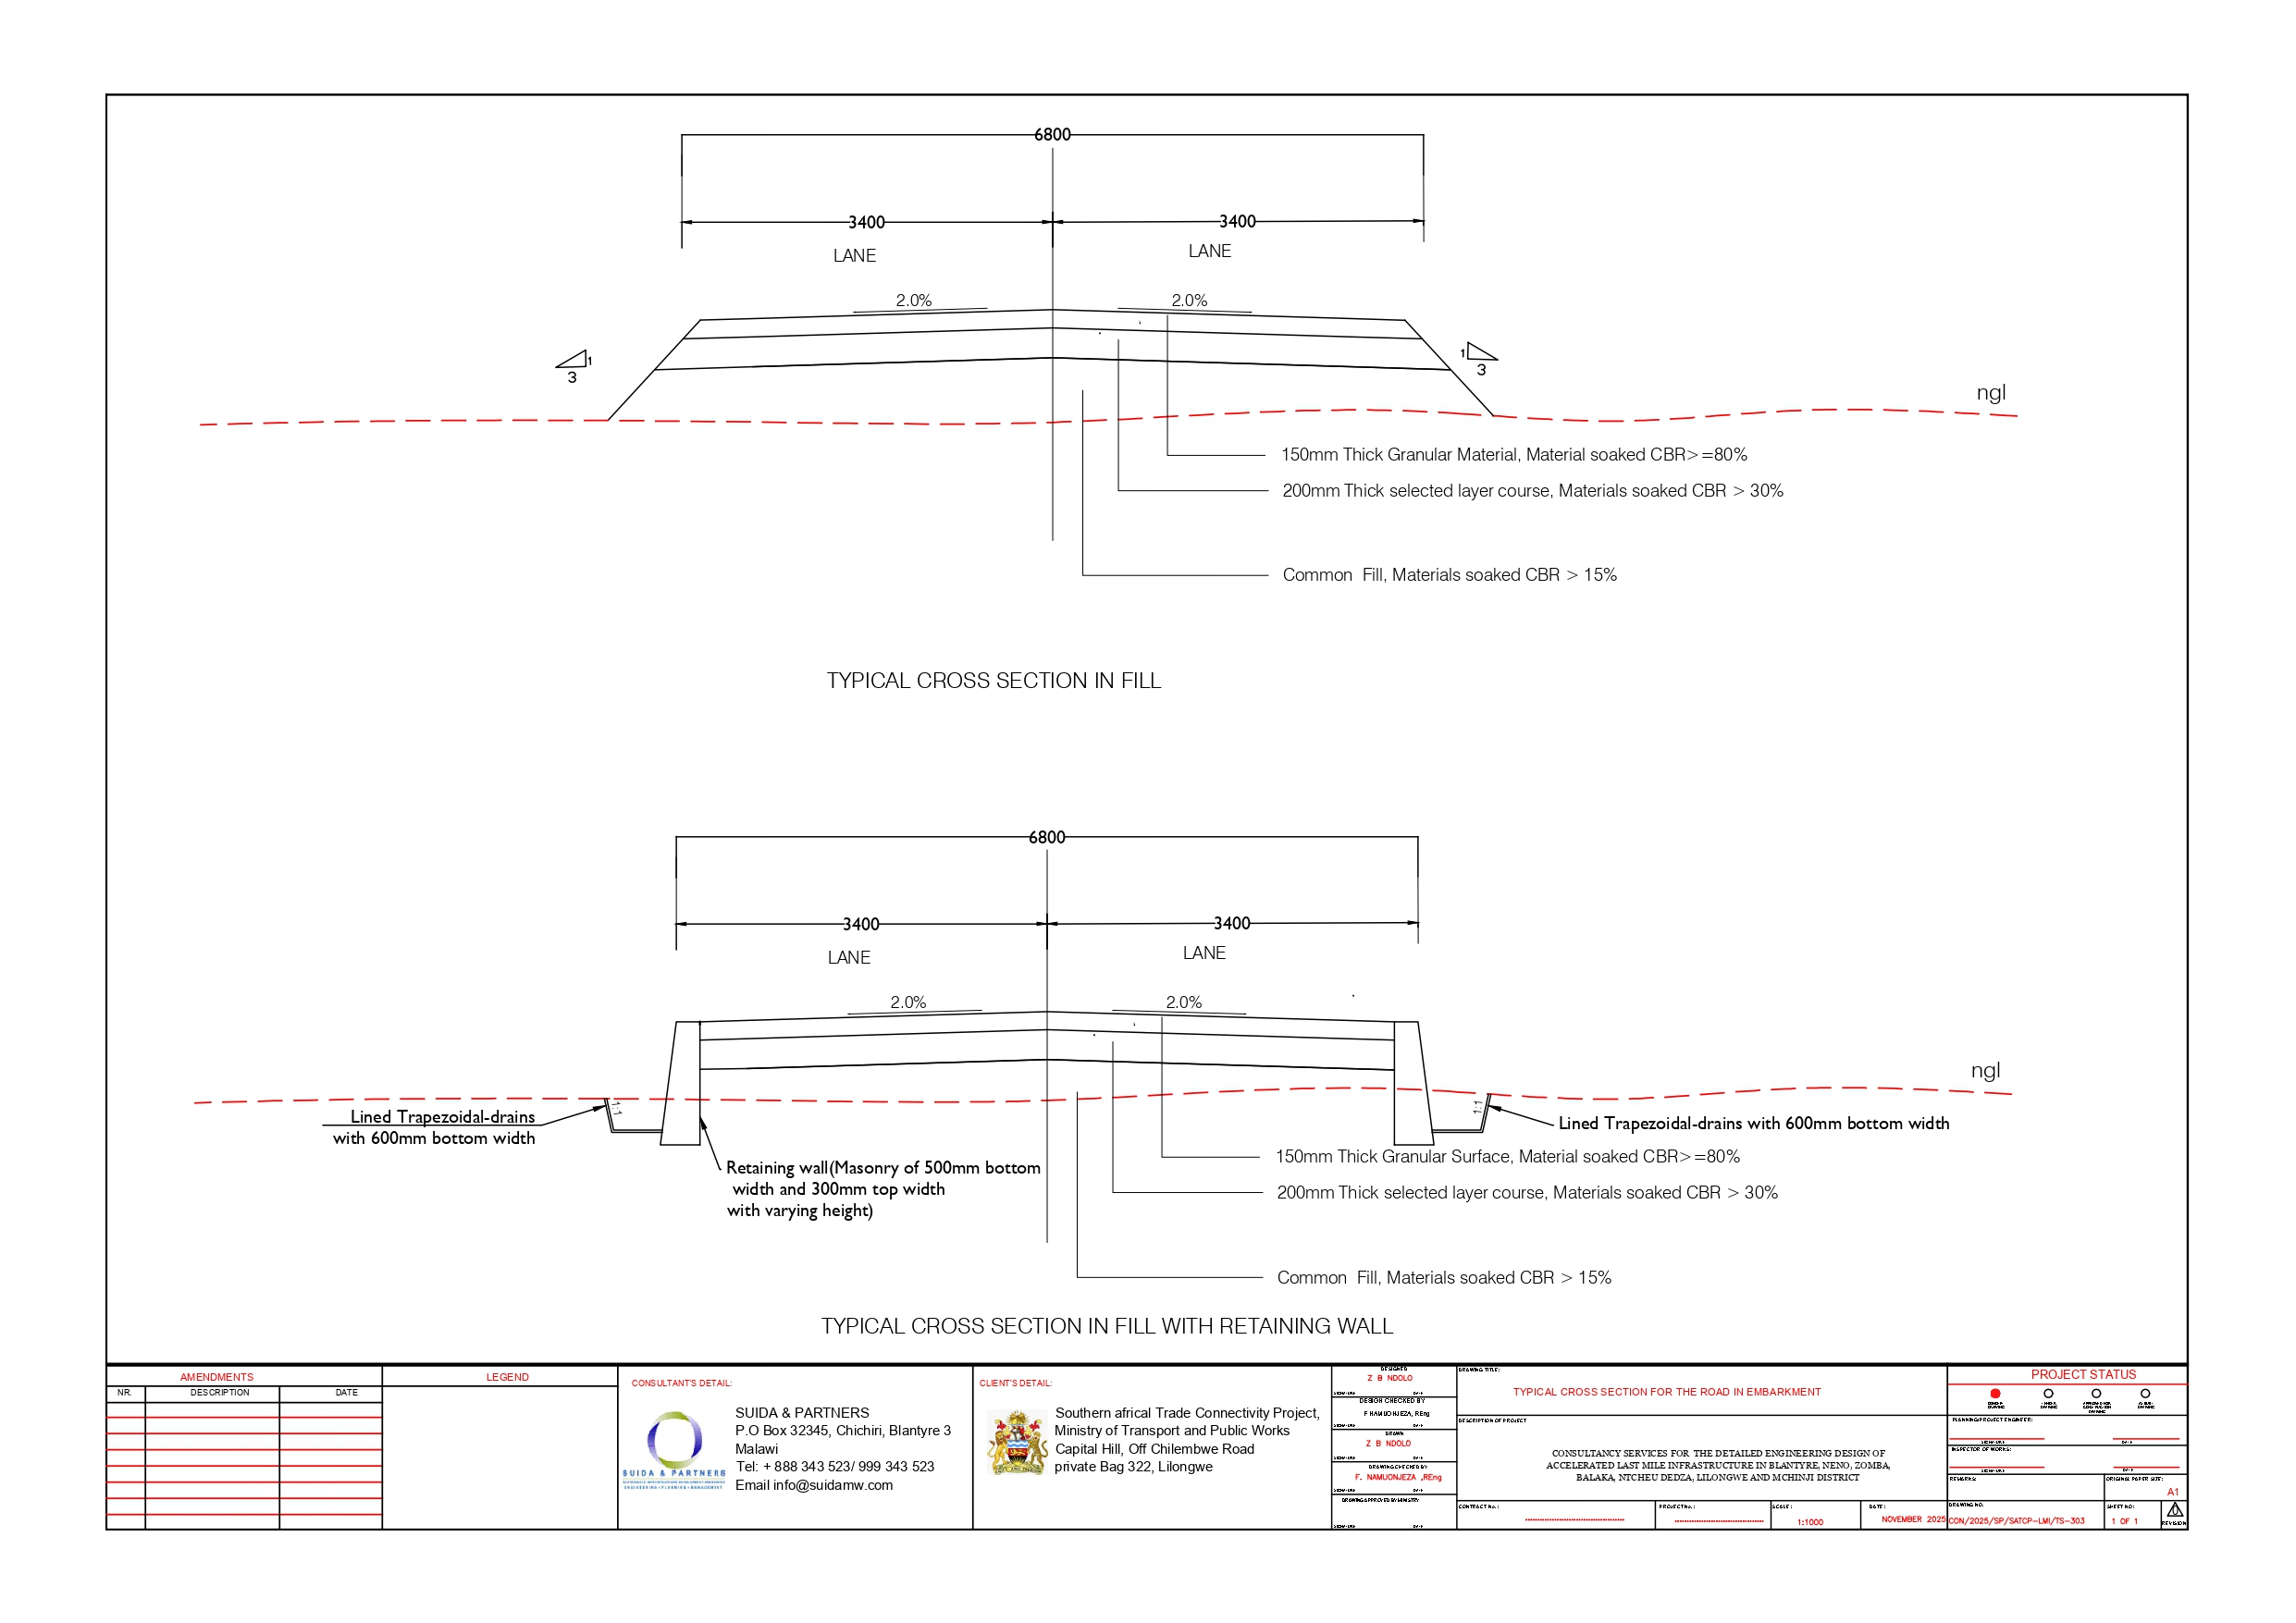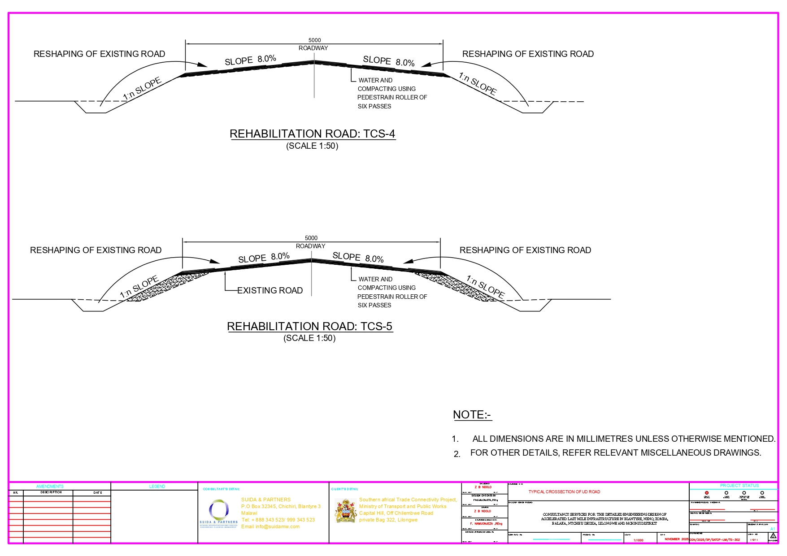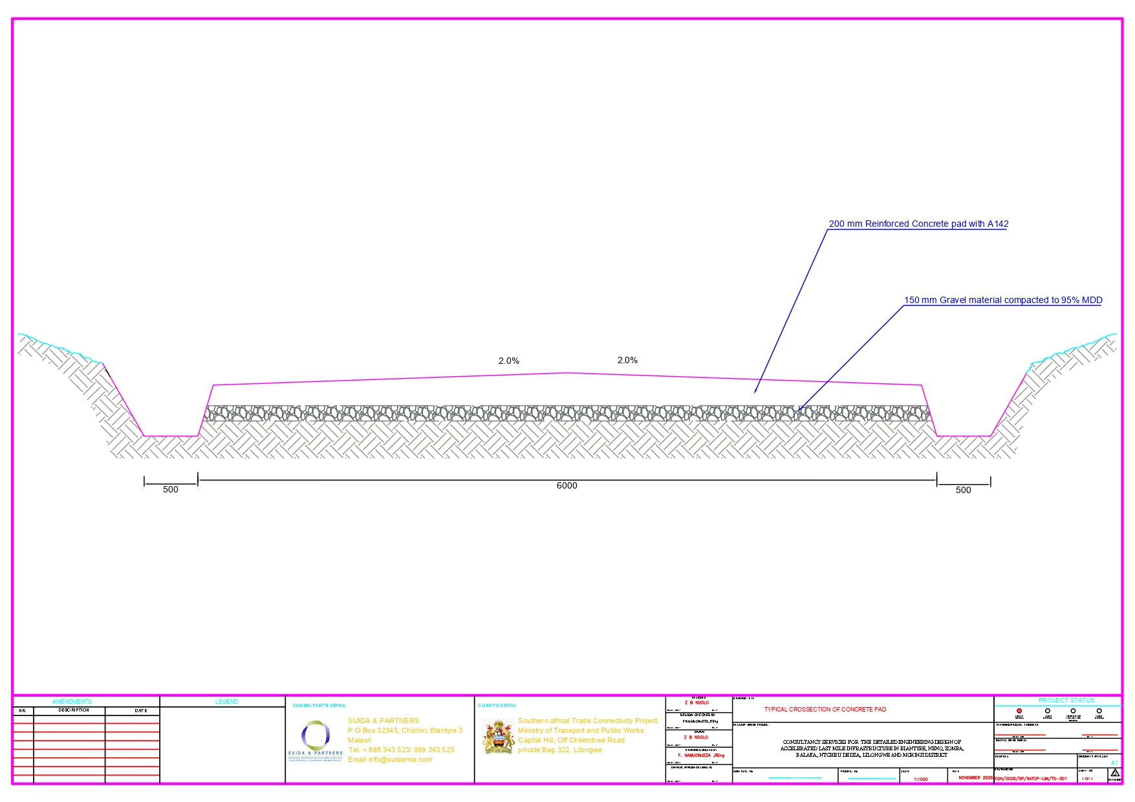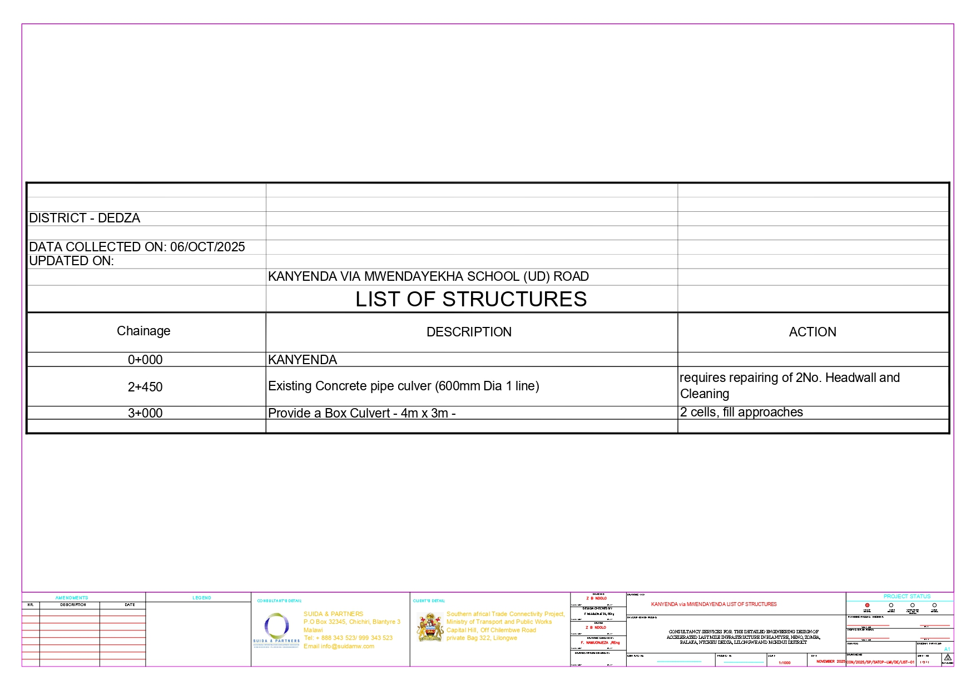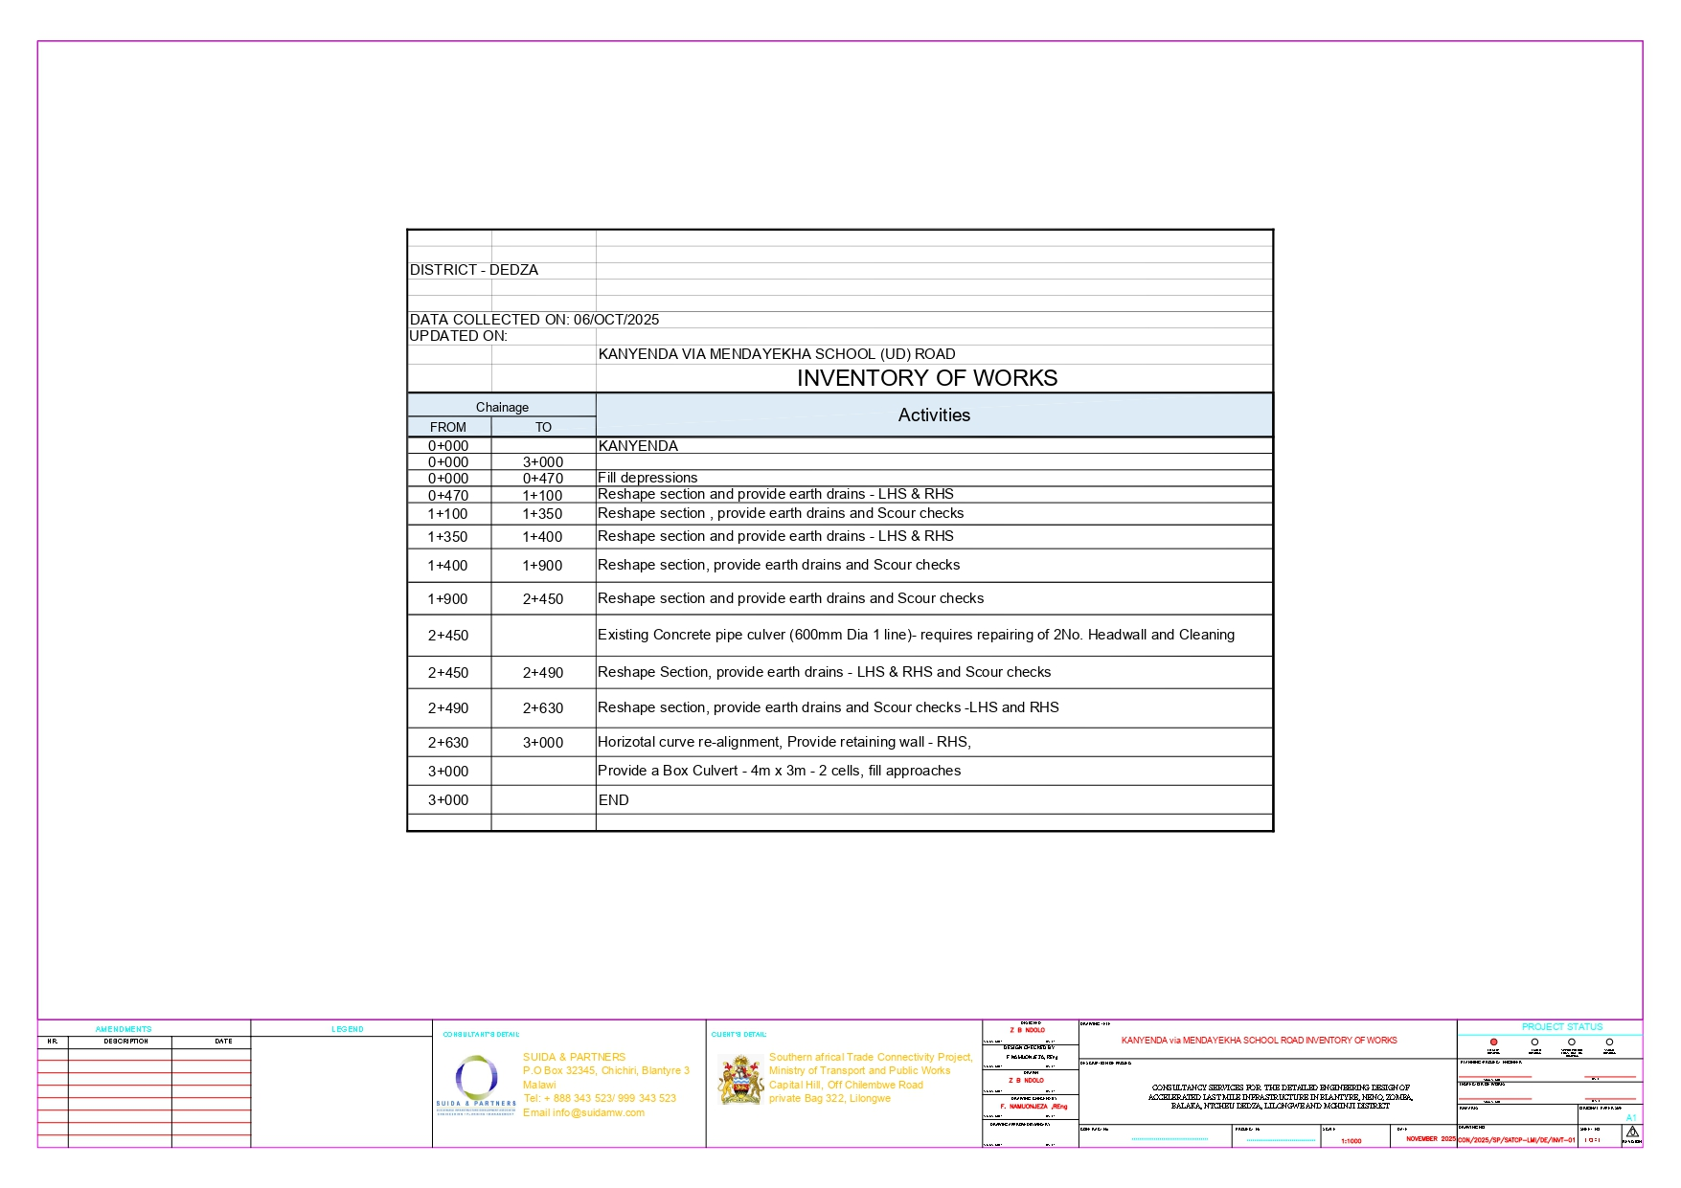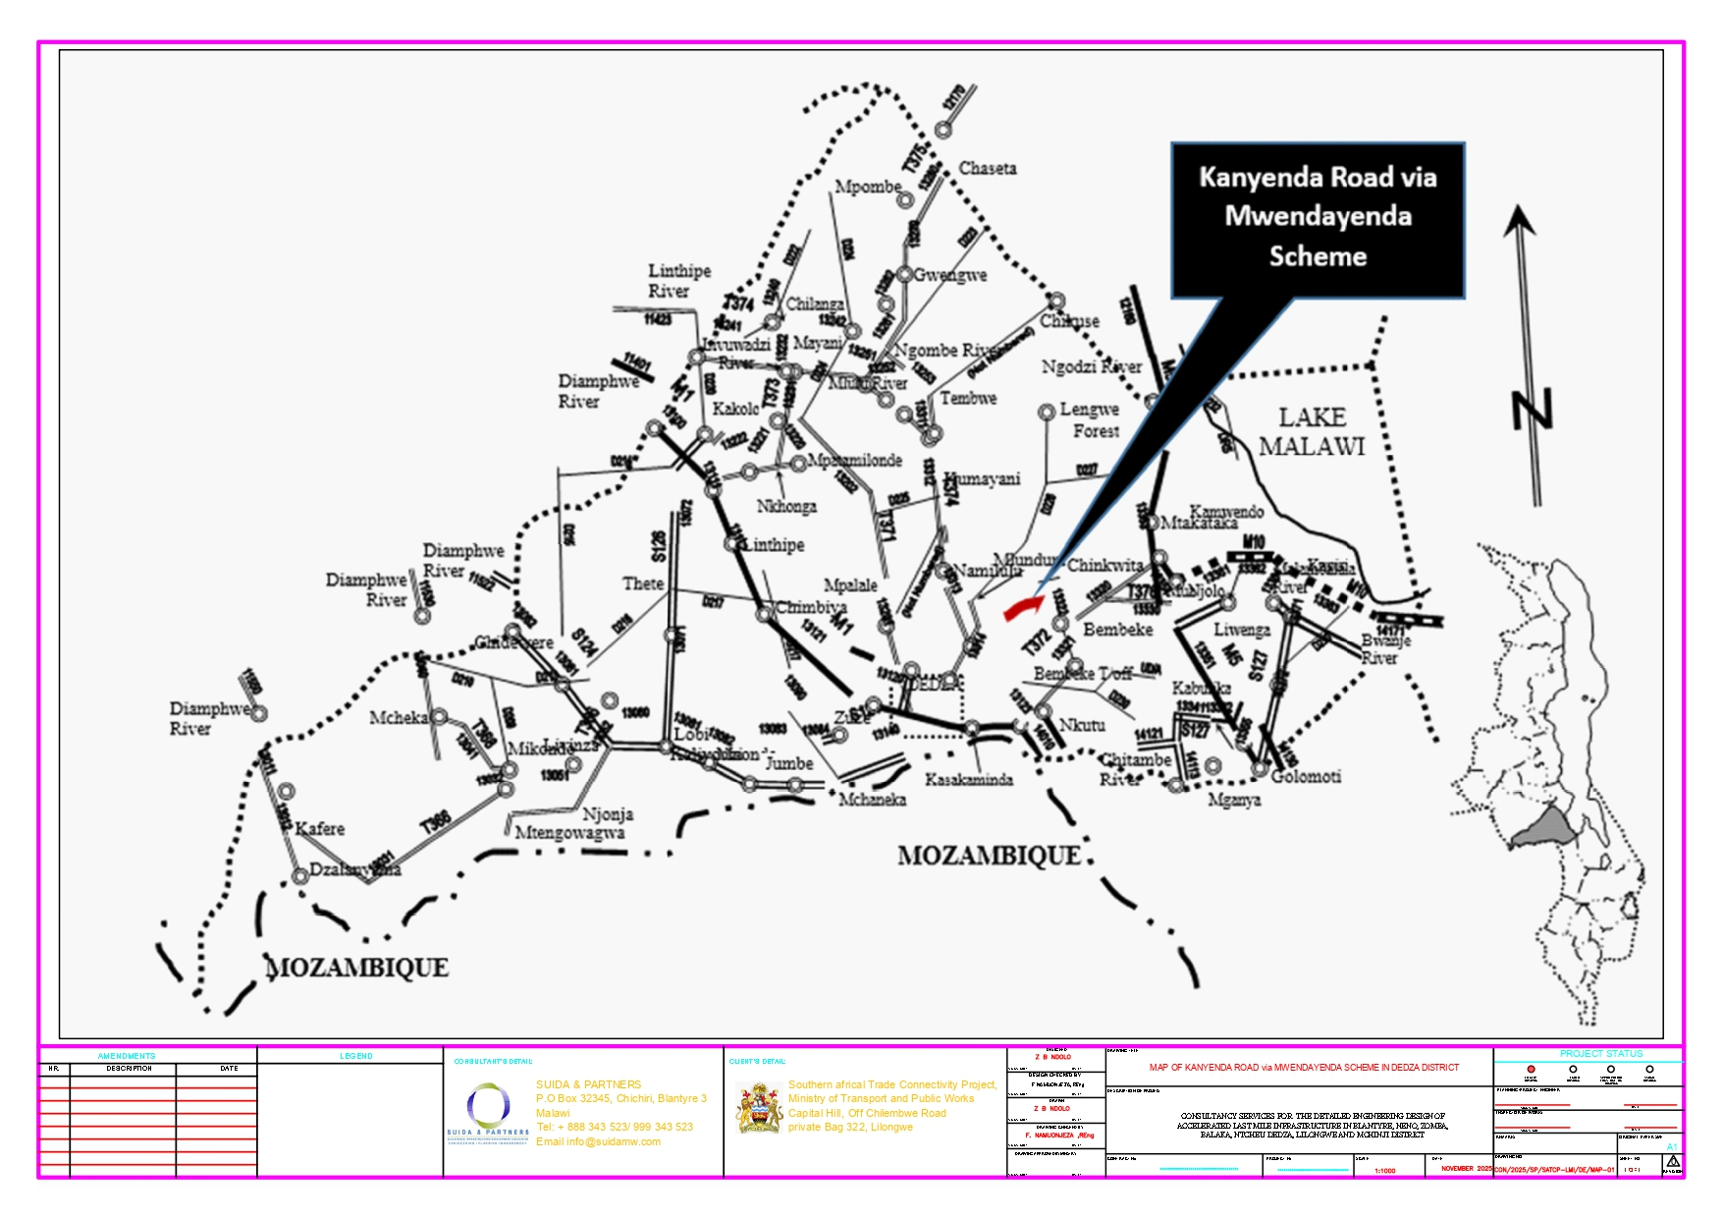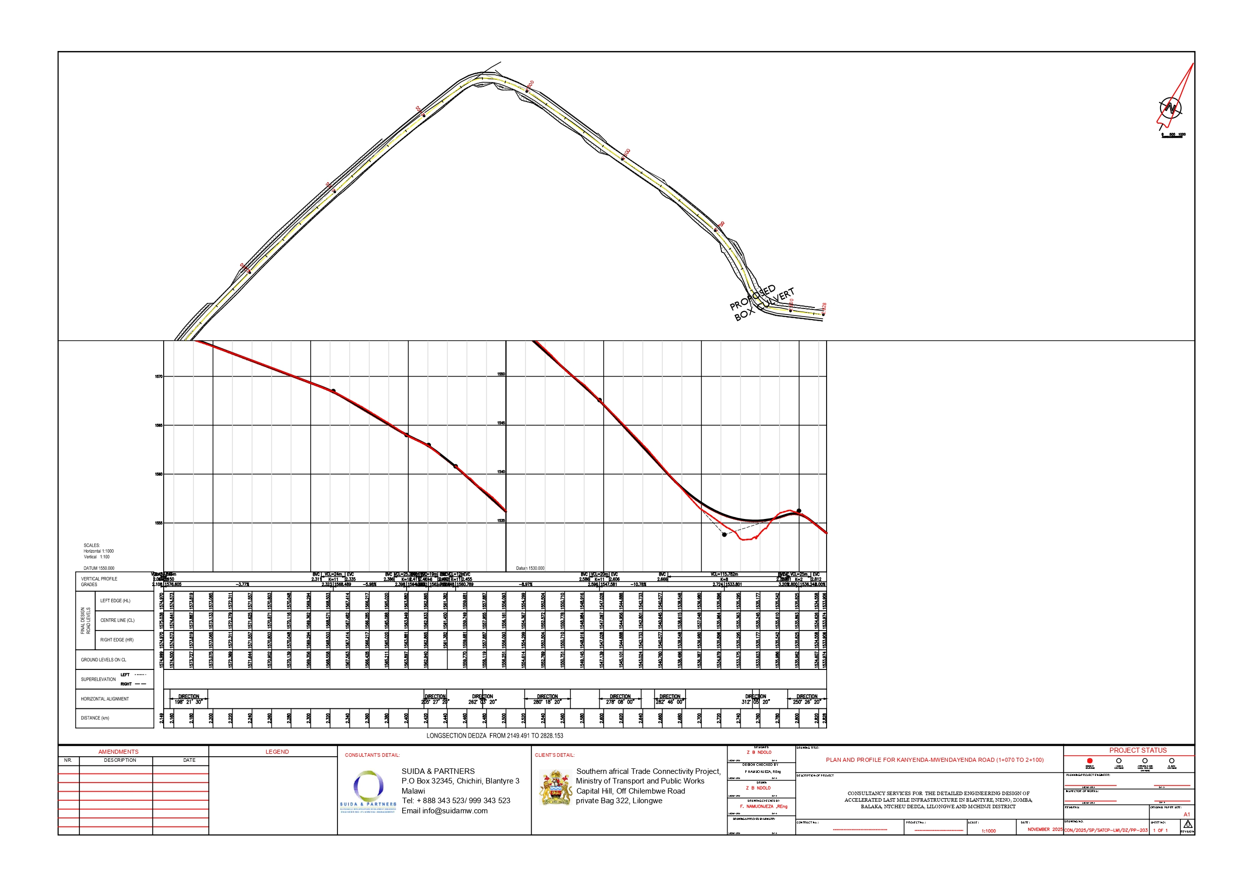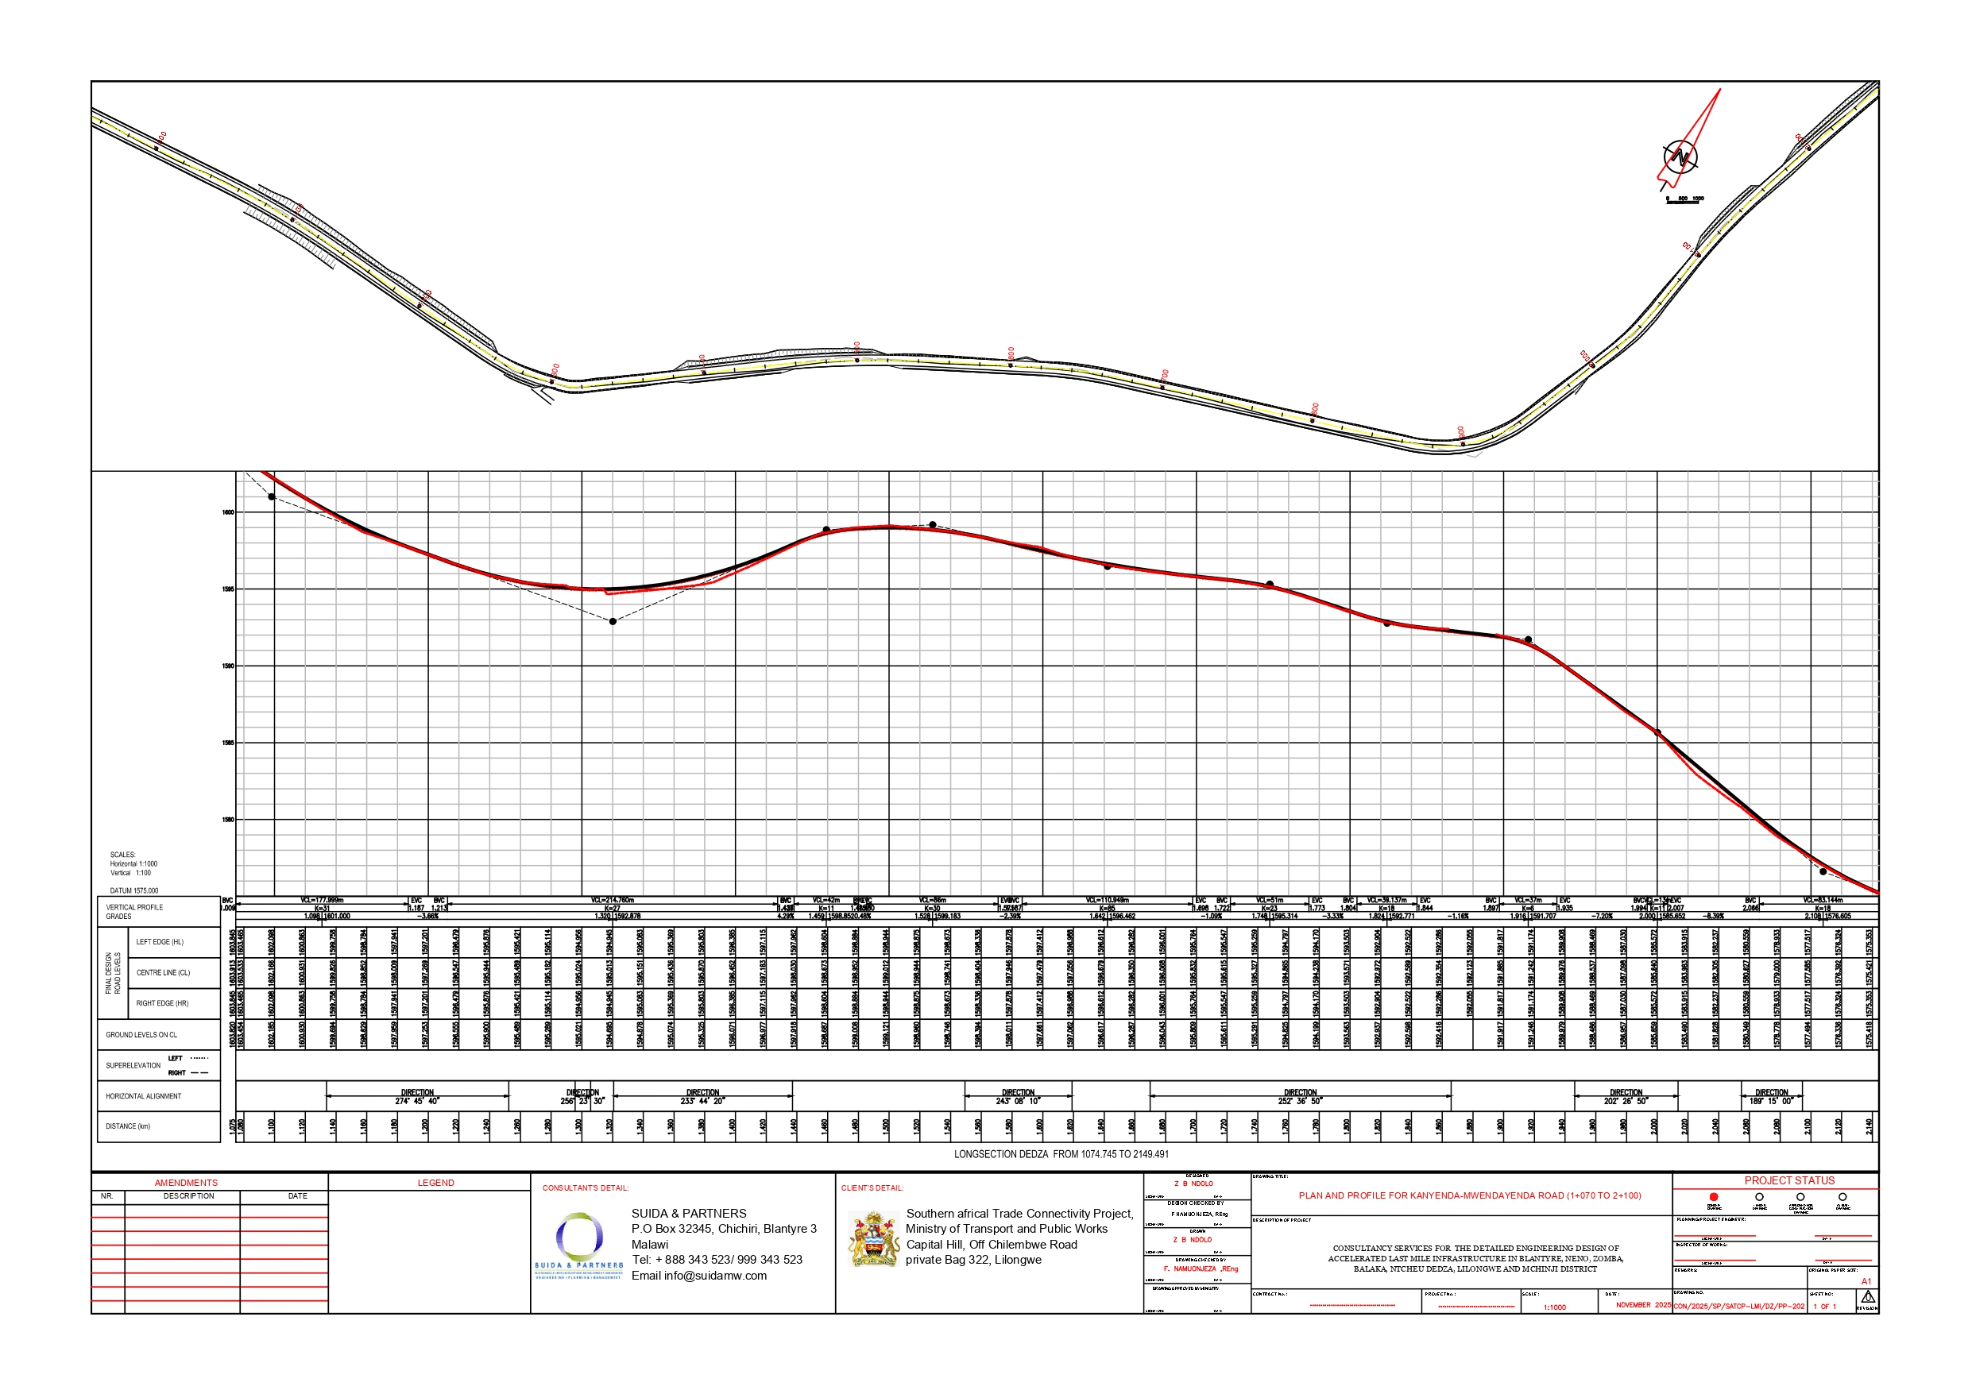

The road reserve and road centre line shown in this figure are indicative only and may not be spatially accurate due to the map scale, basemap limitations, and coordinate system/projection used. They are included for illustrative purposes only and must not be relied upon for surveying, land demarcation, or construction setting out

