
Government of Malawi
Ministry of Transport & Public Works

ENVIRONMENTAL AND SOCIAL MANAGEMENT PLAN (ESMP) FOR THE CONSTRUCTION OF REINFORCED CONCRETE BOX CULVERTS AND SELECTED SPOT IMPROVEMENTS ON THE MDEKA–CHINYANGUTE FEEDER ROAD, BLANTYRE DISTRICT

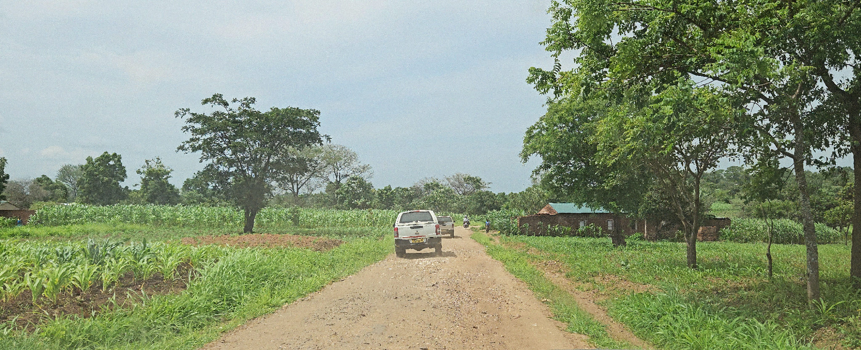

Ministry of Transport and Public Works
Southern Africa Trade and Connectivity Project
Private Bag 322
Lilongwe 3

18 JUNE, 2026

EXECUTIVE SUMMARY
1.0 Project Background
The proposed rehabilitation of the Mdeka–Chinyangute Feeder Roads is a priority rural access intervention under the Southern Africa Trade and Connectivity Project (SATCP), financed by the World Bank and implemented by the Ministry of Transport and Public Works (MoTPW). The project is located in TA Kuntaja, Blantyre District, Southern Region of Malawi.

The feeder roads function primarily as:
- A transitional access corridor linking Mdeka Trading Centre to agricultural production zones;
- A farm-to-market route supporting maize, vegetable, dambo cultivation, and small-scale livestock activities;
- A mobility corridor connecting rural settlements to Mdeka Health Centre, local primary schools (including Mpanda Primary School), and onward referral services in Blantyre City.

The existing road condition is characterized by poor drainage, low-gradient waterlogging sections, erosion-prone areas, and deteriorated gravel surfaces, particularly during the rainy season. These conditions constrain year-round access, increase transport costs, limit agricultural market efficiency, and restrict timely access to social services.

To address environmental and social risks associated with the rehabilitation works, a stand-alone Environmental and Social Management Plan (ESMP) has been prepared in accordance with, The Environment Management Act (2017), The MEPA Guidelines for Environmental Assessment (2025), and the World Bank Safeguard Operational Policies.

The project involves rehabilitation within an existing road reserve and is not expected to require land acquisition or cause physical displacement. Construction is anticipated to last approximately 6–9 months and will prioritise local labour.

2.0 Nature and Scope of the Proposed Project
The project involves rehabilitation and upgrading of the existing feeder roads to improve safety, drainage performance, and all-weather reliability. Key components include:
- Improvement of road formation and gravel running surface;
- Construction and rehabilitation of drainage structures (side drains, mitre drains, culverts);
- Spot improvements in low-lying and drainage-sensitive sections;
- Installation of road safety signage near settlements and schools;
- Sourcing of construction materials from approved sites;
- Rehabilitation of borrow pits and temporary works areas.

3.0 Rationale of the Project
The corridor serves a predominantly low-density agricultural population (fewer than 1,000 directly adjacent households). The road is critical for:
- Transport of agricultural produce to Mdeka Trading Centre;
- Access to health and education services;
- Seasonal mobility during the rainy season.
Poor drainage and surface deterioration currently undermine agricultural productivity, increase vehicle operating costs, and constrain rural economic efficiency. Rehabilitation is therefore essential to improve climate resilience, mobility, and socio-economic connectivity.

4.0 Justification of the Study
Preparation of the ESMP is a statutory requirement under the Environment Management Act (2017) and MEPA Guidelines (2025), including theWorld Bank Safeguard Operational Policies.. The project is classified as a Category B/List B intervention, as impacts are site-specific, largely temporary, and manageable through mitigation measures.The ESMP serves as a binding implementation framework to ensure compliance, monitoring, and accountability throughout the project lifecycle.

5.0 Objectives of the ESMP
The ESMP seeks to:
- Identify potential environmental and social risks;
- Define mitigation and enhancement measures for all project phases;
- Ensure compliance with national legislation and World Bank safeguards;
- Protect workers and communities;
- Establish monitoring and reporting mechanisms;
- Promote inclusive stakeholder engagement.

6.0 Methodology
The ESMP was prepared through:
- Review of relevant policies, legislation, and design documents;
- Field surveys along the corridor;
- Stakeholder consultations with Blantyre District Council, DESC, traditional leaders, schools, and community members;
- Identification of drainage-sensitive and socially sensitive nodes;
- Development of structured mitigation and monitoring measures.

7.0 Summary of Key Positive Impacts and Enhancement Measures

7.1 Improved Agricultural Access and Farm Productivity
Rehabilitation will enhance year-round access to crop production zones and dambos, improving transport efficiency and reducing post-harvest losses.

Enhancement Measures
- Integrate drainage-sensitive design in low-gradient sections.
- Maintain uninterrupted farm access during construction.
- Provide temporary crossings where required.
- Conduct routine culvert desilting during operation.
- Coordinate with farmers during scheduling of works.

7.2 Enhanced Market Connectivity and Reduced Travel Time
Improved surface condition and drainage will reduce travel time and transport costs between farms and Mdeka Trading Centre.

Enhancement Measures
- Maintain adequate gravel thickness.
- Conduct periodic grading.
- Incorporate safe roadside loading areas where feasible.
- Improve signage at trading nodes.
- Support safe pedestrian access near commercial areas.

7.3 Improved Drainage and Flood Resilience
Hydrologically informed culvert sizing will reduce overtopping and waterlogging in low-lying sections.

Enhancement Measures
- Apply peak runoff modelling for culvert design.
- Map drainage convergence zones prior to final design.
- Inspect and clear drainage structures routinely.
- Strengthen embankments in erosion-prone areas.
- Monitor performance during heavy rainfall events.

7.4 Local Employment and Skills Development
Construction will generate short-term employment opportunities.

Enhancement Measures
- Prioritize recruitment of local labour.
- Ensure inclusive recruitment (women and youth).
- Provide OHS training.
- Promote fair labour practices.
- Coordinate labour sourcing with district authorities.

7.5 Local Economic Stimulation
Procurement of local materials and services will stimulate rural economic activity.

Enhancement Measures
- Source materials from licensed local suppliers.
- Support small-scale enterprises.
- Promote transparent procurement.
- Ensure timely payments.
- Monitor local participation levels.

8.0 Summary of Key Negative Impacts and Mitigation Measures

8.1 Soil Erosion and Sedimentation
Earthworks may increase erosion risk in drainage-sensitive areas.

Mitigation Measures
- Install silt traps and sediment barriers.
- Stabilize exposed slopes immediately.
- Compact and shape side drains properly.
- Rehabilitate disturbed areas progressively.

8.2 Water Pollution Risks
Fuel handling and machinery operations may contaminate soils or drainage lines.

Mitigation Measures
- Store fuel in bunded areas.
- Prohibit washing in drainage lines.
- Implement spill prevention plans.
- Remediate contaminated soils where necessary.

8.3 Dust Emissions
Gravel works may generate dust affecting settlements and schools.
Mitigation Measures
- Water exposed surfaces during dry conditions.
- Cover haulage trucks.
- Enforce site speed limits.
- Respond promptly to community complaints.

8.4 Noise and Vibration
Construction equipment may affect nearby institutions.

Mitigation Measures
- Restrict works to daytime hours.
- Maintain equipment regularly.
- Notify schools and communities of high-noise activities.

8.5 Traffic Safety Risks
Increased construction traffic may endanger pedestrians.

Mitigation Measures
- Implement a Traffic Management Plan.
- Install warning signage near schools.
- Deploy trained flaggers.
- Enforce speed controls.

8.6 Occupational Health and Safety Risks
Workers may face physical hazards.

Mitigation Measures
- Provide and enforce PPE use.
- Conduct toolbox talks weekly.
- Maintain first aid facilities.
- Record and track incidents.

8.7 GBV/SEA/SH and Social Risks
Labour influx may increase social vulnerability.
Mitigation Measures
- Enforce Codes of Conduct.
- Conduct GBV/SEA/SH awareness training.
- Establish confidential reporting mechanisms.
- Strengthen community engagement and GRM.

9.0 Conclusion and Recommendations

9.1 Conclusion
The rehabilitation of the Mdeka–Chinyangute Feeder Roads will deliver significant socio-economic benefits by strengthening agricultural access, improving market connectivity, enhancing drainage resilience, and improving access to social services.

Identified environmental and social risks are site-specific and manageable through implementation of the ESMP. With proper supervision, monitoring, and institutional coordination, the project is environmentally and socially acceptable and expected to yield net positive outcomes for communities in TA Kuntaja, Blantyre District.

9.2 Recommendations
To ensure effective implementation:
- Allocate adequate financial and technical resources for ESMP execution;
- Integrate ESMP provisions into contractual obligations;
- Require site-specific management plans prior to mobilisation;
- Establish operational Grievance Redress Mechanisms;
- Obtain all statutory approvals prior to works;
- Deploy qualified Environmental and Social Officers;
- Strengthen coordination among MoTPW (SATCP PIU), Blantyre District Council, and MEPA.
- Schedule brief, joint start‑up and mid‑term E&S review meetings (MoTPW/PIU, Contractor, Supervising Consultant, District Council) to confirm ESMP priorities, resolve issues rapidly, and agree on any short-term adjustments needed during construction.
- Prepare a simple ESMP implementation dashboard/checklist (1–2 pages) for site use, highlighting key do’s and don’ts, critical mitigation measures, and GRM contacts, and require monthly sign‑off by the Contractor’s E&S Officer and the Supervising Consultant.

With full compliance and effective oversight, the project will contribute to climate-resilient rural connectivity and inclusive agricultural development in Blantyre District

ACRONYMS AND ABBREVIATIONS
AIDS | Acquired Immune Deficiency Syndrome
DED | Detailed Engineering Design
DESC | District Environment Sub-Committee
EHS | Environmental, Health and Safety
EMA | Environment Management Act
ESHS | Environmental, Social, Health and Safety
ESIA | Environmental and Social Impact Assessment
ESMMP | Environmental and Social Mitigation and Monitoring Plan
ESMP | Environmental and Social Management Plan
FGD | Focus Group Discussion
GBV | Gender-Based Violence
GIIP | Good International Industry Practice
GRM | Grievance Redress Mechanism
HIV | Human Immunodeficiency Virus
IEC | Information, Education and Communication
IUCN | International Union for Conservation of Nature
LC | Local Council
LMI | Last Mile Infrastructure
MEPA | Malawi Environment Protection Authority
OHS | Occupational Health and Safety
OP/BP | Operational Policy / Bank Procedure (World Bank)
PPE | Personal Protective Equipment
RHS | Right-Hand Side
SATCP | Southern Africa Trade and Connectivity Project
SEA | Sexual Exploitation and Abuse
SEA/SH | Sexual Exploitation and Abuse / Sexual Harassment
SEP | Stakeholder Engagement Plan
SH | Sexual Harassment
STA | Sub-Traditional Authority
WMP | Waste Management Plan

TABLE OF CONTENTS

EXECUTIVE SUMMARY i
ACRONYMS AND ABBREVIATIONS vi
LIST OF TABLES x
LIST OF FIGURES xi
1 CHAPTER 1: INTRODUCTION AND BACKGROUND 13
1.1 Introduction 13
1.2 Project Background 13
1.3 Developer Details 14
1.4 Nature and Scope of the Project 14
1.5 Project Objectives 14
1.6 Justification of the Project 15
1.7 Objectives of the ESMP 15
1.8 Rationale of the ESMP 15
1.9 Methodology 15
1.9.1 Literature and Document Review 15
1.9.2 Field Investigations and Site Verification 16
1.9.3 Stakeholder Consultations 16
1.10 Project Location 16
1.11 Land Tenure and Land Requirement for the Project 23
1.12 Potential Users of the ESMP 23
2 CHAPTER 2: PROJECT DESCRIPTION 25
2.1 Introduction 25
2.2 Project Components and Activities 25
2.3 Spatial Distribution of Works by Chainage 25
2.3.1 Planning and Design Phase 26
2.3.2 Construction Phase 26
2.3.3 Demobilisation Phase 27
2.3.4 Operational Phase 27
2.4 Labour Requirement 27
2.5 Land Requirement 28
2.6 Material Requirements and Sources 29
2.6.1 Water Sources 29
2.6.2 Gravel, Sand, Aggregates, and Rock Materials 30
2.7 Worker Accommodation and Facilities 31
2.8 Waste and Waste Management 31
2.8.1 Waste and Waste Generation 31
2.8.2 Organic Waste 32
2.8.3 Liquid Waste 32
2.8.4 Non-Hazardous Solid Waste 32
2.8.5 Hazardous Waste 32
2.9 Rehabilitation of Temporary Sites 32
3 CHAPTER 3: POLICY AND LEGAL FRAMEWORK 33
3.1 Introduction 33
3.2 National Policies and Strategies 33
3.2.1 Policy Framework 33
3.2.2 Legislative Framework 35
3.3 World Bank Safeguard Operational Policies and Procedures 37
3.4 Environmental Health and Safety Guidelines 38
3.5 Institutional Framework 38
3.6 Summary of Main Statutory Approvals/Licenses to be obtained for the project 39
4 CHAPTER 4: ENVIRONMENTAL AND SOCIAL SETTING 41
4.1 Introduction 41
4.2 Biophysical Environment 41
4.2.1 Topography 41
4.2.2 Geology 41
4.2.3 Soils 43
4.2.4 Climate and Climate Change Risks 45
4.2.5 Water Resources 48
4.3 Flora and Fauna 50
4.3.1 Flora 50
4.3.2 Sensitive Habitats and Ecological Significance 53
4.3.3 Fauna 53
4.3.4 Human–Fauna Interaction 57
4.3.5 Implications for the Project 57
4.4 Sanitation and Waste Management 58
4.5 Overall Environmental Implications 58
4.6 Socio-economic environment 58
4.6.1 Demographic Characteristics 58
4.6.2 Education and Literacy 59
4.6.3 Livelihoods and Economic Activities 59
4.6.4 Health 60
4.6.5 Cultural Heritage 60
4.6.6 Land Use 60
4.6.7 Transport 60
4.6.8 Security 61
4.6.9 Communication and Energy 61
4.6.10 Implications for the Project 61
5 CHAPTER 5: ENVIRONMENTAL AND SOCIAL MANAGEMENT AND MONITORING PLAN 62
5.1 Introduction 62
5.2 Environmental and Social Mitigation and Monitoring Plan (ESMMP) Matrix 64
5.3 Institutional Arrangements and Implementation Capacity 70
ANNEXES 72
Annex 1. Feedback Letter from MEPA 72
Annex 2: List of Stakeholders Consulted 74
Annex 3. Summary of Issues Raised by Stakeholders 75
Annex 4. Sample Code of Conduct for Contractors 77
Annex 5. Barrow Pit Rehabilitation Framework 81
Annex 6. Traffic Management Framework 85
Annex 7. Chance Find Procedure for Last Mile Infrastructure under SATCP 89
Annex 8: Labour Management Guidelines for Contractor Compliance and Preparation of Labour Management Plans (LMPs) 91
Annex 9. Contractor Environmental and Social Management Plan (C-ESMMP) Framework Error! Bookmark not defined.
Annex 10. Waste Management Framework Error! Bookmark not defined.
Annex 11. Stakeholder Engagement Framework Error! Bookmark not defined.
Annex 12. Details of the Consultants (Names, Qualification and Roles of Team Members) Error! Bookmark not defined.
Annex 13. SATCP LMI Grievance Redress Mechanism (GRM) Protocol 95
Annex 14. Spatial distribution of Works 102
Annex 15. Project Design Drawings 104

LIST OF TABLES

Table 1-1. Potential Users of the ESMP and Their Roles 24
Table 2-1. Estimated Labour Requirements at Peak Construction 28
Table 2-2. Water Requirements and Sources 29
Table 2-3. Gravel, Sand, and Aggregate Requirements 30
Table 2-4. Energy Sources and Management Measures 31
Table 2-5. Main Expected Waste Streams 31
Table 3-3-1. Policies Guiding the Project 33
Table 3-2. Legislation Guiding the Project 35
Table 3-3. World Bank Environmental and Social Operational Policies Triggered by the Project 38
Table 3-4. E&S Institutional Framework and Mandates 39
Table 3-5. Summary of Statutory Approvals and Licences Required 40
Table 4-1. Flora Species Sampled from the Mdeka- Chinyangute feeder Project Area and their Conservation Status 51
Table 4-2 Fauna Species Recorded in the Project Area 54
Table 5-1. Institutional responsibilities for ESMP implementation and oversight – Mdeka–Chinyangute Feeder Road 71

LIST OF FIGURES

Figure 1-1. Consultation with Blantyre District Council DESC. 16
Figure 1-2. Location of the Mdeka – Chinyangute Feeder Road 18
Figure 1-3. Aerial view of the project location 19
Figure 1-5. Detailed view of the starting point chainage 0+000 of the road section 20
Figure 1-5. Detailed view of the Namalondwe Section 21
Figure 1-6. Detailed view of the Mpanda Section 22
Figure 4-1. Geological Map of the Mdeka - Chinyangute Feeder Roads Corridor 42
Figure 4-2. Soils of the Mdeka - Chinyangute Feeder Roads Corridor 44
Figure 4-3. Soils of the Mdeka - Chinyangute Feeder Roads Corridor 45
Figure 4-4. average Monthly Max and Min Temperature Pattern for Mdeka–Chinyangute Section 46
Figure 4-5. Monthly Rainfall Pattern for the Mdeka–Chinyangute Corridor 47
Figure 4-6. Hydrological map of the Mdeka - Chinyangute Feeder Roads Corridor 49
Figure 4-7. Cascabella tevetia (with yellow flowers) on the Mdeka- Chinyangute feeder road corridor 50
Figure 4-8. Senna siamea (with yellow flowers) 50
Figure 4-10. Lantana camara and Gmelina arborea along Mdeka- Chinyangute feeder road 53

List of annexes

Annex 1. Feedback Letter from MEPA

Annex 2. Terms of Reference from MEPA

Annex 3a. List of Stakeholders Consulted

Annex 3b. Issues raised by Stakeholders and how they have been addressed in ESMP

Annex 4. Sample Code of Conduct for Contractors

Annex 5. Barrow Pit Rehabilitation Framework

Annex 6. Traffic Management Framework

Annex 7. Chance Find Procedure for Last Mile Infrastructure under SATCP

Annex 8: Labour Management Guidelines for Contractor Compliance and Preparation of Labour Management Plans (LMPs)

Annex 13. Flora and Animal Species of Mdeka Corridor

Annex 14-B. Animal Species

Annex 14. SATCP LMI Grievance Redress Mechanism (GRM) Protocol

Annex 15. Spatial distribution of Works

Annex 16. Project Drawings

CHAPTER 1: INTRODUCTION AND BACKGROUND

Introduction
This Environmental and Social Management Plan (ESMP) has been prepared for the proposed rehabilitation of the Mdeka – Chinyangute Feeder Roads (UD) in Blantyre District, Malawi, under the Last Mile Infrastructure (LMI) component of the Southern Africa Trade and Connectivity Project (SATCP), implemented by the Ministry of Transport and Public Works.

The proposed project comprises two feeder roads:
- Feeder Road 1: Mdeka – Namalondwe School (5.5 km)
- Feeder Road 2: Mdeka Health Centre – Mpanda School (5.1 km)

with a combined length of approximately 10.6 km.

The works involve reshaping, spot re-gravelling, embankment improvement, rehabilitation and upgrading of culverts and drainage structures, scour protection, and associated drainage enhancements. The roads fall under Low Volume Traffic Class (HVPD 7–20) and primarily serve motorcycles, bicycles, light vehicles, schools, and health facilities within the Mdeka area. Following screening by the Malawi Environment Protection Authority (MEPA), the subproject was classified under List B, requiring preparation of a stand-alone ESMP in accordance with The Environment Management Act (2017); the MEPA Guidelines for Environmental Assessment (2025); and World Bank OP/BP 4.01 on Environmental Assessment.

Given that the works are confined to an existing alignment, anticipated impacts are site-specific and will be addressed through appropriate mitigation and monitoring measures outlined in this ESMP.

Project Background
Within Blantyre District, the selected feeder roads provide essential access between rural settlements, schools, health facilities, and trading areas. However, deterioration of drainage structures, erosion of embankments, and inadequate surface shaping have reduced road passability, particularly during the rainy season. Seasonal flooding and sediment deposition have further compromised safe mobility and increased transport costs for local communities. The proposed rehabilitation focuses on restoring functionality of the existing road infrastructure through drainage upgrading, culvert rehabilitation, and surface improvements rather than constructing a new alignment. Given the scale and nature of works, the project has been classified as a Category B intervention under OP/BP 4.01, necessitating preparation of this ESMP.

Developer Details
Name of Developer: | Ministry of Transport and Public Works
Physical Address: | The Project Manager  Southern Africa Trade and Connectivity Project  Private Bag 322  Lilongwe 3
Contact Person: | The Project Manager  Southern Africa Trade and Connectivity Project  Ministry of Transport and Public Works  Private Bag 322  Lilongwe 3.  Cell: 0999088044  Email: hastingsngoma@gmail.com

Nature and Scope of the Project

Based on the Detailed Engineering Design (DED), the proposed project comprises the following interventions:
- Drainage rehabilitation, including cleaning, reshaping and construction of earth and mitre drains;
- Replacement or upgrading of damaged and undersized culverts, including installation of box culverts where required;
- Repair of headwalls and inlet/outlet protection works;
- Embankment formation and stabilisation in low-lying sections;
- Scour protection and erosion control measures;
- Reshaping of road formation to improve surface drainage and riding quality;
- Reinstatement of disturbed areas and temporary traffic management during construction.

The works are linear and site-specific, confined to the existing road reserve and immediate area of influence. No permanent realignment is anticipated. Land requirements are addressed in Section 1.11 and Section 2.4.

Project Objectives

The overall objective of the proposed project is to restore and improve the functionality, safety and climate resilience of feeder roads within the Mdeka area to enhance local access and mobility.
Specifically, the project seeks to:
- Improve all-weather access through rehabilitation of drainage systems and flood-prone sections;
- Enhance connectivity to key social services, including schools and health facilities;
- Reduce travel time and transportation costs for road users;
- Strengthen climate resilience through erosion control and improved drainage infrastructure;
- Support local economic activities by ensuring reliable road access;
- Improve road safety for pedestrians, cyclists, and motorists.

Justification of the Project
The rehabilitation is justified on technical, socio-economic, and climate resilience grounds.
Technically, the roads have deteriorated due to failing drainage, erosion, and inadequate surface maintenance, leading to seasonal inaccessibility and rising maintenance costs.

Socio-economically, the roads serve communities reliant on agriculture and small-scale trade. Poor road conditions constrain mobility, limit access to markets and services, and increase vehicle operating costs.

From a climate perspective, recurrent flooding and runoff damage indicate vulnerability to increasing rainfall intensity. Improved drainage and embankment stabilisation provide a more sustainable solution than repeated reactive maintenance.

Objectives of the ESMP
The primary objective of this ESMP is to provide a site-specific framework for managing environmental and social risks associated with the proposed project.

Specifically, the ESMP aims to:
- Identify potential impacts during construction and operation;
- Apply the mitigation hierarchy (avoid–minimise–restore–compensate where applicable);
- Define clear institutional roles and responsibilities;
- Establish monitoring indicators and compliance requirements;
- Integrate occupational health and safety, labour management, and community safety measures;
- Address gender, social inclusion, and GBV/SEA risks;
- Provide a grievance redress framework.

The ESMP serves as the binding environmental and social management instrument for project implementation.

Rationale of the ESMP
Through its Environmental Clearance letter dated 21 August 2024 (see Annex 1), MEPA determined that the project could proceed without the requirement for a full ESMP under national procedures, subject to specific environmental and social compliance conditions.

Accordingly, this ESMP has been prepared to comply with World Bank safeguard requirements by providing a structured framework for impact assessment, mitigation, monitoring, stakeholder engagement, and accountability during project implementation.

Methodology
The study used in preparation of the ESMP used combined methods such as literature review, field investigations, and relevant stakeholder consultations to identify environmental, social, and OHS risks and translate them into mitigation and monitoring measures.

Literature and Document Review
Review included:
- Project documentation and engineering design drawings;
- MEPA feedback and Terms of Reference;
- National environmental, land, labour, water, and transport legislation;
- World Bank safeguard requirements (ESF / OP 4.01 principles).
This provided the regulatory and technical basis for impact assessment and mitigation development

Field Investigations and Site Verification
Field verification was conducted along the road to assess:
- Drainage crossings and low-lying sections;
- Settlement areas at Govala and Mpyupyu;
- Agricultural land use patterns;
- Road condition, erosion zones, and embankment stability.
Findings were used to validate design assumptions and identify environmental and social risks.

Stakeholder Consultations
Stakeholder consultations were undertaken with Blantyre District Council and local community representatives from the Mdeka and Chinyanguta areas using focus group discussions, key informant interviews, and administration of semi‑structured questionnaires. Key issues raised included flooding and drainage problems, road safety concerns, potential access disruptions during construction, the strong dependence of local livelihoods on agriculture and transport routes, and social risks such as GBV/SEA/SH. Consultations were conducted on 20 January 2026 with the Blantyre District Environment Sub‑Committee (DESC) at Blantyre District Council offices and with community representatives at Mpanda Primary School (Figure 1‑1). The list of stakeholders consulted is provided in Annex 2, while the issues raised and how they have been addressed in the ESMP are presented in Annex 3.

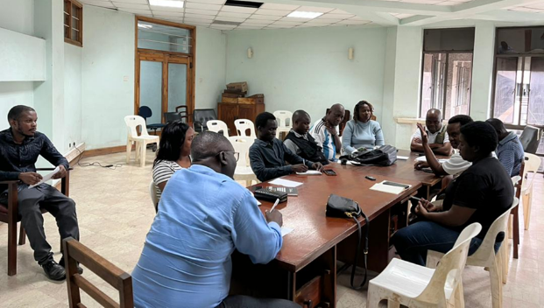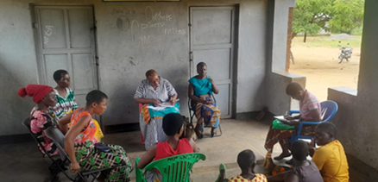
Figure 1-1. Consultation with Blantyre District Council DESC.

Project Location
The Mdeka–Chinyangute Feeder Roads Project is located in Blantyre District, Southern Region of Malawi, within TA Kuntaja. The road serves as a rural agricultural access corridor linking Mdeka Trading Centre to surrounding crop production areas, including dambo cultivation zones and smallholder farms.

The project comprises two connected sections with a combined length of approximately 10.63 km (5.70 km and 4.93 km). The alignment begins at Easting 708,610.81 m, Northing 8,289,502.29 m (Chainage 0+000) at Mdeka Trading Centre and extends toward the Chinyangute agricultural area, terminating at Easting 708,391.07 m, Northing 8,289,031.64 m (UTM, WGS 84 datum).

The project area is characterised by predominantly agricultural land use with scattered settlements and localized institutional facilities near Mdeka. The road corridor supports access to farms, schools, and trading points (Fig ures 1-3 to 1-7; Annex 14).

No protected areas or designated ecological reserves occur within the project footprint. The alignment remains within an existing road corridor and passes through a modified rural landscape.

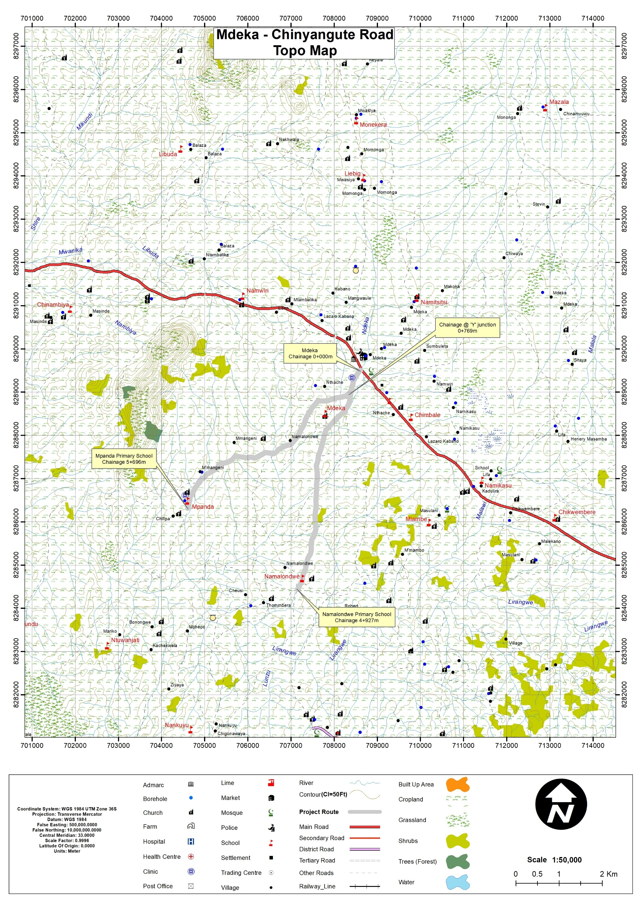
Figure 1-2. Location of the Mdeka – Chinyangute Feeder Road

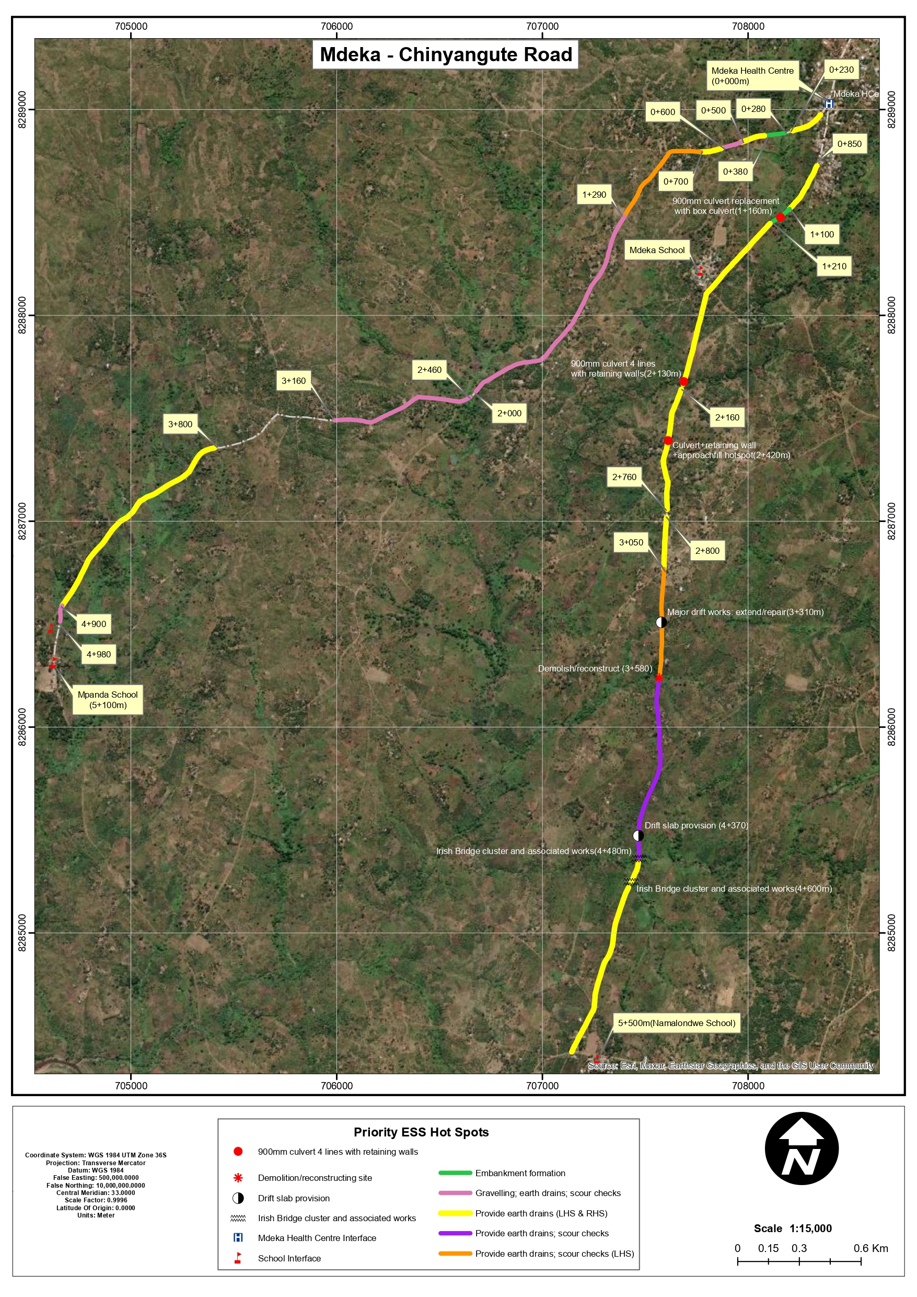
Figure 1-3. Aerial view of the project location
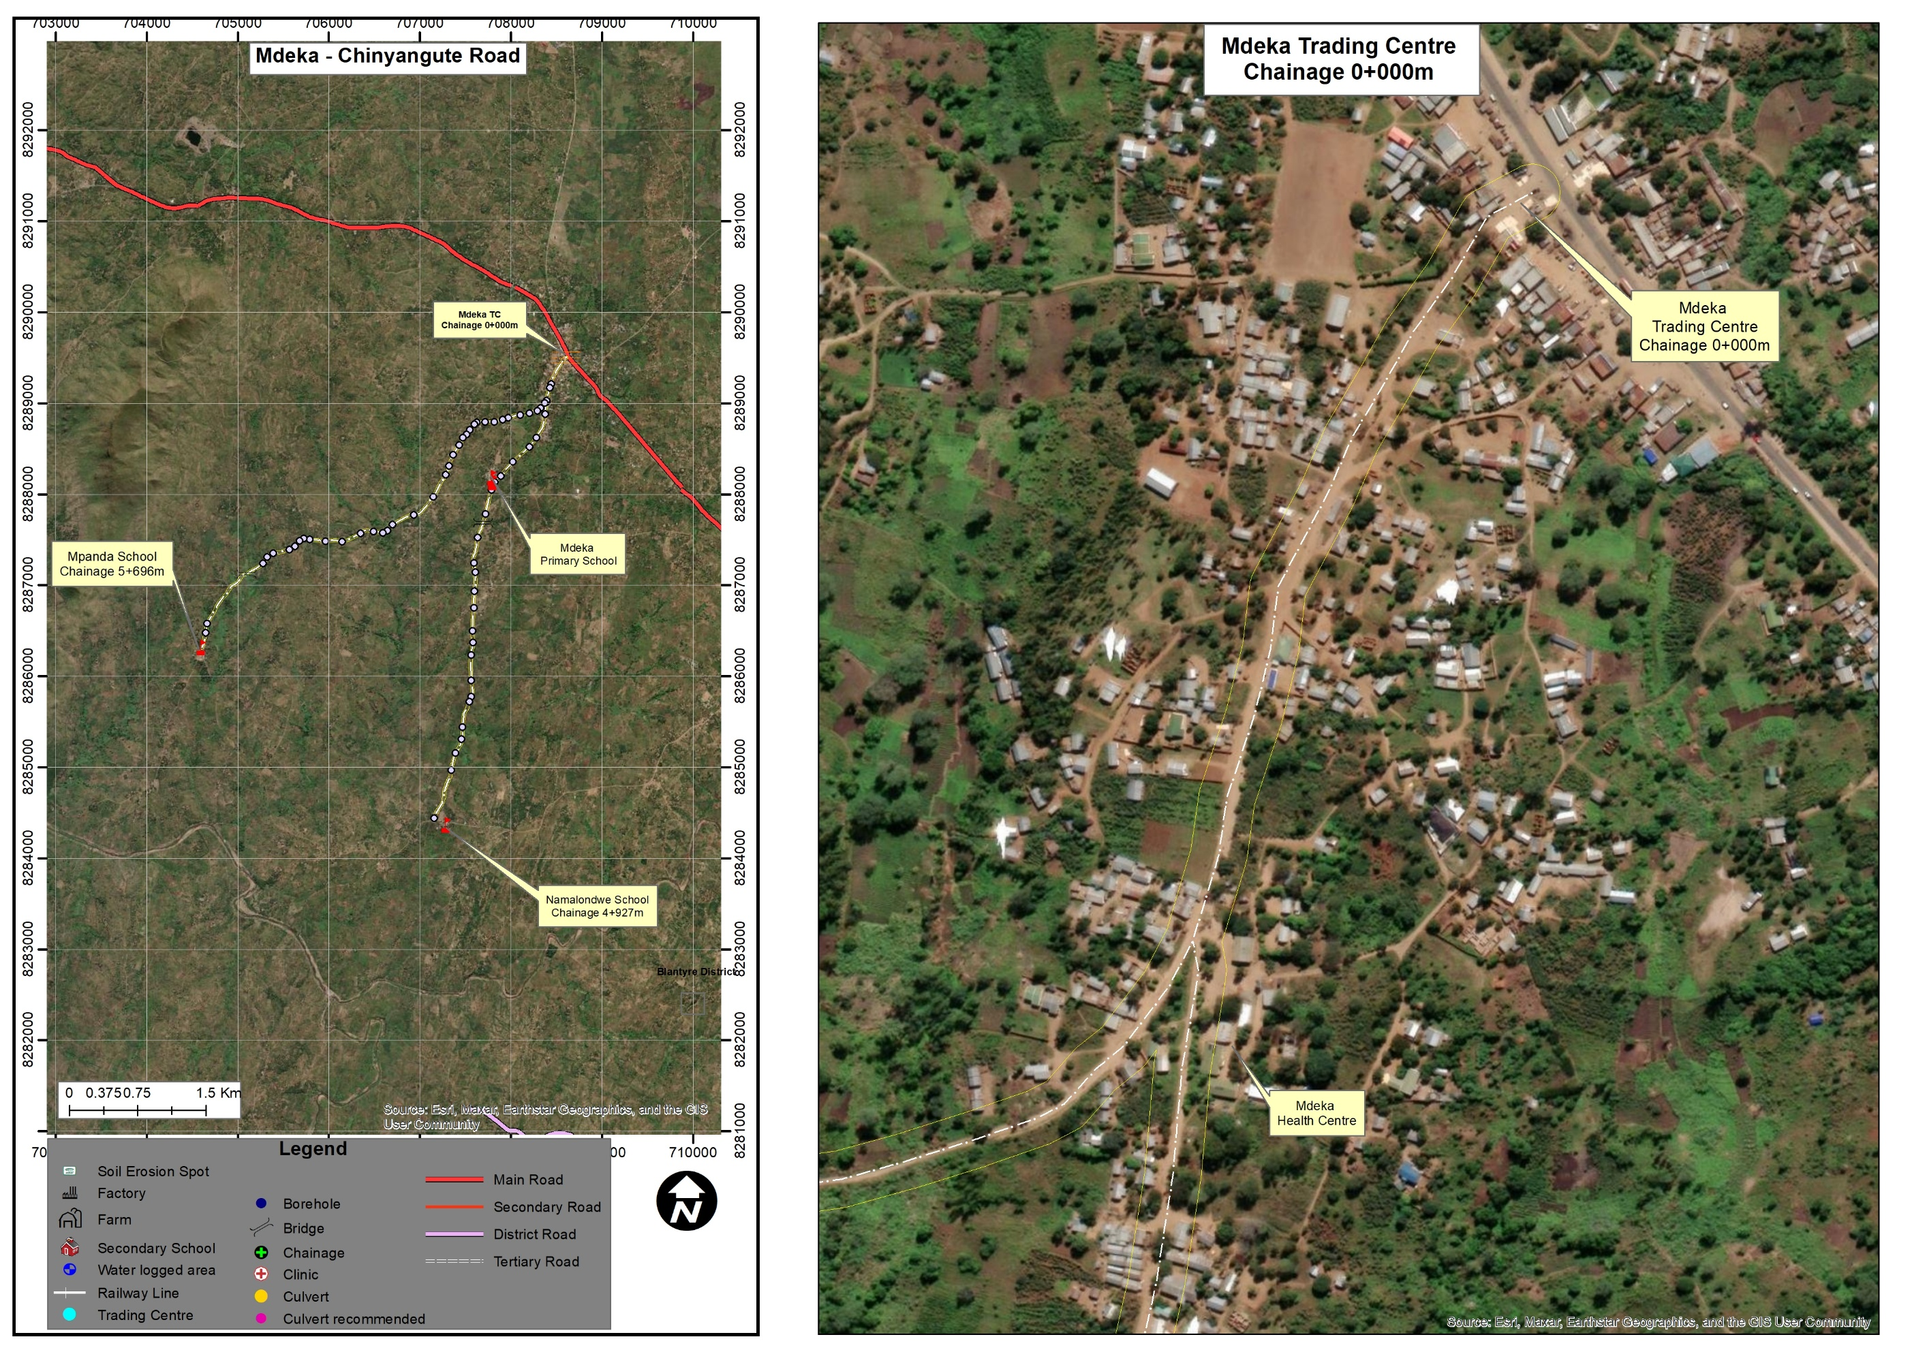
Figure 1-4. Detailed view of the starting point chainage 0+000 of the road section
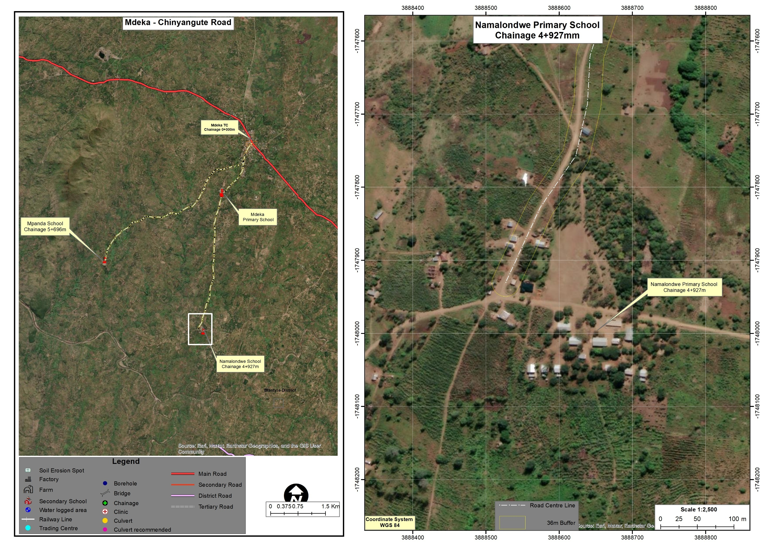
Figure 1-5. Detailed view of the Namalondwe Section

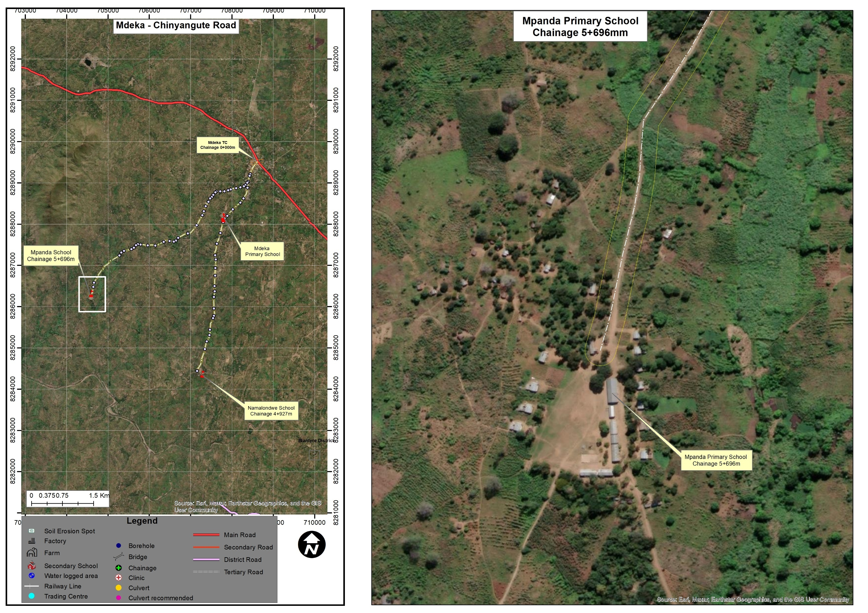
Figure 1-6. Detailed view of the Mpanda Section

Land Tenure and Land Requirement for the Project
The proposed project is located along existing feeder road alignments in Blantyre District, which form part of the public road network administered under the Public Roads Act (1969). The road corridor is therefore designated as public land under Government custody and management.

Land adjacent to the alignment is predominantly held under customary tenure, with communities using it for residential settlement, farming, and small-scale roadside trade. Field observations and consultations confirmed that while agricultural activities extend close to the road, no permanent residential structures lie within the existing road footprint. Some informal cultivation and temporary activities occur within parts of the road reserve, reflecting long-standing land use practices.

The proposed project involves rehabilitation and drainage improvements within the existing road reserve. No road realignment or permanent land acquisition is anticipated. Any temporary disturbances during construction will be managed through appropriate mitigation and access measures as outlined in this ESMP.

The land tenure context comprises public road reserve and surrounding customary landholdings, and the project design minimizes land-related risks in line with national legal provisions and applicable World Bank safeguard requirements.

Potential Users of the ESMP

This Environmental and Social Management Plan (ESMP) provides guidance for managing environmental and social risks associated with the rehabilitation of Zomba–Kachulu Access Road. The document serves as a practical tool for institutions responsible for project implementation, supervision, compliance monitoring, and stakeholder engagement throughout the project lifecycle.
Table 1-1 outlines the key institutions and stakeholders expected to use this ESMP and their respective roles in environmental and social management.

Table 1-1. Potential Users of the ESMP and Their Roles
Potential User | Potential Usage of the ESMP
Malawi Environment Protection Authority (MEPA) | Regulatory review, environmental compliance monitoring, and verification that project implementation aligns with the Environmental Management Act (2017) and MEPA requirements.
Ministry of Transport and Public Works (MoTPW) and PIU | Project owner and implementing authority responsible for overall coordination of the road rehabilitation works and ensuring that environmental and social safeguards are integrated into project implementation under the SATCP Last Mile Infrastructure component.
Blantyre2.3 District Council (including DESC) | Local-level monitoring and coordination of environmental and social management measures, as well as facilitation of engagement with local communities.
Ministry of Labour and National Construction Industry Council (NCIC) | Oversight of labour standards, occupational health and safety compliance, and contractor adherence to national labour regulations.
Project Engineers and Supervising Consultants | Integration of environmental and social requirements into construction supervision, site inspections, and monitoring of mitigation measures during project implementation.
Contractors and Subcontractors | Implementation of ESMP mitigation measures, occupational health and safety provisions, labour management procedures, community health and safety measures, and GBV/SEA/SH prevention requirements during construction.
Local Communities and Road-Corridor Users | Awareness of project activities, potential impacts, mitigation measures, employment opportunities, and access to the project Grievance Redress Mechanism (GRM).
World Bank and Other Oversight Institutions | Safeguards due diligence, implementation supervision, and monitoring of compliance with applicable environmental and social safeguard policies.

CHAPTER 2: PROJECT DESCRIPTION

Introduction
This chapter describes the technical scope of the proposed rehabilitation of the Mdeka–Namalondwe (5.5 km) and Mdeka Health Centre–Mpanda (5.1 km) feeder roads in Blantyre District, with a combined length of approximately 10.6 km. It presents the main engineering works, project components, and implementation activities associated with rehabilitation of the existing alignments within the established road reserve.
The chapter outlines the key activities to be undertaken during planning and design, construction, demobilisation, and operation, including reshaping and re-gravelling of deteriorated sections, embankment formation and improvement, drainage enhancement through earth drains and mitre drains, rehabilitation and upgrading of culverts and drifts, erosion and scour protection, material sourcing, labour requirements, waste management, and reinstatement of disturbed areas. Annex 15 provides the project design drawings, while Annex 14 presents the spatial distribution of works by chainage.

Project Components and Activities
The Mdeka–Chinyangute Feeder Roads Rehabilitation Project involves the upgrading and rehabilitation of two existing gravel feeder roads linking Mdeka Trading Centre to Namalondwe School and to Mpanda School. The works are confined to the existing road prism and are intended to restore road functionality, improve drainage performance, and enhance road safety and climate resilience for surrounding communities. The project focuses on improving road geometry, strengthening embankments, and rehabilitating drainage structures such as concrete pipe culverts, box culverts, drifts, Irish bridges, earth drains, and scour checks to ensure reliable all-weather access to markets, schools, and health facilities.
Field investigations and engineering assessments identified multiple locations where the road formation, embankments, and drainage structures require repair, rehabilitation, or replacement. Particular attention was given to low-lying sections, Irish bridge clusters, and culvert locations where inadequate drainage and scour have historically caused surface damage and access disruptions. The proposed drainage and structure works at each chainage have been defined in the Detailed Engineering Design, with the spatial distribution of works summarised in Annex 14 and detailed drawings provided in Annex 15. The main project activities are implemented across four phases, following the same structure as in Table 2-1 for similar SATCP LMI feeder road subprojects.

Spatial Distribution of Works by Chainage
Rehabilitation works along the Mdeka–Namalondwe and Mdeka Health Centre–Mpanda roads are not continuous; instead, they are concentrated at discrete chainage sections where the Engineer has identified formation, drainage, and structure defects requiring intervention. The chainage references therefore indicate where direct construction activities (reshaping, re-gravelling, culvert rehabilitation, drift and Irish bridge works, embankment formation, earth drains, and scour checks) will occur, and where environmental and social receptors (households, fields, watercourses, schools, health facilities, and trading centres) are most likely to experience disturbance. Annex 14 and Figure 1-3 present a schematic strip map of the two feeder roads showing the distribution of key work types and priority ESS hot spots along the alignment.
On the Mdeka–Namalondwe section (left branch), works extend from chainage 0+000 at Mdeka to chainage 5+500 at Namalondwe. The full section will be reshaped, with targeted embankment formation between chainages 1+100–1+210, earth drains and scour checks at several locations, upgrading and protection of concrete pipe culverts at chainages 2+130, 2+760, and 2+870, and rehabilitation of existing drift and Irish bridge structures between chainages 3+310 and 4+600. These activities will involve localised excavation, concrete works, and installation of retaining walls, marker posts, and scour protection.
On the Mdeka Health Centre–Mpanda section (right branch), works extend from chainage 0+000 at Mdeka Health Centre to chainage 5+100 at Mpanda School. The section will be reshaped with earth drains, complemented by spot gravelling and scour checks between chainages 0+500–0+600, 2+450–2+590, 3+160–3+500, and 4+100–4+980. Numerous concrete pipe culverts between chainages 0+280 and 4+530 will be cleaned, provided with new headwalls and outlet drains, or partially replaced where damaged. Existing box culverts and drifts at chainages 2+540, 4+150, and 4+370 will receive structural repairs, new marker posts, and gravelling of approaches.
Outside the specific chainage sections listed in Annex 14, only routine maintenance and minor touch-ups within the existing road prism are planned, such as local reshaping of side drains or filling of potholes, with limited environmental and social disturbance.

Planning and Design Phase
The planning and design phase involved the preparation of the Detailed Engineering Design, informed by traffic surveys, pavement and geotechnical investigations, hydrological assessments, field reconnaissance, and stakeholder consultations. This phase focused on identifying priority sections requiring intervention, including areas affected by erosion, poor drainage, embankment instability, and deteriorated water crossings.

Design considerations addressed road geometry, drainage capacity, culvert sizing, embankment formation, pavement performance, and constructability, with particular emphasis on low-lying sections, stream crossings, settlement areas, and agricultural interfaces. Environmental and social considerations were integrated into the design process to ensure compatibility with surrounding land uses, minimise disruption to communities, and reduce exposure to climate-related risks such as flooding and erosion.

Construction Phase
The construction phase involves the physical implementation of the rehabilitation works in accordance with the approved designs and specifications. Activities include site establishment, controlled vegetation clearing within the road reserve, earthworks, drainage construction, culvert installation or rehabilitation, embankment formation, and re-gravelling of selected sections.

Construction will be undertaken using a combination of labour and mechanical equipment and will be phased to maintain access for local communities, schools, farms, and trading centres as far as practicable. Environmental and social management measures—including traffic management, occupational health and safety controls, erosion and sediment control, waste management, and community engagement—will be implemented throughout the construction period in accordance with this ESMP.

Demobilisation Phase
The demobilisation phase will commence upon completion of construction works and will involve the removal of construction equipment, machinery, temporary facilities, and unused materials from the site. Temporary work areas, including material stockpiles, borrow areas, and equipment parking zones, will be rehabilitated and reinstated to their original or agreed condition.

All waste generated during construction and demobilisation will be collected, transported, and disposed of at approved sites in accordance with national requirements. The demobilisation phase is intended to ensure that no residual environmental, health, or safety risks remain following completion of the works.

Operational Phase
The operational phase begins once the rehabilitated feeder roads are opened to traffic and handed over to the responsible road authority. During this phase, the roads will provide improved, safer, and more reliable access for communities, traders, agricultural producers, and service providers within the Mdeka–Chinyangute area.

Routine maintenance activities—particularly drainage clearing, minor repairs, and erosion control—will be required to sustain road performance and prolong service life. Potential environmental and social risks during operation are expected to be low and are primarily associated with road safety and maintenance practices. These risks will be managed through standard operational procedures and oversight by the relevant authorities.

Labour Requirement
The rehabilitation works for the Mdeka–Chinyangute Feeder Roads in Blantyre District will be implemented by a contracted construction firm employing a mix of skilled, semi-skilled, and unskilled labour, with a strong emphasis on local recruitment.
At peak construction periods, the contractor is expected to employ approximately 70–85 workers (with a 40/60 male to female ratio), representing the maximum workforce at any one time. Peak labour demand is anticipated during intensive activities such as drainage construction, culvert and drift works, embankment formation, and re-gravelling. Outside these peak periods, workforce numbers are expected to reduce in line with construction sequencing and activity type.

The majority of workers will be recruited locally from Mdeka, Chinyangute, and surrounding communities, particularly for unskilled and semi-skilled roles such as site clearing, manual material handling, drainage works, traffic control, and general site support. This approach is intended to maximise local economic benefits, reduce labour influx, and minimise social risks associated with the presence of a large external workforce, in line with MEPA (2025) good practice.

A limited number of specialised personnel, including engineers, surveyors, and experienced equipment operators, may be sourced from outside the immediate project area to provide technical supervision, quality control, and compliance oversight. These personnel will be engaged mainly on a short-term or intermittent basis, particularly during critical construction stages.

In addition, dedicated Environmental, Social, and Occupational Health and Safety (E&S/OHS) personnel will be engaged to oversee compliance with ESMP requirements. These will include roles such as an Environmental and Social Officer and an OHS Officer, responsible for implementation of mitigation measures, site inspections, worker safety enforcement, incident reporting, and compliance monitoring.

Table 2-1. Estimated Labour Requirements at Peak Construction
SN | Employee Category | Local | External* | Total
1 | Civil Engineering & Supervision | 3 | 2 | 5
2 | Surveying & Setting Out | 3 | 1 | 4
3 | Masonry & Concrete Works | 7 | 0 | 7
4 | Carpentry & Formwork | 4 | 0 | 4
5 | Electrical Works (minor/temporary) | 2 | 1 | 3
6 | Mechanical / Equipment Operators | 6 | 2 | 8
7 | Drainage Construction | 9 | 0 | 9
8 | Excavation & Earthworks | 10 | 0 | 10
9 | Manual Material Handling | 9 | 0 | 9
10 | Site Clearing & Preparation | 7 | 0 | 7
11 | Traffic Control & Safety | 5 | 0 | 5
12 | General Site Maintenance | 4 | 0 | 4
13 | Catering & Welfare Services | 1 | 0 | 1
14 | Security Services | 4 | 0 | 4
15 | Health & Safety Compliance | 1 | 0 | 1
16 | Environmental and Social (combined) | 1 | 0 | 1
 | Sub-Total (Peak Workforce) | 67 | 8 | 75

Land Requirement
The Mdeka–Chinyangute Feeder Roads Rehabilitation Project in Blantyre District will be implemented entirely within the existing road alignment and road reserve. The proposed interventions, including spot re-gravelling, drainage improvements, culvert and drift rehabilitation, embankment reshaping, and minor formation works, are confined to the existing road footprint and do not require any new land acquisition. Where informal temporary structures such as vending booths or groceries placed by their occupants occur within the road reserve along the alignment, the corresponding sections have been deliberately excluded from the spot-based rehabilitation scheme during design, so that construction works avoid them altogether; any residual coordination needs around the immediate working area will be handled under the stakeholder engagement and GRM provisions of this ESMP.

Although there are localized instances of encroachment along sections of the corridor such as small-scale trading activities, cultivation (notably sugarcane), and informal structures near drainage lines. These will not be formalised, regularised or permanently affected under the project. The works are strictly limited to restoring road functionality, improving drainage performance, and enhancing resilience in erosion- and flood-prone sections.

Temporary land use may be required during construction for activities such as material stockpiling, equipment parking, laydown areas, and site facilities. Such use will be undertaken through prior consultation with affected land users and coordination with local authorities, and all affected areas will be reinstated to their original or agreed condition after construction.

The project will not result in physical or economic displacement, and works will be confined to the existing road reserve and scheme footprint. Land-related risks will be managed through clear demarcation of work areas, stakeholder engagement, and implementation of mitigation measures outlined in this ESMP.

Material Requirements and Sources
The rehabilitation of the Mdeka–Chinyangute Feeder Roads will require a range of construction materials to support spot re-gravelling, drainage improvements, culvert and drift rehabilitation, embankment formation, and minor structural works. Material requirements have been carefully considered to ensure that sourcing is technically suitable, environmentally sustainable, and socially acceptable, while supporting efficient project delivery.

Wherever practicable, materials will be sourced from approved local sources within or near Blantyre District to minimise haulage distances, reduce construction costs, limit greenhouse gas emissions, and enhance local economic benefits. All material sourcing activities will comply with the Environment Management Act (2017) and MEPA Environmental Assessment Guidelines (2025), including acquisition of relevant permits and approvals prior to use.

Water Sources
Water will be required for concrete works, compaction, curing, dust suppression, and general site use. For this project, construction water is expected to be sourced primarily from the Lirangwe River, subject to approval by relevant authorities and implementation of appropriate abstraction controls.

Water abstraction will be undertaken in a manner that does not interfere with downstream users, community water needs, or ecological flows. Abstraction points will be clearly defined, and water use will be carefully managed to minimise wastage.

Table 2-2. Water Requirements and Sources
SN | Intended Use | Estimated Demand | Potential Source | Management Measures
1 | Concrete works | Moderate | Approved abstraction points (Lirangwe River) | Controlled abstraction; no contamination
2 | Compaction and curing | Moderate | Approved surface water sources | Efficient use; reuse where feasible
3 | Dust suppression | Low–Moderate | Water bowsers | Limited to dry periods
4 | General site use | Low | Approved water points | Avoid wastage

Gravel, Sand, Aggregates, and Rock Materials
Gravel will be required primarily for the wearing course and spot re-gravelling works. Investigations have identified Michiru Borrow Pit as a suitable source of decomposed rock material with adequate engineering properties for use as gravel wearing course material. The borrow pit has sufficient estimated reserves to meet project demand.

Sand for concrete works and mortar will be sourced from the Lirangwe River, while coarse aggregates, boulders, and rock materials required for culverts, scour protection, and erosion control will be obtained from licensed quarries or approved suppliers.

Unregulated extraction of sand or aggregates from riverbeds, wetlands, or environmentally sensitive areas will not be permitted. All borrow areas will be operated in accordance with approved extraction plans and rehabilitated after use.

Table 2-3. Gravel, Sand, and Aggregate Requirements
SN | Material | Intended Use | Potential Source | Key Environmental Controls
1 | Gravel | Used for spot re-gravelling, road surfacing, strengthening of existing carriageway under earthworks and pavement improvement activities | Michiru Borrow Pit | Site rehabilitation after extraction; controlled haulage to reduce dust.
2 | Sand | Used in concrete and masonry works for culvert construction, headwalls, wing walls, and drainage structures | Licensed abstraction points (Lirangwe River) | No in-stream excavation; abstraction only from approved points
3 | Aggregates | Used in concrete production for culverts, drifts, and other hydraulic structures under drainage improvement works | Approved quarries | Dust Suppression and regulated blasting where applicable
4 | Rock / Boulders | Used for scour protection, erosion control, and protection of drainage structures in flood-prone sections | Licensed quarries | Avoid disturbance of sensitive habitats;  Controlled extraction and transport

Energy Sources
Energy will be required for the operation of construction machinery, vehicles, and temporary site facilities. The primary energy sources will include diesel and petrol for plant and vehicles, and grid electricity or solar power for site offices and welfare facilities where available.

Fuel storage and handling will be strictly controlled to prevent soil and water contamination, with designated refuelling areas and spill prevention measures in place.

Table 2-4. Energy Sources and Management Measures
SN | Energy Source | Intended Use | Management Measures
1 | Diesel | Construction machinery and vehicles | Bunded storage; spill kits
2 | Petrol | Light vehicles and small equipment | Controlled refuelling
3 | Electricity / Solar | Site offices and welfare facilities | Energy-efficient use

Worker Accommodation and Facilities
The project will not establish worker camps, as most workers will be recruited locally and will commute daily from surrounding communities. A small number of skilled personnel who are not locally based may be accommodated in existing lodging facilities in Blantyre and nearby trading centres such as Mdeka, Lirangwe, and Lunzu, rather than in purpose-built camps. Temporary site facilities will be provided to support construction activities, including a site office, drinking water and sanitation facilities, first aid and basic emergency equipment, and designated areas for equipment and material storage. All facilities will be temporary, located within the road reserve or on agreed sites, and will be removed upon completion of the works.

Waste and Waste Management

Waste and Waste Generation
The project is expected to generate limited quantities of waste, primarily during the construction phase. The scale of works is modest and focused on spot re-gravelling, drainage improvements, culvert rehabilitation, and minor structural interventions. No asphalt plants, large batching facilities, or permanent worker camps are associated with the project, and as such overall waste generation is anticipated to be low to moderate.
Waste streams will arise mainly from earthworks, drainage and culvert works, operation and maintenance of construction equipment, material handling, and routine activities at site offices and welfare facilities. Both non-hazardous and small quantities of hazardous waste may be generated during construction, while waste generation during demobilisation is expected to be minimal.

Liquid waste generation will be limited due to the absence of permanent worker camps. Wastewater will be associated mainly with temporary welfare facilities and occasional concrete works. No industrial effluents or continuous liquid discharges are anticipated as part of the project scope.

Table 2-5. Main Expected Waste Streams
Waste Stream | Typical Source | Indicative Quantity
Excavated soil and spoil | Drainage works, culvert installation, earthworks | Low–Moderate
Construction rubble | Culvert rehabilitation, concrete pads, minor structures | Low
Concrete residues | Minor concrete works | Very Low
Scrap metal | Equipment maintenance and minor fabrication | Low
Packaging waste (cement bags, plastics, cartons) | Construction materials | Low
Used oils and lubricants | Equipment and vehicle maintenance | Low
Used batteries | Construction equipment | Very Low
Domestic solid waste | Site offices and welfare facilities | Low
Sanitary wastewater | Temporary welfare facilities | Very Low

Organic Waste
Organic waste is expected to be minimal and will arise mainly from domestic-type activities at site offices and welfare facilities. No food preparation at large scale is anticipated under the project scope.

Liquid Waste
Liquid waste will be limited to sanitary wastewater from temporary welfare facilities and small volumes of wash water from concrete-related activities. No process wastewater or continuous discharges to the environment form part of the project scope.

Non-Hazardous Solid Waste
Non-hazardous solid waste generated during the project will include packaging materials, paper, plastics, construction debris, and surplus excavated material. These wastes are typical of small-scale road rehabilitation activities.

Hazardous Waste
Small quantities of hazardous waste may arise during equipment operation and maintenance, including used oils, lubricants, batteries, and oil-contaminated materials. No hazardous industrial processes or bulk handling of hazardous substances are envisaged under the project.

Rehabilitation of Temporary Sites
Temporary sites used during construction (e.g., for materials, equipment, and site facilities) will be established only for the duration of the works and within the road reserve or agreed areas.

After construction, all temporary sites will be cleared, reshaped, and restored to match surrounding land use and natural drainage conditions. No permanent structures or long-term land use changes will remain.

CHAPTER 3: POLICY AND LEGAL FRAMEWORK

Introduction
This chapter outlines the policy, legal, and institutional framework applicable to the Proposed Rehabilitation of the Mdeka–Chinyangute Feeder Roads (UD) in Blantyre District. It summarises the key national policies, legislation, and regulatory requirements that guide environmental and social planning and management of the proposed works.

The framework is presented in line with the Environment Management Act (2017), the MEPA Guidelines for Environmental Assessment (2025), and the World Bank Operational Policy OP/BP 4.01 on Environmental Assessment. It also identifies the principal institutions responsible for regulation, coordination, and oversight during the planning, construction, and operational phases of the project.

This chapter provides the regulatory context within which the Environmental and Social Management Plan (ESMP) has been prepared.

National Policies and Strategies

Policy Framework
Table 3-1 presents key national policies and strategies that provide the strategic and regulatory framework for planning, implementation, and monitoring of the proposed project. These policies reflect Malawi’s development priorities and establish obligations relating to environmental protection, land administration, water resources management, climate resilience, gender inclusion, labour standards, waste management, and transport sector governance.

Table 3-1. Policies Guiding the Project
Policy / Strategy | Brief Description | Implications for the Project
Malawi 2063 (MW2063) and First 10-Year Implementation Plan (MIP-1, 2021–2030) | Malawi’s long-term national vision and medium-term implementation plan prioritising economic infrastructure, rural connectivity, trade facilitation, and climate resilience. | The road rehabilitation supports MW2063/MIP-1 by improving local connectivity, access to markets and services, and strengthening climate-resilient infrastructure within the existing corridor.
National Environmental Policy (2004) | Framework for integrating environmental sustainability into development planning, including safeguards, pollution prevention, and conservation. | Requires application of environmental management measures, pollution control, and adherence to MEPA requirements throughout implementation.
National Land Policy (2002) | Promotes orderly land administration, secure tenure, and safeguards in land-based development. | Requires respect for public road reserve status and surrounding customary land rights; land requirement considerations are addressed under Section 2.4.
National Water Policy (2005) | Promotes sustainable water resources management, protection of water bodies, and equitable water access. | Requires safeguarding of rivers/streams and responsible water abstraction for construction, with prevention of erosion and siltation from earthworks and drainage activities.
National Gender Policy (2015) | Promotes gender equality and equitable participation in development, including addressing GBV risks and barriers to inclusion. | Requires gender-inclusive consultations, fair access to employment opportunities, and integration of GBV/SEA risk prevention measures in contractor management.
National Climate Change Management Policy (2016) | Provides guidance for climate adaptation and mitigation across sectors; promotes climate-resilient infrastructure. | Requires climate-resilient drainage and erosion control measures, and integration of climate risk considerations in design and construction practices.
National Sanitation Policy (2008) | Provides a framework to improve sanitation and hygiene standards, including safe management of waste. | Requires proper solid and liquid waste management (including segregation, safe storage, and disposal) in line with the waste hierarchy.
National HIV and AIDS Policy (2022–2027) | Aims to reduce new infections and strengthen workplace systems and non-discrimination protections. | Requires workplace HIV and AIDS awareness measures and non-discriminatory practices for workers and communities.
National Transport Policy (2015) | Aims to develop a safe, efficient, sustainable transport system, emphasising rural access, safety, and resilience. | Requires incorporation of road safety measures, access management during construction, and maintenance of connectivity for local communities and services.
National Labour and Employment Policy (2017) | Promotes decent work, fair labour practices, and inclusive access to employment. | Requires fair recruitment, decent working conditions, prevention of child labour, and promotion of local employment consistent with labour laws and OHS standards.
National Forest Policy (2016) | Promotes sustainable forest management and restoration. | Requires minimising vegetation clearing within the road reserve and applying erosion control/rehabilitation measures for disturbed areas.
National Decentralisation Policy (1998) | Devolves planning and service delivery responsibilities to district councils and local structures. | Requires structured engagement with Blantyre District Council and DESC for oversight, monitoring, and alignment with district priorities and by-laws.

Legislative Framework
Table 3-2 presents the key national legislation applicable to the proposed project. These statutes establish the legal framework for environmental management, land use and planning, labour and occupational health and safety, public health, water resources management, and road infrastructure development in Malawi. Compliance with these legal instruments is mandatory and provides the statutory basis for project planning, implementation, and operational oversight, as well as for the environmental and social management measures defined in this ESMP.

Table 3-2. Legislation Guiding the Project
Act | Brief Description | Implications for the Project
Constitution of the Republic of Malawi (1995) | Supreme law guaranteeing environmental protection, human rights, gender equality, and sustainable development (Sections 5, 12(e), 13(d)). | Requires environmentally sound project implementation and adherence to constitutional principles through application of approved safeguards instruments.
Environment Management Act (2017) | Principal legislation for environmental protection and sustainable resource use; mandates environmental assessment and compliance monitoring. | Requires preparation and implementation of an approved ESMP and compliance with conditions set by MEPA prior to and during construction.
Public Roads Act (2023) | Provides for classification, construction, maintenance, and management of public roads, including stormwater management, access control, and safety. | Requires adherence to road reserve management, drainage standards, safety provisions, and lawful execution of rehabilitation works within the public road corridor.
Land Act (2016), Customary Land Act (2016) | Establish the legal framework for land tenure across public, private, and customary land. | Confirms public road reserve status and safeguards surrounding customary land rights; no new land acquisition is required for this project (see Section 2.4).
Water Resources Act (2013) | Regulates water abstraction, pollution control, and protection of water resources. | Requires permits for water abstraction where applicable and implementation of measures to prevent pollution, siltation, and alteration of drainage patterns.
Occupational Safety, Health and Welfare Act (1997) | Provides for safe and healthy workplaces, registration of workplaces, and regulation of plant and machinery. | Requires registration of construction sites, implementation of OHS measures, provision of PPE, and safe working conditions for all workers.
Employment Act (2000) | Establishes minimum employment standards and prohibits forced labour, discrimination, and child labour. | Requires fair recruitment, prohibition of child labour, non-discrimination, and compliance with national employment standards.
Gender Equality Act (2013) | Promotes gender equality and prohibits discrimination and sexual harassment in workplaces. | Requires gender-inclusive employment practices and enforcement of workplace measures to prevent GBV/SEA/SH.
HIV and AIDS (Prevention and Management) Act (2018) | Protects rights of persons living with or affected by HIV and AIDS and guides workplace responses. | Requires non-discriminatory practices, workplace sensitisation, and adherence to national HIV and AIDS guidelines.
Public Health Act (1948) | Provides for public and environmental health, including sanitation, waste management, and drainage. | Requires provision of adequate sanitation, waste disposal facilities, and control of health risks during construction.
Environment Management (Waste Management and Sanitation) Regulations (2008) | Governs solid and liquid waste management, including hazardous waste handling. | Requires waste segregation, safe storage, and disposal through licensed facilities in line with the waste hierarchy.
Data Protection Act (2022) | Provided legal framework for the collection, processing, storage, and sharing of personal data to ensure privacy and protection of individual’s information. | Requires that any stakeholder, worker, or community personal data collected during consultations, grievance handling, employment, or monitoring activities is handled securely, used only for intended project purposes, and protected from unauthorized access or disclosure.
Environment Management (Chemicals and Toxic Substances) Regulations (2008) | Regulates handling, storage, transport, and disposal of chemicals and toxic substances. | Requires controlled storage and disposal of fuels, oils, and chemicals using approved methods and licensed handlers.
Forestry Act (2020) | Provides for conservation and sustainable management of forest resources. | Requires minimisation of vegetation clearing within the road reserve and implementation of erosion control and site rehabilitation measures.
National Parks and Wildlife Act (2017) | Provides for protection of wildlife and biodiversity and regulates activities affecting habitats. | Requires avoidance of habitat disturbance and prohibition of hunting or wildlife exploitation by project workers.
Local Government Act (1998) | Empowers local councils to manage development, environment, sanitation, and community engagement. | Requires coordination with Blantyre District Council and DESC for consultations, monitoring, and alignment with local by-laws.
Physical Planning Act (2016) and Physical Planning (Amendment) Act (2022) | Regulates orderly land development and requires development permission from local authorities. | Requires obtaining Development Permission from the relevant local authority prior to commencement of works.
Construction Industry Act No. 28 of 2025 (CIRA Act) | Establishes the Construction Industry Regulatory Authority (CIRA) to regulate, develop, and promote the construction industry in Malawi. The Authority oversees registration and licensing of contractors, consultants, material manufacturers and suppliers, enforces professional and ethical standards, promotes training and capacity development, and standardizes construction practices and procedures across the industry. | Requires that all contractors, consultants, and suppliers engaged in the proposed Road rehabilitation project be registered and licensed by CIRA, and that construction activities comply with approved industry standards, codes of ethics, and professional conduct requirements. The project must therefore ensure engagement of CIRA-registered entities, adherence to quality and safety standards, and compliance with regulatory oversight for construction works.
Liquid Fuels and Gas (Production and Supply) Act (2004) and Regulations | Regulates storage and handling of liquid fuels and gas. | Requires licensing of any on-site fuel storage exceeding regulatory thresholds and compliance with MERA requirements.

The contractor will be require to develop specific plans in line with frameworks in annexes 4,5,6,7 and 8.

World Bank Safeguard Operational Policies and Procedures
In accordance with World Bank Operational Policy OP/BP 4.01 on Environmental Assessment, the project has been classified as a Category B intervention. This classification reflects the nature and scale of the proposed works.

As a result, only a limited number of World Bank safeguard policies are applicable. The relevant policies triggered by the project are summarised in Table 3-3.

Table 3-3. World Bank Environmental and Social Operational Policies Triggered by the Project
Safeguard Policy | Key Requirements and Application to the Project
Environmental Assessment (OP/BP 4.01) | This policy requires an environmental assessment of projects proposed for Bank financing to ensure environmental sustainability and informed decision-making. The assessment considers impacts on the natural environment (air, water, land), human health and safety, and social aspects. For this project, an Environmental and Social Management Plan (ESMP) has been prepared to identify potential impacts associated with road rehabilitation works and to define appropriate mitigation, monitoring, and institutional measures.
Forests (OP/BP 4.36) | The policy aims to reduce deforestation and promote sustainable forest management. The road rehabilitation does not pass through gazetted forest reserves. Vegetation clearance, where unavoidable, will be limited to the road reserve and managed in accordance with national forestry requirements and good practice, with restoration measures incorporated in the ESMP.
Physical Cultural Resources (OP/BP 4.11) | This policy addresses the protection of cultural heritage, including archaeological, historical, and religious sites. No known physical cultural resources were identified within the project footprint during consultations and field assessments. A Chance Finds Procedure has nonetheless been incorporated into the ESMP to guide appropriate action should any cultural resources be encountered during construction.

Environmental Health and Safety Guidelines

These EHS Guidelines are designed to be used together with the relevant Industry Sector EHS Guidelines, which provide guidance to users on EHS issues in a specific construction or industry sector. The EHS Guidelines are categorized as follows:
- Environmental Guidelines – provide framework for managing air emissions and ambient air quality; energy conservation; wastewater and ambient water quality; water conservation; hazardous materials management; waste management; noise and contaminated Occupational Health and Safety Guidelines - provide framework for managing general facility design and operation; communication and training; physical hazards; chemical hazards; biological hazards; radiological hazards; personal protective equipment; special hazards environment; and monitoring.
- Community Health and Safety Guidelines – provide framework for managing water quality and availability; structural safety of project infrastructure; life and fire safety; traffic safety; transport of hazardous materials; disease prevention and emergy preparedness and response; and
- Construction and Decommissioning Guidelines – provide framework for managing environment; occupational health and safety; and community health and safety, including relevant contractor instruments such as waste management plan, traffic management plan, stakeholder engagement plan, labour management plan, SEA/SH Prevention and Response Plan, biodiversity management plan, gender-action plan, and gender-based violence management plan among others.

Institutional Framework
The implementation of the ESMP is supported by a structured institutional arrangement reflecting regulatory hierarchy and functional responsibilities. At the apex is the environmental regulator, followed by the project client responsible for overall accountability, and supporting institutions that provide technical oversight, coordination, and local-level compliance monitoring. The key institutions and their ESMP-related mandates are summarised in Table 3-4.
Table 3-4. E&S Institutional Framework and Mandates
SN | Institution | ESMP-Related Mandates
1 | Malawi Environment Protection Authority (MEPA) | Apex environmental regulator; reviews and approves ESMP; issues environmental authorisation; conducts compliance monitoring and inspections; enforces corrective actions for non-compliance.
2 | Ministry of Transport and Public Works (MoTPW) | Project Client and overall responsible authority; ensures ESMP implementation and compliance; integrates E&S requirements into project planning, procurement, and execution under SATCP.
3 | SATCP Project Implementation Unit (PIU) | Supports MoTPW in coordinating safeguard implementation; ensures alignment with World Bank requirements; consolidates E&S monitoring and reporting.
4 | Blantyre District Council / DESC | Facilitates stakeholder engagement; participates in site inspections; monitors compliance with local environmental, health, and by-law requirements; supports GRM implementation and resolution.
5 | Ministry of Labour & CIRA | Enforces labour laws and occupational health and safety (OHS) standards; monitors workplace compliance; ensures adherence to labour regulations and contractor registration requirements.

Summary of Main Statutory Approvals/Licenses to be obtained for the project
Implementation of the Mdeka–Chinyangute Feeder Roads (UD) Rehabilitation Project is subject to compliance with applicable statutory approval and licensing requirements under Malawi’s environmental, labour, land use, and occupational health and safety regulatory framework. The required approvals and licences are intended to ensure that project activities are undertaken in accordance with national legal provisions and Good International Industry Practice.

Relevant approvals and permits shall be obtained prior to commencement of construction works, or during implementation where applicable, in line with statutory requirements and institutional mandates.

Table 3-5. Summary of Statutory Approvals and Licences Required
SN | Approval / Licence Required | Applicable Legal / Regulatory Framework | Issuing Institution | Responsible Party | Indicative Timeframe
1 | ESMP Approval / Environmental Clearance | Environment Management Act (2017) | Malawi Environment Protection Authority (MEPA) | MoTPW | Already cleared by MEPA
2 | Approval for Waste Disposal | Environment Management Act (2017); Local Government Act (1998) | MEPA; Blantyre District Council | Contractor | ~2 weeks
3 | Approval for Sand Extraction (where applicable) | Local Government Act (1998) | Blantyre District Council | Contractor | ~2 weeks
4 | Quarrying / Borrow Pit Approval (if required) | Mines and Minerals Act (2018) | Department of Mines | Contractor | Up to 3 months
5 | Workplace Registration Certificate | Occupational Safety, Health and Welfare Act (1997) | Ministry of Labour | Contractor | ~2 weeks
6 | Water Abstraction Permit (if required) | Water Resources Act (2013) | National Water Resources Authority | Contractor | ~2 weeks
7 | Development Permission (where applicable) | Physical Planning Act (2016, as amended 2022); Local Government Act (1998) | Blantyre District Council | MoTPW | ~2 weeks
9 | Fuel Storage Registration / Licence (for on-site storage capacity > 400 litres) | Liquid Fuels and Gas (Production and Supply) Act (2004) and subsidiary Regulations; MERA Notice on mandatory registration and licensing of private storage exceeding 400 litres | Malawi Energy Regulatory Authority (MERA) | Contractor | Up to 3 months

CHAPTER 4: ENVIRONMENTAL AND SOCIAL SETTING

Introduction
This chapter presents a concise description of the environmental and social baseline conditions within the project area of influence in Blantyre District. It outlines the key physical, biological, and socio-economic characteristics relevant to the assessment of potential impacts associated with the proposed rehabilitation works.

Baseline information was obtained through desk review, engineering design documents, site reconnaissance, and stakeholder consultations in accordance with the Environment Management Act (2017), MEPA (2025) guidelines, and applicable World Bank requirements.

Biophysical Environment

Topography
The project road lies within a gently undulating to moderately rolling landscape typical of the southern Malawi plateau margins, as illustrated in Figure 1.3. Elevation ranges approximately between 1,050 and 1,150 metres above sea level, with gradual slopes and shallow valleys (Blantyre District Socio-Ecopnomic Profile, 2017-2022).

The road alignment traverses minor watershed divides and seasonal drainage lines that connect to the Lirangwe River system. Localized low-lying sections are prone to surface water ponding during the rainy season, particularly where drainage infrastructure is limited.

Geology
The proposed location lies within the southern Malawi Precambrian Basement Complex, which is characterised by extensive occurrences of high-grade metamorphic rocks, as illustrated in the Geological Map (Figure 4-1). The spatial distribution of these formations indicates that the project corridor is predominantly underlain by crystalline basement lithologies typical of southern Malawi.

The alignment traverses several geological units, with the dominant formation being Xsy (approximately 85%), comprising anatectic pyroxene-perthosite and perthosite-gneiss. This is followed by Xk (approximately 10%), consisting of charnockitic gneiss and granulite units. Minor occurrences include Xsyn (approximately 4%), represented by perthitic norite, and Xup (less than 1%), comprising pyroxenite and related mafic rocks.

These basement complex rocks are generally strong and competent at depth, providing a stable geological foundation for road infrastructure. However, they are typically overlain by deeply weathered regolith and residual soils, which are more susceptible to erosion, reduced load-bearing capacity, and moisture sensitivity. This characteristic has important implications for road design, particularly in relation to subgrade preparation, drainage provision, and slope stability (Blantyre District Socio-Ecopnomic Profile, 2017-2022).

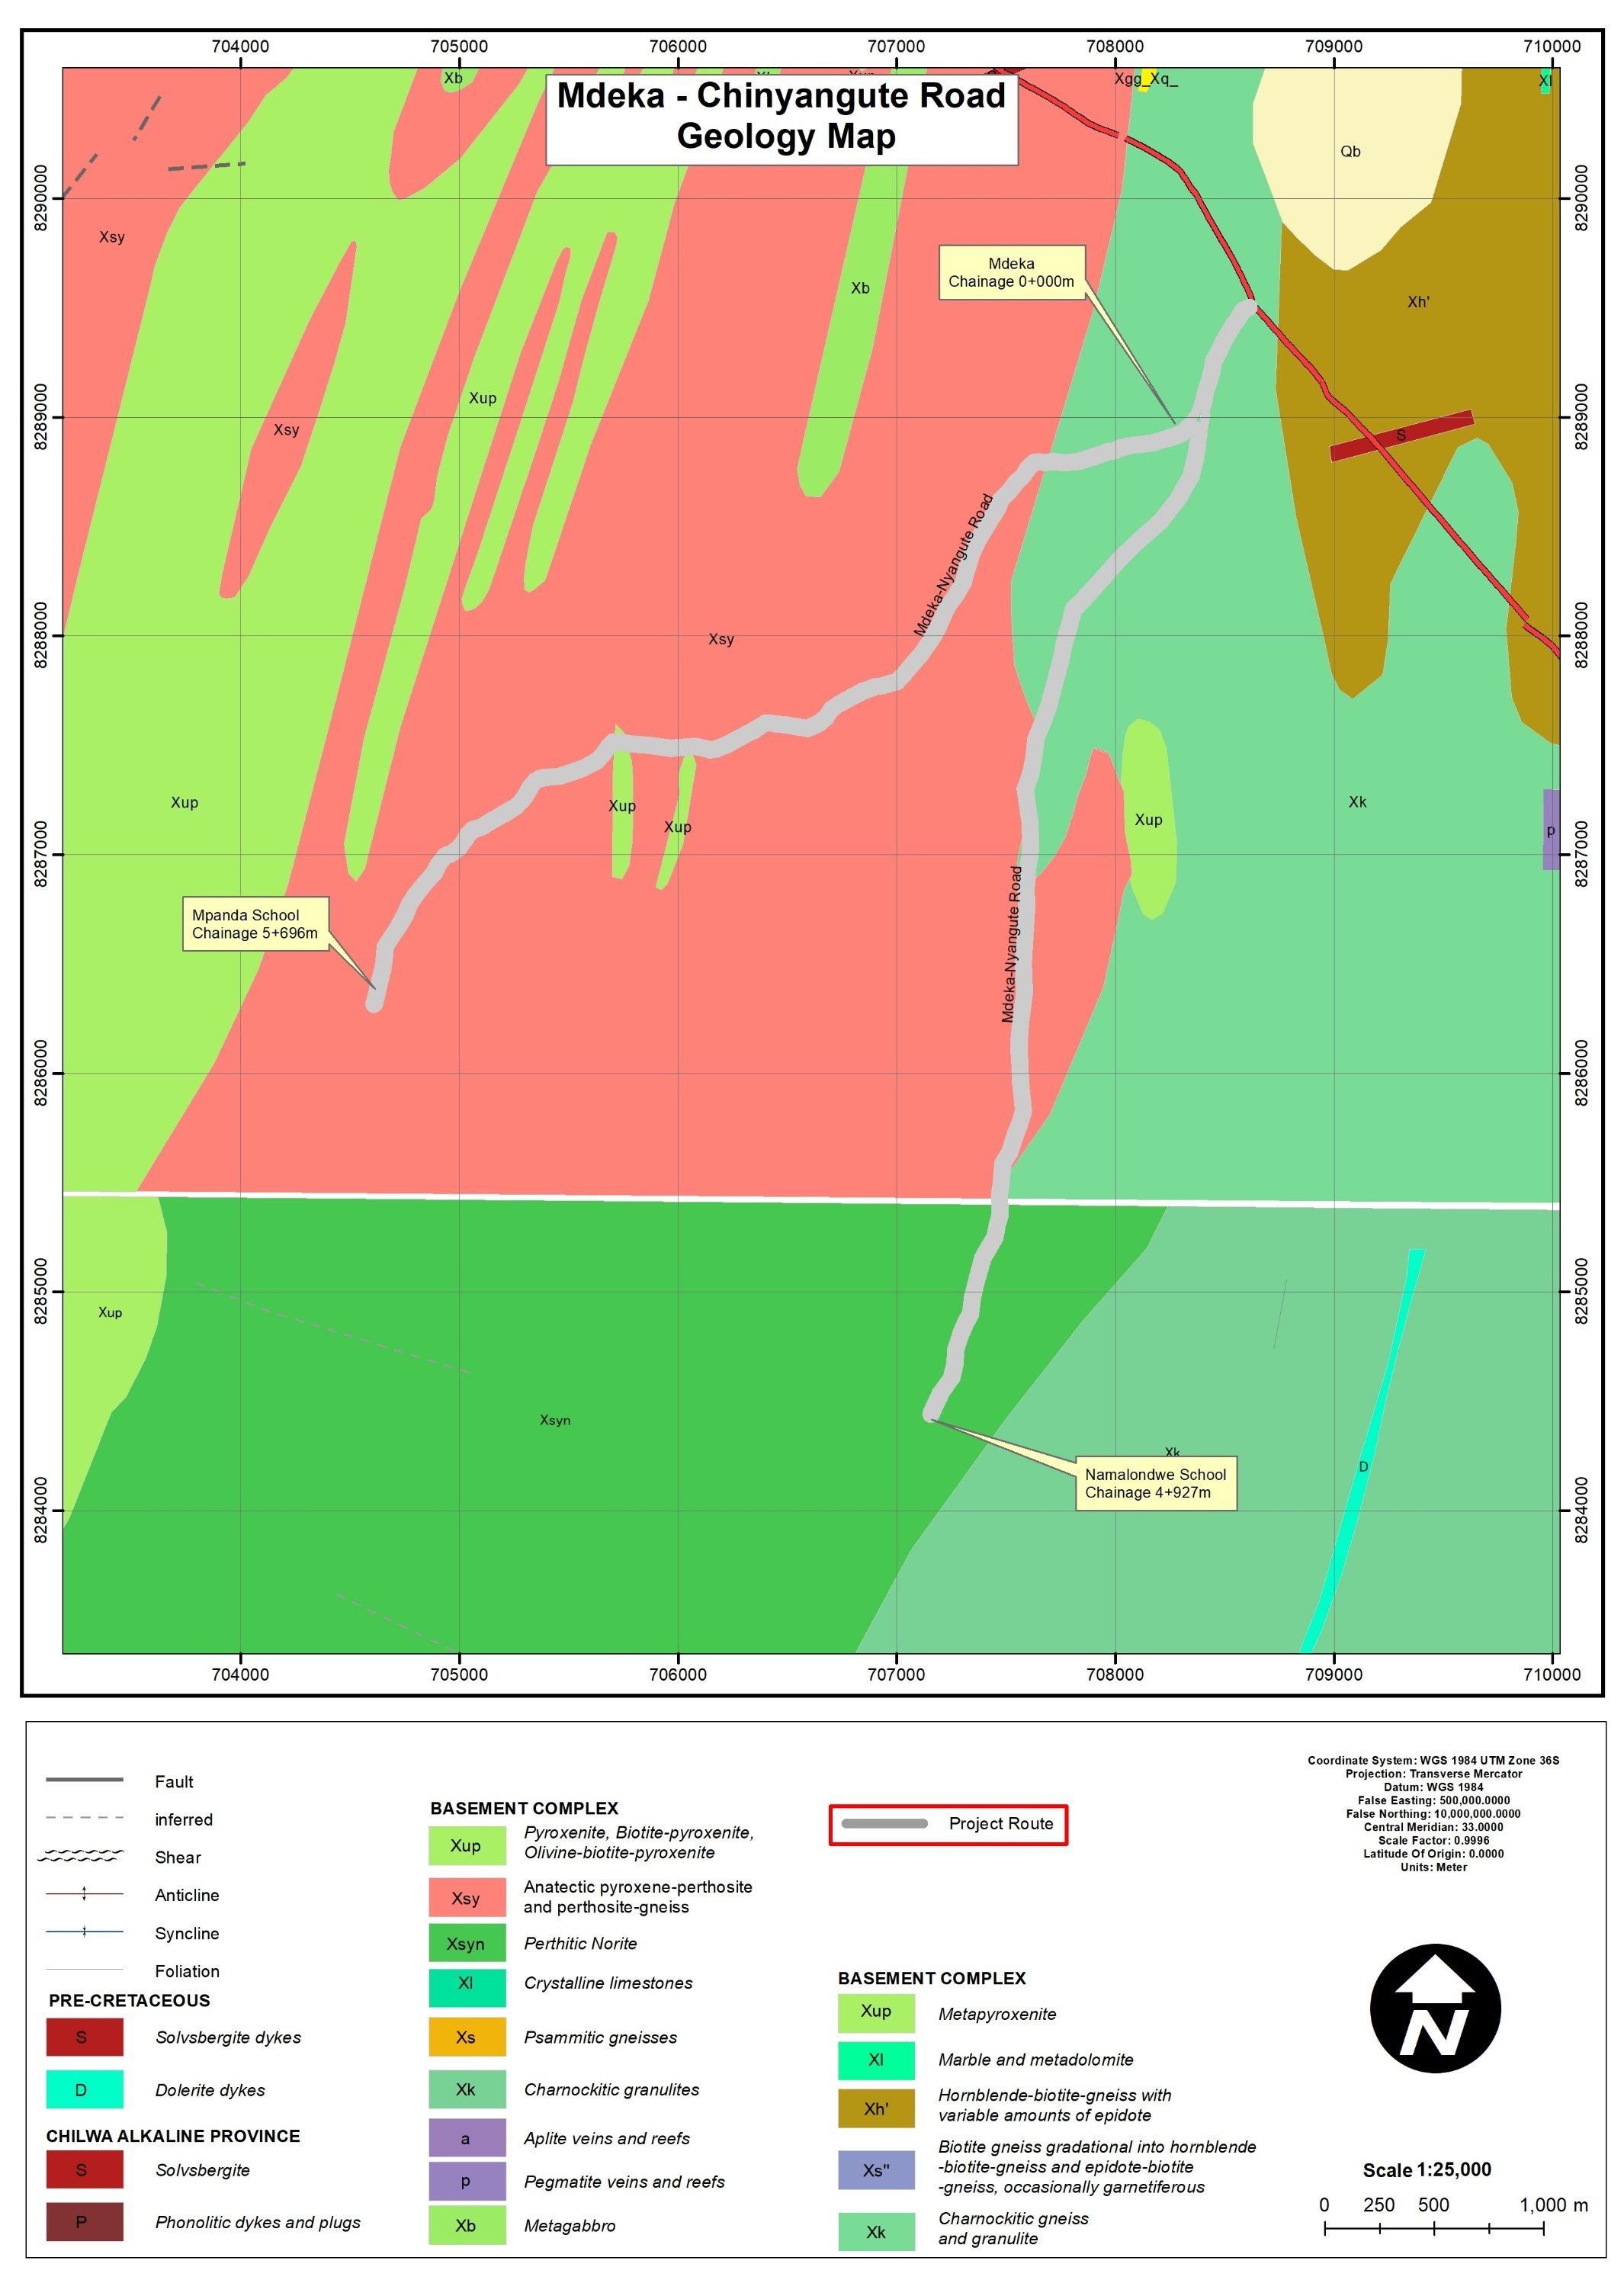
Figure 4-1. Geological Map of the Mdeka - Chinyangute Feeder Roads Corridor

Soils
The proposed road section is entirely underlain by sandy loam soils, as indicated by interpretation of the project-area soils map and confirmed through field observations. Sandy loam soils are generally light-textured, friable, and moderately to well drained. Along the project alignment, these soils exhibit good workability under dry conditions (Blantyre District Socio-Ecopnomic Profile, 2017-2022). Figures 4-2 and 4-4 illustrate the distribution and characteristics of sandy loam soils along the road section.

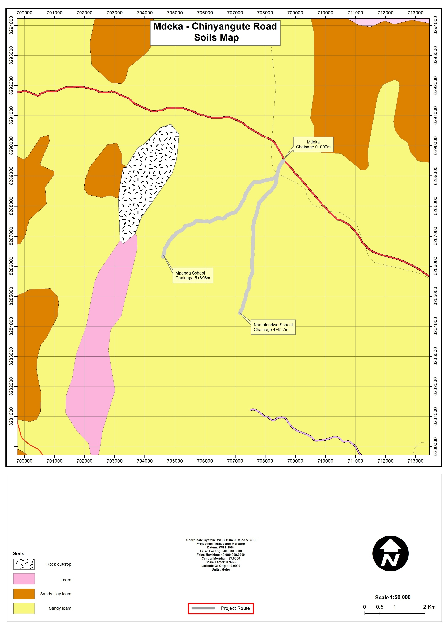
Figure 4-2. Soils of the Mdeka - Chinyangute Feeder Roads Corridor

Figure 4-3. Soils of the Mdeka - Chinyangute Feeder Roads Corridor

Climate and Climate Change Risks
Climate baseline information for the Mdeka–Chinyangute corridor is derived from long-term gridded datasets: ERA5 daily temperature (1951–2022; 0.25° resolution) and CHIRPS daily rainfall (1981–2024; 0.05° resolution). These datasets have been validated in Malawi as reliable proxies for observed data and provide a robust basis for climate-risk analysis (Blantyre District Socio-Ecopnomic Profile, 2017-2022).

General Climate Conditions
The project area lies within Malawi’s sub-tropical climatic zone and exhibits a strongly seasonal regime characterised by a rainy season extending from November to April and a dry season from May to October. This pronounced seasonality directly influences soil moisture conditions, surface runoff generation, erosion processes, and the structural performance of unpaved feeder roads. Climate considerations are therefore central to the design of drainage systems, scheduling of construction activities, and long-term maintenance planning to ensure durability and climate resilience of the rehabilitated road.

Temperature Pattern
Figure 4-2 shows that the Mdeka–Chinyangute corridor experiences a warm sub-tropical climate with relatively moderate seasonal variation in temperature. Mean monthly maximum temperatures are highest from September to November, reaching around 29–30°C at the end of the dry season, and lowest in June and July at about 22–23°C. Mean monthly minimum temperatures follow a similar pattern, dropping to around 11–12°C in June–July and rising to approximately 19–20°C in October–December.

Figure 4-4. average Monthly Max and Min Temperature Pattern for Mdeka–Chinyangute Section

Rainfall Distribution and Rainy Days
Figure 4-5 shows that rainfall in the Mdeka–Chinyangute corridor is strongly seasonal, with a pronounced wet season from November to April and very little rainfall between May and September. Average monthly totals increase sharply from October, peak in January at around 230–250 mm, and remain relatively high through February and March before declining rapidly in April. Rainfall during the dry-season months (May–September) is negligible, underscoring the clear distinction between wet and dry periods and the importance of scheduling construction activities to avoid the peak rainfall months.

Figure 4-5. Monthly Rainfall Pattern for the Mdeka–Chinyangute Corridor

Sunshine Duration
Climatological records derived from ERA5 (1951–2022) indicate that the Mdeka–Chinyangute corridor experiences high annual sunshine levels, particularly during the dry season when cloud cover is minimal (Hersbach et al., 2020; Nkhoma et al., 2025). Peak sunshine duration typically occurs between September and October, coinciding with the late dry season.

These conditions are favourable for construction activities, as they support efficient execution of earthworks and compaction, enhance drying and curing of stabilised materials and concrete, and allow extended daylight working hours. However, prolonged exposure to intense solar radiation during this period increases heat-stress risks for workers, necessitating appropriate occupational health and safety (OHS) measures, including structured work–rest cycles, hydration protocols, and provision of shaded rest areas.

Humidity Trends
Relative humidity in the Mdeka–Chinyangute corridor follows the seasonal rainfall cycle derived from ERA5 and CHIRPS climate records (Hersbach et al., 2020; Funk et al., 2014). Humidity levels are highest during the wet season from December to March, when rainfall and cloud cover are most pronounced, and lowest during the dry season from June to September.

Elevated humidity during the rainy season may affect storage and handling of moisture-sensitive materials such as cement and stabilised soils, and may also reduce worker comfort when combined with high temperatures. Appropriate ventilation of storage facilities, proper material protection, and adequate worker welfare measures are therefore required to maintain construction quality and occupational health standards (Blantyre District Socio-Ecopnomic Profile, 2017-2022).

Wind Speed and Direction
Wind conditions along the Mdeka–Chinyangute corridor are generally moderate, with average speeds ranging between approximately 10 and 16 km/h, based on ERA5 climatological records (Hersbach et al., 2020). Stronger winds typically occur between August and November, during the late dry season and transition to the rains. Seasonal wind shifts influence dust dispersion during construction, particularly in exposed sections. Accordingly, effective dust suppression measures and careful site-layout planning will be required, especially near settlements, schools, and trading centres within the project area of influence.

Climate Change Risks
Analysis of long-term ERA5 and CHIRPS datasets (Hersbach et al., 2020; Funk et al., 2014), together with national climate projections for southern Malawi, indicate increasing variability in rainfall intensity and frequency. Key risks for the corridor include short-duration, high-intensity rainfall events that elevate flash-flood potential; flooding and erosion in low-gradient and drainage-sensitive sections; progressive surface deterioration under repeated wetting–drying cycles; and public health risks associated with stagnant water during the rainy season.

Given the gently undulating terrain and drainage-constrained sections identified in Chapter 4, climate resilience is a critical design consideration. Rehabilitation measures must therefore prioritise adequate hydraulic sizing of culverts and flood-relief structures, improved camber and side-drain formation, erosion control and embankment protection, and adaptive maintenance planning responsive to increasing rainfall variability.

Overall, climate considerations reinforce the need for drainage-focused, resilience-oriented rehabilitation to ensure long-term functionality of the feeder roads under evolving climatic conditions.

Water Resources
The Mdeka–Chinyangute Feeder Roads are situated within the Shire Highlands drainage system. The alignment traverses a low-gradient landscape characterised by seasonal streams and shallow drainage lines (Figure 4-6).
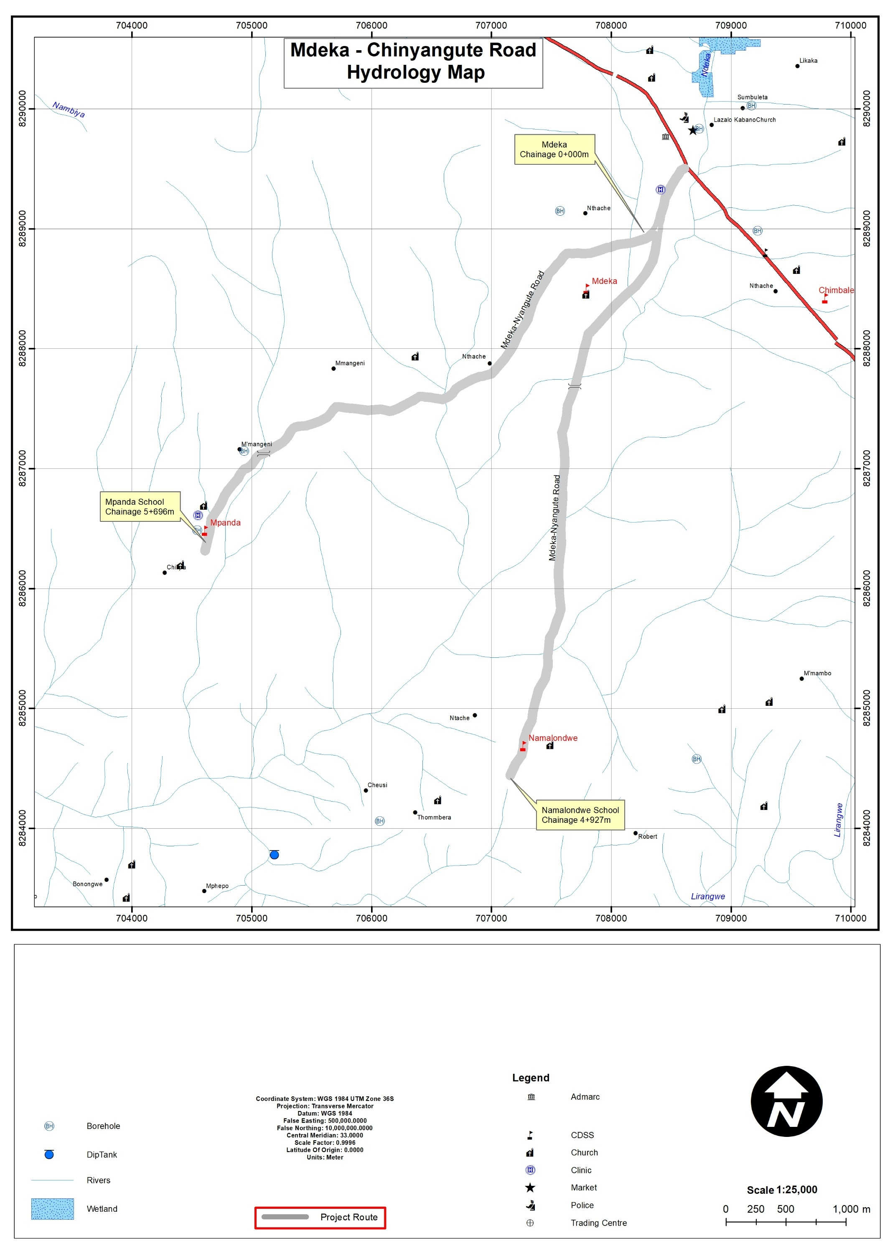
Figure 4-6. Hydrological map of the Mdeka - Chinyangute Feeder Roads Corridor

Flora and Fauna

This section presents the biological baseline for the Mdeka–Chinyangute Feeder Road corridor in accordance with the Environment Management Act (2017), the MEPA Guidelines for Environmental Assessment (2025), and World Bank safeguard requirements. The description covers flora, fauna, and the ecological implications of the proposed rehabilitation works within the project area of influence.

Flora

Vegetation Character and Land Use Context
The project area is characterised by a human-modified landscape dominated by mixed woodland interspersed with subsistence agriculture. Vegetation along the corridor comprises scattered trees and shrubs, including Senna spp. and Cascabela thevetia (Figures 4-8 and 4-9), together with grasses and herbaceous cover typical of disturbed rural environments.

Much of the road reserve and adjacent land is under cultivation, with Zea mays (maize) as the dominant crop and Musa spp. (banana) commonly grown in seasonally moist areas and along ephemeral drainage lines. The vegetation structure therefore reflects a mosaic of remnant indigenous woodland, planted/exotic species, and cultivated fields.

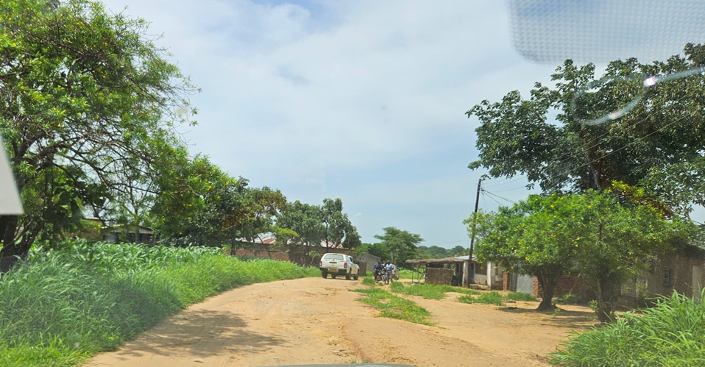
Figure 4-7. Cascabella tevetia (with yellow flowers) on the Mdeka- Chinyangute feeder road corridor
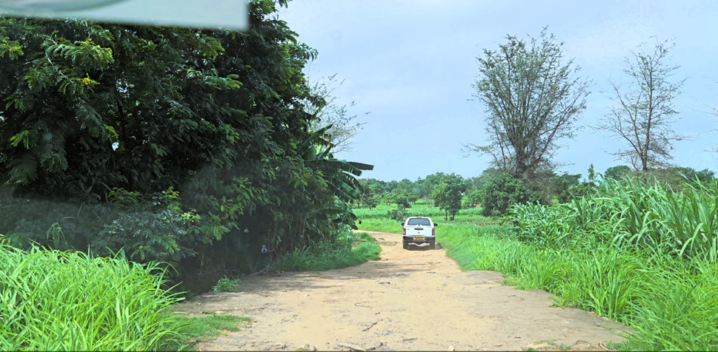
Figure 4-8. Senna siamea (with yellow flowers)

Species Composition and Conservation Status
A total of 39 plant species were recorded during the field survey. The full species list and conservation status are presented in Table 4-1. The majority of recorded species are classified as Least Concern (LC) under the IUCN Red List and are not listed under the National Plant Red Data List. No endemic plant species were recorded within the corridor.

Only one species, Terminalia sericea (silver cluster-leaf), is classified as protected under the Forestry Act (Cap. 63:01) and Forest (Amendment) Rules, 2024. This species occurs in limited distribution within the broader landscape and does not form dense stands within the road footprint.

Table 4-1. Flora Species Sampled from the Mdeka- Chinyangute feeder Project Area and their Conservation Status
Species | Family | Form | English Name | National Plant Red Data List Conservation Status | IUCN Status
Acacia nilotica | Fabaceae | Tree | Gum Arabic Tree | Not Evaluated | Least Concern
Adansonia digitata | Malvaceae | Tree | Baobab | Not Evaluated | Least Concern
Agave americana | Asparagaceae | Herb | Century plant | Not Evaluated | Least Concern
Albizia lebbeck | Fabaceae | Tree | siris | Not Evaluated | Not Evaluated
Annona senegalensis | Annonaceae | Shrub | African custard-apple | Not Evaluated | Least Concern
Asparagus setaceus | Asparagaceae | Herb | Common asparagus fern | Not Evaluated | Not Evaluated
Azadirachta indica | Meliaceae | Tree | Neem | Not Evaluated | Least Concern
Azanza garckeana | Malvaceae | Shrub | African Chewing Gum | Not Evaluated | Not Evaluated
Bambusa vulgaris | Poaceae | Grass (woody) | Common Bamboo | Not Evaluated | Not Evaluated
Bauhinia petersiana | Fabaceae | Tree | kalahari white bauhinia | Least Concern | Least Concern
Brachystegia taxifolia | Fabaceae | Tree | African mahogany | Not Evaluated/ Least concern | Least Concern
Carica papaya | Caricaceae | Tree | Paw paw | Not Evaluated | Not evaluated/not listed
Cascabella tevetia | Apocynaceae | Shrub | Yellow oleander | Not Evaluated | Least Concern
cinerea dichrostachys | Fabaceae | Shrub | Sicklebush | Not Evaluated/ Least concern | Least Concern
Combretum adenogonium | Combretaceae | Tree | Four-leaved bushwillow | Not Evaluated | Least Concern
Eucalyptus globulus | Myrtaceae | Tree | Tasmanian blue gum | Least Concern | Least Concern
Euphorbia ingens | Euphorbiaceae | Tree | Candelabra tree | Not Evaluated/ Least concern | Least Concern
Ficus natalensis | Moraceae | Tree | Natal fig | Least Concern | Least Concern
Gmelina arborea | Lamiaceae | Tree | White teak | Least Concern/ Invasive | Least Concern
Isoberlinia angolensis | Fabaceae | Tree | Isoberlinia angolensis | Not Evaluated | Least Concern
Jacaranda mimosifolia | Bignoniaceae | Tree | Blue jacaranda | Not Evaluated | Least Concern
Jatropha curcas | Euphorbiaceae | Shrub | Physic Nut | Not Evaluated | Least Concern
Kigelia africana | Bignoniaceae | Tree | Sausage Tree | Not Evaluated | Least Concern
Lantana camara | Verbenaceae | Shrub | Common lantana | Not Evaluated/ invasive | Least Concern
Lonchocarpus capassa | Fabaceae | Tree | Apple-leaf | Not Evaluated | Data deficient
Mangifera indica | Anacardiaceae | Tree | Mango | Not Evaluated | Least Concern
Markhamia obtusifolia | Bignoniaceae | Tree | Golden bean tree | Not Evaluated | Least Concern
Piliostigma thonningii | Fabaceae | Tree | Camel's foot tree | Not Evaluated | Least Concern
Ricinus communis | Euphorbiaceae | Shrub | Castor oil plant | Not Evaluated | Least Concern
Sclerocarya caffra | Anacardiaceae | Tree | Marula | Least Concern | Least Concern
Senna alata | Fabaceae | Shrub | Candle Bush | Not Evaluated | Least Concern
Senna siamea | Fabaceae | Tree | Siamese cassia | Least Concern | Least Concern
Terminalia sericea | Combretaceae | Tree | silver cluster-leaf | Least Concern/ Protected | Least Concern
Toona ciliata | Meliace | Tree | Red Cedar | Not Evaluated | Least Concern
Ziziphus mauritiana | Rhamnaceae | Shrub | Indian jujube | Not Evaluated | Least Concern
Ziziphus mucronata | Rhamnaceae | Shrub | Buffalo thorn | Not Evaluated | Least Concern
Moringa oleifera | Moringaceae | Shrub | Moringa | Not Evaluated | Least Concern
Zea mays | Poaceae | Grass | Maize | Least Concern | Least Concern
Source: Consultant 2026

Invasive Alien Species
Figure 4-10 illustrates the presence of invasive species such as Lantana camara and Gmelina arborea within the project area.

Two invasive alien plant species were recorded:
• Lantana camara
• Gmelina arborea

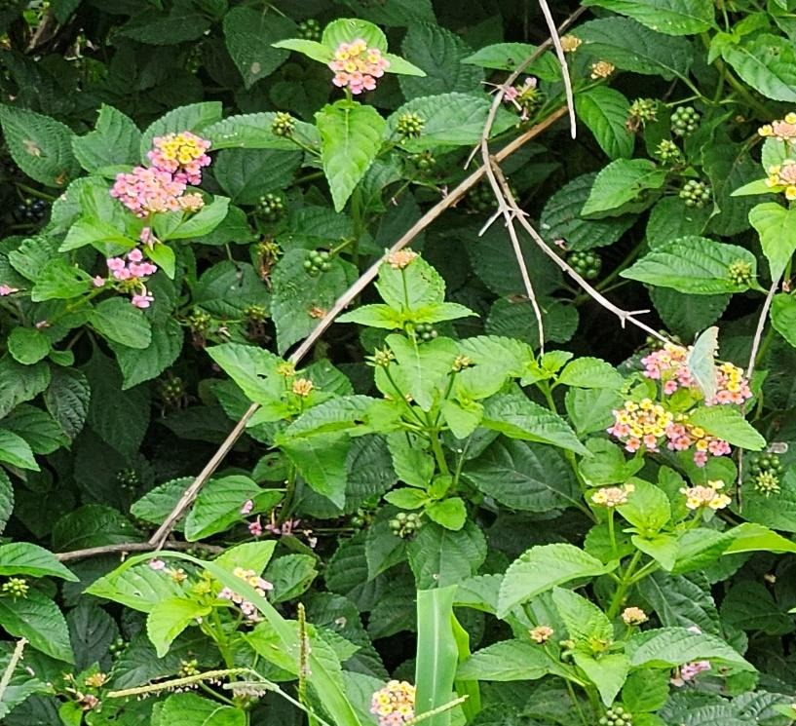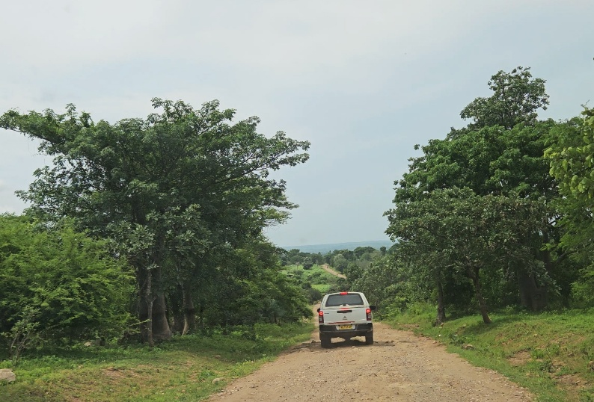
Figure 4-9. Lantana camara and Gmelina arborea along Mdeka- Chinyangute feeder road

Sensitive Habitats and Ecological Significance
No ecologically sensitive habitats, protected forests, wetlands of high conservation value, or critical natural habitats were identified within the road reserve or immediate area of influence.
Vegetation provides habitat, food resources, and soil stabilisation functions but does not exhibit characteristics of high conservation significance.

Overall, the flora baseline indicates a disturbed, agriculturally influenced ecosystem with low biodiversity sensitivity.

Fauna
Faunal surveys recorded five taxonomic groups: mammals, birds, reptiles, amphibians, and macro-invertebrates. All species recorded are widespread and commonly occurring within southern Malawi (Table 4-2).
Table 4-2 Fauna Species Recorded in the Project Area
SN | Taxa | Scientific Name | Common Name | National Status | IUCN Status | Remarks
MAMMALS
1 | Mammal | Epomophorus paraxerus cepapi | Tree squirrel | Least Concern | Least Concern | Common small mammal
2 | Mammal | Crocuta crocuta | Spotted hyena | Not Evaluated | Least Concern | Wide-ranging carnivore
3 | Mammal | Papio cynocephalus | Yellow baboon | Not Evaluated | Least Concern | Common primate
4 | Mammal | Chlorocebus pygerythrus | Vervet monkey | Not Evaluated | Least Concern | Frequently observed
5 | Mammal | Saccostomus capensis | Pouched mouse | Least Concern | Least Concern | Small rodent species
6 | Mammal | Lepus saxatilis | Scrub hare | Not Evaluated | Least Concern | Terrestrial herbivore
7 | Mammal | Sylvicapra grimmia | Bush duiker | Not Evaluated | Least Concern | Occasional sightings
BIRDS
8 | Bird | Euplectes capensis | Yellow bishop | Least Concern | Least Concern | Grassland species
9 | Bird | Pycnonotus barbatus | Common bulbul | Least Concern | Least Concern | Abundant
10 | Bird | Streptopelia semitorquata | Red-eyed dove | Least Concern | Least Concern | Common
11 | Bird | Centropus burchellii | Burchell’s coucal | Least Concern | Least Concern | Shrubland habitats
12 | Bird | Chrysococcyx caprius | Dideric cuckoo | Least Concern | Least Concern | Seasonal presence
13 | Bird | Colius striatus | Speckled mousebird | Least Concern | Least Concern | Common
14 | Bird | Laniarius major | Tropical boubou | Least Concern | Least Concern | Forest edge species
15 | Bird | Merops pusillus | Little bee-eater | Least Concern | Least Concern | Insectivore
16 | Bird | Passer griseus | Northern grey-headed sparrow | Least Concern | Least Concern | Urban/rural
17 | Bird | Pogoniulus chrysoconus | Yellow-fronted tinkerbird | Least Concern | Least Concern | Woodland species
18 | Bird | Streptopelia capicola | Ring-necked dove | Least Concern | Least Concern | Common
19 | Bird | Tchagra senegalus | Black-crowned tchagra | Least Concern | Least Concern | Shrubland
REPTILES
20 | Reptile | Naja mossambica | Mozambique spitting cobra | Not Evaluated | Least Concern | Venomous
21 | Reptile | Chamaeleo dilepis | Flap-necked chameleon | Least Concern | Least Concern | Arboreal
22 | Reptile | Chamaeleo africanus | African chameleon | Not Evaluated | Least Concern | Arboreal
23 | Reptile | Atheris rungweensis | Rungwe sedge viper | Not Evaluated | Least Concern | Venomous
24 | Reptile | Agama mossambica | Mozambique agama | Not Evaluated | Least Concern | Common
25 | Reptile | Bitis arietans | Puff adder | Not Evaluated | Least Concern | Highly venomous
26 | Reptile | Trachylepis striata | African striped skink | Not Evaluated | Least Concern | Common
27 | Reptile | Dendroaspis intermedius | Eastern green mamba | Not Evaluated | Least Concern | Arboreal, venomous
28 | Reptile | Dendroaspis polylepis | Black mamba | Not Evaluated | Least Concern | Highly venomous
29 | Reptile | Agama armata | Peter’s ground agama | Least Concern | Least Concern | Terrestrial
AMPHIBIANS
30 | Amphibian | Breviceps poweri | Power’s rain frog | Least Concern | Least Concern | Fossorial
31 | Amphibian | Ptychadena schillukorum | Schilluk ridged frog | Least Concern | Least Concern | Wetland-associated
32 | Amphibian | Sclerophrys gutturalis | Guttural toad | Least Concern | Least Concern | Common
33 | Amphibian | Xenopus muelleri | Clawed frog | Least Concern | Least Concern | Aquatic
34 | Amphibian | Xenopus laevis | African clawed frog | Least Concern | Least Concern | Aquatic
MACRO-INVERTEBRATES
35 | Invertebrate | Nomadacris septemfasciata | Red locust | Least Concern | Least Concern | Agricultural pest
36 | Invertebrate | Catopsilia florella | African migrant butterfly | Least Concern | Least Concern | Pollinator
37 | Invertebrate | Acraea natalica | Natal acraea | Least Concern | Least Concern | Butterfly
38 | Invertebrate | Apis mellifera | Western honey bee | Least Concern | Data Deficient | Key pollinator
39 | Invertebrate | Acanthacris ruficornis | Garden locust | Not Evaluated | Not Evaluated | Common
40 | Invertebrate | Orthetrum chrysostigma | Epaulet skimmer | Not Evaluated | Least Concern | Dragonfly
41 | Invertebrate | Orthetrum julia | Julia skimmer | Not Evaluated | Least Concern | Dragonfly
42 | Invertebrate | Pachycondyla tarsata | African stink ant | Not Evaluated | Not Evaluated | Soil ecosystem role
43 | Invertebrate | Acrida acuminata | Common stick grasshopper | Not Evaluated | Not Evaluated | Grassland species
44 | Invertebrate | Amauris niavius | Friar butterfly | Not Evaluated | Least Concern | Pollinator

Human–Fauna Interaction
No evidence of human–wildlife conflict, wildlife migration corridors, or significant wildlife crossings was observed during the survey.

Implications for the Project
The biological environment along the Mdeka–Chinyangute corridor is characterised by widespread and resilient species typical of human-modified agricultural landscapes. The absence of endemic, threatened, or critically endangered species, together with the lack of sensitive habitats, indicates low ecological sensitivity within the project footprint.

Potential ecological impacts are expected to be localised and temporary, primarily associated with vegetation clearance, soil disturbance, and increased human activity during construction. These impacts may include short-term habitat modification and displacement of small fauna, particularly reptiles, amphibians, and macro-invertebrates.

Key management considerations include:
- Avoidance and minimisation of unnecessary vegetation clearing;
- Protection of protected tree species such as Terminalia sericea;
- Prevention of invasive species spread;
- Rehabilitation of disturbed areas following construction.
Subject to implementation of mitigation measures outlined in this ESMP, the proposed rehabilitation works are not expected to result in significant, irreversible, or cumulative impacts on biodiversity at local, national, or global levels. The biological environment does not constitute a constraint to project implementation.

Sanitation and Waste Management

Sanitation and waste management conditions along the corridor reflect a predominantly rural setting. Households and institutions rely on traditional pit latrines, and domestic waste is typically managed through household pits. No organised municipal waste collection system exists.

Commercial waste generation is limited to small trading centres at Mdeka and Namalondwe. Key institutions include Mdeka Health Centre, Mdeka Primary School, Namalondwe School, and Mpanda Primary School, all of which utilise on-site sanitation systems.

No significant sanitation hotspots were observed. However, weak local waste systems necessitate strong contractor-managed sanitation and waste controls during construction to prevent drain blockages, pollution, and public health risks.

Overall Environmental Implications

The corridor is generally suitable for rehabilitation due to its stable geological setting and low ecological sensitivity. However, several environmental risks require management:
- Poor natural drainage due to flat to gently undulating terrain;
- Moisture-sensitive subgrade soils;
- Increasing rainfall intensity and flash-flood risk;
- Localised erosion and embankment instability in drainage-sensitive sections.

Accordingly, rehabilitation must prioritise robust drainage design, erosion control, subgrade stabilisation, spill prevention near watercourses, invasive species management, and proper contractor sanitation practices.

Socio-economic environment

Demographic Characteristics
The Mdeka–Chinyangute feeder roads traverse a predominantly rural and low-density population corridor within TA Kuntaja, Blantyre District. While the broader TA population is estimated at approximately 22,000 people (2026 projection), the direct project-affected population is significantly smaller, reflecting the dispersed settlement pattern along the road alignment.

The population directly associated with the feeder road corridor is estimated at approximately 3,500–4,000 persons, derived from about 900 households using an average household size of 4.1 persons per household. Settlement is highly localized, with the main concentration at Mdeka Trading Centre (Chainage 0+000), while the remainder of the alignment passes through sparsely populated agricultural land and dambo areas. Beyond the trading centre, homesteads are scattered and linear, with large sections of the road having minimal residential presence.
Population density is therefore low and discontinuous, with social sensitivity concentrated at key nodes such as Mdeka Trading Centre and nearby institutional areas (e.g., schools at Namalondwe and Mpanda), rather than along the entire corridor.

The demographic structure reflects a youthful rural population, with children and adolescents comprising approximately 45–50%, and the economically active population accounting for about 45%. The elderly constitute a relatively small proportion. Daily population activity along the agricultural stretches is limited, with higher concentrations of people observed mainly at trading and institutional centres.

Sex distribution is broadly balanced, with a slight female majority of approximately 51–52%. Gender roles remain largely traditional, with women predominantly engaged in subsistence agriculture, household management, and informal trade, while men are more involved in marketing, livestock activities, and labour migration. The presence of female-headed households, often linked to male out-migration, introduces elements of heightened socio-economic vulnerability.

Households are characteristic of rural smallholder systems, typically comprising burnt brick or mud block structures, with iron-sheet roofing near trading centres and thatched roofing in more remote areas. Given the dispersed settlement pattern, potential construction-related impacts such as dust, noise, and vibration are expected to be spatially limited, primarily affecting localized settlement clusters rather than the entire corridor.

Education and Literacy
The main schools directly associated with the corridor include Mdeka LEA Primary School, Namalondwe School, and Mpanda Primary School, all located near settlement clusters or terminal sections of the feeder roads and representing localized social receptors.

Available data from Mpanda Primary School indicate a total enrolment of 697 learners, comprising 316 boys and 381 girls, reflecting a higher female enrolment across most classes. However, recorded dropout data for the 2025/2026 academic year show 10 learners withdrew (4 boys and 6 girls), with early marriage identified as a key driver of female dropout, particularly in upper primary (Standards 7 and 8). This highlights persistent gender-related vulnerabilities in education within the project area.

Literacy levels within the broader TA Kuntaja are estimated at approximately 76%, serving as a reasonable proxy for the corridor population. Literacy is generally higher near trading centres and institutional nodes and lower in dispersed rural areas, consistent with the observed settlement pattern.

Livelihoods and Economic Activities
Poverty in rural Blantyre is rampant standing at about 76.6% according to UNDP (2022 report. Agriculture is the dominant livelihood activity along the Mdeka–Chinyangute corridor. The feeder roads primarily serve crop production zones, including maize fields, vegetable gardens, dambo cultivation areas, and small-scale livestock activities. The alignment functions as a farm-to-market access route connecting agricultural fields to Mdeka Trading Centre, which serves as the main commercial hub. Economic activity intensity declines significantly beyond the trading centre, with limited commercial frontage along the agricultural stretch.

Households derive income from smallholder farming, casual labour (ganyu), petty trading, bicycle and motorcycle transport services, and charcoal production. Livelihoods are generally low-income and climate-sensitive, with strong seasonal dependence on rainfall and road accessibility. During the rainy season, road conditions affect the movement of agricultural produce and influence travel time and transport costs.

Health
There are no major health facilities along most sections of the agricultural stretch. Access to healthcare is centred at Mdeka Health Centre near the trading centre, with referrals to Blantyre District Hospital for secondary care. The feeder road provides access between surrounding areas and health facilities.

Common health issues in the area include malaria, diarrhoeal diseases, and respiratory infections, which are associated with prevailing rural sanitation conditions. Access to healthcare varies seasonally, particularly during the rainy season when flooding and poor drainage can limit mobility.

Cultural Heritage
No known cultural heritage sites, sacred areas, or archaeological resources were identified within or adjacent to the alignment. The road follows an existing reserve in continuous use. A Chance Finds Procedure will be implemented during construction to manage any unforeseen discoveries.

Land Use
Land use along the corridor is predominantly agricultural. Approximately 70–75 percent of the alignment traverses cultivated land, including rain-fed fields and dambo production areas. Residential structures account for less than 5 percent of land directly adjacent to the corridor and are concentrated near Mdeka Trading Centre and institutional nodes. Some agricultural encroachment into the road reserve is observed.

Transport
The current main users of the road are predominantly pedestrians, cyclists, and motorcycle operators, reflecting the rural and agriculture-based nature of the corridor. Traffic volumes are low to moderate, with non-motorised and intermediate means of transport dominating. Light vehicles, minibuses, and small trucks use the road intermittently, mainly during the dry season to support produce marketing and service access.

During the rainy season, sections of the road become increasingly impassable due to waterlogging, poor drainage, and surface deterioration, significantly disrupting mobility for communities, school children, and agricultural transport.

Security
Security conditions along the corridor are generally stable. A police unit is located at Mdeka Trading Centre. Reported issues are limited to petty theft and minor disputes. No serious crime hotspots were identified.

Communication and Energy
Mobile network coverage (Airtel and TNM) is generally available near trading centres and weaker in dispersed sections. Radio and community meetings remain primary communication channels.

Household energy use is dominated by biomass (firewood and charcoal). Grid electricity access is limited to trading centre areas. Solar lanterns are increasingly used. Charcoal transport between Chinyangute and Mdeka highlights the role of the road in informal energy supply chains (Blantyre District Socio-Ecopnomic Profile, 2017-2022).

Implications for the Project
The Mdeka–Chinyangute feeder roads traverse a low-density agricultural corridor with fewer than 1,000 directly adjacent households and an estimated direct population of 3,500–4,000 people. The road functions primarily as a transitional production-access route rather than a densely settled residential corridor.

Social sensitivity is localized at Mdeka Trading Centre and school nodes. Continuous residential displacement risks are minimal. Construction-related disturbances will predominantly affect agricultural access rather than dense settlements.

With effective traffic management, school-zone protection, dust control, and community engagement measures, the project is expected to yield substantial net socio-economic benefits through improved mobility, agricultural market access, service connectivity, and climate resilience.

CHAPTER 5: ENVIRONMENTAL AND SOCIAL MANAGEMENT AND MONITORING PLAN

Introduction
This chapter presents the Environmental and Social Mitigation and Monitoring Plan (ESMMP) for the proposed rehabilitation of the Mdeka–Chinyangute Feeder Road. It sets out the mitigation measures, monitoring requirements, implementation responsibilities, and reporting arrangements for managing the environmental and social impacts identified during planning, construction, demobilisation, and operation of the subproject.
The ESMMP provides the framework for implementing environmental and social safeguards in accordance with the Environment Management Act, 2017, the MEPA Guidelines for Environmental Assessment, 2025, and relevant World Bank safeguard and Environmental, Health and Safety (EHS) requirements. It forms part of the environmental and social obligations to be implemented by the Contractor, Supervising Consultant, the MoTPW PIU, Blantyre District Council, and other relevant authorities during project execution.
Monitoring provisions are included to enable the PIU, Supervising Consultant, District Council, and MEPA to systematically track environmental and social performance, verify the effectiveness of mitigation measures, and ensure timely corrective action throughout implementation. Monitoring will focus on key risk areas including erosion and sediment control, drainage functionality, pollution prevention, waste management, occupational health and safety, labour and working conditions, traffic and pedestrian safety, stakeholder engagement, and grievance management.
Monitoring reports will be prepared by the Contractor and submitted on a monthly basis to the PIU, Supervising Consultant, and District Environmental Office for review and follow-up, in line with the project’s three- to four-month implementation schedule.
Framework instruments for contractor implementation
To support effective implementation of the mitigation and monitoring measures set out in this chapter, this ESMMP includes framework instruments in the annexes that establish minimum procedures, standards, and compliance requirements for contractor implementation. Prior to commencement of works, the Contractor shall prepare site-specific plans and procedures based on these framework instruments for review and approval by the Supervising Consultant and PIU, with copy submission to the District Environmental Office where applicable.
At a minimum, the Contractor shall prepare and implement the following site-specific instruments before the relevant activities commence:
- Borrow Pit Rehabilitation Plan, based on Annex 5: Barrow Pit Rehabilitation Framework.
- Traffic Management Plan, based on Annex 6: Traffic Management Framework.
- Labour Management Plan, based on Annex 8: Labour Management Guidelines for Contractor Compliance and Preparation of Labour Management Plans (LMPs).
- Contractor Environmental and Social Management Plan (C-ESMP), based on Annex 9: Contractor Environmental and Social Management Plan (CESMP) Framework, integrating construction-method-specific environmental, social, health, and safety controls.
- Waste Management Plan, based on Annex 10: Waste Management Framework.
- Stakeholder Engagement Plan, based on Annex 11: Stakeholder Engagement Framework.
- GBV/SEA/SH prevention and response measures, consistent with Annex 8: Labour Management Guidelines and Annex 13: SATCP LMI Grievance Redress Mechanism (GRM) Protocol, as applicable to GBV/SEA/SH risk management.
In addition, the Contractor shall implement Annex 4: Sample Code of Conduct for Contractors, Annex 7: Chance Find Procedure for Last Mile Infrastructure under SATCP, and Annex 13: SATCP LMI Grievance Redress Mechanism (GRM) Protocol as mandatory instruments throughout the construction period. These instruments shall apply to all workers, subcontractors, suppliers, and other personnel engaged on the subproject.
All contractor-prepared plans shall demonstrate consistency with Malawi environmental and labour legislation, the Environment Management Act, 2017, MEPA environmental assessment requirements, relevant World Bank safeguard principles, and the mitigation and monitoring commitments set out in this ESMP.

Environmental and Social Mitigation and Monitoring Plan (ESMMP) Matrix

REF | Impacts & Risks | Enhancement / Mitigation Measures | Responsible Institution | Implementation Cost (USD) | Performance Indicator | Frequency | Monitoring Cost (USD)
5.2.1. Planning Phase – Positive Impacts and Enhancement Measures
5.2.1.1 | Improved agricultural market access | Integrate farm access crossings into detailed design; maintain existing field access points; validate alignment with local leaders | MoTPW | Project cost | Access crossings incorporated | Once | 250
5.2.1.2 | Enhanced connectivity to trading centres | Optimise alignment to reduce travel time; incorporate safe loading/offloading areas at Mdeka Trading Centre | MoTPW | Project cost | Travel distance/time reduced in model | Once | 200
5.2.1.3 | Improved flood resilience | Size culverts based on hydrological modelling; map flood-prone sections before final design | MoTPW / Contractor | Project cost | Culverts compliant with design study | Once | 300
5.2.1.4 | Increased stakeholder trust | Conduct stakeholder consultations; ensure inclusion of women and vulnerable groups; establish and operationalize GRM | PIU / District Council | 1000 | No. of consultations; vulnerable representation; functioning GRC | Monthly | 500
5.2.2. Planning Phase – Negative Impacts and Mitigation Measures
5.2.2.1 | Inadequate integration of drainage structures | Conduct detailed drainage mapping; adjust alignment; reinforce crossings | MoTPW | Contractor cost | Crossings approved | Once | N/A
5.2.2.2 | Increased soil erosion risks | Undertake soil stability testing; integrate slope stabilisation measures | MoTPW / DC | Consultant cost | Soil study completed | Once | N/A
5.2.2.3 | Limited inclusion of vulnerable groups | Conduct gender-inclusive consultations; ensure ≥40% women participation | MoTPW | Consultant cost | Participation threshold met | Once | N/A
5.2.2.4 | Inadequate contractor E&S capacity | Deploy ESHS Officer; prepare and implement C-ESMP and management plans (Waste, CoC, Borrow Pits, SEP, Traffic) | Contractor | Contractor cost | ESHS Officer present; plans implemented | Monthly | N/A
5.2.2.5 | Risk of perceived or temporary disturbance to small-scale trading activities, informal structures and cultivation (e.g. sugarcane) located close to the corridor during spot rehabilitation works, despite no formalisation, regularisation or permanent acquisition under the project. | - No road use restrictions by oroviding single lane traffic  - Clearly demarcate construction working width within the existing road reserve and avoid siting of works, storage areas or diversions on trading stalls, informal structures or cultivated plots.  - Conduct pre-construction joint walk-throughs with community leaders to confirm areas of encroachment and explain that works will not formalise or regularise occupations, nor permanently affect structures and crops.  - Maintain access to small businesses and fields during construction through phased works and temporary crossings.  - Use the project GRM to receive and address any grievances related to encroachment or perceived loss. | Contractor; Supervising Consultant; MoTPW / PIU; T/A and ADC/VDC structures | To be included in Contractor’s C-ESMP and contract rates (no separate line item) | - No permanent loss or demolition of informal structures or cultivated plots attributable to the project. - Number of grievances related to encroachment or asset loss resolved satisfactorily. | During site establishment and throughout construction | Included in overall ESMP supervision budget (no separate incremental cost)
5.2.3. Construction Phase – Positive Impacts and Enhancement Measures
5.2.3.1 | Short-term employment creation | Transparent recruitment; promote ≥40% female employment | Contractor | 500 | Recruitment system; % female workers | Once / Monthly | 200
5.2.3.2 | Local economic stimulation | Engage local suppliers; maintain access to trading centres via TMP | Contractor | 500 | % local sourcing; access grievances | Monthly | 200
5.2.4. Construction Phase – Negative Impacts and Mitigation Measures
5.2.4.1 | Soil erosion and sedimentation | Implement erosion controls (drainage diversion, silt traps) | Contractor | 1000 | Control measures in place | Every 2 months | 500
5.2.4.2 | Water pollution | Prohibit washing in water bodies; bund fuel storage; spill response plan | Contractor / MoTPW | Contractor cost | Zero spill incidents | Monthly | 500
5.2.4.3 | Uncontrolled material extraction | Obtain permits; restrict extraction; demarcate and rehabilitate borrow pits | Contractor | Included in contract | Permits; rehabilitation status | Once / Monthly | 500
5.2.4.4 | Dust, noise and traffic risks | Dust suppression; signage; TMP; restrict noisy works | Contractor | 500 | Dust records; grievances; TMP | Monthly | 500
5.2.4.5 | Access disruption | Provide temporary crossings; notify users | Contractor | 500 | <5 complaints | Monthly | 400
5.2.4.6 | OHS risks | Implement OHS Plan; PPE; training; emergency procedures | Contractor | 1000 | OHS plan; training records | Monthly | 500
5.2.4.7 | Labour influx risks (SEA/SH, disease) | Worker CoC; training; SEA/SH-responsive GRM | Contractor | 1000 | % trained; grievances resolved | Monthly | 200
5.2.4.8 | Community health & safety risks | TMP; diversions; fencing; awareness campaigns | Contractor | 1500 | TMP; dust records; fenced sites | Once / Monthly | 500
5.2.4.9 | Temporary disruption of access to farms and social services.  Damage to assets including crops and trees as a result of works | Maintain access to farms, social services etc as part of the Traffic Management Plan including signage, temporary crossings use of flag people, one way traffic, temporary diversions and pedestrian access route  Establish a grievance redress mechanism  Payment of compensation for any losses/ damage to assets inadvertently caused as a result of contractor activities at replacement value | Contractor | Project cost | Signed agreements | Once | N/A
5.2.4.10 | Abusive Labor and Working Conditions(labour exploitation, forced labour, under aged and discriminatory working conditions) | - Explain to all workers’ conditions of service, labor exploitation and contract duration  - Ensure all workers have a signed contract and given a copy  - Implement age verification system using national identification to employ only those that are 18 years old and above and undertake due deligence of primary suppliers to ensure they are not using child labor  - Establish and maintain a Worker Grievance Redress Mechanism that is SEA/SH responsive | Contractor | 1000 | Compliance indicators | Monthly | 200
5.2.4.11 | Cultural heritage impacts | Implement Chance-Find Procedure; train workers | Contractor | 200 | % workers trained | Monthly | 200
5.2.4.12 | Damage to assets | GRM; compensation at replacement value | Contractor | As required | Grievances resolved | Monthly | N/A
5.2.5. Contractor Demobilization Phase – Negative Impacts and Mitigation Measures
5.2.5.1 | Residual waste and disturbed land | Remove waste; restore land and camps | Contractor | 500 | 100% restoration | Once | N/A
5.2.5.2 | Loss of income for workers | Provide notice; settle dues; issue references | Contractor | 400 | N/A | N/A | N/A
5.2.6. Operation and Maintenance Phase – Positive Impacts and Enhancement Measures
5.2.6.1 | Improved agricultural access | Maintain drainage; desilt culverts | MoTPW | Project cost | Functional drainage | Monthly | N/A
5.2.6.2 | Economic growth | Facilitate roadside enterprise zones | Contractor | Project cost | Increased trade | Annually | N/A
5.2.6.3 | Reduced travel time | Maintain gravel; periodic grading | MoTPW | Project cost | Road condition ≥ Good | Annually | N/A
5.2.7. Operation and Maintenance Phase – Negative Impacts and Mitigation Measures
5.2.7.1 | Increased road accidents | Maintain signage; safety campaigns | District Council | Operational cost | Accident trend decreasing | Annually | N/A
5.2.7.2 | Climate vulnerability | Monitor embankments; reinforce drainage | District Council | As required | <2 failures/year | Annually | N/A
5.2.7.3 | Dry season dust | Water roads; plant vegetation | District Council | 1500/year | <5 complaints/year | Annually | N/A

Institutional Arrangements and Implementation Capacity
The Blantyre District Environment Sub-Committee (DESC) is a key institutional body supporting implementation and monitoring of the Environmental and Social Management Plan (ESMP) for the Mdeka–Chinyangute Feeder Roads Rehabilitation Project. Consultations confirmed that the DESC has the mandate, technical awareness, and willingness to participate in environmental and social oversight throughout the project lifecycle. Its role will include conducting joint site inspections with the Contractor and Supervising Consultant, monitoring compliance with ESMP requirements such as occupational health and safety, waste management, drainage and borrow pit management, and community safety measures, and participating in the Grievance Redress Mechanism (GRM) to review and resolve community complaints from Mdeka Trading Centre and surrounding villages.
Despite this readiness, the DESC highlighted operational constraints that may affect its effectiveness, including limited access to transport and fuel, inadequate operational funding, and lack of allowances for field-based monitoring. These constraints may reduce the frequency and coverage of inspections unless supported by project resources.
To strengthen institutional capacity, the DESC recommended logistical and technical support, including provision of fuel and transport for joint inspections, allowances for monitoring teams, standardised ESMP monitoring checklists and reporting templates, and regular coordination meetings with the Contractor, Supervising Consultant, MoTPW PIU, and other district actors. The committee also emphasised early disclosure of the ESMP, spatial distribution of works (Annex 14), and contractor work plans to enable timely planning of monitoring activities.
For short-duration works such as those envisaged under this subproject, the DESC proposed monthly monitoring visits during the construction period, subject to availability of logistical support. For any extended works, quarterly follow-up visits may be considered to verify longer-term rehabilitation of borrow pits, drainage structures, and reinstated areas.
Implementation of the ESMP will require coordinated engagement of national, district, and site-level institutions through routine supervision, reporting, and consultation mechanisms. Detailed responsibilities for specific mitigation and monitoring actions are presented in the ESMP Implementation and Monitoring Matrices.

Table 5-1. Institutional responsibilities for ESMP implementation and oversight – Mdeka–Chinyangute Feeder Road
Institution | Role in ESMP implementation
Ministry of Transport and Public Works (MoTPW) / PIU | Executing agency responsible for overall ESMP oversight; integrates ESMP requirements into bidding documents and contracts, supervises compliance, reviews monitoring reports, and ensures corrective actions are implemented.
Contractor | Holds primary responsibility for implementing ESMP mitigation measures during construction; appoints an Environmental, Health and Safety (EHS) Officer, prepares and implements site-specific management plans (C-ESMP, OHS, traffic, waste, GBV/SEA/SH, borrow pits), and maintains environmental and social compliance records.
Supervising Consultant (SC) | Provides day-to-day supervision of construction activities and verifies contractor compliance with ESMP requirements through regular inspections, non-conformance reports, and technical reporting to the PIU.
Malawi Environment Protection Authority (MEPA) | Provides statutory environmental oversight, including review of the ESMP, issuance of environmental determinations, and periodic compliance inspections in accordance with the Environment Management Act (2017) and MEPA Guidelines (2025).
Blantyre District Council / District Environment Sub-Committee (DESC) | Supports local monitoring and community engagement; participates in joint inspections; monitors borrow pit rehabilitation, drainage protection, and community safety measures; and assists with environmental awareness and GRM processes at district level.

ANNEXES

Annex 1. Feedback Letter from MEPA
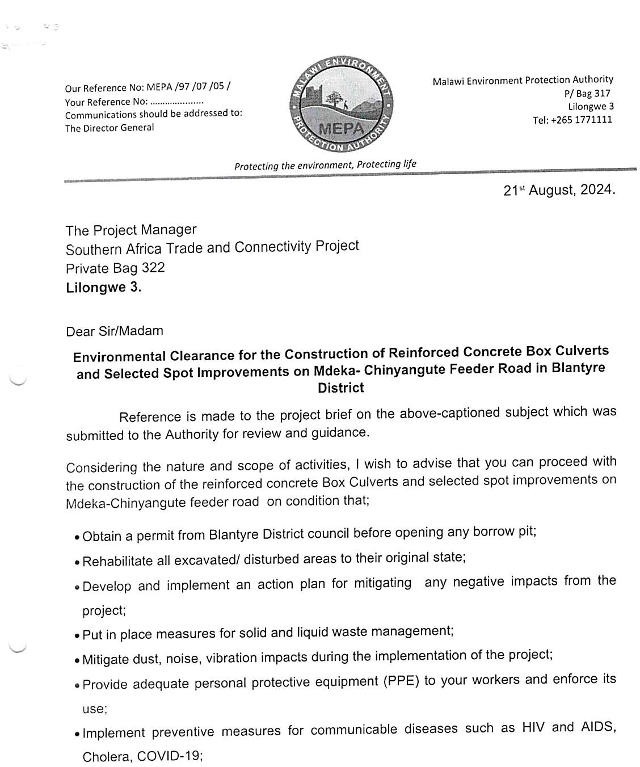
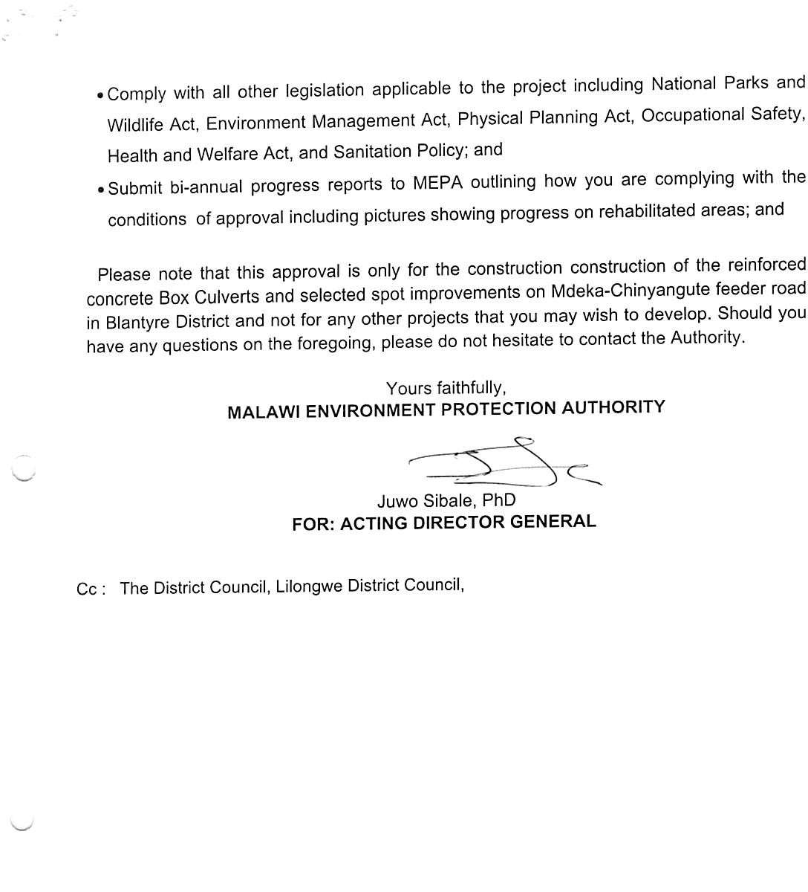

Annex 2: List of Stakeholders Consulted
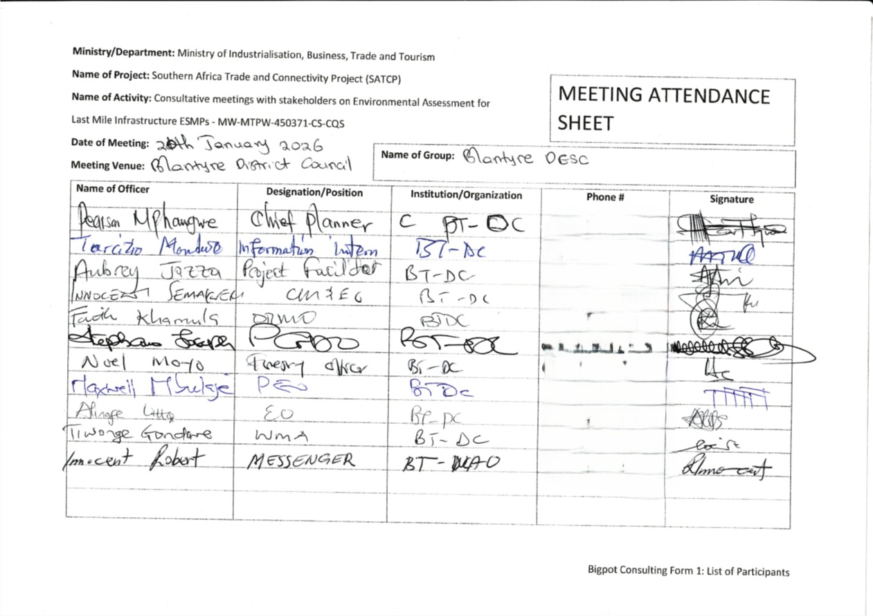

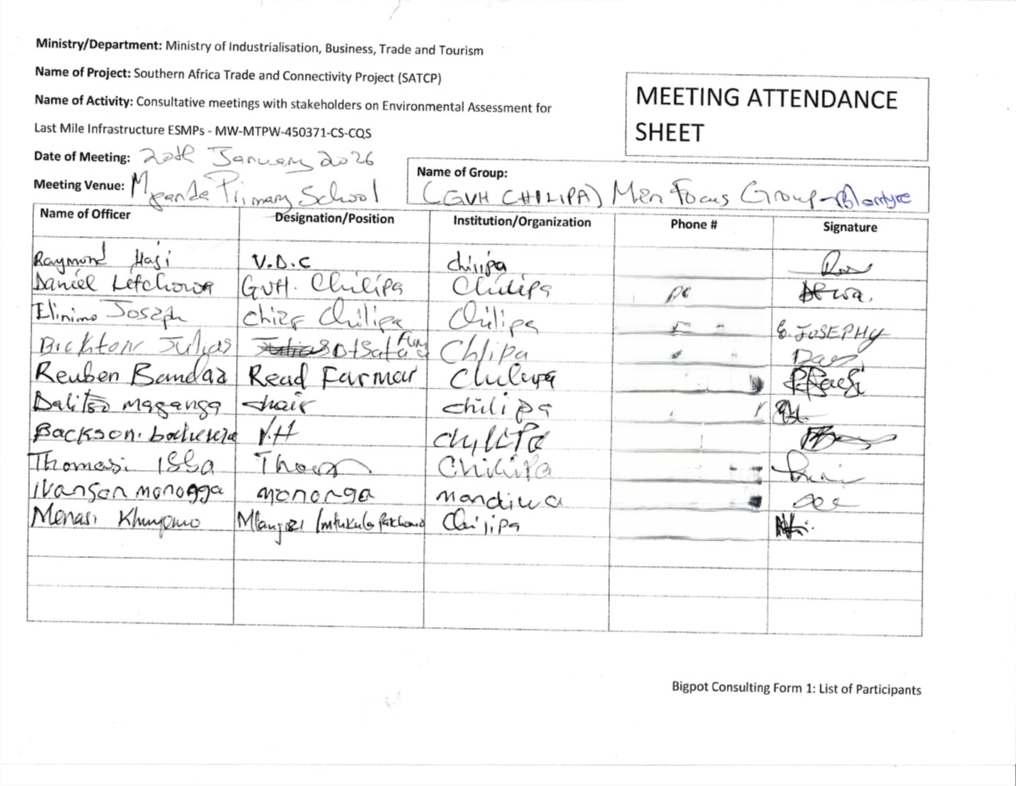
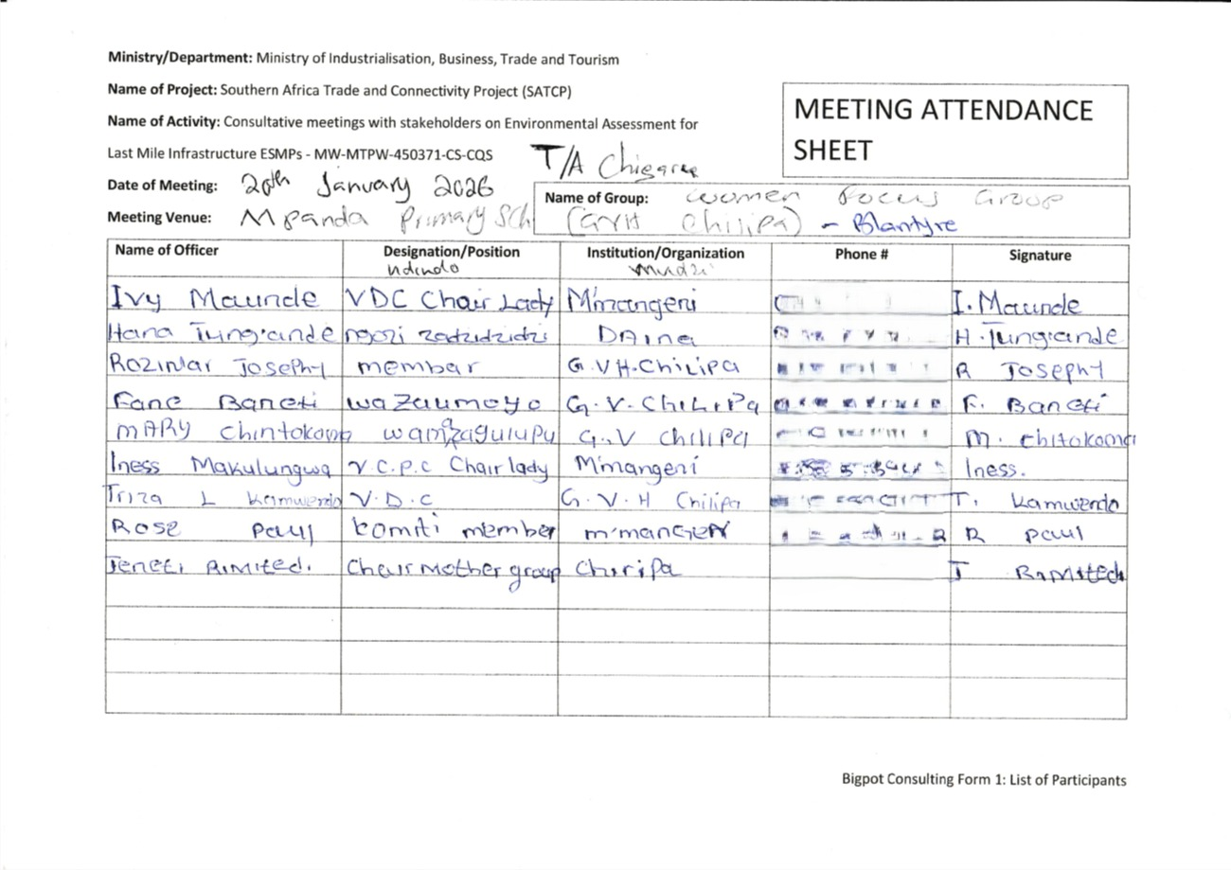

Annex 3. Summary of Issues Raised by Stakeholders

Issues Raised | Who Raised It | How it has been addressed in the ESMP
The proposed project is a welcome development as it is expected to improve the socioeconomic development of the people of Blantyre. In addition, the project will assist the interventions of Blantyre District Council as the area was affected by Cyclone Freddy. | Blantyre District Council – DPD | The ESMP incorporates climate-resilient design measures, including enhanced drainage systems, culvert sizing based on hydrological modelling, and erosion control interventions to address flood risks associated with extreme weather events such as Cyclone Freddy. These measures are complemented by routine maintenance provisions to ensure long-term resilience of the road infrastructure.
Put up measures to ensure that the Council is empowered to monitor compliance of the ESMP by the contractor during project implementation as well as grievance handling | Blantyre District Council – EDO | The ESMP includes provisions for institutional strengthening of the District Council, including capacity building on ESMP supervision, joint monitoring inspections with MoTPW PIU, and active participation in grievance redress mechanisms (GRM). The Council is formally assigned roles in monitoring, reporting, and grievance handling, supported by defined procedures and resources.
Chinyangute is among the high production areas for pigeon peas but experiences poor road network; implementation of the project is expected to improve farmers’ income due to reduced transport costs. | Blantyre District Council – Agriculture Officer | This has been captured as a key positive impact under improved agricultural market access and local economic stimulation. The ESMP includes measures to maintain access to farms during construction and to enhance connectivity to markets, thereby supporting increased farm productivity and reduced post-harvest losses.
The project is expected to significantly enhance trade efficiency by reducing transportation costs and travel times, benefiting local businesses and attracting investment. Engagements should continue throughout the project. | Blantyre District Council – Trade Officer | The ESMP recognises improved trade efficiency as a positive impact and includes measures to facilitate safe roadside trading areas during operation. In addition, a Stakeholder Engagement Plan (SEP) has been incorporated to ensure continuous consultations, information disclosure, and stakeholder participation throughout project implementation.
The project is expected to improve connectivity between Chinyangute and Mdeka. Can the project also finance the development of an irrigation scheme for pigeon peas? | Mdeka Women Pigeon Peas Group | The request for irrigation development is outside the scope of the road rehabilitation project. The ESMP addresses this through stakeholder engagement measures that clearly communicate project scope and limitations. It is noted that such an intervention would require a separate ESIA and feasibility assessment under a different project framework.
As a women farming group, we would also like to be supported with a processing plant for pigeon peas | Mdeka Women Pigeon Peas Group | The ESMP addresses this through expectation management and stakeholder engagement provisions, clarifying that financing of private processing facilities falls outside the eligibility criteria for LMI projects. However, the project includes provisions for local economic empowerment, and the group is advised to explore opportunities under complementary programmes such as matching or competitive grant schemes where applicable.

Annex 4. Sample Code of Conduct for Contractors
1. Purpose and Scope
This Sample Code of Conduct (CoC) provides the minimum mandatory standards of behaviour for all personnel engaged in implementation of SATCP Last Mile Infrastructure (LMI) subprojects, including contractors, sub‑contractors, supervising consultants, suppliers, and all categories of workers (permanent, temporary and day workers). The annex serves as a framework and template for preparation of a project‑specific Contractor’s Code of Conduct, which shall be adapted by each Contractor to reflect the scope, risks, workforce composition and community context of the subproject, and submitted to the Supervising Consultant and the PIU for review and approval prior to mobilisation.
The project‑specific CoC shall apply to all personnel working on or in connection with the subproject and shall be communicated in a language and format that workers understand. Each worker shall sign the approved Code of Conduct as a condition of employment and shall receive induction and periodic refresher training on its requirements, including sanctions for non‑compliance.
The Code addresses risks associated with the following:
- Environmental and social management.
- Occupational health and safety (OHS).
- Labour influx and labour relations.
- Spread of communicable diseases, including HIV and AIDS.
- Sexual harassment (SH), sexual exploitation and abuse (SEA), and gender‑based violence (GBV).
- Child labour and child protection.
- Illicit behaviour, crime and corruption.
- Community health, safety and road safety.
Compliance with the approved Code of Conduct is a contractual obligation for the Contractor and all associated personnel, and a condition of employment on the project. The Contractor shall be responsible for enforcement of the Code at worksites, worker accommodation areas, haul routes and all other project‑related locations, while the Supervising Consultant and PIU shall monitor compliance as part of ESMP and contract implementation.
2. General Obligations
The Supervising Consultant shall ensure that the Contractor and all associated personnel:
a) Legal Compliance
Comply at all times with the laws, regulations, and standards of the Republic of Malawi, including the Environment Management Act (2017), labour laws, occupational safety legislation, and applicable World Bank safeguard requirements.
b) ESHS Planning Instruments
Prepare, implement, and maintain site-specific instruments prior to commencement of works, including:
- Environmental and Social Management Plan (ESMP);
- Health and Safety Management Plan (HSMP);
- HIV and AIDS Awareness Programme;
- Occupational Health and Safety Awareness Programme;
- Road Safety and Traffic Management Plan.
c) Occupational Health and Safety
Provide a safe and healthy working environment, including:
- Provision and compulsory use of appropriate Personal Protective Equipment (PPE);
- Prevention of avoidable accidents and injuries;
- Immediate reporting and correction of unsafe acts or hazardous conditions.
d) Traffic and Road Safety
Implement traffic safety measures, including:
- Temporary speed calming devices and speed-limit signage;
- Warning signs in villages, trading centres, schools, health facilities, and construction zones;
- Enforcement of safe driving practices by all project drivers.
e) Environmental Protection
Avoid unnecessary clearance of trees and vegetation, prevent conflicts over water resources, and ensure sustainable use of natural resources in consultation with local communities.
f) Pollution Prevention
Take all reasonable measures to prevent pollution of air, water, and soil, land degradation, and environmental damage, and ensure compliance with good international industry practice.
g) Worker and Public Safety
Install standard safety signs, barricades, and road markings during construction and after completion to protect workers, communities, and road users.
h) Sanitation and Welfare Facilities
Provide adequate sanitation facilities, including:
- Safe drinking water;
- Decent toilets and washing facilities at worksites and camps;
- Prohibition of open defecation.
i) Site Rehabilitation and Restoration
Restore all disturbed areas after construction, including borrow pits, quarries, stockpiles, camps, access roads, batching plants, fuel storage areas, and waste disposal sites, through landscaping, tree planting, and erosion-control measures.
3. Labour, Ethics, and Social Conduct
j) Non-Discrimination
Prohibit all forms of discrimination in recruitment, employment, and working conditions on the basis of gender, age, ethnicity, disability, religion, marital status, political affiliation, or other protected characteristics.
k) Fair Labour Practices
Adhere to Malawi labour laws by issuing written contracts to skilled and unskilled workers, respecting working hours, wages, and conditions of employment.
l) Prevention of Sexual Harassment
Strictly prohibit sexual harassment, including abusive language, inappropriate gestures, sexually suggestive behaviour, or culturally offensive conduct, particularly towards women and children.
m) Prevention of SEA/GBV
Prohibit any form of sexual exploitation, abuse, or violence, including:
- Exchange of money, goods, services, or employment for sex;
- Exploitative or degrading behaviour;
- Any sexual activity with minors (persons under 18), regardless of consent.
n) Child Protection and Child Labour
Prohibit child labour and all forms of child abuse, exploitation, or endangerment, and ensure children’s safety in and around project areas.
o) Conflict of Interest and Corruption
Avoid conflicts of interest and prohibit bribery, favouritism, or preferential treatment based on personal, financial, or family relationships.
p) Protection of Property and Assets
Safeguard project equipment, materials, and property; prohibit theft, vandalism, misuse, or waste of resources.
q) Grievance Reporting and Non-Retaliation
Ensure that workers and community members can report violations of this Code through established grievance mechanisms without fear of retaliation, provided the report is made in good faith.
4. Enforcement and Accountability
r) Acknowledgement and Sanctions
All workers and contractor personnel shall:
- Read, understand, accept, and sign this Code of Conduct as a condition of employment;
- Attend mandatory induction and refresher training on ESHS and SEA/GBV prevention.
Any violation of this Code of Conduct may result in disciplinary action, including:
- Verbal or written warnings;
- Suspension or dismissal;
- Termination of contract; and/or
- Referral to relevant legal authorities.
5. Contractor Certification
I, the undersigned, confirm that I have read and understood this Code of Conduct and commit to ensuring full compliance by all personnel engaged under this contract.
I Agree /
Name of Authorized Representative: ____________________________
Signature: ____________________________
Name of Company: ____________________________
Physical Address: ____________________________
Company Stamp: ____________________________
Date: ____________________________

Annex 5. Barrow Pit Rehabilitation Framework
(SATCP Last Mile Infrastructure Projects)
1. Introduction and Purpose
This Borrow Pit Rehabilitation Framework applies to all borrow pits identified and utilised under the SATCP Last Mile Infrastructure (LMI) projects. It sets out mandatory procedures for environmentally sound material extraction, operation, rehabilitation and closure of borrow pits so that material sourcing does not result in permanent land degradation, public safety hazards, or adverse impacts on surrounding communities and ecosystems.
The Framework provides the standard requirements that Contractors must follow when preparing site-specific Borrow Pit Management and Rehabilitation Plans for each borrow source they intend to use. These site-specific plans shall form part of the Contractor’s Environmental and Social Management Plan (C-ESMP) and shall be submitted to the Supervising Consultant and the PIU for review and approval prior to opening or using any borrow pit. The Framework shall also be applied within the site-specific ESMP to guide oversight, monitoring and verification of borrow-pit performance throughout construction and post-closure.
2. Project Context
Borrow pits are identified during the design and pre-construction phases of LMI subprojects based on geotechnical investigations undertaken under the Detailed Engineering Design (DED). These borrow pits may supply lateritic gravel, fill material, or other construction materials required for road rehabilitation, drainage works, and ancillary infrastructure.
At the planning stage, borrow pits are considered indicative material sources. Final selection, approval, and use shall be subject to field verification, landowner consent, Environmental and social screening, and approval by relevant authorities.
3. Regulatory and Safeguards Framework
Borrow pit development, operation, and rehabilitation under SATCP LMI projects shall comply with:
- Environment Management Act (2017)
- MEPA Guidelines for Environmental Assessment (2025)
- SATCP ESMF
- World Bank OP/BP 4.01 and OP/BP 4.04 (where applicable)
- Approved ESMPs and DEDs for each LMI subproject
4. Borrow Pit Planning and Site Controls
Before opening or using any borrow pit, the Contractor shall:
- Obtain written approval from the Supervising Consultant and the relevant District Council.
- Secure documented landowner consent and confirmation from the appropriate Traditional Authority.
- Verify land tenure status and agree on access, use, rehabilitation, and handover conditions.
- Clearly demarcate the borrow pit footprint and access routes.
- Strip and stockpile topsoil separately for use during rehabilitation.
- Install warning signage and temporary fencing, particularly where borrow pits are located near settlements, agricultural land, footpaths, or grazing areas.
5. Key Environmental and Social Risks
Typical risks associated with borrow pits under LMI projects include:
- Loss of productive agricultural land
- Open excavations posing injury risks to people and livestock
- Standing water leading to mosquito breeding
- Soil erosion and sediment runoff into nearby streams or wetlands
- Visual scarring of the landscape
- Community dissatisfaction where land is not adequately restored
6. Rehabilitation Objectives
Borrow pit rehabilitation under SATCP LMI projects shall aim to:
- Restore land to a safe, stable, and productive condition
- Prevent erosion, standing water, and slope instability
- Reintegrate rehabilitated sites into agricultural or community land use
- Eliminate public health and safety hazards
- Meet landowner, community, and District Council expectations
7. Rehabilitation Measures
7.1 Progressive Rehabilitation
- Implement rehabilitation progressively, commencing immediately after material extraction in each section.
- Phase excavation activities to minimise the total open area at any given time.
7.2 Backfilling and Reshaping
- Reuse overburden and unsuitable material for backfilling.
- Reshape excavated areas to stable slopes (maximum 1:3).
- Partially backfill deep excavations to eliminate water accumulation.
7.3 Topsoil Replacement
- Evenly spread stockpiled topsoil over rehabilitated surfaces.
- Ensure sufficient topsoil depth to support revegetation or agricultural reuse.
7.4 Drainage and Erosion Control
- Restore surface drainage to natural flow patterns.
- Apply erosion control measures such as contour shaping, grass strips, or stone pitching where required.
7.5 Revegetation
- Revegetate rehabilitated sites using indigenous grass species and locally appropriate tree species, subject to landowner preference.
- Prioritise vegetation that supports soil stabilisation, shade provision, and community utility.
8. Safety and Community Protection
- Secure active borrow pits using fencing, barriers, or warning tape.
- Install clear warning signage in English and local languages.
- Eliminate vertical faces and open pits upon closure.
- Formally hand back rehabilitated sites to landowners after completion.
9. Post-Use Land Options
Subject to agreement with landowners and District Councils, rehabilitated borrow pits may be converted into:
- Agricultural land
- Community woodlots
- Grazing areas
- Controlled water retention areas (only where approved, engineered, and safe)
10. Roles and Responsibilities
Actor | Responsibility
Contractor | Implement borrow pit management and rehabilitation
Supervising Consultant | Approve, supervise, and certify rehabilitation works
District Council / DESC | Community liaison and site verification
Landowners / Traditional Authorities | Accept rehabilitated land

11. Monitoring and Reporting
- Report borrow pit status in monthly ESMP compliance reports.
- Monitor indicators including number of rehabilitated sites, erosion evidence, water ponding, and vegetation establishment.
- Conduct final inspections prior to issuance of completion certificates.
12. Budgeting
- Fully include borrow pit rehabilitation costs in the Contractor’s BoQs and C-ESMP.
- Prohibit approval of any borrow pit without a costed and approved rehabilitation provision.
13. Completion and Handover
Consider borrow pits closed only when rehabilitation is complete, sites are safe and stable, and formal handover documentation is signed by relevant parties.
14. Conclusion
This Borrow Pit Rehabilitation Framework provides a consistent and enforceable approach for managing borrow pits across all SATCP Last Mile Infrastructure projects, ensuring Environmentally responsible material sourcing, protection of community interests, and full compliance with MEPA (2025) and World Bank safeguards.

Annex 6. Traffic Management Framework
1. Introduction
This Traffic and Access Management Framework (TAMF) has been prepared for the Southern Africa Trade and Connectivity Project (SATCP) – Last Mile Infrastructure (LMI) subprojects, including feeder road rehabilitation, drainage improvements, bridge/culvert works and associated construction activities. The Framework sets out the minimum requirements for planning, operating and monitoring construction-related traffic so that works are carried out safely and with limited disruption to local communities and road users.
The Framework provides mandatory guidance for the preparation and implementation of site-specific Traffic and Access Management Plans (TAMPs) by Contractors. For each subproject, the Contractor shall prepare a TAMP consistent with this Framework and submit it to the Supervising Consultant and the SATCP PIU/State Agency for Transport and Construction Projects for review and approval prior to commencement of construction works.
The TAMF aims to ensure that all construction-related traffic—vehicles, equipment and personnel—is managed safely, efficiently and in an environmentally and socially responsible manner, while minimising risks and disruptions to communities, vulnerable road users, businesses, and existing transport infrastructure.
2. Purpose and Objectives
Construction activities will increase vehicular and machinery traffic within worksites and along existing regional and community roads. Without effective management, such traffic may:
- Interfere with normal traffic and pedestrian movements;
- Increase risks of accidents and injuries to workers and the public;
- Damage existing road infrastructure;
- Generate dust, noise, congestion, and community nuisance.
The objectives of this Framework are to:
- Promote safe interaction between construction traffic, pedestrians, and local road users;
- Minimize Environmental and social risks associated with construction traffic;
- Guide the planning, use, and rehabilitation of access roads and haul routes;
- Ensure site-specific traffic impacts are addressed through appropriate design, scheduling, signage, and controls.
3. Access Roads and Haul Routes
a) Planning and Approval
The Contractor shall prepare detailed layout plans for all proposed access roads and haul routes. These plans shall:
- Be submitted to the Supervising Consultant for approval;
- Be accompanied by written consent from affected landowners, Traditional Authorities, or village leadership where applicable.
b) Use of Existing Infrastructure
Existing roads shall be used wherever feasible. Construction of temporary access roads shall only be permitted where unavoidable and upon approval by the Site Manager and relevant stakeholders. Construction of temporary diversions, if required, will require approval of the District and the World Bank.
c) Environmental Considerations
Planning of haul routes shall consider:
- Vegetation and sensitive habitats;
- Watercourses and drainage patterns;
- Existing land use;
- Proximity to households, schools, markets, and health facilities.
d) Construction, Maintenance, and Rehabilitation
The Contractor shall be responsible for:
- Construction and routine maintenance of access and haul roads;
- Installation of drainage infrastructure at early stages to prevent erosion;
- Decommissioning and rehabilitation of temporary roads upon completion of works.
Topsoil shall be stripped and stockpiled prior to construction and reused during rehabilitation. Disturbed areas shall be revegetated using indigenous species where applicable.
e) Dust Suppression
Dust control measures shall be implemented, including:
- Regular watering of access and haul roads;
- Enforcement of speed limits (maximum 30 km/h near settlements);
- Use of dust palliatives where necessary.
Dust suppression activities shall be recorded and reported as part of Environmental compliance monitoring.
4. Traffic Management and Safety Measures
Each site-specific Traffic and Access Management Plan shall include, at minimum, the following components:
4.1 Traffic Control and Signage
- Clearly defined access routes within and around worksites;
- Advance warning signage along haul routes and near construction zones;
- Temporary traffic signs, barriers, and flag persons where required;
- Establishment and enforcement of speed limits and control points.
Where bridge or culvert works require road occupation, temporary bypasses or diversions shall be constructed prior to commencement of works to avoid full road closures.
5. Transport of Materials
The Contractor shall ensure that:
- Vehicles transporting fine or granular materials are fully covered with tarpaulins to prevent dust and spillage;
- Any spillage or pollution along transport routes is cleaned immediately at the Contractor’s cost;
- Delivery schedules are aligned with off-peak hours to reduce congestion and disturbance to communities.
6. Driver Requirements and Conduct
All project drivers and equipment operators shall:
- Hold valid licenses appropriate to the vehicles or machinery operated;
- Be trained and certified in defensive driving and road safety;
- Receive training in eco-driving to reduce fuel consumption and emissions;
- Undergo project induction covering pedestrian safety, fatigue management, and substance abuse prevention.
Driver working hours shall be managed to prevent fatigue, ensuring adequate rest periods. The Contractor shall maintain up-to-date driver registers and dust suppression logs.
7. Interaction with Communities and Sensitive Areas
High-risk interaction areas such as schools, markets, trading centres, and health facilities shall be identified and mapped. Site-specific mitigation measures shall be implemented, including:
- Temporary pedestrian crossings;
- Traffic calming devices (speed bumps, rumble strips);
- Warning lights, reflectors, and signage;
- Temporary bypasses where necessary.
Community engagement shall be coordinated with the Stakeholder Engagement Framework (Annex 11) to ensure awareness of traffic changes and safety measures.
8. Monitoring, Enforcement, and Reporting
The Contractor’s Traffic and Access Management Plan shall include:
- An accident and incident register with clear reporting procedures;
- Random alcohol and drug testing protocols for drivers;
- A penalty and disciplinary structure for non-compliance with traffic safety requirements;
- Regular monitoring of road conditions and prompt repair of damage caused by construction traffic;
- Monthly traffic management reports detailing:
  - Traffic incidents and near misses;
  - Dust and noise control performance;
  - Community complaints related to traffic;
  - Corrective actions undertaken.
The Supervising Consultant shall verify compliance and recommend corrective measures where deficiencies are identified.
9. Institutional Responsibilities
Actor | Key Responsibilities
Contractor | Prepare and implement site-specific TAMPs, ensure compliance
Supervising Consultant | Review, approve, and monitor TAMP implementation
SATCP / PIU | Oversight and enforcement
District Authorities | Local coordination and support
Traffic Police (where applicable) | Enforcement and incident response
10. Conclusion
This Traffic and Access Management Framework establishes mandatory requirements for safe, efficient, and Environmentally responsible management of construction traffic under the SATCP Last Mile Infrastructure subprojects. Effective implementation of this Framework will reduce accident risks, protect communities, and ensure compliance with national legislation and World Bank safeguard requirements.
Site-specific Traffic and Access Management Plans shall be developed and approved prior to commencement of construction works and updated as necessary throughout project implementation.

Annex 7. Chance Find Procedure for Last Mile Infrastructure under SATCP

1. Introduction
This Chance Find Procedure sets out the protocol to be followed if previously unidentified cultural heritage is discovered during implementation of the SATCP Last Mile Infrastructure (LMI) subprojects. Cultural heritage may include, but is not limited to, archaeological materials, graves and burial sites, religious artefacts, sacred or ritual sites, and historical objects that were not identified during the initial environmental and social assessment. The procedure is to be applied by Contractors and Supervising Consultants on all worksites and along all associated project footprints, and ensures that any chance finds are managed in accordance with the Monuments and Relics Act (Cap 29:01) of Malawi and the World Bank’s OP/BP 4.11 on Physical Cultural Resources.
2. Purpose
The purpose of this procedure is to safeguard Malawi’s tangible cultural heritage by ensuring that any unexpected discoveries are handled with care and in accordance with legal and safeguard requirements. The procedure seeks to prevent unauthorized interference, preserve historical and cultural assets, and maintain respect for community traditions and sensitivities.
3. Scope
This procedure applies to all personnel involved in the project, including contractors, subcontractors, consultants, field workers, and any party engaged in construction, material sourcing, excavation, or related site activities. It is applicable to all locations along the project corridor, including campsites, borrow pits, material stockpiles, access roads, and working zones.
4. Definition of a Chance Find
A chance find is defined as any artifact, feature, structure, or site of cultural, historical, or religious significance that is discovered unexpectedly during the execution of project activities. Examples may include human remains, pottery fragments, stone tools, religious objects, altars, burial grounds, historical ruins, or sacred trees. These are typically items or sites not previously recorded or anticipated in the ESMP documentation.
5. Procedure to Follow in the Event of a Chance Find
If a chance find is encountered, the following steps must be followed:
- All work in the immediate vicinity must stop immediately. The affected area must be secured with a buffer zone of no less than 20 to 50 meters to prevent disturbance or looting.
- The Contractor must promptly inform the Supervision Consultant, the Project Implementation Unit (PIU) of the SATP, and the Department of Antiquities (DoA) within 24 hours.
- The DoA will dispatch a qualified cultural heritage or archaeological specialist to assess the nature, significance, and appropriate treatment of the discovery.
- Based on the expert assessment and consultations with relevant stakeholders, the cultural material may be preserved in situ, documented and relocated, or managed in accordance with traditional practices—such as holding customary ceremonies prior to relocating graves or sacred objects.
- No work should resume in the vicinity until the DoA has provided written clearance authorizing continuation. All findings must be properly recorded, photographed, and geotagged for documentation and reporting purposes.

6. Roles and Responsibilities
The Contractor is responsible for ensuring that all site personnel are trained in this procedure and for immediately halting work and protecting the area in the event of a discovery. The Supervision Consultant must verify contractor compliance and support the coordination of response efforts. The PIU is responsible for notifying the Department of Antiquities, facilitating expert engagement, and ensuring adherence to this procedure. The Department of Antiquities will lead assessments, determine the heritage value of the find, and authorize appropriate measures or clearance to resume work.
7. Training and Awareness
To ensure that all relevant personnel are aware of and can implement this procedure, pre-construction induction training will be provided to all workers and supervisors. This will include awareness of local cultural sensitivities and the importance of cultural heritage protection. Refresher training will be conducted every six months or upon the onboarding of new workers. On-site communication materials such as posters and briefing cards will be used to reinforce awareness.
8. Legal and Policy Basis
This procedure is grounded in the Monuments and Relics Act (Cap 29:01) of Malawi, which mandates the protection and reporting of archaeological discoveries and prohibits unauthorized disturbance of cultural resources. It is also aligned with the World Bank’s OP/BP 4.11 (Physical Cultural Resources), which requires Borrowers to avoid, minimize, or mitigate impacts on cultural heritage and to engage relevant communities and authorities in the process of managing heritage resources.
9. Reporting and Documentation
All chance finds must be documented in a standardized reporting format that includes the date and time of discovery, location coordinates (GPS), a physical description of the find, photographic records, and the actions taken. These reports must be submitted to the PIU, the Department of Antiquities, and included in the Contractor’s monthly E&S compliance reporting. Records of follow-up actions, assessments, and final clearance must also be retained.
10. Budget and Resources
A dedicated budget line will be included in the project’s Environmental and Social Management Plan (ESMP) to support implementation of the chance find procedure. This will cover costs associated with expert assessments, protective measures (e.g., fencing), documentation, stakeholder engagement, and cultural or ceremonial activities where required for the proper treatment of sacred or religious sites.

Annex 8: Labour Management Guidelines for Contractor Compliance and Preparation of Labour Management Plans (LMPs)

1. Purpose of these Guidelines
These Labour Management Guidelines are issued to guide Contractors in the preparation and implementation of project‑specific Labour Management Plans (LMPs) for SATCP Last Mile Infrastructure (LMI) road projects. They are not a standalone LMP; rather, they operationalise the project‑level Labour Management Procedures and relevant Malawi labour legislation for application at subproject and contract level.
Specifically, the Guidelines:
- Establish minimum labour and working‑conditions requirements that Contractors must meet on all SATCP LMI contracts.
- Clarify statutory obligations under applicable Malawi labour legislation (including the Employment Act, Occupational Safety, Health and Welfare Act, Gender Equality Act, Child Care, Protection and Justice Act, and Trafficking in Persons Act).
- Define the scope, structure and content expected in Contractor LMPs, including provisions on terms and conditions of employment, OHS, worker accommodation, Code of Conduct, SEA/SH and GBV, child labour, and grievance mechanisms.
- Provide direction on labour‑risk identification, mitigation and monitoring consistent with national law and World Bank requirements for managing social risks (OP/BP 4.01 and the Labour Management Procedures for SATCP).
All Contractors engaged under SATCP shall prepare a site‑specific Labour Management Plan (LMP) consistent with these Guidelines and the project‑level Labour Management Procedures, and submit it to the Supervising Consultant and PIU for review and approval prior to mobilisation. The approved LMP will form part of the Contractor’s C‑ESMP and will be monitored throughout implementation.
2. Legal and Policy Framework
Contractors must ensure their LMPs demonstrate compliance with:
- Employment Act (2000, as amended)
- Occupational Safety, Health and Welfare Act (1997)
- Gender Equality Act (2013)
- Child Care, Protection and Justice Act (2010)
- HIV and AIDS (Prevention and Management) Act (2018)
- Trafficking in Persons Act (2017)
- Public Health Act (1948)
- Applicable minimum wage regulations
- Relevant World Bank safeguards (OP/BP 4.01)
The LMP must clearly reference these instruments and describe how compliance will be operationalised.
3. Categories of Workers to be Covered
The Contractor’s LMP shall cover all categories of project workers, including:
- Direct workers (Contractor employees)
- Subcontracted workers
- Security personnel
- Primary supplier workers
The LMP must describe how labour standards will be applied to subcontractors and suppliers.
4. Minimum Content Requirements for Contractor LMPs
Each Contractor’s LMP must include, at a minimum, the following components:
4.1 Workforce Planning and Recruitment Procedures
The LMP must describe:
- Anticipated labour numbers by category and phase;
- Recruitment procedures;
- Local hiring strategies;
- Non-discrimination measures;
- Age verification procedures;
- Prohibition of forced labour and child labour;
- Record-keeping systems for employees.
Recruitment must comply with Sections 4, 5, 21, and 23 of the Employment Act.
4.2 Employment Conditions
The LMP shall demonstrate how the Contractor will ensure:
- Written contracts for all workers;
- Clear specification of wages, hours, and benefits;
- Compliance with statutory working hours and rest days;
- Provision of annual, sick, and maternity leave;
- Equal pay for equal work;
- Proper termination procedures and severance entitlements.
4.3 Occupational Health and Safety (OHS)
The LMP must include:
- Site-specific OHS risk assessment;
- Hazard identification and control measures;
- PPE provision policy;
- Toolbox talks and safety training plan;
- Accident and incident reporting procedures;
- Emergency response plan;
- First aid and medical arrangements;
- Special protection for young workers (14–18 years).
OHS provisions must comply with the Occupational Safety, Health and Welfare Act (1997).
4.4 Worker Welfare Facilities
The LMP must outline provision of:
- Adequate sanitation facilities (segregated by gender);
- Potable water;
- Waste management systems;
- Rest areas and shelters;
- Medical and first aid facilities;
- Safe worker accommodation (where applicable).
4.5 Gender, GBV, SEA/SH and Child Protection
The LMP shall include:
- A mandatory Code of Conduct;
- GBV/SEA/SH awareness training programme;
- Zero tolerance policy;
- Confidential reporting pathways;
- Sanctions for misconduct;
- Measures to prevent exploitation of minors.
The LMP must align with the project’s GBV Management Framework.
4.7 Workers Grievance Redress Mechanism (WGRM)
The Contractor’s LMP must establish a Workers Grievance Redress Mechanism that:
- Is free and accessible;
- Protects confidentiality;
- Prohibits retaliation;
- Provides defined timelines for resolution;
- Maintains grievance records;
- Allows escalation procedures.
4.8 Monitoring and Reporting
The LMP must describe:
- Internal compliance monitoring procedures;
- Monthly labour reporting requirements;
- OHS statistics reporting;
- Training records;
- Grievance reporting;
- Supervision Consultant oversight arrangements.
5. Key Labour Risks in LMI Road Projects
Contractors shall assess and manage risks including:
- Workplace injuries and accidents;
- Exposure to dust, noise, and hazardous materials;
- Spread of communicable diseases;
- Child labour and forced labour risks;
- Gender-based violence;
- Labour disputes;
- Discrimination and exclusion of vulnerable groups;
- Resource competition due to labour influx.
Mitigation measures must be integrated into the Contractor’s ESMP and Construction Environmental and Social Management Plan (C-ESMP).
6. Review and Approval
No Contractor shall mobilise to site until:
- A project-specific Labour Management Plan has been prepared;
- The LMP has been reviewed and approved by the Supervision Consultant and SATCP;
- The Code of Conduct has been signed by all personnel;
- Induction training on labour standards and GBV has been conducted.
7. Enforcement
Failure to comply with these Guidelines and approved LMP provisions may result in:
- Suspension of works;
- Withholding of payment;
- Contractual penalties;
- Termination of contract.

Annex 13. SATCP LMI Grievance Redress Mechanism (GRM) Protocol

1. Introduction
This Grievance Redress Mechanism (GRM) Protocol has been developed for the Southern Africa Trade and Connectivity Project (SATCP) – Last Mile Infrastructure (LMI) subprojects, including feeder road rehabilitation, drainage improvements, culvert/bridge works and associated construction activities. The GRM provides a structured, project-wide system for receiving, recording, assessing and resolving concerns, queries and complaints from communities, workers and other stakeholders.
The GRM serves as the first line of response to stakeholder concerns, complementing statutory and other grievance channels (e.g. courts, police, labour authorities). It aims to resolve issues as close as possible to the point of impact, using dialogue and collaborative problem-solving, and thereby maintain constructive relations between the project, affected communities and workers.
Construction activities under SATCP LMI are expected to generate grievances related to, among others, land and assets, labour and working conditions, occupational and community health and safety, environmental impacts, and gender-based violence / sexual exploitation and abuse / sexual harassment (GBV/SEA/SH) and trafficking in persons (TIP). Contractors are required to develop and implement site-specific GRM Management Plans consistent with this Protocol.
The GRM will use two complementary modes of recording grievances:
- Manual submission (e.g. verbal, paper forms, grievance boxes, community meetings); and
- Electronic recording in a central database to allow tracking, escalation, and consolidated reporting across SATCP LMI.
Electronic recording will be promoted to support timely management oversight, automatic flagging of overdue cases, and real-time analysis of grievance trends.
2. Categories and Types of Grievances
The GRM will receive and register all grievances related to SATCP LMI activities, whether from project-affected community members, workers or institutions. Grievances may be submitted:
- In person to GRM committee members or project staff.
- By phone, SMS, WhatsApp or project-designated hotlines.
- Via grievance boxes at key locations.
- Through written letters or emails to the PIU, Supervising Consultant or Contractor.
The following categories and examples guide classification (non-exhaustive):
2.1 Construction-related Community Concerns and Livelihood Continuity
- Reinstatement disputes – Disputes about reinstatement of inadvertently damaged crops, structures or roadside assets during construction.
- Access disruption – Concerns about temporary loss of access to homes, services, schools or markets during construction.
- Livelihood continuity – Alleged disruption to roadside businesses or inadvertent crop damage during construction.
2.2 Health and Safety (Workers and Community)
- Safety violations – Inconsistent handling of safety breaches, inadequate enforcement of rules.
- Accidents and injuries – Workplace or traffic accidents, concerns about the response, or perceived unfair dismissal following an accident.
- Health and safety hazards – Exposure to hazardous materials or unsafe conditions, lack or poor quality of PPE.
- Community safety complaints – Dust, noise, blocked accesses to schools/health centres/markets, speeding construction vehicles, unsafe detours, open borrow pits or excavations.
2.3 Labour / Contractor Issues
- Payment disputes – Delayed payment, underpayment or non-payment.
- Working conditions – Poor accommodation, sanitation, unsafe or unhealthy work environments.
- Wage disputes – Wage rates, overtime, non-payment of benefits.
- Discrimination and harassment – Workplace discrimination, bullying, harassment.
- Contract interpretation – Disagreements about terms, duration, or conditions of contracts.
2.4 Gender and Social Inclusion (GSI)
- Gender discrimination – Unequal treatment of women and men in recruitment, pay or opportunities.
- Social exclusion – Exclusion of youth, persons with disabilities or vulnerable groups from employment or consultations.
- Cultural insensitivity – Disrespect for local customs, norms or religious practices.
2.5 Environmental
- Pollution and waste management – Improper waste disposal, dust, noise, spills, or other pollution.
- Community environmental impacts – Perceived damage to water sources, agricultural land, forests or communal resources.
- Natural resource damage – Deforestation, degradation of wetlands, unsustainable material extraction.
2.6 General Project Issues
- Project delays and disruptions – Concerns about prolonged construction or schedule slippage affecting access.
- Communication gaps – Lack of information, unclear messages about project scope, timing and impacts.
- Stakeholder engagement – Inadequate consultation, lack of feedback, or perceptions of exclusion.
2.7 GBV / SEA/SH and TIP (Special Handling)
GBV/SEA/SH and TIP-related grievances require special, survivor-centred handling. These cases will:
- Be received through any GRM entry point, but not investigated by community or project committees.
- Be immediately and confidentially referred (with consent) to trained focal points and survivor service providers/police, in line with the project’s GBV/SEA/SH Action Plan and referral protocol.
- Not be discussed in open committee meetings; only anonymised statistics may be reported.
3. Objectives of the GRM
The GRM seeks to:
- Provide accessible, responsive and demonstrably fair channels through which communities and workers can raise grievances and complaints and obtain timely resolution.
- Maintain open, two-way communication between the project and stakeholders and serve as an early-warning system for emerging risks.
- Resolve most grievances locally and amicably at site or community level, reducing escalation to courts or disruptive conflict.
- Manage expectations and reduce negative perceptions by offering clear information on what the project can and cannot do.
- Prevent accumulation of unresolved grievances that could lead to protests, work stoppages, sabotage or reputational damage.
- Ensure that the rights, dignity and safety of all complainants are respected, including vulnerable and marginalised groups.
- Generate lessons on recurrent issues to support continuous improvement of ESMP and C-ESMP implementation.
4. Principles of the GRM
The SATCP LMI GRM is guided by the following principles:
- Human dignity and rights – All complainants are treated with respect, without discrimination.
- Equity and gender equality – Processes recognise different barriers faced by women, men, youth and vulnerable groups and proactively promote equitable access.
- Accessibility – Multiple, free-of-charge uptake channels (verbal, written, phone, SMS/WhatsApp, boxes, community meetings) are provided in local languages; illiterate complainants can lodge complaints verbally.
- Fairness and impartiality – Grievances are assessed objectively; members with conflicts of interest recuse themselves; complainants may appeal decisions.
- Transparency – Procedures, timelines and possible outcomes are clearly communicated; complainants are informed of progress and decisions.
- Accountability and responsiveness – Clear responsibilities for receiving, logging, processing and closing grievances; time-bound response standards; monitoring of overdue cases.
- Confidentiality and safety – Identity of complainants is protected where requested; anonymous grievances are accepted; special measures protect GBV/SEA/SH survivors.
- Predictability – Sequential steps (receipt, acknowledgement, assessment, resolution, appeal, closure) and associated timeframes are defined and publicised.
- Inclusivity and participation – GRM committees are gender-balanced and include community representatives; stakeholders participate in developing and reviewing solutions.
- Systematic record-keeping – All grievances are logged, tracked and reported (including anonymous ones), with capacity to attach supporting evidence.
- Right to appeal – Complainants can request reconsideration and, if unsatisfied, escalate to higher levels and/or formal legal systems.
- Rule of law – Outcomes are consistent with the Constitution and laws of Malawi and applicable international standards.
5. GRM Structure and Implementation Levels
The GRM operates at three main levels, plus specialised handling for GBV/SEA/SH and TIP:
- Community Level GRM Committee (CGRC) – For community grievances.
- Contractor / Workers’ GRM Committee (WGRC) – For worker-related grievances.
- District Grievance Redress Committee (DGRC) – For escalated and complex cases and oversight.
- Project-Level GRM Focal Point (PIU) – For further escalation, supervision and reporting to SATCP and the World Bank.
5.1 Community Level GRM Committee (CGRC)
Composition (6–10 members, ≥40% women):
- Community representatives (including women and youth).
- Community member(s) from affected villages.
- Community Development Assistant / case worker.
- Representative of community policing or community-based structures.
- Local NGO/CBO representative where available.
Chiefs and political leaders are not formal members, but are kept informed and may support outreach to ensure independence.
Key roles:
- Conduct community sensitisation on GRM procedures and rights.
- Receive grievances (verbal or written), assist complainants to record them, and log all cases.
- Screen and, where within mandate, investigate and facilitate resolution through dialogue with involved parties.
- Refer complex cases or those beyond community mandate (including all GBV/SEA/SH and criminal cases) to the Supervising Consultant and/or DGRC.
- Provide feedback to complainants and record outcomes.
- Submit monthly summaries to the DGRC and Supervising Consultant.
5.2 Contractor / Workers’ GRM Committee (WGRC)
Composition (6–10 members, ≥40% women):
- Worker representatives (skilled and unskilled, including women).
- Contractor’s ESHS/HR representative (secretariat).
- Supervising Consultant representative.
- Where relevant, service provider/GBV focal person.
Key roles:
- Sensitise workers on GRM, Code of Conduct and rights.
- Receive and log grievances from workers (including anonymously).
- Screen and address labour-related complaints within the Contractor’s mandate (wages, conditions, OHS, etc.).
- Refer unresolved or serious cases (e.g. GBV, criminal acts, systemic labour violations) to the DGRC and/or regulatory authorities.
- Provide feedback to complainants and ensure documentation of actions taken.
5.3 District Grievance Redress Committee (DGRC)
Typical composition (with ≥40% women):
- District Environmental Officer.
- Director of Public Works.
- District Social Welfare / Protection Officer.
- District Gender Officer.
- District Labour Officer.
- District Lands Officer.
- HIV and AIDS Coordinator.
- Police representatives (Victim Support Unit and Community Policing).
- District Education Officer (as needed).
- NGO / CSO representative.
- SATCP PIU representative.
- Supervising Consultant and Contractor representatives (as observers/resource persons).
Key roles:
- Receive cases escalated from CGRCs, WGRCs and Supervising Consultant.
- Verify facts (including site visits), mediate and decide on appropriate resolutions.
- Refer GBV/SEA/SH, TIP and other criminal matters to appropriate services/police while ensuring survivor-centred handling.
- Provide guidance, training and backstopping to CGRCs and WGRCs.
- Consolidate and submit quarterly GRM reports to the District Executive Committee and PIU.
- Monitor overall functioning of the GRM and recommend improvements.
5.4 Project-Level GRM Focal Point (PIU)
- Maintain the central GRM database and track status of all cases.
- Provide oversight and quality control of GRM implementation across LMI sites.
- Support resolution of cases escalated from the DGRC where necessary.
- Report GRM performance to SATCP management and the World Bank.
6. GRM Process and Timeframes
The standard process applies to all grievances except GBV/SEA/SH and other sensitive cases, which follow separate confidential protocols.
- Receipt and Registration (Day 0–2)
  - Grievance received via any channel (verbal, written, phone, box, etc.).
  - Logged in the GRM register (paper and/or electronic) with unique ID, date, category, location, and brief description.
  - Complainant receives acknowledgement (receipt, SMS or verbal confirmation).
- Screening and Assignment (Day 2–5)
  - CGRC or WGRC reviews the grievance to confirm whether it falls within their mandate.
  - If yes, they handle it at their level; if not, it is referred to DGRC or appropriate authority (e.g. police, labour office) with documentation.
- Investigation and Proposed Resolution (Day 5–21)
  - Committee gathers information from relevant parties, may conduct site visits, review documents or consult experts.
  - A proposed resolution is formulated (e.g. corrective action, compensation within project rules, explanation, and/or referral).
- Communication of Decision (By Day 21)
  - Decision communicated to the complainant in a language and format they understand.
  - If accepted, the case is implemented and closed.
  - If not accepted, the complainant may appeal to the next GRM level (e.g. from CGRC/WGRC to DGRC, from DGRC to PIU or formal legal system).
- Implementation and Closure (Within agreed timeframe, typically 30–45 days total)
  - Responsible party implements agreed actions.
  - Committee verifies completion and records closure details in the register/database.
- Appeal
  - If unsatisfied, complainants can escalate sequentially (CGRC/WGRC → DGRC → PIU → courts/other formal mechanisms).
  - Appeals and outcomes are logged and reported.
7. Special Protocol for GBV / SEA/SH and TIP
- Any GRM entry point may receive a GBV/SEA/SH/TIP disclosure.
- The receiver must prioritise survivor safety, confidentiality and consent, thank the survivor, avoid probing questions, and not attempt to investigate.
- With the survivor’s consent, the case is referred within 24 hours to a designated GBV Focal Point (e.g. Social Welfare Officer or specialised NGO) and, where appropriate, the police.
- The case is recorded without personal identifiers in the GRM system for statistical and monitoring purposes only.
- No details are discussed in GRM committee meetings; only anonymised numbers and types of cases are reported.
8. Information, Training and Monitoring
- GRM information (process, contacts, timelines, anonymity options) will be disclosed through community meetings, posters, radio spots and worker inductions in accessible languages.
- All GRM committee members receive initial and refresher training on GRM procedures, record-keeping, conflict resolution and GBV-sensitive handling.
- The PIU consolidates monthly/quarterly GRM reports (number of cases, categories, resolution rates, average closure time, outstanding cases) and uses this information to improve ESMP and C-ESMP implementation.

Annex 14. Spatial distribution of Works
Left Section: Mdeka - Namalondwe
Chainage |  | DESCRIPTION
FROM | TO
0+000 |  | MDEKA
0+000 | 5+500 | Reshaping
1+100 | 1+210 | Embankment Formation
1+210 | 1+300 | Reshape section and provide earth drains - LHS & RHS
2+090 | 2+130 | Reshape Section , Provide Earth drains and Scour Checks
2+130 |  | Existing Concrete Pipe Culvert (900mm Dia - 4 lines)- Provide retaining walls, fill approaches, gravelling and provide 4No. Marker posts
2+160 | 2+200 | Reshape Section , Provide Earth drains and Scour Checks- LHS & RHS
2+760 |  | Existing Concrete Pipe Culvert (600mm Dia - 1 line)- Inlet and outlet structures required
2+870 |  | Existing Concrete Pipe Culvert (600mm Dia - 1 line)- Provide 2No. Head walls and clean the culvert
3+310 |  | Existing Drift - Extend drift and repair top slab
4+480 |  | Irish Bridge - provide retaining walls and fill approaches
4+600 |  | Irish Bridge - Requires cleaning, provide retaining walls and repair concrete slab
5+500 |  | NAMALONDWE

Right Section: Mdeka – Mpanda School
0+000 |  | MDEKA HEALTH CENTRE
0+000 | 5+100 | Reshape section and provide earth drains
0+280 |  | Existing Concrete Pipe Culvert (600mm Dia - 1 line)- Provide 1No. Head walls and clean the culvert
0+500 | 0+600 | Gravelling and Scour checks
0+670 |  | Existing Concrete Pipe Culvert (600mm Dia - 1 line)- Requires cleaning
0+680 |  | Provide mitre drain - LHS
0+700 | 1+290 | Provide Scour Checks
1+060 |  | Existing Drift - Provide masonry wall - RHS
1+240 |  | Existing Concrete Pipe Culvert (600mm Dia - 1 line)- Requires cleaning and Excavation of outlet drain
1+240 |  | Existing Concrete Pipe Culvert (600mm Dia - 1 line)- Requires cleaning and Excavation of outlet drain
1+240 | 2+000 | Provide Scour checks
1+560 |  | Existing Concrete Pipe Culvert (600mm Dia - 1 line)- Requires 1No. Head wall, cleaning and Excavation of outlet drain
1+820 |  | Existing Concrete Pipe Culvert (600mm Dia - 1 line)- Requires cleaning and Excavation of outlet drain
1+940 |  | Existing Concrete Pipe Culvert (600mm Dia - 1 line)- Requires cleaning and Excavation of outlet drain
2+520 |  | Existing Concrete Pipe Culvert (600mm Dia - 1 line)- Requires 2No.Head walls, cleaning and Excavation of outlet drain
2+540 |  | Existing Box Culvert - 2 cells - Provide 2 No. Marker Posts, concrete slab and Clean culvert
2+450 | 2+590 | Gravelling and Scour checks
2+830 |  | Existing Concrete Pipe Culvert (600mm Dia - 1 line)- Requires 2No.Head walls, replace 2No. 600mm Dia concrete pipe cleaning and Excavation of outlet drain.
3+150 |  | Existing Concrete Pipe Culvert (600mm Dia - 1 line)- Requires cleaning and Excavation of outlet drain.
3+160 | 3+290 | Gravelling and provide earth drains
3+290 | 3+400 | Gravelling and Scour checks
3+400 |  | Existing Concrete Pipe Culvert (600mm Dia - 1 line)- Requires cleaning and Excavation of outlet drain.
3+400 | 3+500 | Gravelling
3+500 | 3+800 | Gravelling and Scour checks
4+100 | 4+240 | Gravelling
4+150 |  | Existing Box Culvert - 3 cells - Provide 5 No. Marker Posts and Clean culvert
4+370 |  | Existing Drift - Gravelling and 2No. Marker posts
4+480 | 4+590 | Gravelling
4+530 |  | Existing Concrete Pipe Culvert (600mm Dia - 1 line)- Requires 1No. Head walls, cleaning and Excavation of outlet drain.
4+900 | 4+980 | Gravelling and provide earth drains
5+100 |  | MPANDA SCHOOL

Annex 15. Project Design Drawings
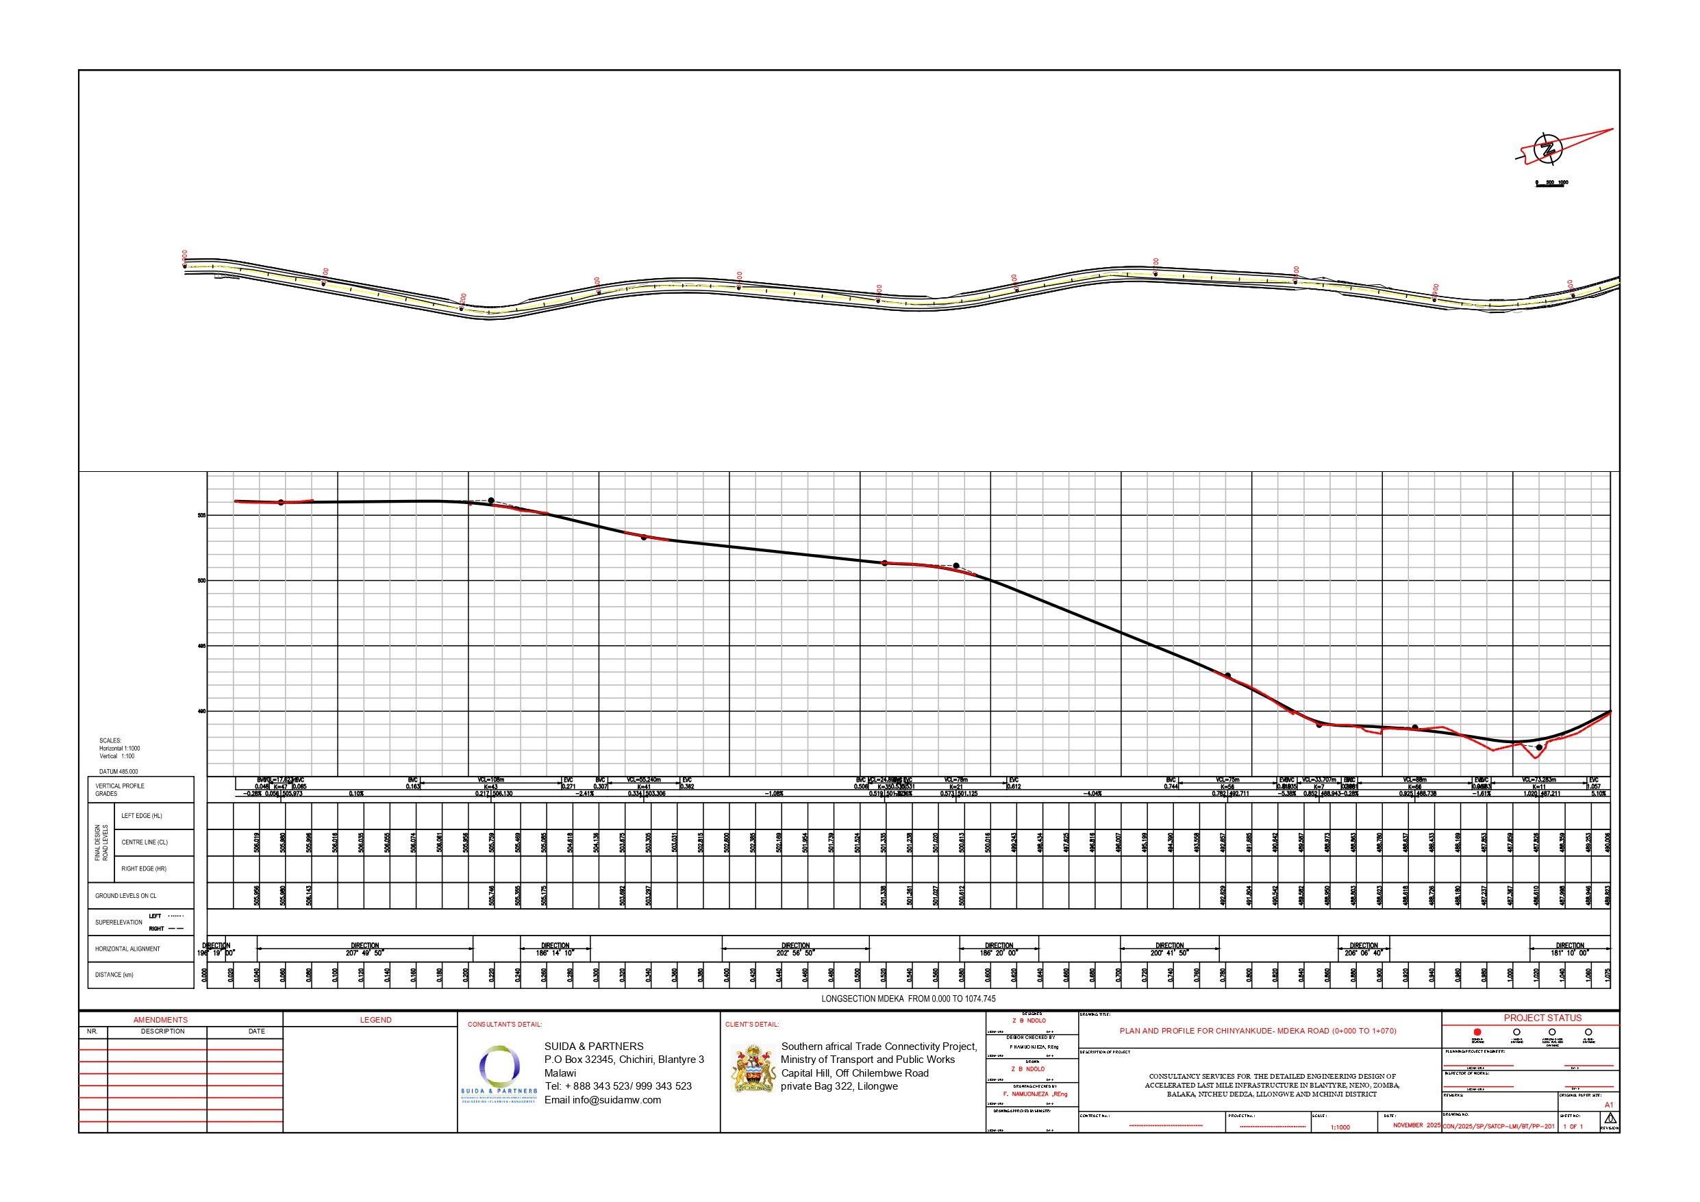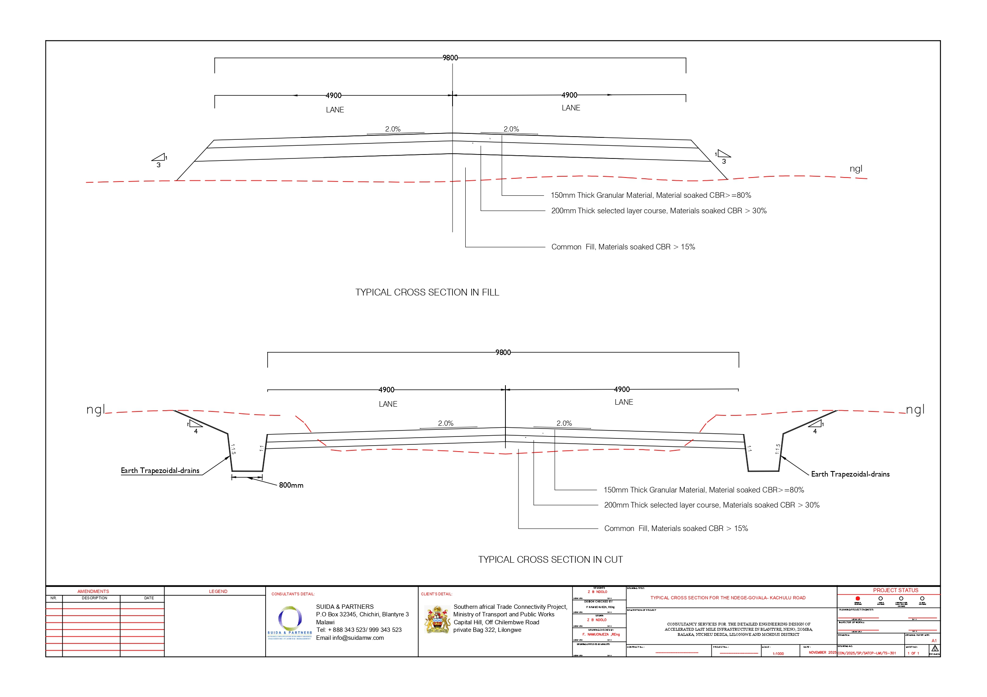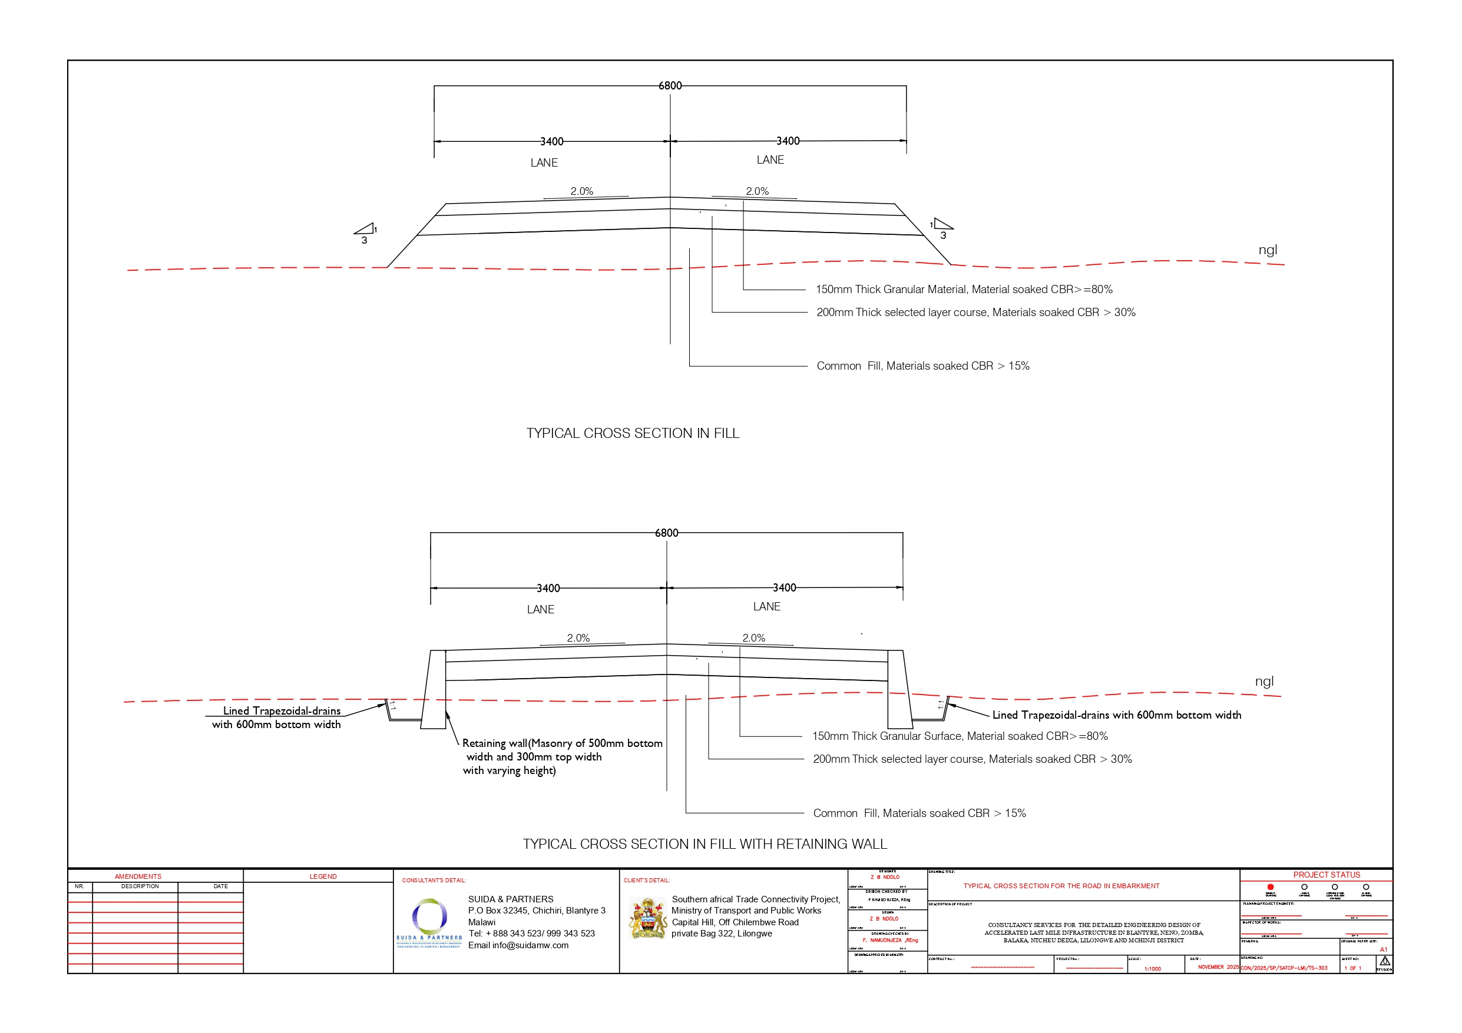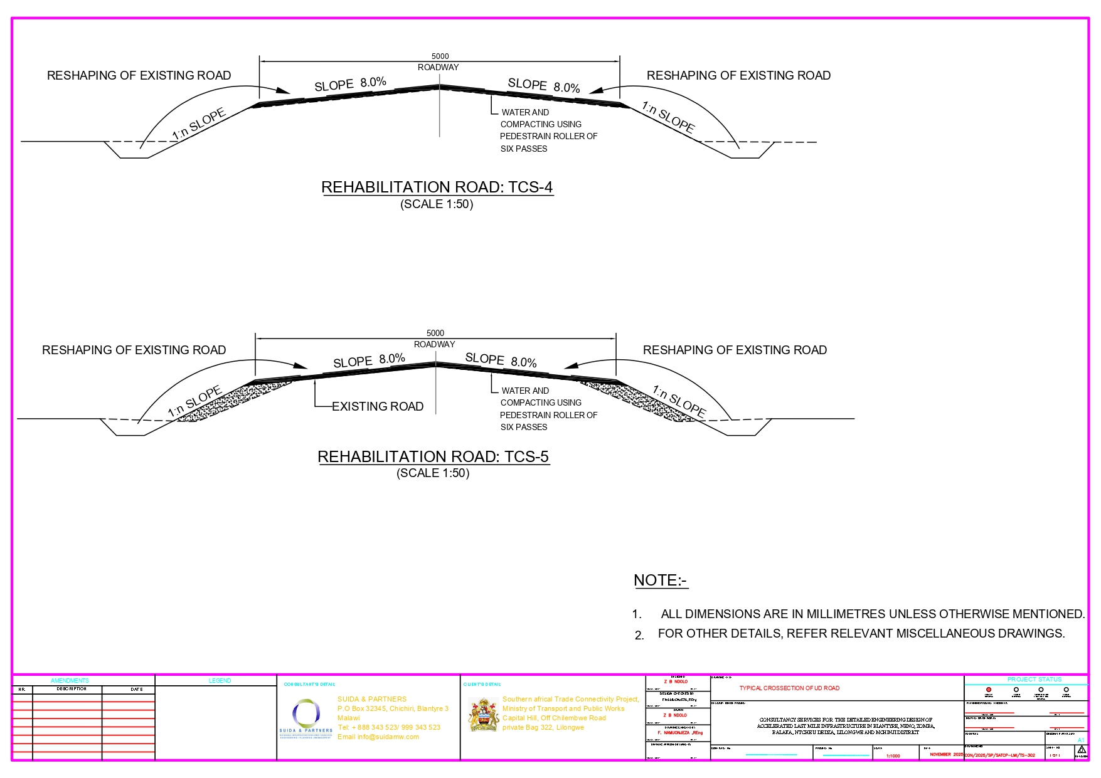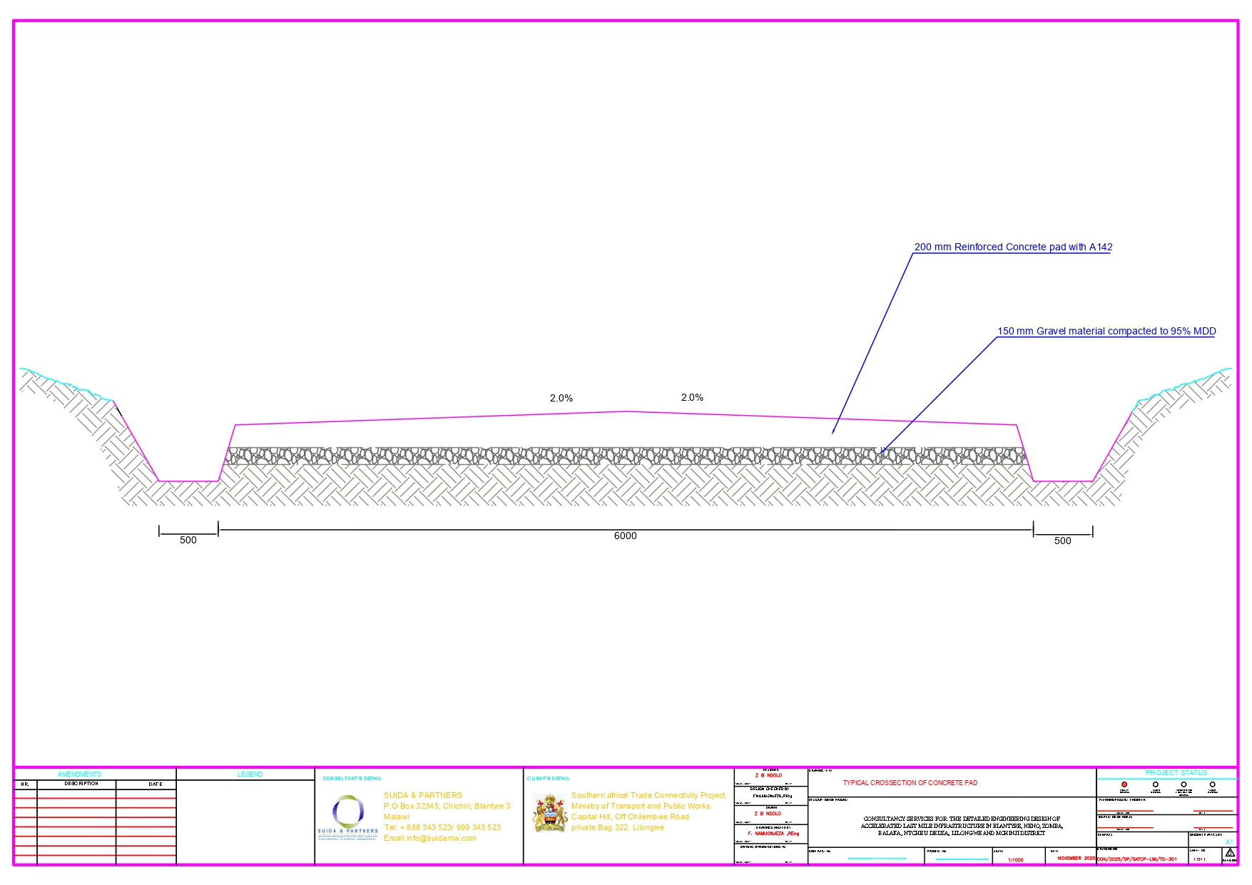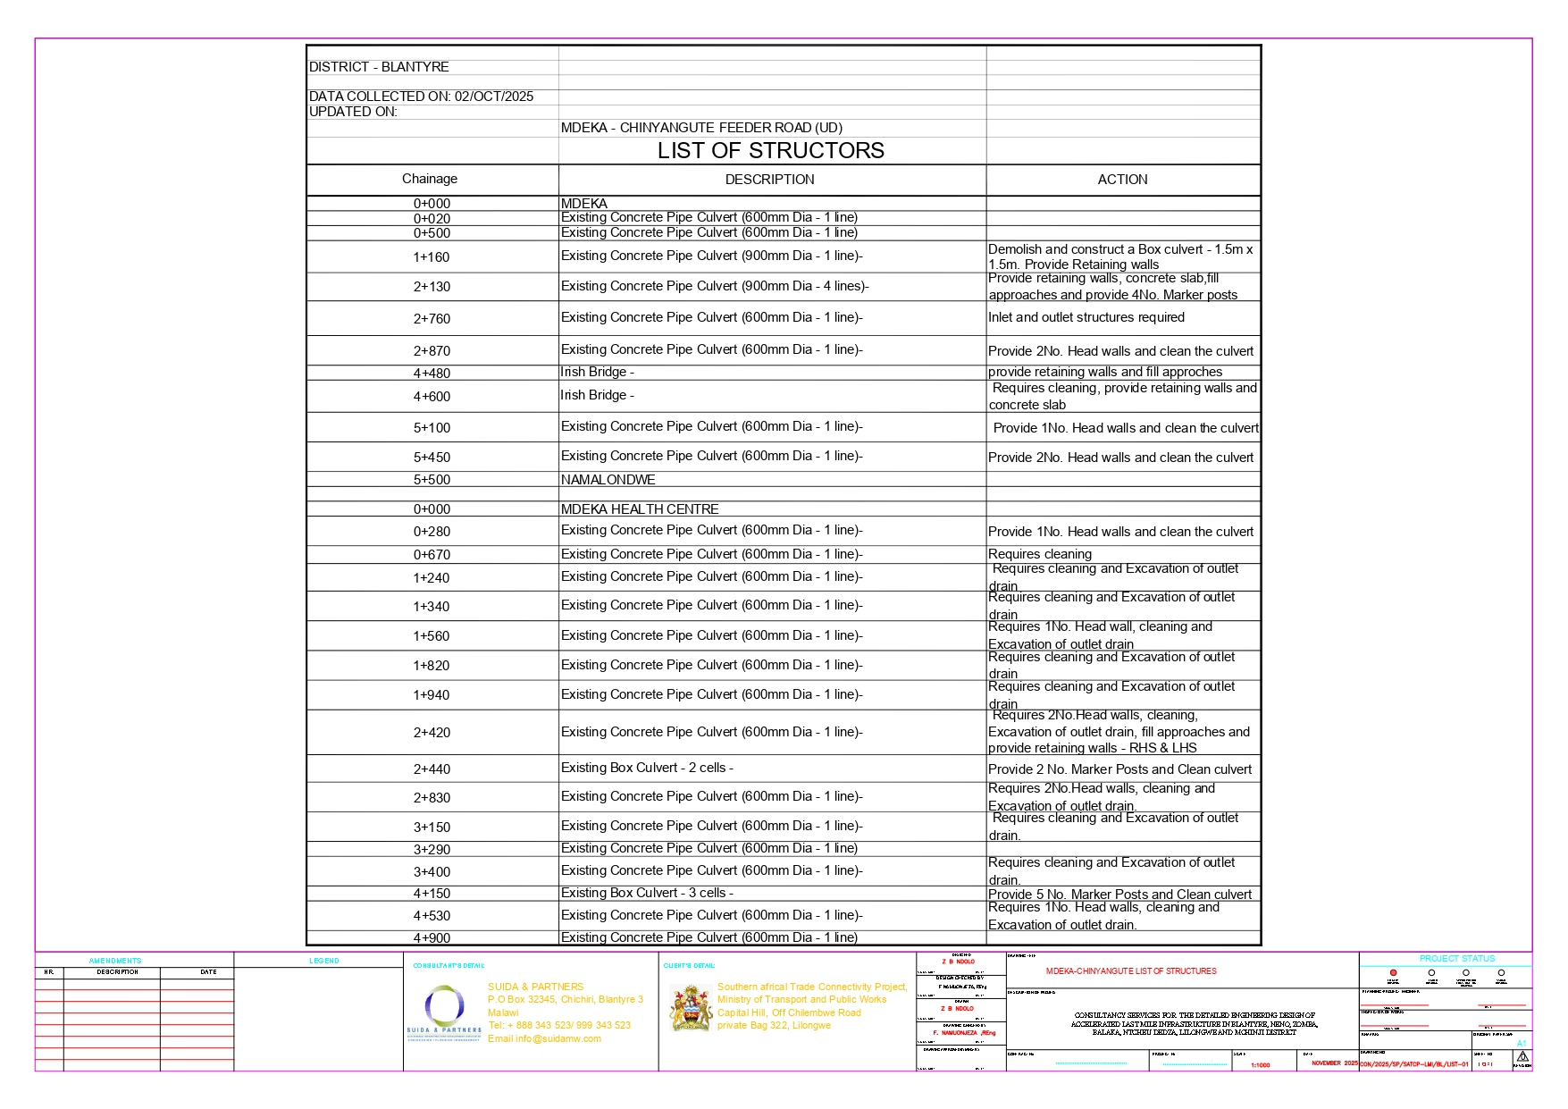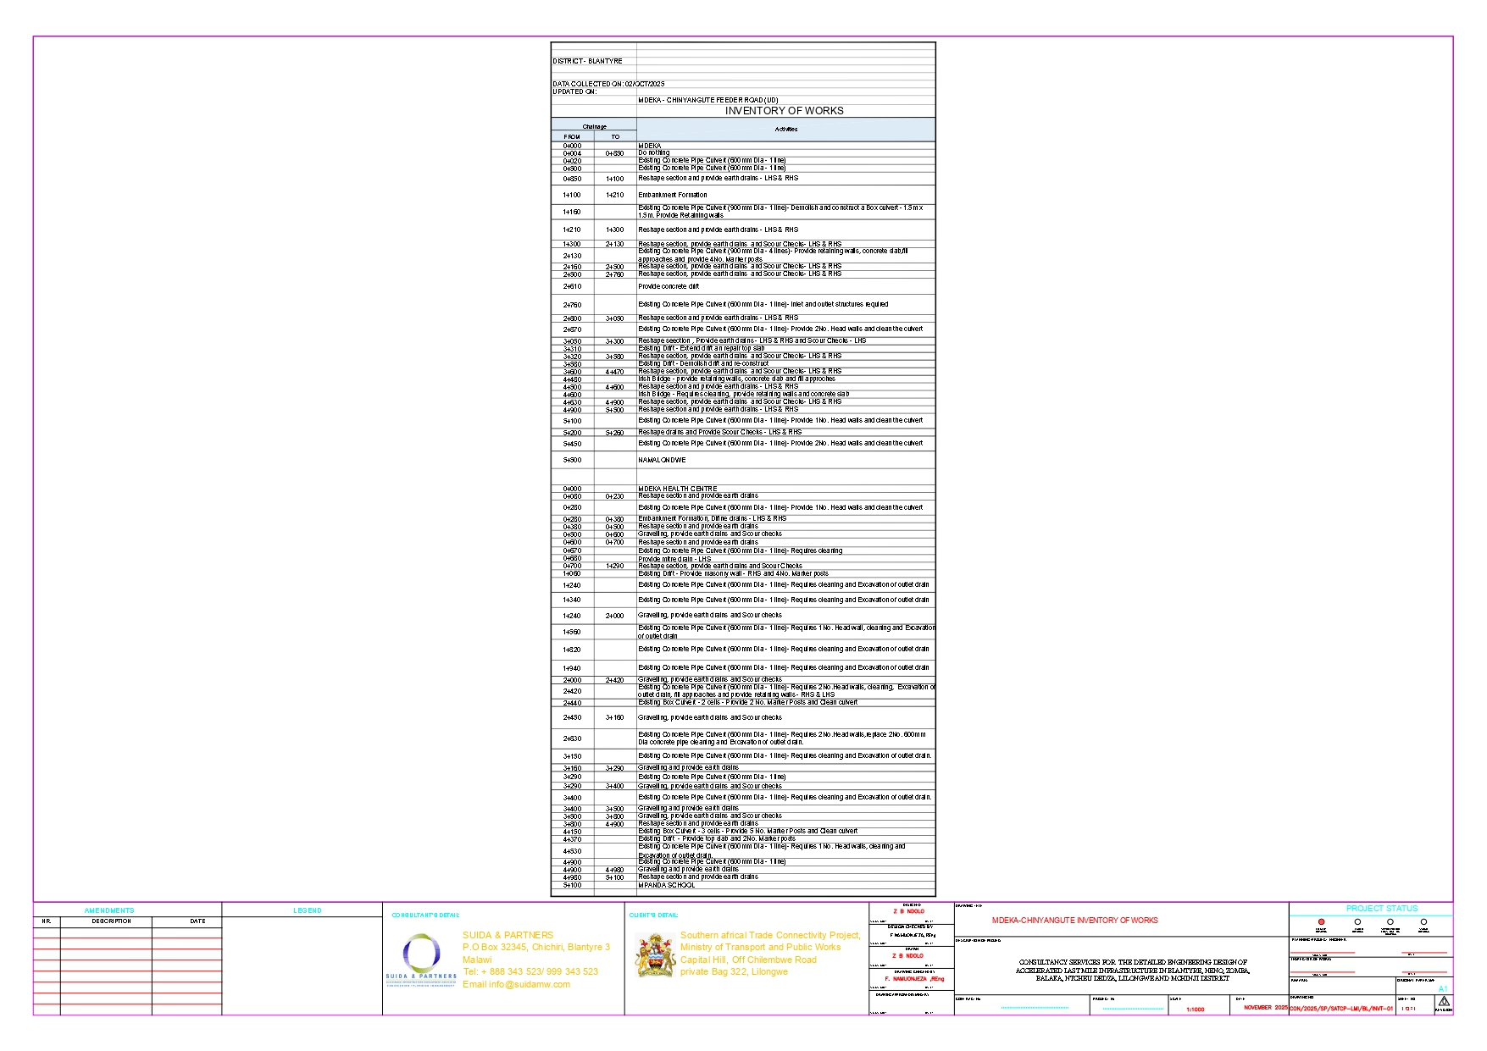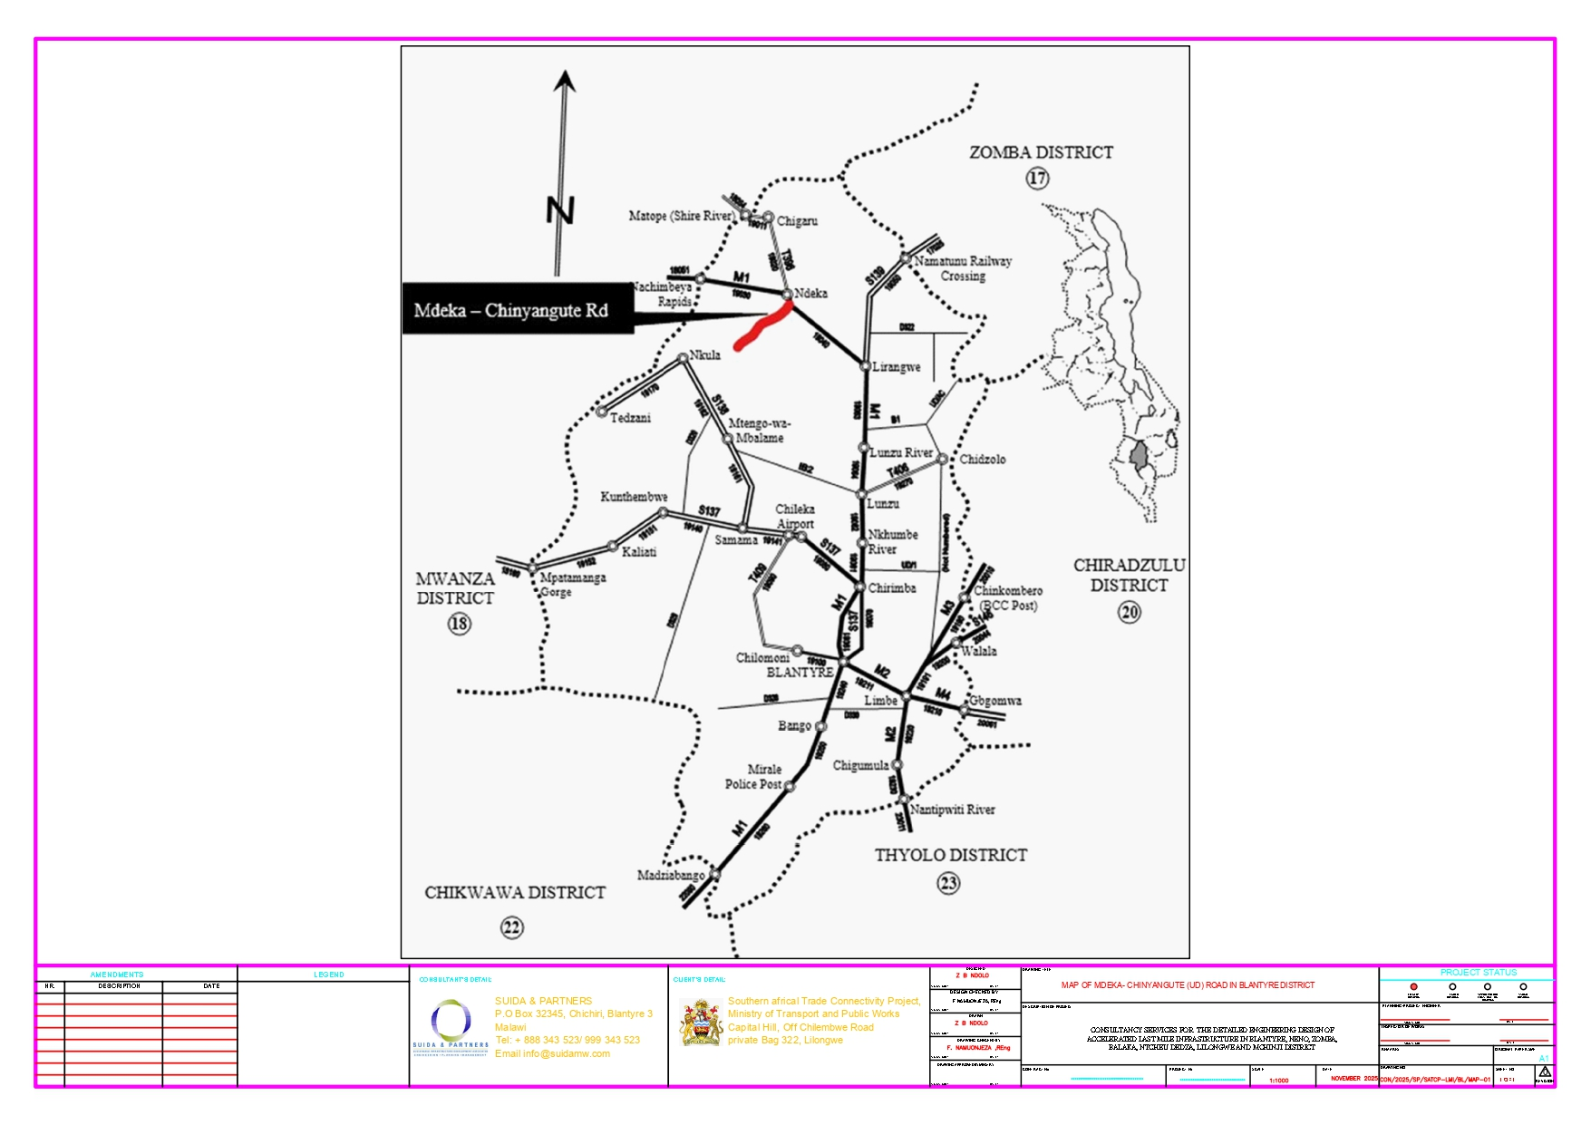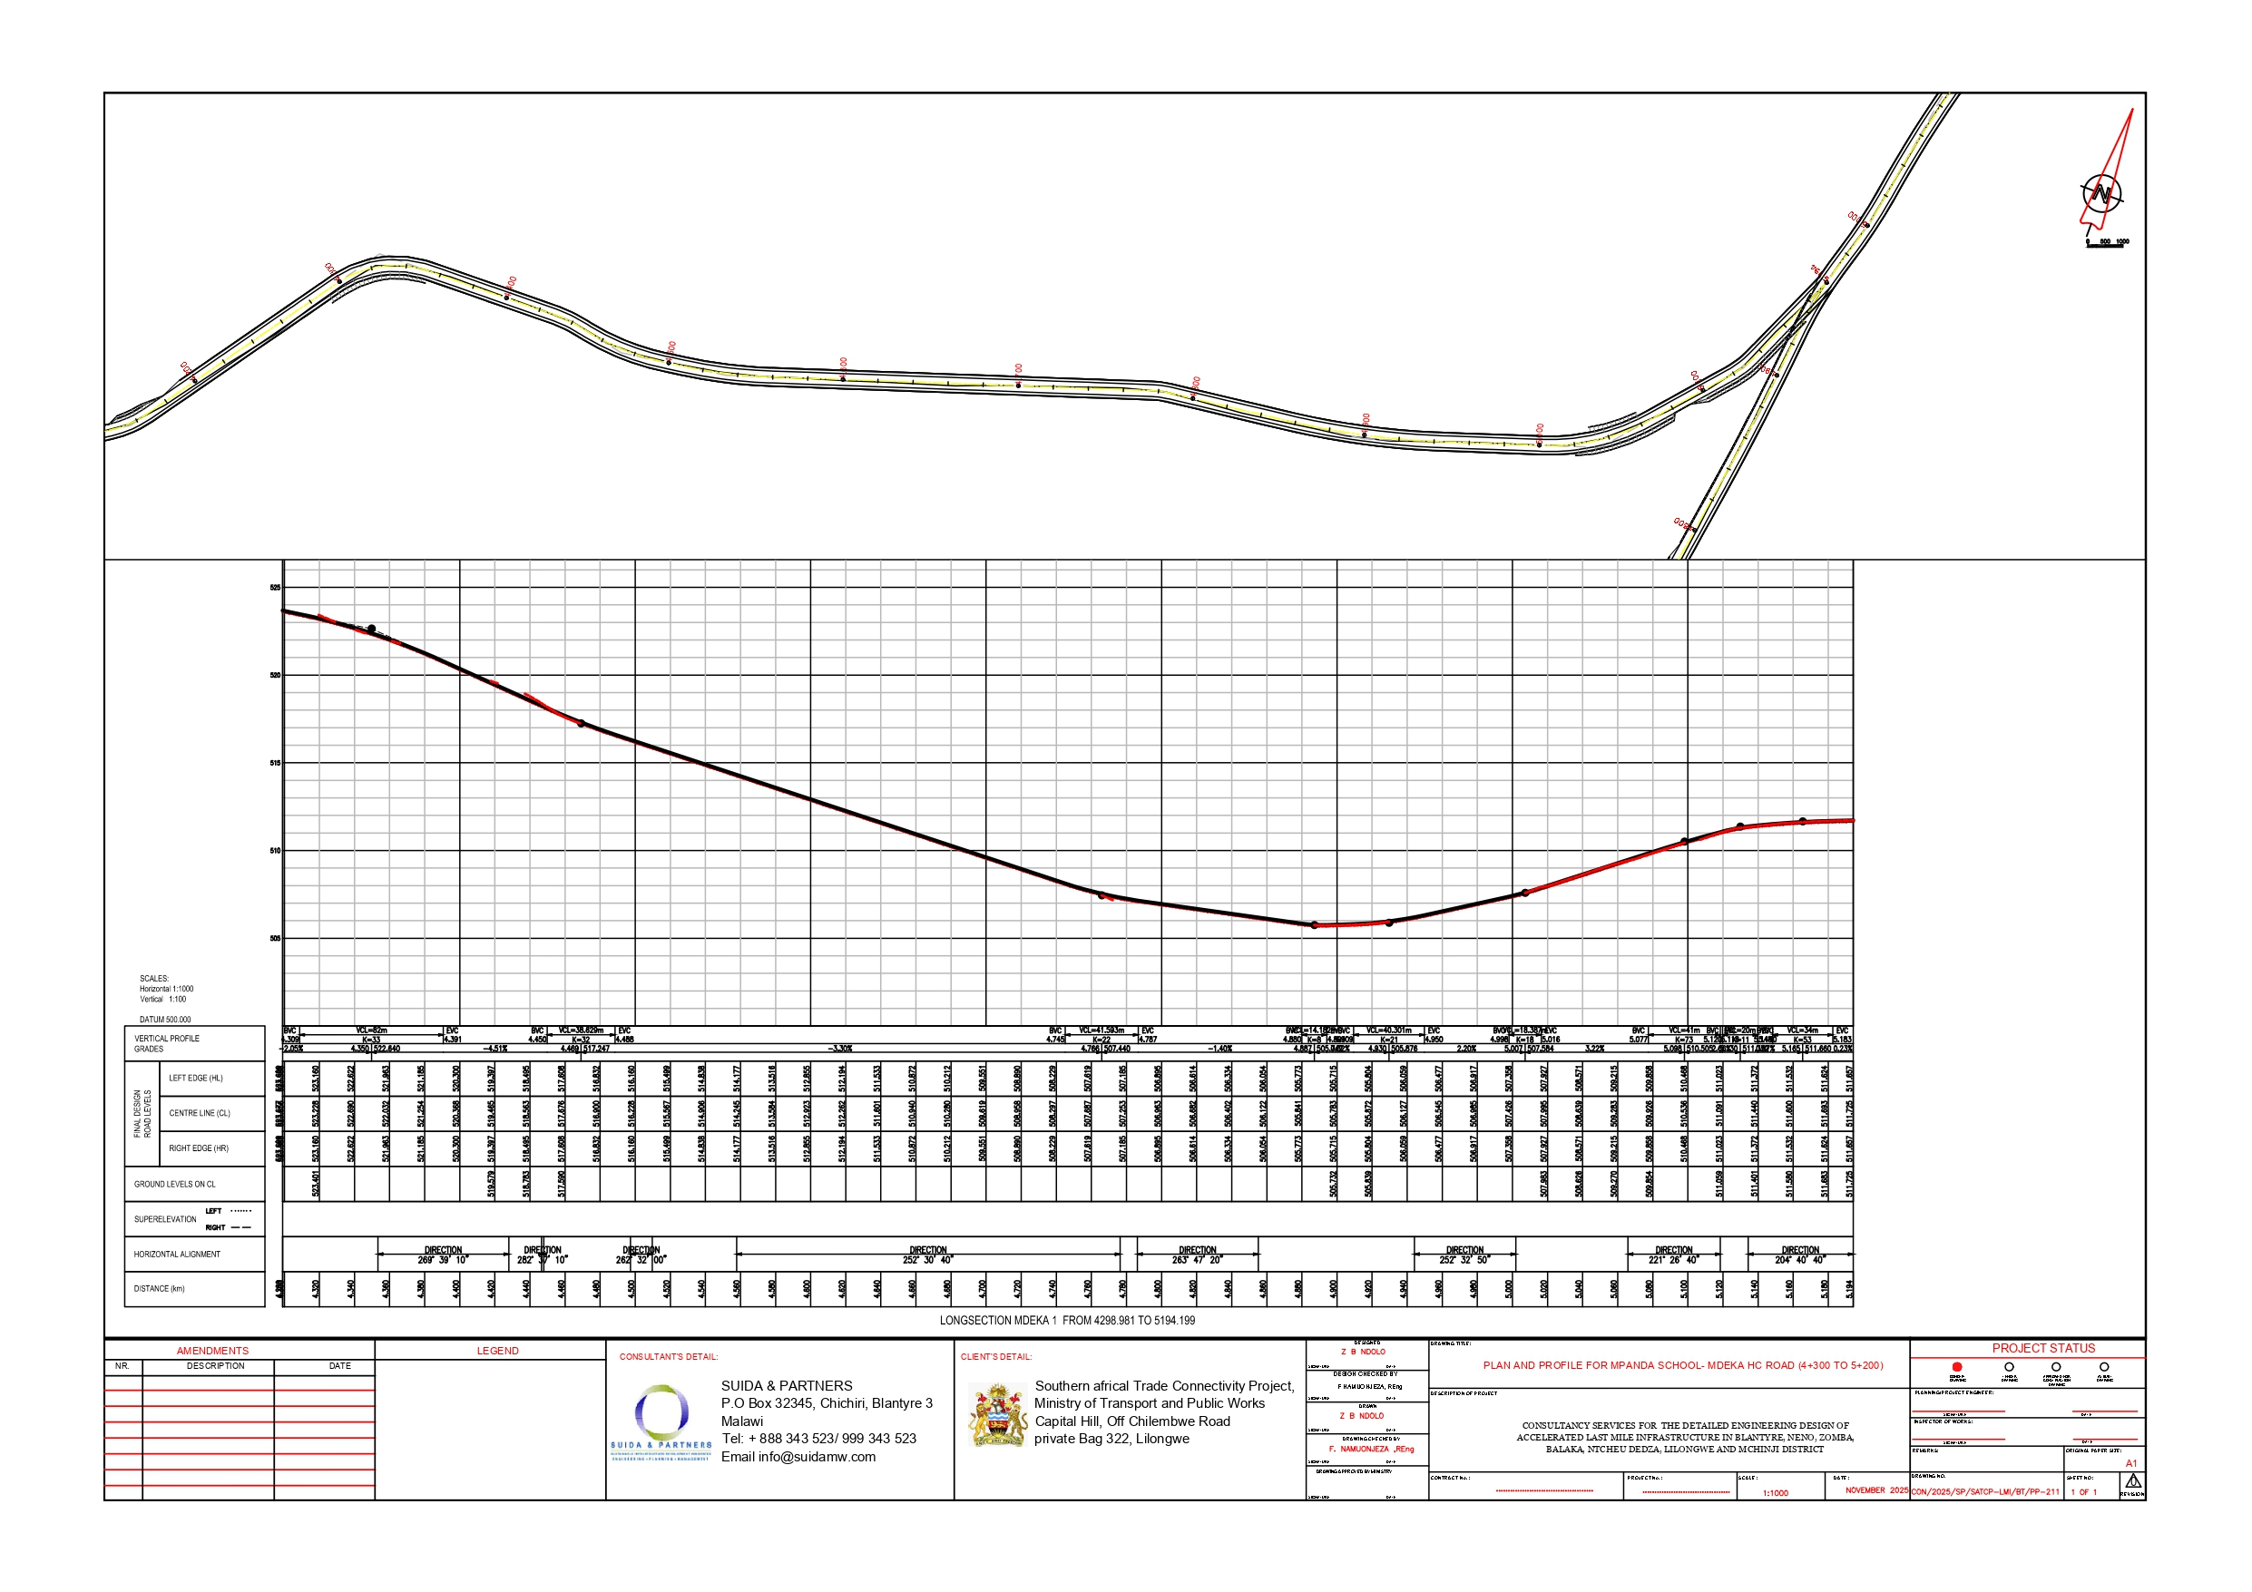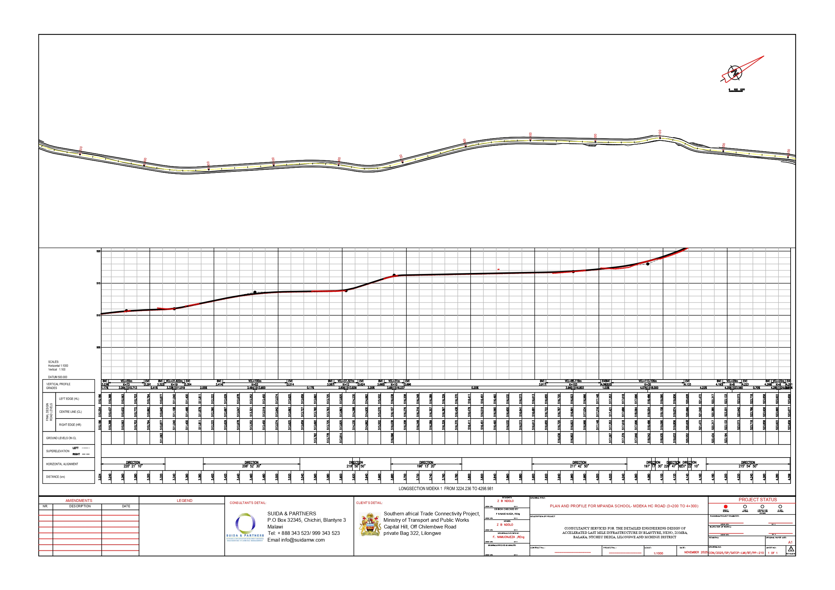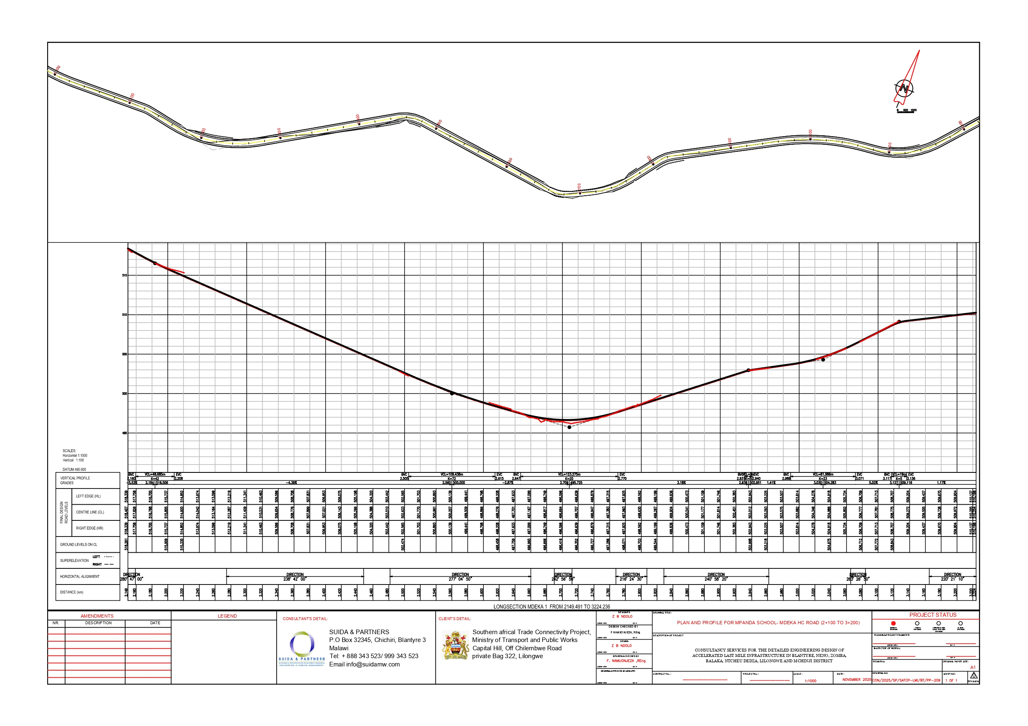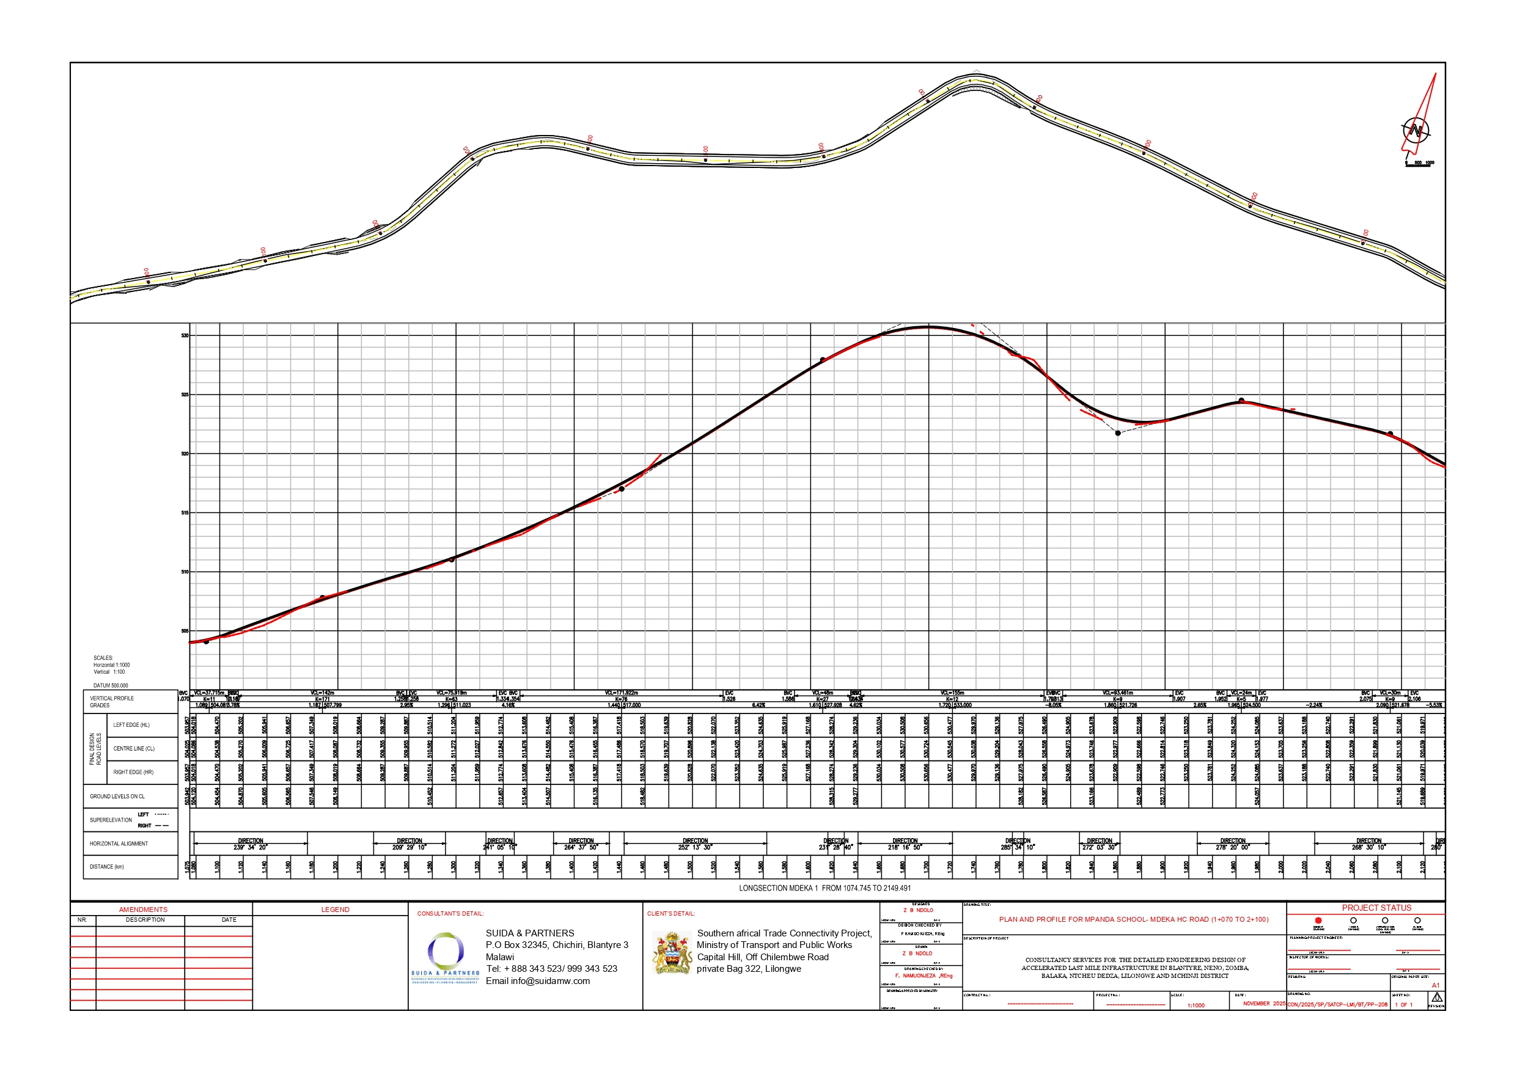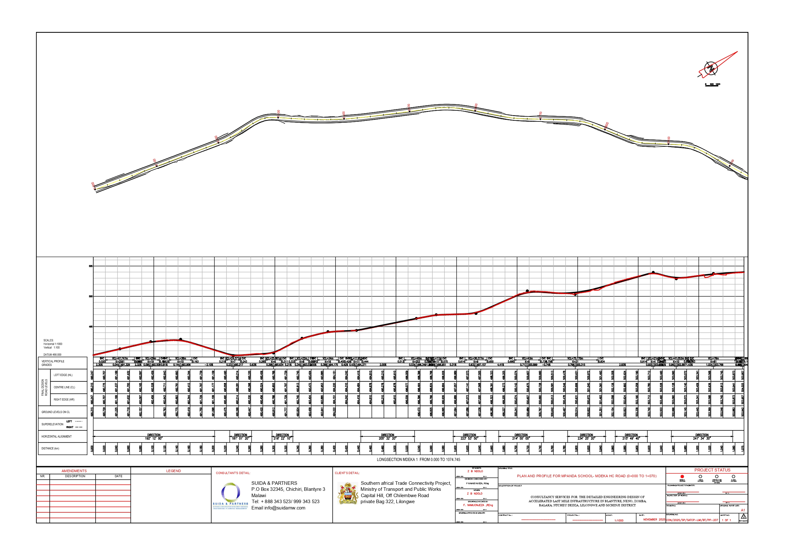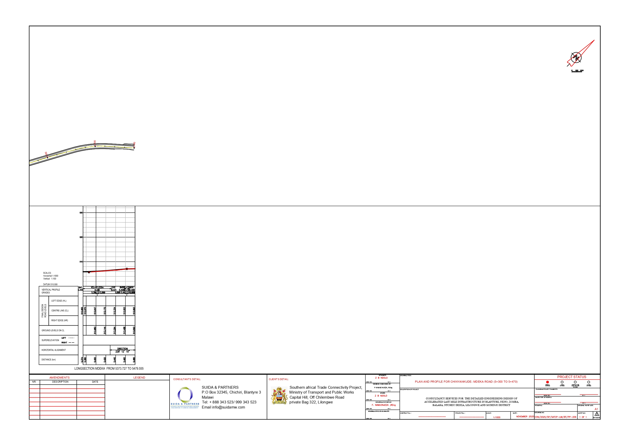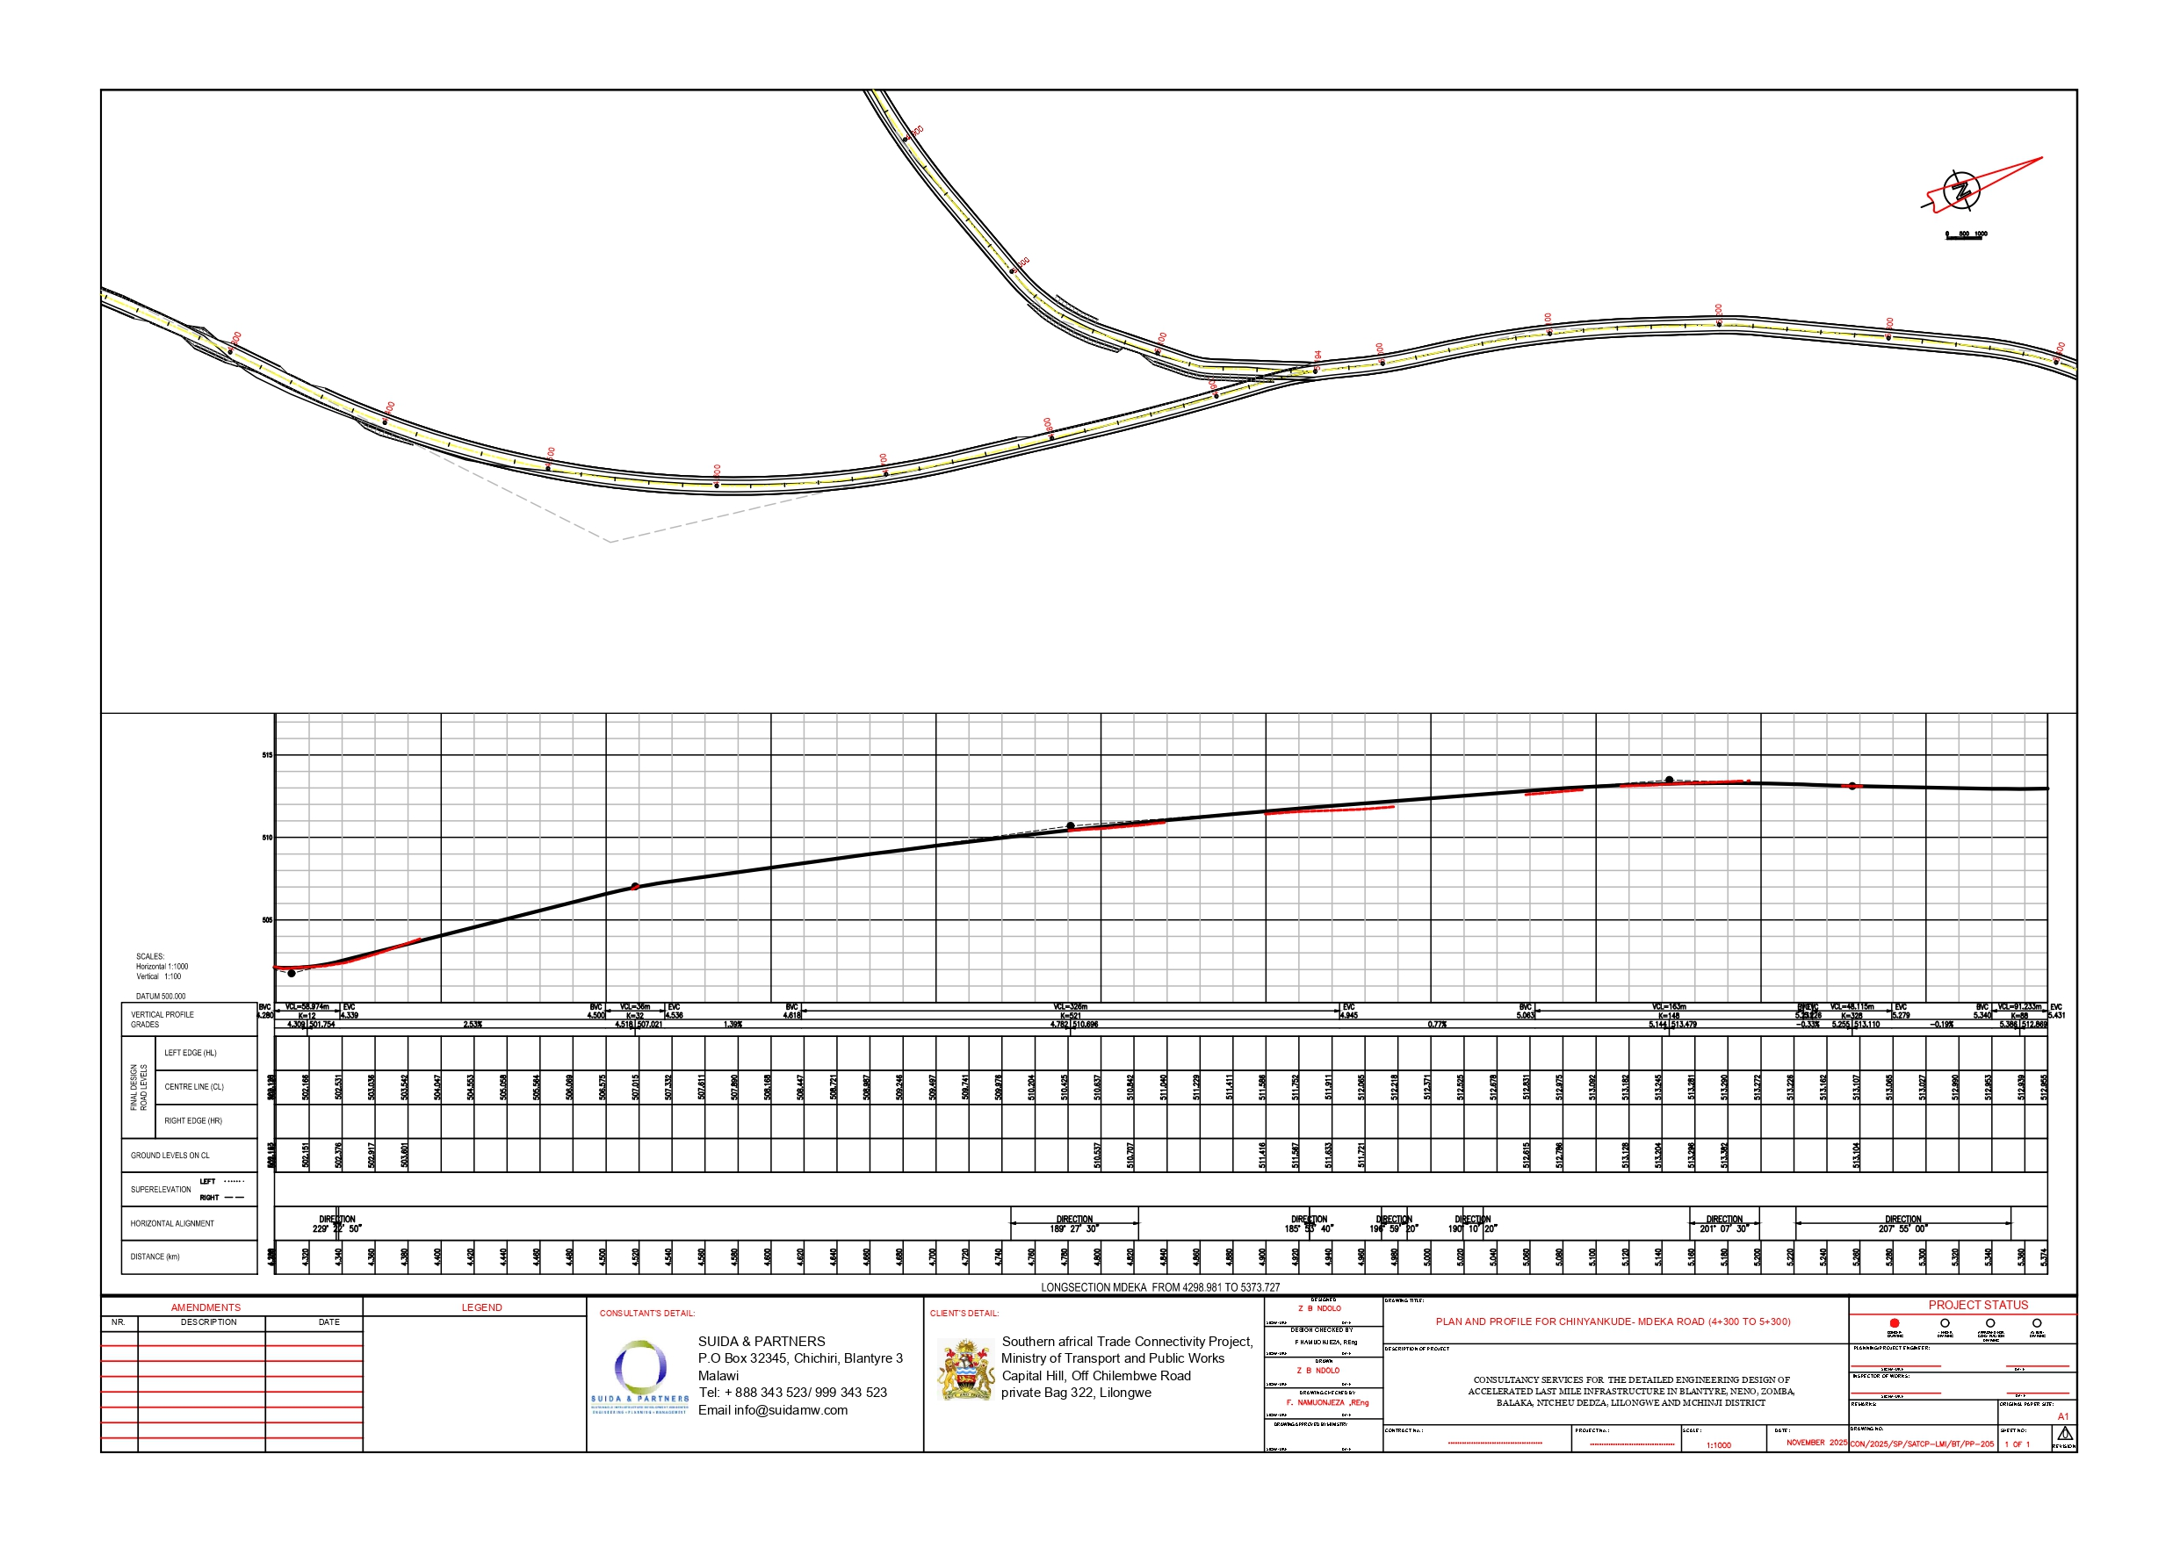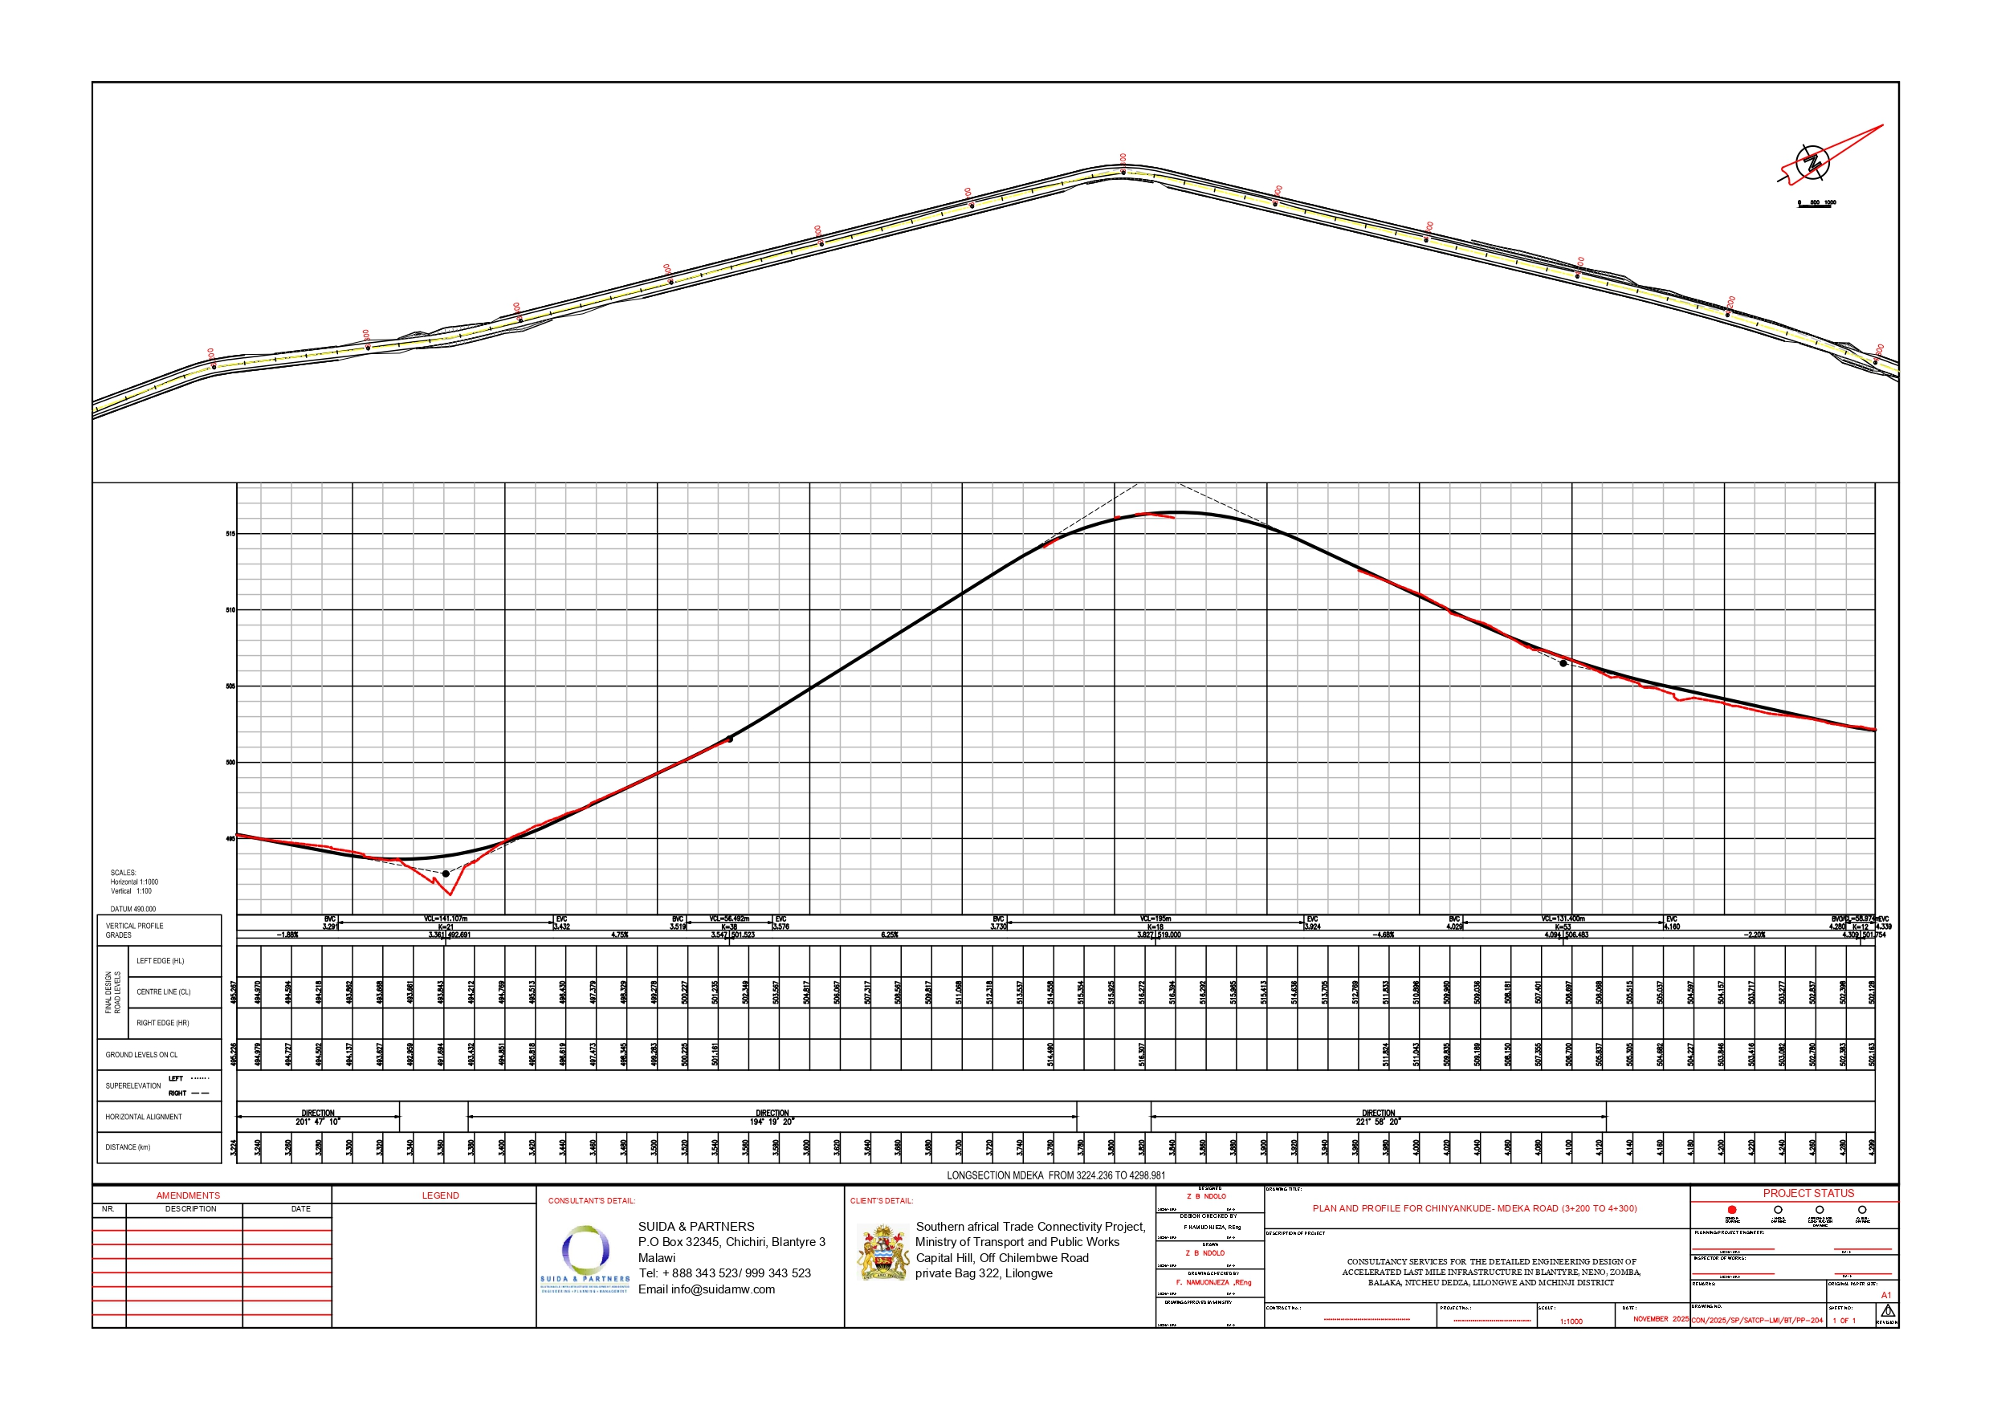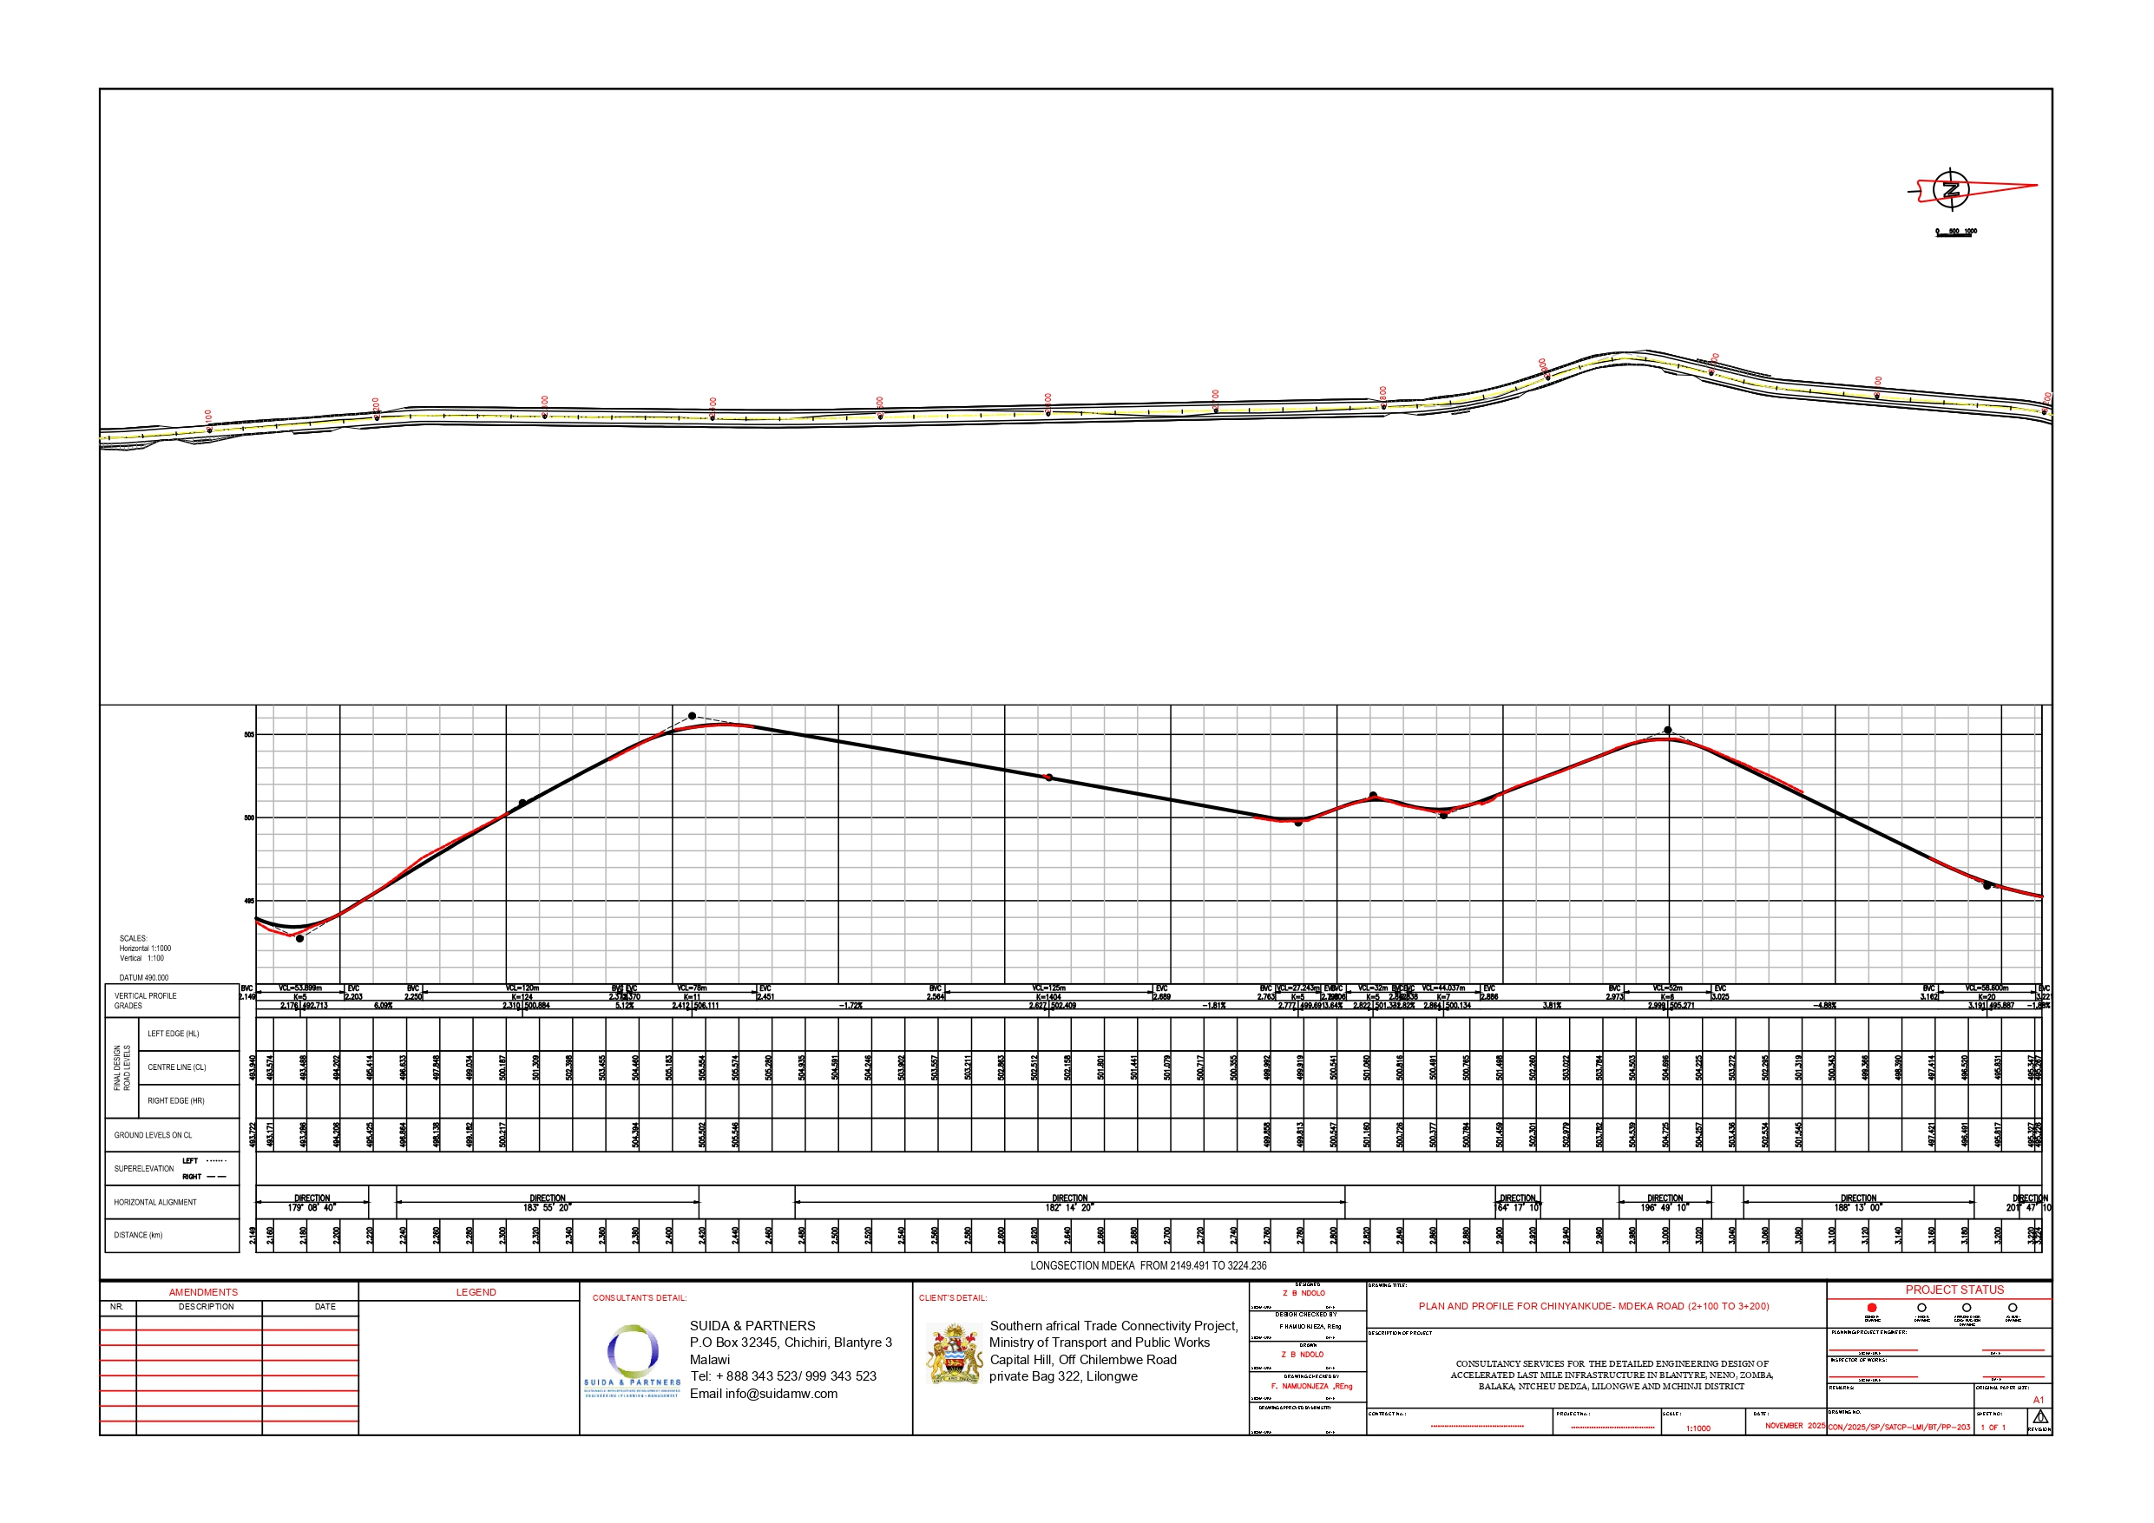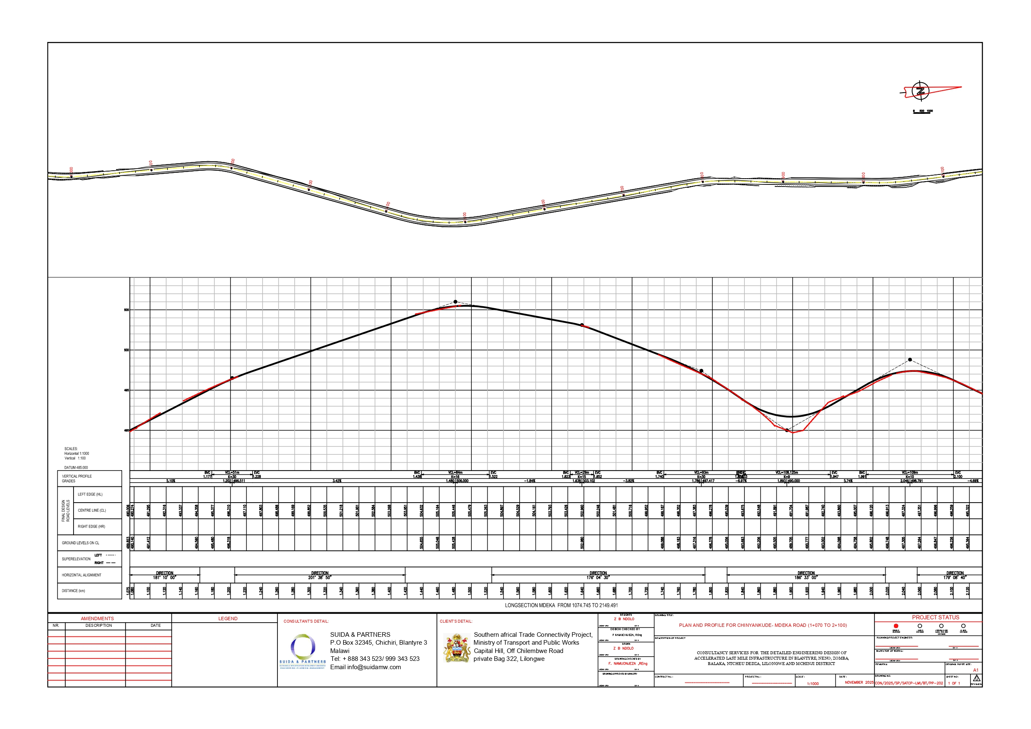

All photographs used in this report were taken during field surveys with prior informed consent from individuals.
The road reserve and road centre line shown in this figure are indicative only and may not be spatially accurate due to the map scale, basemap limitations, and coordinate system/projection used. They are included for illustrative purposes only and must not be relied upon for surveying, land demarcation, or construction setting out.

