
Government of Malawi
Ministry of Transport & Public Works

ENVIRONMENTAL AND SOCIAL MITIGATION AND MONITORING PLAN FOR CONSTRUCTION OF MULTIPLE BOX CULVERTS AT CHINGALU ON MITUNDU TO NSABWEMANYAZI ROAD IN LILONGWE

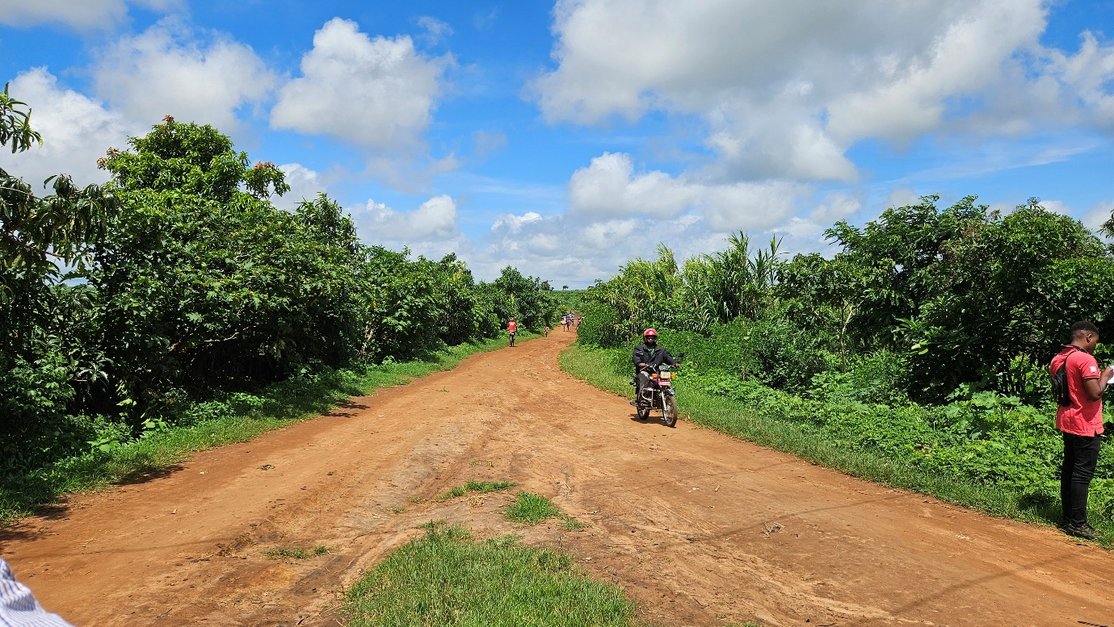

Ministry of Transport and Public Works
Southern Africa Trade and Connectivity Project
Private Bag 322
Lilongwe 3

18 JUNE, 2026

EXECUTIVE SUMMARY
1.0 Project Background
The proposed Nsabwemanyazi Box Culverts (Chingalu Crossing) project is located in Lilongwe District. Key works include installation of box culverts, construction of headwalls, aprons, and erosion control structures, and realignment of drainage channels to maintain natural water flow across an approximately 100 m wetland (dambo) crossing influenced by the Chiole and Chiwiri streams. The project has an estimated cost of approximately USD 200,000 and is scheduled for implementation over a six-month period from May 2026 to October 2026. Construction activities will be undertaken by a contractor who will employ workforce of approximately 40–60 workers and a target of at least 40% gender inclusion.
2.0 Justification of the Study
The preparation of this ESMMP is guided by World Bank cleared ToRs as MEPA had already cleared this project during project brief presentation. The World Bank ToRs required this project to have a stand-alone ESMMP to strengthen environmental and social risk management in line with international best practice.
3.0 Summary of Key Positive Impacts and Enhancement Measures
3.1 Improved Flood Resilience and Drainage Efficiency
The installation of engineered box culverts will significantly improve water conveyance across the wetland crossing, reducing flooding, waterlogging, and wash-out risks.
Enhancement Measures:
- Design culverts based on peak flow and hydrological assessments;
- Integrate climate-resilient hydraulic design allowances;
- Provide adequate scour protection at inlets and outlets;
- Maintain natural drainage alignment to avoid flow obstruction.
3.2 Improved Road Safety at the Crossing
The project will enhance safety for pedestrians, cyclists, and vehicles at a previously hazardous crossing point.
Enhancement Measures:
- Install road safety signage and markers;
- Provide defined crossing points and visibility improvements;
- Implement traffic calming measures at approach sections.
8.3 Local Employment and Income Generation
Construction activities will generate short-term employment opportunities for surrounding communities.
Enhancement Measures:
- Prioritize local labour recruitment;
- Ensure transparent hiring processes;
- Maintain employment records disaggregated by gender.
8.4 Improved Market Access and Mobility
Reliable crossing conditions will enhance connectivity for agricultural produce and local trade.
Enhancement Measures:
- Ensure proper maintenance of culverts and drainage structures;
- Maintain road approaches to ensure year-round usability.
8.5 Strengthened Community Engagement and Accountability
Structured stakeholder engagement will enhance community ownership and transparency.
Enhancement Measures:
- Conduct continuous stakeholder consultations;
- Establish and operationalize a Grievance Redress Mechanism (GRM);
- Ensure inclusion of women and vulnerable groups in consultations.
9.0 Summary of Key Negative Impacts and Mitigation Measures
9.1 Disturbance to Nearby Communities
Construction activities may cause dust, noise, and temporary access disruptions to nearby households and social areas.
Mitigation Measures:
- Restrict works to defined footprints;
- Implement dust suppression and noise control measures;
- Maintain access routes during construction.
9.2 Soil Erosion and Sedimentation
Excavation and drainage works may increase erosion and sediment transport into watercourses.
Mitigation Measures:
- Install silt traps and sediment barriers;
- Stabilize exposed surfaces through vegetation or stone pitching;
- Avoid major earthworks during heavy rainfall.

9.3 Disturbance to Wetland Hydrology
Improper construction may alter natural water flow within the dambo system.
Mitigation Measures:
- Maintain environmental flows during construction works;
- Monitor flow conditions during works.
9.4 Soil and Water Contamination from Fuels and Oils
Leakages from machinery and fuel handling may contaminate soil and water resources.
Mitigation Measures:
- Store fuels in bunded and designated areas;
- Implement spill prevention and response procedures;
- Prohibit refueling near water bodies.
9.5 Land Degradation from Borrow Areas
Material sourcing may result in land scarring and poor site conditions if not properly managed.
Mitigation Measures:
- Use approved borrow sites only;
- Strip and preserve topsoil;
- Rehabilitate borrow areas after use.
9.6 Dust Emissions Affecting Communities
Construction activities may generate dust affecting nearby households and road users.
Mitigation Measures:
- Construct speed humps at every 100 meters to limit
- Regularly water exposed surfaces;
- Put 20 kilometers signage 100 meters away from work area on both sides of the road
- Cover haul trucks carrying gravel;
- Schedule works to minimize disturbance near settlements.
9.7 Traffic and Occupational Safety Risks
Increased movement of construction vehicles and equipment may pose risks to workers and the public.
Mitigation Measures:
- Implement a Traffic Management Plan;
- Install warning signs and deploy flag personnel;
- Provide PPE and enforce safety procedures for workers.
10.0 Conclusion and Recommendations
10.1 Conclusion
The proposed construction of the Nsabwemanyazi Box Culverts at Chingalu Crossing is expected to deliver significant socio-economic and environmental benefits by improving drainage efficiency, reducing flooding, enhancing road safety, and ensuring reliable all-weather access along the Mitundu–Nsabwemanyazi corridor. The intervention will strengthen local mobility, agricultural market access, and access to essential services such as schools and health facilities.
The environmental and social risks identified—particularly those related to wetland disturbance, erosion, sedimentation, pollution, and community safety—are site-specific, temporary, and manageable. With the implementation of the prescribed mitigation and monitoring measures, these risks can be effectively controlled and reversed where necessary.
10.2 Recommendations
- Allocate adequate financial, technical, and human resources to support effective ESMMP implementation and monitoring;
- Integrate all ESMMP requirements into contractual obligations and contractor site-specific management plans;
- Ensure that all site-specific plans (e.g., OHS, traffic management, waste management, erosion control, GBV/SEA/SH) are prepared and approved prior to mobilization;
- Establish and operationalize community and worker grievance redress mechanisms (GRMs);
- Obtain all necessary statutory approvals and permits prior to commencement of works;
- Deploy qualified environmental, social, health, and safety (ESHS) personnel on site throughout the construction phase; and
- Maintain close coordination among the Ministry of Transport and Public Works (MoTPW), Supervising Consultant, Lilongwe District Council, and MEPA to ensure compliance and effective oversight.

ACRONYMS AND ABBREVIATIONS

AIDS | Acquired Immune Deficiency Syndrome
DED | Detailed Engineering Design
DESC | District Environment Sub-Committee
EHS | Environmental, Health and Safety
EMA | Environment Management Act
ESF | Environmental and Social Framework (World Bank)
ESHS | Environmental, Social, Health and Safety
ESIA | Environmental and Social Impact Assessment
ESMMP | Environmental and Social Mitigation and Monitoring Plan
ESMMP | Environmental and Social Management Plan
FGD | Focus Group Discussion
GBV | Gender-Based Violence
GIIP | Good International Industry Practice
GRM | Grievance Redress Mechanism
HIV | Human Immunodeficiency Virus
IEC | Information, Education and Communication
IUCN | International Union for Conservation of Nature
LC | Local Council
LMI | Last Mile Infrastructure
MEPA | Malawi Environment Protection Authority
OHS | Occupational Health and Safety
OP/BP | Operational Policy / Bank Procedure (World Bank)
PPE | Personal Protective Equipment
RHS | Right-Hand Side
SATCP | Southern Africa Trade and Connectivity Project
SEA | Sexual Exploitation and Abuse
SEA/SH | Sexual Exploitation and Abuse / Sexual Harassment
SEP | Stakeholder Engagement Plan
SH | Sexual Harassment
STA | Sub-Traditional Authority
WMP | Waste Management Plan

TABLE OF CONTENTS

EXECUTIVE SUMMARY i
1 CHAPTER 1: INTRODUCTION AND BACKGROUND 1
1.1 Introduction 1
1.2 Developer Details 1
1.3 Objectives of the ESMMP 1
1.4 Methodology for the ESMMP 1
1.5 Project Location 2
1.6 Land Tenure and Land Requirement for the Project 5
1.7 Potential Users of the ESMMP 5
2 CHAPTER 2: PROJECT DESCRIPTION 6
2.1 Introduction 6
2.2 Overall Scope of Rehabilitation 6
2.3 Chainage-Specific Engineering Works 6
2.4 Key Engineering Focus Areas 7
2.5 Labour Requirements 7
2.6 Material Requirements and Sources 8
2.7 Worker Accommodation 8
2.8 Waste and Waste Management 9
2.9 Rehabilitation of Temporary Sites 11
3 CHAPTER 3: POLICY AND LEGAL FRAMEWORK 12
3.1 National Policies and Strategies 12
3.1.1 Policy Framework 12
3.1.2 Legislative Frameworks 14
3.2 World Bank Safeguard Policies and Procedures 16
3.2.1 World Bank Operational Policy OP/BP 4.01: Environmental Assessment 16
3.2.2 World Bank ESHS 16
3.3 Institutional Framework 17
3.4 Summary of Main Statutory Approvals/Licenses to be obtained for the project 17
4 CHAPTER 4: ENVIRONMENTAL AND SOCIAL SETTING 19
4.1 Introduction 19
4.2 Biophysical Environment 19
4.2.1 Topography 19
4.2.2 Geology 19
4.2.3 Soils 22
4.2.4 Climate and Climate Change Risks 24
4.2.5 Water Resources and Quality 26
4.2.6 Flora (Plant Life) 29
4.2.7 Fauna (Animal Life) 32
4.2.8 Human–Fauna Interaction 33
4.3 Socio-economic environment 33
4.3.1 Demography 33
4.3.2 Education and Literacy 34
4.3.3 Health 35
4.3.4 Cultural Heritage 35
4.3.5 Agriculture 35
4.3.6 Economic Activities and Livelihoods 36
4.3.7 Transport 36
4.3.8 Security 36
4.3.9 Land Use 36
4.3.10 Vulnerable and Marginalized Groups 36
4.3.11 Communication 37
4.3.12 Energy Sources 37
4.3.13 Implications for the Project 37
5 CHAPTER 5: ENVIRONMENTAL AND SOCIAL MANAGEMENT PLAN 38
5.1 Introduction 38
5.2 Environmental and Social Mitigation and Monitoring Plan for Mitundu –Nsabwemanyazi 40
5.3 Institutional Arrangements and Implementation Capacity 52
5.4 Monitoring and Oversight Framework 52
5.5 Institutional Coordination Mechanisms 53
REFERENCES 54
ANNEXES 56
Annex 1. Feedback Letter from MEPA 56
Annex 2. List of Stakeholders Consulted 58
Annex 3. Issues raised by Stakeholders and how they have been addressed in ESMMP 60
Annex 4. Sample Code of Conduct for Contractors 63
Annex 5. Barrow Pit Rehabilitation Framework 67
Annex 6. Traffic Management Framework 71
Annex 7. Chance Find Procedure for Last Mile Infrastructure under SATCP 75
Annex 8: Labour Management Guidelines for Contractor Compliance and Preparation of Labour Management Plans (LMPs) 78
Annex 9. Contractor Environmental and Social Management Plan (C-ESMMP) Framework 82
Annex 10. Waste Management Framework 85
Annex 11. Stakeholder Engagement Framework 89
Annex 12. Details of the Consultants (Names, Qualification and Roles of Team Members) 94
Annex 13. SATCP LMI Grievance Redress Mechanism (GRM) Protocol 95
Annex 14. Project Drawings 102

LIST OF FIGURES

Figure 1-1. PIU-Consultant Site handover (LHS) and Consultation with Lilongwe DESC (RHS) 2
Figure 1-2. Project location map 3
Figure 1-3. Aerial view of the Chingalu Section on Mitundu - Nsabwemanyazi Road 4
Figure 4-2. Geological Map of the Mitundu – Nsabwemanyazi Road corridor 21
Figure 4-3. Soils along the Mitundu - Nsabwemany Corridor 23
Figure 4-5. Average monthly rainfall distribution for Mitundu – Nsabwemanyazi Road Corridor. 25
Figure 4-6. Hydrological map of the proposed project area 27
Figure 4-7. Senna siamea species (Behind the sign post) observed along Mitundu- Nsabwemanyazi road 30
Figure 4-8: Pennisetum purpureum (Nappier grass) observed at Chingalu Crossing 30
Figure 4-11. A signpost showing directions and distances to nearby school facilities close to the project location 35
Figure 4-12. Herds of livestock at Chikhokhobe Valley, at Km 2.20 along the Mitundu – Nsabwemanyazi Road 36

LIST OF TABLES

Table 2-1. Chainage Works Details for Mitundu–Nsabwemanyazi Road 6
Table 2-2. Expected Number of People to be Employed (Peak Workforce) 8
Table 2-3. Material Requirements and Sources 8
Table 2-4. Expected Waste Streams, Quantities, Sources and Mitigation Measures (Low-Impact, No-Camp Scenario 10
Table 3-1. Key National Policies Guiding the Project 13
Table 3-2. Key National Legislation Guiding the Project 14
Table 3-3. World Bank Environmental and Social Safeguard Policies Applicable to the Project 16
Table 3-4. Institutional mandates on Environmental and Social Safeguards related to the Project 17
Table 3-5. Summary of Statutory Approvals and Licences Required 18
Table 4-1. Water quality status at Chingalu crossing and associated streams 29
Table 4-2. Plants of the Project Area 31
Table 4-3. Table Animals of the Project Area 32
Table 5-1. ESMMP Implementation Responsibilities 52

List of Annexes

Figure 1-1 Consultation with Balaka DESC 4
Figure 1-2: Location of the proposed Balaka – Mbela – Kachenga Road (S133/381) Road 6
Figure 1-3 : Location of the proposed road in Balaka 7
Figure 1-4: Balaka section of the road 8
Figure 1-5: Toleza Farm section of the road 9
Figure 1-6: Mbela Trading Centre, on the far end of the road 10
Figure 4-1: Geological Map of the Kachenga - Mbela Road section 31
Figure 4-2: Soils of the proposed project area 33
Figure 4-3: Soils within the wetland section and Dark sandy-loam soils within the Toleza Farm Section 34
Figure 4-4: Average Monthly Temperature Pattern (1951–2022) for the Balaka–Mbela–Kachenga Road Section 34
Figure 4-5: Monthly Rainfall Distribution for Balaka District 35
Figure 4-6: Average Monthly Sunshine Duration for Balaka District 35
Figure 4-7: Hydrological map of the area 38
Figure 4-8: Pictorial view of Senna siamea species observed in Balaka- Mbela proposed road project area. 39
Figure 4-9Grasses are a major vegetative composition of the road section 40
Figure 4-10: Flora Species Sampled from the Balaka- Mbela Project Area and their Conservation Status 41
Figure 4-11: Protected species; Pericopsis angolensis in Balaka- Mbela proposed road project area 43
Figure 4-12: Lantana camara an inasive species grown as ornamental at Tepu Trading Centre 43
Figure 4-13: Pictorial view of the vegetation community in Toleza farm 44
Figure 4-14: Mammal Species Recorded in the Balaka–Mbela Road Project Area and Their Conservation Status 45
Figure 4-15: Bird Species Recorded in the Balaka–Mbela Road Project Area and Their Conservation Status 45
Figure 4-17: Reptile Species Recorded in the Balaka–Mbela Road Project Area and Their Conservation Status 46
Figure 4-18: Amphibian Species Recorded in the Balaka–Mbela Road Project Area and Their Conservation Status 46
Figure 4-19: Macro-Invertebrate Species Recorded in the Balaka–Mbela Road Project Area and Their Conservation Status 46
Figure 4-20: Elegant grasshopper (Zonocerus elegans) Recorded within the Project Area 47
Figure 4-21: Mbela Trading Centre 48
Figure 4-22: A clinic towards the Balaka Town approach 51
Figure 4-23: Mixed farming along the corridor 52
Figure 4-24: Lime factory operations along the corridor road 53
Figure 4-25: A pick-up transporting passenger along the proposed route 54
Figure 4-27: Cyclists transporting charcoal to the market along the corridor 56

List of annexes

Annex 1. Feedback Letter from MEPA

Annex 2. Terms of Reference from MEPA

Annex 3a. List of Stakeholders Consulted

Annex 3b. Issues raised by Stakeholders and how they have been addressed in ESMMP

Annex 4. Sample Code of Conduct for Contractors

Annex 5. Barrow Pit Rehabilitation Framework

Annex 6. Traffic Management Framework

Annex 7. Chance Find Procedure for Last Mile Infrastructure under SATCP

Annex 8: Labour Management Guidelines for Contractor Compliance and Preparation of Labour Management Plans (LMPs)

Annex 13. Flora and Animal Species of Mitundu Nsabwe Corridor

Annex 14-B. Animal Species

Annex 14. SATCP LMI Grievance Redress Mechanism (GRM) Protocol

Annex 15. Spatial distribution of Works

Annex 16. Project Drawings

CHAPTER 1: INTRODUCTION AND BACKGROUND

Introduction
This ESMMP has been prepared for the Proposed Construction of Nsabwemanyazi Box Culverts at the Chingalu Stream crossing in Lilongwe District under the SATCP– Last Mile Infrastructure (LMI) initiative. The project targets a ~100 m flood-prone crossing point. The works comprise three box culverts (two double-cell and one single-cell; total five cells of 1.5 m × 1.5 m), together with headwalls, aprons, and erosion protection measures.

Developer Details
Name of Developer: | Ministry of Transport and Public Works
Physical Address: | The Project Manager  Southern Africa Trade and Connectivity Project  Private Bag 322  Lilongwe 3
Contact Person: | The Project Manager  Southern Africa Trade and Connectivity Project  Ministry of Transport and Public Works  Private Bag 322  Lilongwe 3.  Cell: 0999088044  Email: hastingsngoma@gmail.com

Objectives of the ESMMP
The ESMMP provides a practical framework for identifying, mitigating, and monitoring environmental and social impacts associated with the construction works. It defines mitigation measures, assigns institutional responsibilities, establishes monitoring indicators, and ensures compliance with national legislation (EMA 2017, MEPA 2025) and World Bank safeguards. It also integrates occupational health and safety, community safety, labour management, and grievance redress mechanisms.

Methodology for the ESMMP
The ESMMP was prepared using a streamlined and site-focused methodology, combining desk review, field verification, and stakeholder consultations to ensure that environmental and social risks were appropriately identified and addressed.
The process began with a review of key project documents, including the Detailed Engineering Design (DED), project briefs, MEPA clearance conditions, and World Bank–cleared Terms of Reference, which guided the scope and depth of the assessment.
A field assessment was conducted on 28 January 2028 to verify site conditions at the Chingalu Stream crossing, including hydrological characteristics, terrain, vegetation, surrounding land use, and environmental sensitivities associated with the confluence of the Chiwiri and Chiole streams. The site visit enabled ground-truthing of the proposed culvert design and identification of key risks such as erosion, sedimentation, and construction-related disturbances.
Stakeholder consultations were undertaken concurrently, including engagement with the District Environmental Sub-Committee (DESC) and local community members through meetings and focused discussions. These consultations provided critical insights on flooding challenges, drainage issues, safety concerns, livelihood dependencies, and community expectations, which were incorporated into the ESMMP mitigation and management measures (Annex 4).
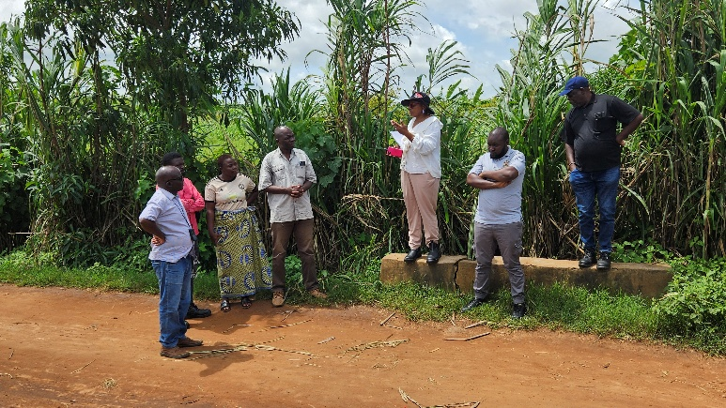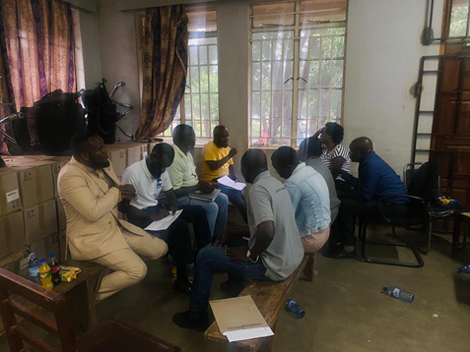
Figure 1. PIU-Consultant Site handover (LHS) and Consultation with Lilongwe DESC (RHS)

Project Location
The project is located in Lilongwe District along the Mitundu–Nsabwemanyazi road at the Chingalu Stream crossing, near the confluence of the Chiwiri and Chiole streams. The site is defined by coordinates 14°15'20.3"S, 33°48'49.0"E and covers a ~100 m crossing section (Figures 1-2 to 1-3).
The area is predominantly rural agricultural land with scattered settlements, and the crossing is prone to seasonal flooding, disrupting access. Project maps illustrate the exact location, alignment, and surrounding environment.

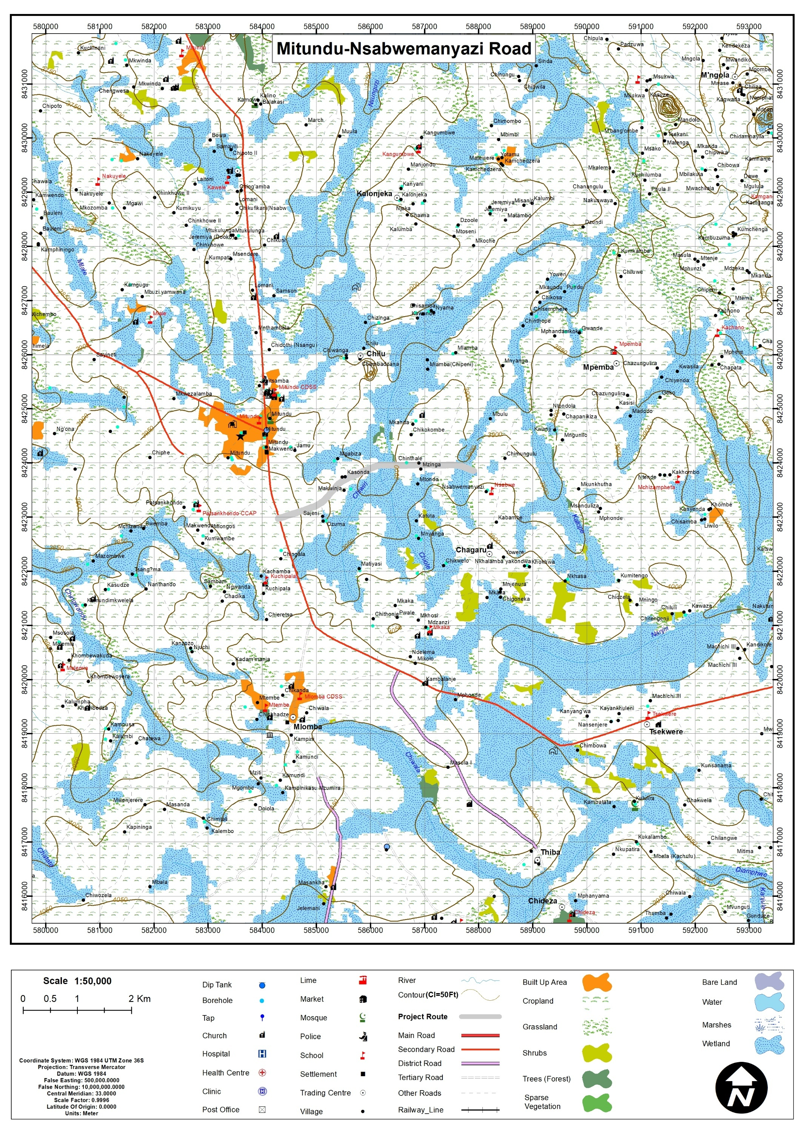
Figure CHAPTER 1: INTRODUCTION AND BACKGROUND-2. Project location map

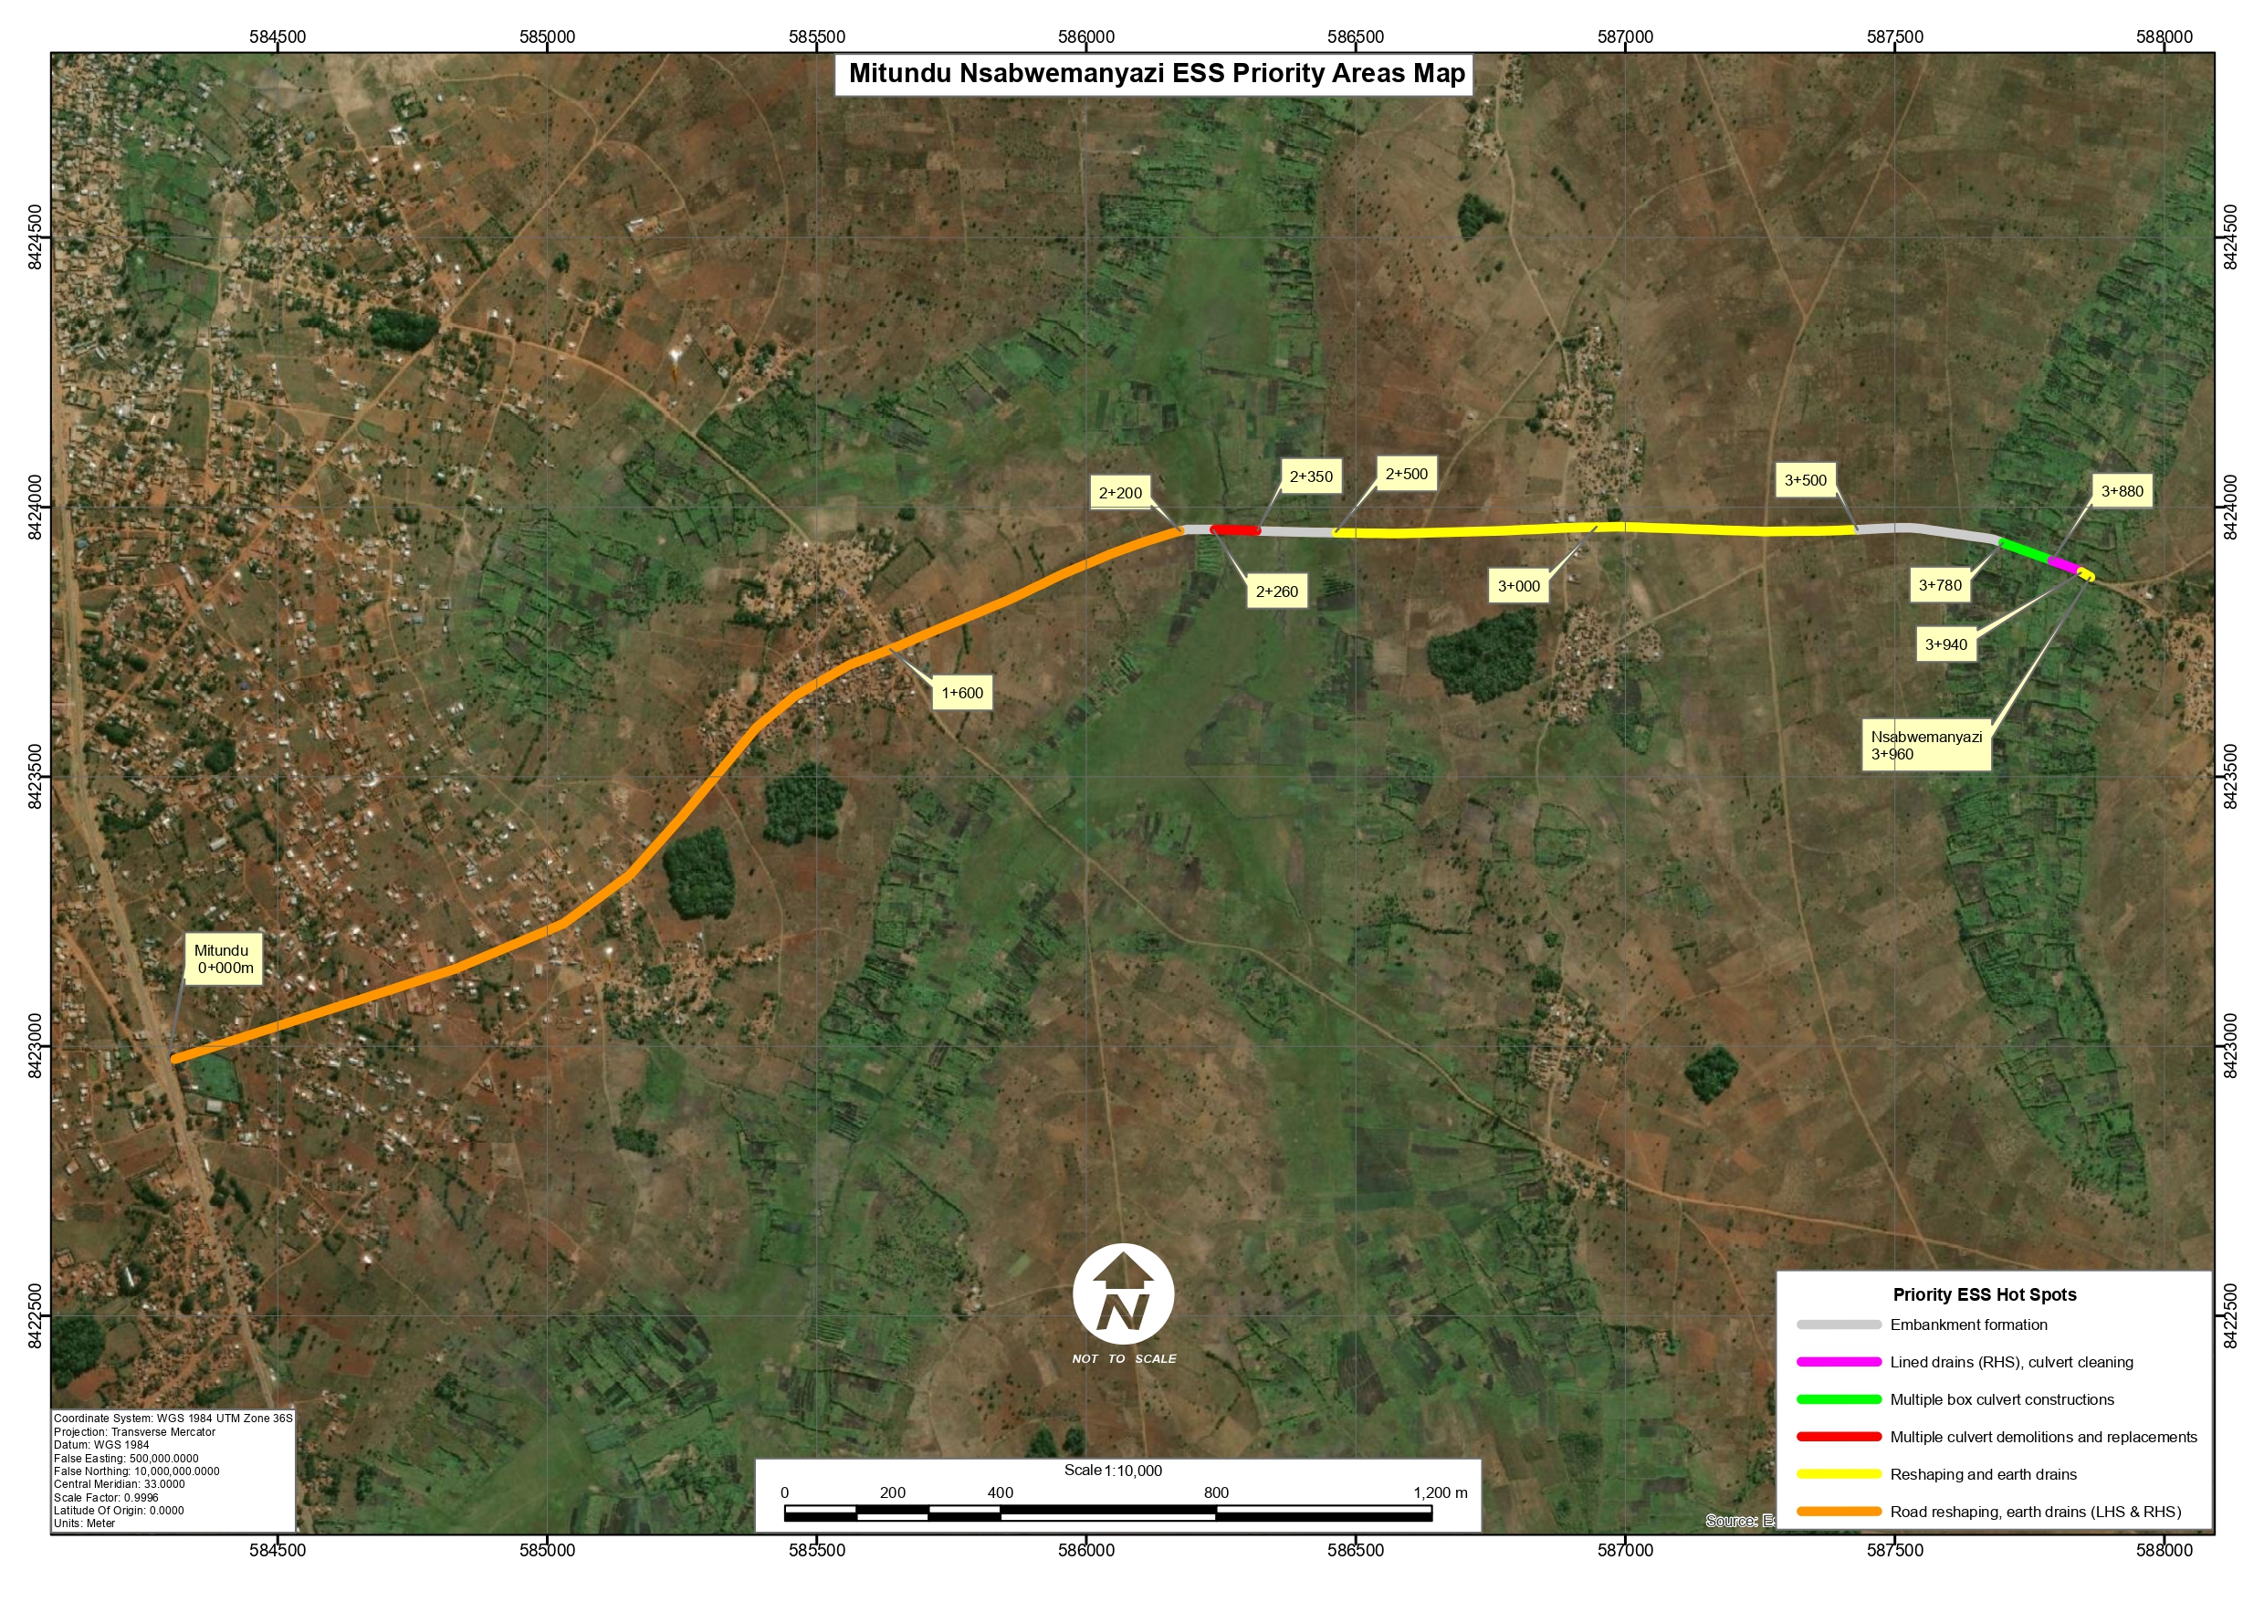
Figure CHAPTER 1: INTRODUCTION AND BACKGROUND-3. Aerial view of the Chingalu Section on Mitundu - Nsabwemanyazi Road

Land Tenure and Land Requirement for the Project
The proposed project site is located within an area where land is predominantly held under customary tenure, administered through local traditional leadership structures. The surrounding land is mainly used for smallholder agriculture, with scattered settlements and community access paths. The proposed works are confined to a ~100 m river crossing section within the existing road alignment and footprint, and do not involve expansion beyond the established corridor.
Any temporary land use required for construction activities—such as material stockpiles, equipment positioning, or access—will be limited, short-term, and managed through consultation with affected land users and local authorities, in compliance with national regulations, MEPA guidelines, and World Bank safeguards.

Potential Users of the ESMMP
This ESMMP serves as the primary environmental and social mitigation and monitoring tool for all stakeholders involved in the Nsabwemanyazi Box Culverts subproject.
Key users include MEPA for regulatory oversight; the Ministry of Transport and Public Works for project implementation and coordination under SATCP; Lilongwe District Council and DESC for local monitoring and coordination; supervising engineers and consultants for compliance supervision; and contractors and subcontractors for implementation of mitigation measures.
Additional users include local communities and road-corridor users, who will rely on the ESMMP for understanding project impacts, mitigation measures, and grievance mechanisms, as well as the World Bank for safeguards compliance review.

CHAPTER 2: PROJECT DESCRIPTION

Introduction
This chapter describes the scope and principal activities for the proposed rehabilitation works along the Mitundu–Nsabwemanyazi Road in Lilongwe District under the Southern Africa Trade and Connectivity Project (SATCP) – Last Mile Infrastructure component, implemented by the Ministry of Transport and Public Works (MoTPW). The subproject involves targeted rehabilitation of priority sections along the existing road corridor to improve all-weather access, restore drainage performance, stabilise erosion-prone areas, and address failing crossing structures and embankments identified in the Detailed Engineering Design and chainage inventory.
The proposed works will be undertaken within the existing road alignment and road reserve and are concentrated at defined intervention points rather than along the full corridor. This specific alignment is also reflected in Figure 1-3, which shows the environmental and social priority hotspots between Mitundu and Nsabwemanyazi. Where informal temporary structures such as vending booths or groceries placed by their occupants occur within the road reserve along the alignment, the corresponding sections have been deliberately excluded from the spot-based rehabilitation scheme during design, so that construction works avoid them altogether; any residual coordination needs around the immediate working area will be handled under the stakeholder engagement and GRM provisions of this ESMMP.

Overall Scope of Rehabilitation
The proposed works comprise targeted rehabilitation measures focused on sections affected by drainage failure, deterioration of existing culvert structures, localised erosion, embankment instability, and roadside drainage deficiencies. The interventions include gravelling, rehabilitation of existing box culverts, construction of new box culverts, embankment formation, retaining wall construction, provision of lined drains, and cleaning and excavation of outlet drainage from an existing concrete pipe culvert.
These measures are intended to improve hydraulic conveyance, reduce overtopping and scour, strengthen structural stability at vulnerable sections, and maintain safer and more reliable road access for surrounding communities and road users.

Chainage-Specific Engineering Works
Table 2-1 presents the chainage-specific scope of works for the Mitundu–Nsabwemanyazi Road.

Table 2-1. Chainage Works Details for Mitundu–Nsabwemanyazi Road
From chainage | To chainage | Description of works
0+000 | 2+200 | Existing road section from Mitundu; no major priority rehabilitation works identified under this package.
2+200 | 2+500 | Gravelling of identified priority section.
2+260 | 2+260 | Existing 2-cell box culvert (2.1 m × 4.0 m); provide four wing walls.
2+320 | 2+320 | Existing 1-cell box culvert (2.5 m × 1.7 m); demolish existing wing walls and reconstruct.
2+360 | 2+360 | Existing 2-cell box culvert (1.9 m × 1.7 m); construct aprons and demolish and reconstruct wing walls.
3+650 | 3+940 | Embankment formation.
3+650 | 3+770 | Provide retaining walls on both left-hand side (LHS) and right-hand side (RHS).
3+775 | 3+775 | Construct 2-cell box culvert, 1.5 m × 1.5 m.
3+805 | 3+805 | Construct 2-cell box culvert, 1.5 m × 1.5 m.
3+860 | 3+860 | Construct 1-cell box culvert, 1.5 m × 1.5 m.
3+770 | 3+880 | Provide retaining walls on both LHS and RHS.
3+880 | 3+940 | Provide lined drains on the RHS.
3+930 | 3+930 | Existing 600 mm diameter double-line concrete pipe culvert; clean culvert and excavate outlet drain.
3+960 | End | Nsabwemanyazi project end point.

Key Engineering Focus Areas
The chainage inventory shows that the principal rehabilitation works are concentrated in two main sections: chainage 2+200–2+500 and chainage 3+650–3+940. These sections cover gravelling, rehabilitation of existing drainage crossings, new box culvert construction, embankment formation, retaining wall installation, lined drainage, and improvement of outlet drainage conditions.
This chainage-based presentation provides a clearer link between the physical works and the environmental and social risks to be assessed in subsequent chapters, particularly in relation to drainage management, erosion control, community safety, access disruption, spoil handling, and construction impacts at identified hotspot locations.

Labour Requirements
The works will be undertaken by a contractor employing a mix of skilled, semi-skilled, and unskilled labour, with priority given to local recruitment from communities within Lilongwe District. The workforce will be temporary with an estimated peak of approximately 40–60 workers.
Most roles—particularly unskilled and semi-skilled positions—will be filled locally to enhance local economic benefits and minimise labour influx risks, while a limited number of specialised personnel will be sourced externally for technical supervision and quality assurance. Gender inclusion will be promoted with a target of at least 40% participation of either gender where feasible. The indicative workforce composition is summarised in Table 2-2.

Table2- 2. Expected Number of People to be Employed (Peak Workforce)
SN | Employee Category | Local | External* | Total
1 | Civil Engineering and Supervision | 2 | 2 | 4
2 | Surveying and Setting Out | 2 | 1 | 3
3 | Masonry and Concrete Works | 5 | 0 | 5
4 | Carpentry and Formwork | 3 | 0 | 3
5 | Mechanical / Equipment Operators | 4 | 2 | 6
6 | Culvert Installation and Drainage Works | 6 | 0 | 6
7 | Excavation and Earthworks | 8 | 0 | 8
8 | Manual Material Handling | 6 | 0 | 6
9 | Site Clearing and Preparation | 4 | 0 | 4
10 | Traffic Control and Safety | 3 | 0 | 3
11 | General Site Maintenance | 3 | 0 | 3
12 | Catering and Welfare Services | 1 | 0 | 1
13 | Security Services | 2 | 0 | 2
14 | Health and Safety Compliance | 2 | 0 | 2
15 | Environmental & Social Management | 2 | 0 | 2

Material Requirements and Sources
The construction of the Nsabwemanyazi culverts will require materials for concrete works, drainage structures, and erosion protection.
Table 2-3. Material Requirements and Sources
Material | Unit | Est. Quantity* | Source (DED-Informed) | Use
Cement | Bags (50 kg) | 450 – 600 | Licensed suppliers (Lilongwe/Mitundu) | Reinforced concrete for culvert base, walls, slabs, headwalls, aprons
Sand | m³ | 45 – 60 | Approved river sand sources (local streams) | Concrete and mortar
Aggregates | m³ | 80 – 110 | Licensed quarries | Structural concrete works
Reinforcement steel | Tonnes | 6 – 10 | Licensed suppliers | Culvert structural elements
Rock / boulders (riprap) | m³ | 60 – 90 | Approved quarries / local sources | Erosion protection at inlets and outlets
Water | m³/day | 4 – 6 | Surface water (Chingalu Stream) / boreholes | Concrete mixing and curing
Fuel | Litres | 1,500 – 2,500 | Licensed fuel stations (Mitundu/Lilongwe) | Equipment operation (excavators, mixers, transport)
* Quantities are indicative and derived from the DED scope for three culvert structures (five cells total), including associated headwalls, aprons, and localized drainage/erosion protection works. Final quantities to be confirmed through BoQ.

Worker Accommodation
The project will not require permanent worker camps, as most of the workforce will be locally recruited from surrounding communities and will commute to the site on a daily basis. Where accommodation is required for a limited number of non-local or specialised personnel, this will be provided through rented properties within Mitundu Trading Centre.
Temporary on-site facilities will be established to support construction activities and will include site offices, sanitation facilities, potable water supply, designated rest areas, and first aid stations. All temporary facilities will be decommissioned and the sites restored to their original or agreed condition upon completion of the works, in line with ESMMP requirements.

Waste and Waste Management
The construction of the Nsabwemanyazi box culverts on the Chingalu Stream is expected to generate low volumes of waste, given the limited scope of works, absence of worker camps, and short construction duration. Waste generation will primarily arise from excavation, concrete works, minor site clearance, and routine worker activities. Due to the project’s location on a dambo land near the confluence of the Chiwiri and Chiole streams, strict controls will be required to prevent contamination of surface water and surrounding agricultural land.
ESMMP will be implemented in accordance with the Environmental Management Act (2017), MEPA Guidelines (2025), and World Bank Environmental and Social Framework (ESF) requirements. Waste management will follow the hierarchy of avoidance, minimisation, reuse, recycling, and safe disposal. Particular emphasis will be placed on preventing discharge of any waste into the Chingalu Stream and maintaining appropriate buffer distances for all waste handling activities.
The anticipated waste streams, estimated quantities, sources, and proposed mitigation measures are summarised in Table 2-4.

Table2- 4. Expected Waste Streams, Quantities, Sources and Mitigation Measures (Low-Impact, No-Camp Scenario
Waste Category | Waste Stream | Unit | Est. Quantity | Potential Sources | Proposed Mitigation Measures
Non-hazardous (construction) | Excavated soil and spoil | m³ | 100–150 | Culvert foundation excavation, drainage shaping | Reuse suitable material for backfilling and approach shaping; stockpile away from river (>30 m); stabilise exposed spoil; dispose excess at approved sites
Non-hazardous (construction) | Unsuitable/wet excavated material | m³ | 15–30 | Saturated streambed and valley soils | Segregate and dispose at approved spoil areas; avoid dumping near watercourses; stabilise to prevent runoff
Non-hazardous (construction) | Construction rubble (concrete/masonry) | m³ | 5–10 | Minor demolition of existing structures or defective works | Reuse as fill where suitable; otherwise dispose at approved sites; prevent entry into stream
Non-hazardous (construction) | Concrete waste / washout | m³ | 3–6 | Concrete works (culverts, aprons, headwalls) | Provide designated lined washout pit away from stream; allow curing before reuse/disposal; prohibit discharge into watercourse
Recyclable | Scrap metal | kg | 100–250 | Reinforcement offcuts, binding wire | Collect and store in designated area; sell to licensed recyclers
Non-hazardous (packaging) | Cement bags and plastic packaging | kg | 50–100 | Cement use, material packaging | Segregate at source; reuse where possible; collect and dispose through licensed waste handlers
Non-hazardous (vegetation) | Cleared vegetation | m³ | 5–15 | Site clearance within footprint | Minimise clearing; reuse as mulch or compost; no open burning unless authorised
Hazardous | Used oils and lubricants | litres | 40–80 | Equipment maintenance (minimal servicing on-site) | Store in sealed containers on impermeable surface; dispose via licensed hazardous waste handlers; maintain spill kits
Hazardous | Oily rags / contaminated materials | kg | 10–20 | Equipment maintenance, spill response | Store in sealed containers; dispose as hazardous waste through handlers approved by MEPA
Non-hazardous (domestic) | Domestic solid waste | kg/day | 5–10 | Workers (no camp, day use only) | Provide covered bins; daily collection; dispose at approved municipal or designated sites
Liquid / sanitary | Wastewater from welfare facilities | litres/day | 50–100 | Handwashing and sanitation only (no bathing/laundry) | Use portable toilets with sealed tanks; no discharge to ground or stream; regular emptying by licensed providers; locate facilities ≥30 m from watercourse
Liquid / sanitary | Sewage (portable toilets) | litres/day | 50–100 | Temporary sanitation facilities | Managed through portable units; periodic removal and disposal at approved treatment facilities

Rehabilitation of Temporary Sites
All temporary construction areas, including stockpiles, equipment storage areas, and access points, will be rehabilitated after completion of the works. Rehabilitation will involve removal of temporary structures and waste, regrading of disturbed areas, restoration of natural drainage, and stabilisation of stream banks, particularly given the sensitive river crossing location.
Disturbed areas will be allowed to naturally regenerate or replanted with appropriate local vegetation where necessary. All rehabilitation activities will be implemented in line with ESMMP requirements and verified by the Supervising Engineer prior to project handover.

CHAPTER 3: POLICY AND LEGAL FRAMEWORK

National Policies and Strategies

Policy Framework
Table 3-1 presents key national policies and strategies that provide the strategic and regulatory framework for planning, implementation, and monitoring of the proposed project. These policies reflect Malawi’s development priorities and establish obligations relating to environmental protection, land administration, water resources management, climate resilience, gender inclusion, labour standards, waste management, and transport sector governance.

Table 3-1. Key National Policies Guiding the Project
Policy / Strategy | Brief Description | Implications for the Project
Malawi 2063 (MW2063) and First 10-Year Implementation Plan (MIP-1, 2021–2030) | Malawi’s long-term national development vision and medium-term implementation plan prioritising economic infrastructure, rural connectivity, trade facilitation, and climate resilience. | Rehabilitation of the proposed Road contributes to MW2063 and MIP-1 by improving rural connectivity, enhancing access to markets and social services, and strengthening climate-resilient transport infrastructure.
National Environmental Policy (2004) | Provides the overarching framework for integrating environmental sustainability into development planning and decision-making. | Requires integration of environmental safeguards, pollution prevention measures, and adherence to environmental assessment requirements administered by MEPA.
National Land Policy (2002) | Promotes orderly land administration, secure land tenure, and sustainable land use management. | Requires respect for the legal road reserve while ensuring that surrounding customary land rights are safeguarded.
National Water Policy (2005) | Promotes sustainable water resources management, protection of water bodies, and equitable access to water resources. | Requires protection of nearby rivers and streams during construction and responsible water abstraction for construction purposes, including prevention of erosion and siltation from earthworks and drainage works.
National Gender Policy (2015) | Promotes gender equality and equitable participation of women and men in development processes. | Requires gender-inclusive stakeholder engagement, equal employment opportunities, and integration of Gender-Based Violence (GBV) and Sexual Exploitation and Abuse (SEA) risk prevention measures during project implementation.
National Climate Change Management Policy (2016) | Provides guidance for climate change adaptation and mitigation across sectors. | Requires integration of climate-resilient design features such as adequate drainage systems, erosion control, and improved road formation to withstand extreme rainfall events.
National Sanitation Policy (2008) | Provides a framework for improving sanitation and hygiene standards and safe management of waste. | Requires appropriate management of solid and liquid waste generated during construction activities, including safe storage and disposal practices.
National HIV and AIDS Policy (2022–2027) | Aims to reduce HIV transmission and strengthen workplace HIV prevention and non-discrimination measures. | Requires implementation of HIV and AIDS awareness programmes for construction workers and communities and promotion of non-discriminatory workplace practices.
National Transport Policy (2015) | Aims to develop a safe, efficient, and sustainable transport system in Malawi. | Supports rehabilitation of rural roads to improve access and connectivity, and requires incorporation of road safety considerations and safe traffic management during construction.
National Labour and Employment Policy (2017) | Promotes decent work, fair labour practices, and protection of workers’ rights. | Requires fair recruitment practices, decent working conditions, prohibition of child labour, and compliance with occupational health and safety standards.
National Forest Policy (2016) | Promotes sustainable forest management and restoration of degraded landscapes. | Requires minimisation of vegetation clearing within the road reserve and implementation of erosion control and site rehabilitation measures after construction.
National Decentralisation Policy (1998) | Provides the framework for devolved governance and planning at district level. | Requires engagement with the District Council and the District Environmental Sub-Committee (DESC) for environmental oversight, monitoring, and alignment with district development priorities and by-laws.

Legislative Frameworks
Table 3-2 outlines the principal national legislation governing implementation.
Table 3-2. Key National Legislation Guiding the Project
Act | Brief Description | Implications for the Project
Constitution of the Republic of Malawi (1995) | The supreme law of Malawi guaranteeing environmental protection, human rights, gender equality, and sustainable development (Sections 5, 12(e), and 13(d)). | Requires environmentally sound project implementation and protection of community rights through application of approved environmental and social safeguards instruments.
Environment Management Act (2017) | Principal legislation governing environmental protection, environmental assessment, pollution control, and sustainable natural resource management in Malawi. | Requires preparation and implementation of an ESMMP and compliance with environmental requirements administered by MEPA prior to and during project implementation.
Public Roads Act (2023) | Provides the legal framework for classification, development, rehabilitation, and maintenance of public roads and associated infrastructure. | Requires that rehabilitation works be undertaken within the legally designated road reserve and that appropriate drainage, safety, and access management standards are applied.
Land Act (2016) and Customary Land Act (2016) | Establish the legal framework governing land tenure systems, land administration, acquisition of land for public purposes, and compensation. | Confirms the legal status of the public road reserve and requires that surrounding customary land rights are respected. No land acquisition is anticipated as works are confined within the existing road corridor.
Water Resources Act (2013) | Provides for sustainable management, allocation, and protection of water resources in Malawi. | Requires permits for water abstraction where necessary and implementation of measures to prevent pollution, erosion, and sedimentation of nearby water bodies during construction.
Occupational Safety, Health and Welfare Act (1997) | Establishes requirements for safe and healthy workplaces and regulates plant, machinery, and hazardous working conditions. | Requires implementation of Occupational Health and Safety (OHS) measures including provision of PPE, site safety procedures, and safe operation of construction equipment.
Employment Act (2000) | Provides minimum employment standards and prohibits forced labour, discrimination, and child labour. | Requires fair recruitment procedures, compliance with labour standards, and prohibition of child labour in project activities.
Gender Equality Act (2013) | Promotes gender equality and prohibits discrimination, harassment, and exploitation in workplaces and society. | Requires gender-inclusive employment practices and enforcement of measures to prevent Gender-Based Violence (GBV), Sexual Exploitation and Abuse (SEA), and Sexual Harassment (SH).
Child Care, Protection and Justice Act (2011) | Protects the rights, welfare, and development of children in Malawi and provides legal mechanisms to prevent abuse, neglect, exploitation, and harmful practices affecting children. | Requires the proposed project to enforce zero child labour, ensure child safety around construction sites, and implement reporting and response mechanisms for child protection risks in accordance with Sections 3, 79, and 80–82 of the Act.
HIV and AIDS (Prevention and Management) Act (2018) | Protects rights of people living with HIV and AIDS and promotes workplace awareness and prevention programmes. | Requires non-discriminatory practices and implementation of HIV awareness programmes among construction workers and surrounding communities.
Public Health Act (1948) | Provides legal provisions for safeguarding public health, sanitation, drainage, and disease prevention. | Requires provision of sanitation facilities at construction sites and proper waste management to prevent public health risks.
Environment Management (Waste Management and Sanitation) Regulations (2008) | Regulates management of solid and liquid waste, including hazardous waste handling and disposal. | Requires segregation, safe storage, transportation, and disposal of waste generated during construction activities.
Environment Management (Chemicals and Toxic Substances) Regulations (2008) | Regulates the handling, storage, transportation, and disposal of chemicals and hazardous substances. | Requires proper storage and handling of fuels, lubricants, and chemicals used in construction operations.
Forestry Act (2020) | Provides for conservation, sustainable management, and protection of forest resources. | Requires minimisation of vegetation clearing within the road reserve and rehabilitation of disturbed areas after construction.
National Parks and Wildlife Act (2017) | Provides for conservation and management of wildlife resources and biodiversity. | Requires that project activities avoid disturbance to wildlife habitats and prohibits hunting or exploitation of wildlife by project workers.
Local Government Act (1998) | Empowers district councils to manage development planning, environmental management, and service delivery. | Requires coordination with the District Council and the District Environmental Sub-Committee (DESC) for project consultations, monitoring, and compliance with district by-laws.
Physical Planning Act (2016) and Physical Planning (Amendment) Act (2022) | Regulates land use planning and requires development permission for infrastructure projects. | Requires obtaining Development Permission from the District Council prior to commencement of works.
Liquid Fuels and Gas (Production and Supply) Act (2004), Chapter 50:03 | Regulates the production, storage, transportation, distribution and supply of liquid fuels and gas in Malawi. The Act establishes licensing requirements and safety standards to ensure proper handling and management of petroleum products and gas within the country. | Where project activities involve the storage or use of petroleum products (e.g., diesel for construction equipment or generators), fuel handling must comply with national safety and licensing requirements. Contractors must ensure safe storage, transport and use of fuels to prevent spills, fire hazards and environmental contamination, and must comply with regulatory requirements governing fuel supply chains.
Construction Industry Act No. 28 of 2025 (CIRA Act) | Establishes the Construction Industry Regulatory Authority (CIRA) to regulate, develop, and promote the construction industry in Malawi. The Authority oversees registration and licensing of contractors, consultants, material manufacturers and suppliers, enforces professional and ethical standards, promotes training and capacity development, and standardizes construction practices and procedures across the industry. | Requires that all contractors, consultants, and suppliers engaged in the proposed Road rehabilitation project be registered and licensed by CIRA, and that construction activities comply with approved industry standards, codes of ethics, and professional conduct requirements. The project must therefore ensure engagement of CIRA-registered entities, adherence to quality and safety standards, and compliance with regulatory oversight for construction works.

The contractor will develop specific plan in line with frameworks in annexes 4, 5,6,7,8 and 13

World Bank Safeguard Policies and Procedures

World Bank Operational Policy OP/BP 4.01: Environmental Assessment
In accordance with OP/BP 4.01, a stand-alone ESMMP has been prepared to guide environmental and social risk management. The applicable World Bank safeguard policies relevant to the subproject are summarised in Table 3-3, which provides the basis for compliance and ensures that project implementation is environmentally sound, socially responsible, and aligned with international good practice, while delivering improved flood resilience and access at the crossing.
Table3-3. World Bank Environmental and Social Safeguard Policies Applicable to the Project
Safeguard Policy | Key Requirements and Application to the Project
Environmental Assessment (OP/BP 4.01) | Requires environmental assessment of projects financed by the World Bank to ensure environmental sustainability and informed decision-making. For the proposed project, an ESMMP has been prepared to identify potential impacts and define mitigation, monitoring, and institutional measures.
Natural Habitats (OP/BP 4.04) | Seeks to ensure that projects do not cause significant degradation of natural habitats. The road rehabilitation works are confined to an existing corridor and do not traverse protected areas or critical natural habitats. Any disturbance to roadside vegetation will be minor and reversible.

World Bank ESHS
The Project will implement the World Bank Environmental, Health and Safety (EHS) Guidelines. These guidelines represent Good International Industry Practice (GIIP) and provide a framework for managing environmental, occupational health, and social risks throughout the project lifecycle.

Institutional Framework
Table 3-5 presents the key institutions with statutory and regulatory mandates relevant to environmental and social (E&S) safeguards for the Nsabwemanyazi Box Culverts (Chingalu Crossing) project. These institutions provide policy direction, regulatory oversight, compliance enforcement, and technical guidance to ensure that the project aligns with national legislation, including the Environment Management Act (2017), MEPA Guidelines (2025), and applicable sectoral laws.

Table3- 8. Institutional mandates on Environmental and Social Safeguards related to the Project
SN | Institution | Mandate in E&S Safeguards Related to the Project
1 | Malawi Environment Protection Authority (MEPA) | Principal environmental regulator responsible for environmental assessment, approval, and compliance monitoring of ESMMPs; enforces provisions of the Environment Management Act (2017).
2 | Ministry of Natural Resources, Energy and Mining | Provides national policy oversight on environmental management and ensures integration of sustainability principles across development sectors.
3 | Ministry of Lands | Regulates land administration, land use planning, and development control; ensures compliance with land laws and protection of public land (including road reserves).
4 | Ministry of Transport and Public Works (MoTPW) | Provides sector policy oversight for transport infrastructure; ensures integration of environmental and social safeguards within transport sector programmes.
6 | Ministry of Local Government and Rural Development | Oversees decentralized governance and local development planning; ensures integration of environmental and social considerations at district level.
7 | Lilongwe District Council | Enforces district-level by-laws, environmental health standards, and land use controls; facilitates local monitoring and community-level compliance.
8 | District Environment Sub-Committee (DESC) | Technical advisory body coordinating environmental management at district level; reviews projects, provides environmental guidance, and supports compliance monitoring.
9 | Ministry of Labour | Regulates labour standards, occupational health and safety, and worker welfare in accordance with national labour legislation.
10 | Construction Industry Regulatory Authority (CIRA) | Regulates construction industry standards, contractor registration, and compliance with construction safety and professional practice requirements under the Construction Industry Act (2025).

Summary of Main Statutory Approvals/Licenses to be obtained for the project
The implementation of the Mitundu–Nsabwemanyazi Road Rehabilitation Project requires compliance with several statutory approval and licensing requirements to ensure adherence to Malawi’s environmental, labour, land use, water resources, and occupational safety regulations. These approvals shall be obtained prior to, or during, project implementation as applicable, depending on the nature and timing of the works. Refer to Table 3-5.

Table 9. Summary of Statutory Approvals and Licences Required
SN | Approval / Licence Required | Applicable Legal / Regulatory Framework | Issuing Institution | Responsible Party | Indicative Timeframe
1 | ESMMP Approval / Environmental Clearance | Environment Management Act (2017) | Malawi Environment Protection Authority (MEPA) | MoTPW | Already Cleared by MEPA
2 | Construction Project Registration | Construction Industry Act (2025) | Construction Industry Regulatory Authority (CIRA) | MoTPW / Contractor | ~2–4 weeks
3 | Approval for Waste Disposal | Environment Management Act (2017); Local Government and Rural Development Act (1998) | MEPA; Lilongwe District Council | Contractor | ~2 weeks
4 | Approval for Sand Extraction | Local Government and Rural Development Act (1998) | Lilongwe District Council | Contractor | ~2 weeks
5 | Quarrying / Borrow Pit Approval | Mines and Minerals Act (2018) | Department of Mines | Contractor | Up to 3 months
6 | Workplace Registration Certificate | Occupational Safety, Health and Welfare Act (1997) | Ministry of Labour | Contractor | ~2 weeks
7 | Water Abstraction Permit | Water Resources Act (2013) | National Water Resources Authority | Contractor | ~2 weeks
8 | Development Permission | Physical Planning Act (2016, as amended 2022); Local Government and Rural Development Act (1998) | Lilongwe District Council | MoTPW | ~2 weeks
9 | Fuel Storage Licence | Liquid Fuels and Gas (Production and Supply) Act (2004) and Regulations | Malawi Energy Regulatory Authority (MERA) | Contractor | Up to 3 months

CHAPTER 4: ENVIRONMENTAL AND SOCIAL SETTING

Introduction
This chapter presents the environmental and social baseline conditions for the Nsabwemanyazi Box Culverts (Chingalu Crossing) along the Mitundu–Nsabwemanyazi corridor in Lilongwe District. The site is located within a wetland (dambo) system influenced by the Chiole and Chiwiri streams and is currently affected by flooding and poor drainage.

Biophysical Environment

Topography
The Chingalu crossing site (14°15'20.3"S, 33°48'49.0"E), located along the Mitundu–Nsabwemanyazi Road, is situated within a gently undulating lowland landscape characterised by broad, shallow drainage depressions (dambos) interspersed with slightly elevated cultivated areas. Elevation in the project area is approximately 1,180–1,220 m above sea level, with minimal local relief and gradual slopes directing runoff into the Chingalu drainage system.
The surrounding terrain is predominantly flat to gently sloping, promoting slow surface runoff, seasonal water accumulation, and lateral spreading of flows across the wetland area during the rainy season.
The landscape is dominated by agricultural land use, with cultivated fields extending close to the drainage areas, while settlements are located on slightly raised ground away from the wetland system. The extensive presence of wetlands and marshy zones, as indicated on the map, reflects poor natural drainage and high seasonal water retention capacity.
Although the terrain does not present risks such as landslides or steep slope instability, it is highly sensitive to hydrological alterations, particularly at crossing points. Poorly designed or undersized drainage structures may lead to water impoundment, overtopping, or localized erosion.
Overall, the topographic and drainage setting underscores the importance of appropriately designed box culverts and associated drainage structures at the Chingalu crossing to ensure unimpeded flow conveyance, maintain natural hydrological connectivity, and prevent flooding or erosion impacts within the surrounding agricultural landscape.

Geology
The geology of the Chingalu crossing area, as illustrated in Figure 4-2, is dominated by superficial deposits associated with dambo and alluvial systems, underlain by basement complex rocks typical of the central Malawi plateau.
At the specific culvert location (14°15'20.3"S, 33°48'49.0"E), the terrain is primarily characterised by dambos (DS) and river/dambo alluvium (RD), consisting of soft, fine-grained, and moisture-retentive soils. These deposits are typically composed of clayey to silty materials with high water-holding capacity, which explains the seasonal saturation and slow drainage conditions observed at the crossing. The presence of grey to black clays (Q_) in localized pockets further indicates poor permeability and susceptibility to waterlogging.
Upstream, including the Chiole and Chiwiri tributaries, and extending downstream along the wetland corridor, the geology remains uniformly dominated by these superficial deposits, reflecting a continuous low-energy depositional environment. This uniformity supports the observed consistent hydrological behaviour and water quality characteristics across the crossing.
The underlying basement complex rocks, including biotite gneiss and porphyroblastic gneiss, occur at depth and in isolated outcrops beyond the immediate wetland zone. These formations are competent but largely masked by the overlying alluvial and dambo sediments, and therefore have limited direct influence on surface conditions at the crossing point.
From an engineering and environmental perspective, the dominance of soft alluvial and dambo soils presents key considerations:
- Low bearing capacity and high compressibility, requiring appropriate foundation design for culverts;
- High susceptibility to erosion and sediment mobilisation during construction;
- Sensitivity to disturbance, particularly under saturated conditions.
Overall, the geological setting underscores the need for carefully designed culvert foundations, erosion protection measures, and drainage control, to ensure structural stability and maintain the integrity of the wetland system.

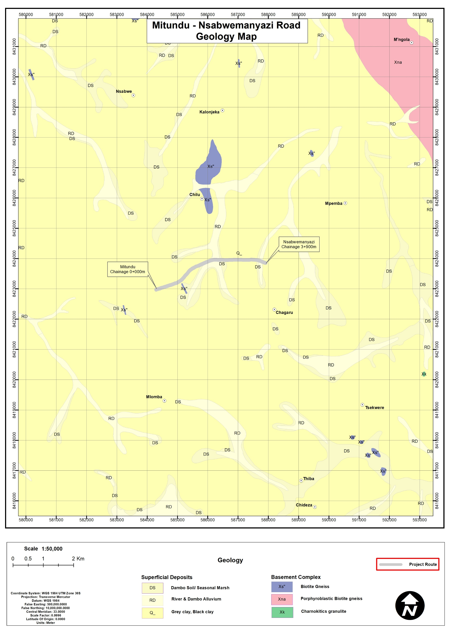
Figure CHAPTER 4: ENVIRONMENTAL AND SOCIAL SETTING-4. Geological Map of the Mitundu – Nsabwemanyazi Road corridor

Soils
The project area is uniformly underlain by sandy clay loam soils, with consistent characteristics across the crossing point and road alignment. These soils offer moderate drainage and adequate bearing capacity, making them generally suitable for road construction (Figure 4-3).
However, they are moisture-sensitive, with potential for softening, reduced strength, and erosion during the rainy season, particularly in poorly drained or low-lying areas.
Overall, the soils are appropriate for gravel road rehabilitation, provided that proper compaction, drainage, and erosion control measures are implemented to ensure long-term stability and performance.

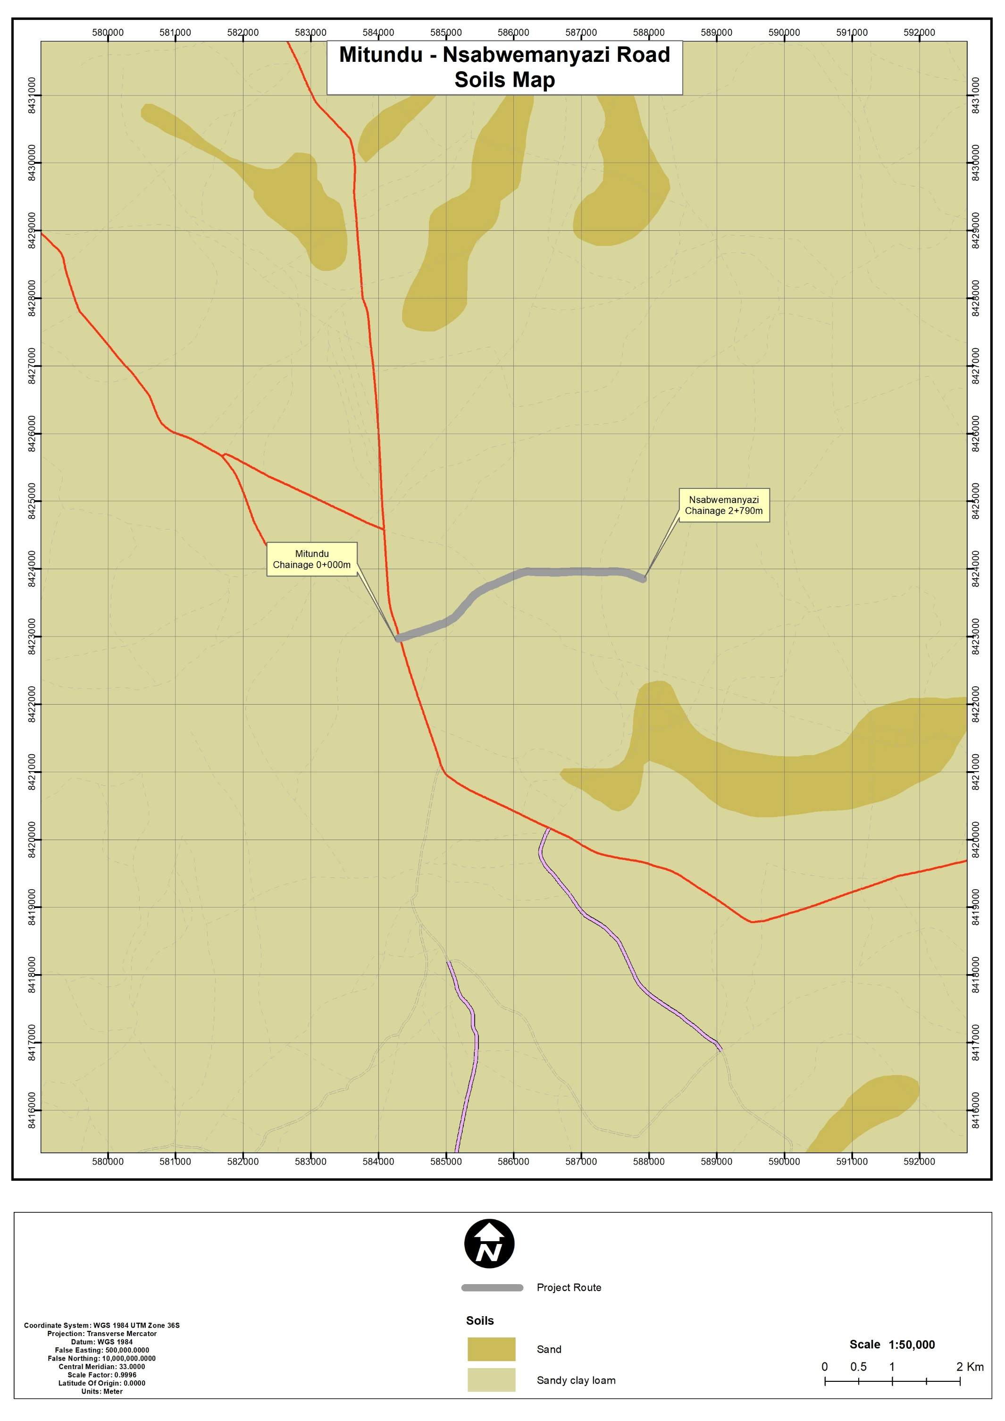
Figure CHAPTER 4: ENVIRONMENTAL AND SOCIAL SETTING-5. Soils along the Mitundu - Nsabwemany Corridor

Climate and Climate Change Risks

General Climate Conditions
The Mitundu–Nsabwemanyazi Road Corridor lies within the central Malawi plateau climatic zone and is characterized by a subtropical climate with two distinct seasons, namely the rainy season (November to April) and the dry season (May to October). During the rainy season, intense convective storms generate high runoff, especially in low-lying and drainage crossing areas, while the dry season is associated with dust generation and gradual surface deterioration of gravel roads.

Temperature Pattern
The corridor experiences moderate and relatively stable temperatures throughout the year, with a gradual seasonal variation. Mean monthly temperatures range from approximately 16°C in the cool dry season (June–July) to about 23–24°C (Lilongwe SEP 2022-2030) during the hot dry season (October–November) (Figure 4-4). Temperatures decline steadily from January to mid-year before rising again toward the onset of the rains. The rainy season remains warm but is moderated by cloud cover.

Rainfall Pattern
Rainfall in the project area follows a unimodal distribution, with the majority occurring between November and April. Peak rainfall is observed between January and February (approximately 340–350 mm/month), with significant rainfall also recorded in December and March. Rainfall declines sharply from April onward, with minimal to near-zero precipitation between May and September, before gradually increasing again in October and November (Figure 4-5). The rainfall is typically intense and short-duration, resulting in high surface runoff and increased drainage loads. These conditions elevate the risk of erosion, sedimentation, culvert overtopping, and localized flooding, particularly during peak rainfall months. Conversely, the dry season offers favourable conditions for construction but contributes to dust generation and surface loosening of gravel materials.

Figure 6. Average monthly rainfall distribution for Mitundu – Nsabwemanyazi Road Corridor.
Data Source: CHIRPS Rainfall Dataset (1981–2024), Climate Hazards Center, University of California Santa Barbara.

Sunshine, Humidity, and Wind Conditions
Seasonal climatic variations are also reflected in sunshine, humidity, and wind patterns. The rainy season is associated with high humidity, increased cloud cover, and reduced solar radiation, while the dry season experiences higher sunshine intensity and lower humidity levels. Wind conditions are generally moderate throughout the year, with slightly stronger winds occurring toward the end of the dry season. These winds can contribute to increased dust dispersion, particularly along exposed gravel road sections during construction and operation.

Climate Change Risks
Climate projections for central Malawi indicate rising temperatures and increasing rainfall variability, with a growing likelihood of more intense storm events. For the Mitundu–Nsabwemanyazi Road Corridor, key climate-related risks include increased surface runoff, flash flooding, and accelerated soil erosion, particularly during high-intensity rainfall events. There is also a risk of overtopping or inadequate capacity of drainage structures, as well as weakening of the road subgrade under saturated conditions, especially in low-lying areas. Additionally, prolonged dry periods may contribute to increased dust emissions and faster degradation of gravel surfaces, leading to higher maintenance requirements.
To enhance climate resilience, the project design should incorporate adequately sized drainage systems, effective erosion control measures, proper road camber, and routine maintenance regimes. These interventions are essential to ensure long-term durability and performance of the road under both current climatic conditions and projected future climate variability.

Water Resources and Quality

Hydrological Setting
The Chingalu crossing is situated within a wetland-dominated hydrological system characterized by flat terrain and diffuse drainage patterns. The crossing is drained by two perennial streams—Chiole (south-east) and Chiwiri (south-west), which converge just upstream of the crossing point. Beyond this confluence, water flow spreads across a broad, shallow wetland (dambo) system, resulting in slow-moving and laterally distributed flows.
Unlike confined river systems, hydrological conditions at Chingalu are relatively uniform along the stretch, with minimal variation between upstream and downstream sections. Flow regimes are strongly influenced by seasonal rainfall, with increased inundation during the rainy season (November–April) and reduced but sustained baseflows during the dry season.
The surrounding wetland areas serve important ecological and hydrological functions, including water storage, flow regulation, and groundwater recharge, while also supporting local agricultural activities and water supply sources.
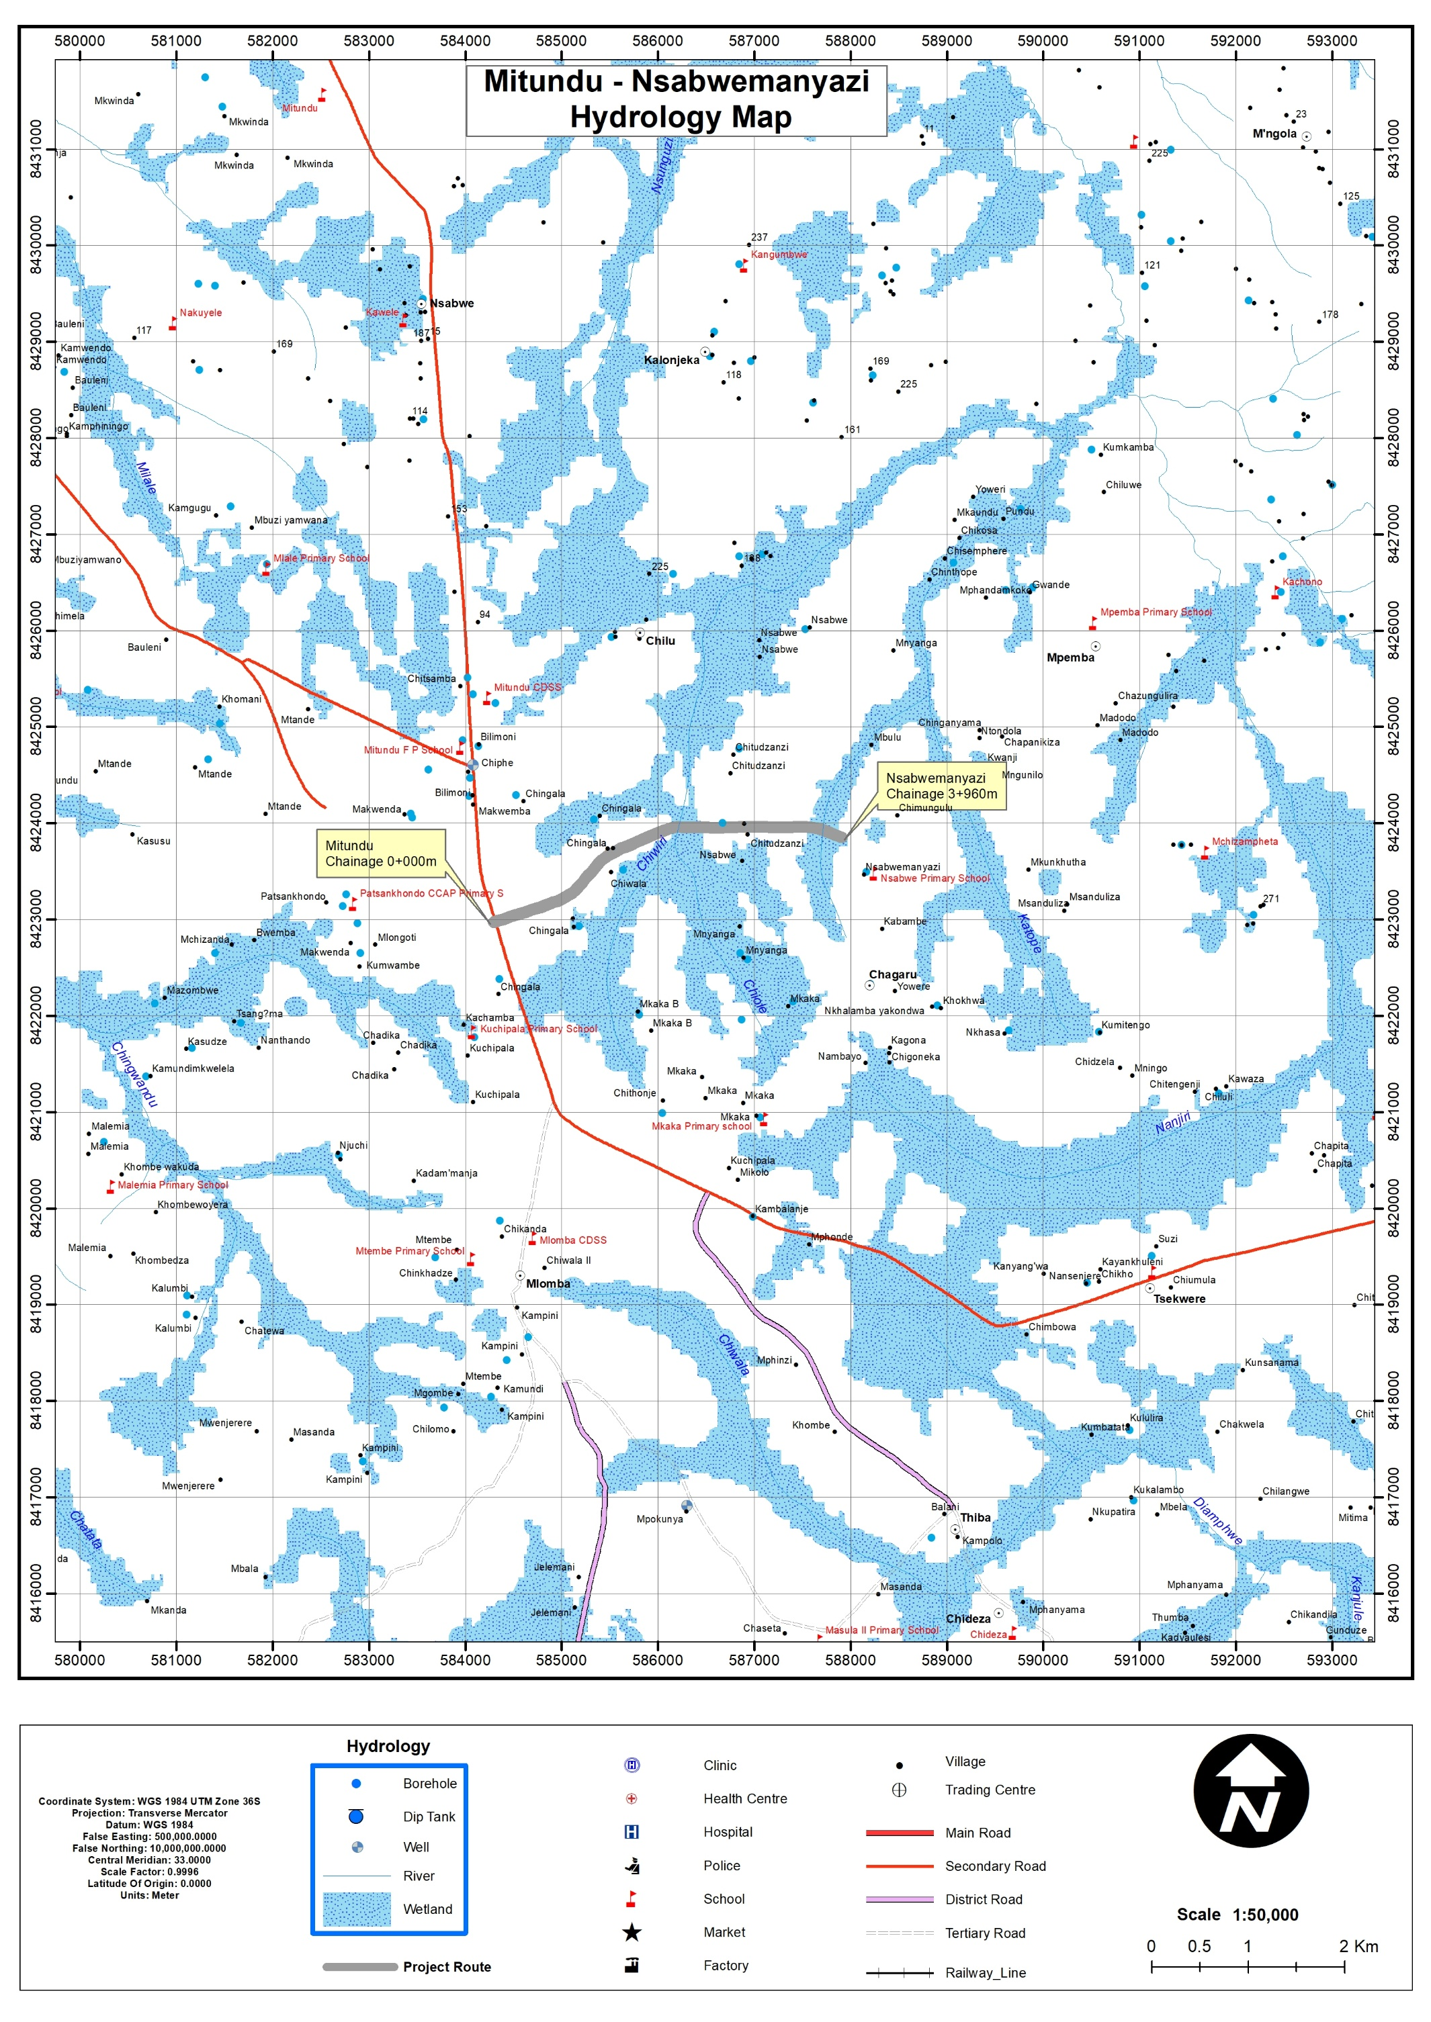
Figure CHAPTER 4: ENVIRONMENTAL AND SOCIAL SETTING-7. Hydrological map of the proposed project area

Hydrological Risks and Implications
Hydrological risks at the crossing are primarily associated with the flat wetland terrain and seasonal rainfall dynamics, rather than high-energy river flows. Key risks include:
- Waterlogging and prolonged subgrade saturation;
- Localized flooding and overtopping during peak rainfall events;
- Reduced drainage efficiency due to low flow velocities; and
- Sediment accumulation within culverts and drainage paths.
These conditions necessitate the design of adequate cross-drainage structures capable of accommodating wide, shallow flows, alongside proper road elevation, erosion control, and routine maintenance to ensure long-term performance.

Water Quality Conditions
Water quality assessments conducted at Chingalu crossing and along the contributing streams (Chiole and Chiwiri) indicate that physico-chemical parameters are generally within acceptable limits, with minimal spatial variation across sampling points. Parameters such as pH, temperature, electrical conductivity, total dissolved solids, chloride, sulphate, and nitrate reflect low levels of dissolved constituents, consistent with relatively unpolluted rural catchments dominated by agriculture.
However, there is a slight increase in turbidity, suspended solids, and iron concentrations from upstream to downstream, suggesting sediment mobilisation associated with surface runoff and wetland disturbance, particularly during the rainy season.
Microbiological parameters, including faecal coliforms, E. coli, and faecal streptococci, are elevated above recommended limits. This indicates moderate faecal contamination, likely linked to livestock grazing, diffuse agricultural runoff, and limited sanitation controls within the catchment (Table 4-1).
Overall, water quality is considered good in terms of chemical characteristics but moderately impacted in terms of microbial contamination, which is typical for rural wetland environments.
Table 10. Water quality status at Chingalu crossing and associated streams
Parameter | MS 691:2005 Standard | Upstream – SE (≈500 m, Chiole Stream) | Upstream – SW (≈500 m, Chiwiri Stream) | Crossing Point | Downstream (≈500 m from culverts) | Remarks
pH | 6.0–9.5 | 6.70 | 6.74 | 6.85 | 6.95 | Within acceptable range; consistent across tributaries and main channel
Temperature (°C) | Not specified | 22.5 | 22.7 | 22.9 | 23.1 | Normal for tropical surface waters
Electrical Conductivity (µS/cm at 25°C) | 3500 | 30 | 33 | 38 | 44 | Very low; reflects limited dissolved salts
Total Dissolved Solids (mg/L) | 2000 | 19 | 21 | 27 | 34 | Low and within acceptable limits
Chloride (mg/L) | 750 | 0.2 | 0.2 | 0.3 | 0.4 | Minimal variation; low anthropogenic influence
Sulphate (mg/L) | 800 | 0.8 | 0.9 | 1.0 | 1.2 | Slight increase associated with soil runoff
Nitrate (mg/L) | 1 | 0.17 | 0.19 | 0.24 | 0.30 | Low; reflects diffuse agricultural inputs
Iron (mg/L) | 3 | 0.14 | 0.16 | 0.22 | 0.30 | Slight increase linked to sediment mobilisation
Turbidity (NTU) | 25 | 4.0 | 4.3 | 5.8 | 7.0 | Moderate; influenced by surface runoff
Suspended Solids (mg/L) | Not specified | 5.8 | 6.2 | 7.5 | 9.0 | Slight increase downstream due to cumulative inputs
Faecal Coliform (/100 ml) | 50 | 68 | 72 | 110 | 140 | Elevated; associated with livestock and diffuse runoff
E. coli (/100 ml) | Not specified | 60 | 66 | 100 | 130 | Indicates moderate faecal contamination
Faecal Streptococci (/100 ml) | 0 | 9 | 11 | 45 | 80 | Elevated; consistent with livestock presence

Flora (Plant Life)
The proposed intervention is localized at the Chingalu crossing (Nsabwemanyazi area) for installation of box culverts. As such, this assessment focuses on site-specific vegetation conditions at the crossing, while referencing the broader road corridor only for contextual comparison.
Vegetation at and around the Chingalu crossing is highly modified and predominantly composed of scattered mixed woodland interspersed with cultivated land. Common species observed in the immediate project footprint and adjacent areas include Senna species, Acacia species, and Pennisetum purpureum (Napier grass), alongside cultivated crops such as Zea mays (maize) within the road reserve and nearby farms. This reflects a human-influenced agro-ecosystem rather than intact natural vegetation.
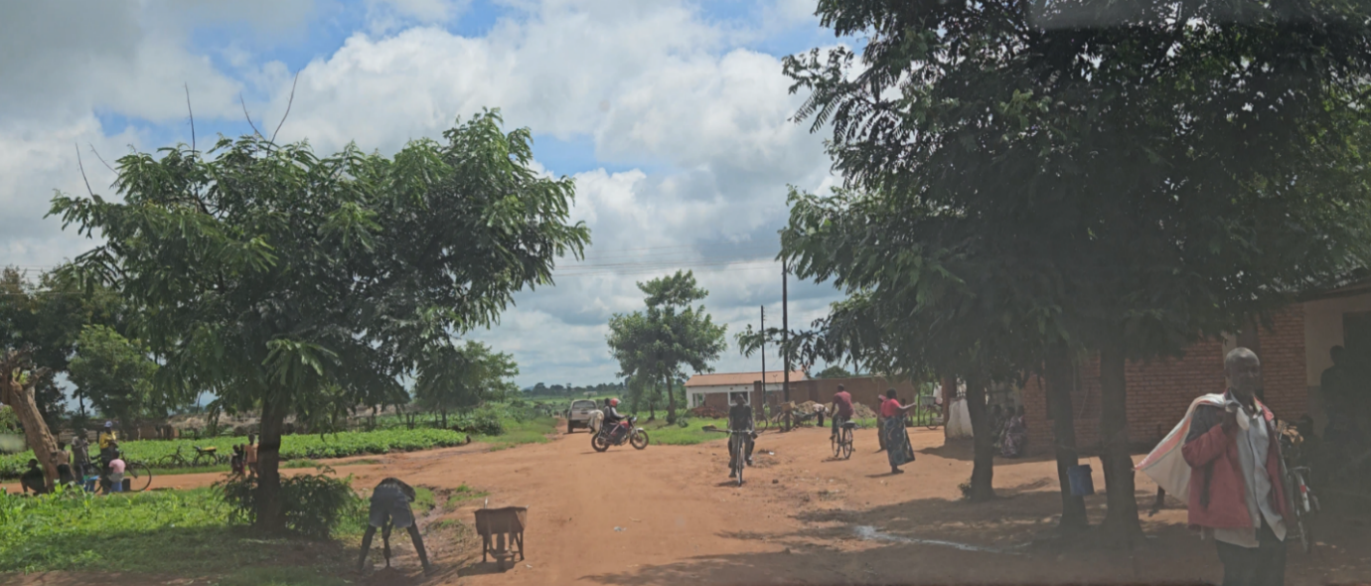
Figure CHAPTER 4: ENVIRONMENTAL AND SOCIAL SETTING-8. Senna siamea species (Behind the sign post) observed along Mitundu- Nsabwemanyazi road

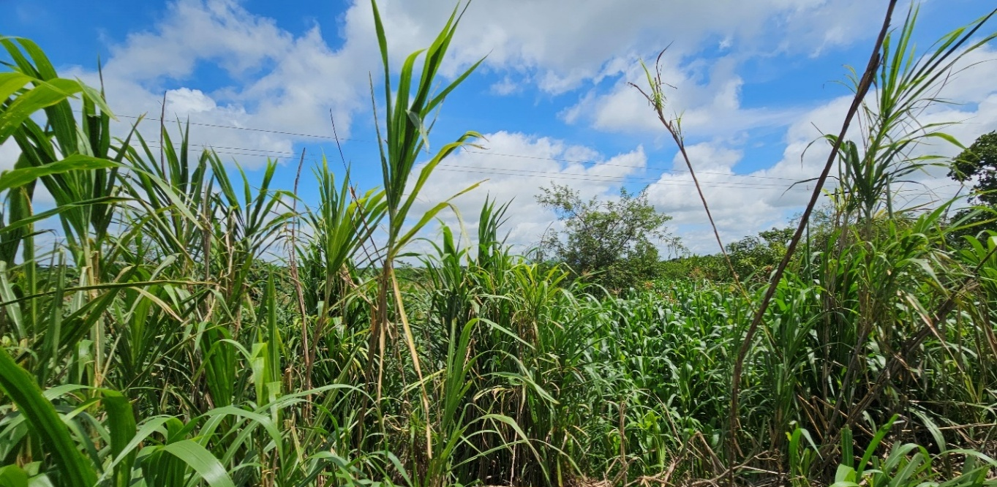
Figure CHAPTER 4: ENVIRONMENTAL AND SOCIAL SETTING-9: Pennisetum purpureum (Nappier grass) observed at Chingalu Crossing

Field surveys recorded a total of approximately 20 plant species within the project area, comprising a mix of trees, shrubs, herbs, and grasses, dominated by common and widely distributed species. The species composition and conservation status are presented in Table 4-2. No endemic species were identified within the project footprint or surrounding areas.
Table 11. Plants of the Project Area
Species | Form/ Habit | English Name | National Plant Red Data List Conservation Status | IUCN Status
Acacia albida | Tree | Apple-ring Acacia | Not Evaluated | Least Concern
Agave americana | Herb | Century plant | Not Evaluated | Least Concern
Albizia lebbeck | Tree | siris | Not Evaluated | Not Evaluated
Bidens Pilosa | Herb | Cobbler's pegs | Not Evaluated | Not Evaluated
Cascabella tevetia | Shrub | Yellow oleander | Not Evaluated/ Least concern | Least Concern
Jatropha curcas | Shrub | Physic Nut | Not Evaluated | Least Concern
Mangifera indica | Tree | Mango | Not Evaluated | Least Concern
Moringa oleifera | Shrub | Moringa | Not Evaluated | Least Concern
Musa paradisiaca | Herb | Plantain | Not Evaluated | Not Evaluated
Pennisetum purpureum | Grass | Napier grass | Not Evaluated | Least Concern
Phragmites mauritianus | Grass | African Reed | Not Evaluated | Least Concern
Psidium guajava | Herb | Guava | Not Evaluated | Least Concern
Rauvolfia caffra | Tree | Quinine Tree | Not Evaluated | Least Concern
Ricinus communis | Shrub | Castor oil plant | Not Evaluated | Least Concern
Senna siamea | Tree | Siamese cassia | Least Concern | Least Concern
Senna spectabilis | Tree | Spectacular Cassia | Least Concern | Least Concern
sida acuta | Herb | broom weed | Least Concern | Not Evaluated
solanum chrysotrichum | shrub | Giant devil's fig | Not Evaluated | Least Concern
Zea mays | Grass | Maize | Least Concern | Least Concern
Source: Consultant 2026

All recorded species are classified as Not Evaluated or Least Concern (LC) under both the National Plant Red Data List and the IUCN Red List, indicating low conservation sensitivity. Furthermore, no protected or threatened species were identified, and no invasive alien species were recorded within the site or surrounding areas.
Despite the modified nature of the site, the vegetation at the crossing still provides localized ecological functions, including:
- Habitat and nesting support for small fauna such as birds (see Figure 3)
- Soil stabilization and erosion control, particularly during the rainy season
- Enhancement of soil fertility through species such as nitrogen-fixing trees
In terms of habitat sensitivity, the Chingalu crossing itself is not considered a sensitive ecological area, having been significantly altered by agriculture and human activity. A relatively more natural feature—the Chikhokhobe Valley, located approximately 1 km away from the crossing—supports livestock grazing but is spatially distinct and not directly influenced by the proposed culvert works.
Overall, the flora baseline indicates a low ecological sensitivity at the project site, with impacts expected to be localized, minimal, and manageable through standard good construction practices.

Fauna (Animal Life)
The fauna assessment indicates a low-diversity, human-modified ecosystem typical of rural agricultural landscapes.
A total of 8 species were recorded within the project area, comprising 3 mammals, 4 birds, 4 reptiles, 3 amphibians, and 9 macro-invertebrates, as presented in the consolidated Table 4-2. The species observed are predominantly common and widely distributed, associated with disturbed habitats, farmland, and scattered vegetation.
Table4-2. Animals of the Project Area
SN | Scientific Name | Taxa / Group | Common/Local Name | IUCN Status | Remarks
1 | Epomophorus paraxerus cepapi | Mammal | Tree squirrel | Least Concern | Arboreal species
2 | Lepus saxatilis | Mammal | Scrub Hare | Least Concern | Common in open areas
3 | Mastomys natalensis | Mammal | Natal Multimammate Mouse | Least Concern | Highly adaptable species
4 | Euplectes capensis | Bird | Yellow Bishop | Least Concern | Common grassland bird
5 | Pycnonotus barbatus | Bird | Common Bulbul | Least Concern | Widespread species
6 | Colius striatus | Bird | Speckled Mousebird | Least Concern | Common shrubland bird
7 | Laniarius major | Bird | Tropical Boubou | Least Concern | Dense vegetation species
8 | Merops pusillus | Bird | Little Bee-eater | Least Concern | Open habitat species
9 | Chamaeleo dilepis | Reptile | Flap-necked Chameleon | Least Concern | Arboreal species
10 | Chamaeleo africanus | Reptile | African Chameleon | Least Concern | Tree-associated
11 | Agama mossambica | Reptile | Mozambique Agama | Least Concern | Common lizard
12 | Agama armata | Reptile | Peter’s Ground Agama | Least Concern | Ground-dwelling

All recorded species are classified as Not Evaluated, Data Deficient, or Least Concern (LC) under the IUCN Red List, with no threatened, protected, endemic, or invasive species identified within the project footprint or its immediate surroundings.
At the Chingalu crossing, fauna presence is largely limited to small, adaptable species, with ecological functions linked to vegetation cover and seasonal moisture conditions. While construction activities—particularly vegetation clearing and earthworks—may result in temporary disturbance or displacement, these impacts are expected to be localized and reversible.
Overall, the fauna baseline confirms low ecological sensitivity at the project site, and potential impacts from culvert installation are minor and manageable through standard environmental and social mitigation measures.

Human–Fauna Interaction
There were no records and reports of human-wildlife interaction or conflicts from the Mitundu- Nsabwemanyazi road project area during the time of survey. No wildlife movement across the project corridor was observed during the survey, except the feeding livestock observed along the proposed project area.
4.2.9 Implications for the Project
The proposed works at Chingalu crossing are located in a modified agricultural landscape with low ecological sensitivity, characterised by common species and no threatened or protected biodiversity (see consolidated Table 4.2.7.X).
Impacts from culvert installation are expected to be localized, temporary, and of low significance, mainly related to vegetation clearance and minor fauna disturbance. However, the presence of a dambo (drainage/wetland feature) introduces a moderate risk if natural hydrology is altered.
With appropriate design and mitigation measures, particularly for drainage management and erosion control, residual environmental impacts will be low and manageable.

Socio-economic environment

Demography
The Mitundu–Changalu–Nsabwemanyazi Road traverses a predominantly rural population within TA Chiseka, which has an estimated 76,583 people (2018 Census). The immediate Project Influence Area (PIA) comprises approximately 3,000 households, translating to about 12,900 people, representing 16.8% of the TA population, confirming the road’s strategic importance for access to services and markets.
Population density is estimated at 187 persons/km², indicating a moderately populated rural setting, with localized high-density clusters observed around Nsabwemanyazi and trading centres where settlements are concentrated close to the road, increasing exposure to construction impacts.
The population is distinctly youthful:
- 48% (≈36,760) are aged 0–17 years
- 47% (≈35,994) are economically active (18–64 years)
- 5% (≈3,829) are elderly (65+)
This results in a high dependency ratio of ~113 dependents per 100 working-age persons, implying strong demand for social services and high pedestrian activity, particularly among school-going children.
Gender distribution shows a slight female majority (51.6%), equating to approximately 39,521 females and 37,062 males. Notably, about 36% of households (≈6,411) are female-headed, highlighting potential vulnerability and the need for gender-responsive safeguards.
Average household size is 4.3 persons, giving an estimated 17,809 households in TA Chiseka. Settlements are mainly burnt brick structures with iron-sheet roofing, often located close to the road alignment, increasing sensitivity to dust, vibration, and access disruptions during rehabilitation works.

Education and Literacy
The Nsabwemanyazi corridor is characterised by limited and overstretched education infrastructure, with Nsabwemanyazi Primary School serving 1,025 learners against only 11 active teachers, resulting in a high pupil–teacher ratio of ~93:1 (above the 1:60 standard). Secondary education access is constrained, with learners attending Mpemba CDSS or travelling longer distances to Mitundu Secondary, while alternative primary access (Mitundu Primary) is located about 7 km away. The area has a high school-age population (48% ≈ 36,760 persons), and dropout rates are significant, particularly among girls (34% vs 28% for boys), driven by poverty, early marriages, pregnancies, and long travel distances. Learners rely heavily on the road corridor, making them highly vulnerable to construction-related safety risks.
Literacy levels are moderate but below district averages, estimated at 65–70% compared to 75% district-wide, with persistent gender disparities (female literacy lower than male). These conditions reflect structural barriers to education access and quality, underscoring the need for road safety, access continuity, and gender-responsive safeguards during project implementation.
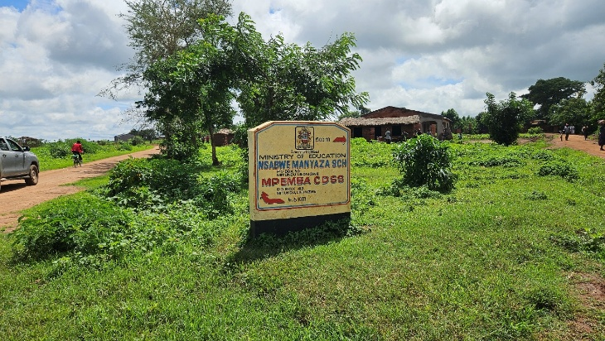
Figure 10. A signpost showing directions and distances to nearby school facilities close to the project location

Health
Based on available population and housing statistics, as well as consultations with the District Environment Sub-Committee (DESC) and communities within the project influence area, access to healthcare along the Nsabwemanyazi corridor is primarily through Mitundu Health Centre, located approximately 5 km from the proposed project site. Referral services are accessed at higher-level facilities in Lilongwe, notably Bwaila Hospital and Kamuzu Central Hospital, both located at an approximate distance of 35 km from the corridor.
Consultations indicate that over 80% of households depend directly on the road corridor to reach these health facilities, underscoring the road’s critical role in enabling timely access to healthcare, particularly during the rainy season when mobility is often constrained.
The most commonly reported illnesses in the project area include malaria, respiratory infections, and diarrhoeal diseases, consistent with prevailing rural health conditions. It is estimated that approximately 86% of households’ access improved water sources, mainly boreholes; however, risks of waterborne diseases persist due to sanitation and drainage challenges.
These baseline conditions highlight the importance of managing construction-related public health risks, including dust generation, disruption of natural drainage, and potential contamination from fuel or waste, to avoid exacerbating existing health vulnerabilities within the corridor.

Cultural Heritage
No graves, shrines, or sacred sites were identified along the alignment during consultations. A church located near the road was identified as a community asset requiring protection. While no known archaeological resources were recorded, a Chance Finds Procedure will be implemented to manage any unexpected discoveries during excavation works.

Agriculture
Based on consultations with the DESC and communities within the project area, agriculture is the dominant livelihood activity, with almost all households relying on farming as their primary source of income. Key crops reported during field consultations include maize, tomatoes, leafy vegetables, groundnuts, tobacco, and sweet potatoes, primarily produced under smallholder systems for both subsistence and local markets. In addition to crop production, livestock rearing is widely practiced, with households commonly keeping goats, cattle, pigs, sheep, and poultry as an important complementary livelihood source for income generation, nutrition, and asset accumulation.
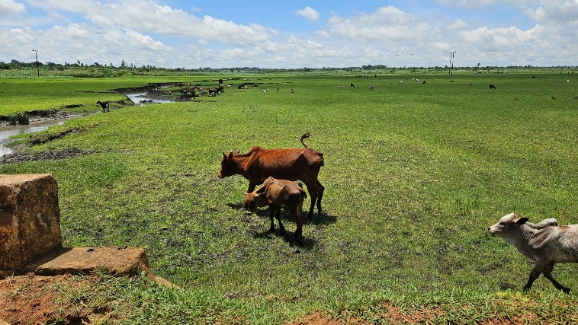
Figure 11. Herds of livestock at Chikhokhobe Valley, at Km 2.20 along the Mitundu – Nsabwemanyazi Road
The road corridor is critical for agricultural and livestock value chains, facilitating movement of farm inputs, access to grazing areas, transport of produce and livestock to markets, and linkage to trading centres. Poor road conditions therefore directly affect market access, transport costs, and income stability, underscoring the importance of the proposed road rehabilitation for improving livelihoods in the project area.

Economic Activities and Livelihoods
Poverty prevalence in Lilongwe rural stands at 56% (Lilongwe SEP 202-20303). The main economic activity in the area is farming on small scale. Beyond farming, households supplement income through petty trade, bicycle and motorcycle transport services, and casual labour (ganyu). Poverty levels in Lilongwe Rural are approximately 51%, with about 20% classified as ultra-poor. This indicates high economic vulnerability and strong reliance on affordable transport infrastructure.

Transport
Transport within the corridor is dominated by walking, bicycles, motorcycles, and occasional light vehicles. Approximately 70–80% of produce movement occurs through non-motorized means, according to FGD estimates. Steep sections and drainage failures currently increase accident risk and seasonal inaccessibility Construction of the culverts will enhance year-round mobility and safety.

Security
Security conditions within the project area are generally stable under traditional leadership and established local governance structures. The nearest formal law enforcement facility is the Mitundu Police Unit, located approximately 7 km from the corridor.

Land Use
Land use is predominantly agricultural with linear settlement along the corridor. Work will be confined to the existing road reserve, and any spot improvements adjacent to settlements will be designed to avoid disturbance to homes, structures and roadside assets.

Vulnerable and Marginalized Groups
Vulnerable groups include female-headed households (36%), elderly persons (5%), children under 18 (48%), ultra-poor households (20%), and persons with disabilities (estimated 6–7%). These groups are disproportionately sensitive to dust, safety risks, and temporary access disruption.

Communication
Communication channels include Village Development Committees, Area Development Committees, traditional leaders, and Community Policing Forums. Mobile coverage (TNM and Airtel) exists but is inconsistent. Radio remains the dominant medium of information dissemination.

Energy Sources
Less than 15% of households have access to grid electricity. Approximately 84% rely on firewood and 15% use charcoal as primary cooking fuel. These patterns reflect rural energy constraints and moderate socio-economic vulnerability.

Implications for the Project
The Mitundu–Changalu–Msabwemanyazi Road serves a predominantly rural population of 76,583 persons within TA Chiseka, with approximately 12,900 persons (16.8%) directly dependent on the corridor. The area is characterized by a youthful population (48% under 18), a high dependency ratio, strong reliance on agriculture (82% workforce), and elevated poverty levels (51%).
Road rehabilitation will enhance year-round mobility, improve access to schools and health facilities, reduce transport costs for agricultural produce, and strengthen economic resilience. However, high pedestrian movement, proximity of houses to the alignment, dependence on boreholes, and the presence of vulnerable groups require strong management.

CHAPTER 5: ENVIRONMENTAL AND SOCIAL MITIGATION AND MONITORING PLAN

Introduction
This chapter presents the Environmental and Social Mitigation and Monitoring Plan (ESMMP) for the proposed Mitundu–Nsabwemanyazi Box Culverts Project at Chingalu crossing in Lilongwe District. It sets out the mitigation measures, monitoring requirements, implementation responsibilities, and reporting arrangements for managing the environmental and social impacts identified during planning, construction, demobilisation, and operation of the subproject.
The ESMMP provides the framework for implementing environmental and social safeguards in accordance with the Environment Management Act, 2017, applicable MEPA environmental assessment requirements, and relevant World Bank safeguard and environmental and social risk management requirements. It forms part of the environmental and social obligations to be implemented by the Contractor, Supervising Consultant, MoTPW PIU, Lilongwe District Council, and other relevant authorities during project execution.
Monitoring provisions are included to enable the MoTPW PIU, Supervising Consultant, Lilongwe District Council, and MEPA to systematically track environmental and social performance, verify the effectiveness of mitigation measures, and ensure timely corrective action throughout implementation. Monitoring will focus on key risk areas including erosion and sediment control, drainage functionality, wetland protection, pollution prevention, waste management, occupational health and safety, labour and working conditions, traffic and pedestrian safety, stakeholder engagement, and grievance management.
Monitoring reports will be prepared by the Contractor and submitted on a monthly basis to the PIU, Supervising Consultant, and District Environmental Office for review and follow-up in line with the project implementation schedule.
Framework instruments for contractor implementation
To support effective implementation of the mitigation and monitoring measures set out in this chapter, this ESMMP includes framework instruments in the annexes that establish minimum procedures, standards, and compliance requirements for contractor implementation. Prior to commencement of works, the Contractor shall prepare site-specific plans and procedures based on these framework instruments for review and approval by the Supervising Consultant and MoTPW PIU, with copy submission to the District Environmental Office where applicable.
At a minimum, the Contractor shall prepare and implement the following site-specific instruments before the relevant activities commence:
- Borrow Pit Rehabilitation Plan, based on Annex 5: Borrow Pit Rehabilitation Framework.
- Traffic Management Plan, based on Annex 6: Traffic Management Framework.
- Labour Management Plan, based on Annex 8: Labour Management Guidelines for Contractor Compliance and Preparation of Labour Management Plans (LMPs).
- Contractor Environmental and Social Management Plan (CESMMP), based on Annex 9: Contractor Environmental and Social Management Plan (C-ESMMP) Framework, integrating construction-method-specific environmental, social, health, and safety controls.
- Waste Management Plan, based on Annex 10: Waste Management Framework.
- Stakeholder Engagement Plan, based on Annex 11: Stakeholder Engagement Framework.
- GBV/SEA/SH prevention and response measures, consistent with Annex 8: Labour Management Guidelines and Annex 13: SATCP LMI Grievance Redress Mechanism (GRM) Protocol, as applicable to GBV/SEA/SH risk management.
In addition, the Contractor shall implement Annex 4: Sample Code of Conduct for Contractors, Annex 7: Chance Find Procedure for Last Mile Infrastructure under SATCP, and Annex 13: SATCP LMI Grievance Redress Mechanism (GRM) Protocol as mandatory instruments throughout the construction period. These instruments shall apply to all workers, subcontractors, suppliers, and other personnel engaged on the subproject.
All contractor-prepared plans shall demonstrate consistency with Malawi environmental and labour legislation, the Environment Management Act, 2017, MEPA environmental assessment requirements, relevant World Bank safeguard principles, and the mitigation and monitoring commitments set out in this ESMMP.

Environmental and Social Mitigation and Monitoring Plan for Mitundu –Nsabwemanyazi
REF | Impacts & Risks | Enhancement / Mitigation Measures | Responsible Institution | Implementation Cost (USD) | Performance/Monitoring Indicator | Frequency | Monitoring cost (USD)
5.2.1 Planning Phase – Positive Impacts and Enhancement Measures
1 | Improved drainage and reduced flooding | Design culverts based on hydrological analysis; include adequate sizing, freeboard, and scour protection | MoTPW / Design Engineer | project cost | Approved hydrological design | Once | N/A
2 | Improved stakeholder acceptance | Conduct stakeholder consultations and disclose ESMMP  Establish and operationalize a Grievance Redress Mechanism (GRM)  Ensure inclusion of women and vulnerable groups in consultations | Contractor / District Council | 1000 | Number of consultations conducted  Availability of 1 Functioning GRC  Representation of vulnerable people in consultation groups and GRCs | Monthly | 500
3 | Early planning of local employment opportunities. | - Include local labour provisions in procurement documents;  - Establish transparent recruitment procedures;  - Promote gender-inclusive employment to achieve 40% female employment | - MoTPW  - Contractor  Contractor | 200 | Presence of labour and gender clauses in bidding documents | Once | 800
5.2.2 Planning Phase – Negative Impacts and Mitigation Measures
1 | Inadequate capacity of contractors to identify and manage the potential environmental and social risks | Contractor to include an Environmental, Social, Health and Safety (ESHS) Officer in their staffing to be based at site.  Develop and implement C-ESMP and associated management plans in line with the frameworks, Malawi regulations and WB EHS guidelines and policies covering  - Waste Management Plan  - Code of Conduct  - Borrow Pit Rehabilitation  - Stakeholder Engagement Plan  - Traffic Management Plan | Contractor | Contractor cost | ESHS Officer on site  C-ESMP and associated plans developed and implemented | Monthly | N/A
2 | Anxiety to loss of land and assets | Sensitize communities site on the Project  No land take outside of the project area  Establish a grievance mechanism | PIU and Design Engineer | 200 | Number of sensitization sessions done | Twice | 50
3 | Poor early decisions on borrow pits and material sources. | Verify land ownership; obtain landowner consent; integrate borrow pit management obligations in contracts. | MoTPW, DCs | 1000 | Number of approved material sites with documented consent | Once | 500
5.2.3 Construction Phase – Positive Impacts and Enhancement Measures
1 | Short-term employment creation for local communities | Establish and implement transparent recruitment procedures;  Promote gender-inclusive employment to achieve 40% female employment. | Contractor | 500 | Recruitment procedure in place  40% of employees are female | 1.Once  2. Monthly | 200
2 | Local procurements leading to increased circulation of income in local economies. | Engagement of local vendors and service providers where possible;  Maintain access to trading centres as part of the Traffic Management plan including signage, temporary crossings, diversions use of flag people etc. | Contractor | 500 | % locally sourced goods/services  Number of grievances received related to access | Monthly | 100
3 | Skills transfer | Provide on-the-job training to workers | Contractor | 100 | Number of workers trained | Monthly | N/A
5.2.4 Construction Phase – Negative Impacts and Mitigation Measures
1 | Vegetation loss | Limit clearing to construction footprint;  Restore vegetation after works including borrow pits. Where possible, rehabilitate borrow pits progressively.  Replant trees at a ratio of 1:10 | Contractor | 500 | Area cleared against planned area for works  Area rehabilitated  Number of trees planted | Monthly | 500
2 | Soil erosion and sedimentation | Install erosion control measures (silt traps, drainage channels, slope stabilization) to manage impact during construction, while permanent measures are being constructed as per design | Contractor | 100 | Control measures (silt traps, drainage channels, slope stabilization) in place during construction | Every two months | 500
3 | Disruption of water flow | Provide temporary diversion channels during culvert installation and maintain environmental flows | Contractor | 500 | Diversion channels in place and records of flows (inspections) | Monthly | 500
4 | Soil and water contamination | Establish designated fuelling areas; provide spill kits; ensure proper storage of fuels | Contractor | 500 | Availability of spill kits and designated areas for fuelling and fuel storage areas | Monthly | 500
4 | Soil and water contamination | Provision of sanitation facilities for workers, | Contractor | 500 | Number of facilities provided | once | 200
4 | Soil and water contamination | Provide waste bins and train workers on waste management as part of inductions | Contractor | 200 | Number of bins being used on site | Every two months | 100
5 | Dust emissions | Apply water spraying; implement speed control measures; cover transported materials | Contractor | 1000 | Records of dust suppression activities  Number of grievances related to dust | Monthly | 500
6 | Occupational Health and Safety risks | Provide ESHS Personnel  Implement measures indicated in SATCP’s OHS Management Framework  Carry out risk assessment and implement measures accordingly  Induct all workers on the OHS Plan and conduct toolbox talks on at least a weekly basis  Provide PPE to all workers and enforce its use.  Implement emergency preparedness procedures included in the OHS Management Framework | Contractor | 1000 | Accident, near miss and incident records  Risk assessment records  Training records for workers on OHS plan available on site | Monthly | 500
7 | Climate-related risks: increased surface runoff, flash flooding, and accelerated soil erosion, particularly during high-intensity rainfall events | Store loose soil material, waste, concrete mix and fuel away from the river banks | Contractor | 1000 | Designated sites for waste, fuels and concrete mixing away from riverbank  Provide shelter/rest areas for workers | Monthly | 500
8 | Noise and vibration | Restrict working hours to daylight hours  Regular servicing of equipment | Contractor | N/A | Number of dust, noise, or traffic-related complaints recorded | Monthly | 500
9 | Disruption of aquatic ecology as a result of sand mining | Acquire sand mining permits from authorities or Procure from licensed suppliers  Rehabilitation of sand mining areas | Contractor | 500 | Permits available on site  % of disturbed sand mining areas rehabilitated | Once  Monthly | 500
10 | Community Health and Safety risks | Implement dust suppression  Conduct awareness campaigns on HIV/Aids, Cholera and other communicable diseases  Provide safe diversion for safe movement of traffic (including signage, barriers and passable diversion) | Contractor | 500 | Traffic management plan developed and available on site | Monthly | 600
11 | Temporary loss of access to land due to use for ancillary facilities including diversions and storage area | Maintain access to farms, social services etc as part of the Traffic Management Plan including signage, temporary crossings use of flag people, one way traffic, temporary diversions and pedestrian access route  Establish a grievance redress mechanism  Payment of compensation for any losses/ damage to assets inadvertently caused as a result of contractor activities at replacement value | Contractor | Project cost | Signed sale/lease agreements shared with PIU | Once | N/A
12 | Temporary disruption of access to farms and social services. | Maintain access to farms, social services etc as part of the Traffic Management Plan including signage, temporary crossings use of flag people etc. | Contractor | Costed above | Number of grievances related to issues with access | Monthly | N/A
13 | Labour influx risks including communicable diseases, SEA/SH and social tensions. | Ensure all workers are trained on and sign Worker Code of Conduct  Conduct HIV/AIDS and SEA/SH awareness training;  Establish and maintain a Community Grievance Redress Mechanism that is SEA/SH responsive | Contractor | 1000 | % of workers signed the CoC against number employed  % of workers who received training on CoC against number employed  % of workers who received training on HIV/AIDS, SEA/SH against number employed  Number of Grievances received  % of grievances received against resolved within indicated timelines | Monthly | 200
14 | Labor exploitation, abuse (forced or underage), and discriminatory working conditions | Explain to all workers’ conditions of service, labour expectations and contract duration  Ensure all workers have a signed contract and given a copy  Implement age verification system using national identification to employ only those that are 18 years old and above  Establish and maintain a Worker Grievance Redress Mechanism that is SEA/SH responsive | Contractor | 600 | - % of workers with signed contract against number employed  - No of underage workers  - Availability of functioning WGRC  - % of grievances resolved against received within indicated timelines | Monthly | 200
15 | Impact to Cultural Heritage | Implement a Chance Finds Procedure including the training of workers | Contractor | 200 | % of workers trained on chance finds procedure | Monthly | 200
16 | Accidental damage to assets including crops, churches, water pipes and trees as a result of works | No works outside of agreed limits, where assets are located close to the road.  Briefing to workers on expectations on activities in these areas to avoid accidental damage.  Establish a grievance redress mechanism  Payment of compensation for any losses/ damage to assets inadvertently caused as a result of contractor activities at replacement value | Contractor | Cost as per unintended damage. | Number of grievances related to lost assets received  % of grievances related to lost assets resolved in agreed timelines | Monthly | N/A
17 | Environmental degradation from uncontrolled material extraction. | Acquire permits for material extraction or procure from licensed suppliers  Restrict extraction to approved sites; prohibit riverbed and wetland extraction; demarcate borrow pits.  Rehabilitate Borrow pits and sand mining areas. Progressive rehabilitation should be implemented where possible. | Contractor | Include in contract | Permits available on site  Number of demarcated borrow pits  % area of borrow pit rehabilitated | Once  Monthly  Monthly and prior to site handover by Contractor | 500
5.2.5 Contractor Demobilization Phase – Negative Impacts
1 | Residual waste and disturbed land | Remove all waste; dispose at approved sites; clean-up / restore site  Restore temporary storage area to pre project conditions. | Contractor | 500 | 100% waste removed and disposed at disposal site approved by District Council  100% of disturbed land restored to the satisfaction of the client and District in line with agreed plans | Once | 600
1 | Residual waste and disturbed land | Regrade and stabilise disturbed areas; restore drainage | Contractor | 500 | 100% of disturbed land restored to the satisfaction of the client and District in line with agreed plans | Once | 600
2 | Sudden loss of income for local workers. | Provide advance notice (a month), ensure payment of dues and issue work references where possible. | Contractor | 400 | N/A | N/A | N/A
5.2.6 Operation and Maintenance Phase – Positive Impacts and Enhancement Measures
1 | Improved accessibility | Maintain culverts and road surface regularly  Maintain signage, road safety measures and traffic calming devices near settlements. | MoTPW / District Council | 5,000/year | Number of maintenance activities carried out | As per District Council routine | N/A
2 | Reduced erosion and waterlogging at drainage infrastructure locations | Routine inspection and clearing of drainage structures | District Council | 3,000/year | Number of inspections carried out | As per District Council routine | N/A
5.2.7 | Operation and Maintenance Phase – Negative Impacts and Mitigation Measures
1 | Culvert blockage and flooding | Regular desilting and removal of debris | District Council | 2,500/year | Number of maintenance activities carried out | As per District Council routine | N/A
2 | Downstream erosion | Install and maintain energy dissipation structures | MoTPW / District Council | 4,000 | Energy dissipation structures installed | N/A | N/A
3 | Extreme rainfall impacts | Conduct periodic structural inspections and maintenance | MoTPW | Subject to damage assessment | Number of inspections carried out | As per District Council routine | N/A

Reports of monitoring activities will be prepared by the contractor and submitted on a Monthly basis to the PIU and the Environmental District Officer because the project will be implemented in three months.

Institutional Arrangements and Implementation Capacity
This section outlines the key institutions responsible for implementing the ESMMP for the Chingalu (Nsabwemanyazi) box culverts project, including their specific roles in ensuring compliance with environmental and social safeguards throughout the project lifecycle.
Table 13. ESMMP Implementation Responsibilities
Institution | Key Roles and Responsibilities
Contractor | Has primary responsibility for implementing all ESMMP mitigation and management measures in line with contractual environmental and social requirements. Shall appoint a qualified Environmental, Health and Safety (EHS) Officer and prepare site-specific management plans (waste management, OHS, traffic management, erosion and sediment control, and GBV/SEA/SH prevention). Responsible for implementing measures related to culvert installation, water flow management, wetland protection, and pollution prevention. Maintains compliance records and submits periodic progress and monitoring reports.
Ministry of Transport and Public Works (MoTPW) / Project Implementation Unit (PIU) | Acts as the executing agency and provides overall oversight. Ensures ESMMP requirements are integrated into bidding and contract documents, supervises contractor performance, reviews monitoring reports, and enforces corrective actions where necessary.
Supervising Consultant (SC) | Provides day-to-day technical supervision of works. Ensures construction activities—particularly box culvert installation, drainage alignment, erosion control, and safety measures—are implemented in accordance with approved designs and ESMMP requirements. Verifies compliance through routine site inspections and reporting.
The Lilongwe District Environment Sub-Committee (DESC) | will serve as a key interface between the project and local communities, supporting monitoring and grievance management, although its effectiveness may be constrained by logistical and resource limitations
PIU | will provide overall technical oversight for environmental and social safeguards, including coordinating monitoring activities, reviewing compliance reports, and liaising with MEPA and the District Council.

Monitoring and Oversight Framework
Monitoring of ESMMP implementation for the Chingalu (Nsabwemanyazi) box culverts project will be conducted at multiple levels to ensure compliance, transparency, and effective performance of environmental and social safeguards.
At the site level, the Supervising Consultant, in collaboration with MoTPW (PIU), will undertake routine inspections to verify implementation of key mitigation measures, including drainage functionality, erosion and sediment control, water quality protection, traffic and pedestrian safety, waste management, and occupational health and safety at the culvert crossing.
At the regulatory level, the Malawi Environment Protection Authority (MEPA) will provide statutory oversight and may conduct periodic compliance inspections and audits in accordance with the Environment Management Act (2017).
At the district level, the Lilongwe District Council, through the DESC, will support local monitoring, facilitate community engagement, and manage grievances related to project implementation.

Institutional Coordination Mechanisms
Implementation of the ESMMP will require coordinated engagement among national, district, and site-level institutions. Regular coordination meetings and joint site inspections involving MoTPW (PIU), the Supervising Consultant, the Contractor, MEPA, and Lilongwe District Council will be conducted to review compliance status, address emerging environmental and social issues, and track implementation progress.
A Grievance Redress Mechanism (GRM) will be established at both project and district levels to ensure that community concerns—particularly those related to water flow disruptions, access, safety, and construction-related disturbances—are systematically recorded, assessed, and resolved within defined timelines.

REFERENCES
1. Policies and Strategies
Government of Malawi. (1994). National environmental action plan. Ministry of Natural Resources.
Government of Malawi. (2002). Malawi national land policy. Ministry of Lands, Housing and Urban Development.
Government of Malawi. (2004). National environmental policy. Ministry of Natural Resources.
Government of Malawi. (2015). National transport policy. Ministry of Transport and Public Works.
Government of Malawi. (2016). National climate change management policy. Ministry of Natural Resources, Energy and Mining.
Government of Malawi. (2016). National forest policy. Ministry of Natural Resources, Energy and Mining.
Government of Malawi. (2018). Malawi 2063: An inclusively wealthy and self-reliant nation. National Planning Commission.
Government of Malawi. (2022). National water policy. Ministry of Agriculture, Irrigation and Water Development.
Government of Malawi. (2025). National gender policy. Ministry of Gender, Community Development and Social Welfare.

2. Legislation and Regulations
Government of Malawi. (1995). Constitution of the Republic of Malawi. Government Printer.
Government of Malawi. (1948). Public Health Act. Government Printer.
Government of Malawi. (1997). Occupational Safety, Health and Welfare Act. Government Printer.
Government of Malawi. (1998). Local Government Act. Government Printer.
Government of Malawi. (2000, as amended). Employment Act. Government Printer.
Government of Malawi. (2010). Child Care, Protection and Justice Act. Government Printer.
Government of Malawi. (2013). Water Resources Act. Government Printer.
Government of Malawi. (2017). Environment Management Act. Government Printer.
Government of Malawi. (2017). Gender Equality Act. Government Printer.
Government of Malawi. (2017). Trafficking in Persons Act. Government Printer.
Government of Malawi. (2018). HIV and AIDS (Prevention and Management) Act. Government Printer.
Government of Malawi. (2020). Forestry Act. Government Printer.
Government of Malawi. (2017). National Parks and Wildlife Act. Government Printer.
Government of Malawi. (2019). Mines and Minerals Act. Government Printer.
Government of Malawi. (2022). Land Act. Government Printer.
Government of Malawi. (2023). Public Roads Act. Government Printer.

3. Guidelines, Standards, and Institutional Frameworks
Malawi Environment Protection Authority (MEPA). (2025). Guidelines for Environmental assessment (2nd ed.). Government of Malawi.
Malawi Environment Protection Authority (MEPA). (2008). environmental management (waste management and sanitation) regulations. Government of Malawi.
Government of Malawi. (2020). Chemicals and toxic substances management guidelines. Ministry of Natural Resources.
World Bank. (2004). Operational Policy OP/BP 4.01: Environmental Assessment. World Bank Group.
World Bank. (2017). Environmental and social framework. World Bank Group.
World Bank. (2018). Good practice note: Addressing gender-based violence in investment project financing. World Bank Group.

4. Project and Technical Documents
Suida & Partners. (2025). Detailed engineering design report (draft) for accelerated last-mile infrastructure in Blantyre, Neno, Zomba, Balaka, Ntcheu, Dedza, Lilongwe and Mchinji districts, Malawi (Contract No. MW-MTPW-454201-CS-QCBS). Ministry of Transport and Public Works, Government of Malawi; Southern Africa Trade and Connectivity Project (SATCP).
Government of Malawi, Ministry of Transport and Public Works. (2026). Inception report: Consultancy services for preparation of Environmental and social management plans for proposed last-mile infrastructure under the Southern Africa Trade and Connectivity Project (SATCP). Project Implementation Unit.

5. Statistical Reports and Other Literature
National Statistical Office (NSO). (2018). 2018 Malawi population and housing census report. Government of Malawi.
National Statistical Office (NSO). (2018). 2018 Malawi population and housing census: District analytical report – Lilongwe. Government of Malawi.
National Statistical Office (NSO). (2018). 2018 Malawi population and housing census: District analytical report – Lilongwe. Government of Malawi.
National Statistical Office (NSO). (2018). 2018 Malawi population and housing census: District analytical report – Lilongwe. Government of Malawi.
National Statistical Office (NSO). (2024). Malawi labour force survey report. Government of Malawi.

ANNEXES

Annex 1. Feedback Letter from MEPA
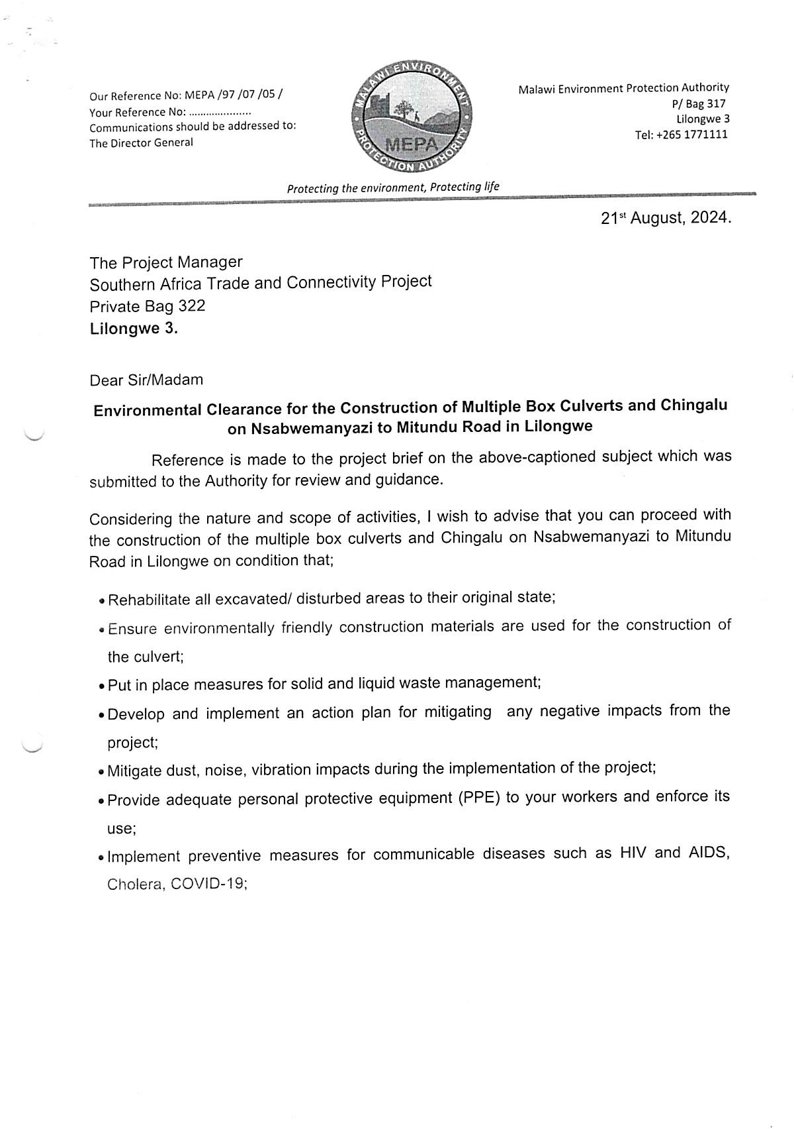

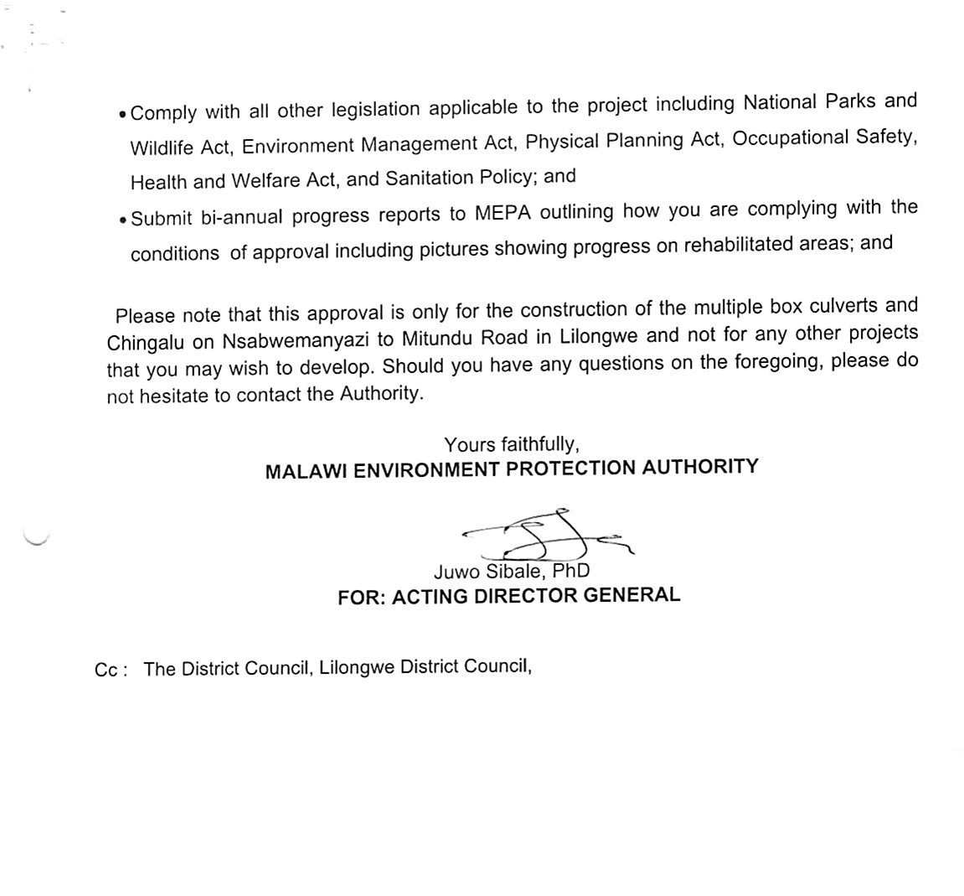

Annex 2. List of Stakeholders Consulted
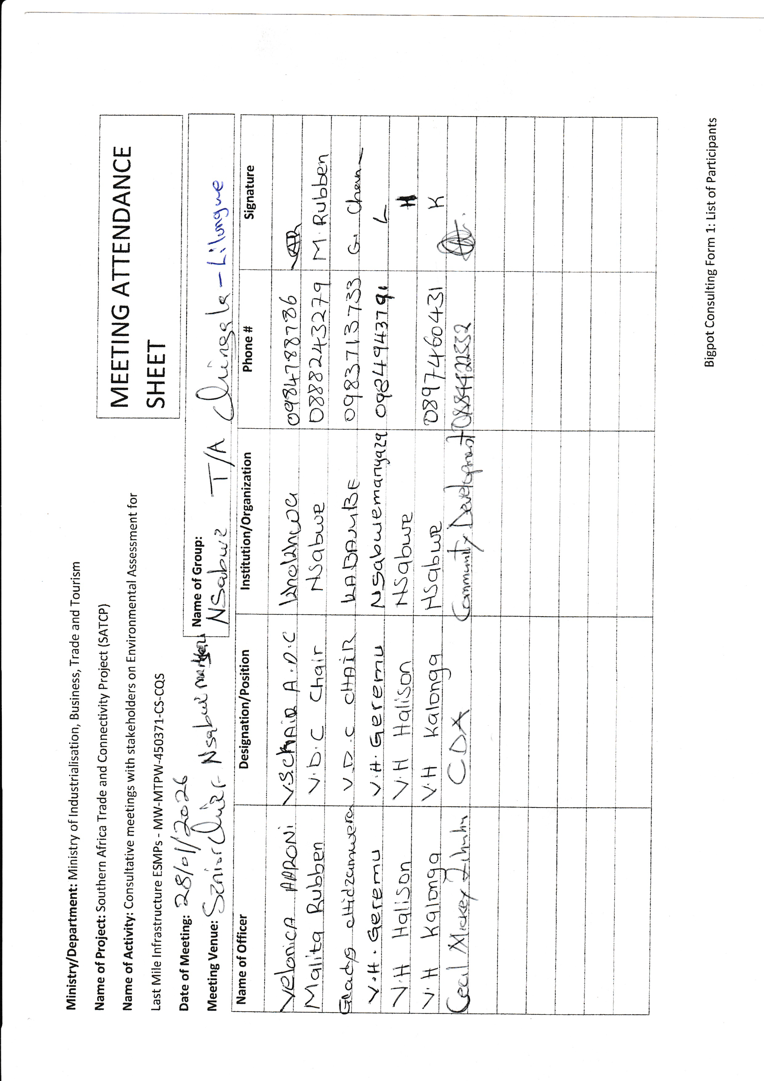

Annex 3. Issues raised by Stakeholders and how they have been addressed in ESMMP
SN | Issue Raised | Raised By | ESMMP Response / Intervention | ESMMP Reference (Section / Table / Annex)
1 | Lack of early engagement and formal briefing of the District Environmental Sub-Committee prior to consultation | DESC | The project will continue engaging communities | ESMMP
2 | Need to share project maps, designs, and ESMMP documentation with district authorities for technical review | DESC | Approved ESMMP will be disclosed | ESMMP
3 | Poor drainage systems along the road leading to stormwater flowing over the road during heavy rainfall | DESC | This will be taken care in the DED | ESMMP
4 | Presence of dambo sections and drainage challenges requiring careful engineering design | DESC | This will be taken care in the DED | ESMMP
5 | Soil erosion along steep road sections and erosion-prone segments | Men FGD, Women FGD | This will be taken care in the DED | ESMMP
6 | Road becomes impassable during heavy rains affecting mobility and access to services | Men FGD, Women FGD | This will be taken care in the DED | ESMMP
7 | Dust during the dry season affecting visibility, homes, and health of nearby residents | Men FGD, Women FGD | This will be taken care in the DED | ESMMP
8 | Houses and gardens located close to the road may fall within the construction footprint | Men FGD, Women FGD | This will be taken care in the DED | ESMMP
9 | Presence of community assets such as churches and water pipelines near the road corridor | Men FGD, Women FGD | This will be taken care in the DED | ESMMP
10 | Risk of damage or contamination to boreholes and water infrastructure during construction | Men FGD, Women FGD | This will be taken care in the DED | ESMMP
11 | Risk of contamination of water sources from fuel spills, oil, or construction waste | Men FGD, Women FGD | Covered in the ESMMP | ESMMP
12 | Lack of a fully designated waste disposal site in the district complicating waste management | DESC | Covered in the ESMMP | ESMMP
13 | Need for contractors to develop proper waste management systems for construction activities | DESC, Men FGD, Women FGD | Covered in the ESMMP | ESMMP
14 | Potential environmental degradation from borrow pits and material extraction sites | DESC | Covered in the ESMMP | ESMMP
15 | Need for responsible sourcing of construction materials and rehabilitation of borrow areas | DESC | Covered in the ESMMP | ESMMP
16 | Temporary disruption of farming activities, markets, and transport of agricultural produce | Men FGD, Women FGD | Covered in the ESMMP | ESMMP
17 | Farming and small businesses (vegetables, tomatoes, mpiru) depend heavily on road access | Men FGD, Women FGD | Covered in the ESMMP | ESMMP
18 | Risk of accidents due to steep road sections and construction traffic | Men FGD, Women FGD | Covered in the ESMMP | ESMMP
19 | Children approaching construction machinery and open excavations creating safety risks | Men FGD, Women FGD | Covered in the ESMMP | ESMMP
20 | Need for traffic safety measures such as signage, speed controls, fencing of hazardous areas, and pedestrian crossings | Men FGD, Women FGD | Covered in the ESMMP | ESMMP
21 | Need to prioritize local labour including women and youth during construction | Men FGD, Women FGD | Covered in the ESMMP | ESMMP
22 | Labour risks including child labour, unsafe working conditions, and lack of PPE | DESC | Covered in the ESMMP | ESMMP
23 | Potential GBV, sexual exploitation, or harassment linked to worker presence and alcohol use | DESC, Men FGD, Women FGD | Covered in the ESMMP | ESMMP
24 | Need for strong worker Codes of Conduct and community awareness on GBV prevention | Men FGD, Women FGD | Covered in the ESMMP | ESMMP
25 | Presence of vulnerable groups including elderly persons, female-headed households, and persons with disabilities | Men FGD, Women FGD | Covered in the ESMMP | ESMMP
26 | Need for effective grievance redress mechanisms involving community leadership structures | DESC, Men FGD, Women FGD | Covered in the ESMMP | ESMMP
27 | Importance of continuous communication with communities before and during construction | Men FGD, Women FGD | Covered in the ESMMP | ESMMP
28 | Need for regular monitoring visits and coordination between district officers and contractors | DESC | Covered in the ESMMP | ESMMP
29 | Importance of prioritizing drainage improvements and culvert installation for road sustainability | DESC, Men FGD, Women FGD | Covered in the ESMMP | ESMMP
30 | Community expectation that the project will improve mobility, market access, and economic activity | Men FGD, Women FGD | Covered in the ESMMP | ESMMP

Annex 4. Sample Code of Conduct for Contractors
1. Purpose and Scope
This Code of Conduct (CoC) sets out mandatory standards of behaviour for all personnel engaged in the implementation of the SATCP Last Mile Infrastructure (LMI) subprojects, including contractors, sub-contractors, supervising consultants, suppliers, and all categories of workers (permanent, temporary, and day workers).
The Code addresses risks associated with:
- Environmental and Social management
- Occupational health and safety (OHS)
- Labour influx and labour relations
- Spread of communicable diseases (including HIV and AIDS)
- Sexual harassment (SH), sexual exploitation and abuse (SEA), and gender-based violence (GBV)
- Child labour and child protection
- Illicit behaviour, crime, and corruption
- Community health and road safety
Compliance with this Code of Conduct is a contractual obligation and a condition of employment on the project.
2. General Obligations
The Supervising Consultant shall ensure that the Contractor and all associated personnel:
a) Legal Compliance
Comply at all times with the laws, regulations, and standards of the Republic of Malawi, including the Environment Management Act (2017), labour laws, occupational safety legislation, and applicable World Bank safeguard requirements.
b) ESHS Planning Instruments
Prepare, implement, and maintain site-specific instruments prior to commencement of works, including:
- Environmental and Social Management Plan (ESMMP);
- Health and Safety Management Plan (HSMP);
- HIV and AIDS Awareness Programme;
- Occupational Health and Safety Awareness Programme;
- Road Safety and Traffic Management Plan.
c) Occupational Health and Safety
Provide a safe and healthy working environment, including:
- Provision and compulsory use of appropriate Personal Protective Equipment (PPE);
- Prevention of avoidable accidents and injuries;
- Immediate reporting and correction of unsafe acts or hazardous conditions.
d) Traffic and Road Safety
Implement traffic safety measures, including:
- Temporary speed calming devices and speed-limit signage;
- Warning signs in villages, trading centres, schools, health facilities, and construction zones;
- Enforcement of safe driving practices by all project drivers.
e) Environmental Protection
Avoid unnecessary clearance of trees and vegetation, prevent conflicts over water resources, and ensure sustainable use of natural resources in consultation with local communities.
f) Pollution Prevention
Take all reasonable measures to prevent pollution of air, water, and soil, land degradation, and environmental damage, and ensure compliance with good international industry practice.
g) Worker and Public Safety
Install standard safety signs, barricades, and road markings during construction and after completion to protect workers, communities, and road users.
h) Sanitation and Welfare Facilities
Provide adequate sanitation facilities, including:
- Safe drinking water;
- Decent toilets and washing facilities at worksites and camps;
- Prohibition of open defecation.
i) Site Rehabilitation and Restoration
Restore all disturbed areas after construction, including borrow pits, quarries, stockpiles, camps, access roads, batching plants, fuel storage areas, and waste disposal sites, through landscaping, tree planting, and erosion-control measures.
3. Labour, Ethics, and Social Conduct
j) Non-Discrimination
Prohibit all forms of discrimination in recruitment, employment, and working conditions on the basis of gender, age, ethnicity, disability, religion, marital status, political affiliation, or other protected characteristics.
k) Fair Labour Practices
Adhere to Malawi labour laws by issuing written contracts to skilled and unskilled workers, respecting working hours, wages, and conditions of employment.
l) Prevention of Sexual Harassment
Strictly prohibit sexual harassment, including abusive language, inappropriate gestures, sexually suggestive behaviour, or culturally offensive conduct, particularly towards women and children.
m) Prevention of SEA/GBV
Prohibit any form of sexual exploitation, abuse, or violence, including:
- Exchange of money, goods, services, or employment for sex;
- Exploitative or degrading behaviour;
- Any sexual activity with minors (persons under 18), regardless of consent.
n) Child Protection and Child Labour
Prohibit child labour and all forms of child abuse, exploitation, or endangerment, and ensure children’s safety in and around project areas.
o) Conflict of Interest and Corruption
Avoid conflicts of interest and prohibit bribery, favouritism, or preferential treatment based on personal, financial, or family relationships.
p) Protection of Property and Assets
Safeguard project equipment, materials, and property; prohibit theft, vandalism, misuse, or waste of resources.
q) Grievance Reporting and Non-Retaliation
Ensure that workers and community members can report violations of this Code through established grievance mechanisms without fear of retaliation, provided the report is made in good faith.
4. Enforcement and Accountability
r) Acknowledgement and Sanctions
All workers and contractor personnel shall:
- Read, understand, accept, and sign this Code of Conduct as a condition of employment;
- Attend mandatory induction and refresher training on ESHS and SEA/GBV prevention.
Any violation of this Code of Conduct may result in disciplinary action, including:
- Verbal or written warnings;
- Suspension or dismissal;
- Termination of contract; and/or
- Referral to relevant legal authorities.
5. Contractor Certification
I, the undersigned, confirm that I have read and understood this Code of Conduct and commit to ensuring full compliance by all personnel engaged under this contract.
I Agree /
Name of Authorized Representative: ____________________________
Signature: ____________________________
Name of Company: ____________________________
Physical Address: ____________________________
Company Stamp: ____________________________
Date: ____________________________

Annex 5. Barrow Pit Rehabilitation Framework
(SATCP Last Mile Infrastructure Projects)
1. Introduction and Purpose
This Borrow Pit Rehabilitation Framework applies to all borrow pits identified and utilised under the SATCP Last Mile Infrastructure (LMI) Projects. It provides mandatory procedures for Environmental sound material extraction, rehabilitation, and closure of borrow pits to ensure that material sourcing does not result in permanent land degradation, public safety hazards, or adverse impacts on surrounding communities and ecosystems.
The Framework shall be implemented as an integral part of each site-specific Environmental and Social Management Plan (ESMMP) and Contractor’s Environmental and Social Management Plan (C-ESMMP).
2. Project Context
Borrow pits are identified during the design and pre-construction phases of LMI subprojects based on geotechnical investigations undertaken under the Detailed Engineering Design (DED). These borrow pits may supply lateritic gravel, fill material, or other construction materials required for road rehabilitation, drainage works, and ancillary infrastructure.
At the planning stage, borrow pits are considered indicative material sources. Final selection, approval, and use shall be subject to field verification, landowner consent, environmental and social screening, and approval by relevant authorities.
3. Regulatory and Safeguards Framework
Borrow pit development, operation, and rehabilitation under SATCP LMI projects shall comply with:
- Environment Management Act (2017)
- MEPA Guidelines for Environmental Assessment (2025)
- SATCP ESMF
- World Bank OP/BP 4.01 and OP/BP 4.04 (where applicable)
- Approved ESMMPs and DEDs for each LMI subproject
4. Borrow Pit Planning and Site Controls
Before opening or using any borrow pit, the Contractor shall:
- Obtain written approval from the Supervising Consultant and the relevant District Council.
- Secure documented landowner consent and confirmation from the appropriate Traditional Authority.
- Verify land tenure status and agree on access, use, rehabilitation, and handover conditions.
- Clearly demarcate the borrow pit footprint and access routes.
- Strip and stockpile topsoil separately for use during rehabilitation.
- Install warning signage and temporary fencing, particularly where borrow pits are located near settlements, agricultural land, footpaths, or grazing areas.
5. Key Environmental and Social Risks
Typical risks associated with borrow pits under LMI projects include:
- Loss of productive agricultural land
- Open excavations posing injury risks to people and livestock
- Standing water leading to mosquito breeding
- Soil erosion and sediment runoff into nearby streams or wetlands
- Visual scarring of the landscape
- Community dissatisfaction where land is not adequately restored
6. Rehabilitation Objectives
Borrow pit rehabilitation under SATCP LMI projects shall aim to:
- Restore land to a safe, stable, and productive condition
- Prevent erosion, standing water, and slope instability
- Reintegrate rehabilitated sites into agricultural or community land use
- Eliminate public health and safety hazards
- Meet landowner, community, and District Council expectations
7. Rehabilitation Measures
7.1 Progressive Rehabilitation
- Implement rehabilitation progressively, commencing immediately after material extraction in each section.
- Phase excavation activities to minimise the total open area at any given time.
7.2 Backfilling and Reshaping
- Reuse overburden and unsuitable material for backfilling.
- Reshape excavated areas to stable slopes (maximum 1:3).
- Partially backfill deep excavations to eliminate water accumulation.
7.3 Topsoil Replacement
- Evenly spread stockpiled topsoil over rehabilitated surfaces.
- Ensure sufficient topsoil depth to support revegetation or agricultural reuse.
7.4 Drainage and Erosion Control
- Restore surface drainage to natural flow patterns.
- Apply erosion control measures such as contour shaping, grass strips, or stone pitching where required.
7.5 Revegetation
- Revegetate rehabilitated sites using indigenous grass species and locally appropriate tree species, subject to landowner preference.
- Prioritise vegetation that supports soil stabilisation, shade provision, and community utility.
8. Safety and Community Protection
- Secure active borrow pits using fencing, barriers, or warning tape.
- Install clear warning signage in English and local languages.
- Eliminate vertical faces and open pits upon closure.
- Formally hand back rehabilitated sites to landowners after completion.
9. Post-Use Land Options
Subject to agreement with landowners and District Councils, rehabilitated borrow pits may be converted into:
- Agricultural land
- Community woodlots
- Grazing areas
- Controlled water retention areas (only where approved, engineered, and safe)
10. Roles and Responsibilities
Actor | Responsibility
Contractor | Implement borrow pit management and rehabilitation
Supervising Consultant | Approve, supervise, and certify rehabilitation works
District Council / DESC | Community liaison and site verification
Landowners / Traditional Authorities | Accept rehabilitated land

11. Monitoring and Reporting
- Report borrow pit status in monthly ESMMP compliance reports.
- Monitor indicators including number of rehabilitated sites, erosion evidence, water ponding, and vegetation establishment.
- Conduct final inspections prior to issuance of completion certificates.
12. Budgeting
- Fully include borrow pit rehabilitation costs in the Contractor’s BoQs and C-ESMMP.
- Prohibit approval of any borrow pit without a costed and approved rehabilitation provision.
13. Completion and Handover
Consider borrow pits closed only when rehabilitation is complete, sites are safe and stable, and formal handover documentation is signed by relevant parties.
14. Conclusion
This Borrow Pit Rehabilitation Framework provides a consistent and enforceable approach for managing borrow pits across all SATCP Last Mile Infrastructure projects, ensuring Environmentally responsible material sourcing, protection of community interests, and full compliance with MEPA (2025) and World Bank safeguards.

Annex 6. Traffic Management Framework
1. Introduction
This Traffic and Access Management Framework (TAMF) has been prepared for the Southern Africa Trade and Connectivity Project (SATCP) – Last Mile Infrastructure (LMI) subprojects, including feeder road rehabilitation, drainage improvements, bridge/culvert works, and associated construction activities.
The Framework provides mandatory guidance for the preparation and implementation of site-specific Traffic and Access Management Plans (TAMPs) by Contractors. Each TAMP shall be submitted to the Supervising Consultant and the State Agency for Transport and Construction Projects (SATCP) for review and approval prior to commencement of construction works.
The Framework aims to ensure that all construction-related traffic—vehicles, equipment, and personnel—is managed safely, efficiently, and in an Environmentally responsible manner, while minimizing risks and disruptions to communities, road users, and existing infrastructure.
2. Purpose and Objectives
Construction activities will increase vehicular and machinery traffic within worksites and along existing regional and community roads. Without effective management, such traffic may:
- Interfere with normal traffic and pedestrian movements;
- Increase risks of accidents and injuries to workers and the public;
- Damage existing road infrastructure;
- Generate dust, noise, congestion, and community nuisance.
The objectives of this Framework are to:
- Promote safe interaction between construction traffic, pedestrians, and local road users;
- Minimize Environmental and social risks associated with construction traffic;
- Guide the planning, use, and rehabilitation of access roads and haul routes;
- Ensure site-specific traffic impacts are addressed through appropriate design, scheduling, signage, and controls.
3. Access Roads and Haul Routes
a) Planning and Approval
The Contractor shall prepare detailed layout plans for all proposed access roads and haul routes. These plans shall:
- Be submitted to the Supervising Consultant for approval;
- Be accompanied by written consent from affected landowners, Traditional Authorities, or village leadership where applicable.
b) Use of Existing Infrastructure
Existing roads shall be used wherever feasible. Construction of temporary access roads shall only be permitted where unavoidable and upon approval by the Site Manager and relevant stakeholders. Construction of temporary diversions, if required, will require approval of the District and the World Bank.
c) Environmental Considerations
Planning of haul routes shall consider:
- Vegetation and sensitive habitats;
- Watercourses and drainage patterns;
- Existing land use;
- Proximity to households, schools, markets, and health facilities.
d) Construction, Maintenance, and Rehabilitation
The Contractor shall be responsible for:
- Construction and routine maintenance of access and haul roads;
- Installation of drainage infrastructure at early stages to prevent erosion;
- Decommissioning and rehabilitation of temporary roads upon completion of works.
Topsoil shall be stripped and stockpiled prior to construction and reused during rehabilitation. Disturbed areas shall be revegetated using indigenous species where applicable.
e) Dust Suppression
Dust control measures shall be implemented, including:
- Regular watering of access and haul roads;
- Enforcement of speed limits (maximum 30 km/h near settlements);
- Use of dust palliatives where necessary.
Dust suppression activities shall be recorded and reported as part of Environmental compliance monitoring.
4. Traffic Management and Safety Measures
Each site-specific Traffic and Access Management Plan shall include, at minimum, the following components:
4.1 Traffic Control and Signage
- Clearly defined access routes within and around worksites;
- Advance warning signage along haul routes and near construction zones;
- Temporary traffic signs, barriers, and flag persons where required;
- Establishment and enforcement of speed limits and control points.
Where bridge or culvert works require road occupation, temporary bypasses or diversions shall be constructed prior to commencement of works to avoid full road closures.
5. Transport of Materials
The Contractor shall ensure that:
- Vehicles transporting fine or granular materials are fully covered with tarpaulins to prevent dust and spillage;
- Any spillage or pollution along transport routes is cleaned immediately at the Contractor’s cost;
- Delivery schedules are aligned with off-peak hours to reduce congestion and disturbance to communities.
6. Driver Requirements and Conduct
All project drivers and equipment operators shall:
- Hold valid licenses appropriate to the vehicles or machinery operated;
- Be trained and certified in defensive driving and road safety;
- Receive training in eco-driving to reduce fuel consumption and emissions;
- Undergo project induction covering pedestrian safety, fatigue management, and substance abuse prevention.
Driver working hours shall be managed to prevent fatigue, ensuring adequate rest periods. The Contractor shall maintain up-to-date driver registers and dust suppression logs.
7. Interaction with Communities and Sensitive Areas
High-risk interaction areas such as schools, markets, trading centres, and health facilities shall be identified and mapped. Site-specific mitigation measures shall be implemented, including:
- Temporary pedestrian crossings;
- Traffic calming devices (speed bumps, rumble strips);
- Warning lights, reflectors, and signage;
- Temporary bypasses where necessary.
Community engagement shall be coordinated with the Stakeholder Engagement Framework (Annex 11) to ensure awareness of traffic changes and safety measures.
8. Monitoring, Enforcement, and Reporting
The Contractor’s Traffic and Access Management Plan shall include:
- An accident and incident register with clear reporting procedures;
- Random alcohol and drug testing protocols for drivers;
- A penalty and disciplinary structure for non-compliance with traffic safety requirements;
- Regular monitoring of road conditions and prompt repair of damage caused by construction traffic;
- Monthly traffic management reports detailing:
  - Traffic incidents and near misses;
  - Dust and noise control performance;
  - Community complaints related to traffic;
  - Corrective actions undertaken.
The Supervising Consultant shall verify compliance and recommend corrective measures where deficiencies are identified.
9. Institutional Responsibilities
Actor | Key Responsibilities
Contractor | Prepare and implement site-specific TAMPs, ensure compliance
Supervising Consultant | Review, approve, and monitor TAMP implementation
SATCP / PIU | Oversight and enforcement
District Authorities | Local coordination and support
Traffic Police (where applicable) | Enforcement and incident response
10. Conclusion
This Traffic and Access Management Framework establishes mandatory requirements for safe, efficient, and environmentally responsible management of construction traffic under the SATCP Last Mile Infrastructure subprojects. Effective implementation of this Framework will reduce accident risks, protect communities, and ensure compliance with national legislation and World Bank safeguard requirements.
Site-specific Traffic and Access Management Plans shall be developed and approved prior to commencement of construction works and updated as necessary throughout project implementation.

Annex 7. Chance Find Procedure for Last Mile Infrastructure under SATCP

1. Introduction
This Chance Find Procedure outlines the protocol to be followed in the event that previously unidentified cultural heritage is discovered during the implementation of the Last Mile Infrastructure under the SATCP. Cultural heritage may include archaeological materials, graves, religious artifacts, sacred sites, or historical objects not identified during the initial environmental and social assessment. This procedure ensures compliance with the requirements of the Monuments and Relics Act (Cap 29:01) of Malawi and World Bank’s OP/BP 4.11 (Physical Cultural Resources).

2. Purpose
The purpose of this procedure is to safeguard Malawi’s tangible cultural heritage by ensuring that any unexpected discoveries are handled with care and in accordance with legal and safeguard requirements. The procedure seeks to prevent unauthorized interference, preserve historical and cultural assets, and maintain respect for community traditions and sensitivities.

3. Scope
This procedure applies to all personnel involved in the project, including contractors, subcontractors, consultants, field workers, and any party engaged in construction, material sourcing, excavation, or related site activities. It is applicable to all locations along the project corridor, including campsites, borrow pits, material stockpiles, access roads, and working zones.

4. Definition of a Chance Find
A chance find is defined as any artifact, feature, structure, or site of cultural, historical, or religious significance that is discovered unexpectedly during the execution of project activities. Examples may include human remains, pottery fragments, stone tools, religious objects, altars, burial grounds, historical ruins, or sacred trees. These are typically items or sites not previously recorded or anticipated in the ESMMP documentation.

5. Procedure to Follow in the Event of a Chance Find
If a chance find is encountered, the following steps must be followed:
- All work in the immediate vicinity must stop immediately. The affected area must be secured with a buffer zone of no less than 20 to 50 meters to prevent disturbance or looting.
- The Contractor must promptly inform the Supervision Consultant, the Project Implementation Unit (PIU) of the SATP, and the Department of Antiquities (DoA) within 24 hours.
- The DoA will dispatch a qualified cultural heritage or archaeological specialist to assess the nature, significance, and appropriate treatment of the discovery.
- Based on the expert assessment and consultations with relevant stakeholders, the cultural material may be preserved in situ, documented and relocated, or managed in accordance with traditional practices—such as holding customary ceremonies prior to relocating graves or sacred objects.
- No work should resume in the vicinity until the DoA has provided written clearance authorizing continuation. All findings must be properly recorded, photographed, and geotagged for documentation and reporting purposes.

6. Roles and Responsibilities
The Contractor is responsible for ensuring that all site personnel are trained in this procedure and for immediately halting work and protecting the area in the event of a discovery. The Supervision Consultant must verify contractor compliance and support the coordination of response efforts. The PIU is responsible for notifying the Department of Antiquities, facilitating expert engagement, and ensuring adherence to this procedure. The Department of Antiquities will lead assessments, determine the heritage value of the find, and authorize appropriate measures or clearance to resume work.

7. Training and Awareness
To ensure that all relevant personnel are aware of and can implement this procedure, pre-construction induction training will be provided to all workers and supervisors. This will include awareness of local cultural sensitivities and the importance of cultural heritage protection. Refresher training will be conducted every six months or upon the onboarding of new workers. On-site communication materials such as posters and briefing cards will be used to reinforce awareness.

8. Legal and Policy Basis
This procedure is grounded in the Monuments and Relics Act (Cap 29:01) of Malawi, which mandates the protection and reporting of archaeological discoveries and prohibits unauthorized disturbance of cultural resources. It is also aligned with the World Bank’s OP/BP 4.11 (Physical Cultural Resources), which requires Borrowers to avoid, minimize, or mitigate impacts on cultural heritage and to engage relevant communities and authorities in the process of managing heritage resources.

9. Reporting and Documentation
All chance finds must be documented in a standardized reporting format that includes the date and time of discovery, location coordinates (GPS), a physical description of the find, photographic records, and the actions taken. These reports must be submitted to the PIU, the Department of Antiquities, and included in the Contractor’s monthly E&S compliance reporting. Records of follow-up actions, assessments, and final clearance must also be retained.

10. Budget and Resources
A dedicated budget line will be included in the project’s Environmental and Social Management Plan (ESMMP) to support implementation of the chance find procedure. This will cover costs associated with expert assessments, protective measures (e.g., fencing), documentation, stakeholder engagement, and cultural or ceremonial activities where required for the proper treatment of sacred or religious sites.

Annex 8: Labour Management Guidelines for Contractor Compliance and Preparation of Labour Management Plans (LMPs)

1. Purpose of these Guidelines
These Labour Management Guidelines are issued to guide Contractors in the preparation and implementation of Project-Specific Labour Management Plans (LMPs) for Last Mile Infrastructure (LMI) road projects.
They are not a standalone LMP. Rather, they:
- Establish minimum compliance requirements;
- Clarify statutory obligations under Malawi labour legislation;
- Define the scope and content expected in Contractor LMPs;
- Provide direction on labour risk management consistent with:
  - Employment Act (2000, as amended),
  - Occupational Safety, Health and Welfare Act (1997),
  - Gender Equality Act (2013),
  - Child Care, Protection and Justice Act (2010),
  - Trafficking in Persons Act (2017),
  - World Bank OP/BP 4.01 requirements for managing social risks.
All Contractors engaged under SATCP shall prepare a site-specific Labour Management Plan (LMP) consistent with these Guidelines prior to mobilisation.
2. Legal and Policy Framework
Contractors must ensure their LMPs demonstrate compliance with:
- Employment Act (2000, as amended)
- Occupational Safety, Health and Welfare Act (1997)
- Gender Equality Act (2013)
- Child Care, Protection and Justice Act (2010)
- HIV and AIDS (Prevention and Management) Act (2018)
- Trafficking in Persons Act (2017)
- Public Health Act (1948)
- Applicable minimum wage regulations
- Relevant World Bank safeguards (OP/BP 4.01)
The LMP must clearly reference these instruments and describe how compliance will be operationalised.
3. Categories of Workers to be Covered
The Contractor’s LMP shall cover all categories of project workers, including:
- Direct workers (Contractor employees)
- Subcontracted workers
- Security personnel
- Primary supplier workers
The LMP must describe how labour standards will be applied to subcontractors and suppliers.
4. Minimum Content Requirements for Contractor LMPs
Each Contractor’s LMP must include, at a minimum, the following components:
4.1 Workforce Planning and Recruitment Procedures
The LMP must describe:
- Anticipated labour numbers by category and phase;
- Recruitment procedures;
- Local hiring strategies;
- Non-discrimination measures;
- Age verification procedures;
- Prohibition of forced labour and child labour;
- Record-keeping systems for employees.
Recruitment must comply with Sections 4, 5, 21, and 23 of the Employment Act.
4.2 Employment Conditions
The LMP shall demonstrate how the Contractor will ensure:
- Written contracts for all workers;
- Clear specification of wages, hours, and benefits;
- Compliance with statutory working hours and rest days;
- Provision of annual, sick, and maternity leave;
- Equal pay for equal work;
- Proper termination procedures and severance entitlements.
4.3 Occupational Health and Safety (OHS)
The LMP must include:
- Site-specific OHS risk assessment;
- Hazard identification and control measures;
- PPE provision policy;
- Toolbox talks and safety training plan;
- Accident and incident reporting procedures;
- Emergency response plan;
- First aid and medical arrangements;
- Special protection for young workers (14–18 years).
OHS provisions must comply with the Occupational Safety, Health and Welfare Act (1997).
4.4 Worker Welfare Facilities
The LMP must outline provision of:
- Adequate sanitation facilities (segregated by gender);
- Potable water;
- Waste management systems;
- Rest areas and shelters;
- Medical and first aid facilities;
- Safe worker accommodation (where applicable).
4.5 Gender, GBV, SEA/SH and Child Protection
The LMP shall include:
- A mandatory Code of Conduct;
- GBV/SEA/SH awareness training programme;
- Zero tolerance policy;
- Confidential reporting pathways;
- Sanctions for misconduct;
- Measures to prevent exploitation of minors.
The LMP must align with the project’s GBV Management Framework.
4.7 Workers Grievance Redress Mechanism (WGRM)
The Contractor’s LMP must establish a Workers Grievance Redress Mechanism that:
- Is free and accessible;
- Protects confidentiality;
- Prohibits retaliation;
- Provides defined timelines for resolution;
- Maintains grievance records;
- Allows escalation procedures.
4.8 Monitoring and Reporting
The LMP must describe:
- Internal compliance monitoring procedures;
- Monthly labour reporting requirements;
- OHS statistics reporting;
- Training records;
- Grievance reporting;
- Supervision Consultant oversight arrangements.
5. Key Labour Risks in LMI Road Projects
Contractors shall assess and manage risks including:
- Workplace injuries and accidents;
- Exposure to dust, noise, and hazardous materials;
- Spread of communicable diseases;
- Child labour and forced labour risks;
- Gender-based violence;
- Labour disputes;
- Discrimination and exclusion of vulnerable groups;
- Resource competition due to labour influx.
Mitigation measures must be integrated into the Contractor’s ESMMP and Construction Environmental and Social Management Plan (C-ESMMP).
6. Review and Approval
No Contractor shall mobilise to site until:
- A project-specific Labour Management Plan has been prepared;
- The LMP has been reviewed and approved by the Supervision Consultant and SATCP;
- The Code of Conduct has been signed by all personnel;
- Induction training on labour standards and GBV has been conducted.
7. Enforcement
Failure to comply with these Guidelines and approved LMP provisions may result in:
- Suspension of works;
- Withholding of payment;
- Contractual penalties;
- Termination of contract.

Annex 13. SATCP LMI Grievance Redress Mechanism (GRM) Protocol
1. Introduction
This Grievance Redress Mechanism (GRM) Protocol has been developed for the Southern Africa Trade and Connectivity Project (SATCP) – Last Mile Infrastructure (LMI) subprojects, including feeder road rehabilitation, drainage improvements, culvert/bridge works and associated construction activities. The GRM provides a structured, project-wide system for receiving, recording, assessing and resolving concerns, queries and complaints from communities, workers and other stakeholders.
The GRM serves as the first line of response to stakeholder concerns, complementing statutory and other grievance channels (e.g. courts, police, labour authorities). It aims to resolve issues as close as possible to the point of impact, using dialogue and collaborative problem-solving, and thereby maintain constructive relations between the project, affected communities and workers.
Construction activities under SATCP LMI are expected to generate grievances related to, among others, land and assets, labour and working conditions, occupational and community health and safety, environmental impacts, and gender-based violence / sexual exploitation and abuse / sexual harassment (GBV/SEA/SH) and trafficking in persons (TIP). Contractors are required to develop and implement site-specific GRM Management Plans consistent with this Protocol.
The GRM will use two complementary modes of recording grievances:
- Manual submission (e.g. verbal, paper forms, grievance boxes, community meetings); and
- Electronic recording in a central database to allow tracking, escalation, and consolidated reporting across SATCP LMI.
Electronic recording will be promoted to support timely management oversight, automatic flagging of overdue cases, and real-time analysis of grievance trends.
2. Categories and Types of Grievances
The GRM will receive and register all grievances related to SATCP LMI activities, whether from project-affected community members, workers or institutions. Grievances may be submitted:
- In person to GRM committee members or project staff.
- By phone, SMS, WhatsApp or project-designated hotlines.
- Via grievance boxes at key locations.
- Through written letters or emails to the PIU, Supervising Consultant or Contractor.
The following categories and examples guide classification (non-exhaustive):
2.1 Construction-related Community Concerns and Livelihood Continuity
- Reinstatement disputes – Disputes about reinstatement of inadvertently damaged crops, structures or roadside assets during construction.
- Access disruption – Concerns about temporary loss of access to homes, services, schools or markets during construction.
- Livelihood continuity – Alleged disruption to roadside businesses or inadvertent crop damage during construction.
2.2 Health and Safety (Workers and Community)
- Safety violations – Inconsistent handling of safety breaches, inadequate enforcement of rules.
- Accidents and injuries – Workplace or traffic accidents, concerns about the response, or perceived unfair dismissal following an accident.
- Health and safety hazards – Exposure to hazardous materials or unsafe conditions, lack or poor quality of PPE.
- Community safety complaints – Dust, noise, blocked accesses to schools/health centres/markets, speeding construction vehicles, unsafe detours, open borrow pits or excavations.
2.3 Labour / Contractor Issues
- Payment disputes – Delayed payment, underpayment or non-payment.
- Working conditions – Poor accommodation, sanitation, unsafe or unhealthy work environments.
- Wage disputes – Wage rates, overtime, non-payment of benefits.
- Discrimination and harassment – Workplace discrimination, bullying, harassment.
- Contract interpretation – Disagreements about terms, duration, or conditions of contracts.
2.4 Gender and Social Inclusion (GSI)
- Gender discrimination – Unequal treatment of women and men in recruitment, pay or opportunities.
- Social exclusion – Exclusion of youth, persons with disabilities or vulnerable groups from employment or consultations.
- Cultural insensitivity – Disrespect for local customs, norms or religious practices.
2.5 Environmental
- Pollution and waste management – Improper waste disposal, dust, noise, spills, or other pollution.
- Community environmental impacts – Perceived damage to water sources, agricultural land, forests or communal resources.
- Natural resource damage – Deforestation, degradation of wetlands, unsustainable material extraction.
2.6 General Project Issues
- Project delays and disruptions – Concerns about prolonged construction or schedule slippage affecting access.
- Communication gaps – Lack of information, unclear messages about project scope, timing and impacts.
- Stakeholder engagement – Inadequate consultation, lack of feedback, or perceptions of exclusion.
2.7 GBV / SEA/SH and TIP (Special Handling)
GBV/SEA/SH and TIP-related grievances require special, survivor-centred handling. These cases will:
- Be received through any GRM entry point, but not investigated by community or project committees.
- Be immediately and confidentially referred (with consent) to trained focal points and survivor service providers/police, in line with the project’s GBV/SEA/SH Action Plan and referral protocol.
- Not be discussed in open committee meetings; only anonymised statistics may be reported.
3. Objectives of the GRM
The GRM seeks to:
- Provide accessible, responsive and demonstrably fair channels through which communities and workers can raise grievances and complaints and obtain timely resolution.
- Maintain open, two-way communication between the project and stakeholders and serve as an early-warning system for emerging risks.
- Resolve most grievances locally and amicably at site or community level, reducing escalation to courts or disruptive conflict.
- Manage expectations and reduce negative perceptions by offering clear information on what the project can and cannot do.
- Prevent accumulation of unresolved grievances that could lead to protests, work stoppages, sabotage or reputational damage.
- Ensure that the rights, dignity and safety of all complainants are respected, including vulnerable and marginalised groups.
- Generate lessons on recurrent issues to support continuous improvement of ESMMP and C-ESMMP implementation.
4. Principles of the GRM
The SATCP LMI GRM is guided by the following principles:
- Human dignity and rights – All complainants are treated with respect, without discrimination.
- Equity and gender equality – Processes recognise different barriers faced by women, men, youth and vulnerable groups and proactively promote equitable access.
- Accessibility – Multiple, free-of-charge uptake channels (verbal, written, phone, SMS/WhatsApp, boxes, community meetings) are provided in local languages; illiterate complainants can lodge complaints verbally.
- Fairness and impartiality – Grievances are assessed objectively; members with conflicts of interest recuse themselves; complainants may appeal decisions.
- Transparency – Procedures, timelines and possible outcomes are clearly communicated; complainants are informed of progress and decisions.
- Accountability and responsiveness – Clear responsibilities for receiving, logging, processing and closing grievances; time-bound response standards; monitoring of overdue cases.
- Confidentiality and safety – Identity of complainants is protected where requested; anonymous grievances are accepted; special measures protect GBV/SEA/SH survivors.
- Predictability – Sequential steps (receipt, acknowledgement, assessment, resolution, appeal, closure) and associated timeframes are defined and publicised.
- Inclusivity and participation – GRM committees are gender-balanced and include community representatives; stakeholders participate in developing and reviewing solutions.
- Systematic record-keeping – All grievances are logged, tracked and reported (including anonymous ones), with capacity to attach supporting evidence.
- Right to appeal – Complainants can request reconsideration and, if unsatisfied, escalate to higher levels and/or formal legal systems.
- Rule of law – Outcomes are consistent with the Constitution and laws of Malawi and applicable international standards.
5. GRM Structure and Implementation Levels
The GRM operates at three main levels, plus specialised handling for GBV/SEA/SH and TIP:
- Community Level GRM Committee (CGRC) – For community grievances.
- Contractor / Workers’ GRM Committee (WGRC) – For worker-related grievances.
- District Grievance Redress Committee (DGRC) – For escalated and complex cases and oversight.
- Project-Level GRM Focal Point (PIU) – For further escalation, supervision and reporting to SATCP and the World Bank.
5.1 Community Level GRM Committee (CGRC)
Composition (6–10 members, ≥40% women):
- Community representatives (including women and youth).
- Community member(s) from affected villages.
- Community Development Assistant / case worker.
- Representative of community policing or community-based structures.
- Local NGO/CBO representative where available.
Chiefs and political leaders are not formal members, but are kept informed and may support outreach to ensure independence.
Key roles:
- Conduct community sensitisation on GRM procedures and rights.
- Receive grievances (verbal or written), assist complainants to record them, and log all cases.
- Screen and, where within mandate, investigate and facilitate resolution through dialogue with involved parties.
- Refer complex cases or those beyond community mandate (including all GBV/SEA/SH and criminal cases) to the Supervising Consultant and/or DGRC.
- Provide feedback to complainants and record outcomes.
- Submit monthly summaries to the DGRC and Supervising Consultant.
5.2 Contractor / Workers’ GRM Committee (WGRC)
Composition (6–10 members, ≥40% women):
- Worker representatives (skilled and unskilled, including women).
- Contractor’s ESHS/HR representative (secretariat).
- Supervising Consultant representative.
- Where relevant, service provider/GBV focal person.
Key roles:
- Sensitise workers on GRM, Code of Conduct and rights.
- Receive and log grievances from workers (including anonymously).
- Screen and address labour-related complaints within the Contractor’s mandate (wages, conditions, OHS, etc.).
- Refer unresolved or serious cases (e.g. GBV, criminal acts, systemic labour violations) to the DGRC and/or regulatory authorities.
- Provide feedback to complainants and ensure documentation of actions taken.
5.3 District Grievance Redress Committee (DGRC)
Typical composition (with ≥40% women):
- District Environmental Officer.
- Director of Public Works.
- District Social Welfare / Protection Officer.
- District Gender Officer.
- District Labour Officer.
- District Lands Officer.
- HIV and AIDS Coordinator.
- Police representatives (Victim Support Unit and Community Policing).
- District Education Officer (as needed).
- NGO / CSO representative.
- SATCP PIU representative.
- Supervising Consultant and Contractor representatives (as observers/resource persons).
Key roles:
- Receive cases escalated from CGRCs, WGRCs and Supervising Consultant.
- Verify facts (including site visits), mediate and decide on appropriate resolutions.
- Refer GBV/SEA/SH, TIP and other criminal matters to appropriate services/police while ensuring survivor-centred handling.
- Provide guidance, training and backstopping to CGRCs and WGRCs.
- Consolidate and submit quarterly GRM reports to the District Executive Committee and PIU.
- Monitor overall functioning of the GRM and recommend improvements.
5.4 Project-Level GRM Focal Point (PIU)
- Maintain the central GRM database and track status of all cases.
- Provide oversight and quality control of GRM implementation across LMI sites.
- Support resolution of cases escalated from the DGRC where necessary.
- Report GRM performance to SATCP management and the World Bank.
6. GRM Process and Timeframes
The standard process applies to all grievances except GBV/SEA/SH and other sensitive cases, which follow separate confidential protocols.
- Receipt and Registration (Day 0–2)
  - Grievance received via any channel (verbal, written, phone, box, etc.).
  - Logged in the GRM register (paper and/or electronic) with unique ID, date, category, location, and brief description.
  - Complainant receives acknowledgement (receipt, SMS or verbal confirmation).
- Screening and Assignment (Day 2–5)
  - CGRC or WGRC reviews the grievance to confirm whether it falls within their mandate.
  - If yes, they handle it at their level; if not, it is referred to DGRC or appropriate authority (e.g. police, labour office) with documentation.
- Investigation and Proposed Resolution (Day 5–21)
  - Committee gathers information from relevant parties, may conduct site visits, review documents or consult experts.
  - A proposed resolution is formulated (e.g. corrective action, compensation within project rules, explanation, and/or referral).
- Communication of Decision (By Day 21)
  - Decision communicated to the complainant in a language and format they understand.
  - If accepted, the case is implemented and closed.
  - If not accepted, the complainant may appeal to the next GRM level (e.g. from CGRC/WGRC to DGRC, from DGRC to PIU or formal legal system).
- Implementation and Closure (Within agreed timeframe, typically 30–45 days total)
  - Responsible party implements agreed actions.
  - Committee verifies completion and records closure details in the register/database.
- Appeal
  - If unsatisfied, complainants can escalate sequentially (CGRC/WGRC → DGRC → PIU → courts/other formal mechanisms).
  - Appeals and outcomes are logged and reported.
7. Special Protocol for GBV / SEA/SH and TIP
- Any GRM entry point may receive a GBV/SEA/SH/TIP disclosure.
- The receiver must prioritise survivor safety, confidentiality and consent, thank the survivor, avoid probing questions, and not attempt to investigate.
- With the survivor’s consent, the case is referred within 24 hours to a designated GBV Focal Point (e.g. Social Welfare Officer or specialised NGO) and, where appropriate, the police.
- The case is recorded without personal identifiers in the GRM system for statistical and monitoring purposes only.
- No details are discussed in GRM committee meetings; only anonymised numbers and types of cases are reported.
8. Information, Training and Monitoring
- GRM information (process, contacts, timelines, anonymity options) will be disclosed through community meetings, posters, radio spots and worker inductions in accessible languages.
- All GRM committee members receive initial and refresher training on GRM procedures, record-keeping, conflict resolution and GBV-sensitive handling.
- The PIU consolidates monthly/quarterly GRM reports (number of cases, categories, resolution rates, average closure time, outstanding cases) and uses this information to improve ESMMP and C-ESMMP implementation.

Annex 14. Project Drawings

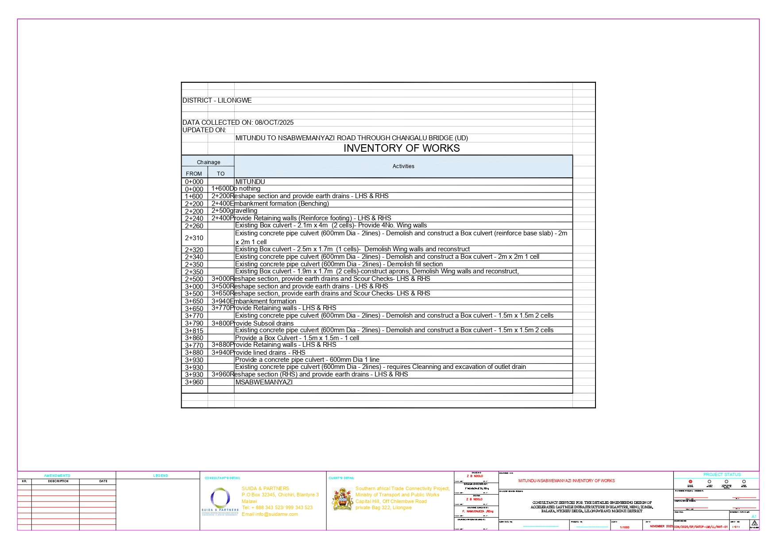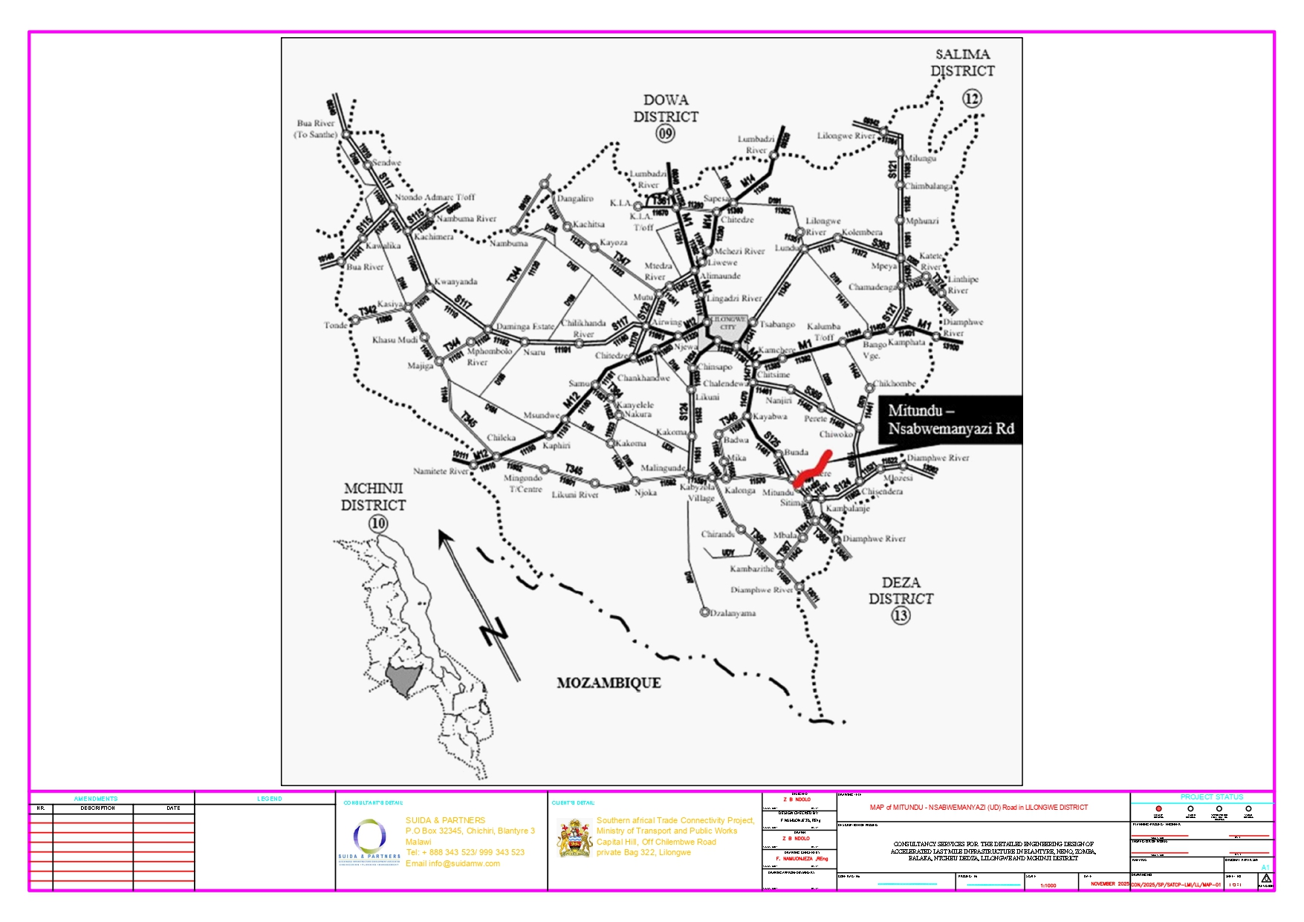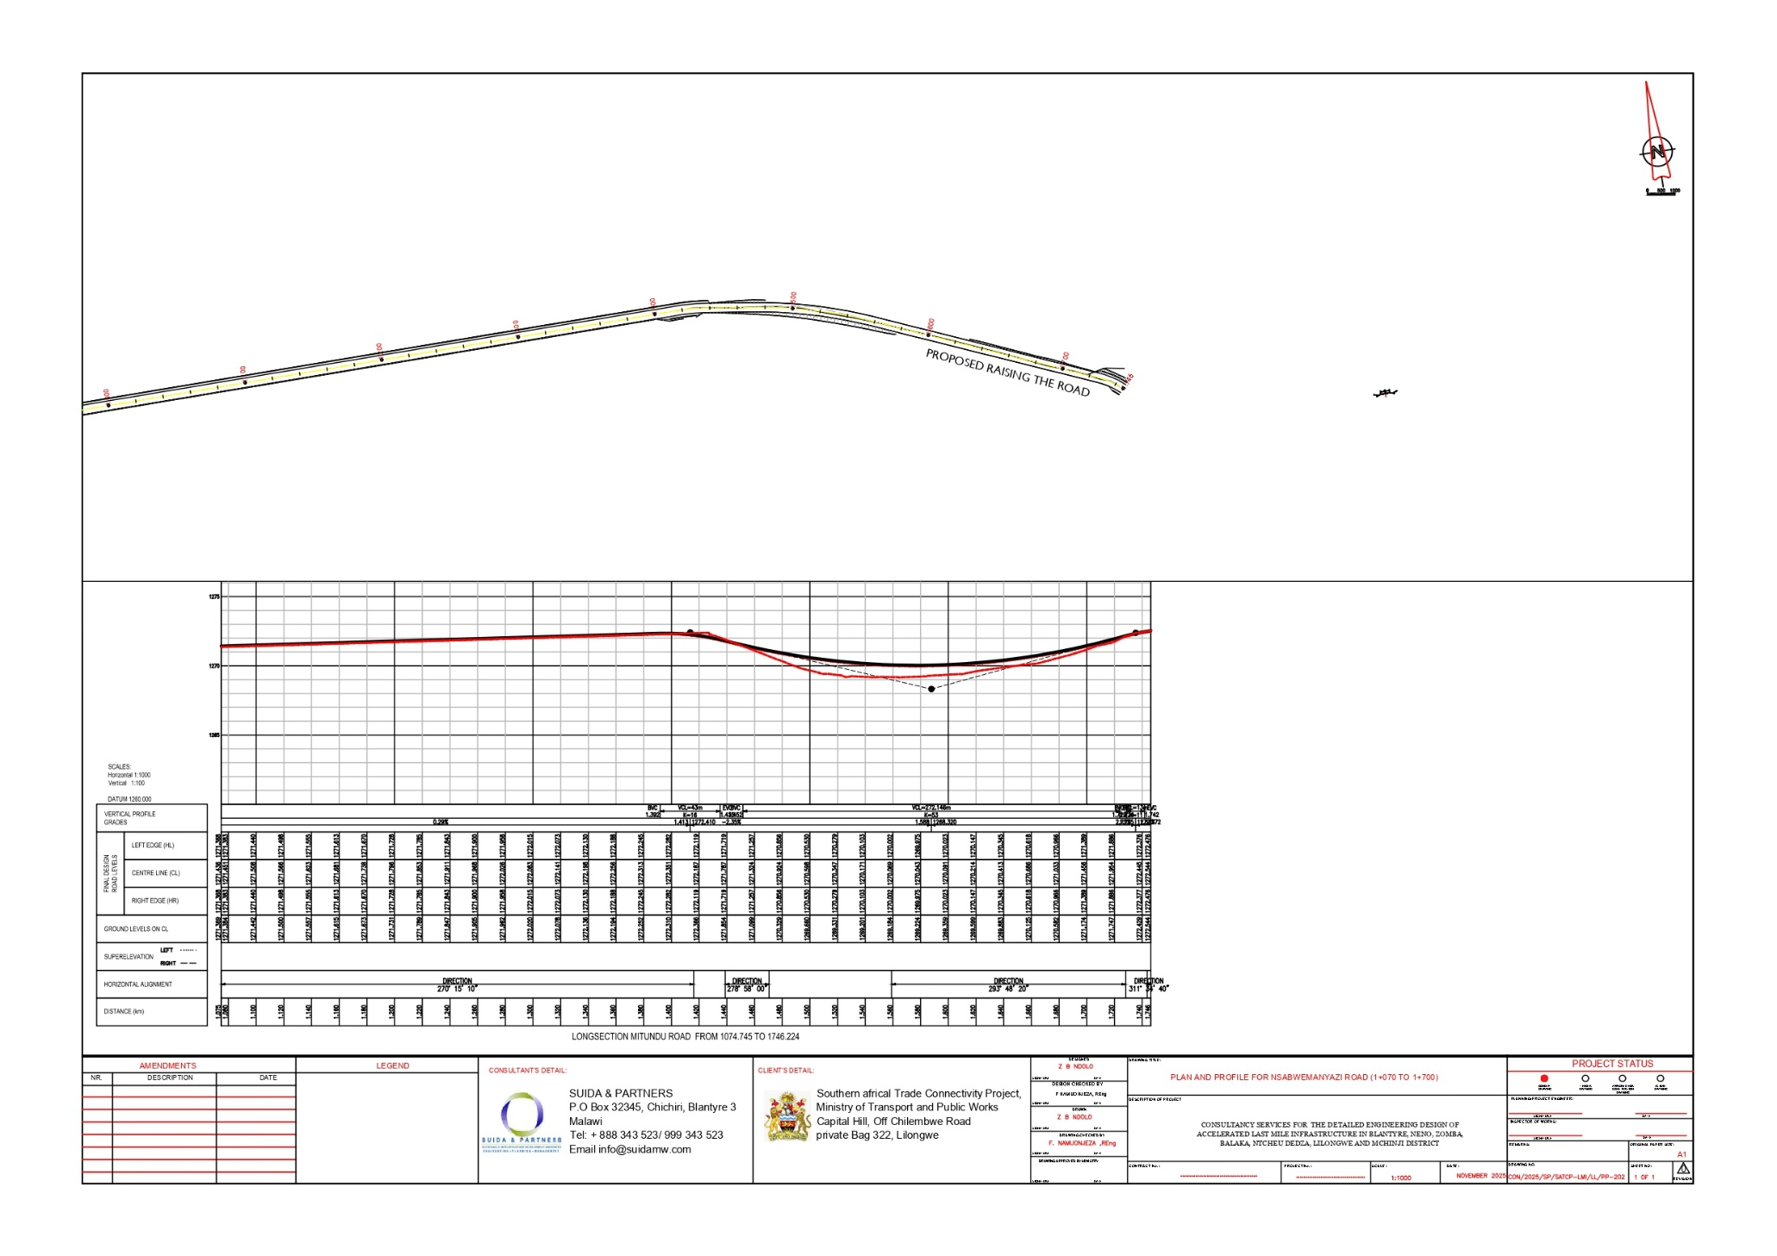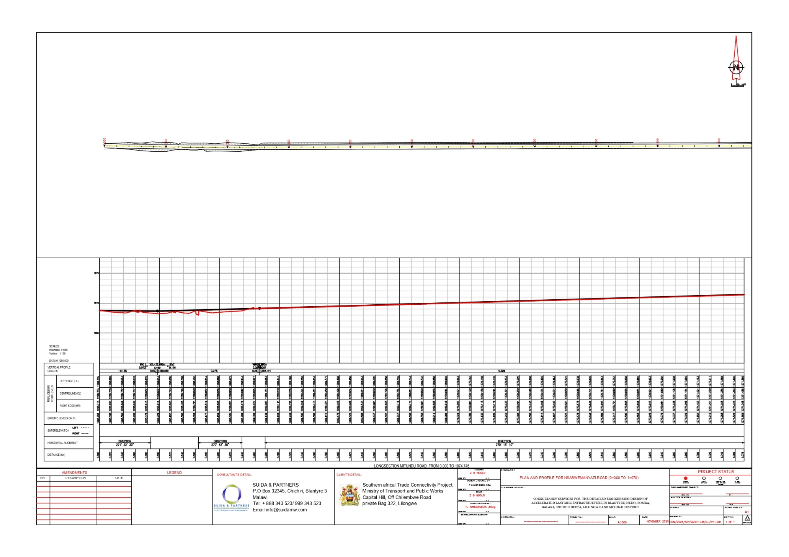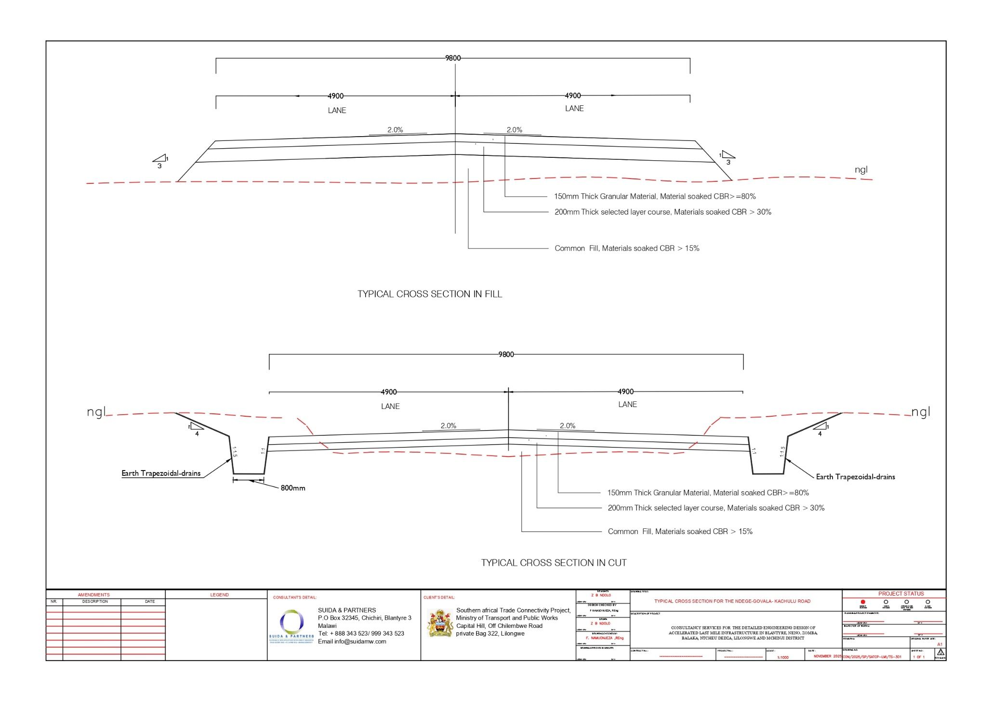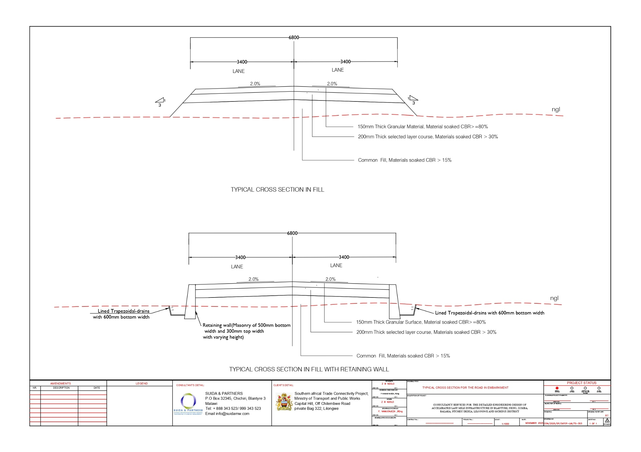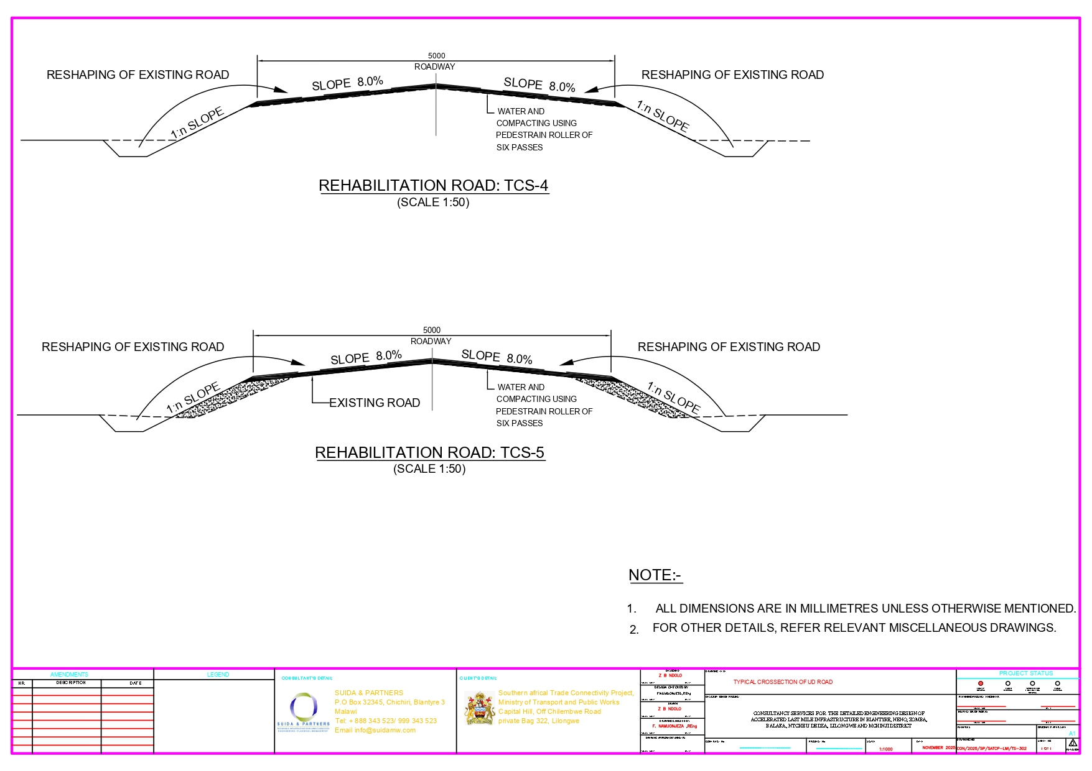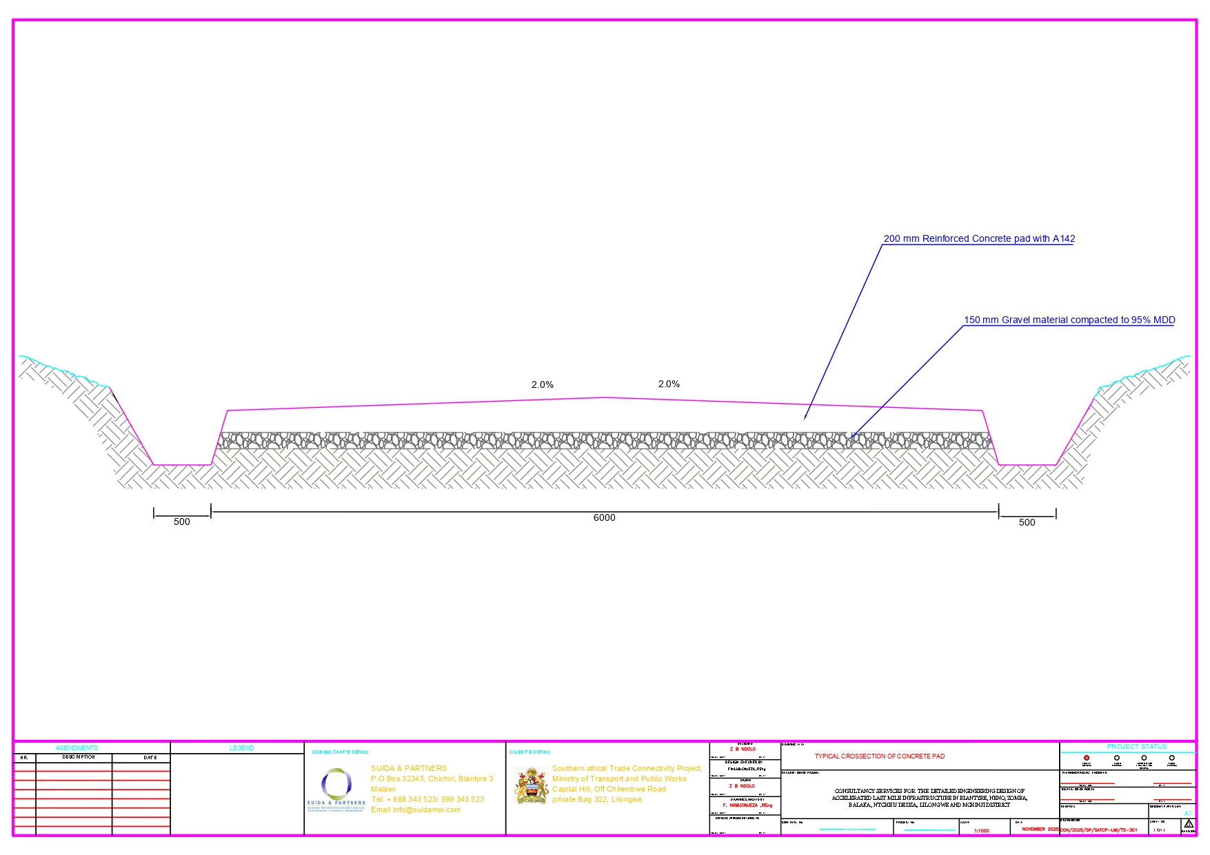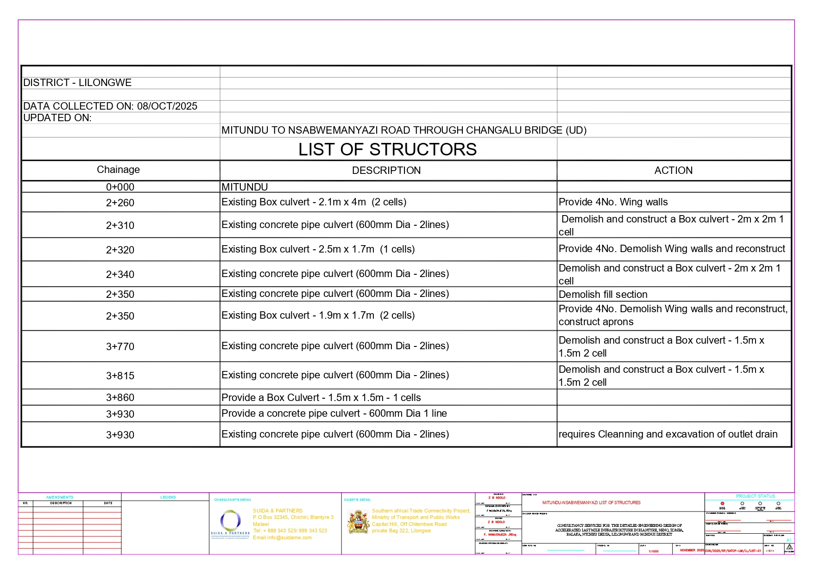

The road reserve and road centre line shown in this figure are indicative only and may not be spatially accurate due to the map scale, basemap limitations, and coordinate system/projection used. They are included for illustrative purposes only and must not be relied upon for surveying, land demarcation, or construction setting out

