
Government of Malawi

Ministry of Transport & Public Works

ENVIRONMENTAL AND SOCIAL MITIGATION AND MONITORING PLAN (ESMMP) FOR THE PROPOSED REHABILITATION OF BALAKA–MBELA–KACHENGA (S133/T381) ROAD IN BALAKA DISTRICT

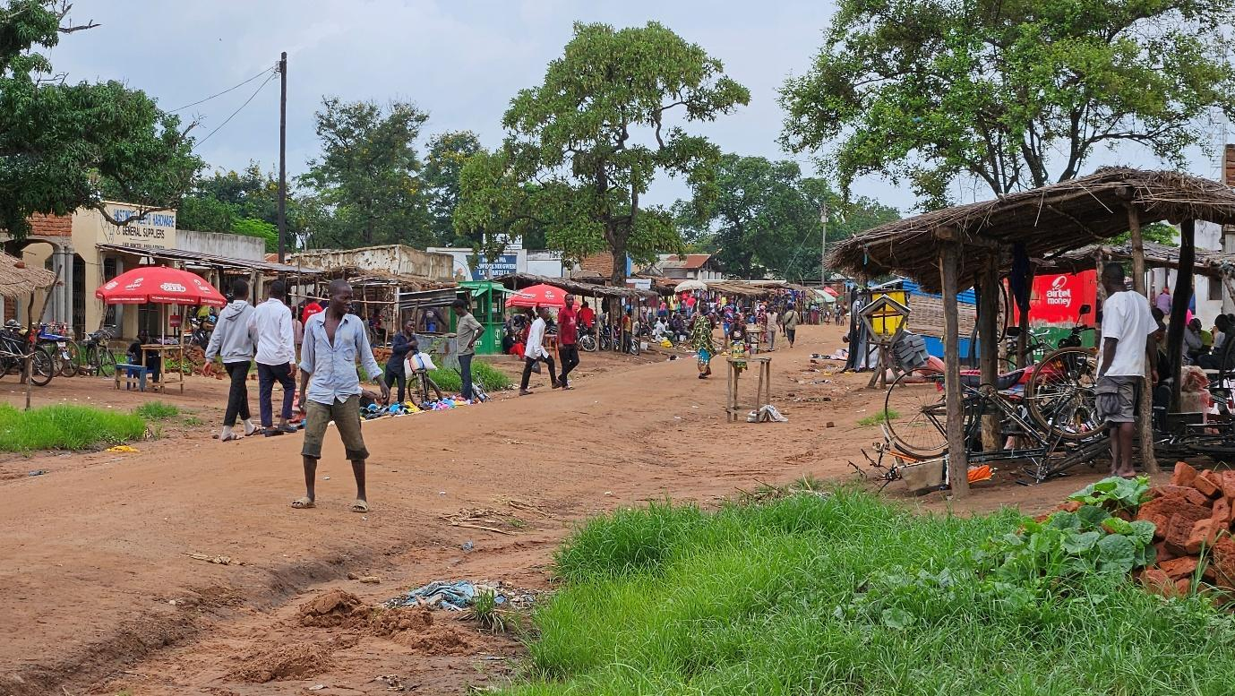

Ministry of Transport and Public Works
Southern Africa Trade and Connectivity Project
Private Bag 322
Lilongwe 3

18 JUNE 2026

EXECUTIVE SUMMARY
1.0 Project Background
The proposed rehabilitation of the Balaka–Mbela–Kachenga Road is a key intervention under the Southern Africa Trade and Connectivity Project (SATCP), funded by the World Bank and implemented by the Ministry of Transport and Public Works (MoTPW). The project involves the upgrading of approximately 15 km of the existing Balaka–Mbela–Kachenga feeder road in Balaka District to a durable gravel standard, including regravelling, drainage improvements, culvert installation, and associated earthworks. The rehabilitation works are estimated at USD 700,000, with implementation scheduled over a 10-month period from June 2026 to April 2027.
The road serves as an important rural transport corridor linking Balaka Town, Mbela Trading Centre, Kachenga, and surrounding agricultural communities. It plays a critical role in supporting agricultural production, market access, and mobility to health and education services, while facilitating socio-economic interaction within the district. Upgrading the road is therefore expected to significantly improve year-round accessibility, reduce travel time and vehicle operating costs, and strengthen rural economic linkages.
To address environmental and social considerations associated with the rehabilitation works, an Environmental and Social Mitigation and Monitoring Plan (ESMMP) has been prepared. The ESMMP ensures compliance with the Environment Management Act (2017), the Malawi Environment Protection Authority (MEPA) Guidelines for Environmental Assessment (2025), and the World Bank environmental and social safeguard requirements applicable to infrastructure rehabilitation projects.
The project will be implemented within the existing road reserve, and therefore no land acquisition or physical displacement is anticipated. Construction activities will occur over the project implementation period, with peak labour demand during earthworks, drainage construction, and gravel surfacing. The workforce will be predominantly locally sourced, creating temporary employment opportunities for both skilled and unskilled labour, including women and youth. No permanent employment is expected during the operation phase; as routine maintenance will continue to be carried out by MoTPW through existing road maintenance arrangements.
2.0 Nature and Scope of the Proposed Project
The proposed project involves the rehabilitation and upgrading of the existing Balaka–Mbela–Kachenga Road to improve accessibility, safety, and all-weather reliability. Key components of the project include:
- Improvement of the road formation and running surface;
- Construction and rehabilitation of drainage structures, including side drains, mitre drains, culverts, and flood-relief structures;
- Localised realignment and shaping to improve road safety and drainage;
- Rehabilitation of existing structures and installation of road safety features, including signage and traffic calming measures near settlements and schools;
- Sourcing of construction materials such as gravel, laterite, sand, and aggregates from approved sites;
- Rehabilitation of borrow pits and material sources after use.
3.0 Rationale of the Proposed Project
The Balaka–Mbela–Kachenga Road is a critical access route for predominantly rural communities whose livelihoods depend on agriculture, petty trading, and casual labour. Poor road conditions, particularly during the rainy season, currently constrain access to markets, health facilities, schools, and emergency services, and increase transport costs for farmers and traders.
Rehabilitation of the road is therefore essential to:
- Improve year-round connectivity and resilience to seasonal flooding;
- Reduce travel time and vehicle operating costs;
- Strengthen agricultural value chains and rural market participation;
- Enhance access to social services and economic opportunities.
4.0 Justification of the Study
Preparation of the ESMMP for the Balaka–Mbela–Kachenga Road is a requirement under the Environment Management Act (2017) and the MEPA Guidelines for Environmental Assessment (2025). The project involves rehabilitation of an existing road (15 kilometers) and is expected to generate localised, temporary, and reversible impacts that can be effectively managed through an ESMMP, without requiring a full Environmental and Social Impact Assessment (ESIA).
In line with national procedures, the ESMMP serves as a binding instrument to ensure that environmental, social, occupational health and safety, and gender-related risks are identified, mitigated, and monitored throughout the project life cycle. This ESMMP has also been prepared in line with the World Bank Operational Policies.
5.0 Objectives of the ESMMP
The objectives of the ESMMP are to:
- Identify potential environmental and social impacts and risks associated with the project;
- Define practical mitigation and enhancement measures for all project phases;
- Ensure compliance with national legislation, MEPA requirements, and World Bank safeguards;
- Protect the health and safety of workers and local communities;
- Establish monitoring, reporting, and corrective action mechanisms;
- Promote stakeholder engagement, transparency, and accountability.
6.0 Methodology Used to Prepare the ESMMP
The ESMMP was prepared using a structured approach consistent with MEPA requirements and international good practice. The methodology included:
- Desk review of relevant national policies, legislation, MEPA guidelines, project design documents, and World Bank safeguard requirements;
- Field assessments along the Balaka–Mbela–Kachenga Road corridor to document baseline biophysical and socio-economic conditions;
- Stakeholder consultations with District Council officials, traditional leaders, community representatives, and institutional stakeholders;
- Identification and analysis of key environmental and social risks related to drainage sensitivity, material sourcing, road safety, labour, and community health;
- Development of mitigation, enhancement, and monitoring measures tailored to site-specific conditions.
7.0 Summary of Key Positive Impacts and Enhancement Measures
- Improved project design responsiveness through incorporation of local biophysical and socio-economic conditions, including flat terrain, drainage sensitivity, trading centres, schools, and agricultural land use.
Enhancement Measures:
- Apply site-specific design solutions reflecting local terrain, drainage patterns, settlement layouts, schools, trading centres, and agricultural land use.
- Integrate context-appropriate drainage structures, access provisions, and road safety features into the final design.
- Maintain the existing road footprint where feasible to avoid encroachment on sensitive land uses and livelihoods.
- Document design adaptations in the ESMMP and supervision records and validate them through engagement with District Councils.
- Early identification of sensitive receptors (e.g. girls’ secondary schools, trading centres, wetlands), enabling risk reduction and informed planning.
Enhancement Measures:
- Identify and map sensitive receptors during planning and incorporate appropriate buffers and protection measures into project design.
- Engage school management, community leaders, and District Councils early to confirm access, safety, and protection requirements.
- Schedule construction activities to avoid peak school hours and periods of high community activity where feasible.
- Integrate sensitive-receptor management measures into bidding documents and the Contractor’s ESMMP.
- Opportunities for early planning of local employment and prioritisation of community labour.
Enhancement Measures:
- Integrate local labour requirements and recruitment principles into procurement and contract documents.
- Plan transparent and non-discriminatory recruitment procedures in consultation with Traditional Authorities and District Councils.
- Include provisions for gender-inclusive employment and basic skills development during construction.
- Early planning for sustainable sourcing of construction materials (borrow pits, gravel, sand), reducing ad hoc extraction and environmental degradation.
Enhancement Measures:
- Identify, screen, and approve borrow pits and material sources during planning, prioritising licensed sites and locations outside wetlands, dambos, and productive farmland.
- Include borrow pit management and rehabilitation requirements in bidding documents and contract conditions.
- Plan for progressive rehabilitation and post-use land restoration of material sites.
- Improved road quality and durability through controlled sourcing and use of construction materials.
Enhancement Measures
- Source gravel, sand, and laterite only from approved material sites.
- Control excavation depth, footprint, and haul routes and implement dust, erosion, and runoff controls.
- Reuse suitable excavated materials where technically feasible.
8.0 Summary of Key Negative Impacts and Mitigation Measures
- Inadequate consideration of local sensitivities (schools, trading centres, wetlands, informal road-reserve use) leading to avoidable social and safety risks.
Mitigation Measures:
- Undertake site-specific environmental and social screening during planning to identify schools, health facilities, trading centres, wetlands, and drainage-sensitive sections.
- Refine designs to incorporate appropriate buffers, access provisions, drainage structures, and road safety features in sensitive locations.
- Validate design assumptions through engagement with District Councils, Traditional Authorities, and affected communities.
- Poor early decisions on borrow pits, quarries, and sand sources increasing the risk of wetland degradation, farmland loss, or community conflict.
Mitigation Measures:
- Identify, screen, and approve environmentally acceptable material sources during planning, prioritising licensed or previously disturbed sites and locations outside wetlands, dambos, rivers, and productive farmland.
- Verify land ownership and secure documented landowner consent for proposed borrow pits.
- Integrate borrow pit management and rehabilitation obligations into the design, Bills of Quantities, and construction contracts.
- Dust, noise, vibration, and traffic safety risks, particularly near settlements, trading centres, and schools located within or adjacent to the road reserve.
Mitigation Measures:
- Implement dust suppression, noise control, and traffic management measures, with enhanced controls near schools and trading centres.
- Install warning signage, speed controls, and deploy flag persons where pedestrian activity is high.
- Restrict high-noise activities to daylight hours and avoid school hours where feasible.
- Temporary disruption of access to farms, markets, schools, and health facilities.
Mitigation Measures:
- There will be no access restrictions to formal and informal businesses as well as social infrastructure through use of of a one way traffic system, temporary diversions and pedestrian access routes
- Coordinate work schedules with community leaders to minimise disruption during peak activity periods.
- Labour influx–related risks, including pressure on local services, communicable disease transmission, and social tensions.
Mitigation Measures:
- Enforce a worker Code of Conduct covering acceptable behaviour, GBV/SEA/SH prevention, and community relations.
- Implement worker health screening, HIV/AIDS and communicable disease awareness programmes, and community sensitisation.
- Prioritise local labour recruitment to minimise labour influx where feasible.
- Environmental degradation from uncontrolled extraction of gravel, sand, or laterite, including riverbank erosion, wetland damage, farmland loss, and unsafe open pits.
Mitigation Measures:
- Restrict material extraction strictly to approved and permitted sites.
- Prohibit extraction from riverbeds, riverbanks, wetlands, and dambos.
- Clearly demarcate borrow pit boundaries and access routes and control excavation depth and footprint.
- Abandoned borrow pits and material sites posing safety hazards, mosquito breeding grounds, and land degradation.
Mitigation Measures:
- Rehabilitate all borrow pits and material sites through re-contouring and stabilisation of slopes, backfilling or reshaping where feasible, replacement of topsoil, and re-vegetation.
- Eliminate standing water to prevent mosquito breeding.
9.0 Conclusion and Recommendations
9.1 Conclusion
The rehabilitation of the Balaka–Mbela–Kachenga Road under the SATCP will deliver substantial socio-economic benefits through improved rural connectivity, enhanced access to markets and services, and short-term employment opportunities. While the project presents identifiable environmental and social risks, these risks are clearly defined, site-specific, and manageable through the implementation of the ESMMP.
All identified impacts—both positive and negative—are addressed using clearly articulated enhancement and mitigation measures, supported by measurable performance indicators and institutional responsibilities. With effective implementation, supervision, and monitoring, the project is assessed as environmentally and socially acceptable.
9.2 Recommendations
- Allocate adequate financial and technical resources to ensure full implementation of the ESMMP and associated monitoring activities.
- Implement all ESMMP measures as specified, ensuring adherence to approved mitigation actions, responsibilities, timelines, and monitoring indicators.
- Integrate ESMMP requirements into construction contracts and Bills of Quantities so that environmental and social obligations are fully costed and enforceable.
- Ensure all approved ESMMP mitigation measures are integrated into construction planning before mobilisation.
- Maintain strong coordination among Ministry of Transport and Public Works, Malawi Environment Protection Authority, and Balaka District Council to support implementation and compliance.
- Ensure construction begins only after environmental and social obligations in the approved ESMMP are incorporated into implementation arrangements.
- Conduct regular monitoring and inspections to verify implementation of mitigation measures and performance indicators.
- Ensure utility crossings are identified before excavation and accidental damage to community water pipes is repaired immediately.
- Limit vegetation clearance to approved work areas and rehabilitate disturbed sections using locally appropriate plant species.
- Maintain worker Codes of Conduct, communicable disease awareness, and GBV prevention measures during construction.
- Ensure borrow pits are fenced, signposted, access-controlled, and rehabilitated after use.
- Ensure that works are restricted to chainage sections identified in the approved design and in Table 2‑2, and that sensitive sections intentionally skipped to avoid physical displacement or significant loss of assets are not re‑introduced without prior environmental and social review.
- In the event that future design changes propose works beyond the existing road reserve or in currently skipped sections, those works will be reassessed separately and addressed in accordance with applicable national legislation and World Bank requirements prior to their implementation, and will not proceed under the current ESMMP scope.

ACRONYMS AND ABBREVIATIONS

AIDS | Acquired Immune Deficiency Syndrome
DED | Detailed Engineering Design
DESC | District Environment Sub-Committee
EHS | Environmental, Health and Safety
EMA | Environment Management Act
ESF | Environmental and Social Framework (World Bank)
ESHS | Environmental, Social, Health and Safety
ESIA | Environmental and Social Impact Assessment
ESMMP | Environmental and Social Mitigation and Monitoring Plan
ESMMP | Environmental and Social Management Plan
FGD | Focus Group Discussion
GBV | Gender-Based Violence
GBV/SEA | Gender-Based Violence / Sexual Exploitation and Abuse
GBV/SEA/SH | Gender-Based Violence / Sexual Exploitation and Abuse / Sexual Harassment
GIIP | Good International Industry Practice
GRM | Grievance Redress Mechanism
HIV | Human Immunodeficiency Virus
HIV/AIDS | Human Immunodeficiency Virus / Acquired Immune Deficiency Syndrome
IEC | Information, Education and Communication
IUCN | International Union for Conservation of Nature
LC | Local Council
LMI | Last Mile Infrastructure
MEPA | Malawi Environment Protection Authority
OHS | Occupational Health and Safety
OP/BP | Operational Policy / Bank Procedure (World Bank)
PPE | Personal Protective Equipment
RA | Roads Authority
RHS | Right-Hand Side
SATCP | Southern Africa Trade and Connectivity Project
SEA | Sexual Exploitation and Abuse
SEA/SH | Sexual Exploitation and Abuse / Sexual Harassment
SEP | Stakeholder Engagement Plan
SH | Sexual Harassment
STA | Sub-Traditional Authority
WMP | Waste Management Plan

TABLE OF CONTENTS

1 CHAPTER 1: INTRODUCTION AND BACKGROUND 1
1.1 Introduction 1
1.2 Project Background 1
1.3 Developer Details 2
1.4 Nature and Scope of the Project 2
1.5 Project Objectives 2
1.6 Justification of the Project 2
1.7 Objectives of the ESMMP 3
1.8 Rationale of the ESMMP 3
1.9 Methodology 4
1.10 Project Location 4
1.11 Land Tenure and Land Requirement for the Project 11
1.12 Potential Users of the ESMMP 11
2 CHAPTER 2: PROJECT DESCRIPTION 13
2.1 Introduction 13
2.2 Project Components and Activities 13
2.3 Spatial Distribution of Works by Chainage 14
2.4 Labour Requirement 16
2.5 Material Requirements and Sources 17
2.6 Worker Accommodation and Facilities 18
2.7 Waste and Waste Management 18
2.8 Rehabilitation of Temporary Structures 19
3 CHAPTER 3: POLICY AND LEGAL FRAMEWORK 20
3.1 Introduction 20
3.2 National Policies and Strategies 20
3.2.1 Policy Framework 20
3.2.2 Legislative Framework 21
3.3 World Bank Safeguard Policies and Procedures 23
3.3.1 World Bank Operational Policy OP/BP 4.01: Environmental Assessment 23
3.3.2 World Bank Environmental, Health and Safety (EHS) Guidelines 25
3.3.3 World Bank Requirements on Sexual Exploitation and Abuse (SEA) and Sexual Harassment (SH) 25
3.4 Institutional Framework 26
3.5 Summary of Main Statutory Approvals/Licenses to be Obtained for the Project 27
4 CHAPTER 4: ENVIRONMENTAL AND SOCIAL SETTING 28
4.1 Introduction 28
4.2 Biophysical Environment 28
4.2.1 Topography 28
4.2.2 Geology 28
4.2.3 Soils 31
4.2.4 Climate and Climate Change Risks 33
4.2.5 Water Resources 35
4.2.6 Flora of the Project Area 38
4.2.7 Fauna of the Area 42
4.2.8 Sanitation and Waste Management 45
4.2.9 Implications for the Project 46
4.3 Socio-economic environment 47
4.3.1 Demographic Characteristics 47
4.3.2 Education and Literacy 47
4.3.3 Health 48
4.3.4 Cultural Heritage 48
4.3.5 Agriculture 49
4.3.6 Economic Activities/Livelihoods 49
4.3.7 Transport 50
4.3.8 Security 51
4.3.9 Land Use 51
4.3.10 Vulnerable and Marginalized Groups 52
4.3.11 Communication 52
4.3.12 Energy Sources 52
5 CHAPTER 5: ENVIRONMENTAL AND SOCIAL MITIGATION AND MONITORING PLAN 54
5.1 Introduction 54
5.2 Environmental and Social Mitigation and Monitoring Plan for Balaka Mbela Kachenga Road 56
5.3 Institutional Capacity for ESMMP Implementation 66

LIST OF TABLES

Table 1-1. Potential Users of the ESMMP and Their Roles 11
Table 2-1. Project Components and Activities 13
Table 2-2. Spatial Distribution of Works by Chainage 15
Table 2-3. Expected Number of People to be Employed (Peak Workforce) 16
Table 2-4. Material required, estimated quantities, potential sources 17
Table 2-5. Waste Streams and Waste Management 18
Table 3-1: Policies Guiding the project 20
Table 3-2: Legislation Guiding the Project 21
Table 3-3. World Bank Environmental and Social Safeguard Policies Applicable to the Project 24
Table 3-4. Institutional mandates on Environmental and Social Safeguards related to the Project 26
Table 3-5: Summary of statutory Approvals and Licenses Required 27
Table 5-5-1. Institutional Responsibilities for ESMMP Implementation and Oversight 67

LIST OF FIGURES

Figure 1-1 Consultation with Balaka DESC 4
Figure 1-2: Location of the proposed Balaka – Mbela – Kachenga Road (S133/381) Road 6
Figure 1-3 : Location of the proposed road in Balaka 7
Figure 1-4: Balaka section of the road 8
Figure 1-5: Toleza Farm section of the road 9
Figure 1-6: Mbela Trading Centre, on the far end of the road 10
Figure 4-1: Geological Map of the Kachenga - Mbela Road section 30
Figure 4-2: Soils of the proposed project area 32
Figure 4-3: Soils within the wetland section and Dark sandy-loam soils within the Toleza Farm Section 33
Figure 4-4: Average Monthly Temperature Pattern (1951–2022) for the Balaka–Mbela–Kachenga Road Section 33
Figure 4-5: Monthly Rainfall Distribution for Balaka District 34
Figure 4-6: Average Monthly Sunshine Duration for Balaka District 34
Figure 4-7: Hydrological map of the area 37
Figure 4-8: Pictorial view of Senna siamea species observed in Balaka- Mbela proposed road project area. 38
Figure 4-9Grasses are a major vegetative composition of the road section 38
Figure 4-10: Flora Species Sampled from the Balaka- Mbela Project Area and their Conservation Status 39
Figure 4-11: Protected species; Pericopsis angolensis in Balaka- Mbela proposed road project area 41
Figure 4-12: Lantana camara an inasive species grown as ornamental at Tepu Trading Centre 41
Figure 4-13: Pictorial view of the vegetation community in Toleza farm 42
Figure 4-14: Mammal Species Recorded in the Balaka–Mbela Road Project Area and Their Conservation Status 43
Figure 4-15: Bird Species Recorded in the Balaka–Mbela Road Project Area and Their Conservation Status 43
Figure 4-17: Reptile Species Recorded in the Balaka–Mbela Road Project Area and Their Conservation Status 44
Figure 4-18: Amphibian Species Recorded in the Balaka–Mbela Road Project Area and Their Conservation Status 44
Figure 4-19: Macro-Invertebrate Species Recorded in the Balaka–Mbela Road Project Area and Their Conservation Status 44
Figure 4-20: Elegant grasshopper (Zonocerus elegans) Recorded within the Project Area 45
Figure 4-21: Mbela Trading Centre 46
Figure 4-22: A clinic towards the Balaka Town approach 48
Figure 4-23: Mixed farming along the corridor 49
Figure 4-24: Lime factory operations along the corridor road 50
Figure 4-25: A pick-up transporting passenger along the proposed route 51
Figure 4-27: Cyclists transporting charcoal to the market along the corridor 53

List of annexes

Annex 1. Feedback Letter from MEPA

Annex 2. Terms of Reference from MEPA

Annex 3a. List of Stakeholders Consulted

Annex 3b. Issues raised by Stakeholders and how they have been addressed in ESMMP

Annex 4. Sample Code of Conduct for Contractors

Annex 5. Barrow Pit Rehabilitation Framework

Annex 6. Traffic Management Framework

Annex 7. Chance Find Procedure for Last Mile Infrastructure under SATCP

Annex 8: Labour Management Guidelines for Contractor Compliance and Preparation of Labour Management Plans (LMPs)

Annex 13. Flora and Animal Species of Balaka-Kachenga Corridor

Annex 14-B. Animal Species

Annex 14. SATCP LMI Grievance Redress Mechanism (GRM) Protocol

Annex 15. Spatial distribution of Works

Annex 16. Project Drawings

CHAPTER 1: INTRODUCTION AND BACKGROUND

Introduction
This Environmental and Social Management Plan (ESMMP) has been prepared for the Proposed Rehabilitation of the Balaka–Mbela–Kachenga Road (S133/T381) in Balaka District, Malawi, one of the priority Last Mile Infrastructure (LMI) subprojects under the Southern Africa Trade and Connectivity Project (SATCP) implemented by the Government of Malawi through the Ministry of Transport and Public Works. The LMI initiative aims to strengthen rural transport connectivity between agricultural production areas, trading centres, and the primary transport corridors that support domestic and regional trade flows. These investments are intended to improve market access for rural producers, reduce transport costs, and enhance the resilience of rural mobility systems.
The proposed intervention involves the rehabilitation and gravelling of approximately 15 km of the existing road corridor, including improvements to drainage infrastructure, culvert installation and upgrading, embankment stabilisation, and localized flood protection works. The estimated cost of the subproject is approximately USD 700,000, with an anticipated implementation period from June 2026 to April 2027.
While the project is expected to generate significant socio-economic benefits—such as improved mobility, enhanced access to markets, health and education facilities, and stimulation of local economic activity—it may also generate localized environmental and social risks associated with earthworks, borrow material extraction, drainage modification, construction traffic, and worker–community interactions. Accordingly, this ESMMP has been prepared in accordance with the Environment Management Act (2017), the Malawi Environment Protection Authority (MEPA) Guidelines for Environmental Assessment (2025), and the World Bank Operational Policy OP/BP 4.01 on Environmental Assessment. The ESMMP provides a structured framework for applying the mitigation hierarchy—avoidance, minimisation, mitigation, and management—to ensure that potential adverse environmental and social impacts are systematically addressed.

Project Background
The Balaka–Mbela–Kachenga (S133/T381) Road serves as an important feeder link within the Nacala Development Corridor, which connects Malawi to the Port of Nacala in Mozambique and supports regional trade flows. However, the existing road has deteriorated due to poor drainage, damaged culverts, embankment erosion, and seasonal flooding, leading to reduced accessibility, increased transport costs, and disruptions to movement of people, goods, and services. The proposed project will rehabilitate the existing alignment through drainage improvements, culvert upgrading, embankment stabilisation, and flood protection works.

Developer Details
Name of Developer: | Ministry of Transport and Public Works
Physical Address: | The Project Manager  Southern Africa Trade and Connectivity Project  Private Bag 322  Lilongwe 3
Contact Person: | The Project Manager  Southern Africa Trade and Connectivity Project  Ministry of Transport and Public Works  Private Bag 322  Lilongwe 3.  Cell: 0999088044  Email: hastingsngoma@gmail.com

Nature and Scope of the Project
The project involves rehabilitation of the existing road through drainage improvement, culvert upgrading, embankment stabilisation, and flood protection measures. Key activities include cleaning and reconstructing roadside drains, installing mitre drains, replacing undersized culverts with appropriately sized box culverts, repairing culvert headwalls, and implementing inlet and outlet protection works to control erosion. Additional works include reshaping the road formation to improve surface drainage and riding quality, stabilising embankments in flood-prone areas, and implementing flood management measures at critical crossings such as the Luwawadzi area.
The interventions are linear and site-specific, implemented along defined chainages within the existing road reserve, and include ancillary measures such as temporary traffic management and reinstatement of disturbed areas. No permanent land acquisition or realignment of the road alignment is anticipated

Project Objectives
The Balaka–Mbela–Kachenga (S133/T381) Road Rehabilitation Project aims to restore the functionality, safety, and climate resilience of the existing road corridor in Balaka District through rehabilitation of deteriorated sections, upgrading of drainage infrastructure, and treatment of flood-prone areas to ensure reliable all-weather access and improved road passability.
The project also seeks to improve movement of people, agricultural produce, and goods between surrounding communities, trading centres, and service facilities by reducing travel constraints caused by poor road conditions, seasonal flooding, and drainage failure. In addition, the intervention aims to enhance road durability through embankment stabilisation, culvert rehabilitation, and flood protection measures while supporting safer road use for local communities and road users.

Justification of the Project
The rehabilitation of the Balaka–Mbela–Kachenga (S133/T381) Road is justified by technical, socio-economic, environmental, and strategic considerations. Technically, the road has deteriorated due to inadequate drainage, damaged culverts, embankment erosion, and recurrent flooding, which reduce passability during the rainy season, increase vehicle operating costs, and compromise road safety. Rehabilitation is therefore necessary to restore reliable functionality and prevent further infrastructure degradation.
Socio-economically, the road serves predominantly agricultural communities in Balaka District and provides critical access to markets, trading centres, schools, and health facilities. Poor road conditions limit movement of agricultural produce, contribute to post-harvest losses, and constrain rural livelihoods. Improving the road will strengthen agricultural value chains, enhance rural mobility, and support local economic development.
Strategically, the road acts as a last-mile link to the Nacala Development Corridor, connecting rural production areas to higher-order transport networks that facilitate regional trade through the Port of Nacala in Mozambique. Upgrading the road will therefore improve the efficiency and competitiveness of agricultural commodity flows within the corridor.
The project also addresses climate resilience challenges, as recurrent flooding and erosion highlight the road’s vulnerability to extreme rainfall. The proposed works incorporate improved drainage, embankment protection, and flood mitigation measures to enhance long-term infrastructure resilience.

Objectives of the ESMMP
The Environmental and Social Management Plan (ESMMP) provides a practical framework for identifying, managing, and monitoring environmental and social risks associated with the rehabilitation of the Balaka–Mbela–Kachenga (S133/T381) Road. Its main purpose is to ensure that project impacts arising from construction and operation activities—such as drainage works, culvert upgrades, embankment formation, and flood protection—are avoided, minimized, or mitigated in accordance with the mitigation hierarchy.
The ESMMP establishes clear institutional responsibilities, defines site-specific mitigation measures, and sets out a monitoring framework with measurable indicators to ensure compliance with national legislation and safeguard requirements, including the Environment Management Act (2017), MEPA Guidelines for Environmental Assessment (2025), and World Bank OP/BP 4.01. It also integrates occupational health and safety, community health and safety, labour management, gender and social inclusion, and GBV/SEA risk management, while providing mechanisms for stakeholder engagement and grievance redress.

Rationale of the ESMMP
The Malawi Environment Protection Authority (MEPA) reviewed the project brief for the rehabilitation and upgrading of the Balaka–Mbela–Kachenga Road to gravel standard and formally determined that the project requires preparation of an Environmental and Social Management Plan (ESMMP) in accordance with the Environment Management Act (2017) before implementation can commence.
Through its determination, MEPA issued Terms of Reference (ToR) outlining the required scope of the ESMMP. These require the project to: provide a detailed description of the project location, objectives, costs, inputs, and workforce; prepare site maps and plans showing the project area and surrounding environmental features; describe the main construction activities, including drainage works, borrow pit operations, road safety features, materials sourcing, machinery use, and expected waste streams; and obtain necessary permits, including borrow pit approvals from Balaka District Council.
The ToR further require the ESMMP to review the relevant legal and policy framework, including environmental, land, water, gender, occupational safety, and public health legislation, and to identify, assess, and analyse potential environmental, social, and climate change impacts associated with the proposed rehabilitation activities.

Methodology
The ESMMP was prepared using a structured three-phase approach aligned with the Environment Management Act (2017), Malawi Environment Protection Authority Guidelines for Environmental Assessment (2025), and World Bank OP/BP 4.01, together with applicable environmental and social safeguard requirements. The methodology combined literature review, field assessments, and stakeholder consultations to identify and assess environmental and social risks associated with the rehabilitation of the Balaka–Mbela–Kachenga Road.
A literature review was conducted on relevant national legislation, sector policies, World Bank safeguard requirements, the Detailed Engineering Design (DED), and the MEPA-issued Terms of Reference to establish regulatory, technical, and safeguard context. Field visits conducted on 16 January 2026 assessed baseline environmental and social conditions along the road corridor, focusing on road condition, drainage systems, culverts, flood-prone areas, land use, settlements, and environmental sensitivities.
Stakeholder consultations, also held on 16 January 2026, involved the Balaka District Environment Sub-Committee (DESC) and community representatives at Mbela Trading Centre to gather local perspectives on drainage issues, road safety, livelihoods, access during construction, and employment opportunities. The findings from these three phases informed the impact assessment and mitigation measures presented in the ESMMP.

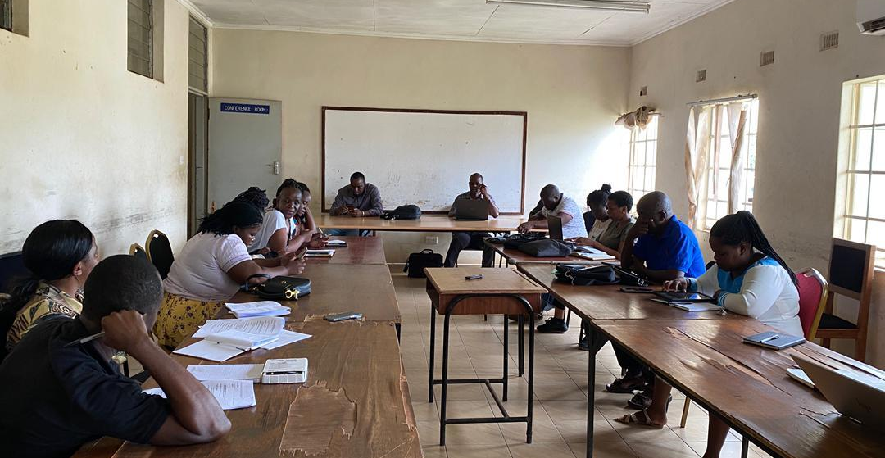
Figure 1-1 Consultation with Balaka DESC

Project Location
The Balaka–Mbela–Kachenga (S133/T381) Road is located in Balaka District, Southern Region of Malawi, and forms part of the district’s secondary road network, providing connectivity between Balaka Town and surrounding rural trading centres and settlements. The project road starts from Balaka Town (locally referred to as pa Chintengo) at Chainage 0+000 m and extends to Mbela Trading Centre at approximately Chainage 14+000 m.
Geographically, the road alignment lies between approximate coordinates Longitude 34.965282° E, Latitude –14.980292° S at the Balaka Town end and Longitude 35.051903° E, Latitude –14.914235° S at the Mbela Trading Centre end. The road traverses predominantly rural landscapes characterised by mixed land uses, including smallholder agricultural fields, dispersed settlements, and trading centres. Detailed maps showing the project location, road alignment, and key spatial features are provided in the relevant annexes of this ESMMP.

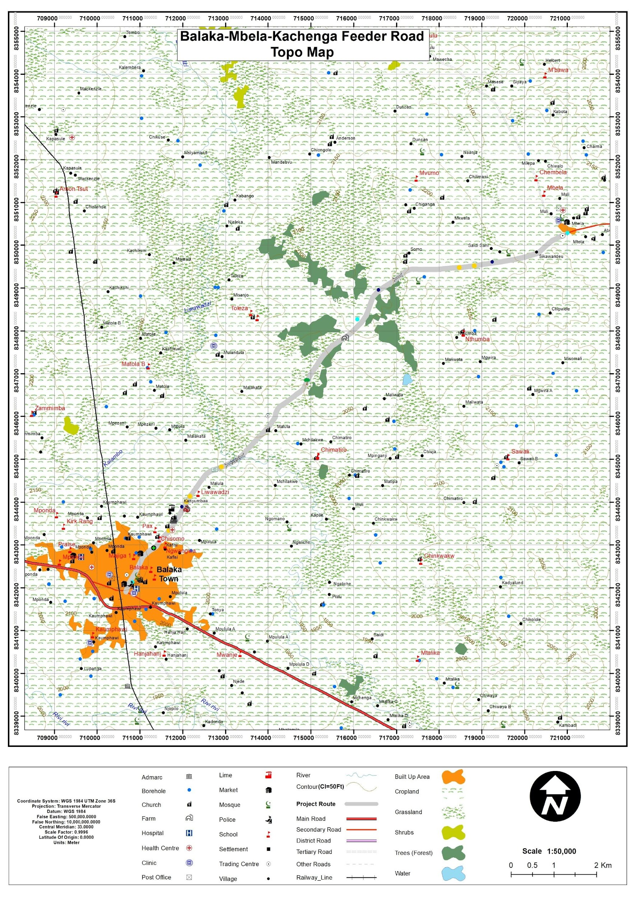
Figure 1-2: Location of the proposed Balaka – Mbela – Kachenga Road (S133/381) Road
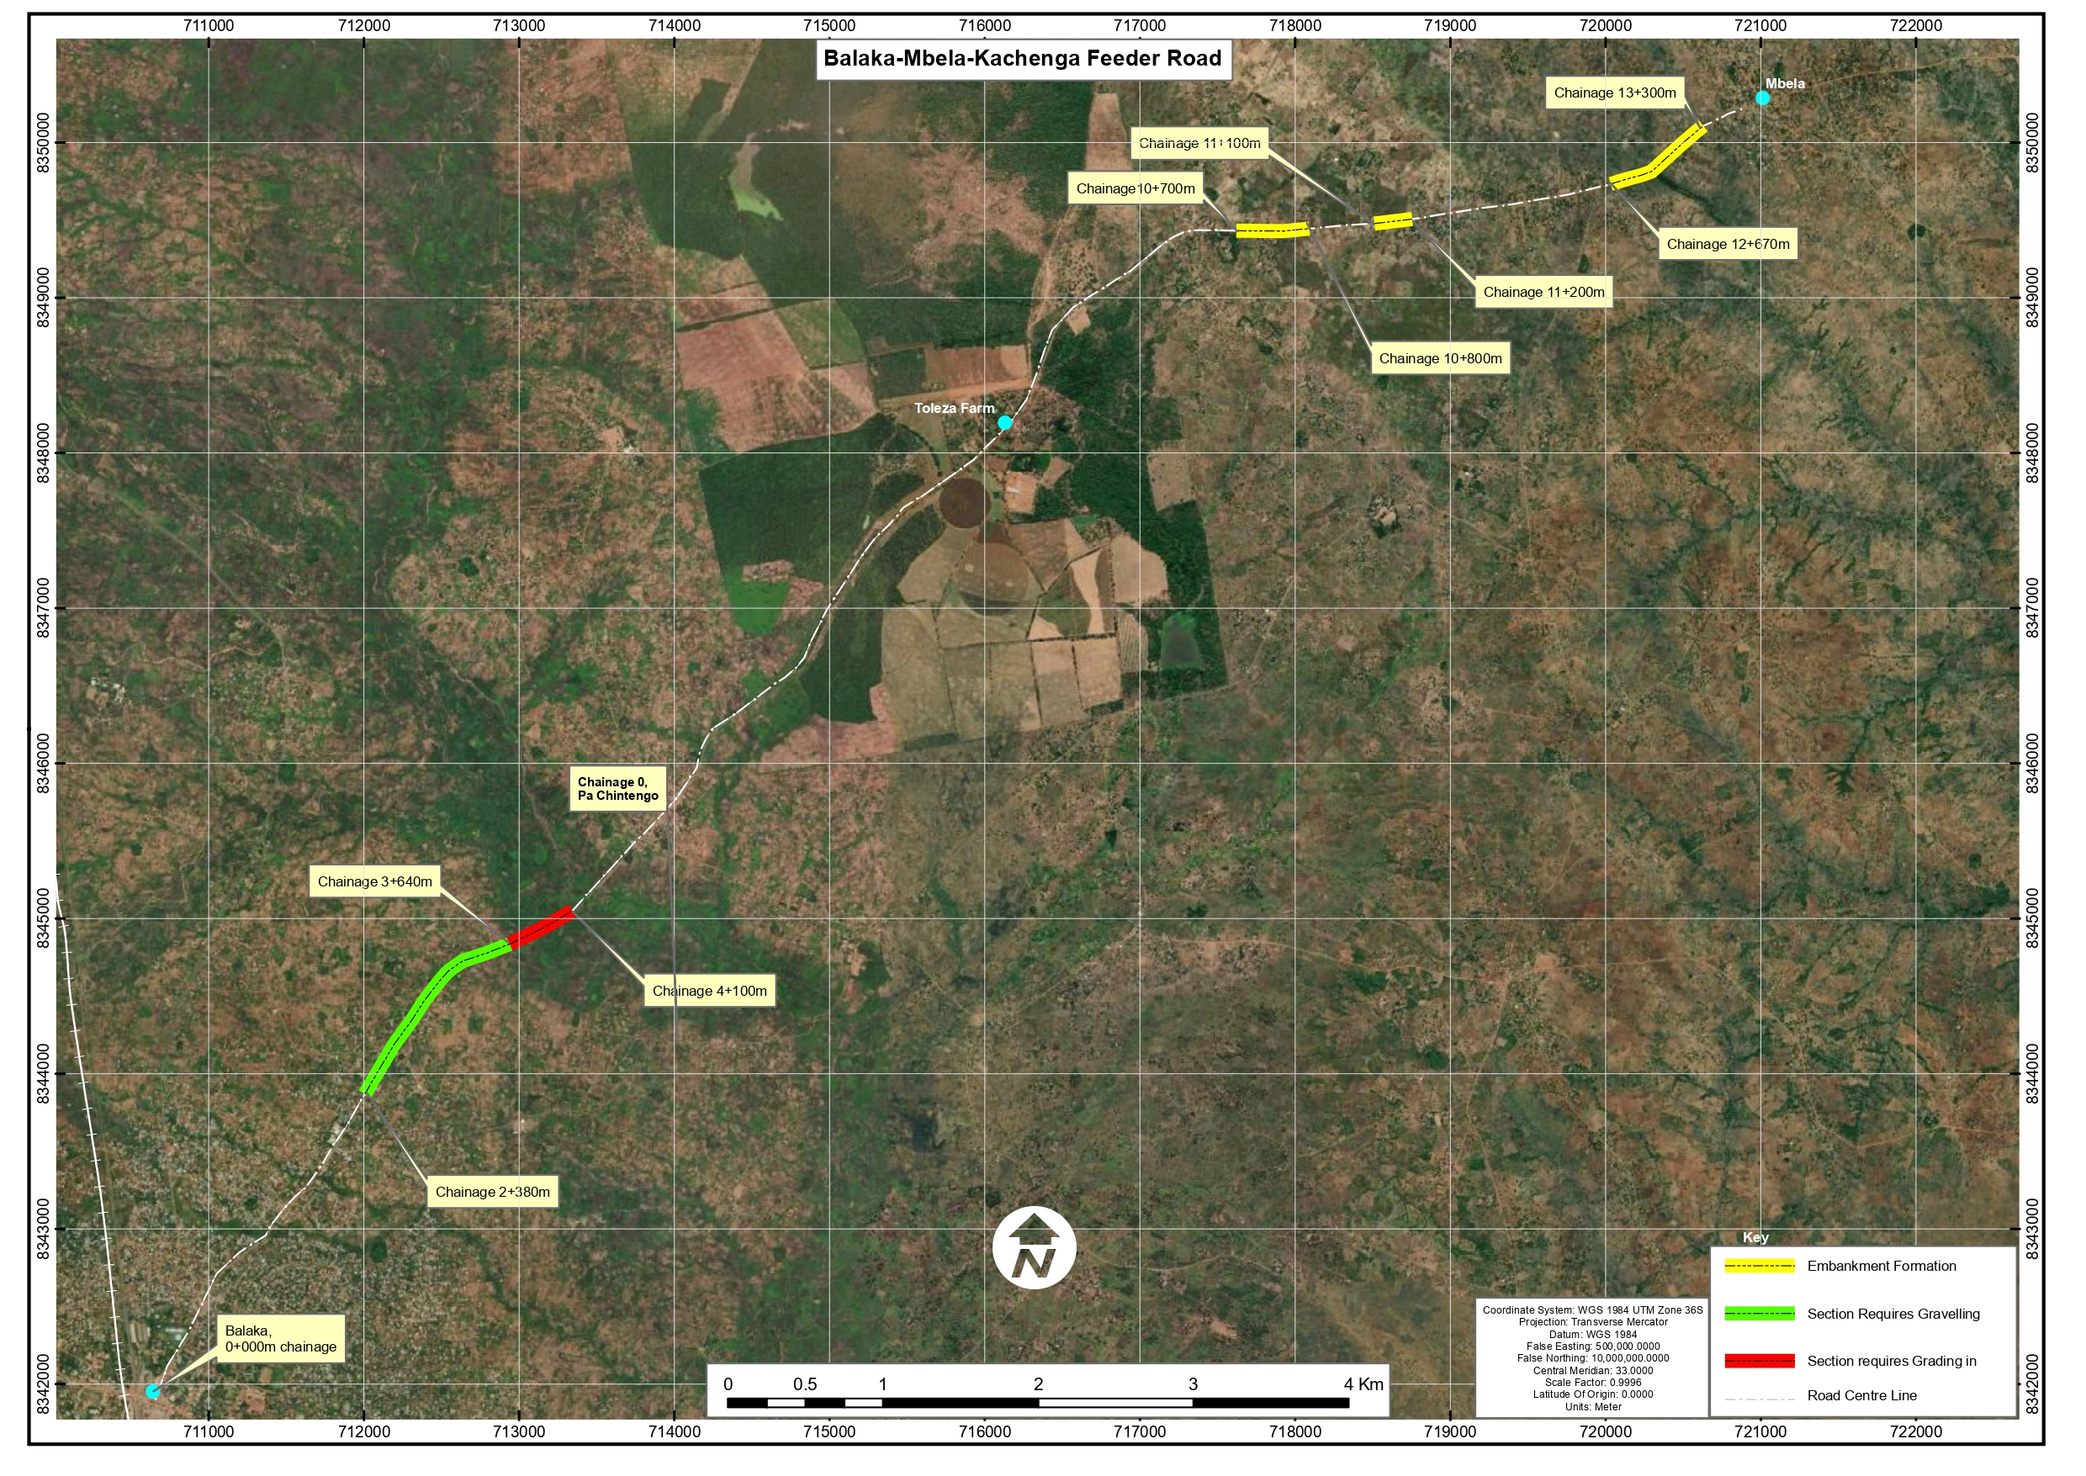
Figure 1-3 : Location of the proposed road in Balaka
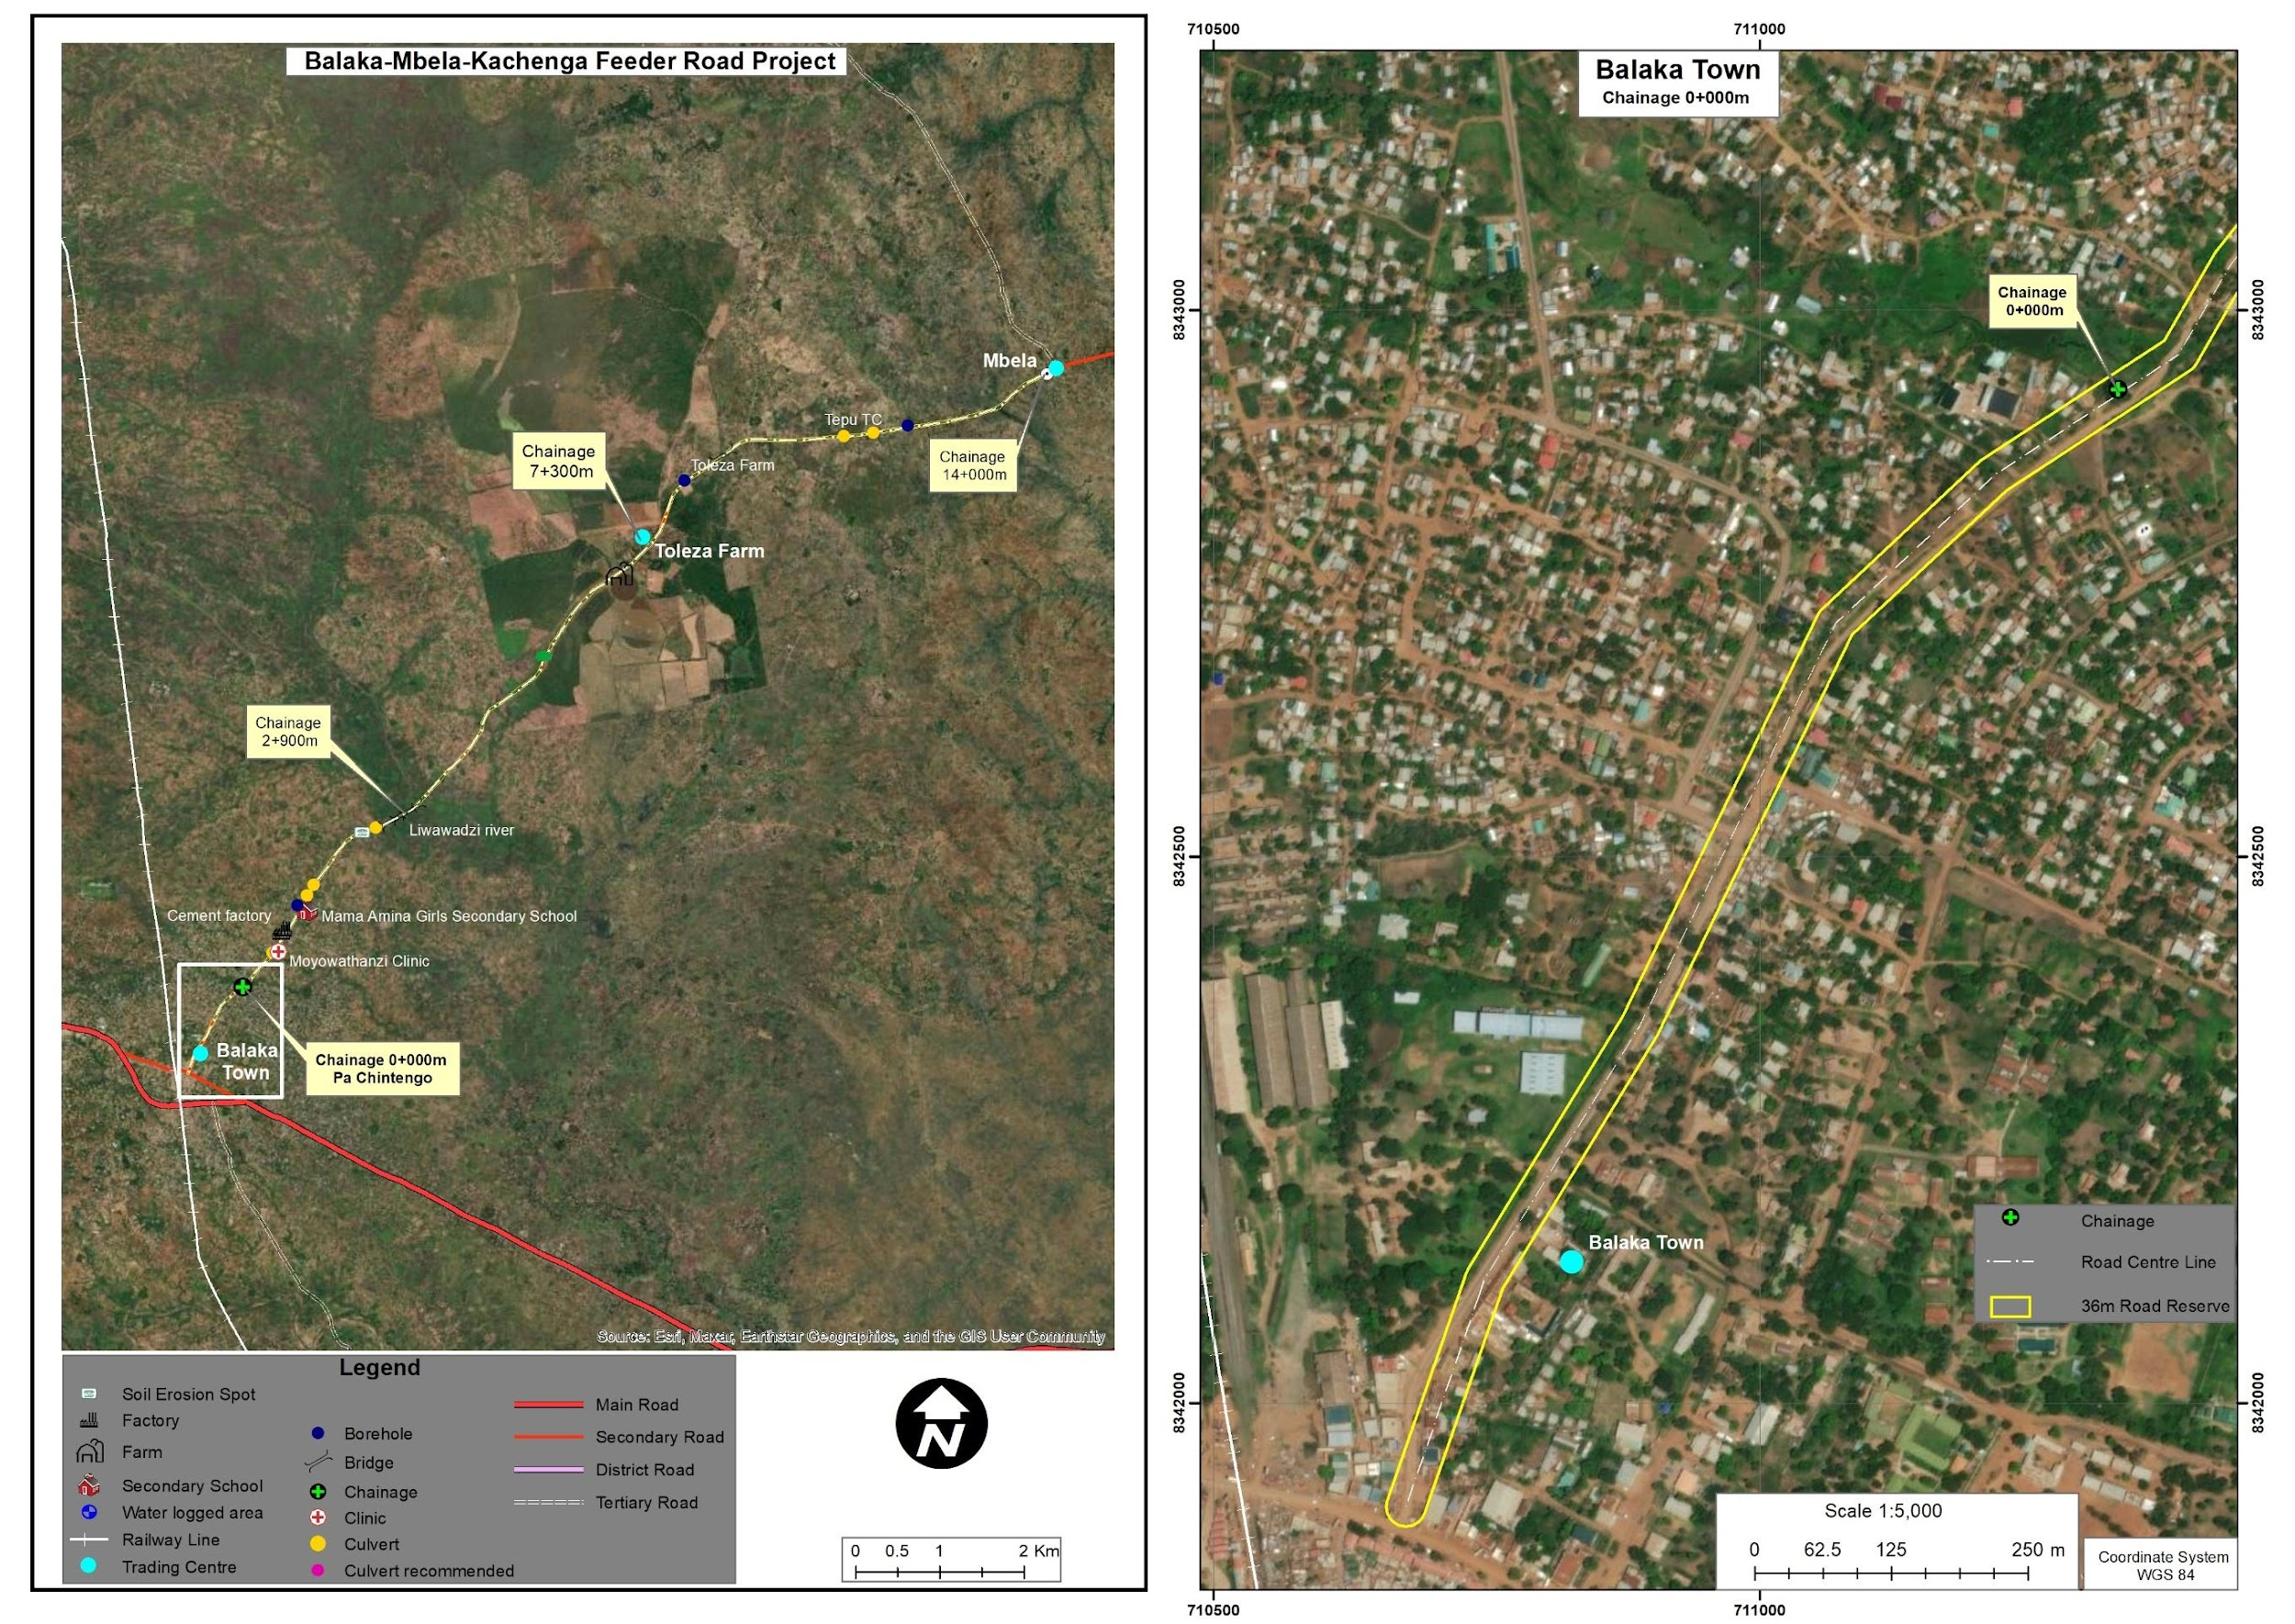
Figure 1-4: Balaka section of the road
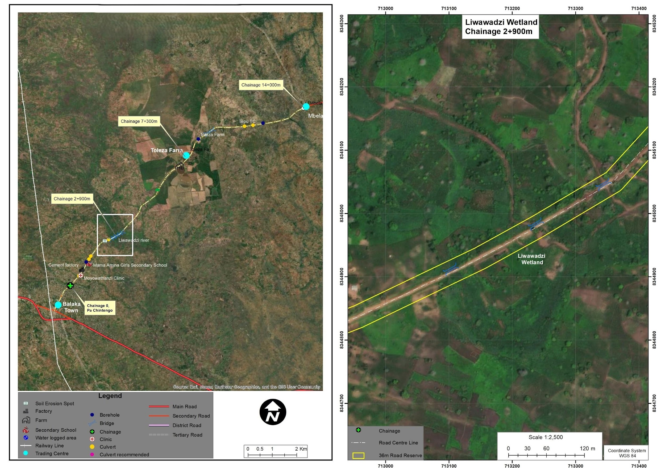
Figure 1-5: Toleza Farm section of the road
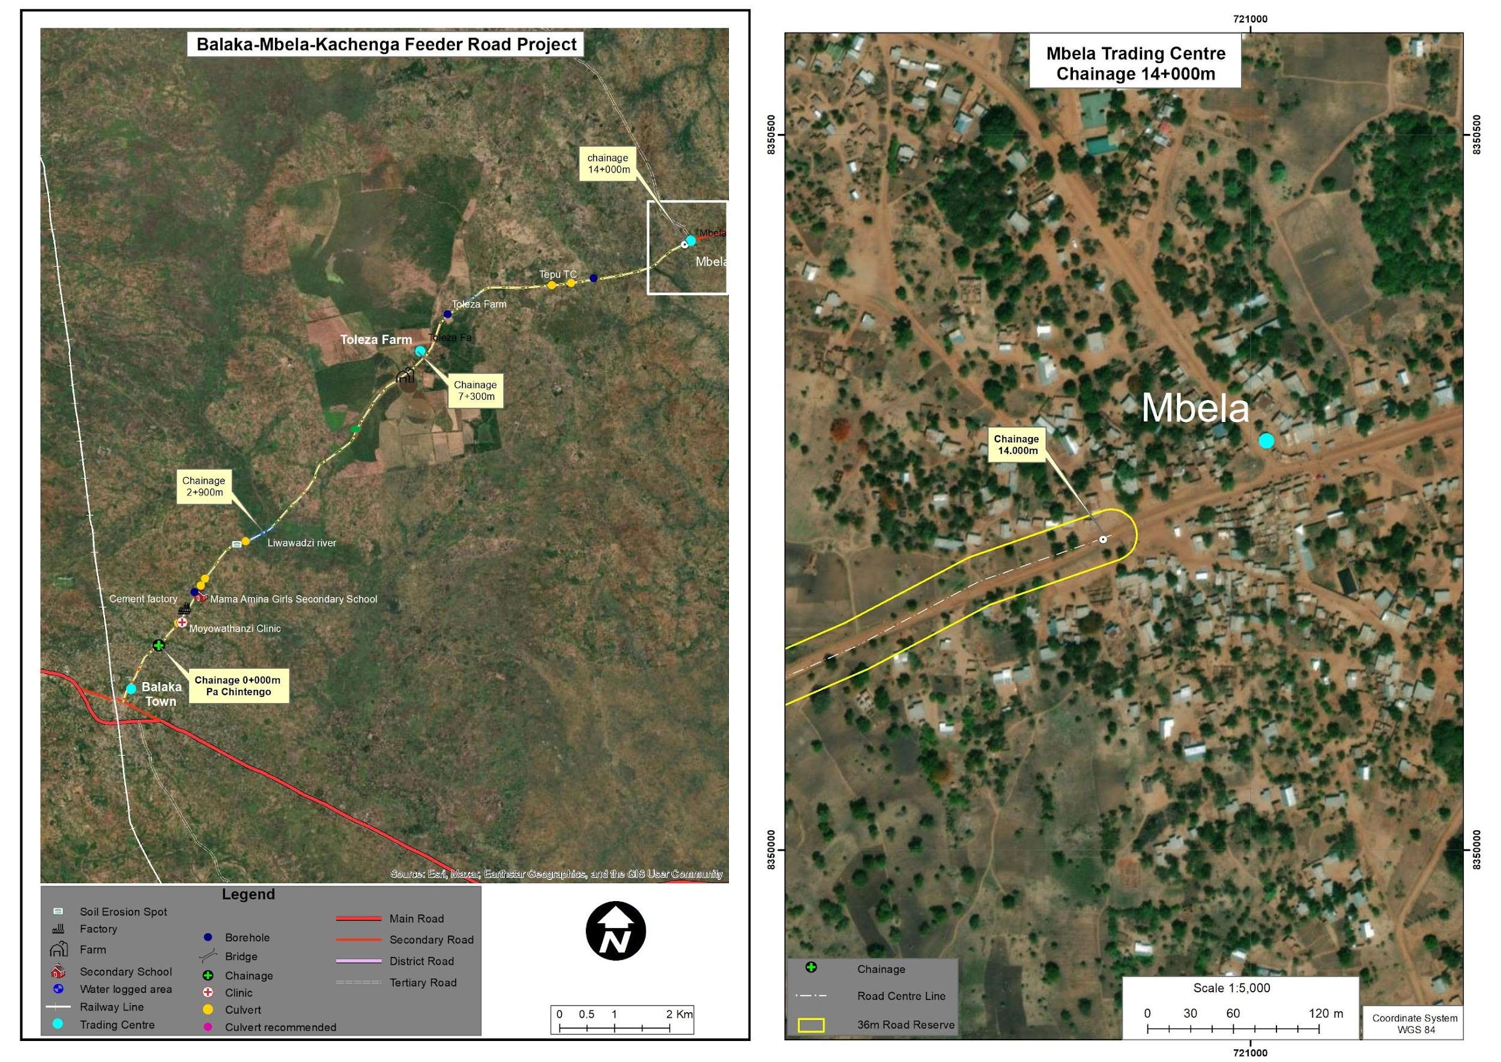
Figure 1-6: Mbela Trading Centre, on the far end of the road

Land Tenure and Land Requirement for the Project
The Balaka–Mbela–Kachenga (S133/T381) Road is an existing public road under the Public Roads Act (1969), with the corridor itself classified as public land, while adjacent land is predominantly customary and used for housing, farming and small‑scale trade. Field observations recorded informal use and encroachment within parts of the road reserve (cultivation, temporary structures and roadside trading); however, in line with the spatial distribution of works in Table 2‑2, the rehabilitation design has been configured to avoid these sensitive chainage sections and to confine works to locations that can be implemented fully within the existing road reserve. On this basis, the subproject does not involve land take beyond the existing road reserve, and if future design changes propose works in skipped sections or outside the reserve, those works will be reassessed separately and addressed in accordance with applicable national legislation and World Bank requirements prior to their implementation. Where informal temporary structures such as vending booths or groceries placed by their occupants occur within the road reserve along the alignment, the corresponding sections have been deliberately excluded from the spot-based rehabilitation scheme during design, so that construction works avoid them altogether; any residual coordination needs around the immediate working area will be handled under the stakeholder engagement and GRM provisions of this ESMMP.

Potential Users of the ESMMP
This Environmental and Social Management Plan (ESMMP) for the Proposed Rehabilitation of the Balaka–Mbela–Kachenga (S133/T381) Road is intended to serve as a practical management and compliance tool for a range of stakeholders involved in the planning, implementation, supervision, and monitoring of the project. The ESMMP provides guidance on environmental and social risk management measures to be applied throughout the project lifecycle.
Table 1-1 outlines the key institutions and stakeholders expected to use this ESMMP and their respective roles in environmental and social management.
Table 1-1. Potential Users of the ESMMP and Their Roles
Potential User | Potential Usage of the ESMMP
Malawi Environment Protection Authority (MEPA) | Regulatory review, environmental compliance monitoring, and verification that project implementation aligns with the Environmental Management Act (2017) and MEPA requirements.
Ministry of Transport and Public Works (MoTPW) and PIU, Roads Authority | Project owner and implementing authority responsible for overall coordination of the road rehabilitation works and ensuring that environmental and social safeguards are integrated into project implementation under the SATCP Last Mile Infrastructure component.
Balaka District Council (including DESC) | Local-level monitoring and coordination of environmental and social management measures, as well as facilitation of engagement with local communities.
Ministry of Labour and National Construction Industry Council (NCIC) | Oversight of labour standards, occupational health and safety compliance, and contractor adherence to national labour regulations.
Project Engineers and Supervising Consultants | Integration of environmental and social requirements into construction supervision, site inspections, and monitoring of mitigation measures during project implementation.
Contractors and Subcontractors | Implementation of ESMMP mitigation measures, occupational health and safety provisions, labour management procedures, community health and safety measures, and GBV/SEA/SH prevention requirements during construction.
Local Communities and Road-Corridor Users | Awareness of project activities, potential impacts, mitigation measures, employment opportunities, and access to the project Grievance Redress Mechanism (GRM).
World Bank and Other Oversight Institutions | Safeguards due diligence, implementation supervision, and monitoring of compliance with applicable environmental and social safeguard policies.

In this regard, the ESMMP serves as a living document that supports coordinated action among all stakeholders to ensure that the road rehabilitation works are implemented in an environmentally sound, socially responsible, and compliant manner.

CHAPTER 2: PROJECT DESCRIPTION

Introduction
This chapter describes the technical scope of the Proposed Rehabilitation of the 15 km Balaka–Mbela–Kachenga (S133/T381) Road, including the main engineering works, project components, and implementation activities associated with rehabilitation of the existing road alignment.
It outlines the key activities to be undertaken during planning and design, construction, demobilisation, and operation, including drainage improvement, culvert works, embankment stabilisation, material sourcing, labour requirements, waste management, and reinstatement of disturbed areas.

Project Components and Activities
The Balaka–Mbela–Kachenga Road Rehabilitation Project involves the upgrading and rehabilitation of approximately 15 km of existing gravel road between Balaka and Kachenga in Balaka District. The works will be undertaken within the existing road reserve and are intended to restore road functionality, improve drainage performance, and reduce flood-related disruptions along the corridor. The project focuses on improving road geometry, strengthening embankments, and rehabilitating drainage structures such as culverts and mitre drains to ensure reliable all-weather access for surrounding communities.
Field investigations and engineering assessments identified several deteriorated road sections and drainage structures requiring repair, rehabilitation, or replacement. Particular attention was given to flood-prone areas, including sections near wetlands and the Liwawadzi River crossing, where drainage failures have historically caused road overtopping and transport disruptions. The proposed drainage design, including culvert openings and stormwater management measures, was reviewed by the project hydrologist and confirmed to be adequate for expected runoff conditions. Detailed engineering drawings and specifications for the works are provided in Annex 12. The main project activities will be implemented across four phases as summarized in Table 2-1.
Table 2-1. Project Components and Activities
Phase | Description of Activities
Pre-Construction / Design Phase | Preparation of Detailed Engineering Designs (DED) based on field investigations, engineering surveys, and hydrological analysis. This phase included verification of existing road infrastructure and drainage structures such as box culverts, Armco culverts, concrete pipe culverts, and bridges along the corridor. Flood-prone sections and drainage deficiencies were identified, particularly near wetlands and the Liwawadzi River floodplain. Engineering designs incorporated improvements to road geometry, embankment stabilization, culvert rehabilitation and replacement, installation of mitre drains, and erosion protection works. The hydrologist confirmed that the proposed culvert sizes and drainage openings are adequate to convey stormwater flows. Detailed drawings and specifications are provided in Annex 12.
Construction Phase | Implementation of rehabilitation works including site establishment, vegetation clearing within the road reserve, and earthworks for reshaping and grading of the road formation. Deteriorated sections will be excavated and stabilized, and embankments strengthened in low-lying areas. Drainage works will include cleaning, repairing, and replacing existing culverts, construction of new headwalls and wing walls, excavation of inlet and outlet drains, installation of mitre drains and earth drains, and provision of scour protection. Damaged culverts will be replaced with larger box culverts where necessary to improve hydraulic capacity. Rehabilitation works will also include repairs to the Liwawadzi Bridge, including filling approaches, repairing wing walls, and installing marker posts. Construction activities will be undertaken using labour and machinery while maintaining community access where possible, and will be supported by implementation of environmental and social mitigation measures in accordance with the ESMMP.
Contractors Demobilisation Phase | Removal of construction machinery, equipment, and temporary facilities such as storage areas and worker camps. Temporary access tracks and stockpile areas will be cleared and restored. Borrow pits and other disturbed areas will be rehabilitated through re-contouring and stabilization. Construction waste will be removed and disposed of at approved sites in coordination with the District Council, and drainage channels temporarily altered during construction will be restored to natural flow patterns.
Operation and Maintenance Phase | Upon completion of construction works, the rehabilitated road will be opened to traffic and handed over to the Ministry of Transport and Public Works (MoTPW) for routine operation and maintenance. Maintenance activities will include periodic grading of the gravel surface, clearing of culverts and drainage channels, repair of erosion damage, and maintenance of road safety features such as signage and marker posts. Environmental and social risks during this phase are expected to be limited and will mainly relate to road safety management and regular maintenance of drainage systems to prevent flooding or blockage.

Spatial Distribution of Works by Chainage
Rehabilitation works along the Balaka–Mbela road are not continuous; instead, they are concentrated at discrete chainage sections where the Engineer has identified drainage, formation and structure defects requiring intervention. The chainage references therefore indicate where direct construction activities (earthworks, culvert replacement, grading, gravelling and embankment formation) will occur, and where environmental and social receptors (households, fields, watercourses and community facilities) are most likely to experience disturbance. Table 2-2 presents a schematic strip route of the project road from chainage 0+000 at Balaka (pa Chintengo) to chainage 15+000 at Mbera, showing the distribution of key work types along the alignment.
Between approximately chainages 2+380 and 3+640, and 3+640 and 4+100, spot gravelling and grading will be undertaken to restore the running surface and cross-fall, resulting in localised earthworks, dust generation and temporary traffic disruptions. Around chainage 3+280, a series of culvert and bridge-related works will be implemented, including filling approaches and headwall construction for the Luwawadzi Bridge and existing box culverts, and replacement of the twin Armco culvert at chainage 3+600 with a reinforced concrete box culvert. These structure works will involve excavation within and adjacent to watercourses and drainage lines, temporary diversion or control of stormwater flows, and increased movement of construction plant and materials.
Further along the alignment, multiple short sections of embankment formation are proposed between chainages 10+700–10+800, 11+100–11+200 and 12+670–13+300 to correct vertical alignment, improve side slopes and reinstate failed sections of road prism. These locations represent the main zones of cut-and-fill operations, with potential for slope instability, erosion and sedimentation. Throughout the mid-section of the road, from approximately chainage 3+100 to 13+200, several mitre drains will be constructed on the left-hand and right-hand sides at the chainages indicated in Table 2-2 to improve side drainage and reduce concentration of runoff in the main side drains. These are short, localised excavations that extend from the side drain into adjacent ground and farmlands and will require careful siting and reinstatement to avoid unnecessary loss of productive land and to prevent gullying.
Outside the specific chainage sections listed in Table 2-2, only routine maintenance and minor touch-ups within the existing road prism are planned (such as local reshaping of side drains or pothole repair).
Table 2-2. Spatial Distribution of Works by Chainage
CHAINAGE |  | DESCRIPTION TASKS
FROM | TO | DESCRIPTION TASKS
0+000 |  | BALAKA
3+100 |  | Provide mitre drain - LHS
3+280 |  | Luwawadzi Bridge - Fill approaches and provide 6No. Marker posts
2+380 | 3+640 | Section Requires Gravelling
3+380 |  | Existing Box Culvert 2m x 1.2m - Provide 2no. Head walls
3+410 |  | Existing Box Culvert 4.8m x 3.2m - Provide 2no. Head walls
3+515 |  | Existing Box Culvert 2m x 1.5m - 3 Cells - Provide 4no. Head walls
3+600 |  | Existing Armco Culvert ( 2 lines) - Remove and replace with a Box culverts - 2m x 2m 3 Cells
3+640 | 4+100 | Section requires Grading in
3+700 |  | Provide mitre drain - RHS
4+020 |  | Provide mitre drain - LHS
5+100 |  | Provide mitre drain - RHS
5+200 |  | Provide mitre drain - RHS
6+100 |  | Provide mitre drain - LHS
6+200 |  | Provide mitre drain - RHS
6+300 |  | Provide mitre drain - RHS
6+380 |  | Provide mitre drain - RHS
6+380 |  | Provide mitre drain - LHS
6+420 |  | Provide mitre drain - RHS
6+500 |  | Provide mitre drain - RHS
6+900 |  | Provide mitre drain - RHS
7+000 |  | Provide mitre drain - RHS
7+020 |  | Provide mitre drain - RHS
7+100 |  | Provide mitre drain - RHS
7+200 |  | Provide mitre drain - RHS
8+400 |  | Provide mitre drain - LHS & RHS
8+600 |  | Provide mitre drain - RHS
8+900 |  | Provide mitre drain - RHS
9+000 |  | Provide mitre drain - RHS
9+035 |  | Provide mitre drain - LHS
10+100 |  | Provide mitre drain - LHS
10+200 |  | Provide mitre drain - LHS
10+400 |  | Provide mitre drain - LHS
10+700 |  | Provide mitre drain - RHS
10+700 | 10+800 | Embankment Formation
11+100 | 11+200 | Embankment Formation
11+500 |  | Provide mitre drain - RHS
12+540 |  | Provide mitre drain - RHS
12+670 | 13+300 | Embankment Formation
13+200 |  | Provide mitre drain - RHS
15+000 |  | Mbera

Labour Requirement
The rehabilitation of the Balaka–Mbela–Kachenga (S133/T381) Road will be undertaken by a contractor employing a mix of skilled, semi-skilled, and unskilled labour, with a strong emphasis on local recruitment. The workforce will be temporary and at peak construction, the project is expected to engage approximately 80–84 workers, mainly during intensive activities such as drainage construction, culvert installation, and embankment reshaping. Outside peak periods, workforce numbers will decline depending on the construction schedule.
Key labour characteristics include:
- Majority local recruitment for unskilled and semi-skilled roles (e.g., site clearing, manual works, drainage, traffic control).
- Limited external specialists (e.g., engineers, surveyors, equipment operators) engaged for technical supervision and quality assurance.
- Employment across categories including civil works supervision, surveying, drainage and culvert construction, earthworks, equipment operation, traffic management, site security, and environmental, social and OHS compliance.
- Commitment to gender inclusion, with the contractor encouraged to engage at least 40% representation of either gender, where feasible.
As summarized in Table 2-3, the estimated peak workforce comprises 77 local workers and 6 external specialists, giving a total of 83 personnel across different technical and support roles. Labour management will be guided by OHS measures, worker codes of conduct, and grievance redress mechanisms outlined in the ESMMP.
Table 2-3. Expected Number of People to be Employed (Peak Workforce)
SN | Employee Category | Local | External* | Total
1 | Civil Engineering and Supervision | 3 | 2 | 5
2 | Surveying and Setting Out | 3 | 1 | 4
3 | Masonry and Concrete Works | 8 | 0 | 8
4 | Carpentry and Formwork | 5 | 0 | 5
5 | Electrical Works (minor/temporary) | 3 | 1 | 4
6 | Mechanical / Equipment Operators | 6 | 2 | 8
7 | Drainage Construction | 10 | 0 | 10
8 | Excavation and Earthworks | 12 | 0 | 12
9 | Manual Material Handling | 10 | 0 | 10
10 | Site Clearing and Preparation | 8 | 0 | 8
11 | Traffic Control and Safety | 5 | 0 | 5
12 | General Site Maintenance | 5 | 0 | 5
13 | Catering and Welfare Services | 1 | 0 | 1
14 | Security Services | 4 | 0 | 4
15 | Environmental, Social and OHS Compliance | 4 | 0 | 4
 | Sub-Total (Peak Workforce) | 77 | 6 | 83
*External staff refers to specialised non-local personnel engaged on a short-term or intermittent basis.

Material Requirements and Sources
The rehabilitation works will require construction materials for earthworks, drainage improvement, culvert installation, and related site activities. The key material requirements, estimated quantities, potential sources, and intended uses are summarised in Table 2-4.
Potential borrow material sources identified in the Detailed Engineering Design (DED) include Bitris Gavinala Borrow Pit (Chainage 4+200) and another borrow area near Chainage 7+500, both identified through geotechnical investigations. These sources are indicative only and will be subject to verification, landowner consent, environmental and social screening, and approval before use. Borrow pit management and rehabilitation measures will be included in the Contractor’s Environmental and Social Management Plan (C-ESMMP) in accordance with Malawi Environment Protection Authority guidelines and World Bank safeguard requirements.
Water for construction activities such as concrete works, compaction, dust suppression, and site use will be sourced from approved boreholes, licensed suppliers, or authorised surface water points, ensuring that abstraction does not affect downstream users or ecological flows.
Additional materials such as sand, aggregates, boulders, and selected fill will be obtained from licensed quarries or approved suppliers, while energy needs will primarily involve diesel, petrol, and electricity/solar power for machinery and site facilities. Appropriate environmental controls will be implemented to prevent pollution, regulate extraction, and ensure site restoration after use.
Table 2-4. Material required, estimated quantities, potential sources
SN | Material Required | Unit | Estimated Quantity | Potential Sources | Remarks (Use in Project Activities)
1 | Lateritic gravel / selected fill | m³ | Moderate | Bitris Gavinala Borrow Pit (Ch. 4+200); Borrow pit near Ch. 7+500 | Road formation, embankment reshaping, earthworks
2 | Sand | m³ | Moderate | Licensed river sand suppliers | Concrete and mortar for culverts and drainage works
3 | Aggregates | m³ | Moderate | Approved quarries | Culvert installation, drainage structures, concrete works
4 | Boulders / rock | m³ | Low–Moderate | Licensed quarries / approved sources | Erosion protection, scour control, drainage stabilisation
5 | Water | m³/day | Moderate | Approved boreholes, licensed suppliers, authorised surface sources | Concrete works, compaction, dust suppression
6 | Diesel | Litres | Moderate | Licensed fuel suppliers | Construction machinery and haulage vehicles
7 | Petrol | Litres | Low | Licensed fuel suppliers | Light equipment and supervision vehicles
8 | Electricity / Solar | kWh | Low | Public electricity grid / solar systems | Site offices and welfare facilities

All material sourcing and extraction activities will be undertaken in compliance with national regulations and MEPA environmental safeguards, with measures to ensure site restoration, pollution prevention, and protection of nearby communities and natural resources.

Worker Accommodation and Facilities
The project will not require the establishment of large or permanent worker camps. Most workers will be locally recruited and will commute daily from nearby communities and trading centres. A small number of specialised personnel who may not be locally based may be accommodated in existing lodging facilities such as guesthouses or rented accommodation within Balaka Town or nearby trading centres rather than in purpose-built camps.
Temporary site facilities will be established to support construction activities and will include site offices for project management and supervision, welfare facilities such as potable drinking water points, sanitation facilities and rest areas, first-aid and basic emergency response equipment, and designated areas for equipment parking and material storage.
All worker facilities will comply with national labour legislation, occupational health and safety requirements, and relevant World Bank good practice guidelines. Adequate sanitation facilities, segregated by gender where appropriate, will be maintained in hygienic condition, and safe drinking water will be provided at all construction sites. The contractor will enforce a worker Code of Conduct and community interaction protocols to prevent adverse interactions with surrounding communities. Upon completion of works, all temporary facilities will be dismantled and the sites restored to their original or agreed condition.

Waste and Waste Management
The contractor will implement a site-specific Waste Management Plan (WMP) following the hierarchy of avoidance, reduction, reuse, recycling, and safe disposal, consistent with MEPA requirements and World Bank good practice. Waste will be segregated at source, temporarily stored at designated areas, and transported to approved municipal or licensed disposal facilities. Liquid waste from welfare facilities will be managed through portable sanitation or septic systems, serviced by licensed operators. Hazardous waste will be securely stored and handled only by MEPA licensed collectors. The main waste streams and management measures are summarised in Table 2-5 below.
Table 2-5. Waste Streams and Waste Management
Waste Stream | Possible Sources |  | Key Management Measures
Excavated soil / spoil | Earthworks, drainage, culverts |  | Reuse for backfilling and shaping; excess disposed at approved sites
Construction rubble | Culvert works, minor structures |  | Reuse where suitable; dispose at council-approved sites
Concrete waste | Minor concrete works |  | Minimise wastage; cure and reuse as hardcore or dispose safely
Scrap metal | Equipment maintenance |  | Collect and sell to licensed recyclers
Packaging waste | Cement bags, plastics |  | Segregate, reuse where possible, dispose via licensed handlers
Used oils and lubricants | Machinery maintenance |  | Store in sealed containers; dispose through licensed hazardous waste handlers
Used batteries | Equipment operation |  | Safe storage and return to licensed recyclers
Domestic waste | Site offices, workers |  | Regular collection and disposal at municipal facilities
Sewage | Welfare facilities |  | Portable toilets/septic systems serviced by licensed operators

Organic waste from welfare facilities will be collected and disposed of at approved municipal sites, while liquid waste such as sanitary wastewater and concrete wash water will be contained and safely managed to prevent contamination. Hazardous waste (e.g., oils, batteries) will be stored in labelled containers and removed by licensed hazardous waste handlers, with no on-site disposal, burning, or burial permitted.

Rehabilitation of Temporary Structures
Temporary structures required during construction—such as material stockpiling areas, equipment yards, site offices, welfare facilities, and temporary access points—will be established within the existing road reserve or on land accessed through short-term agreements with land users and will only be used for the duration of the works. Upon completion of construction, all temporary sites will be fully rehabilitated to their original or agreed condition. This will involve the removal of all structures, equipment, waste, and surplus materials; regrading of disturbed areas; restoration of natural drainage patterns; and stabilization of exposed soils to prevent erosion. Disturbed areas will be allowed to regenerate naturally or will be replanted with appropriate local vegetation where necessary. Borrow areas and stockpiling sites will be reshaped to blend with the surrounding landscape and made safe for future use. No temporary site will be abandoned without prior inspection and approval by the supervising engineer and relevant authorities. The contractor will be responsible for completing all rehabilitation works prior to final project handover, ensuring that no residual environmental or safety risks remain and that affected land users are not disadvantaged.

CHAPTER 3: POLICY AND LEGAL FRAMEWORK

Introduction
This chapter reviews the policy, legal, and institutional framework applicable to the proposed project. It highlights the key national policies and legislation that guide environmental and social risk management for the project and summarises the regulatory approvals and licences required to ensure compliance with Malawi’s environmental governance framework and the World Bank OP/BP 4.01 safeguard requirements. The chapter also outlines the core roles of relevant institutions involved in regulation, implementation, and oversight of environmental and social performance during the planning, construction, and operational phases of the project.

National Policies and Strategies

Policy Framework
Table 3-1 presents key national policies and strategies that provide the strategic and regulatory framework for planning, implementation, and monitoring of the proposed project. These policies reflect Malawi’s development priorities and establish obligations relating to environmental protection, land administration, water resources management, climate resilience, gender inclusion, labour standards, waste management, and transport sector governance.
Table 3-1: Policies Guiding the project
Policy / Strategy | Brief Description | Implications for the Project
Malawi 2063 (MW2063) and First 10-Year Implementation Plan (MIP-1, 2021–2030) | Malawi’s long-term national development vision and medium-term implementation plan prioritising economic infrastructure, rural connectivity, trade facilitation, and climate resilience. | Rehabilitation of the proposed Road contributes to MW2063 and MIP-1 by improving rural connectivity, enhancing access to markets and social services, and strengthening climate-resilient transport infrastructure.
National Environmental Policy (2004) | Provides the overarching framework for integrating environmental sustainability into development planning and decision-making. | Requires integration of environmental safeguards, pollution prevention measures, and adherence to environmental assessment requirements administered by MEPA.
National Land Policy (2002) | Promotes orderly land administration, secure land tenure, and sustainable land use management. | Requires respect for the legal road reserve while ensuring that surrounding customary land rights are safeguarded.
National Water Policy (2005) | Promotes sustainable water resources management, protection of water bodies, and equitable access to water resources. | Requires protection of nearby rivers and streams during construction and responsible water abstraction for construction purposes, including prevention of erosion and siltation from earthworks and drainage works.
National Gender Policy (2015) | Promotes gender equality and equitable participation of women and men in development processes. | Requires gender-inclusive stakeholder engagement, equal employment opportunities, and integration of Gender-Based Violence (GBV) and Sexual Exploitation and Abuse (SEA) risk prevention measures during project implementation.
National Climate Change Management Policy (2016) | Provides guidance for climate change adaptation and mitigation across sectors. | Requires integration of climate-resilient design features such as adequate drainage systems, erosion control, and improved road formation to withstand extreme rainfall events.
National Sanitation Policy (2008) | Provides a framework for improving sanitation and hygiene standards and safe management of waste. | Requires appropriate management of solid and liquid waste generated during construction activities, including safe storage and disposal practices.
National HIV and AIDS Policy (2022–2027) | Aims to reduce HIV transmission and strengthen workplace HIV prevention and non-discrimination measures. | Requires implementation of HIV and AIDS awareness programmes for construction workers and communities and promotion of non-discriminatory workplace practices.
National Transport Policy (2015) | Aims to develop a safe, efficient, and sustainable transport system in Malawi. | Supports rehabilitation of rural roads to improve access and connectivity, and requires incorporation of road safety considerations and safe traffic management during construction.
National Labour and Employment Policy (2017) | Promotes decent work, fair labour practices, and protection of workers’ rights. | Requires fair recruitment practices, decent working conditions, prohibition of child labour, and compliance with occupational health and safety standards.
National Forest Policy (2016) | Promotes sustainable forest management and restoration of degraded landscapes. | Requires minimisation of vegetation clearing within the road reserve and implementation of erosion control and site rehabilitation measures after construction.
National Decentralisation Policy (1998) | Provides the framework for devolved governance and planning at district level. | Requires engagement with the District Council and the District Environmental Sub-Committee (DESC) for environmental oversight, monitoring, and alignment with district development priorities and by-laws.

Legislative Framework
Table 3-2 outlines the principal national legislation governing the implementation of the Proposed Rehabilitation of the Balaka–Mbela–Kachenga (S133/T381) Road. These statutes provide the legal basis for environmental protection, land administration, labour standards, occupational health and safety, public health, water resources management, and road infrastructure development in Malawi. Compliance with these laws is mandatory and informs the design, construction, and operation of the project, as well as the mitigation and monitoring measures set out in this ESMMP.
Table 3-2: Legislation Guiding the Project
Act | Brief Description | Implications for the Project
Constitution of the Republic of Malawi (1995) | The supreme law of Malawi guaranteeing environmental protection, human rights, gender equality, and sustainable development (Sections 5, 12(e), and 13(d)). | Requires environmentally sound project implementation and protection of community rights through application of approved environmental and social safeguards instruments.
Environment Management Act (2017) | Principal legislation governing environmental protection, environmental assessment, pollution control, and sustainable natural resource management in Malawi. | Requires preparation and implementation of an ESMMP and compliance with environmental requirements administered by MEPA prior to and during project implementation.
Public Roads Act (2023) | Provides the legal framework for classification, development, rehabilitation, and maintenance of public roads and associated infrastructure. | Requires that rehabilitation works be undertaken within the legally designated road reserve and that appropriate drainage, safety, and access management standards are applied.
Land Act (2016) and Customary Land Act (2016) | Establish the legal framework governing land tenure systems, land administration, acquisition of land for public purposes, and compensation. | Confirms the legal status of the public road reserve and requires that surrounding customary land rights are respected. No land acquisition is anticipated as works are confined within the existing road corridor.
Water Resources Act (2013) | Provides for sustainable management, allocation, and protection of water resources in Malawi. | Requires permits for water abstraction where necessary and implementation of measures to prevent pollution, erosion, and sedimentation of nearby water bodies during construction.
Occupational Safety, Health and Welfare Act (1997) | Establishes requirements for safe and healthy workplaces and regulates plant, machinery, and hazardous working conditions. | Requires implementation of Occupational Health and Safety (OHS) measures including provision of PPE, site safety procedures, and safe operation of construction equipment. Refer to annexes 6&8 where the contractor will require to develop those plans
Employment Act (2000) | Provides minimum employment standards and prohibits forced labour, discrimination, and child labour. | Requires fair recruitment procedures, compliance with labour standards, and prohibition of child labour in project activities. Refer to annex 8 where the contractor will require to develop a plan
Gender Equality Act (2013) | Promotes gender equality and prohibits discrimination, harassment, and exploitation in workplaces and society. | Requires gender-inclusive employment practices and enforcement of measures to prevent Gender-Based Violence (GBV), Sexual Exploitation and Abuse (SEA), and Sexual Harassment (SH).
Data Protection Act (2024) | Regulates the collection, processing, storage, use, and protection of personal data in Malawi, including obligations relating to confidentiality, lawful processing, and protection of personal information. | Requires that stakeholder information collected through consultations, attendance registers, interviews, grievance redress, and project monitoring activities be used strictly for project purposes, securely stored, and handled in a manner that protects confidentiality and privacy.
Child Care, Protection and Justice Act (2011) | Protects the rights, welfare, and development of children in Malawi and provides legal mechanisms to prevent abuse, neglect, exploitation, and harmful practices affecting children. | Requires the proposed project to enforce zero child labour, ensure child safety around construction sites, and implement reporting and response mechanisms for child protection risks in accordance with Sections 3, 79, and 80–82 of the Act.
HIV and AIDS (Prevention and Management) Act (2018) | Protects rights of people living with HIV and AIDS and promotes workplace awareness and prevention programmes. | Requires non-discriminatory practices and implementation of HIV awareness programmes among construction workers and surrounding communities.
Public Health Act (1948) | Provides legal provisions for safeguarding public health, sanitation, drainage, and disease prevention. | Requires provision of sanitation facilities at construction sites and proper waste management to prevent public health risks.
Environment Management (Waste Management and Sanitation) Regulations (2008) | Regulates management of solid and liquid waste, including hazardous waste handling and disposal. | Requires segregation, safe storage, transportation, and disposal of waste generated during construction activities.
Environment Management (Chemicals and Toxic Substances) Regulations (2008) | Regulates the handling, storage, transportation, and disposal of chemicals and hazardous substances. | Requires proper storage and handling of fuels, lubricants, and chemicals used in construction operations.
Forestry Act (2020) | Provides for conservation, sustainable management, and protection of forest resources. | Requires minimisation of vegetation clearing within the road reserve and rehabilitation of disturbed areas after construction.
National Parks and Wildlife Act (2017) | Provides for conservation and management of wildlife resources and biodiversity. | Requires that project activities avoid disturbance to wildlife habitats and prohibits hunting or exploitation of wildlife by project workers.
Local Government Act (1998) | Empowers district councils to manage development planning, environmental management, and service delivery. | Requires coordination with the District Council and the District Environmental Sub-Committee (DESC) for project consultations, monitoring, and compliance with district by-laws. The contractor will develop a barrow pit rehabilitation plan (refer annex 5)
Physical Planning Act (2016) and Physical Planning (Amendment) Act (2022) | Regulates land use planning and requires development permission for infrastructure projects. | Requires obtaining Development Permission from the District Council prior to commencement of works.
Liquid Fuels and Gas (Production and Supply) Act (2004), Chapter 50:03 | Regulates the production, storage, transportation, distribution and supply of liquid fuels and gas in Malawi. The Act establishes licensing requirements and safety standards to ensure proper handling and management of petroleum products and gas within the country. | Where project activities involve the storage or use of petroleum products (e.g., diesel for construction equipment or generators), fuel handling must comply with national safety and licensing requirements. Contractors must ensure safe storage, transport and use of fuels to prevent spills, fire hazards and environmental contamination, and must comply with regulatory requirements governing fuel supply chains.
Construction Industry Act No. 28 of 2025 (CIRA Act) | Establishes the Construction Industry Regulatory Authority (CIRA) to regulate, develop, and promote the construction industry in Malawi. The Authority oversees registration and licensing of contractors, consultants, material manufacturers and suppliers, enforces professional and ethical standards, promotes training and capacity development, and standardizes construction practices and procedures across the industry. | Requires that all contractors, consultants, and suppliers engaged in the proposed Road rehabilitation project be registered and licensed by CIRA, and that construction activities comply with approved industry standards, codes of ethics, and professional conduct requirements. The project must therefore ensure engagement of CIRA-registered entities, adherence to quality and safety standards, and compliance with regulatory oversight for construction works.

World Bank Safeguard Policies and Procedures

World Bank Operational Policy OP/BP 4.01: Environmental Assessment
The proposed Rehabilitation of the Balaka–Mbela–Kachenga (S133/T381) Road is financed under a World Bank–supported programme and is therefore subject to Operational Policy OP/BP 4.01 on Environmental Assessment. This policy governs the identification, assessment, and management of environmental and social risks associated with Bank-financed projects.
Given the rehabilitation nature of the works, their confinement to the existing road reserve, and the selective, chainage-based scope that avoids areas requiring land acquisition, OP/BP 4.01 remains the principal safeguard policy applicable to this project. A stand-alone Environmental and Social Mitigation and Monitoring Plan (ESMMP) has been prepared in accordance with OP/BP 4.01 to provide the basis for compliance and to ensure that project implementation is environmentally sound, socially responsible, and aligned with good international practice.
The ESMMP identifies potential impacts associated with road rehabilitation works (including earthworks, gravelling, culvert rehabilitation and replacement, embankment formation, mitre drains, and bridge approach works) and defines corresponding mitigation, monitoring, and institutional measures. It also integrates occupational health and safety (OHS), road safety, waste and pollution management, community health and safety, and chance-find procedures for cultural heritage.
Table 3-3. World Bank Environmental and Social Safeguard Policies Applicable to the Project
Safeguard Policy | Key requirements and application to the project
Environmental Assessment (OP/BP 4.01) | Requires environmental assessment of projects financed by the World Bank to ensure environmental sustainability and informed decision-making. For this project, a stand-alone ESMMP has been prepared to identify potential environmental and social risks associated with chainage-specific rehabilitation works and to define mitigation, monitoring, and institutional measures. The ESMMP also consolidates OHS procedures, traffic and community safety measures, waste and wastewater controls, and provisions for managing potential interactions with roadside communities and encroachers.
Natural Habitats (OP/BP 4.04) | Seeks to ensure that projects do not cause significant degradation of natural habitats. The rehabilitation works are confined to an existing road corridor and do not traverse protected areas or critical natural habitats. Any disturbance to roadside vegetation will be minor, localised, and reversible, and will be managed through standard erosion control and revegetation measures.
Physical Cultural Resources (OP/BP 4.11) and Involuntary Resettlement (OP 4.12)
Encroachers are present within the road reserve at certain trading centres and along sections where fields and temporary vending structures extend close to the road. However, the rehabilitation design has adopted a selective, chainage-based approach that avoids works requiring land acquisition or physical displacement (Figure 1-3); the subproject does not involve land take beyond the existing road reserve and no involuntary land take is expected as such OP4.12 Involuntary Resettlement is not triggered. Management of any temporary access disruptions or economic disturbance is addressed through ESMMP measures, including advance notification, traffic management, and maintenance of safe access.
No known physical cultural resources were identified within the project footprint during consultations and field assessments. Nonetheless, the ESMMP includes a Chance Find Procedure to ensure that any archaeological, historical, or religious artefacts discovered during works are appropriately reported, secured, and managed in consultation with relevant authorities. These measures address cultural heritage risks under OP/BP 4.01 without triggering OP/BP 4.11 as a stand-alone policy.

World Bank Environmental, Health and Safety (EHS) Guidelines
The project will implement the World Bank Group Environmental, Health and Safety (EHS) Guidelines as Good International Industry Practice for managing environmental, occupational health, and community safety risks during road rehabilitation. The applicable guidance is drawn primarily from the General EHS Guidelines and the sector-specific EHS Guidelines for Toll Roads, adapted to a non-toll rural feeder road context.
The General EHS Guidelines apply to common construction-related risks such as dust and emissions, noise and vibration, waste and wastewater management, OHS, and emergency preparedness. The Toll Roads guidance provides additional direction on traffic management, road user safety, temporary diversions, signage and visibility, and safe operation of heavy equipment within active traffic corridors. These requirements are reflected in the ESMMP and will guide contractor obligations during planning, construction, and demobilization.
Key EHS risk areas and indicative controls under this project include:
- Air quality and dust control – water spraying of exposed surfaces, speed control for construction vehicles, and covering of haulage trucks.
- Noise and vibration management – proper maintenance of machinery, restriction of noisy activities near sensitive receptors, and adherence to agreed working hours.
- Wastewater and stormwater management – control of runoff from construction areas, protection of roadside drains, and prevention of sediment and concrete washout entering watercourses.
- Solid and hazardous waste management – waste segregation, secure on-site storage, controlled transport, disposal through approved facilities, and spill prevention for fuels and lubricants.
- Occupational health and safety – hazard identification, provision and use of appropriate PPE, toolbox talks, safe work procedures, first-aid facilities, and incident reporting and investigation.
- Community health and safety – traffic control, warning signage, flag persons where needed, pedestrian safety arrangements, fencing or demarcation of work areas, and measures to prevent construction-related accidents.

World Bank Requirements on Sexual Exploitation and Abuse (SEA) and Sexual Harassment (SH)
World Bank-financed projects must put in place robust measures to prevent and respond to Sexual Exploitation and Abuse (SEA) and Sexual Harassment (SH), particularly where civil works involve contractor personnel working in close proximity to communities. The Bank applies a zero-tolerance approach to SEA/SH, requiring practical safeguards to protect women, children, and other vulnerable groups and to promote safe project implementation.
For this project, key contractor obligations include:
- Code of Conduct – Adoption and strict enforcement of a written Code of Conduct for all workers and subcontractors that explicitly prohibits SEA/SH, child abuse, and other forms of Gender-Based Violence (GBV), with clear sanctions for non-compliance.
- Worker training – Induction and periodic refresher training for all workers on acceptable behaviour, SEA/SH prohibition, reporting duties, and consequences of violations.
- Awareness and reporting – Ensuring workers understand behavioural standards, disciplinary measures, and their obligation to report any suspected SEA/SH incidents.
- Community sensitisation – Outreach and awareness activities, particularly at trading centres and settlements along the corridor, to inform community members about expected worker conduct and available reporting channels.
- Confidential GRM – Establishment and operation of a survivor-centred, confidential grievance mechanism that enables safe reporting, provides timely referral to support services, and respects the wishes and privacy of survivors.
Non-compliance with SEA/SH obligations may result in removal of individuals from the site, termination of employment or contracts, and referral to relevant authorities in line with national legislation and the World Bank Good Practice Note on SEA/SH in civil works projects.

Institutional Framework
Implementation of the ESMMP and associated safeguard requirements for the Balaka–Mbela–Kachenga Road Rehabilitation Project requires coordinated action among national and local institutions responsible for environmental regulation, land administration, transport infrastructure, labour, and local governance. These institutions provide policy direction, regulatory oversight, technical guidance, and enforcement to ensure that the project aligns with national legislation, MEPA guidelines, and applicable World Bank requirements.
Table 3-4. Institutional mandates on Environmental and Social Safeguards related to the Project
SN | Institution | Mandate in E&S safeguards related to the project
1 | Malawi Environment Protection Authority (MEPA) | Principal environmental regulator responsible for review and approval of ESMMPs, issuance of environmental determination or clearance, and compliance monitoring through inspections and enforcement actions under the Environment Management Act (2017).
2 | Ministry of Natural Resources and Climate Change (or equivalent) | Provides national policy oversight on environmental management, climate change, and natural resources, and ensures integration of sustainability principles across development sectors.
3 | Ministry of Lands | Regulates land administration, land use planning, and development control; ensures compliance with land laws and protection of public land, including road reserves used for the project.
4 | Ministry of Transport and Public Works (MoTPW) | Provides sector policy oversight for transport infrastructure and, through the Roads Authority and PIU, ensures integration of environmental and social safeguards into road sector programmes and contracts.
5 | Roads Authority (RA) | Responsible for planning, development, and management of the main, secondary, and tertiary road network; oversees implementation of ESMMP requirements in road projects and ensures contractors comply with technical and safeguard standards.
6 | Ministry of Local Government (through Balaka District Council and DESC) | Oversees decentralised development planning; through the District Council and District Environmental Sub-Committee (DESC) facilitates community consultations, enforces district by-laws and environmental health standards, and participates in local monitoring and grievance management.
7 | Ministry of Labour | Regulates labour standards, working conditions, and occupational health and safety; ensures that contractors comply with labour legislation, including prohibition of child labour and forced labour.
8 | Construction Industry Regulatory Authority (CIRA) | Regulates the construction industry, including registration and licensing of contractors and consultants, and enforcement of construction quality, safety, and professional practice requirements under the Construction Industry Act (2025).

Together, these institutions ensure that the ESMMP is adequately reviewed, implemented, monitored, and enforced, with MEPA providing regulatory oversight, MoTPW and the Roads Authority leading sector implementation, and the District Council and other ministries supporting planning, labour compliance, and community-level monitoring.

Summary of Main Statutory Approvals/Licenses to be Obtained for the Project
The implementations of the Balaka–Mbela–Kachenga Road Rehabilitation Project requires compliance with several statutory approval and licensing requirements to ensure adherence to Malawi’s environmental, labour, land-use, water resources, and safety regulations. These approvals must be obtained prior to, or during, project implementation as applicable. Refer to Table 3-5 for the specific approvals, responsible institutions, and timing requirements.
Table 3-5: Summary of statutory Approvals and Licenses Required
SN | Approval / Licence Required | Applicable Legal / Regulatory Framework | Issuing Institution | Responsible Party | Indicative Timeframe
1 | ESMMP Approval / Environmental Clearance | Environment Management Act (2017) | MEPA | MoTPW | Up to 3 months
2 | Approval for Waste Disposal | Environment Management Act (2017); Local Government Act (1998) | MEPA; Balaka District Council | MoTPW | ~2 weeks
3 | Approval for Sand Extraction (where applicable) | Local Government Act (1998) | Balaka District Council | MoTPW | ~2 weeks
4 | Quarrying / Borrow Pit Approval (if required) | Mines and Minerals Act (2018) | Department of Mines | MoTPW | Up to 3 months
5 | Workplace Registration Certificate | Occupational Safety, Health and Welfare Act (1997) | Ministry of Labour | MoTPW | ~2 weeks
6 | Water Abstraction Permit (if required) | Water Resources Act (2013) | National Water Resources Authority | MoTPW | ~2 weeks
7 | Development Permission | Physical Planning Act (2016, as amended 2022); Local Government Act (1998) | Balaka District Council | MoTPW | ~2 weeks
8 | Fuel Storage Registration / Licence (for on-site storage capacity > 400 litres) | Liquid Fuels and Gas (Production and Supply) Act (2004) and subsidiary Regulations; MERA Notice on mandatory registration and licensing of private storage exceeding 400 litres | Malawi Energy Regulatory Authority (MERA) | Contractor | Up to 3 months

CHAPTER 4: ENVIRONMENTAL AND SOCIAL SETTING

Introduction
This chapter presents the environmental and social baseline conditions within the project area of influence for the proposed road rehabilitation works and provides the reference for identifying potential environmental and social risks and impacts associated with the project.
The baseline is based on desk review of secondary data, engineering design information, field observations, and stakeholder consultations, and covers the physical, biological, and socio-economic conditions along the existing road alignment and adjacent areas relevant to project implementation.

Biophysical Environment

Topography
The road corridor traverses a predominantly flat to gently undulating landscape typical of the Upper Shire sub-catchment within the Zambezi River Basin. The terrain consists mainly of broad plains with shallow gradients and minimal elevation variation, while limited natural gradients reduce drainage efficiency and contribute to seasonal surface water accumulation in some sections.
A key topographic feature occurs at the Liwawadzi River crossing (around Chainage 2+900 m), where the road passes through a shallow floodplain prone to seasonal inundation and waterlogging (Figure 1-3). These low-lying conditions are associated with localized pavement deterioration, shoulder erosion, and temporary ponding during the rainy season. Around Toleza Farm (approximately Chainage 7+300 m), the corridor crosses extensive flat agricultural land, where poor drainage characteristics and fine-textured soils contribute to ponding, sheet runoff, and localized edge erosion.
Beyond Mbela Trading Centre, the terrain remains largely flat with minor localized rises near settlements and road junctions. The absence of steep slopes limits slope instability, while flat terrain and low gradients influence drainage behaviour and water retention during periods of heavy rainfall.

Geology
The road corridor lies within the Precambrian Basement Complex of southern Malawi, part of the Mozambique Belt, characterised by high-grade metamorphic rocks that have undergone prolonged tectonic evolution and tropical weathering. The geology is dominated by gneissic and granulitic basement rocks, including biotite gneiss, garnet-biotite gneiss, and hornblende-bearing gneiss, with localized occurrences of charnockitic gneiss and granulites. These rocks are generally competent at depth but are rarely exposed at the surface due to extensive weathered regolith cover.
Across most sections of the road section, the basement is overlain by residual and colluvial soils derived from weathered gneiss, typically reddish-brown, fine-grained to gravelly in texture. In low-lying areas and river crossing zones, particularly within the Liwawadzi River catchment, the sub-surface is characterised by Quaternary alluvial deposits composed of silts, sands, and clayey sediments. These deposits are associated with seasonal saturation and weaker sub-surface characteristics compared to surrounding upland sections.
Minor lithologies such as calc-silicate gneiss, quartzite, and amphibolite occur locally but are limited in extent. Regional structural features occur within the broader geological setting, although no active faults intersect the alignment, and the area falls within a tectonically stable zone with low seismic activity.
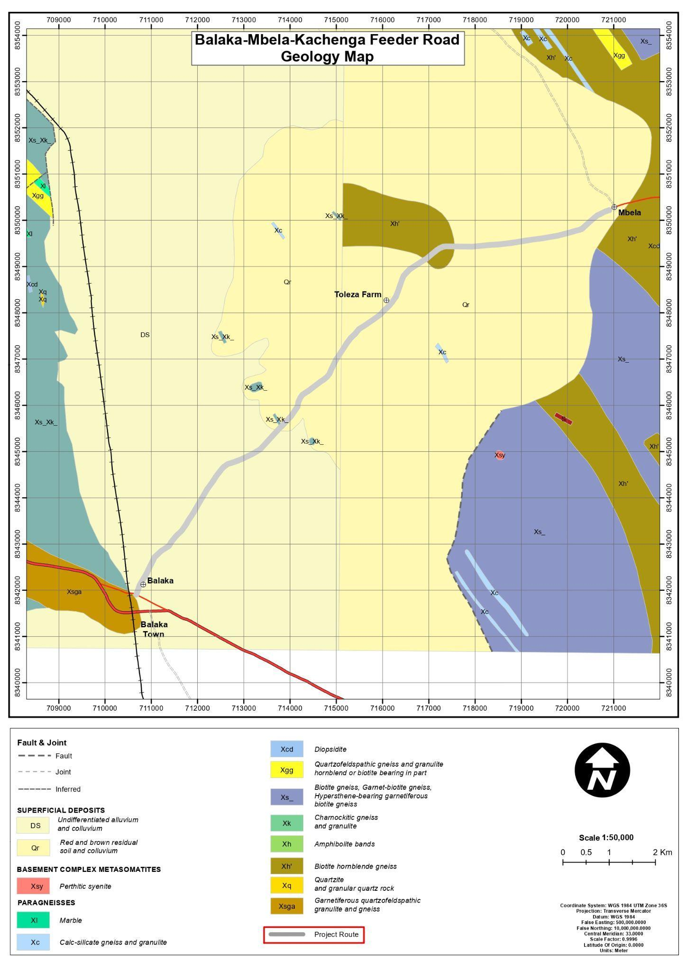
Figure 4-1: Geological Map of the Kachenga - Mbela Road section

Soils
Soils along the road section consist mainly of residual and transported materials derived from weathered Precambrian basement rocks, with localized Quaternary alluvial deposits occurring in low-lying sections of the Upper Shire sub-catchment. Soil characteristics vary along the alignment in response to topography, drainage patterns, and surrounding land use.
The dominant soil type is sandy clay loam, particularly between Balaka Town, Toleza Farm, and Mbela. These soils are moderately well drained under dry conditions but become moisture-sensitive during the rainy season, with localized softening and reduced surface stability observed where water accumulates.
In low-lying sections and drainage convergence zones, including areas near the Liwawadzi River crossing, clay loam and alluvial soils occur. These soils are poorly drained, prone to seasonal saturation, and generally exhibit weaker structural characteristics than adjacent upland soils. Toward Mbela, sandy clay soils with relatively higher plasticity and moisture retention are common, while loamy sands near Balaka are comparatively better drained but more susceptible to erosion where surface cover is disturbed.

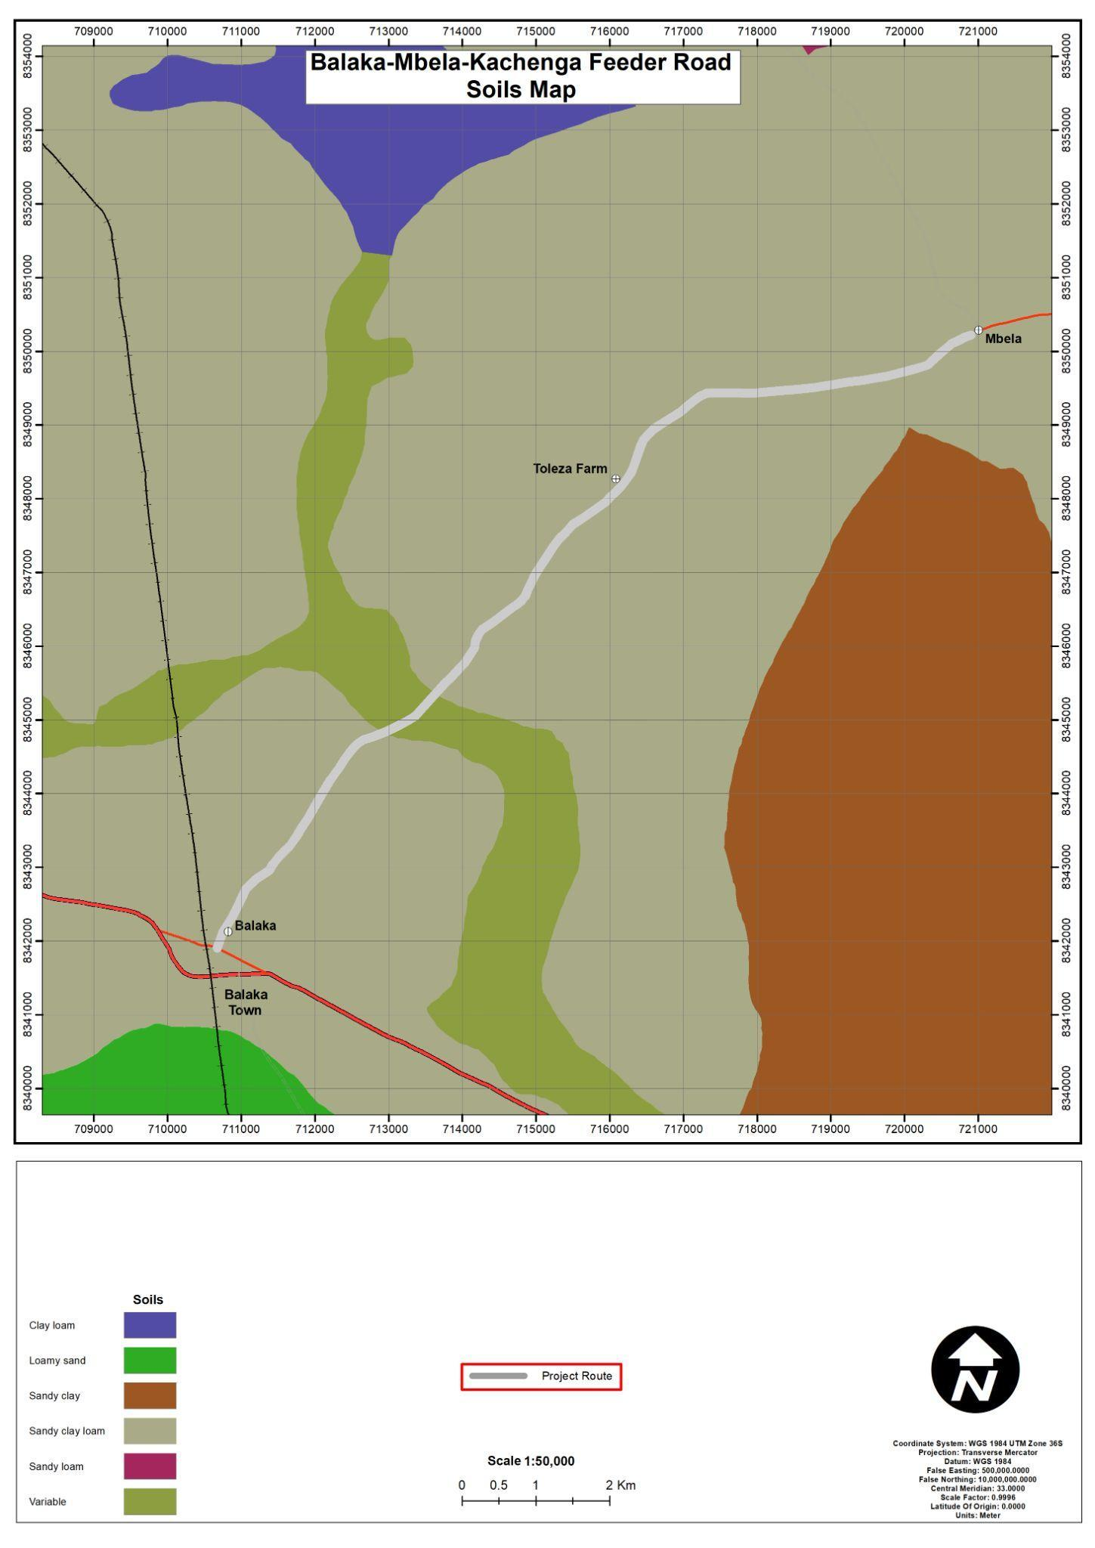
Figure 4-2: Soils of the proposed project area

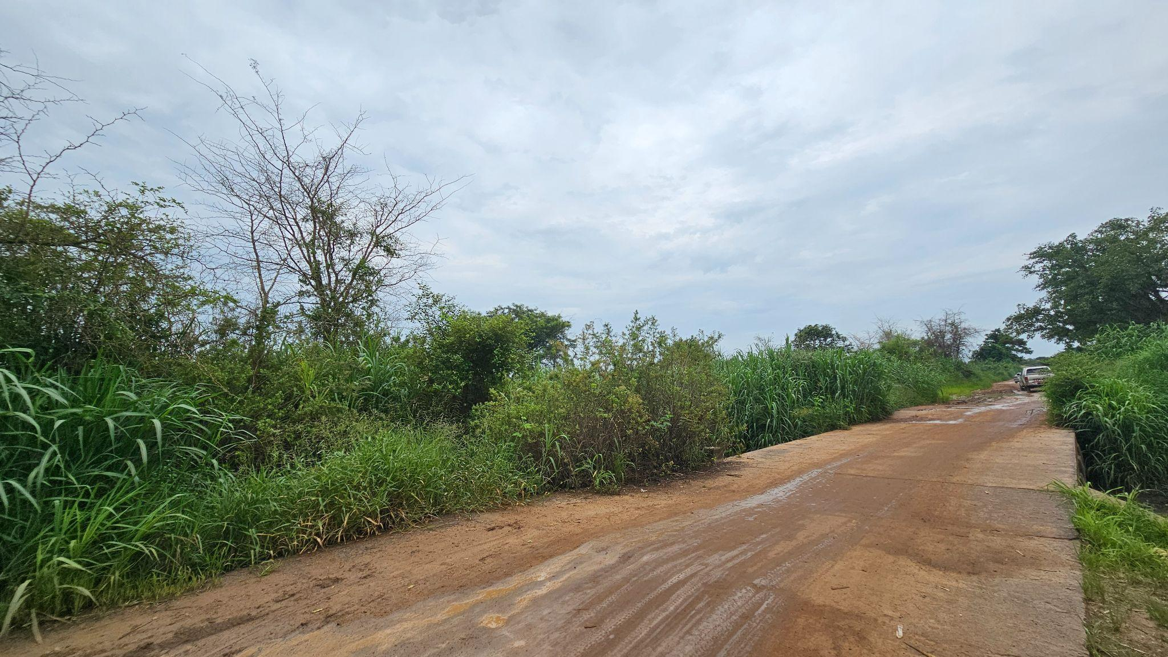 | 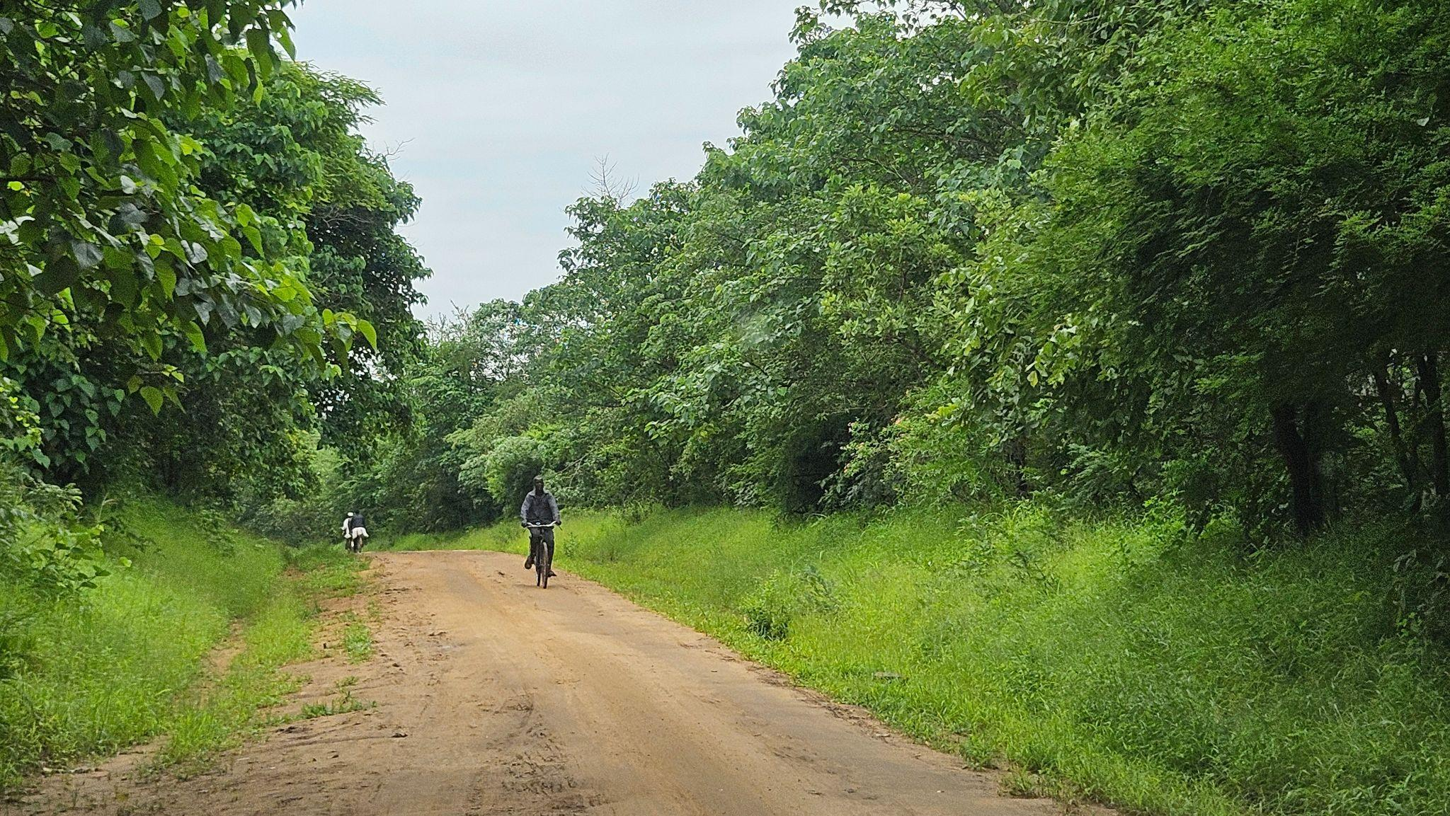
Figure 4-3: Soils within the wetland section and Dark sandy-loam soils within the Toleza Farm Section

Climate and Climate Change Risks
The project area lies within a sub-tropical climatic zone of southern Malawi, characterised by two main seasons: a rainy season (November–April) and a dry season (May–October). These seasonal patterns strongly influence soil moisture, runoff generation, vegetation growth, and the performance of earth and gravel roads, making climate conditions a key factor in construction scheduling, drainage design, and maintenance planning.
Temperature patterns show a warm regime with mean annual temperatures of approximately 18–26°C. The hottest period occurs between October and November, while June–July represent the coolest months and generally provide favourable construction conditions.

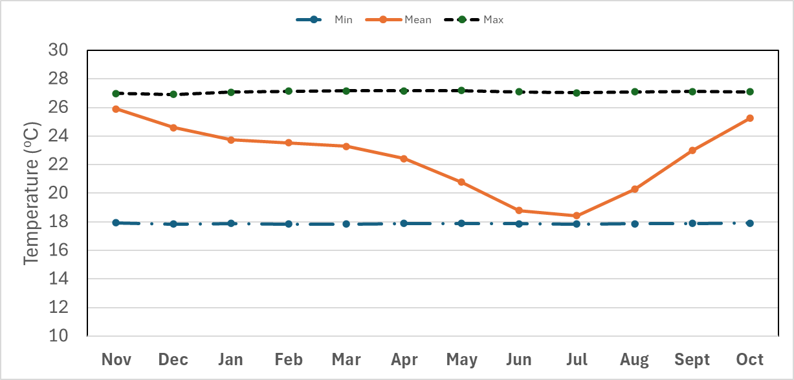
Figure 4-4: Average Monthly Temperature Pattern (1951–2022) for the Balaka–Mbela–Kachenga Road Section

Rainfall distribution follows a unimodal seasonal pattern, with the highest rainfall typically recorded between December and February, often exceeding 250–270 mm per month. Peak rainy months may experience 15–20 rainy days, while the dry season (June–August) records minimal rainfall.

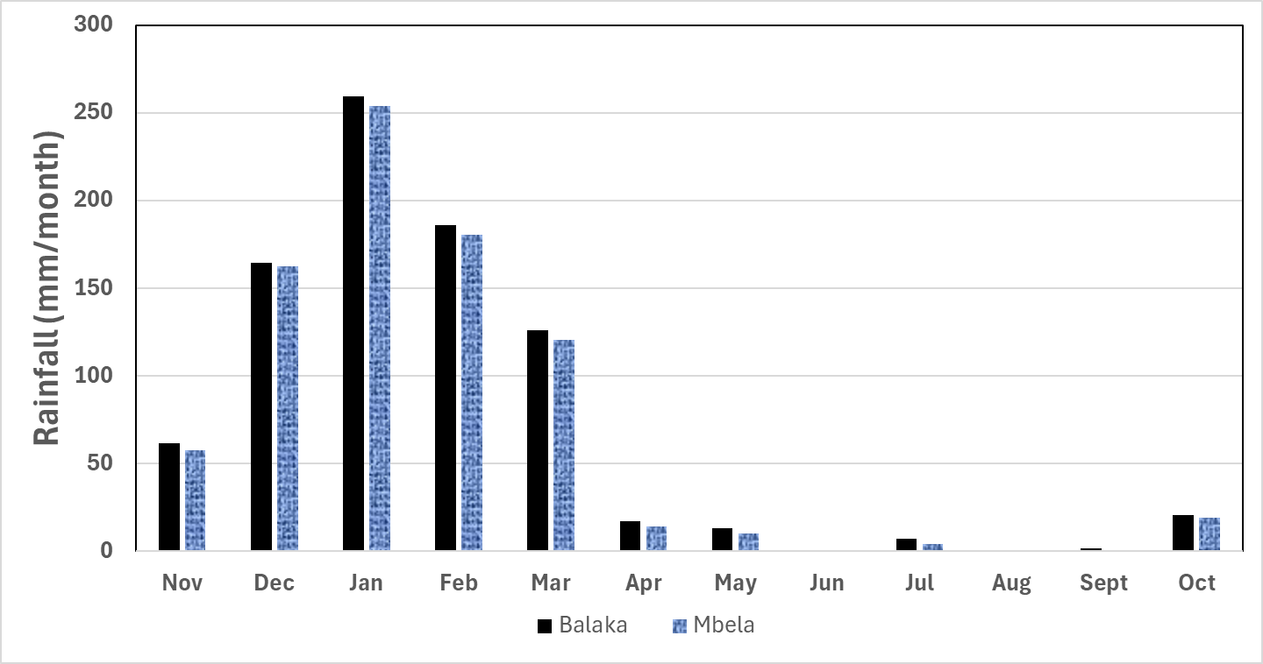
Figure 4-5: Monthly Rainfall Distribution for Balaka District
The area experiences high sunshine duration averaging 2,900–3,000 hours per year, with the longest sunshine periods occurring during the dry season (May–October).

Figure 4-6: Average Monthly Sunshine Duration for Balaka District
Relative humidity is highest during the rainy season (December–March) and lowest in the dry season (June–September). High humidity can affect material storage, curing of construction materials, and worker comfort, requiring appropriate occupational health and site management measures.
Wind conditions are generally moderate (10–16 km/h), with stronger winds occurring between August and November. Seasonal wind directions influence dust dispersion and site layout planning, necessitating dust control measures during earthworks and haulage.
Climate change projections for southern Malawi indicate increasing risks including:
- Rainfall variability and intense storm events, increasing flood risks in low-lying areas and river crossings.
- Flooding and erosion, particularly along flat terrain and clay-rich soils.
- Extreme weather events, which may accelerate road deterioration.
- Health risks, including increased exposure to vector-borne diseases where standing water occurs.
These conditions highlight the importance of climate-resilient road rehabilitation, particularly through improved drainage systems, erosion control measures, and adaptive maintenance planning to sustain road performance under changing climatic conditions.

Water Resources
The road section lies within the Upper Shire sub-catchment of the Zambezi River Basin, where hydrological conditions are strongly seasonal and rainfall-driven. Surface runoff peaks during the rainy season (November–April) and declines significantly during the dry season (May–October).
As illustrated in Figure 4-8 (Hydrological Map of the Project Area), the section traverses a low-gradient landscape with numerous seasonal streams, shallow drainage lines, dambos, and wetlands. Drainage is largely diffuse, with runoff spreading across low-lying areas rather than confined to well-defined river channels.
A key hydrological feature is the Liwawadzi River crossing, where the road intersects a seasonal floodplain and wetland system. During heavy rainfall, the river can overflow into surrounding dambos, causing temporary flooding, slow drainage, and waterlogging. In addition, several minor seasonal streams and wetland pockets occur along the road section, particularly between Balaka Town, Toleza Farm, and Mbela, increasing the road’s exposure to ponding, drainage congestion, and erosion.
Groundwater levels are generally shallow and rise during the rainy season, especially near wetlands. Communities along the road section rely on boreholes, taps, and water tanks for domestic water supply.
Key hydrological sensitivities include:
- Seasonal flooding and surface runoff in low-lying sections.
- Erosion and sediment transport into wetlands and streams during earthworks.
- Risk of water contamination from improper handling of fuels or construction materials.
The road section therefore exhibits seasonally dynamic hydrological conditions associated with low-gradient terrain, wetland influence, and temporary expansion of surface water during peak rainfall periods.
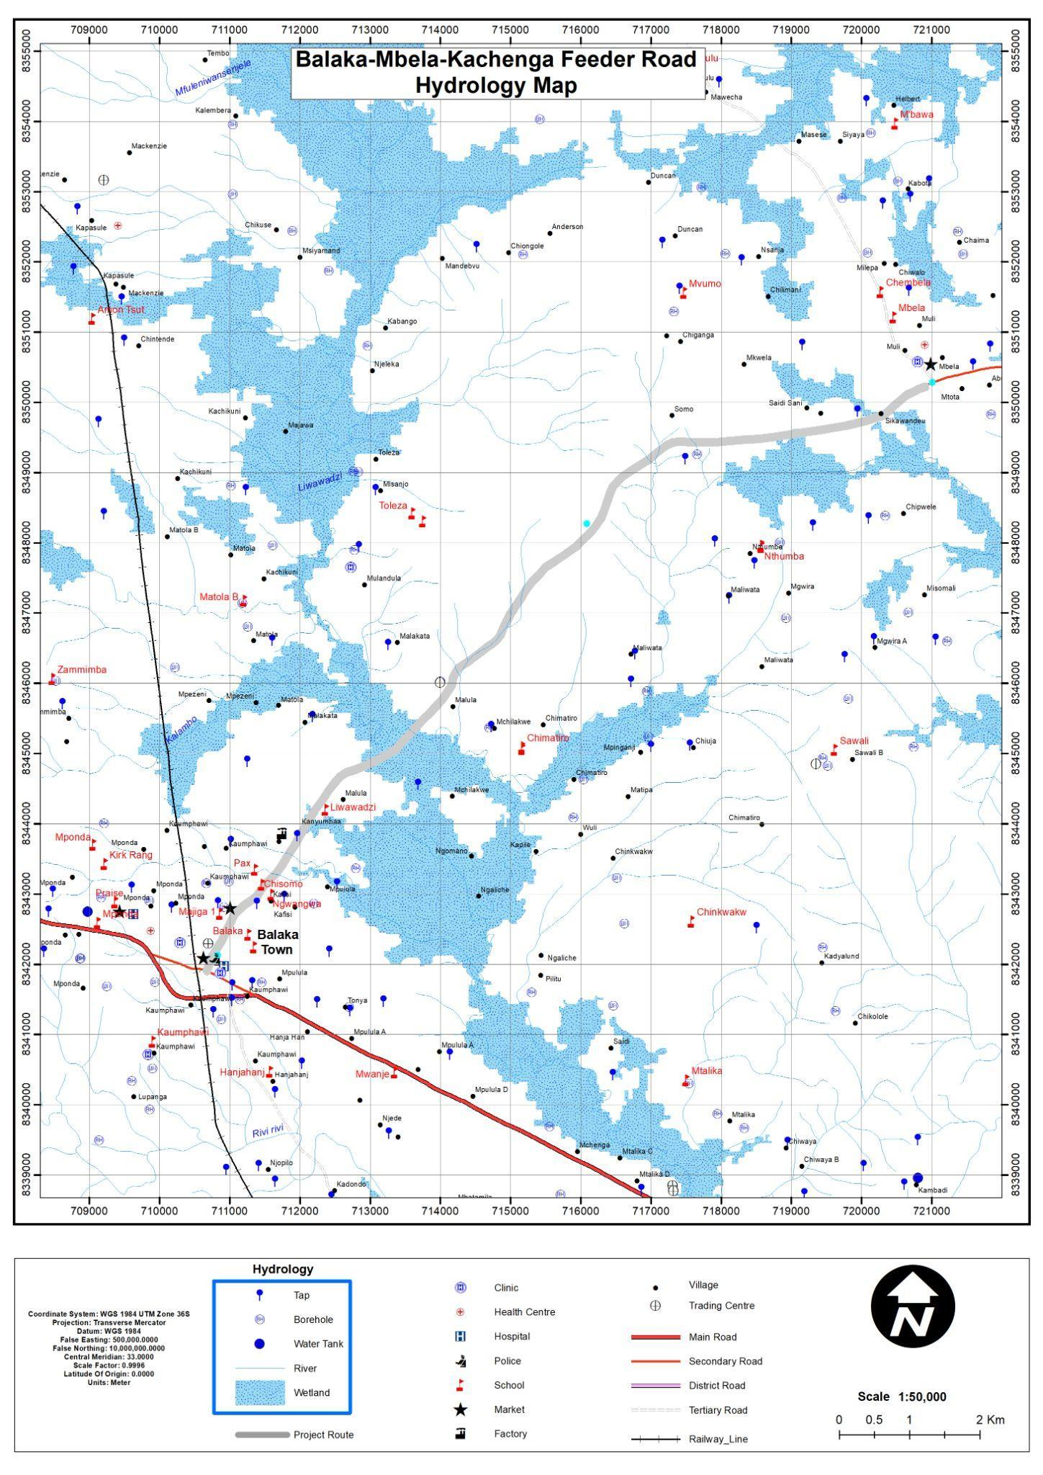
Figure 4-7: Hydrological map of the area

Flora of the Project Area
The Balaka–Mbela road section is predominantly characterised by mixed woodland vegetation. Common species observed include Senna spp., Gmelina arborea, and Acacia spp., particularly in sections associated with wetlands approaching Mbela Market, alongside scattered trees, shrubs, grasses, and herbs. The road reserve also supports cultivated crops such as maize (Zea mays), cassava (Manihot esculenta), and groundnuts (Arachis hypogaea). Vegetation condition varies along the alignment, with relatively intact cover in localized areas such as Toleza Farm, while other sections show moderate disturbance attributable to agricultural activities and natural processes.
Field surveys recorded a total of 46 plant species, none of which are endemic to the area. Most species are classified as Least Concern under national and IUCN conservation listings; however, Khaya anthotheca (East African mahogany) was identified as a protected and threatened species under both the National Plant Red Data List and the Forestry Act, alongside other protected species including Pericopsis angolensis and Terminalia sericea. The invasive alien species Lantana camara was also recorded, posing a potential threat to indigenous vegetation through competitive exclusion. Ecologically, the vegetation provides habitat and food resources for fauna, contributes to soil protection, and supports ecosystem stability. Sensitive habitats within the project area are limited and mainly include Toleza Farm and small Senna woodlot patches, which function as local biodiversity refugia due to reduced disturbance.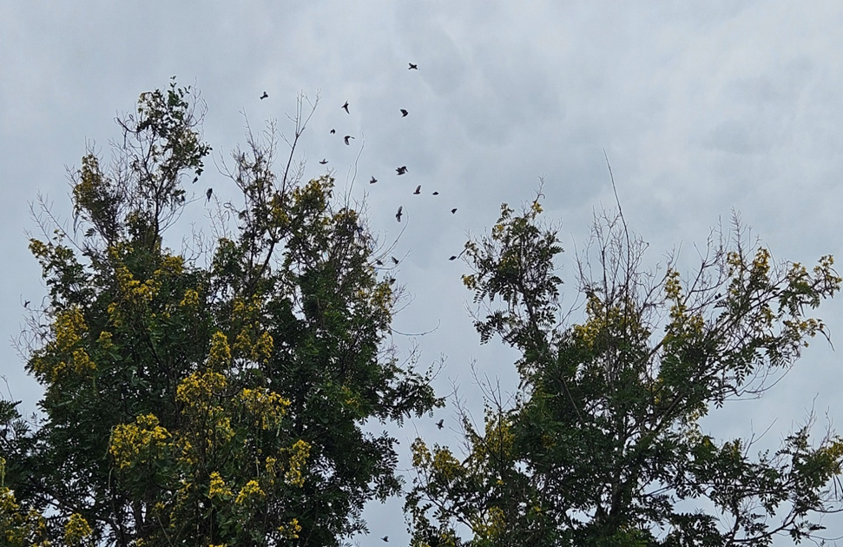
Figure 4-8: Pictorial view of Senna siamea species observed in Balaka- Mbela proposed road project area.
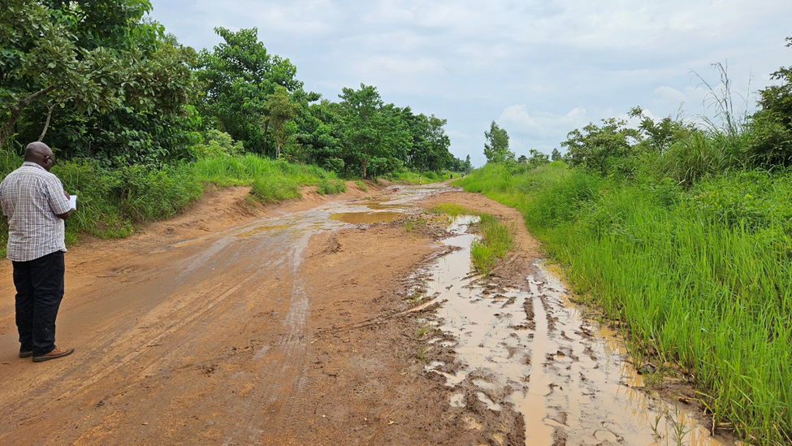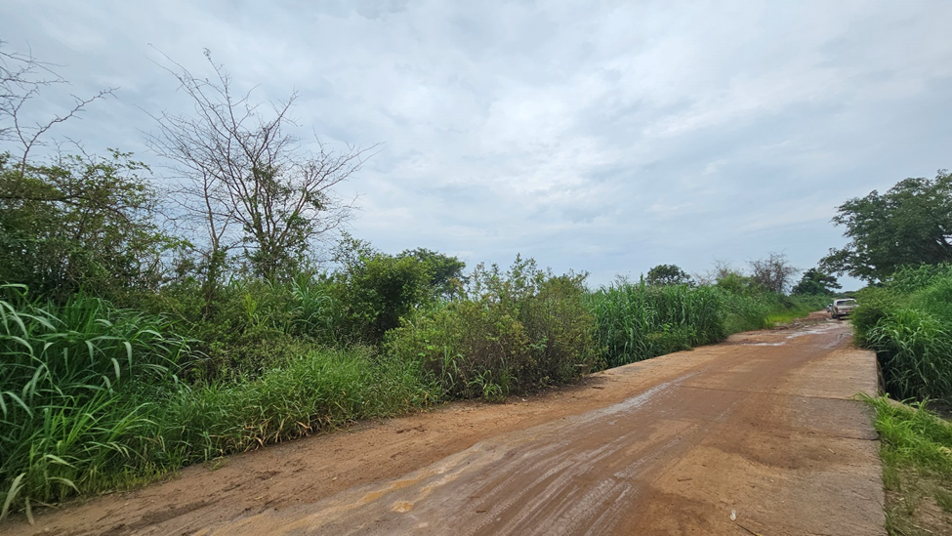
Figure 4-9Grasses are a major vegetative composition of the road section
Figure 4-10: Flora Species Sampled from the Balaka- Mbela Project Area and their Conservation Status
Species | Family | Form | English Name | National Plant Red Data List Conservation Status | IUCN Status
Acacia alata | Fabaceae | Shrub | Candle Bush | Least Concern | Not Evaluated
Faidherbia albida (Acacia albida) | Fabaceae | Tree | Apple-ring Acacia | Not Listed | Least Concern
Acacia nilotica | Fabaceae | Tree | Gum Arabic Tree | Not Listed | Least Concern
Acacia polyacantha | Fabaceae | Tree | White Thorn | Not Listed | Least Concern
Adansonia digitata | Malvaceae | Tree | Baobab | Not Listed | Least Concern
Agave americana | Asparagaceae | Herb | Century Plant | Not Listed | Least Concern
Anacardium occidentale | Anacardiaceae | Tree | Cashew Tree | Not Listed | Least Concern
Annona senegalensis | Annonaceae | Shrub | African Custard Apple | Not Listed | Least Concern
Azanza garckeana | Malvaceae | Shrub | African Chewing Gum | Not Listed | Least Concern
Bambusa vulgaris | Poaceae | Woody Grass | Common Bamboo | Not Listed | Not Evaluated
Combretum adenogonium | Combretaceae | Tree | Four-leaved Bushwillow | Not Listed | Least Concern
Dalbergia mollis | Fabaceae | Tree | Mollis Rosewood | Not Listed | Least Concern
Diplorhynchus condylocarpon | Apocynaceae | Tree | Horn-pod Tree | Not Listed | Least Concern
Eucalyptus globulus | Myrtaceae | Tree | Tasmanian Blue Gum | Least Concern | Least Concern
Ficus capensis | Moraceae | Tree | Cape Fig | Not Listed | Least Concern
Ficus natalensis | Moraceae | Tree | Natal Fig | Least Concern | Least Concern
Gmelina arborea | Lamiaceae | Tree | White Teak | Least Concern | Least Concern
Jacaranda mimosifolia | Bignoniaceae | Tree | Blue Jacaranda | Not Listed | Least Concern
Jatropha curcas | Euphorbiaceae | Shrub | Physic Nut | Not Listed | Vulnerable
Khaya anthotheca | Meliaceae | Tree | East African Mahogany | Protected / Least Concern | Least Concern
Kigelia africana | Bignoniaceae | Tree | Sausage Tree | Not Listed | Least Concern
Lantana camara | Verbenaceae | Shrub | Common Lantana | Invasive Species | Least Concern
Lonchocarpus capassa | Fabaceae | Tree | Apple-leaf | Not Listed | Data Deficient
Mangifera indica | Anacardiaceae | Tree | Mango | Not Listed | Least Concern
Melia azedarach | Meliaceae | Tree | Chinaberry Tree | Not Listed | Least Concern
Morus alba | Moraceae | Shrub | White Mulberry | Not Listed | Least Concern
Monoon longifolium | Annonaceae | Tree | False Ashoka Tree | Not Listed | Least Concern
Moringa oleifera | Moringaceae | Shrub | Moringa | Not Listed | Least Concern
Newtonia buchananii | Fabaceae | Tree | Forest Newtonia | Not Listed | Data Deficient
Opuntia ficus-indica | Cactaceae | Shrub | Prickly Pear | Not Listed | Least Concern
Pennisetum purpureum | Poaceae | Grass | Napier Grass | Not Listed | Least Concern
Pericopsis angolensis | Fabaceae | Tree | Mwanga | Protected / Least Concern | Least Concern
Persea americana | Lauraceae | Tree | Avocado | Not Listed | Least Concern
Phragmites mauritianus | Poaceae | Grass | African Reed | Not Listed | Least Concern
Piliostigma thonningii | Fabaceae | Tree | Camel’s Foot Tree | Not Listed | Least Concern
Psidium guajava | Myrtaceae | Shrub | Guava | Not Listed | Least Concern
Sclerocarya birrea | Anacardiaceae | Tree | Marula | Not Listed | Least Concern
Senna siamea | Fabaceae | Tree | Siamese Cassia | Least Concern | Least Concern
Senna spectabilis | Fabaceae | Tree | Spectacular Cassia | Least Concern | Least Concern
Tamarindus indica | Fabaceae | Tree | Tamarind | Not Listed | Least Concern
Terminalia catappa | Combretaceae | Tree | Tropical Almond | Not Listed | Least Concern
Terminalia sericea | Combretaceae | Tree | Silver Cluster-leaf | Protected / Least Concern | Least Concern
Vernonia glabra | Asteraceae | Herb | Cornflower Vernonia | Not Listed | Not Evaluated
Vitex doniana | Lamiaceae | Tree | Black Plum | Not Listed | Least Concern
Widdringtonia nodiflora | Cupressaceae | Shrub | Mountain Cypress | Not Listed | Least Concern
Ziziphus mauritiana | Rhamnaceae | Shrub | Indian Jujube | Not Listed | Least Concern
Arachis hypogaea | Fabaceae | Herb | Groundnut | Cultivated Species | Not Evaluated
Source: ESMMP Consultant 2026
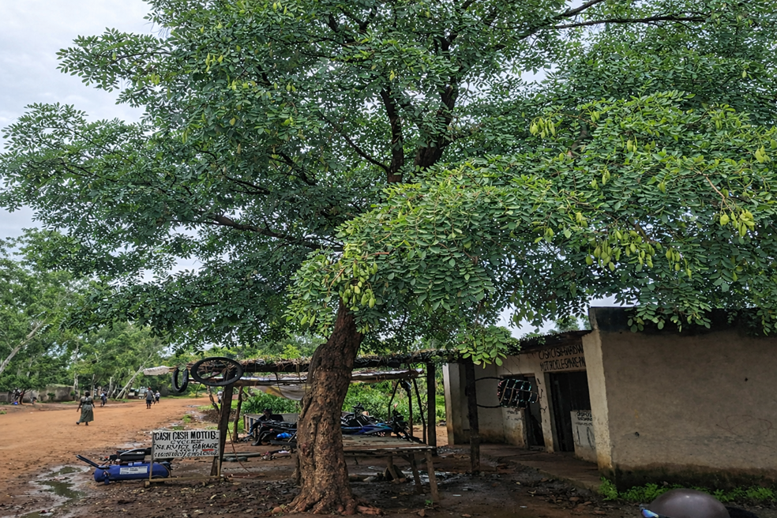
Figure 4-11: Protected species; Pericopsis angolensis in Balaka- Mbela proposed road project area

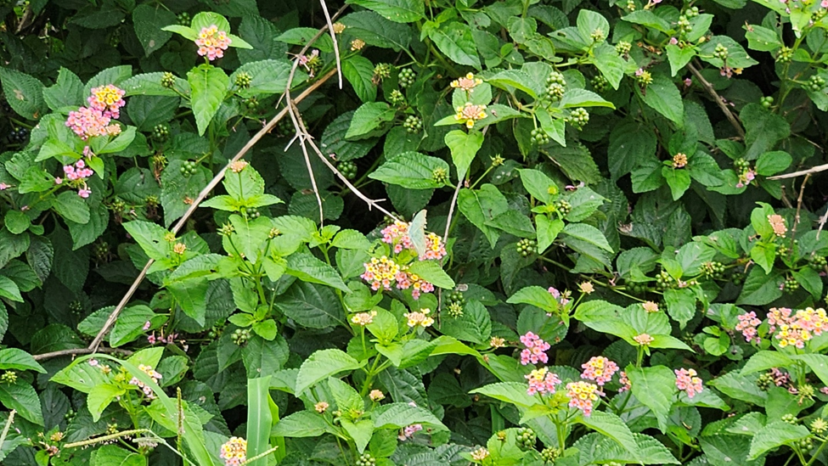
Figure 4-12: Lantana camara an inasive species grown as ornamental at Tepu Trading Centre

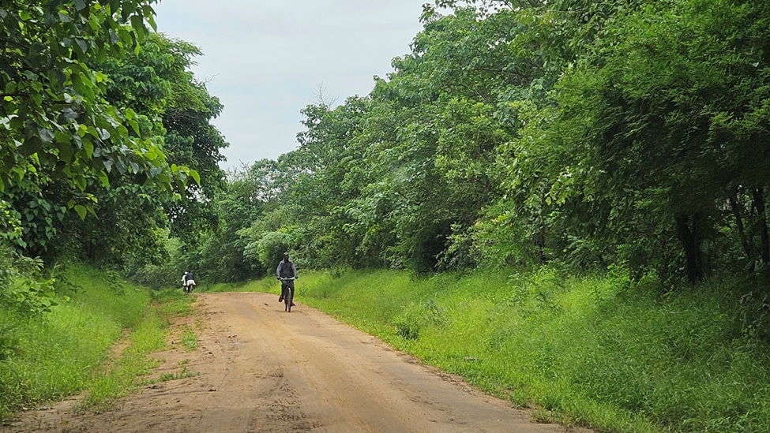
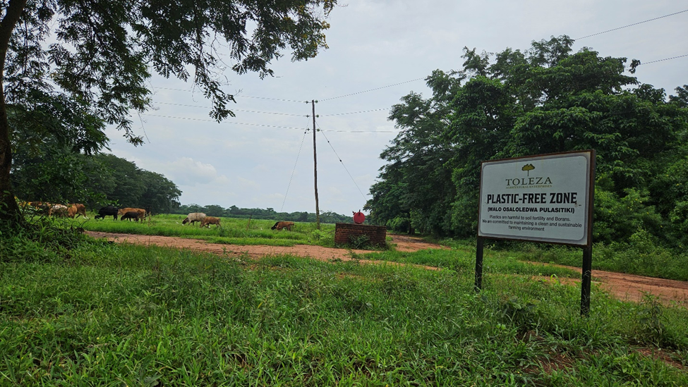
Figure 4-13: Pictorial view of the vegetation community in Toleza farm
Source of Data: ESMMP Consultant 2026

Fauna of the Area
The road section passes through a heavily modified agro-rural landscape dominated by subsistence farming, grazing, scattered settlements, and limited semi-natural vegetation. Prolonged land conversion and sustained human activity have substantially reduced faunal diversity, resulting in assemblages dominated by common, widespread, and disturbance-tolerant species. Field surveys, transect walks, and community consultations recorded fauna from five major taxonomic groups—mammals, birds, reptiles, amphibians, and macro-invertebrates—with no endemic, rare, or globally threatened species identified within the road reserve or immediate zone of influence.
Nine mammal species were recorded, primarily small to medium-sized taxa typical of disturbed environments, including common duiker (Sylvicapra grimmia), scrub hare (Lepus saxatilis), Natal multimammate mouse (Mastomys natalensis), pouched mouse (Saccostomus capensis), vervet monkey (Chlorocebus pygerythrus), and yellow baboon (Papio cynocephalus), with occasional reports of spotted hyena (Crocuta crocuta) and southern reedbuck (Redunca arundinum). All mammal species are classified as Least Concern under the IUCN Red List, with no endemic, invasive, or legally protected species recorded.
Figure 4-14: Mammal Species Recorded in the Balaka–Mbela Road Project Area and Their Conservation Status
Scientific Name | Common Name | National Status | IUCN Status
Sylvicapra grimmia | Common Duiker | Not Listed | Least Concern
Mastomys natalensis | Natal Multimammate Mouse | Not Listed | Least Concern
Crocuta crocuta | Spotted Hyena | Not Listed | Least Concern
Lepus saxatilis | Scrub Hare | Not Listed | Least Concern
Redunca arundinum | Southern Reedbuck | Not Listed | Least Concern
Epomophorus crypturus | Epauletted Fruit Bat | Least Concern | Least Concern
Papio cynocephalus | Yellow Baboon | Not Listed | Least Concern
Chlorocebus pygerythrus | Vervet Monkey | Not Listed | Least Concern
Saccostomus campestris | Pouched Mouse | Least Concern | Least Concern

Thirteen bird species were observed along the corridor, largely associated with open farmland, grazing areas, and roadside vegetation. Common species included cattle egret (Bubulcus ibis), pied crow (Corvus albus), ring-necked dove (Streptopelia capicola), red-eyed dove (Streptopelia semitorquata), southern grey-headed sparrow (Passer diffusus), common bulbul (Pycnonotus barbatus), and little bee-eater (Merops pusillus). Cattle egrets were particularly frequent at Toleza Farm, where they forage alongside livestock, a behaviour characteristic of human-modified agricultural systems. All recorded bird species are classified as Least Concern, with no endemic or threatened taxa identified.
Figure 4-15: Bird Species Recorded in the Balaka–Mbela Road Project Area and Their Conservation Status
Scientific Name | Common Name | National Status | IUCN Status
Bubulcus ibis | Cattle Egret | Not Listed | Least Concern
Corvus albus | Pied Crow | Not Listed | Least Concern
Uraeginthus angolensis | Blue-breasted Cordonbleu | Not Listed | Least Concern
Pycnonotus barbatus | Common Bulbul | Not Listed | Least Concern
Passer diffusus | Southern Grey-headed Sparrow | Not Listed | Least Concern
Streptopelia capicola | Ring-necked Dove | Not Listed | Least Concern
Passer griseus | Northern Grey-headed Sparrow | Not Listed | Least Concern
Pogoniulus chrysoconus | Yellow-fronted Tinkerbird | Not Listed | Least Concern
Chrysococcyx caprius | Dideric Cuckoo | Not Listed | Least Concern
Streptopelia semitorquata | Red-eyed Dove | Not Listed | Least Concern
Tchagra senegalus | Black-crowned Tchagra | Not Listed | Least Concern
Merops pusillus | Little Bee-eater | Not Listed | Least Concern
Aquila nipalensis | Steppe Eagle | Not Listed | Least Concern

Eight reptile species were recorded, including African striped skink (Trachylepis striata), African chameleon (Chamaeleo africanus), Mozambique agama (Agama mossambica), puff adder (Bitis arietans), black mamba (Dendroaspis polylepis), eastern green mamba (Dendroaspis intermedius), and Mozambique spitting cobra (Naja mossambica). All are classified as Least Concern and are not listed as protected under national wildlife legislation.
Figure 4-16: Reptile Species Recorded in the Balaka–Mbela Road Project Area and Their Conservation Status
Scientific Name | Common Name | National Status | IUCN Status
Trachylepis striata | African Striped Skink | Not Listed | Least Concern
Chamaeleo africanus | African Chameleon | Not Listed | Least Concern
Agama mossambica | Mozambique Agama | Not Listed | Least Concern
Bitis arietans | Puff Adder | Not Listed | Least Concern
Dendroaspis polylepis | Black Mamba | Not Listed | Least Concern
Naja mossambica | Mozambique Spitting Cobra | Not Listed | Least Concern
Dendroaspis angusticeps | Eastern Green Mamba | Not Listed | Least Concern

Four amphibian species were documented—Eastern olive toad (Amietophrynus garmani), guttural toad (Sclerophrys gutturalis), Power’s rain frog (Breviceps poweri), and clawed frog (Xenopus muelleri)—mainly associated with seasonally waterlogged areas, drainage lines, wetlands, and river crossings, particularly near the Liwawadzi River. All amphibians recorded are classified as Least Concern, with no endemic or invasive species identified.
Figure 4-17: Amphibian Species Recorded in the Balaka–Mbela Road Project Area and Their Conservation Status
Scientific Name | Common Name | National Status | IUCN Status
Sclerophrys garmani | Eastern Olive Toad | Not Listed | Least Concern
Sclerophrys gutturalis | Guttural Toad | Not Listed | Least Concern
Breviceps poweri | Power’s Rain Frog | Not Listed | Least Concern
Xenopus muelleri | Mueller’s Clawed Frog | Not Listed | Least Concern

Macro-invertebrate fauna comprised nine common insect species typical of farmland and grassland ecosystems, including elegant grasshopper (Zonocerus elegans), red locust (Nomadacris septemfasciata), African migrant butterfly (Catopsilia florella), Natal acraea (Acraea natalica), western honey bee (Apis mellifera), garden locust (Acanthacris ruficornis), and dragonflies such as epaulet skimmer (Orthetrum chrysostigma). These species play key ecological roles in pollination and nutrient cycling and are all classified as Least Concern.
Figure 4-18: Macro-Invertebrate Species Recorded in the Balaka–Mbela Road Project Area and Their Conservation Status
Scientific Name | Common Name | National Status | IUCN Status
Zonocerus elegans | Elegant Grasshopper | Not Listed | Least Concern
Nomadacris septemfasciata | Red Locust | Not Listed | Least Concern
Catopsilia florella | African Migrant | Not Listed | Least Concern
Acraea natalica | Natal Acraea | Not Listed | Least Concern
Apis mellifera | Western Honey Bee | Not Listed | Least Concern
Acanthacris ruficornis | Garden Locust | Not Listed | Least Concern
Orthetrum chrysostigma | Epaulet Skimmer | Not Listed | Least Concern
Crocothemis sanguinolenta | Scarlet Skimmer | Not Listed | Least Concern


Figure 4-19: Elegant grasshopper (Zonocerus elegans) Recorded within the Project Area

No significant human–wildlife conflicts, wildlife corridors, or regular crossing points were identified along the road section. Faunal activity was generally low and dispersed, reflecting long-term settlement and agricultural land use, with relatively higher activity confined to Toleza Farm.

Sanitation and Waste Management
Based on field observations and consultations with communities along the road section, most households and public institutions rely on traditional pit latrines for sanitation. These facilities are typically unlined and privately managed at household level. In addition, waste pits are commonly used for the disposal of domestic solid waste, reflecting the absence of organised waste collection services.
There is no formal or centralised solid waste management system serving the project area. Household waste management practices are largely informal and include burial in waste pits, open dumping, and periodic burning. Organic waste is sometimes composted or disposed of in fields, while non-biodegradable materials such as plastics are frequently burned or discarded in open areas.
In trading centres along the proposed road, particularly around Mbela Trading Centre and roadside market areas, higher population density and commercial activity have resulted in increased waste generation. Due to limited space, lack of waste receptacles, and absence of regular collection services, unregulated waste dumping and open burning were observed, including disposal along road verges and in nearby open spaces. These practices pose risks to public health, contribute to environmental pollution, and may obstruct drainage infrastructure during the rainy season.

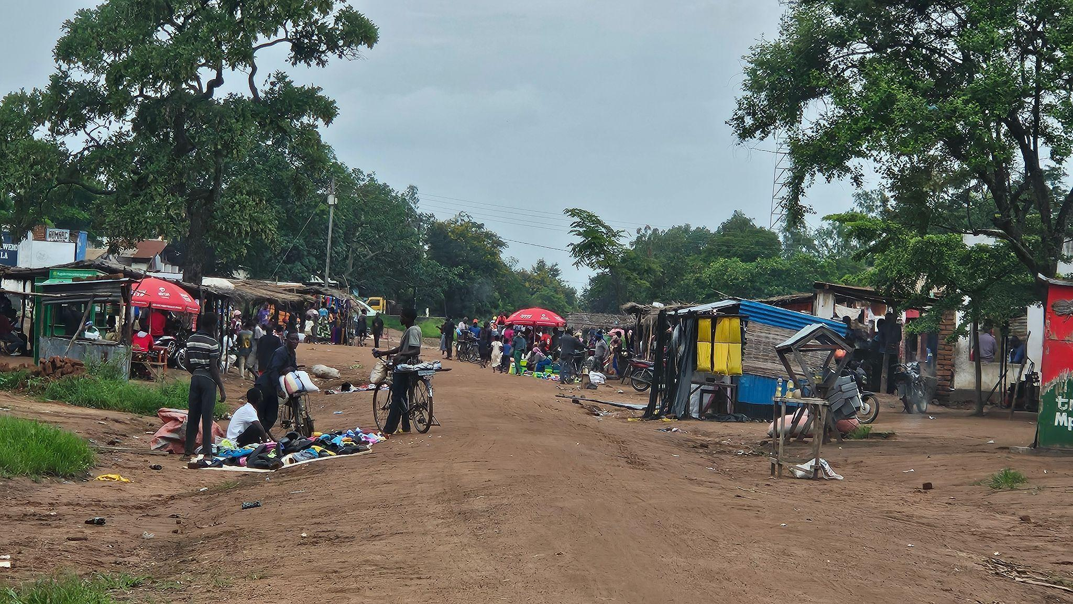
Figure 4-20: Mbela Trading Centre
The current sanitation and waste management conditions highlight the need for appropriate mitigation measures during construction, including provision of adequate sanitation facilities at work sites, controlled waste handling by contractors, and community sensitisation to prevent further environmental degradation in areas affected by project activities.

Implications for the Project
The road section is generally suitable for rehabilitation because it is flat to gently undulating and has no major geological instability risks. However, the same flat relief causes poor natural drainage, leading to ponding, waterlogging, rutting, and edge erosion, especially at low points such as the Liwawadzi River crossing and wetland-adjacent sections.
Subsurface conditions are mostly weathered basement-derived soils with localized alluvial silts/clays in floodplain areas; these are moisture-sensitive and can lose strength during the rainy season, requiring subgrade improvement, selective replacement/stabilisation, and strict compaction/moisture control.
Climate seasonality and increasing rainfall intensity heighten risks of flash flooding, erosion, culvert overtopping, and rapid road deterioration, making robust drainage (camber, side/mitre drains, culverts, flood relief) and erosion/sediment controls critical. Wetlands and shallow groundwater increase sensitivity to sedimentation and pollution, so spill prevention and protected work practices near watercourses are essential.
Biodiversity sensitivity is generally low, but Toleza Farm and protected tree species require avoidance/minimisation of clearing and compliance controls; Lantana camara disturbance may spread invasives. Weak local sanitation/waste systems mean contractors must implement strong site sanitation and waste management to prevent public health risks and drain blockages.

Socio-economic environment

Demographic Characteristics
The population within the corridor of influence area is estimated at approximately 17,600 people in 2018, projected to reach about 22,600 by 2026 based on the Balaka District intercensal annual growth rate of 3.2 percent recorded in the 2018 Population and Housing Census. For the purposes of this ESMMP, the corridor of influence is defined as the 4 km wide band (2 km either side) along the 14 km Balaka–Mbela–Kachenga (S133/T381) Road alignment between Balaka Town (Chainage 0+000 m) and Mbela Trading Centre (Chainage 14+000 m), including ancillary sites (borrow areas, access roads, laydown areas and construction camps) located within this band. Population figures are based on 2018 NSO enumeration areas and sub‑district units whose centroids fall within this corridor, with EA‑level and sub‑district populations aggregated and projected to 2026 using the 3.2 percent annual growth rate for Balaka District. Population distribution is uneven, with higher concentrations near Balaka Town and Mbela Trading Centre, while the central sections around Toleza Farm are more sparsely populated and dominated by agricultural land.
Population density is therefore low to moderate overall, with localized settlement clusters near trading centres and road junctions, and dispersed rural homesteads across farming areas and wetlands.
The demographic profile is predominantly youthful, with 45–50% of the population under 18 years, about 45% in the economically active age group (18–64 years), and less than 5% elderly (65+). The sex composition is relatively balanced, with a slight female majority (about 51–52% female; 48–49% male). Households are mainly extended rural family units, averaging 4.5–5 persons per household, and housing structures typically consist of single-storey brick or mud houses with iron-sheet or thatched roofs.
Migration and mobility patterns are largely short-distance and seasonal. Temporary out-migration of men and youth occurs during the agricultural off-season to nearby urban centres such as Balaka, Liwonde, and Blantyre for casual labour or trading. In-migration is limited and mostly associated with farming, marriage, or small-scale trading activities, particularly around Mbela Trading Centre. Daily mobility within the corridor is high as residents travel for markets, schools, health services, and water access, highlighting the importance of the road for local economic activity and social connectivity.

Education and Literacy
Education:
Education facilities along the corridor are limited and generally located outside the immediate road reserve. The main education institution directly adjacent to the road is Mamamina Girls Islamic Secondary School, located around Chainage 1+600 m, where its perimeter fence lies close to the existing road alignment. The school accommodates approximately 250 female students and 12 teachers (8 male and 4 female) and operates a bursary-supported system with no reported student dropout during consultations.
Other surrounding settlements rely on education facilities located at some distance from the road corridor, consistent with the dispersed rural settlement pattern observed along the project area.
Literacy:
Literacy levels within the corridor reflect the wider rural profile of Balaka District, where the overall literacy rate is estimated at about 70 percent according to the 2018 Population and Housing Census. Literacy tends to be relatively higher near trading centres and institutional settlements and lower in dispersed rural communities where access to education facilities is more limited. Gender disparities remain evident, with female literacy generally lower among older age groups, although recent improvements in girls’ education are contributing to better literacy outcomes among younger populations.

Health
Health conditions along the corridor reflect a rural setting with limited health infrastructure. Access to healthcare is mainly provided through Balaka District Hospital as the main referral facility, Mbela Health Centre as the primary healthcare facility serving corridor communities, and Umoyo wa Thanzi Private Clinic, which provides basic outpatient and maternal health services but with limited service capacity.
Common health conditions reported in the corridor include malaria, diarrhoeal diseases, respiratory infections, and water-borne illnesses, which are associated with poor sanitation, reliance on pit latrines, informal waste disposal, and limited formal waste management systems, particularly in trading centres such as Mbela Trading Centre. Road accessibility also influences healthcare access, especially during the rainy season when flooding and poor drainage affect movement to health facilities and referral services.

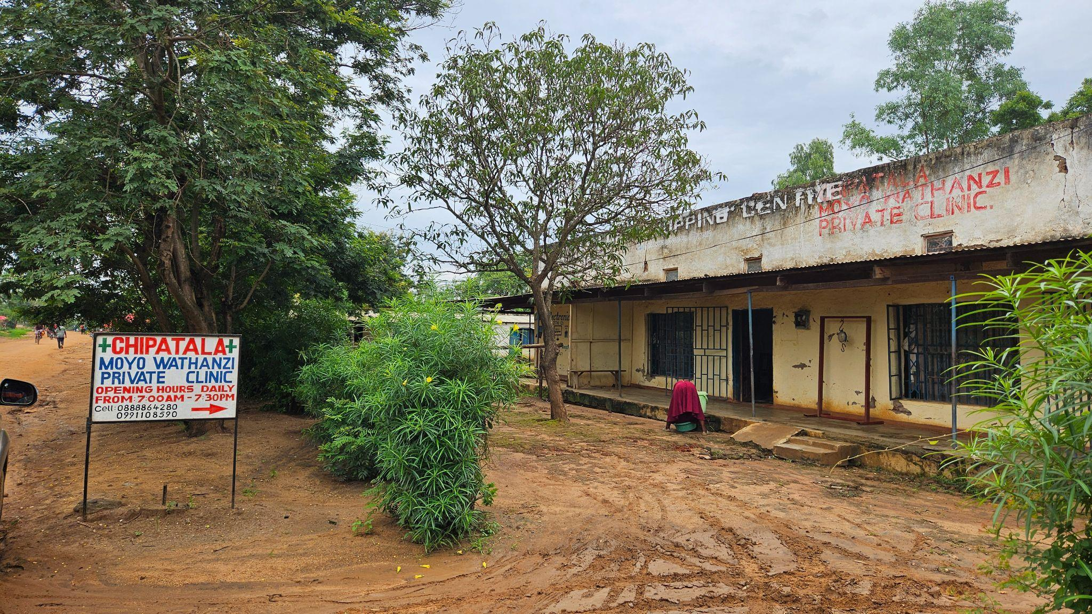
Figure 4-21: A clinic towards the Balaka Town approach

Cultural Heritage
Baseline assessments, stakeholder consultations, and field observations indicate no known cultural heritage sites, archaeological resources, sacred sites, or graveyards within or near the road corridor. The road follows an existing and long-used road reserve, and no historical structures, monuments, shrines, or culturally significant locations were identified.
Although risks are considered negligible, there remains a low possibility of chance finds (e.g., buried artefacts or unmarked graves) during excavation, particularly in previously undisturbed areas or near wetlands and river crossings. To address this, the ESMMP includes a Chance Finds Procedure, requiring contractors to stop work, secure the site, and notify relevant authorities if any cultural materials are discovered during construction (Annex 11).

Agriculture
Agriculture is the dominant livelihood activity along the Balaka–Mbela–Kachenga Road corridor. Households primarily engage in smallholder rain-fed agriculture, cultivating staple and cash crops such as maize, pigeon peas, groundnuts, sorghum, and beans. In low-lying areas near seasonal streams and wetland fringes—particularly around the Liwawadzi system—communities also practice limited dry-season gardening, mainly for vegetables, taking advantage of residual soil moisture. It was observed that a number of families cultivate close to the current road access and there does not seem to be any knowledge or enforcement in the project impact area of the road reserve.
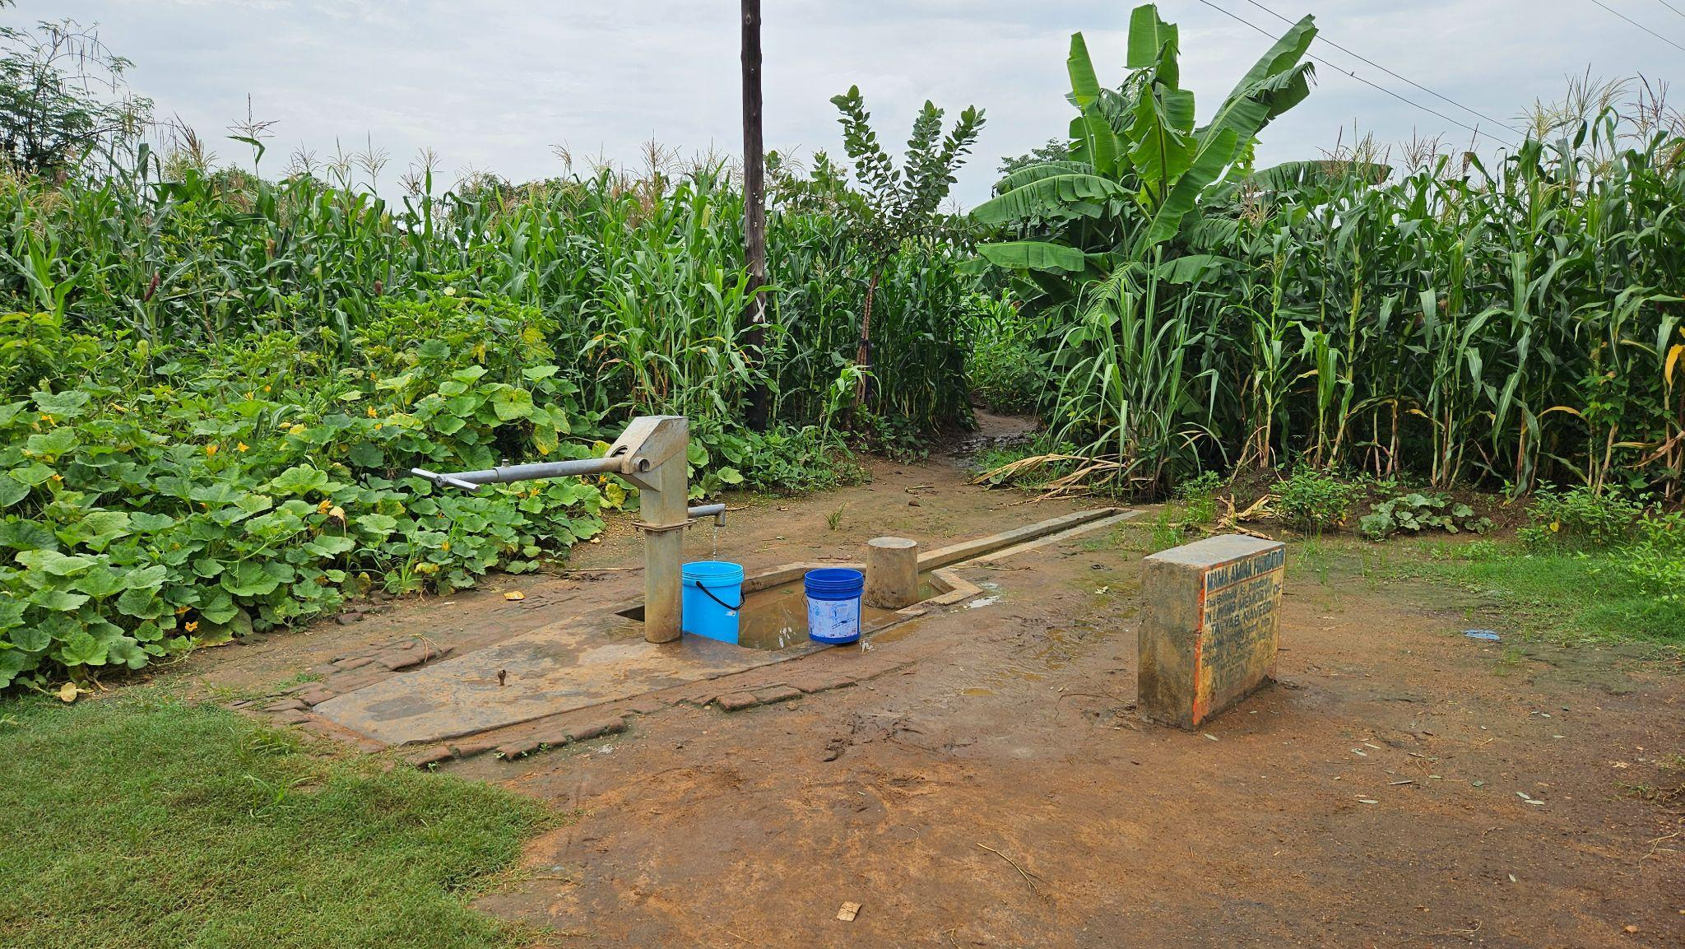
Figure 4-22: Mixed farming along the corridor
In addition to smallholder farming, the corridor hosts Toleza Farm, a significant private agricultural enterprise located along the road alignment. Toleza Farm undertakes both crop production and livestock rearing, contributing to local employment, input supply chains, and agricultural output beyond subsistence levels. Agricultural production along the corridor is otherwise largely subsistence-oriented, with surplus produce sold at Mbela Trading Centre, Kachenga trading area, and informal roadside markets. The road is therefore critical for access to farm inputs, extension services, and output markets, particularly during the post-harvest period.

Economic Activities/Livelihoods
The majority of people in the area of impact are poor. According to Malawi Poverty Report (2021) 22.9% of people in Balaka are ultra poor. Livelihoods along the corridor are predominantly informal and agriculture based. The main income sources of people in the district include ganyu (casual labour) at 42.5 percent, entrepreneurship and business at 18.4 percent, formal employment at 9.5 percent, food crop sales at 6.1 percent, cash crop sales at 5.1 percent, and petty trading at 3.4 percent. Other household income sources include remittances, pensions, and public works programmes.
Local economic activities also include small-scale trading, bicycle and motorcycle taxi services, brick moulding, carpentry, and petty vending, the latter largely undertaken by women. Economic activity is concentrated around the outskirts of Balaka, Mbela Trading Centre, and Kachenga Trading Area, which function as local commercial hubs for grain trading, agro-input supply, retail trade, and informal food vending. Market days, particularly at Mbela Trading Centre, attract traders from surrounding areas including Mangochi District.
Livelihoods remain low-income and climate-sensitive, with strong dependence on agriculture and seasonal road accessibility. Gender differences are evident, with women more engaged in petty trading and farm production, while men are more represented in produce marketing, agro-dealing, and transport-related activities.
.
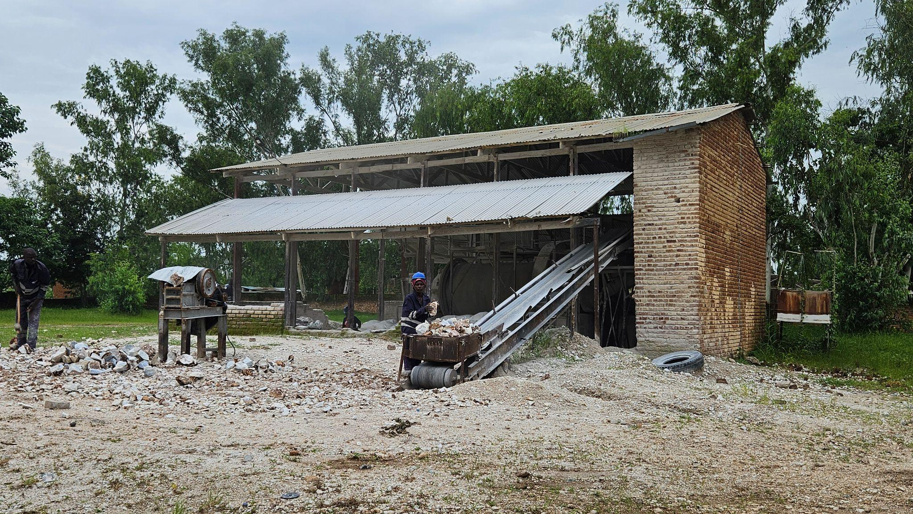
Figure 4-23: Lime factory operations along the corridor road

Transport
Transport along the Balaka–Mbela–Kachenga Road corridor is currently constrained by poor road surface conditions, inadequate drainage, and seasonal flooding, as documented in the Detailed Engineering Design (DED) report. The road primarily serves pedestrians, bicycles, motorcycles, and light vehicles, with limited use by minibuses and small trucks during the dry season. Traffic volumes are generally low to moderate, dominated by non-motorised and intermediate means of transport.
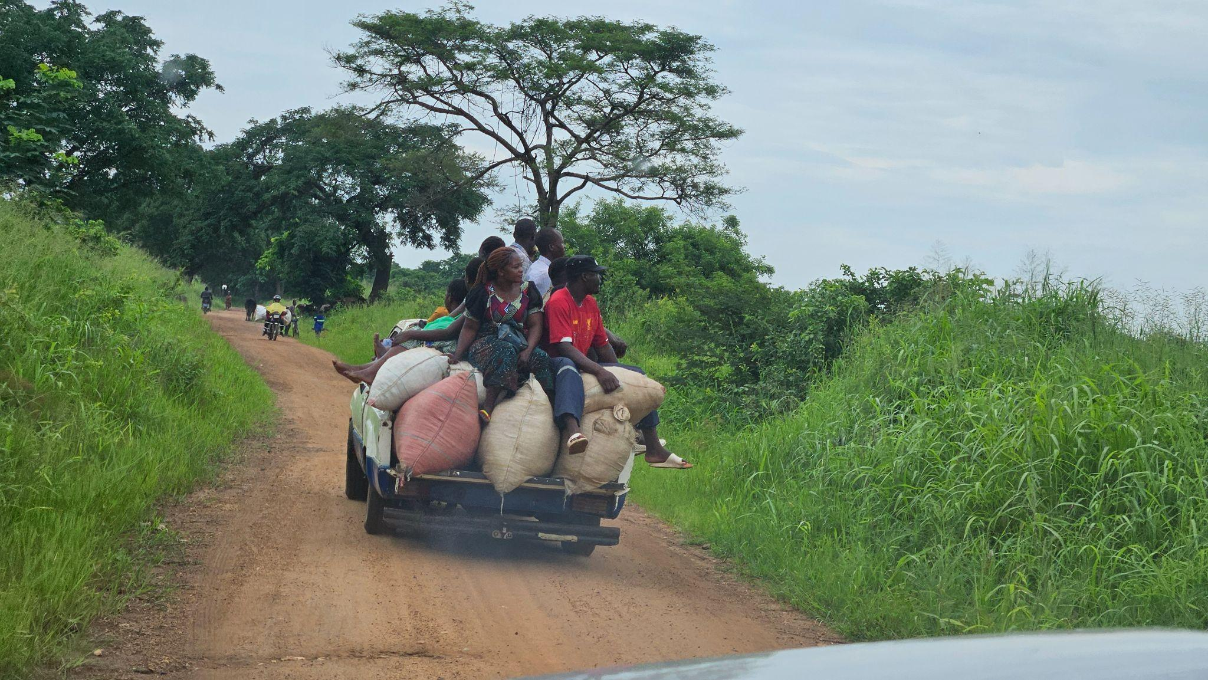
Figure 4-24: A pick-up transporting passenger along the proposed route
During the rainy season, waterlogging, erosion, and damaged drainage structures frequently disrupt access, affecting school attendance, access to health facilities, agricultural produce movement, and emergency response. The proposed rehabilitation—including improved camber, side drains, mitre drains, and culverts—is expected to significantly improve connectivity, safety, and reliability of transport, enabling consistent access throughout the year.

Security
Security conditions along the Balaka–Mbela–Kachenga Road corridor are generally stable. Communities rely on traditional leadership structures, community policing initiatives, and support from the Malawi Police Service, mainly accessed through Balaka. Common security concerns reported during consultations include petty theft, bicycle theft, motorcycle theft, particularly during late hours, and occasional disputes associated with land use and trading activities.
No major crime hotspots were identified along the corridor during consultations, and security management at community level remains largely informal through local leadership and neighbourhood monitoring arrangements.

Land Use
Land use along the corridor is predominantly rural and mixed, comprising residential settlements, smallholder agricultural fields, private farms (including Toleza Farm), trading centres, and undeveloped open land. Development is largely linear, following the existing road alignment, particularly around Mbela and Kachenga.
The road occupies an established public road reserve, although instances of informal encroachment—such as cultivation and temporary roadside structures—were observed in certain locations during field surveys. In line with the spatial distribution of works presented in Table 2‑2 and the detailed chainage design, the rehabilitation works are strictly confined to the existing alignment and road reserve, and have been configured to avoid sections where permanent houses or critical community infrastructure (such as schools, health facilities and churches) are located within the working width. Sensitive chainages where works would otherwise affect permanent structures or significant fixed assets have been deliberately omitted (“skipped”) from the scope of works and will be limited to routine maintenance activities only. On this basis, the subproject does not involve land take beyond the existing road reserve under the planned rehabilitation works; however, if future design changes introduce works in currently skipped sections or extend beyond the existing road reserve, this ESMMP will be supplemented by additional safeguard instruments determined to be applicable under national legislation and World Bank requirements, prior to implementation of such changes.

Vulnerable and Marginalized Groups
Vulnerable and marginalised groups along the corridor include female‑headed households, elderly persons, persons with disabilities, child‑headed households and very poor farming households. These groups are particularly sensitive to access disruptions, loss of informal trading opportunities and climate‑related shocks such as floods and droughts. Although the project has been designed so that sections where works would directly affect permanent houses or critical community infrastructure are avoided (see Table 2‑2), construction activities within the existing road reserve may still expose vulnerable groups to short‑term disturbances (e.g. temporary access constraints, safety risks and noise) if not carefully managed. The ESMMP therefore emphasises safe and continuous access during works, inclusive local employment opportunities, gender‑responsive measures, and accessible, culturally appropriate grievance mechanisms, in line with World Bank social inclusion principles and good practice for protecting vulnerable road users and communities.

Communication
Communication services along the corridor are primarily provided through mobile phone networks, with coverage from Airtel and TNM (in that order of reliability and coverage). Network availability is generally good in trading centres and settlement clusters but weaker in some low-lying and sparsely populated sections.
Radio remains the most widely used medium for information dissemination, complemented by community meetings and announcements through traditional leadership structures. Internet access is limited and largely confined to Balaka Town and major trading centres. These communication channels will be utilised for stakeholder engagement, information disclosure, and grievance redress during project implementation.

Energy Sources
Household energy use along the Balaka–Mbela–Kachenga Road corridor is dominated by biomass, particularly firewood and charcoal, which are the main sources of energy for cooking and heating. Access to grid electricity remains limited and is concentrated mainly in trading centres and a small number of relatively better-off households, while most rural households depend on traditional energy sources. Solar lanterns and small solar home systems are increasingly used for lighting and mobile phone charging, reflecting gradual uptake of off-grid energy options within the corridor.
During field assessment, bicycle loads of charcoal were observed being transported from the Mbela–Kachenga direction towards Balaka, indicating the prevalence of charcoal production and trade both as an energy source and a livelihood activity in surrounding rural settlements.
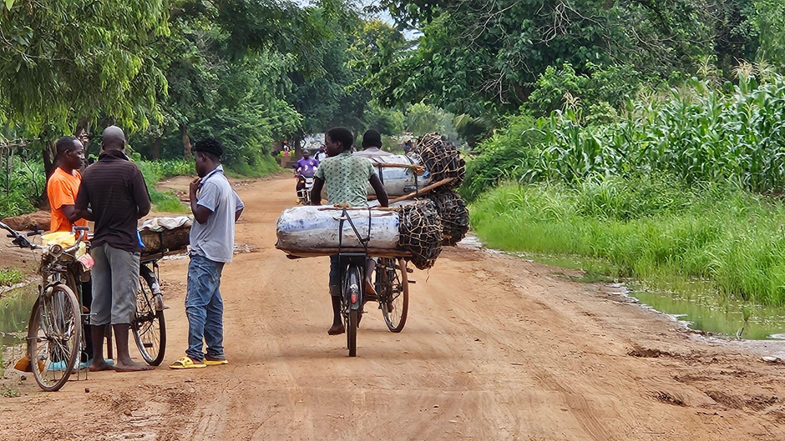
Figure 4-25: Cyclists transporting charcoal to the market along the corridor
During construction, contractor energy requirements will be met through diesel-powered equipment and generators. Fuel storage, handling, and spill prevention measures will be implemented in accordance with the ESMMP and applicable national regulations to minimise environmental and safety risks.
Implication for the Project
The Balaka–Mbela–Kachenga Road corridor serves a predominantly rural, youthful, and agrarian population with low-to-moderate settlement density and strong dependence on the road for access to markets, health services, education, and livelihoods. Population growth and daily mobility underscore the road’s importance as a social and economic lifeline.
Overall literacy is moderate, with spatial and gender disparities, requiring inclusive, locally appropriate communication during project implementation. Livelihoods are largely informal and climate-sensitive, dominated by smallholder agriculture, ganyu, and petty trading—particularly by women. Poor road conditions currently constrain market access and service delivery, especially during the rainy season.
No land take beyond the existing road reserve and no impacts on physical cultural resources are anticipated under the current design. In accordance with Table 2‑2, sections where rehabilitation activities would directly affect permanent structures, critical community infrastructure or other sensitive roadside uses are to be avoided or skipped, and works will remain confined to locations that can be undertaken within the existing road alignment and reserve; should subsequent design revisions introduce impacts that extend beyond the existing road reserve, those works will be reassessed separately and addressed in accordance with applicable national legislation and World Bank requirements before they proceed.

CHAPTER 5: ENVIRONMENTAL AND SOCIAL MITIGATION AND MONITORING PLAN

Introduction
This chapter presents the Environmental and Social Mitigation and Monitoring Plan (ESMMP) for the proposed rehabilitation of the Balaka –Mbela –Kachenga Road. It sets out the mitigation measures, monitoring requirements, implementation responsibilities, and reporting arrangements for managing the environmental and social impacts identified during planning, construction, demobilisation, and operation of the subproject.
The ESMMP provides the framework for implementing environmental and social safeguards in accordance with the Environment Management Act, 2017, applicable MEPA environmental assessment requirements, and relevant World Bank safeguard and environmental and social risk management requirements. It forms part of the environmental and social obligations to be implemented by the Contractor, Supervising Consultant, the Roads Authority or MoTPW PIU (as applicable), the District Council, and other relevant authorities during project execution.
Monitoring provisions are included to enable the PIU, Supervising Consultant, District Council, and MEPA to systematically track environmental and social performance, verify the effectiveness of mitigation measures, and ensure timely corrective action throughout implementation. Monitoring will focus on key risk areas including erosion and sediment control, drainage functionality, pollution prevention, waste management, occupational health and safety, labour and working conditions, traffic and pedestrian safety, stakeholder engagement, and grievance management.
Monitoring reports will be prepared by the Contractor and submitted on a monthly basis to the PIU, Supervising Consultant, and District Environmental Office for review and follow-up in line with the project’s nine-month implementation schedule.
Framework instruments for contractor implementation
To support effective implementation of the mitigation and monitoring measures set out in this chapter, this ESMMP includes framework instruments in the annexes that establish minimum procedures, standards, and compliance requirements for contractor implementation. Prior to commencement of works, the Contractor shall prepare site-specific plans and procedures based on these framework instruments for review and approval by the Supervising Consultant and PIU, with copy submission to the District Environmental Office where applicable.
At a minimum, the Contractor shall prepare and implement the following site-specific instruments before the relevant activities commence:
- Borrow Pit Rehabilitation Plan, based on Annex 5: Borrow Pit Rehabilitation Framework.
- Traffic Management Plan, based on Annex 6: Traffic Management Framework.
- Labour Management Plan, based on Annex 8: Labour Management Guidelines for Contractor Compliance and Preparation of Labour Management Plans (LMPs).
- Contractor Environmental and Social Management Plan (C-ESMP), based on Annex 9: Contractor Environmental and Social Management Plan (C-ESMP) Framework, integrating construction-method-specific environmental, social, health, and safety controls.
- Waste Management Plan, based on Annex 10: Waste Management Framework.
- Stakeholder Engagement Plan, based on Annex 11: Stakeholder Engagement Framework.
- GBV/SEA/SH prevention and response measures, consistent with Annex 8: Labour Management Guidelines and Annex 13: SATCP LMI Grievance Redress Mechanism (GRM) Protocol, as applicable to GBV/SEA/SH risk management.
In addition, the Contractor shall implement Annex 4: Sample Code of Conduct for Contractors, Annex 7: Chance Find Procedure for Last Mile Infrastructure under SATCP, and Annex 13: SATCP LMI Grievance Redress Mechanism (GRM) Protocol as mandatory instruments throughout the construction period. These instruments shall apply to all workers, subcontractors, suppliers, and other personnel engaged on the subproject.
All contractor-prepared plans shall demonstrate consistency with Malawi environmental and labour legislation, the Environment Management Act, 2017, MEPA environmental assessment requirements, relevant World Bank safeguard principles, and the mitigation and monitoring commitments set out in this ESMMP.

Environmental and Social Mitigation and Monitoring Plan for Balaka Mbela Kachenga Road

REF. | Impacts & Risks | Impact and Risk Enhancement Measures | Responsible Institution | Implementation Cost (USD) | Performance Indicator | Frequency | Monitoring  Cost (USD)
5.2.1 Planning Phase – Positive Impacts and Enhancement Measures
5.2.1.1 | Improved project design responsiveness through incorporation of local biophysical and socio-economic conditions. | Apply site-specific design solutions reflecting terrain, drainage, settlements, and sensitive receptors; integrate road safety features and maintain existing road footprint where feasible; validate through consultation with District Councils. | MoTPW, Design Engineer | Included in design | Approved drawings; design review reports; consultation records | Once | 1,200
5.2.1.2 | Early identification of sensitive receptors (schools, wetlands, trading centres). | Map sensitive receptors; incorporate buffers and protection measures; engage school management and local leaders; integrate measures in bid documents and ESMMP. | MoTPW, District Councils | 1,000 | Number of sensitive receptors mapped and documented | Once | 500
5.2.1.3 | Early planning of local employment opportunities. | - Include local labour provisions in procurement documents;  - Establish transparent recruitment procedures;  - Promote gender-inclusive employment to achieve 40% female employment | - MoTPW  - Contractor  - Contractor | 200 | Presence of labour and gender clauses in bidding documents | Once | 400
5.2.1.4 | Planning for sustainable sourcing of construction materials. | Identify and approve borrow pits outside wetlands and farmland; include borrow pit rehabilitation provisions in contracts. | MoTPW, DCs | 1,000 | Number of material sources approved prior to construction | Once | 500
5.2.2 Planning Phase – Negative Impacts and Mitigation Measures
5.2.2.1 | Inadequate consideration of local sensitivities leading to avoidable risks. | Conduct site-specific environmental and social screening; refine design to incorporate buffers, drainage and safety features; validate with local authorities. | MoTPW | 1,000 | Number of unresolved design-related community issues | Once | 500
5.2.2.2 | Poor early decisions on borrow pits and material sources. | Verify land ownership; obtain landowner consent in line with applicable World Bank requirements; integrate borrow pit management obligations in contracts. | MoTPW, DCs | 1,500 | Number of approved material sites with documented consent | Once | 1,000
5.2.2.3 | Limited stakeholder engagement causing misinformation. | Conduct consultations and community meetings; disclose project information; establish feedback channels and grievance redress mechanism. | MoTPW, DCs | 1,500 | Number of stakeholder meetings conducted | Once | 1,000
5.2.2.4 | Inadequate capacity of contractors to identify and manage the potential environmental and social risks | Contractor to include an Environmental, Social, Health and Safety (ESHS) Officer in their staffing to be based at site.  Develop and implement Contractor-ESMMP (C-ESMMP) and associated management plans in line with the frameworks, Malawi regulations and WB EHS guidelines and policies covering:  - Waste Management Plan  - Code of Conduct  - Borrow Pit Rehabilitation  - Stakeholder Engagement Plan  - Traffic Management Plan | Contractor | Contractor Cost | ESHS Officer on site  C-ESMMP developed and being followed. | Monthly | N/A
5.2.3 Construction Phase – Positive Impacts and Enhancement Measures
5.2.3.1 | Short-term employment creation for local communities. | - Establish and implement transparent recruitment procedures;  - Promote gender-inclusive employment to achieve 40% female employment. | Contractor | 500 | - Recruitment procedure in place  - 40% of employees are female | 1.Once  2. Monthly | 200
5.2.3.2 | Local procurements leading to increased circulation of income in local economies. | - Engagement of local vendors and service providers where possible;  - Maintain access to trading centres as part of the Traffic Management plan including signage, temporary crossings, diversions, use of flag people etc. | Contractor | 500 | - % locally sourced goods/services  - Number of grievances received related to access | Monthly | 200
5.2.4 Construction Phase – Negative Impacts and Mitigation Measures
5.2.4.1 | Dust, noise, vibration and traffic safety risks near settlements and schools. | Implement dust suppression;  Install warning signs and speed controls;  Restrict noisy works during school hours. | Contractor | 1,000 | Records of dust suppression activities.  Number of grievances related to dust or noise including from sensitive receptors | Monthly | 500
5.2.4.2 | Environmental degradation from uncontrolled material extraction. | Acquire permits for material extraction or procure from licensed suppliers  Restrict extraction to approved sites; prohibit riverbed and wetland extraction; demarcate borrow pits.  Rehabilitate Borrow pits and sand mining areas. Progressive rehabilitation should be implemented where possible. | Contractor | Include in contract | Permits available on site  Number of demarcated borrow pits  % area of borrow pit rehabilitated | Once  Monthly  Monthly and prior to site handover by Contractor | 500
5.2.4.3 | Soil erosion and sedimentation of drainage lines. | Implement erosion control measures including drainage diversion and sediment traps. | Contractor | 1000 | Control measures (silt traps, drainage channels, slope stabilization) in place during construction | Every two months | 500
 | Loss of vegetation and risk of spread of invasive species | Implement replanting protocols – 10 trees for every tree felled.  Training of workers on invasive species and prohibit planting of invasive species during replanting or rehabilitation of sites | Contractor | 500 | Number of trees replanted per tree felled  Training and awareness sessions conducted | Every two months | 500
5.2.4.4 | Occupational health and safety risks to workers. | - Develop and implement an OHS Plan for all activities  - Induct all workers on the OHS Plan and conduct toolbox talks on at least a weekly basis  - Provide PPE to all workers and enforce its use.  - Develop and implement emergency preparedness procedures. | Contractor | 500 | OHS Plan developed, available on site.  Training records for workers on OHS plan and emergency response procedures available on site | Monthly | 500
5.2.4.5 | Health and Safety Risks to Communities | Incorporate Community Health and Safety Risks in Traffic Management Plan  Implement dust suppression  Provide safe diversion for safe movement of traffic  Fence off borrow pits and active work areas | Contractor | 2500 | Traffic management plan developed and available on site  Records of dust suppression activities  Diversion provided  Number of borrow pits fenced off | Once | 500
5.2.4.6 | Health and Safety Risks to Communities | Conduct awareness campaigns on HIV/Aids, Cholera and other communicable diseases  Provide safe diversion for safe movement of traffic (including signage, barriers and passable diversion) | Contractor | 500 | Toolbox talks records | Monthly | 200
5.2.4.7 | Temporary loss of access to land for ancillary facilities including borrow pits, diversions and construction camps | Enter into negotiated agreements with clear payment modalities as needed in line with applicable World Bank requirements  Contractor to restore land | Contractor | TBC based on cost of land | Signed Contract shared with PIU | Once | N/A
5.2.4.8 | Temporary disruption of access to farms and social services.  Damage to assets including crops and trees as a result of works | There will be no restrictions of access Maintain access to farms, social services etc as part of the Traffic Management Plan including signage, temporary crossings use of flag people, one way traffic, temporary diversions and pedestrian access route  Establish a grievance redress mechanism  Payment of compensation for any losses/ damage to assets inadvertently caused as a result of contractor activities at replacement value | Contractor | Costed above  + any additional costs for unintended damage. | Number of grievances related to issues with access | Monthly | N/A
5.2.4.9 | Labour influx risks including communicable diseases, SEA/SH and social tensions. | Ensure all workers sign and are trained on the Worker Code of Conduct  Conduct HIV/AIDS and SEA/SH awareness training;  Establish and maintain a Community Grievance Redress Mechanism that is SEA/SH responsive | Contractor | 200 | - % of workers signed the CoC  - % of workers who received training on CoC  - % of workers who received training on HIV/AIDS, SEA/SH  - Number of Grievances received  - % of grievances resolved in 10 days | Monthly | 200
5.2.4.10 | Abusive Labour and Working Conditions (labour exploitation, forced labour, under aged and discriminatory working conditions) | - Explain to all workers’ conditions of service, labour exploitation and contract duration  - Ensure all workers have a signed contract and given a copy  - Implement age verification system using national identification to employ only those that are 18 years old and above and undertake due diligence of primary suppliers to ensure they are not using child labour  - Establish and maintain a Worker Grievance Redress Mechanism that is SEA/SH responsive | Contractor | 600 | - % of workers with signed contract  - Number of underaged workers  - Availability of functioning WGRC  - Number of Grievances received  - % of grievances resolved in 10 days | Monthly | 200
5.2.4.10b | Disruption of activities Balaka Girls Islamic Secondary School along the road alignment | - Engagement will be undertaken with the School prior to the start of works | Contractor | 100 | - Number of meetings | Every two weeks | 50
5.2.4.11 | Impact to Cultural Heritage | Implement a Chance Finds Procedure including the training of workers | Contractor | 200 | % of workers trained on chance finds procedure | Monthly | 200
5.2.4.12 | Climate-related risks: increased surface runoff, flash flooding, and accelerated soil erosion, particularly during high-intensity rainfall events | Store loose soil material, waste, concrete mix and fuel away from the river banks  Provide shelter/rest areas for workers | Contractor | 100 | Availability of designated sites for waste, fuels and concrete mixing away from riverbank  Shelter provided for workers on site | Monthly | 200
5.2.5 Demobilization Phase – Negative Impacts and Mitigation Measures
5.2.5.1 | Residual waste and disturbed land | Remove all waste; dispose at approved sites; clean up / restore site  Restore temporary camps to pre project conditions. | Contractor | 500 | 100% waste removed and disposed at disposal site approved by District Council  100% of disturbed land restored to the satisfaction of the client and District in line with agreed plans | Once | 1000
5.2.5.2 | Sudden loss of income for local workers. | Provide advance notice; ensure payment of dues; issue references where possible. | Contractor | 400 | N/A | N/A | N/A
5.2.6 Operation and Maintenance Phase – Positive Impacts and Enhancement Measures
5.2.6.1 | Year-round road access improving mobility and service delivery. | Maintain signage, road safety measures and traffic calming devices near settlements. | MoTPW | Operational costs | N/A | N/A | N/A
5.2.6.2 | Reduced erosion and waterlogging at drainage infrastructure locations | Routine inspection and clearing of drainage structures | District Council | Operational costs | Number of maintenance activities carried out | As per District Council and Roads Authority routine | N/A
5.2.7 Operation and Maintenance Phase – Negative Impacts and Mitigation Measures
5.2.7.1 | Drain blockage and flooding due to poor maintenance. | Routine inspection and clearing of drains and culverts. | MoTPW | Operational Costs | N/A | N/A | N/A
5.2.7.2 | Unregulated roadside trading and encroachment. | Conduct road reserve sensitization and enforce reserve boundaries with District Councils. | MoTPW, DCs | Operational costs | N/A | N/A | N/A

Institutional Capacity for ESMMP Implementation
The District Environment Sub-Committee (DESC) for Balaka District is a key institutional body responsible for supporting the implementation and monitoring of the Environmental and Social Management Plan (ESMMP) for the Balaka–Mbela–Kachenga Road Rehabilitation Project. Consultations confirmed that the DESC has the mandate, technical awareness, and willingness to participate in environmental and social oversight throughout the project lifecycle. Its anticipated role includes conducting joint site inspections with the Contractor and Supervising Engineer, monitoring compliance with ESMMP requirements such as occupational health and safety, waste management, and community safety measures, and participating in the Grievance Redress Mechanism (GRM) to review and resolve community complaints.
Despite this readiness, the DESC identified several operational constraints that may affect its effectiveness, particularly limited access to transport and fuel, insufficient operational funding, and lack of allowances for field monitoring activities. These limitations may reduce the frequency and effectiveness of monitoring unless addressed through project support.
To strengthen institutional capacity, the DESC recommended logistical and technical support, including provision of fuel and transport for site inspections, allowances for monitoring teams, standardized ESMMP monitoring checklists and reporting templates, and regular coordination meetings with the Contractor, Supervising Engineer, and MoTPW. The committee also emphasized the need for early disclosure of the ESMMP and contractor work plans to facilitate proper monitoring planning.
In terms of oversight, the DESC proposed monthly monitoring visits for short-duration construction works and quarterly visits for longer-term projects, provided logistical support is available.
Implementation of the ESMMP will require coordination among national, district, and site-level institutions through routine supervision, reporting, and consultation mechanisms. Detailed responsibilities for specific mitigation and monitoring actions are presented in the ESMMP Implementation and Monitoring Matrices.

Table 5-5-1. Institutional Responsibilities for ESMMP Implementation and Oversight
Institution | Role in ESMMP Implementation
Ministry of Transport and Public Works (MoTPW) and PIU | Executing agency responsible for overall ESMMP oversight; integrates ESMMP requirements into project contracts, supervises compliance, reviews monitoring reports, and ensures corrective actions are implemented.
Contractor | Primary responsibility for implementing ESMMP mitigation measures during construction; appoints an Environmental, Health and Safety (EHS) Officer, prepares site-specific management plans, implements environmental safeguards, and maintains compliance records.
Supervising Consultant (SC) | Provides day-to-day supervision of construction activities and verifies contractor compliance with ESMMP requirements through regular inspections and technical reporting.
Malawi Environment Protection Authority (MEPA) | Provides statutory environmental oversight and conducts compliance inspections in accordance with the Environment Management Act (2017).
Balaka District Council / District Environment Sub-Committee (DESC) | Supports local monitoring, facilitates community engagement, and assists with environmental awareness and grievance handling at the district level.

ANNEXES

Annex 1. Feedback Letter from MEPA
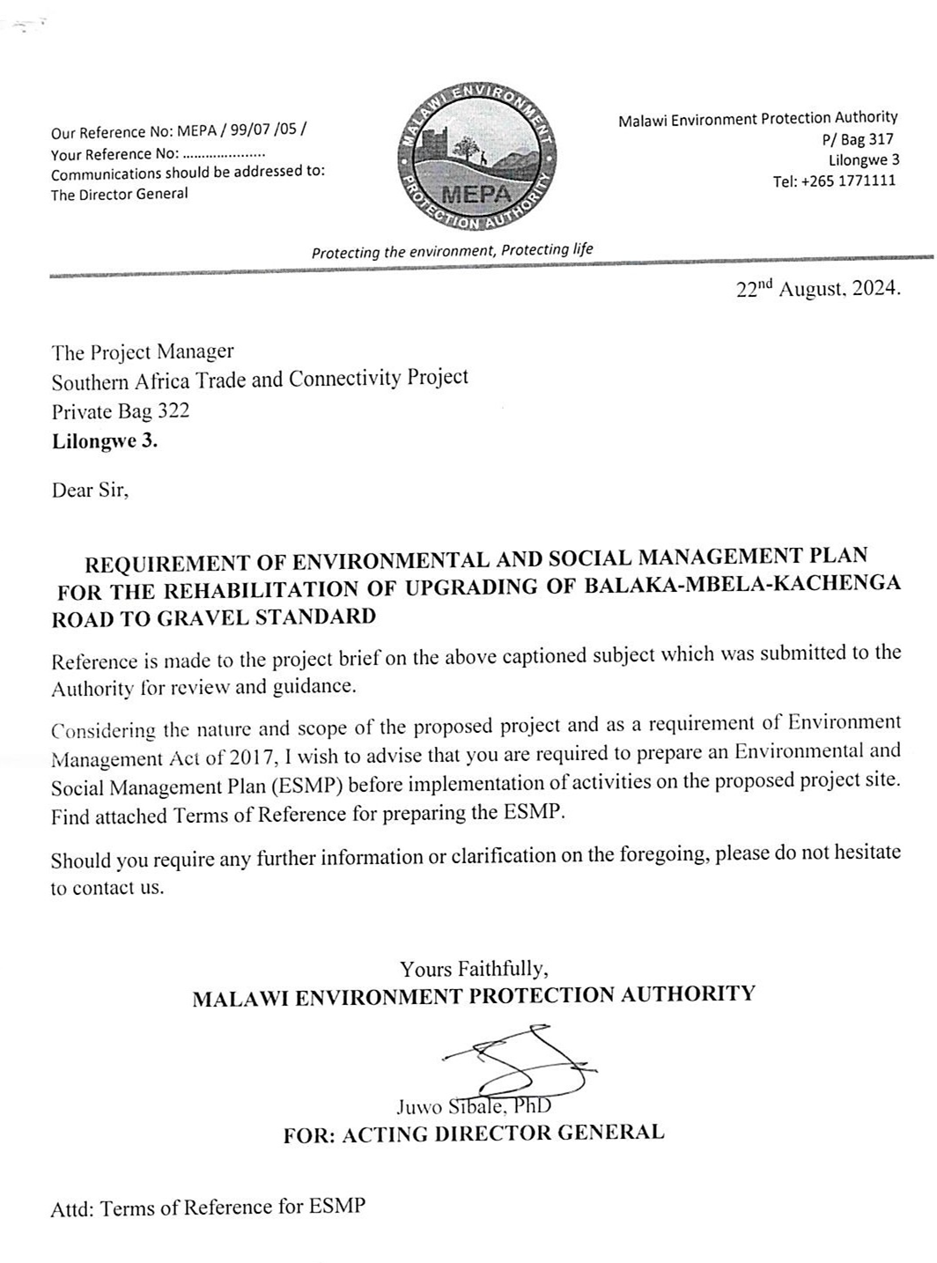

Annex 2. Terms of Reference from MEPA
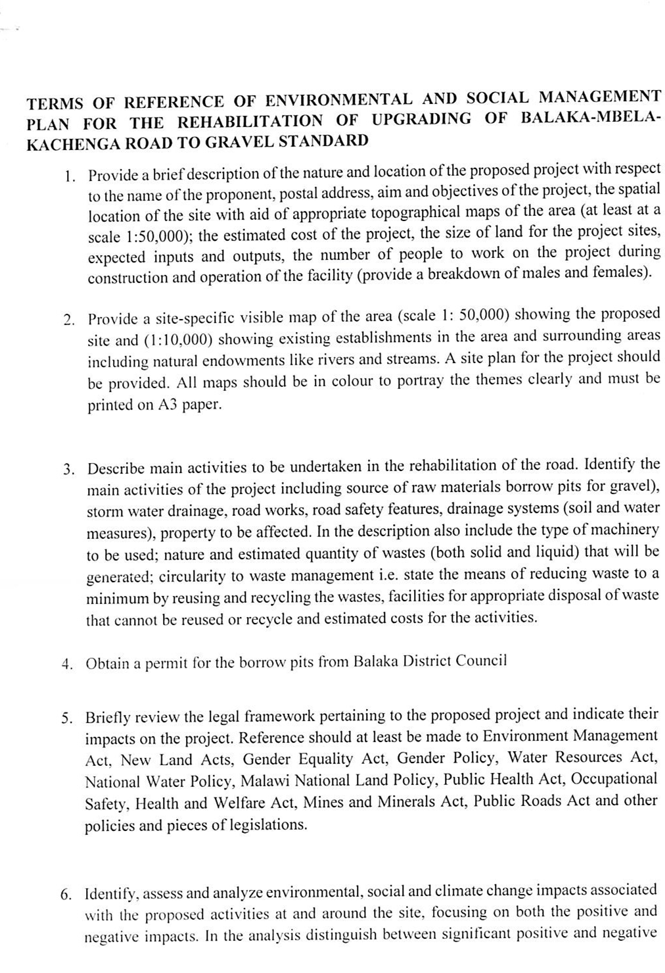

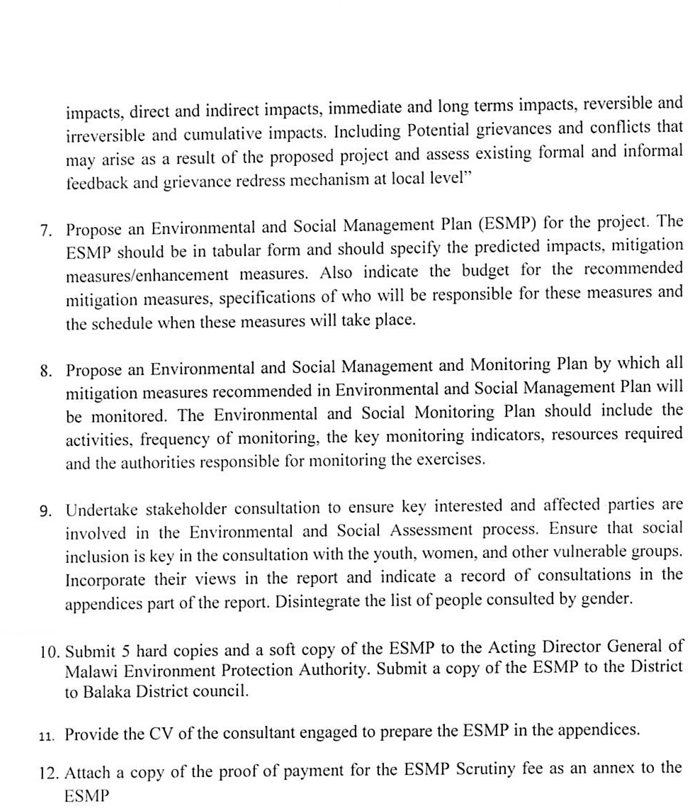

Annex 3a. List of Stakeholders Consulted
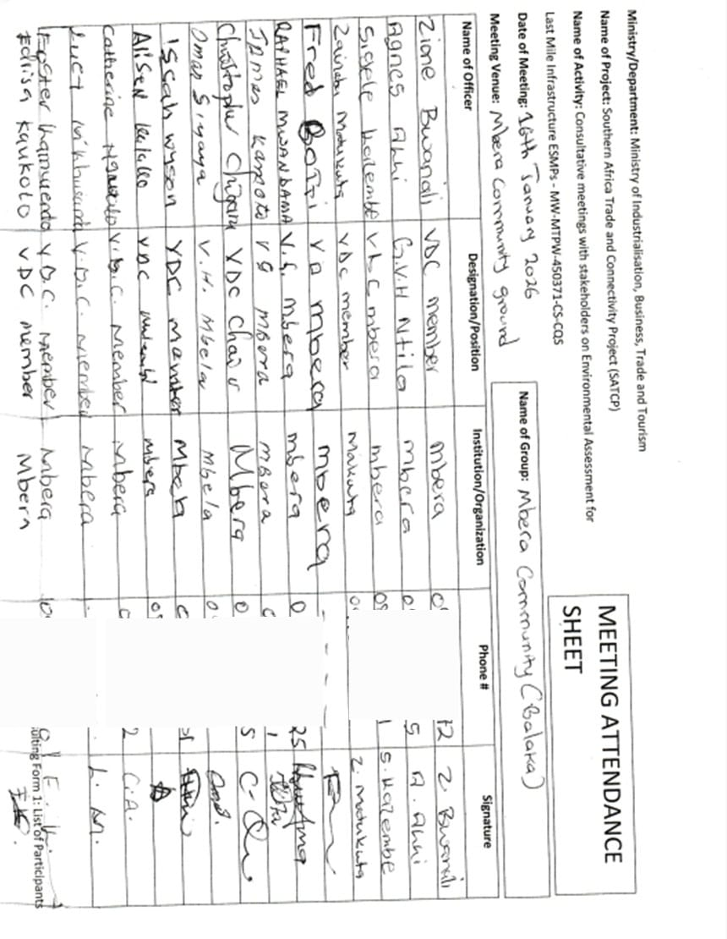

Annex 4b. Issues raised by stakeholders and how they have been addressed in the revised ESMMP
SN | Issue Raised | Raised By | ESMMP Response / Intervention | ESMMP Reference (Section / Table / Annex)
1 | Flooding and overtopping of the road near wetlands and the Liwawadzi River floodplain | DESC / Community Consultations | Integrate drainage improvements through culverts, side drains, embankment stabilization, and protection of natural drainage pathways along flood-prone sections. | Section 4.2.5 Water Resources; Section 5.2 ESMMP
2 | Risk of soil erosion, embankment instability, and sedimentation of watercourses | DESC | Apply erosion control measures including slope protection, controlled spoil placement, and sediment management in disturbed sections. | Section 5.2 ESMMP
3 | Protection of boreholes, water pipelines, and irrigation infrastructure | DESC / Community Consultations | Identify utility crossings before excavation and ensure immediate restoration where accidental damage occurs. | Section 5.2 ESMMP
4 | Borrow pits may create environmental damage and safety hazards if not rehabilitated | DESC | Use approved borrow pits, apply controlled extraction, signposting, access restriction, and rehabilitation after material extraction. | Section 2.4 Material Sources; Section 5.2 ESMMP
5 | Waste management and risk of environmental pollution from construction activities | DESC | Provide waste collection points, sanitation facilities, controlled disposal, and prevent contamination of surrounding land and drainage systems. | Section 5.2 ESMMP
6 | Risk of dust, noise, and disturbance to nearby settlements during construction | Community FGD | Control dust through watering and regulate noisy activities near settlements and sensitive receptors. | Section 5.2 ESMMP
7 | Road safety risks for children, pedestrians, and motorcyclists | Community FGD | Install warning signage, speed controls, phased access arrangements, and deploy flag persons in sensitive locations. | Section 5.2 ESMMP
8 | Risk of GBV, SEA/SH, and sexual exploitation associated with contractor presence | Community FGD / DESC | Enforce worker Codes of Conduct, sensitisation, reporting channels, and referral measures. | Section 5.2 ESMMP
9 | Child protection and prevention of child labour | DESC | Prohibit child labour and enforce labour supervision and reporting procedures. | Section 5.2 ESMMP
10 | Disruption of roadside trading, crops, and livelihoods during construction | Community FGD | Maintain phased construction and preserve access to farms, homes, and trading points during works. | Section 5.2 ESMMP
11 | Local employment opportunities for women and youth | Community FGD | Prioritise local labour recruitment under fair and transparent hiring arrangements. | Section 5.2 ESMMP
12 | Need for stronger communication and continuous stakeholder engagement | DESC / Community FGD | Maintain consultation, disclosure of construction schedules, and use local grievance channels. | Section 5.2 ESMMP
13 | Land disputes and protection of community assets such as crops and roadside structures | Community Consultations | Avoid unnecessary asset damage and apply grievance procedures where disputes arise. | Section 5.2 ESMMP
14 | Cultural heritage protection and possible chance finds during excavation | DESC | Apply chance-find procedures where cultural materials or graves are encountered. | Section 5.2 ESMMP; Annex 11
15 | Limited capacity of the District Environmental Sub-Committee (DESC) to monitor ESMMP implementation | DESC | Strengthen district participation through joint inspections and monitoring responsibilities during implementation. | Monitoring responsibilities as shown across Section 5.2 ESMMP table
16 | Vegetation clearance may affect regenerating vegetation and spread invasive species | DESC / Community Consultations | Limit vegetation clearing to approved work areas and rehabilitate disturbed sections appropriately. | Section 5.2 ESMMP
17 | Risk of damage to community water pipes and small utility connections during excavation | Community FGD | Confirm utility locations before excavation and repair accidental damage immediately. | Section 5.2 ESMMP

Annex 4. Sample Code of Conduct for Contractors
1. Purpose and Scope
This Sample Code of Conduct (CoC) provides the minimum mandatory standards of behaviour for all personnel engaged in implementation of SATCP Last Mile Infrastructure (LMI) subprojects, including contractors, sub‑contractors, supervising consultants, suppliers, and all categories of workers (permanent, temporary and day workers). The annex serves as a framework and template for preparation of a project‑specific Contractor’s Code of Conduct, which shall be adapted by each Contractor to reflect the scope, risks, workforce composition and community context of the subproject, and submitted to the Supervising Consultant and the PIU for review and approval prior to mobilisation.
The project‑specific CoC shall apply to all personnel working on or in connection with the subproject and shall be communicated in a language and format that workers understand. Each worker shall sign the approved Code of Conduct as a condition of employment and shall receive induction and periodic refresher training on its requirements, including sanctions for non‑compliance.
The Code addresses risks associated with the following:
- Environmental and social management.
- Occupational health and safety (OHS).
- Labour influx and labour relations.
- Spread of communicable diseases, including HIV and AIDS.
- Sexual harassment (SH), sexual exploitation and abuse (SEA), and gender‑based violence (GBV).
- Child labour and child protection.
- Illicit behaviour, crime and corruption.
- Community health, safety and road safety.
Compliance with the approved Code of Conduct is a contractual obligation for the Contractor and all associated personnel, and a condition of employment on the project. The Contractor shall be responsible for enforcement of the Code at worksites, worker accommodation areas, haul routes and all other project‑related locations, while the Supervising Consultant and PIU shall monitor compliance as part of ESMMP and contract implementation.
2. General Obligations
The Supervising Consultant shall ensure that the Contractor and all associated personnel:
a) Legal Compliance
Comply at all times with the laws, regulations, and standards of the Republic of Malawi, including the Environment Management Act (2017), labour laws, occupational safety legislation, and applicable World Bank safeguard requirements.
b) ESHS Planning Instruments
Prepare, implement, and maintain site-specific instruments prior to commencement of works, including:
- Environmental and Social Management Plan (ESMMP);
- Health and Safety Management Plan (HSMP);
- HIV and AIDS Awareness Programme;
- Occupational Health and Safety Awareness Programme;
- Road Safety and Traffic Management Plan.
c) Occupational Health and Safety
Provide a safe and healthy working environment, including:
- Provision and compulsory use of appropriate Personal Protective Equipment (PPE);
- Prevention of avoidable accidents and injuries;
- Immediate reporting and correction of unsafe acts or hazardous conditions.
d) Traffic and Road Safety
Implement traffic safety measures, including:
- Temporary speed calming devices and speed-limit signage;
- Warning signs in villages, trading centres, schools, health facilities, and construction zones;
- Enforcement of safe driving practices by all project drivers.
e) Environmental Protection
Avoid unnecessary clearance of trees and vegetation, prevent conflicts over water resources, and ensure sustainable use of natural resources in consultation with local communities.
f) Pollution Prevention
Take all reasonable measures to prevent pollution of air, water, and soil, land degradation, and environmental damage, and ensure compliance with good international industry practice.
g) Worker and Public Safety
Install standard safety signs, barricades, and road markings during construction and after completion to protect workers, communities, and road users.
h) Sanitation and Welfare Facilities
Provide adequate sanitation facilities, including:
- Safe drinking water;
- Decent toilets and washing facilities at worksites and camps;
- Prohibition of open defecation.
i) Site Rehabilitation and Restoration
Restore all disturbed areas after construction, including borrow pits, quarries, stockpiles, camps, access roads, batching plants, fuel storage areas, and waste disposal sites, through landscaping, tree planting, and erosion-control measures.
3. Labour, Ethics, and Social Conduct
j) Non-Discrimination
Prohibit all forms of discrimination in recruitment, employment, and working conditions on the basis of gender, age, ethnicity, disability, religion, marital status, political affiliation, or other protected characteristics.
k) Fair Labour Practices
Adhere to Malawi labour laws by issuing written contracts to skilled and unskilled workers, respecting working hours, wages, and conditions of employment.
l) Prevention of Sexual Harassment
Strictly prohibit sexual harassment, including abusive language, inappropriate gestures, sexually suggestive behaviour, or culturally offensive conduct, particularly towards women and children.
m) Prevention of SEA/GBV
Prohibit any form of sexual exploitation, abuse, or violence, including:
- Exchange of money, goods, services, or employment for sex;
- Exploitative or degrading behaviour;
- Any sexual activity with minors (persons under 18), regardless of consent.
n) Child Protection and Child Labour
Prohibit child labour and all forms of child abuse, exploitation, or endangerment, and ensure children’s safety in and around project areas.
o) Conflict of Interest and Corruption
Avoid conflicts of interest and prohibit bribery, favouritism, or preferential treatment based on personal, financial, or family relationships.
p) Protection of Property and Assets
Safeguard project equipment, materials, and property; prohibit theft, vandalism, misuse, or waste of resources.
q) Grievance Reporting and Non-Retaliation
Ensure that workers and community members can report violations of this Code through established grievance mechanisms without fear of retaliation, provided the report is made in good faith.
4. Enforcement and Accountability
r) Acknowledgement and Sanctions
All workers and contractor personnel shall:
- Read, understand, accept, and sign this Code of Conduct as a condition of employment;
- Attend mandatory induction and refresher training on ESHS and SEA/GBV prevention.
Any violation of this Code of Conduct may result in disciplinary action, including:
- Verbal or written warnings;
- Suspension or dismissal;
- Termination of contract; and/or
- Referral to relevant legal authorities.
5. Contractor Certification
I, the undersigned, confirm that I have read and understood this Code of Conduct and commit to ensuring full compliance by all personnel engaged under this contract.
I Agree /
Name of Authorized Representative: ____________________________
Signature: ____________________________
Name of Company: ____________________________
Physical Address: ____________________________
Company Stamp: ____________________________
Date: ____________________________

Annex 5. Barrow Pit Rehabilitation Framework
(SATCP Last Mile Infrastructure Projects)
1. Introduction and Purpose
This Borrow Pit Rehabilitation Framework applies to all borrow pits identified and utilised under the SATCP Last Mile Infrastructure (LMI) projects. It sets out mandatory procedures for environmentally sound material extraction, operation, rehabilitation and closure of borrow pits so that material sourcing does not result in permanent land degradation, public safety hazards, or adverse impacts on surrounding communities and ecosystems.
The Framework provides the standard requirements that Contractors must follow when preparing site-specific Borrow Pit Management and Rehabilitation Plans for each borrow source they intend to use. These site-specific plans shall form part of the Contractor’s Environmental and Social Management Plan (C-ESMMP) and shall be submitted to the Supervising Consultant and the PIU for review and approval prior to opening or using any borrow pit. The Framework shall also be applied within the site-specific ESMMP to guide oversight, monitoring and verification of borrow-pit performance throughout construction and post-closure.
2. Project Context
Borrow pits are identified during the design and pre-construction phases of LMI subprojects based on geotechnical investigations undertaken under the Detailed Engineering Design (DED). These borrow pits may supply lateritic gravel, fill material, or other construction materials required for road rehabilitation, drainage works, and ancillary infrastructure.
At the planning stage, borrow pits are considered indicative material sources. Final selection, approval, and use shall be subject to field verification, landowner consent, Environmental and social screening, and approval by relevant authorities.
3. Regulatory and Safeguards Framework
Borrow pit development, operation, and rehabilitation under SATCP LMI projects shall comply with:
- Environment Management Act (2017)
- MEPA Guidelines for Environmental Assessment (2025)
- SATCP ESMF
- World Bank OP/BP 4.01 and OP/BP 4.04 (where applicable)
- Approved ESMMPs and DEDs for each LMI subproject
4. Borrow Pit Planning and Site Controls
Before opening or using any borrow pit, the Contractor shall:
- Obtain written approval from the Supervising Consultant and the relevant District Council.
- Secure documented landowner consent and confirmation from the appropriate Traditional Authority.
- Verify land tenure status and agree on access, use, rehabilitation, and handover conditions.
- Clearly demarcate the borrow pit footprint and access routes.
- Strip and stockpile topsoil separately for use during rehabilitation.
- Install warning signage and temporary fencing, particularly where borrow pits are located near settlements, agricultural land, footpaths, or grazing areas.
5. Key Environmental and Social Risks
Typical risks associated with borrow pits under LMI projects include:
- Loss of productive agricultural land
- Open excavations posing injury risks to people and livestock
- Standing water leading to mosquito breeding
- Soil erosion and sediment runoff into nearby streams or wetlands
- Visual scarring of the landscape
- Community dissatisfaction where land is not adequately restored
6. Rehabilitation Objectives
Borrow pit rehabilitation under SATCP LMI projects shall aim to:
- Restore land to a safe, stable, and productive condition
- Prevent erosion, standing water, and slope instability
- Reintegrate rehabilitated sites into agricultural or community land use
- Eliminate public health and safety hazards
- Meet landowner, community, and District Council expectations
7. Rehabilitation Measures
7.1 Progressive Rehabilitation
- Implement rehabilitation progressively, commencing immediately after material extraction in each section.
- Phase excavation activities to minimise the total open area at any given time.
7.2 Backfilling and Reshaping
- Reuse overburden and unsuitable material for backfilling.
- Reshape excavated areas to stable slopes (maximum 1:3).
- Partially backfill deep excavations to eliminate water accumulation.
7.3 Topsoil Replacement
- Evenly spread stockpiled topsoil over rehabilitated surfaces.
- Ensure sufficient topsoil depth to support revegetation or agricultural reuse.
7.4 Drainage and Erosion Control
- Restore surface drainage to natural flow patterns.
- Apply erosion control measures such as contour shaping, grass strips, or stone pitching where required.
7.5 Revegetation
- Revegetate rehabilitated sites using indigenous grass species and locally appropriate tree species, subject to landowner preference.
- Prioritise vegetation that supports soil stabilisation, shade provision, and community utility.
8. Safety and Community Protection
- Secure active borrow pits using fencing, barriers, or warning tape.
- Install clear warning signage in English and local languages.
- Eliminate vertical faces and open pits upon closure.
- Formally hand back rehabilitated sites to landowners after completion.
9. Post-Use Land Options
Subject to agreement with landowners and District Councils, rehabilitated borrow pits may be converted into:
- Agricultural land
- Community woodlots
- Grazing areas
- Controlled water retention areas (only where approved, engineered, and safe)
10. Roles and Responsibilities
Actor | Responsibility
Contractor | Implement borrow pit management and rehabilitation
Supervising Consultant | Approve, supervise, and certify rehabilitation works
District Council / DESC | Community liaison and site verification
Landowners / Traditional Authorities | Accept rehabilitated land

11. Monitoring and Reporting
- Report borrow pit status in monthly ESMMP compliance reports.
- Monitor indicators including number of rehabilitated sites, erosion evidence, water ponding, and vegetation establishment.
- Conduct final inspections prior to issuance of completion certificates.
12. Budgeting
- Fully include borrow pit rehabilitation costs in the Contractor’s BoQs and C-ESMMP.
- Prohibit approval of any borrow pit without a costed and approved rehabilitation provision.
13. Completion and Handover
Consider borrow pits closed only when rehabilitation is complete, sites are safe and stable, and formal handover documentation is signed by relevant parties.
14. Conclusion
This Borrow Pit Rehabilitation Framework provides a consistent and enforceable approach for managing borrow pits across all SATCP Last Mile Infrastructure projects, ensuring Environmentally responsible material sourcing, protection of community interests, and full compliance with MEPA (2025) and World Bank safeguards.

Annex 6. Traffic Management Framework
1. Introduction
This Traffic and Access Management Framework (TAMF) has been prepared for the Southern Africa Trade and Connectivity Project (SATCP) – Last Mile Infrastructure (LMI) subprojects, including feeder road rehabilitation, drainage improvements, bridge/culvert works and associated construction activities. The Framework sets out the minimum requirements for planning, operating and monitoring construction-related traffic so that works are carried out safely and with limited disruption to local communities and road users.
The Framework provides mandatory guidance for the preparation and implementation of site-specific Traffic and Access Management Plans (TAMPs) by Contractors. For each subproject, the Contractor shall prepare a TAMP consistent with this Framework and submit it to the Supervising Consultant and the SATCP PIU/State Agency for Transport and Construction Projects for review and approval prior to commencement of construction works.
The TAMF aims to ensure that all construction-related traffic—vehicles, equipment and personnel—is managed safely, efficiently and in an environmentally and socially responsible manner, while minimising risks and disruptions to communities, vulnerable road users, businesses, and existing transport infrastructure.
2. Purpose and Objectives
Construction activities will increase vehicular and machinery traffic within worksites and along existing regional and community roads. Without effective management, such traffic may:
- Interfere with normal traffic and pedestrian movements;
- Increase risks of accidents and injuries to workers and the public;
- Damage existing road infrastructure;
- Generate dust, noise, congestion, and community nuisance.
The objectives of this Framework are to:
- Promote safe interaction between construction traffic, pedestrians, and local road users;
- Minimize Environmental and social risks associated with construction traffic;
- Guide the planning, use, and rehabilitation of access roads and haul routes;
- Ensure site-specific traffic impacts are addressed through appropriate design, scheduling, signage, and controls.
3. Access Roads and Haul Routes
a) Planning and Approval
The Contractor shall prepare detailed layout plans for all proposed access roads and haul routes. These plans shall:
- Be submitted to the Supervising Consultant for approval;
- Be accompanied by written consent from affected landowners, Traditional Authorities, or village leadership where applicable.
b) Use of Existing Infrastructure
Existing roads shall be used wherever feasible. Construction of temporary access roads shall only be permitted where unavoidable and upon approval by the Site Manager and relevant stakeholders. Construction of temporary diversions, if required, will require approval of the District and the World Bank.
c) Environmental Considerations
Planning of haul routes shall consider:
- Vegetation and sensitive habitats;
- Watercourses and drainage patterns;
- Existing land use;
- Proximity to households, schools, markets, and health facilities.
d) Construction, Maintenance, and Rehabilitation
The Contractor shall be responsible for:
- Construction and routine maintenance of access and haul roads;
- Installation of drainage infrastructure at early stages to prevent erosion;
- Decommissioning and rehabilitation of temporary roads upon completion of works.
Topsoil shall be stripped and stockpiled prior to construction and reused during rehabilitation. Disturbed areas shall be revegetated using indigenous species where applicable.
e) Dust Suppression
Dust control measures shall be implemented, including:
- Regular watering of access and haul roads;
- Enforcement of speed limits (maximum 30 km/h near settlements);
- Use of dust palliatives where necessary.
Dust suppression activities shall be recorded and reported as part of Environmental compliance monitoring.
4. Traffic Management and Safety Measures
Each site-specific Traffic and Access Management Plan shall include, at minimum, the following components:
4.1 Traffic Control and Signage
- Clearly defined access routes within and around worksites;
- Advance warning signage along haul routes and near construction zones;
- Temporary traffic signs, barriers, and flag persons where required;
- Establishment and enforcement of speed limits and control points.
Where bridge or culvert works require road occupation, temporary bypasses or diversions shall be constructed prior to commencement of works to avoid full road closures.
5. Transport of Materials
The Contractor shall ensure that:
- Vehicles transporting fine or granular materials are fully covered with tarpaulins to prevent dust and spillage;
- Any spillage or pollution along transport routes is cleaned immediately at the Contractor’s cost;
- Delivery schedules are aligned with off-peak hours to reduce congestion and disturbance to communities.
6. Driver Requirements and Conduct
All project drivers and equipment operators shall:
- Hold valid licenses appropriate to the vehicles or machinery operated;
- Be trained and certified in defensive driving and road safety;
- Receive training in eco-driving to reduce fuel consumption and emissions;
- Undergo project induction covering pedestrian safety, fatigue management, and substance abuse prevention.
Driver working hours shall be managed to prevent fatigue, ensuring adequate rest periods. The Contractor shall maintain up-to-date driver registers and dust suppression logs.
7. Interaction with Communities and Sensitive Areas
High-risk interaction areas such as schools, markets, trading centres, and health facilities shall be identified and mapped. Site-specific mitigation measures shall be implemented, including:
- Temporary pedestrian crossings;
- Traffic calming devices (speed bumps, rumble strips);
- Warning lights, reflectors, and signage;
- Temporary bypasses where necessary.
Community engagement shall be coordinated with the Stakeholder Engagement Framework (Annex 11) to ensure awareness of traffic changes and safety measures.
8. Monitoring, Enforcement, and Reporting
The Contractor’s Traffic and Access Management Plan shall include:
- An accident and incident register with clear reporting procedures;
- Random alcohol and drug testing protocols for drivers;
- A penalty and disciplinary structure for non-compliance with traffic safety requirements;
- Regular monitoring of road conditions and prompt repair of damage caused by construction traffic;
- Monthly traffic management reports detailing:
  - Traffic incidents and near misses;
  - Dust and noise control performance;
  - Community complaints related to traffic;
  - Corrective actions undertaken.
The Supervising Consultant shall verify compliance and recommend corrective measures where deficiencies are identified.
9. Institutional Responsibilities
Actor | Key Responsibilities
Contractor | Prepare and implement site-specific TAMPs, ensure compliance
Supervising Consultant | Review, approve, and monitor TAMP implementation
SATCP / PIU | Oversight and enforcement
District Authorities | Local coordination and support
Traffic Police (where applicable) | Enforcement and incident response
10. Conclusion
This Traffic and Access Management Framework establishes mandatory requirements for safe, efficient, and Environmentally responsible management of construction traffic under the SATCP Last Mile Infrastructure subprojects. Effective implementation of this Framework will reduce accident risks, protect communities, and ensure compliance with national legislation and World Bank safeguard requirements.
Site-specific Traffic and Access Management Plans shall be developed and approved prior to commencement of construction works and updated as necessary throughout project implementation.

Annex 7. Chance Find Procedure for Last Mile Infrastructure under SATCP

1. Introduction
This Chance Find Procedure sets out the protocol to be followed if previously unidentified cultural heritage is discovered during implementation of the SATCP Last Mile Infrastructure (LMI) subprojects. Cultural heritage may include, but is not limited to, archaeological materials, graves and burial sites, religious artefacts, sacred or ritual sites, and historical objects that were not identified during the initial environmental and social assessment. The procedure is to be applied by Contractors and Supervising Consultants on all worksites and along all associated project footprints, and ensures that any chance finds are managed in accordance with the Monuments and Relics Act (Cap 29:01) of Malawi and the World Bank’s OP/BP 4.11 on Physical Cultural Resources.
2. Purpose
The purpose of this procedure is to safeguard Malawi’s tangible cultural heritage by ensuring that any unexpected discoveries are handled with care and in accordance with legal and safeguard requirements. The procedure seeks to prevent unauthorized interference, preserve historical and cultural assets, and maintain respect for community traditions and sensitivities.
3. Scope
This procedure applies to all personnel involved in the project, including contractors, subcontractors, consultants, field workers, and any party engaged in construction, material sourcing, excavation, or related site activities. It is applicable to all locations along the project corridor, including campsites, borrow pits, material stockpiles, access roads, and working zones.
4. Definition of a Chance Find
A chance find is defined as any artifact, feature, structure, or site of cultural, historical, or religious significance that is discovered unexpectedly during the execution of project activities. Examples may include human remains, pottery fragments, stone tools, religious objects, altars, burial grounds, historical ruins, or sacred trees. These are typically items or sites not previously recorded or anticipated in the ESMMP documentation.
5. Procedure to Follow in the Event of a Chance Find
If a chance find is encountered, the following steps must be followed:
- All work in the immediate vicinity must stop immediately. The affected area must be secured with a buffer zone of no less than 20 to 50 meters to prevent disturbance or looting.
- The Contractor must promptly inform the Supervision Consultant, the Project Implementation Unit (PIU) of the SATP, and the Department of Antiquities (DoA) within 24 hours.
- The DoA will dispatch a qualified cultural heritage or archaeological specialist to assess the nature, significance, and appropriate treatment of the discovery.
- Based on the expert assessment and consultations with relevant stakeholders, the cultural material may be preserved in situ, documented and relocated, or managed in accordance with traditional practices—such as holding customary ceremonies prior to relocating graves or sacred objects.
- No work should resume in the vicinity until the DoA has provided written clearance authorizing continuation. All findings must be properly recorded, photographed, and geotagged for documentation and reporting purposes.

6. Roles and Responsibilities
The Contractor is responsible for ensuring that all site personnel are trained in this procedure and for immediately halting work and protecting the area in the event of a discovery. The Supervision Consultant must verify contractor compliance and support the coordination of response efforts. The PIU is responsible for notifying the Department of Antiquities, facilitating expert engagement, and ensuring adherence to this procedure. The Department of Antiquities will lead assessments, determine the heritage value of the find, and authorize appropriate measures or clearance to resume work.
7. Training and Awareness
To ensure that all relevant personnel are aware of and can implement this procedure, pre-construction induction training will be provided to all workers and supervisors. This will include awareness of local cultural sensitivities and the importance of cultural heritage protection. Refresher training will be conducted every six months or upon the onboarding of new workers. On-site communication materials such as posters and briefing cards will be used to reinforce awareness.
8. Legal and Policy Basis
This procedure is grounded in the Monuments and Relics Act (Cap 29:01) of Malawi, which mandates the protection and reporting of archaeological discoveries and prohibits unauthorized disturbance of cultural resources. It is also aligned with the World Bank’s OP/BP 4.11 (Physical Cultural Resources), which requires Borrowers to avoid, minimize, or mitigate impacts on cultural heritage and to engage relevant communities and authorities in the process of managing heritage resources.
9. Reporting and Documentation
All chance finds must be documented in a standardized reporting format that includes the date and time of discovery, location coordinates (GPS), a physical description of the find, photographic records, and the actions taken. These reports must be submitted to the PIU, the Department of Antiquities, and included in the Contractor’s monthly E&S compliance reporting. Records of follow-up actions, assessments, and final clearance must also be retained.
10. Budget and Resources
A dedicated budget line will be included in the project’s Environmental and Social Management Plan (ESMMP) to support implementation of the chance find procedure. This will cover costs associated with expert assessments, protective measures (e.g., fencing), documentation, stakeholder engagement, and cultural or ceremonial activities where required for the proper treatment of sacred or religious sites.

Annex 8: Labour Management Guidelines for Contractor Compliance and Preparation of Labour Management Plans (LMPs)

1. Purpose of these Guidelines
These Labour Management Guidelines are issued to guide Contractors in the preparation and implementation of project‑specific Labour Management Plans (LMPs) for SATCP Last Mile Infrastructure (LMI) road projects. They are not a standalone LMP; rather, they operationalise the project‑level Labour Management Procedures and relevant Malawi labour legislation for application at subproject and contract level.
Specifically, the Guidelines:
- Establish minimum labour and working‑conditions requirements that Contractors must meet on all SATCP LMI contracts.
- Clarify statutory obligations under applicable Malawi labour legislation (including the Employment Act, Occupational Safety, Health and Welfare Act, Gender Equality Act, Child Care, Protection and Justice Act, and Trafficking in Persons Act).
- Define the scope, structure and content expected in Contractor LMPs, including provisions on terms and conditions of employment, OHS, worker accommodation, Code of Conduct, SEA/SH and GBV, child labour, and grievance mechanisms.
- Provide direction on labour‑risk identification, mitigation and monitoring consistent with national law and World Bank requirements for managing social risks (OP/BP 4.01 and the Labour Management Procedures for SATCP).
All Contractors engaged under SATCP shall prepare a site‑specific Labour Management Plan (LMP) consistent with these Guidelines and the project‑level Labour Management Procedures, and submit it to the Supervising Consultant and PIU for review and approval prior to mobilisation. The approved LMP will form part of the Contractor’s C‑ESMMP and will be monitored throughout implementation.
2. Legal and Policy Framework
Contractors must ensure their LMPs demonstrate compliance with:
- Employment Act (2000, as amended)
- Occupational Safety, Health and Welfare Act (1997)
- Gender Equality Act (2013)
- Child Care, Protection and Justice Act (2010)
- HIV and AIDS (Prevention and Management) Act (2018)
- Trafficking in Persons Act (2017)
- Public Health Act (1948)
- Applicable minimum wage regulations
- Relevant World Bank safeguards (OP/BP 4.01)
The LMP must clearly reference these instruments and describe how compliance will be operationalised.
3. Categories of Workers to be Covered
The Contractor’s LMP shall cover all categories of project workers, including:
- Direct workers (Contractor employees)
- Subcontracted workers
- Security personnel
- Primary supplier workers
The LMP must describe how labour standards will be applied to subcontractors and suppliers.
4. Minimum Content Requirements for Contractor LMPs
Each Contractor’s LMP must include, at a minimum, the following components:
4.1 Workforce Planning and Recruitment Procedures
The LMP must describe:
- Anticipated labour numbers by category and phase;
- Recruitment procedures;
- Local hiring strategies;
- Non-discrimination measures;
- Age verification procedures;
- Prohibition of forced labour and child labour;
- Record-keeping systems for employees.
Recruitment must comply with Sections 4, 5, 21, and 23 of the Employment Act.
4.2 Employment Conditions
The LMP shall demonstrate how the Contractor will ensure:
- Written contracts for all workers;
- Clear specification of wages, hours, and benefits;
- Compliance with statutory working hours and rest days;
- Provision of annual, sick, and maternity leave;
- Equal pay for equal work;
- Proper termination procedures and severance entitlements.
4.3 Occupational Health and Safety (OHS)
The LMP must include:
- Site-specific OHS risk assessment;
- Hazard identification and control measures;
- PPE provision policy;
- Toolbox talks and safety training plan;
- Accident and incident reporting procedures;
- Emergency response plan;
- First aid and medical arrangements;
- Special protection for young workers (14–18 years).
OHS provisions must comply with the Occupational Safety, Health and Welfare Act (1997).
4.4 Worker Welfare Facilities
The LMP must outline provision of:
- Adequate sanitation facilities (segregated by gender);
- Potable water;
- Waste management systems;
- Rest areas and shelters;
- Medical and first aid facilities;
- Safe worker accommodation (where applicable).
4.5 Gender, GBV, SEA/SH and Child Protection
The LMP shall include:
- A mandatory Code of Conduct;
- GBV/SEA/SH awareness training programme;
- Zero tolerance policy;
- Confidential reporting pathways;
- Sanctions for misconduct;
- Measures to prevent exploitation of minors.
The LMP must align with the project’s GBV Management Framework.
4.7 Workers Grievance Redress Mechanism (WGRM)
The Contractor’s LMP must establish a Workers Grievance Redress Mechanism that:
- Is free and accessible;
- Protects confidentiality;
- Prohibits retaliation;
- Provides defined timelines for resolution;
- Maintains grievance records;
- Allows escalation procedures.
4.8 Monitoring and Reporting
The LMP must describe:
- Internal compliance monitoring procedures;
- Monthly labour reporting requirements;
- OHS statistics reporting;
- Training records;
- Grievance reporting;
- Supervision Consultant oversight arrangements.
5. Key Labour Risks in LMI Road Projects
Contractors shall assess and manage risks including:
- Workplace injuries and accidents;
- Exposure to dust, noise, and hazardous materials;
- Spread of communicable diseases;
- Child labour and forced labour risks;
- Gender-based violence;
- Labour disputes;
- Discrimination and exclusion of vulnerable groups;
- Resource competition due to labour influx.
Mitigation measures must be integrated into the Contractor’s ESMMP and Construction Environmental and Social Management Plan (C-ESMMP).
6. Review and Approval
No Contractor shall mobilise to site until:
- A project-specific Labour Management Plan has been prepared;
- The LMP has been reviewed and approved by the Supervision Consultant and Roads Authority/SATCP;
- The Code of Conduct has been signed by all personnel;
- Induction training on labour standards and GBV has been conducted.
7. Enforcement
Failure to comply with these Guidelines and approved LMP provisions may result in:
- Suspension of works;
- Withholding of payment;
- Contractual penalties;
- Termination of contract.

Annex 13. SATCP LMI Grievance Redress Mechanism (GRM) Protocol
1. Introduction
This Grievance Redress Mechanism (GRM) Protocol has been developed for the Southern Africa Trade and Connectivity Project (SATCP) – Last Mile Infrastructure (LMI) subprojects, including feeder road rehabilitation, drainage improvements, culvert/bridge works and associated construction activities. The GRM provides a structured, project-wide system for receiving, recording, assessing and resolving concerns, queries and complaints from communities, workers and other stakeholders.
The GRM serves as the first line of response to stakeholder concerns, complementing statutory and other grievance channels (e.g. courts, police, labour authorities). It aims to resolve issues as close as possible to the point of impact, using dialogue and collaborative problem-solving, and thereby maintain constructive relations between the project, affected communities and workers.
Construction activities under SATCP LMI are expected to generate grievances related to, among others, land and assets, labour and working conditions, occupational and community health and safety, environmental impacts, and gender-based violence / sexual exploitation and abuse / sexual harassment (GBV/SEA/SH) and trafficking in persons (TIP). Contractors are required to develop and implement site-specific GRM Management Plans consistent with this Protocol.
The GRM will use two complementary modes of recording grievances:
- Manual submission (e.g. verbal, paper forms, grievance boxes, community meetings); and
- Electronic recording in a central database to allow tracking, escalation, and consolidated reporting across SATCP LMI.
Electronic recording will be promoted to support timely management oversight, automatic flagging of overdue cases, and real-time analysis of grievance trends.
2. Categories and Types of Grievances
The GRM will receive and register all grievances related to SATCP LMI activities, whether from community members, workers or institutions. Grievances may be submitted:
- In person to GRM committee members or project staff.
- By phone, SMS, WhatsApp or project-designated hotlines.
- Via grievance boxes at key locations.
- Through written letters or emails to the PIU, Supervising Consultant or Contractor.
The following categories and examples guide classification (non-exhaustive):
2.1 Construction-related Community Concerns and Livelihood Continuity
- Reinstatement disputes – Disputes about reinstatement of inadvertently damaged crops, structures or roadside assets during construction.
- Access disruption – Concerns about temporary loss of access to homes, services, schools or markets during construction.
- Livelihood continuity – Alleged negative impacts on income sources (e.g. crop damage, disruption of business).
2.2 Health and Safety (Workers and Community)
- Safety violations – Inconsistent handling of safety breaches, inadequate enforcement of rules.
- Accidents and injuries – Workplace or traffic accidents, concerns about the response, or perceived unfair dismissal following an accident.
- Health and safety hazards – Exposure to hazardous materials or unsafe conditions, lack or poor quality of PPE.
- Community safety complaints – Dust, noise, blocked accesses to schools/health centres/markets, speeding construction vehicles, unsafe detours, open borrow pits or excavations.
2.3 Labour / Contractor Issues
- Payment disputes – Delayed payment, underpayment or non-payment.
- Working conditions – Poor accommodation, sanitation, unsafe or unhealthy work environments.
- Wage disputes – Wage rates, overtime, non-payment of benefits.
- Discrimination and harassment – Workplace discrimination, bullying, harassment.
- Contract interpretation – Disagreements about terms, duration, or conditions of contracts.
2.4 Gender and Social Inclusion (GSI)
- Gender discrimination – Unequal treatment of women and men in recruitment, pay or opportunities.
- Social exclusion – Exclusion of youth, persons with disabilities or vulnerable groups from employment or consultations.
- Cultural insensitivity – Disrespect for local customs, norms or religious practices.
2.5 Environmental
- Pollution and waste management – Improper waste disposal, dust, noise, spills, or other pollution.
- Community environmental impacts – Perceived damage to water sources, agricultural land, forests or communal resources.
- Natural resource damage – Deforestation, degradation of wetlands, unsustainable material extraction.
2.6 General Project Issues
- Project delays and disruptions – Concerns about prolonged construction or schedule slippage affecting access.
- Communication gaps – Lack of information, unclear messages about project scope, timing and impacts.
- Stakeholder engagement – Inadequate consultation, lack of feedback, or perceptions of exclusion.
2.7 GBV / SEA/SH and TIP (Special Handling)
GBV/SEA/SH and TIP-related grievances require special, survivor-centred handling. These cases will:
- Be received through any GRM entry point, but not investigated by community or project committees.
- Be immediately and confidentially referred (with consent) to trained focal points and survivor service providers/police, in line with the project’s GBV/SEA/SH Action Plan and referral protocol.
- Not be discussed in open committee meetings; only anonymised statistics may be reported.
3. Objectives of the GRM
The GRM seeks to:
- Provide accessible, responsive and demonstrably fair channels through which communities and workers can raise grievances and complaints and obtain timely resolution.
- Maintain open, two-way communication between the project and stakeholders and serve as an early-warning system for emerging risks.
- Resolve most grievances locally and amicably at site or community level, reducing escalation to courts or disruptive conflict.
- Manage expectations and reduce negative perceptions by offering clear information on what the project can and cannot do.
- Prevent accumulation of unresolved grievances that could lead to protests, work stoppages, sabotage or reputational damage.
- Ensure that the rights, dignity and safety of all complainants are respected, including vulnerable and marginalised groups.
- Generate lessons on recurrent issues to support continuous improvement of ESMMP and C-ESMMP implementation.
4. Principles of the GRM
The SATCP LMI GRM is guided by the following principles:
- Human dignity and rights – All complainants are treated with respect, without discrimination.
- Equity and gender equality – Processes recognise different barriers faced by women, men, youth and vulnerable groups and proactively promote equitable access.
- Accessibility – Multiple, free-of-charge uptake channels (verbal, written, phone, SMS/WhatsApp, boxes, community meetings) are provided in local languages; illiterate complainants can lodge complaints verbally.
- Fairness and impartiality – Grievances are assessed objectively; members with conflicts of interest recuse themselves; complainants may appeal decisions.
- Transparency – Procedures, timelines and possible outcomes are clearly communicated; complainants are informed of progress and decisions.
- Accountability and responsiveness – Clear responsibilities for receiving, logging, processing and closing grievances; time-bound response standards; monitoring of overdue cases.
- Confidentiality and safety – Identity of complainants is protected where requested; anonymous grievances are accepted; special measures protect GBV/SEA/SH survivors.
- Predictability – Sequential steps (receipt, acknowledgement, assessment, resolution, appeal, closure) and associated timeframes are defined and publicised.
- Inclusivity and participation – GRM committees are gender-balanced and include community representatives; stakeholders participate in developing and reviewing solutions.
- Systematic record-keeping – All grievances are logged, tracked and reported (including anonymous ones), with capacity to attach supporting evidence.
- Right to appeal – Complainants can request reconsideration and, if unsatisfied, escalate to higher levels and/or formal legal systems.
- Rule of law – Outcomes are consistent with the Constitution and laws of Malawi and applicable international standards.
5. GRM Structure and Implementation Levels
The GRM operates at three main levels, plus specialised handling for GBV/SEA/SH and TIP:
- Community Level GRM Committee (CGRC) – For community grievances.
- Contractor / Workers’ GRM Committee (WGRC) – For worker-related grievances.
- District Grievance Redress Committee (DGRC) – For escalated and complex cases and oversight.
- Project-Level GRM Focal Point (PIU) – For further escalation, supervision and reporting to SATCP and the World Bank.
5.1 Community Level GRM Committee (CGRC)
Composition (6–10 members, ≥40% women):
- Community representatives (including women and youth).
- Community member(s) from affected villages.
- Community Development Assistant / case worker.
- Representative of community policing or community-based structures.
- Local NGO/CBO representative where available.
Chiefs and political leaders are not formal members, but are kept informed and may support outreach to ensure independence.
Key roles:
- Conduct community sensitisation on GRM procedures and rights.
- Receive grievances (verbal or written), assist complainants to record them, and log all cases.
- Screen and, where within mandate, investigate and facilitate resolution through dialogue with involved parties.
- Refer complex cases or those beyond community mandate (including all GBV/SEA/SH and criminal cases) to the Supervising Consultant and/or DGRC.
- Provide feedback to complainants and record outcomes.
- Submit monthly summaries to the DGRC and Supervising Consultant.
5.2 Contractor / Workers’ GRM Committee (WGRC)
Composition (6–10 members, ≥40% women):
- Worker representatives (skilled and unskilled, including women).
- Contractor’s ESHS/HR representative (secretariat).
- Supervising Consultant representative.
- Where relevant, service provider/GBV focal person.
Key roles:
- Sensitise workers on GRM, Code of Conduct and rights.
- Receive and log grievances from workers (including anonymously).
- Screen and address labour-related complaints within the Contractor’s mandate (wages, conditions, OHS, etc.).
- Refer unresolved or serious cases (e.g. GBV, criminal acts, systemic labour violations) to the DGRC and/or regulatory authorities.
- Provide feedback to complainants and ensure documentation of actions taken.
5.3 District Grievance Redress Committee (DGRC)
Typical composition (with ≥40% women):
- District Environmental Officer.
- Director of Public Works.
- District Social Welfare / Protection Officer.
- District Gender Officer.
- District Labour Officer.
- District Lands Officer.
- HIV and AIDS Coordinator.
- Police representatives (Victim Support Unit and Community Policing).
- District Education Officer (as needed).
- NGO / CSO representative.
- SATCP PIU representative.
- Supervising Consultant and Contractor representatives (as observers/resource persons).
Key roles:
- Receive cases escalated from CGRCs, WGRCs and Supervising Consultant.
- Verify facts (including site visits), mediate and decide on appropriate resolutions.
- Refer GBV/SEA/SH, TIP and other criminal matters to appropriate services/police while ensuring survivor-centred handling.
- Provide guidance, training and backstopping to CGRCs and WGRCs.
- Consolidate and submit quarterly GRM reports to the District Executive Committee and PIU.
- Monitor overall functioning of the GRM and recommend improvements.
5.4 Project-Level GRM Focal Point (PIU)
- Maintain the central GRM database and track status of all cases.
- Provide oversight and quality control of GRM implementation across LMI sites.
- Support resolution of cases escalated from the DGRC where necessary.
- Report GRM performance to SATCP management and the World Bank.
6. GRM Process and Timeframes
The standard process applies to all grievances except GBV/SEA/SH and other sensitive cases, which follow separate confidential protocols.
- Receipt and Registration (Day 0–2)
  - Grievance received via any channel (verbal, written, phone, box, etc.).
  - Logged in the GRM register (paper and/or electronic) with unique ID, date, category, location, and brief description.
  - Complainant receives acknowledgement (receipt, SMS or verbal confirmation).
- Screening and Assignment (Day 2–5)
  - CGRC or WGRC reviews the grievance to confirm whether it falls within their mandate.
  - If yes, they handle it at their level; if not, it is referred to DGRC or appropriate authority (e.g. police, labour office) with documentation.
- Investigation and Proposed Resolution (Day 5–21)
  - Committee gathers information from relevant parties, may conduct site visits, review documents or consult experts.
  - A proposed resolution is formulated (e.g. corrective action, compensation within project rules, explanation, and/or referral).
- Communication of Decision (By Day 21)
  - Decision communicated to the complainant in a language and format they understand.
  - If accepted, the case is implemented and closed.
  - If not accepted, the complainant may appeal to the next GRM level (e.g. from CGRC/WGRC to DGRC, from DGRC to PIU or formal legal system).
- Implementation and Closure (Within agreed timeframe, typically 30–45 days total)
  - Responsible party implements agreed actions.
  - Committee verifies completion and records closure details in the register/database.
- Appeal
  - If unsatisfied, complainants can escalate sequentially (CGRC/WGRC → DGRC → PIU → courts/other formal mechanisms).
  - Appeals and outcomes are logged and reported.
7. Special Protocol for GBV / SEA/SH and TIP
- Any GRM entry point may receive a GBV/SEA/SH/TIP disclosure.
- The receiver must prioritise survivor safety, confidentiality and consent, thank the survivor, avoid probing questions, and not attempt to investigate.
- With the survivor’s consent, the case is referred within 24 hours to a designated GBV Focal Point (e.g. Social Welfare Officer or specialised NGO) and, where appropriate, the police.
- The case is recorded without personal identifiers in the GRM system for statistical and monitoring purposes only.
- No details are discussed in GRM committee meetings; only anonymised numbers and types of cases are reported.
8. Information, Training and Monitoring
- GRM information (process, contacts, timelines, anonymity options) will be disclosed through community meetings, posters, radio spots and worker inductions in accessible languages.
- All GRM committee members receive initial and refresher training on GRM procedures, record-keeping, conflict resolution and GBV-sensitive handling.
- The PIU consolidates monthly/quarterly GRM reports (number of cases, categories, resolution rates, average closure time, outstanding cases) and uses this information to improve ESMMP and C-ESMMP implementation.

Annex 14. Project Design Drawings
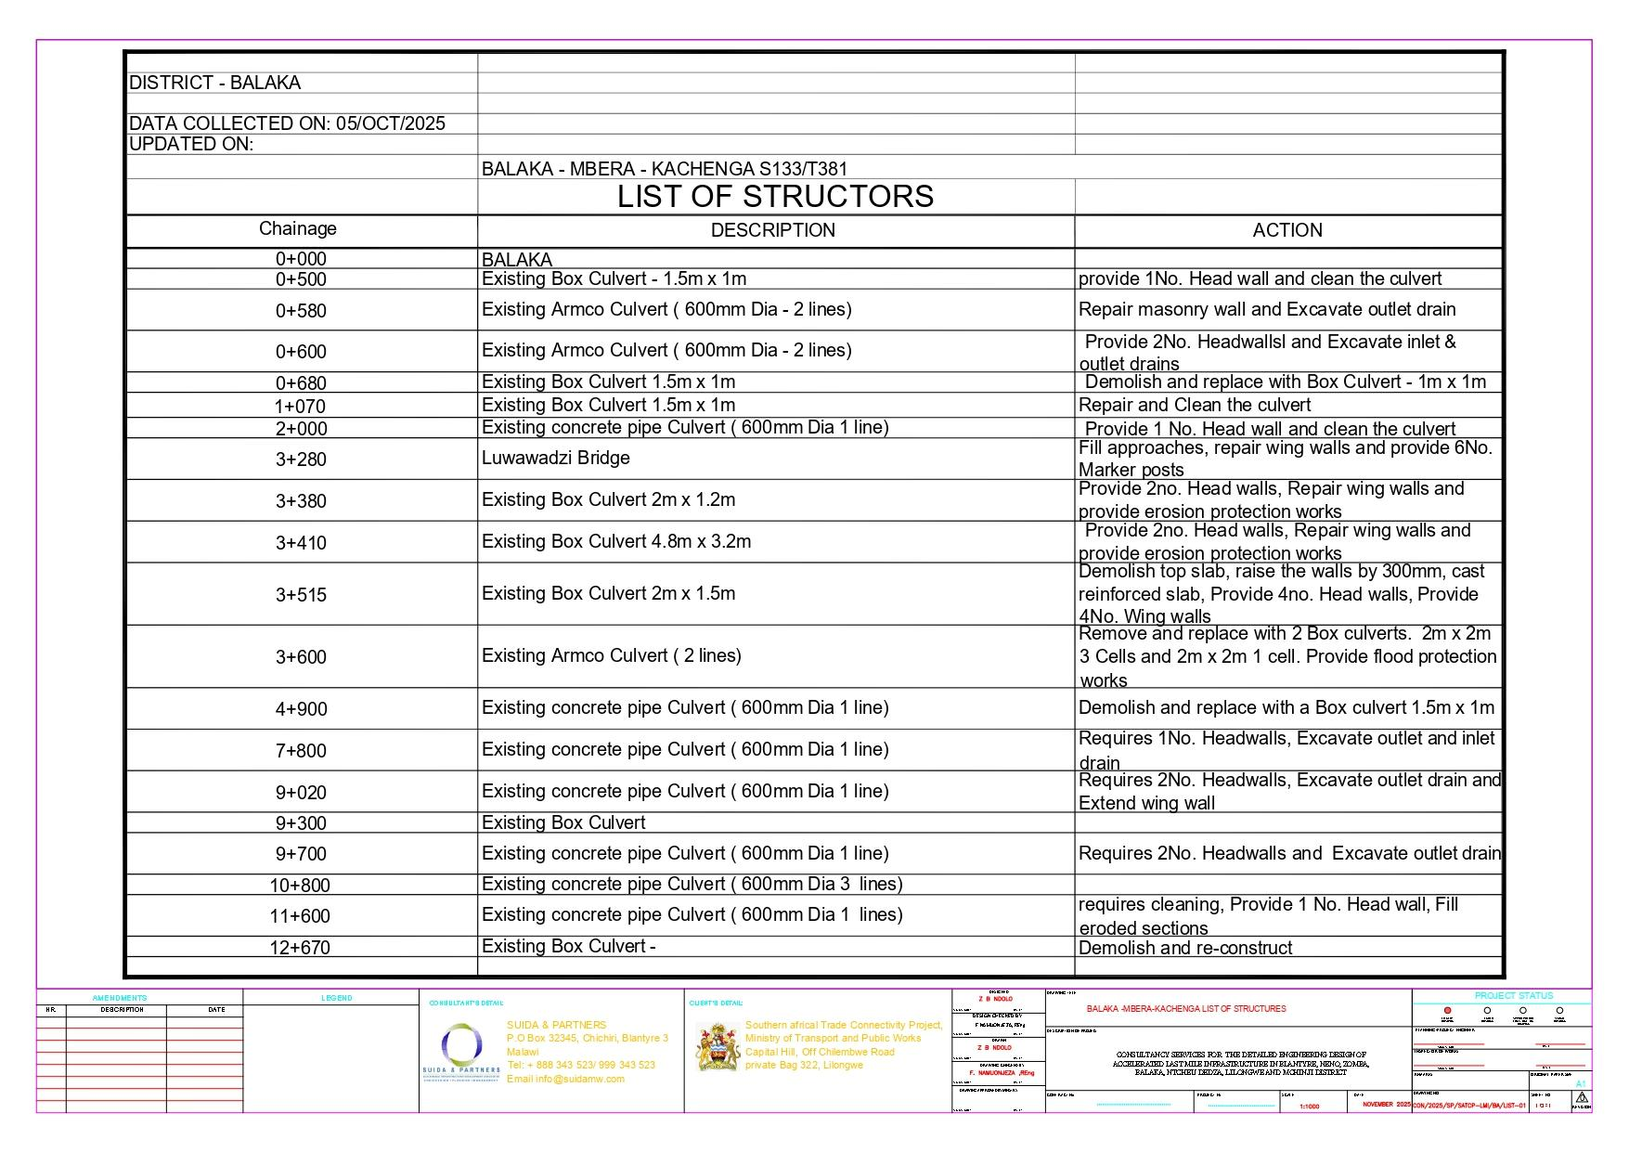
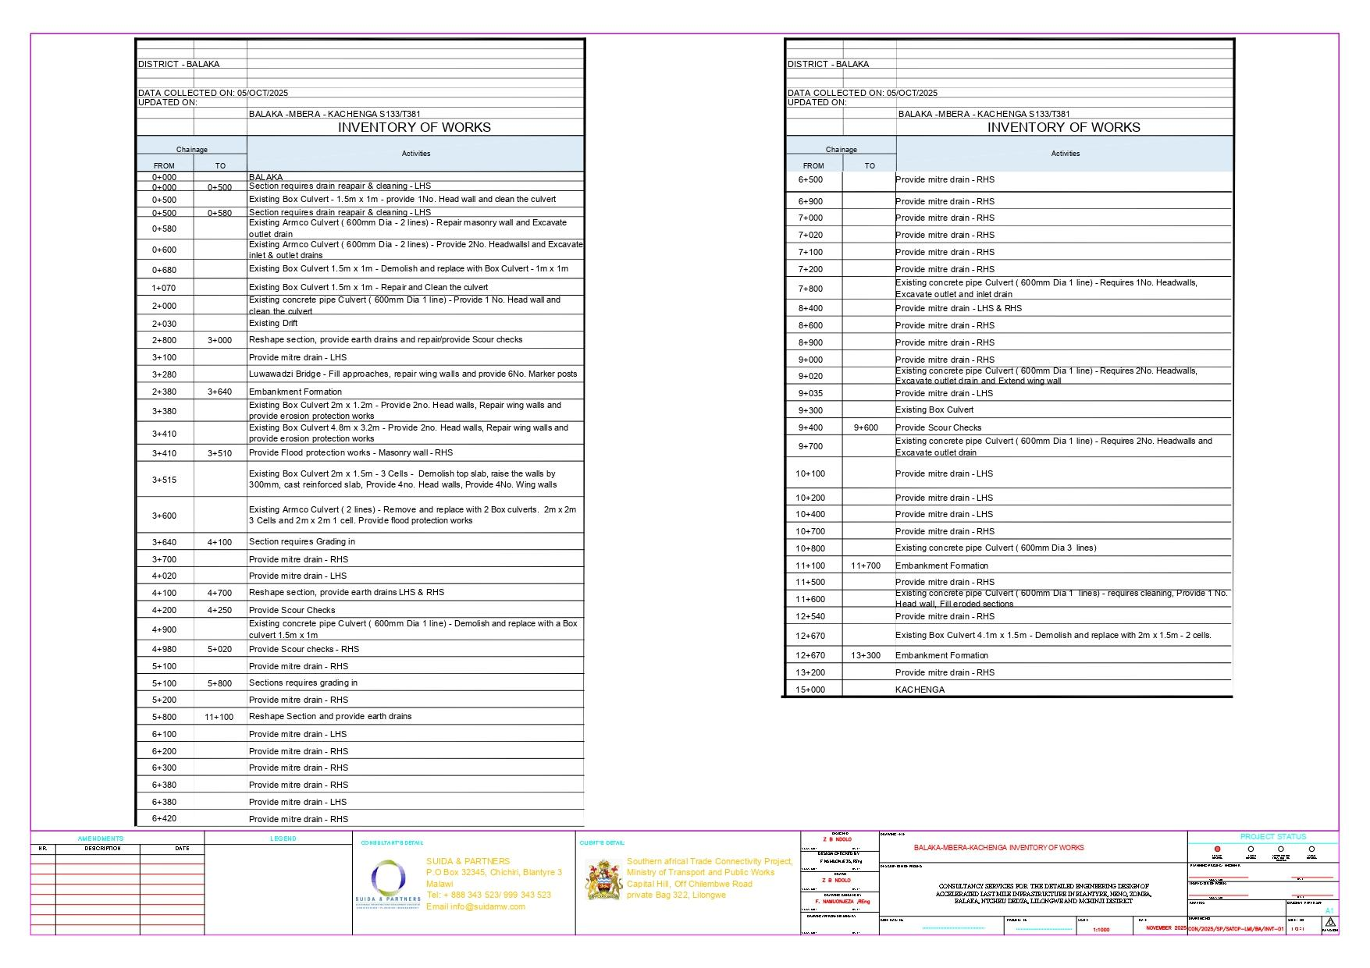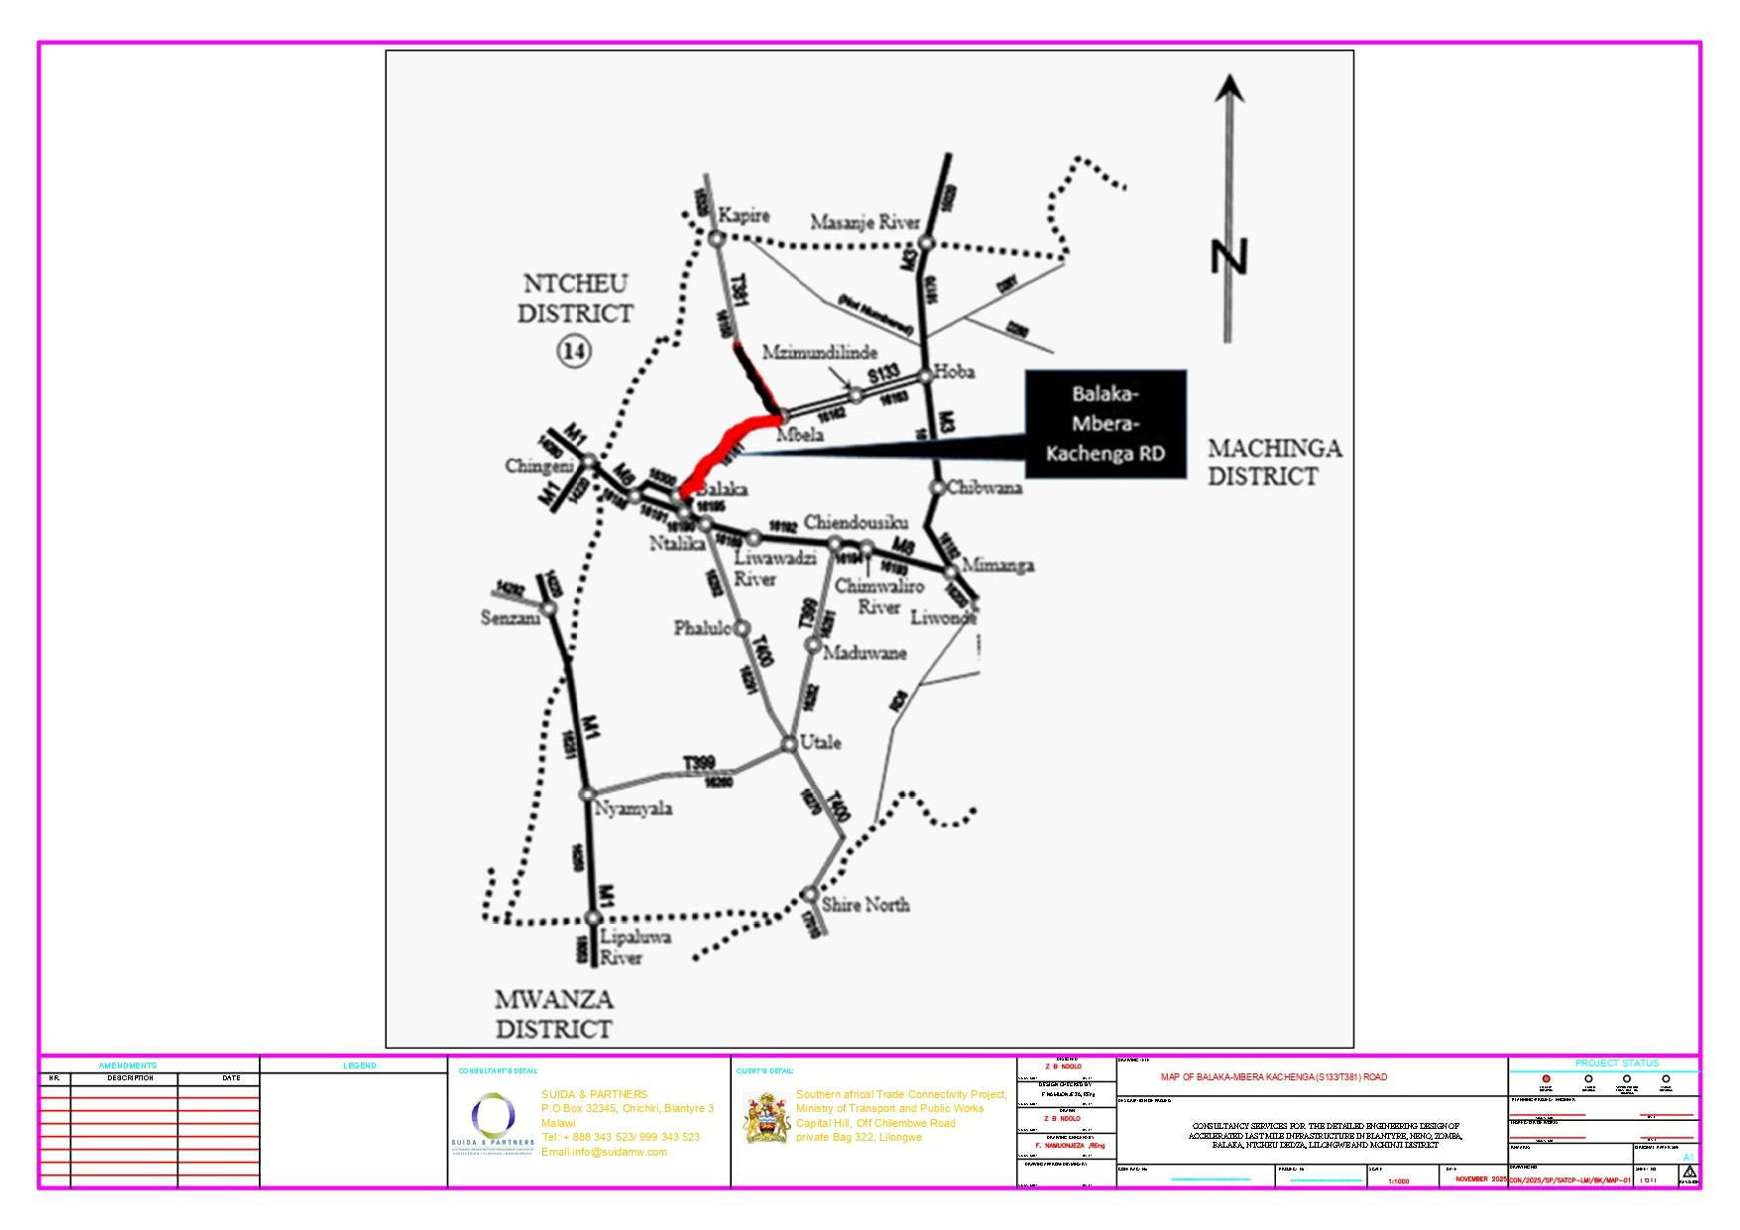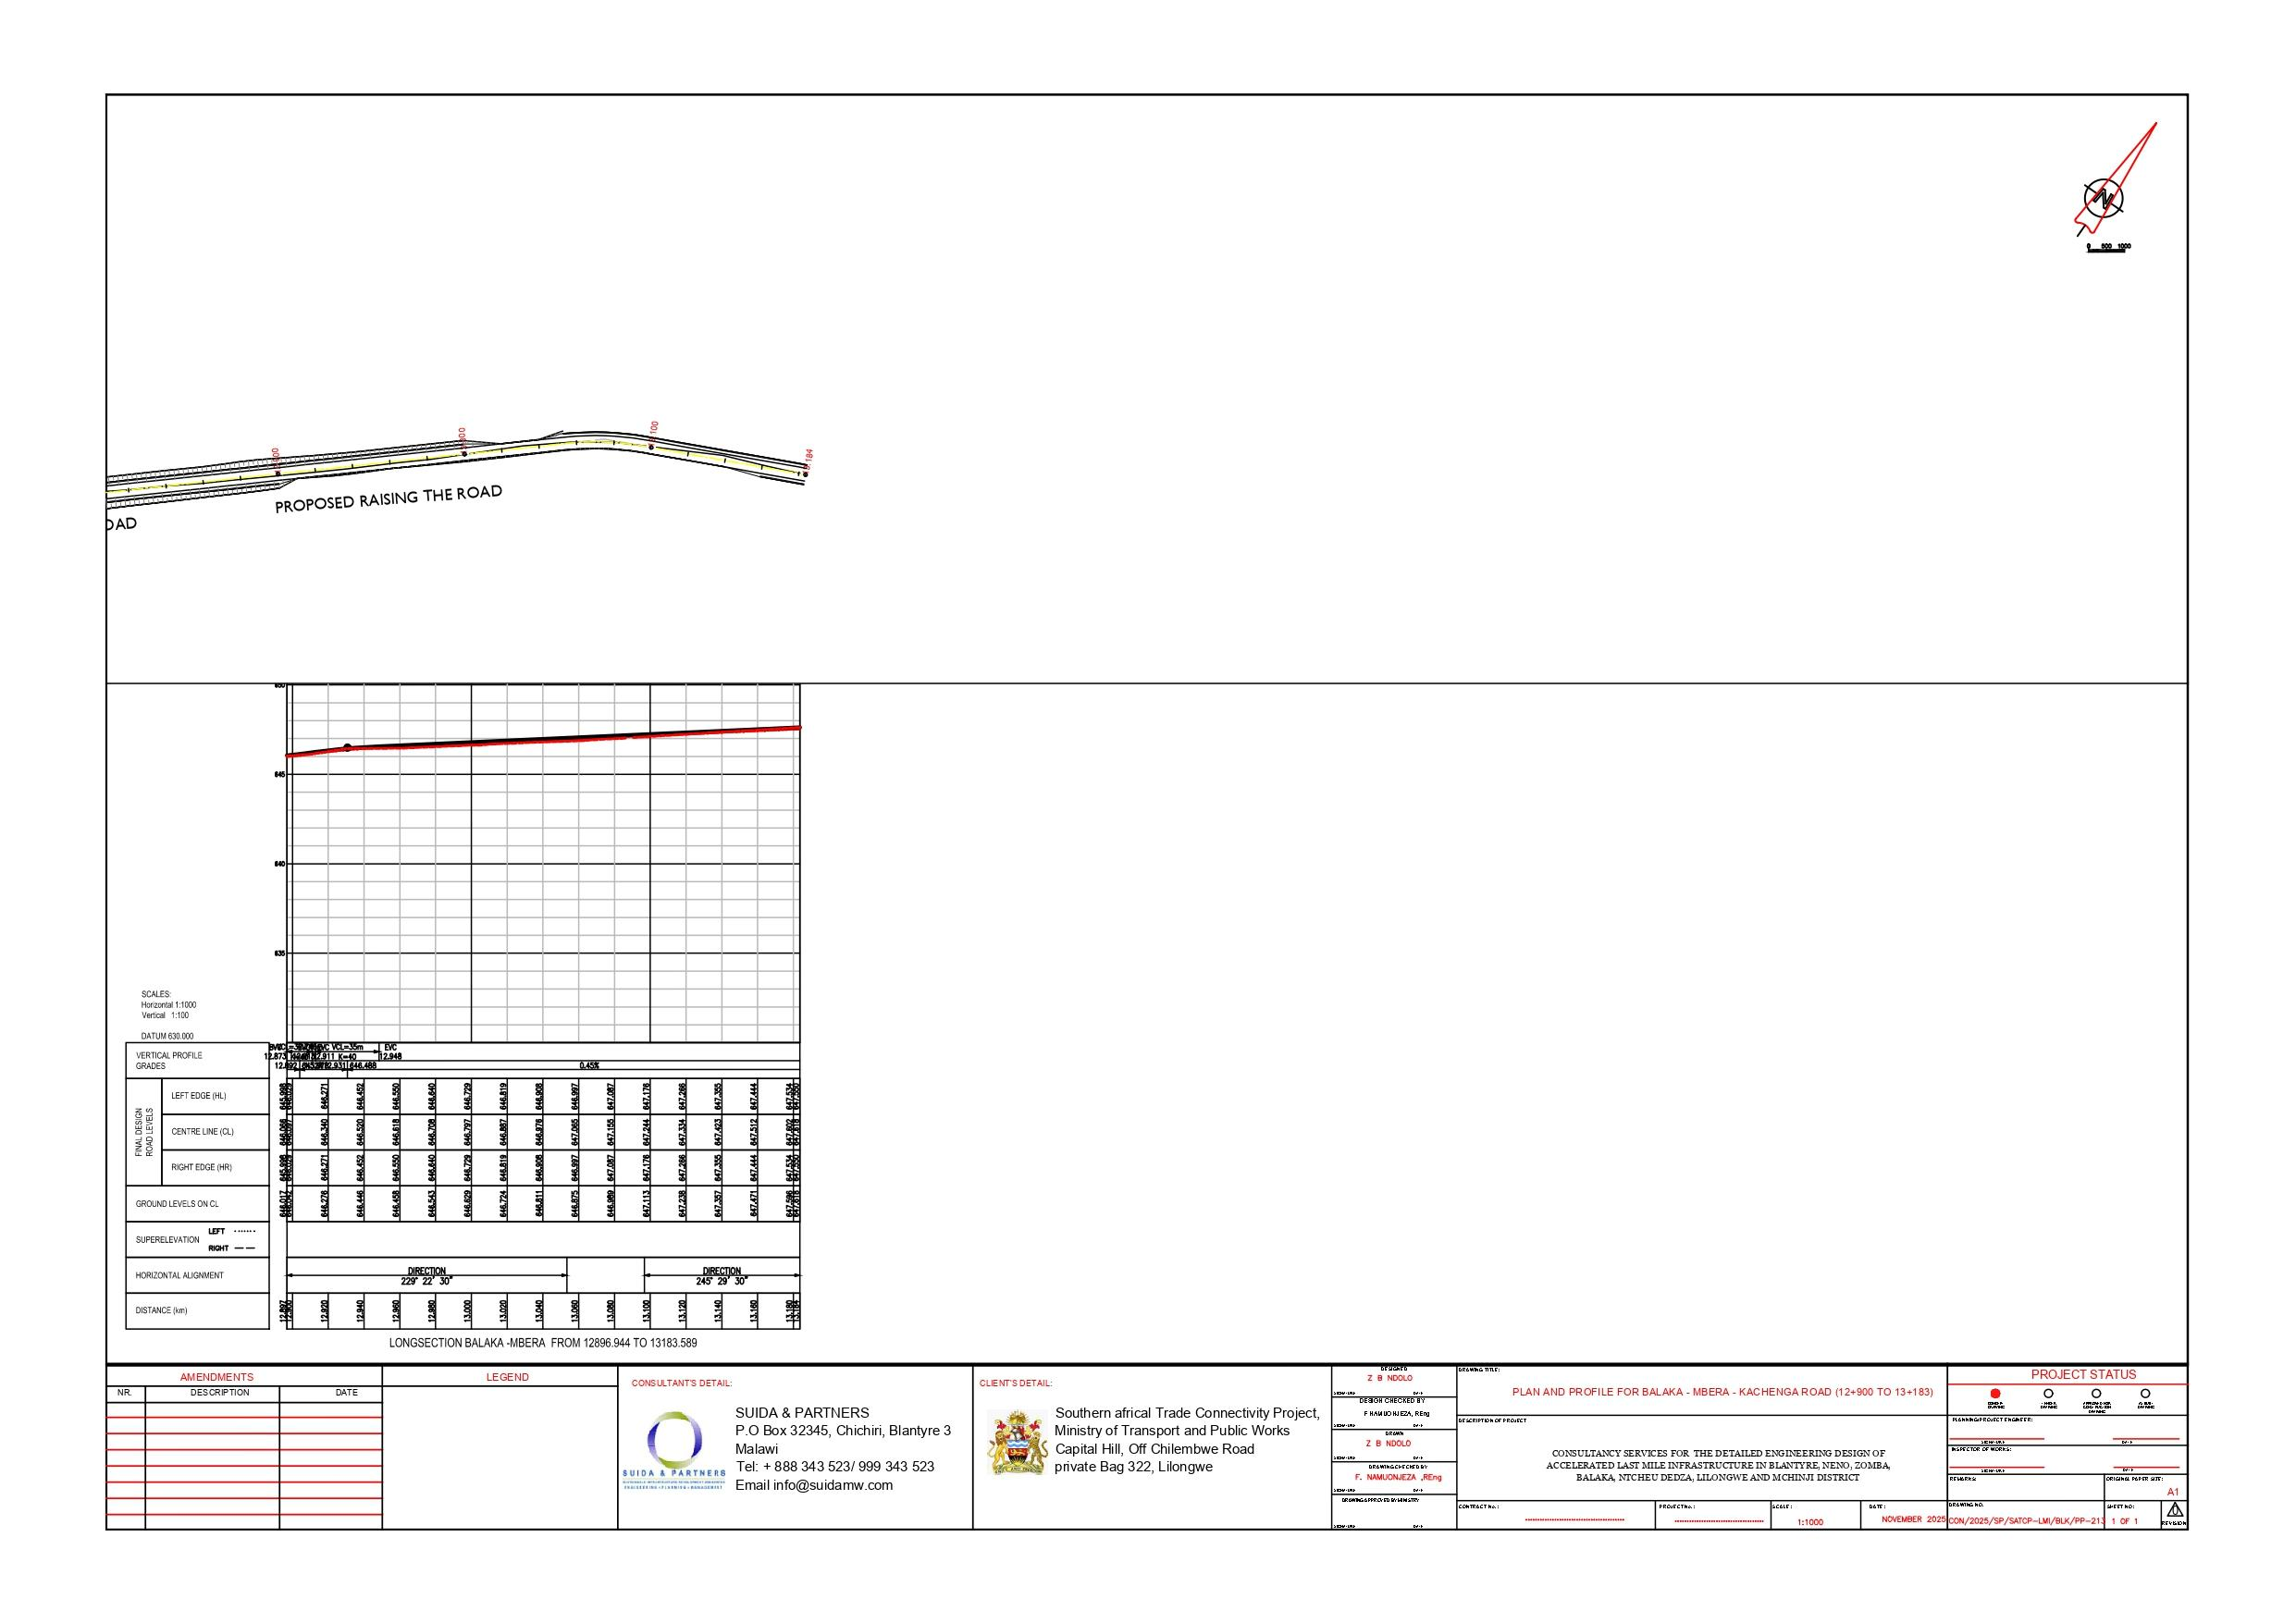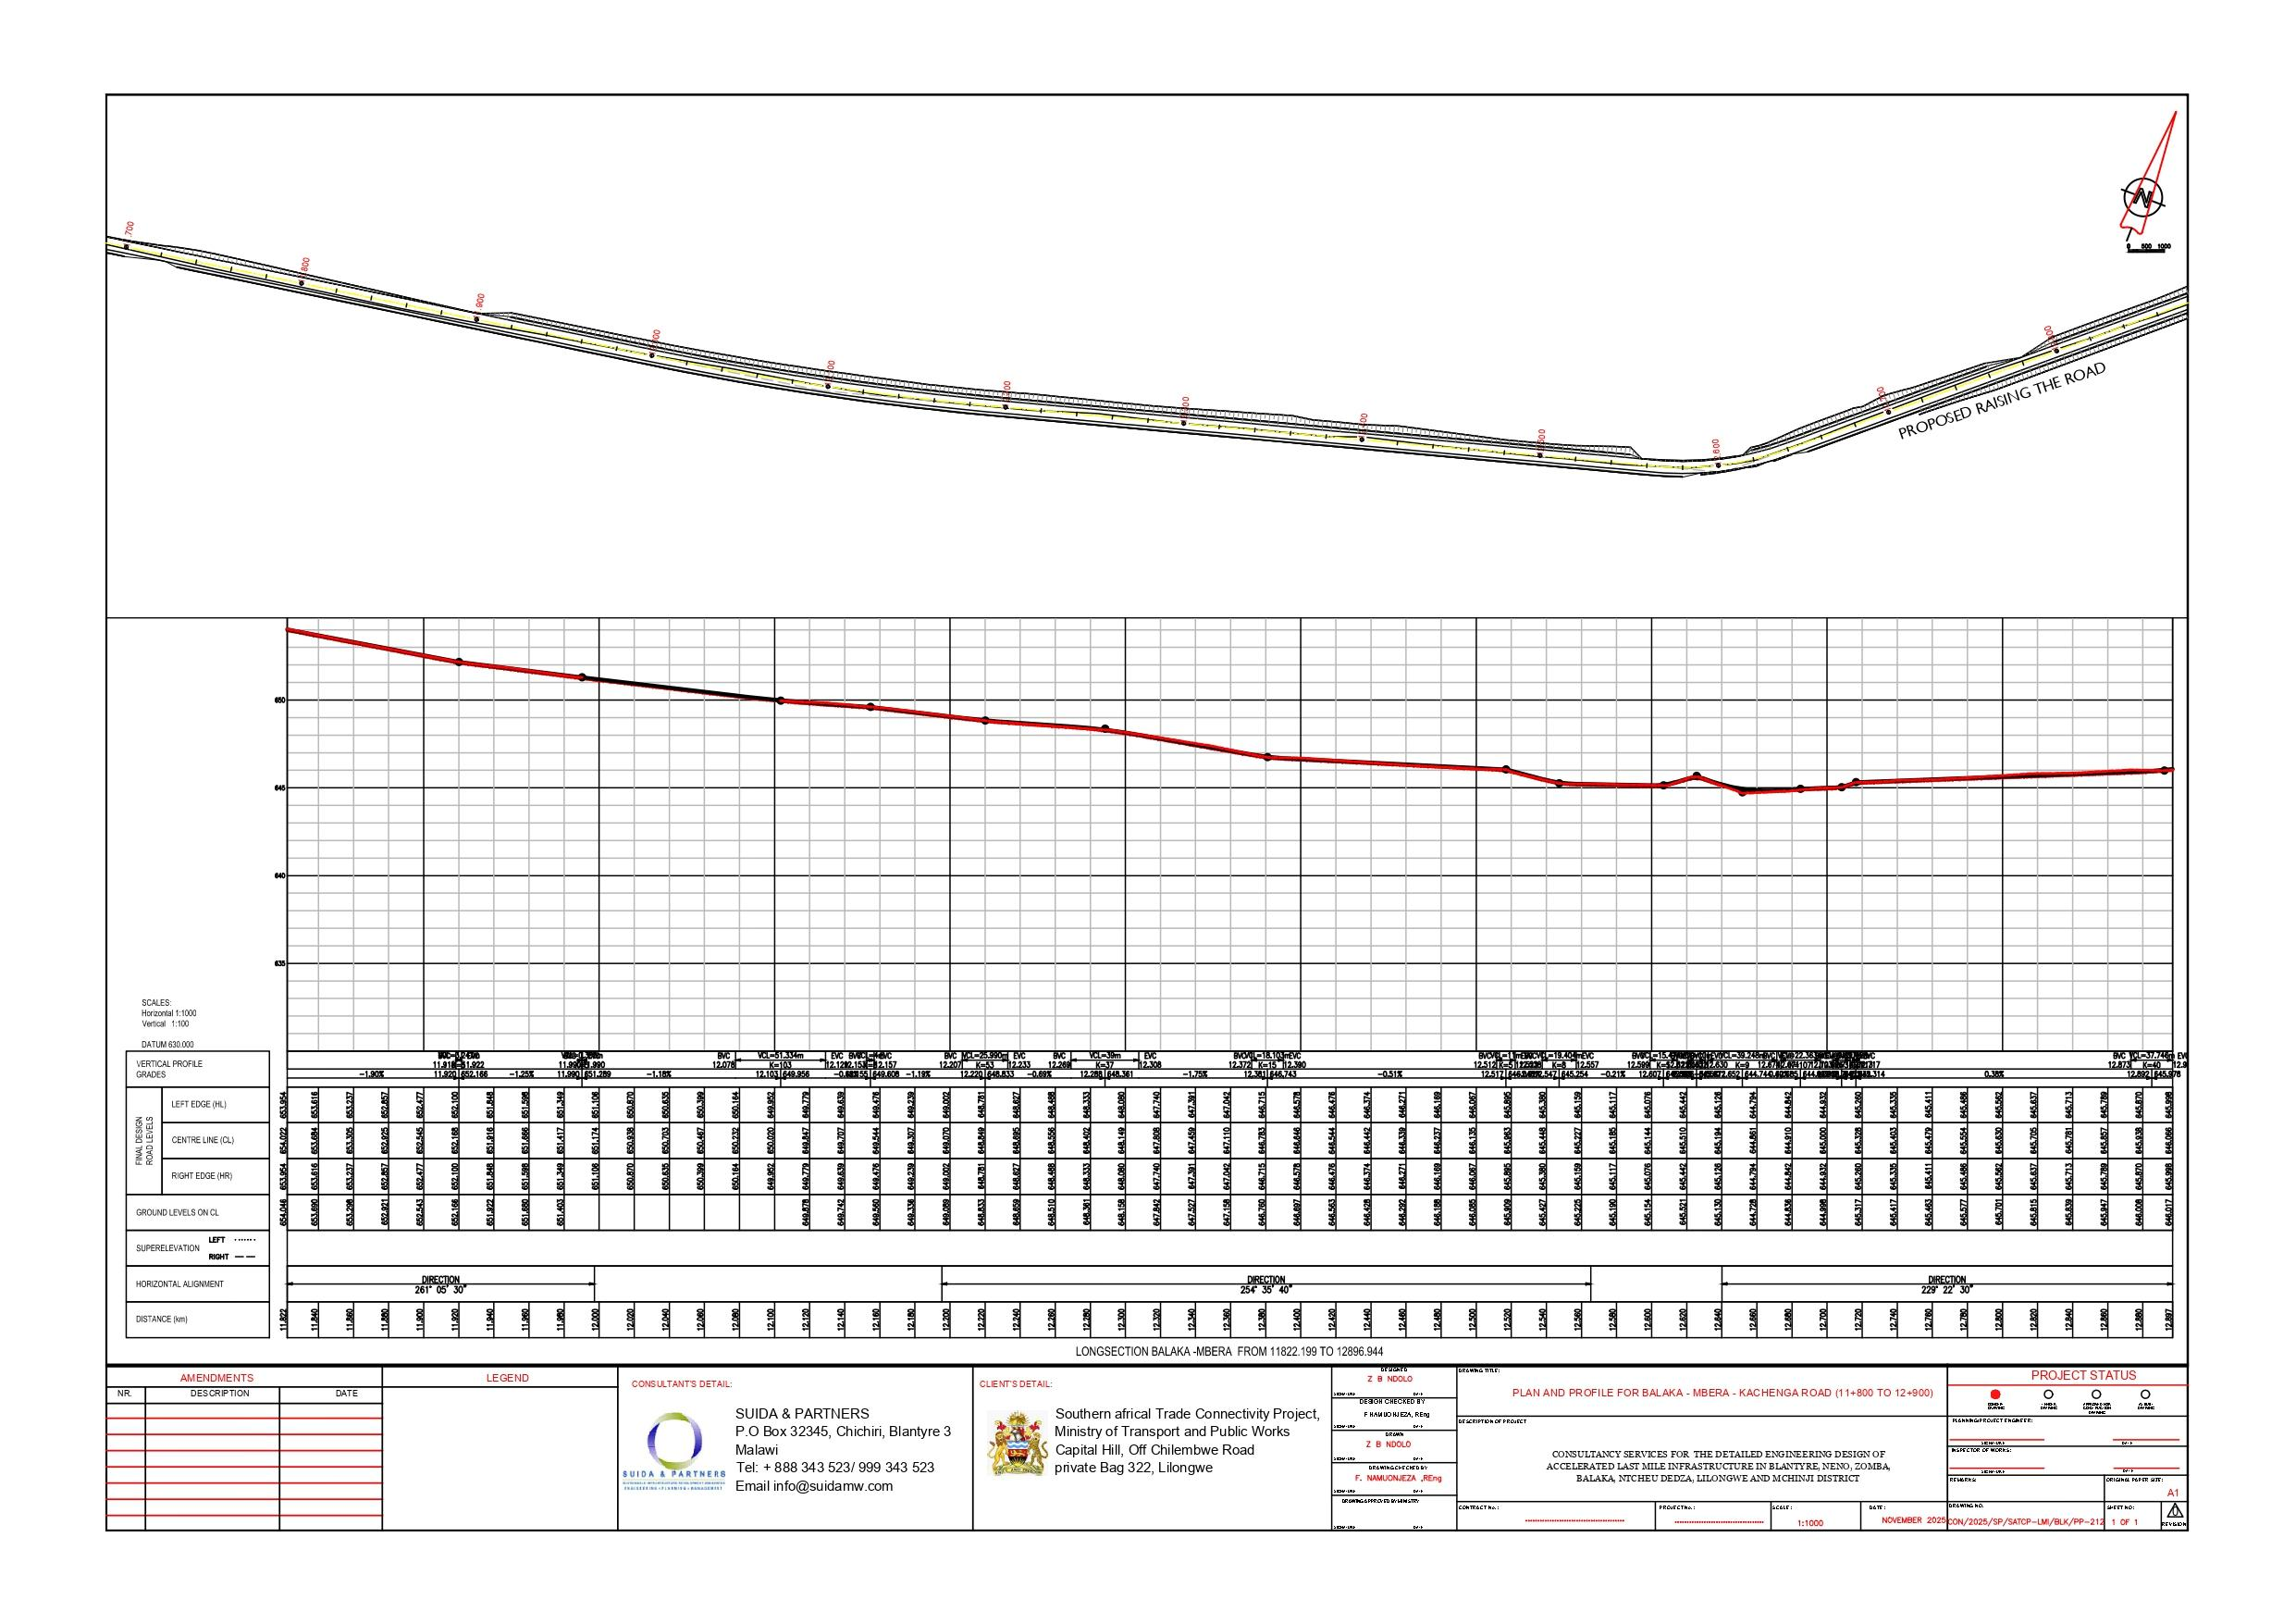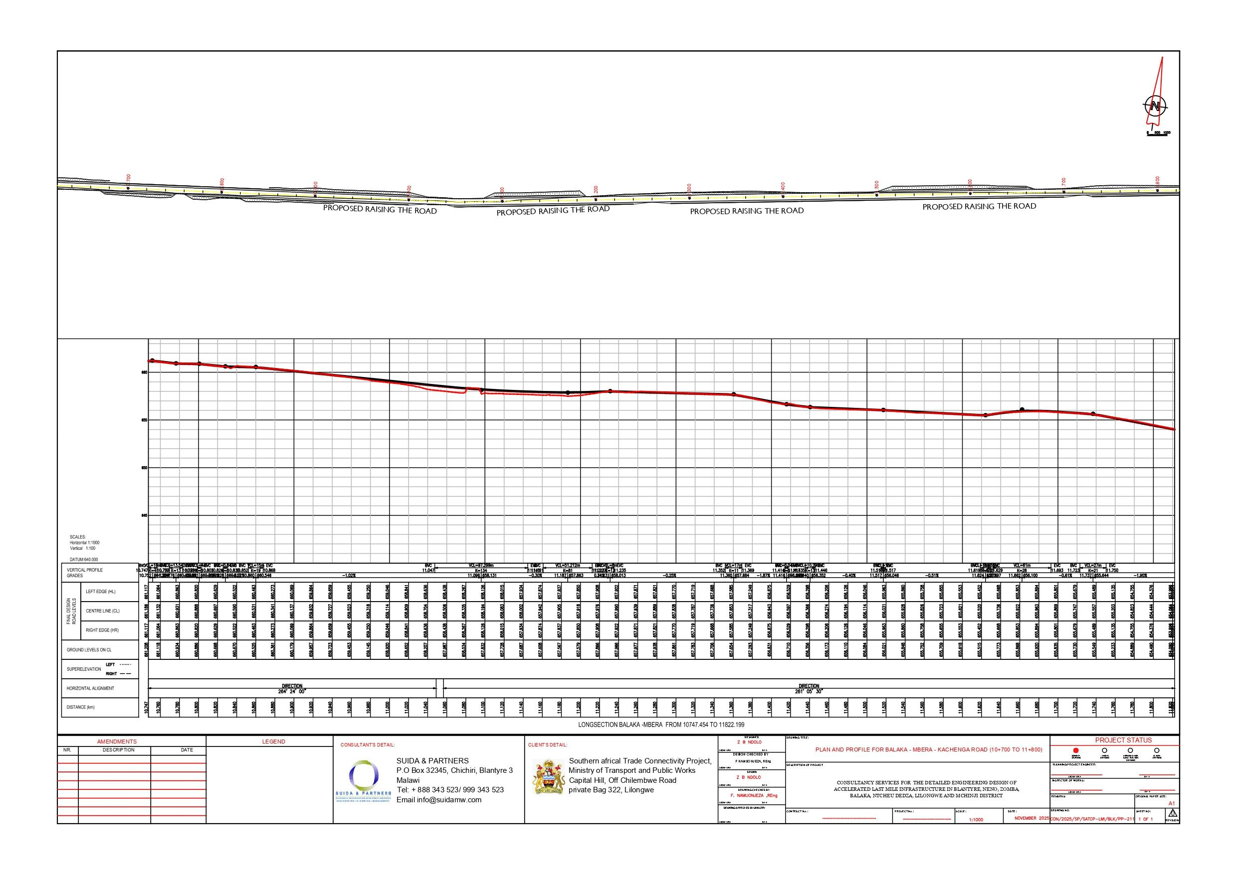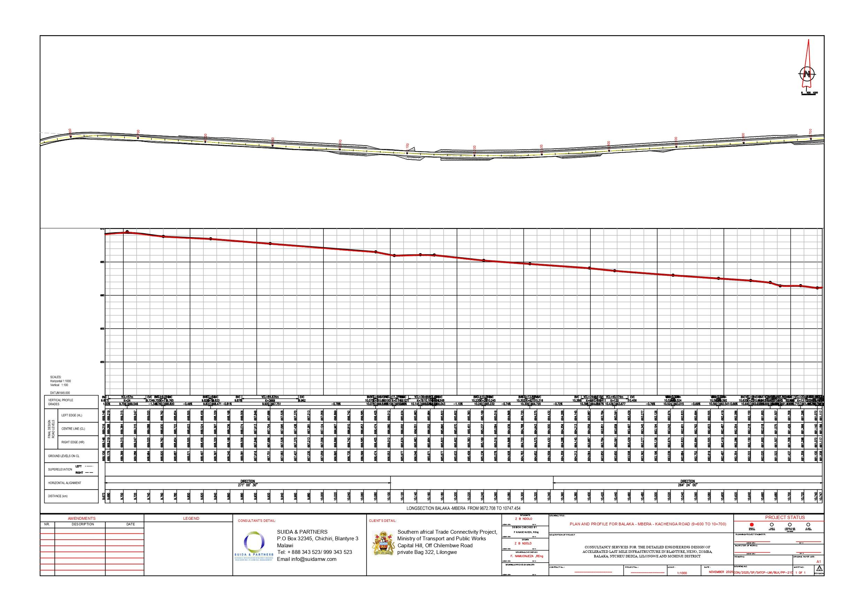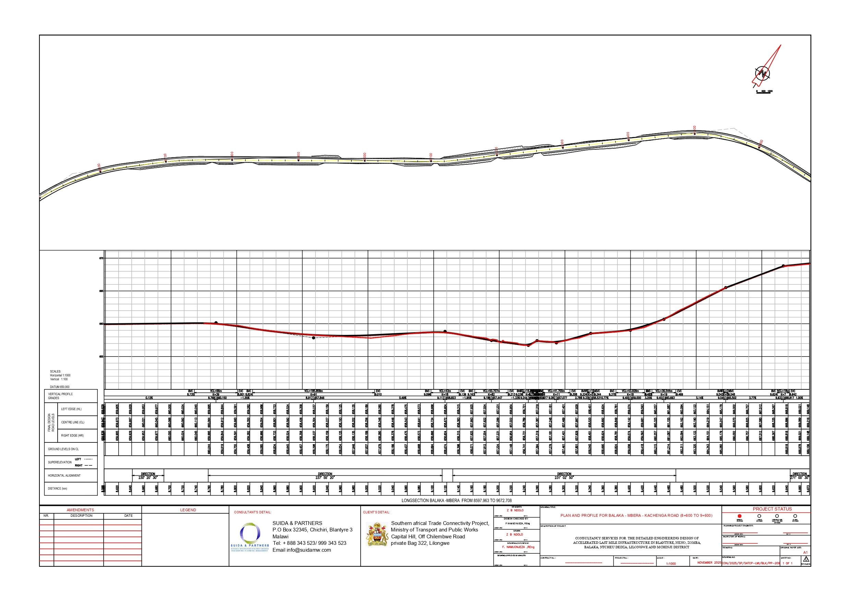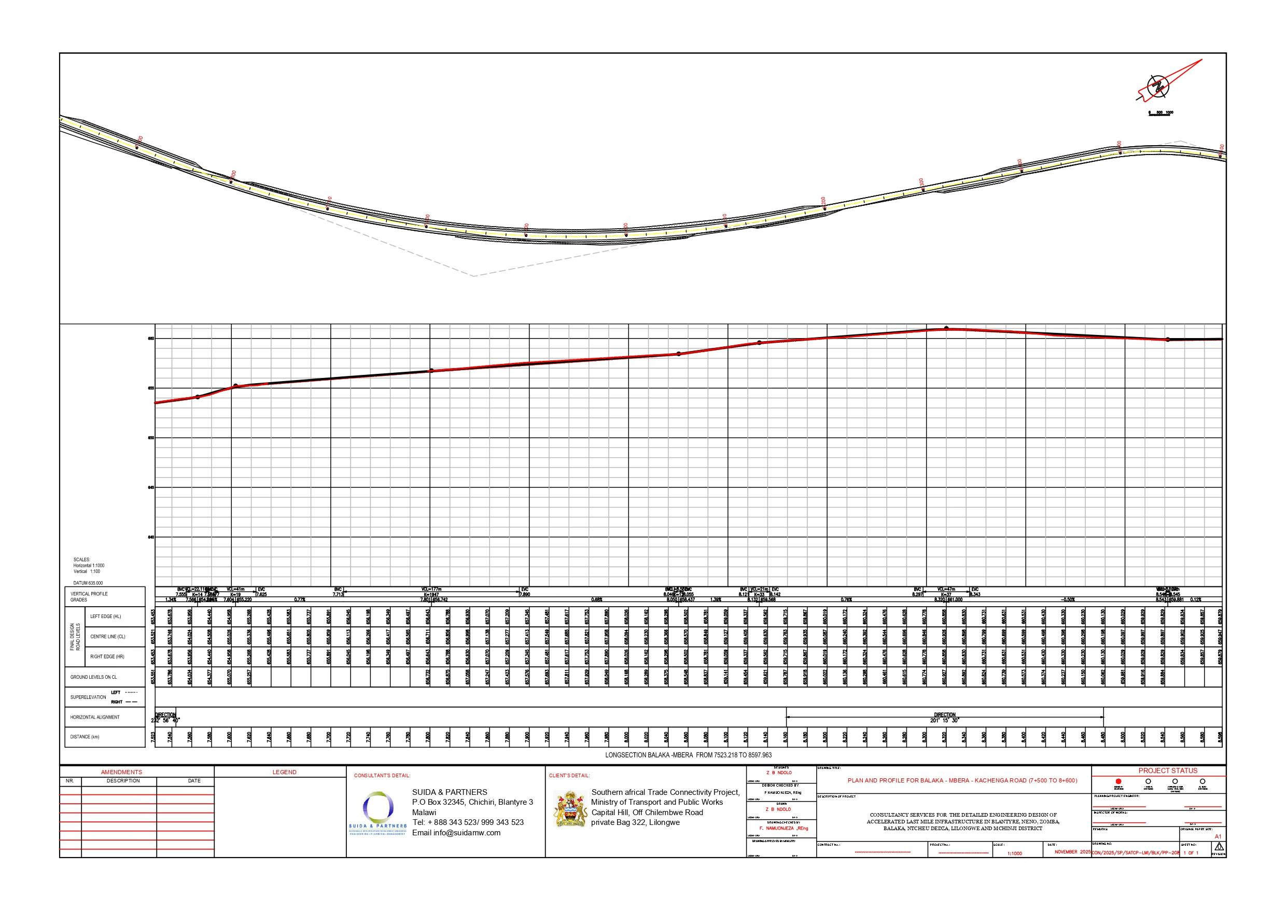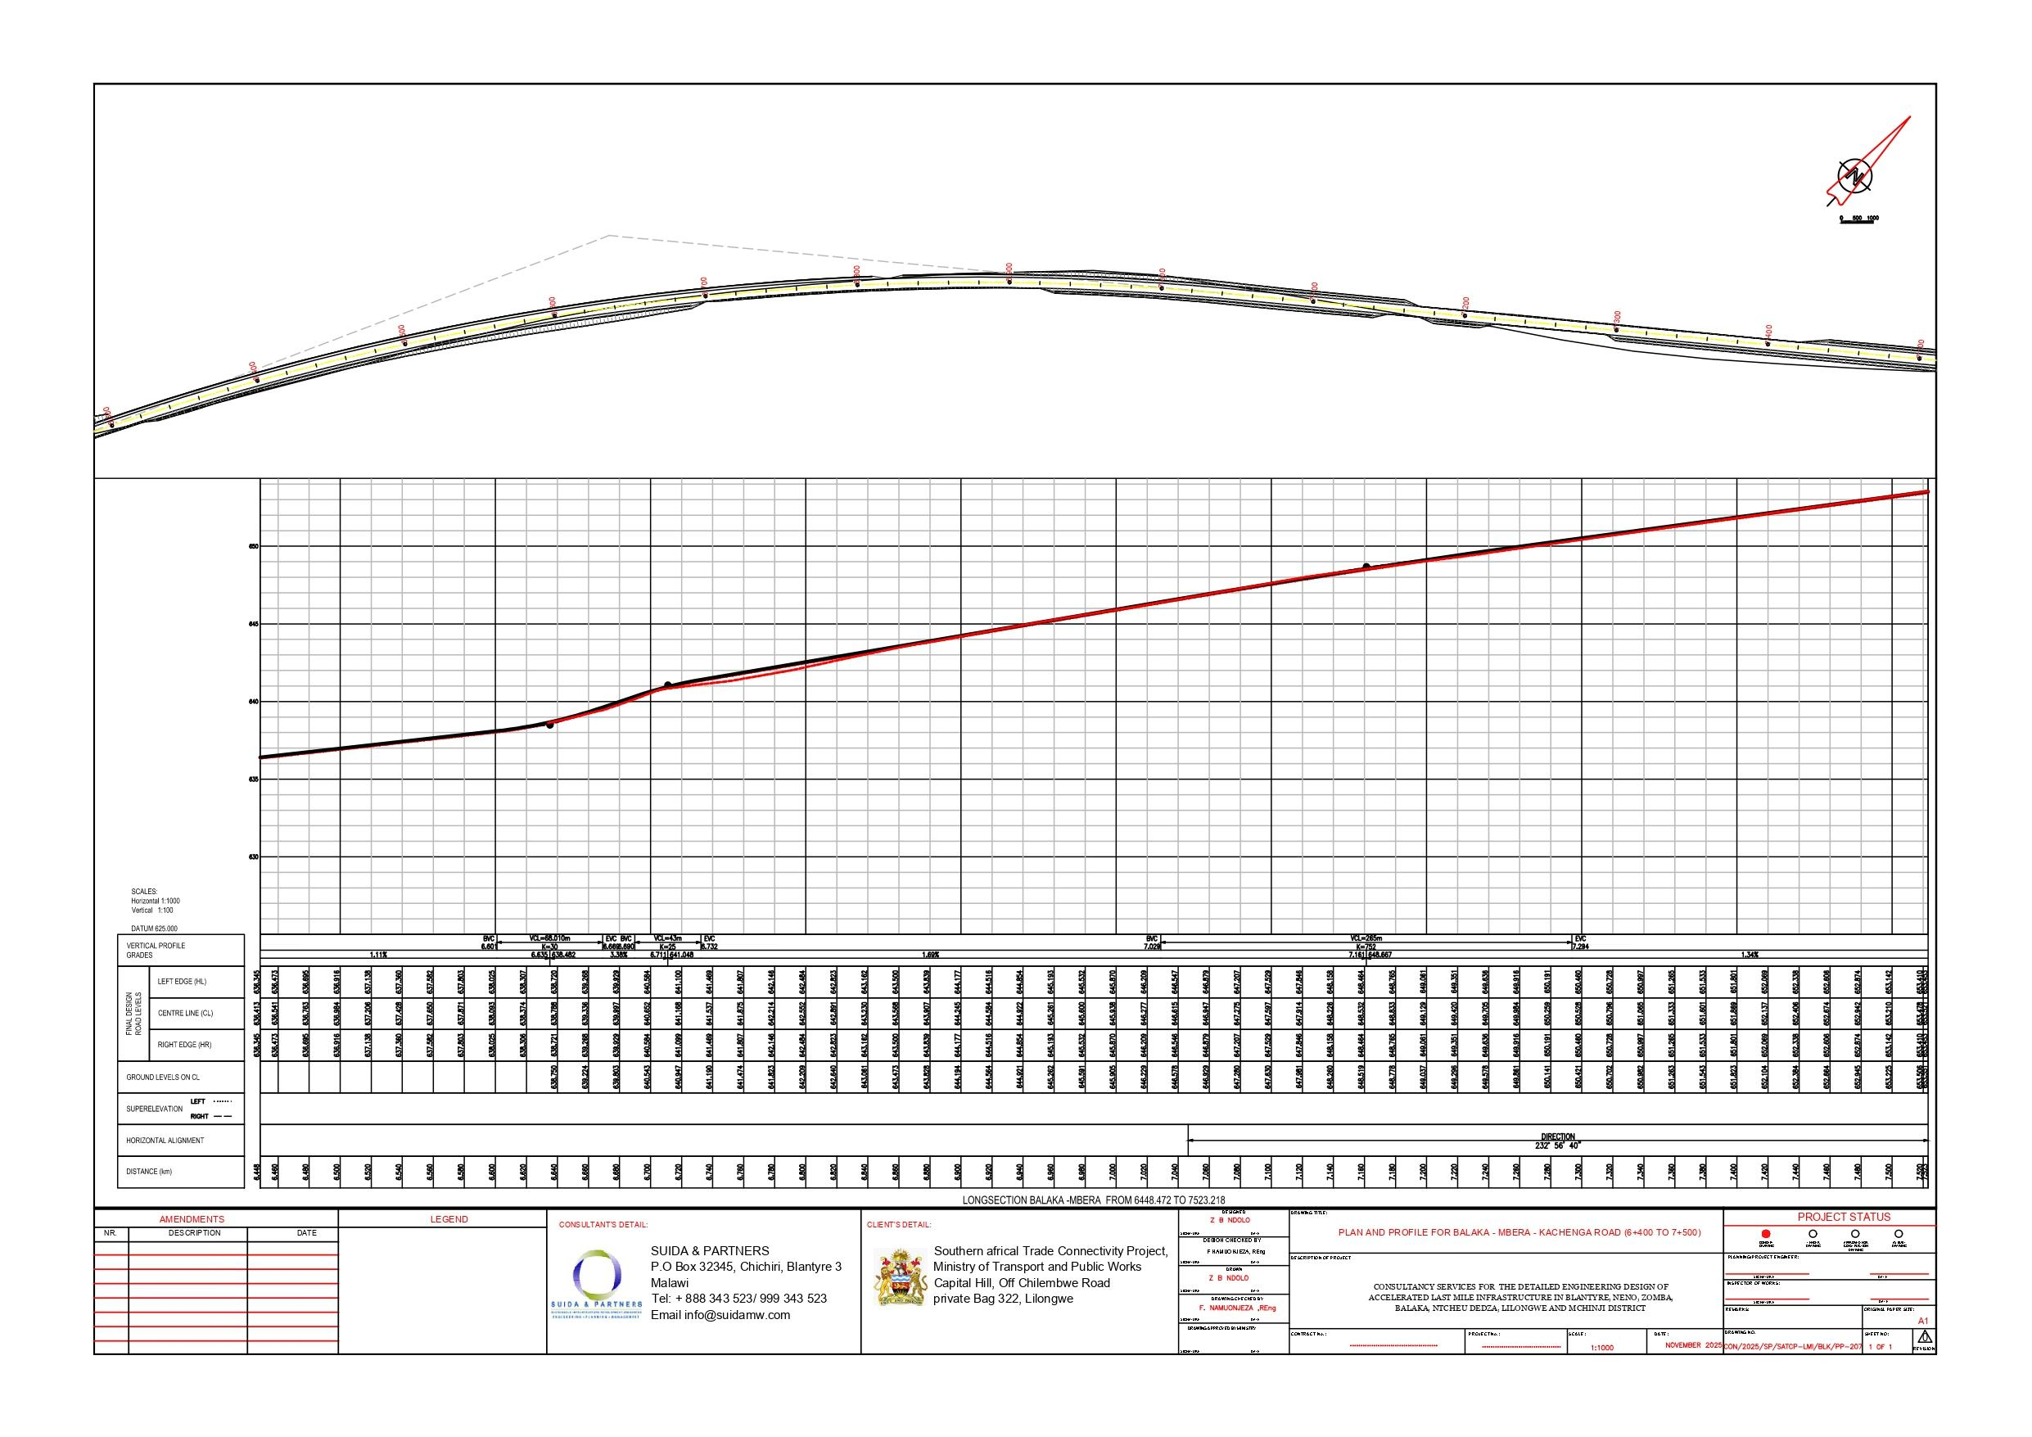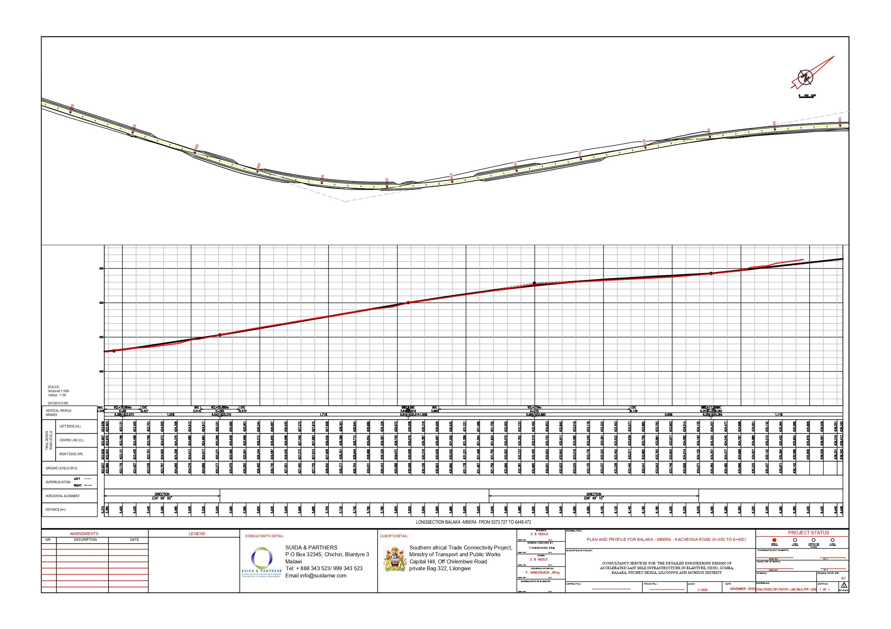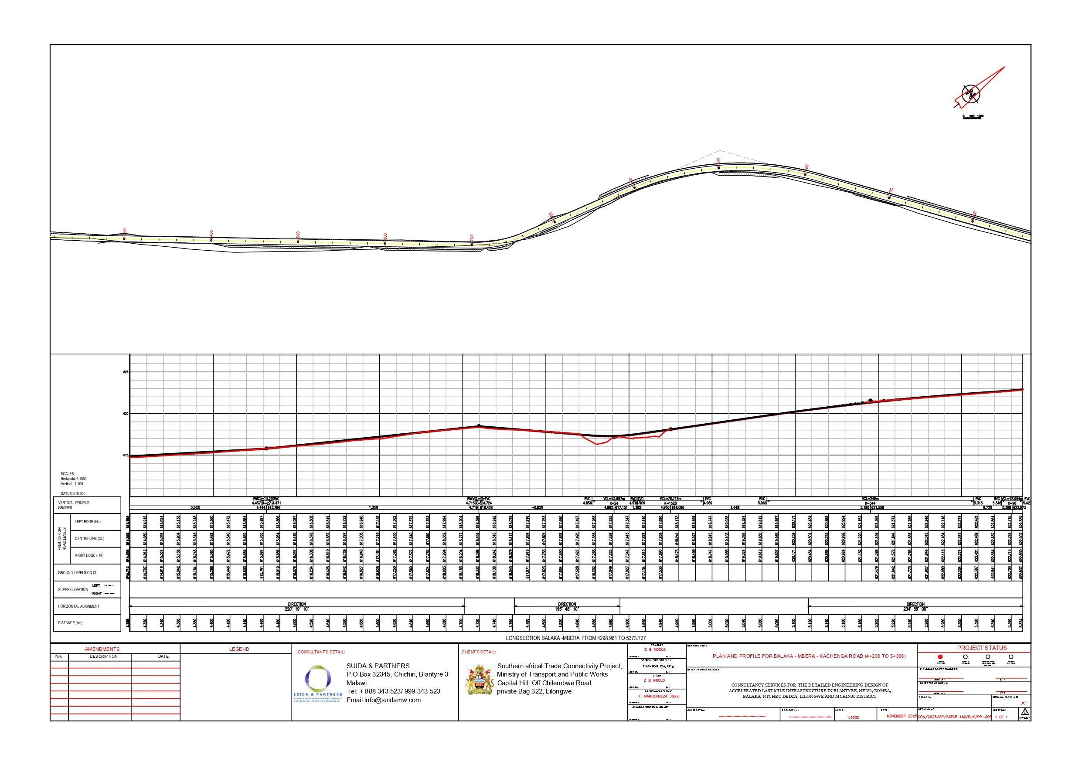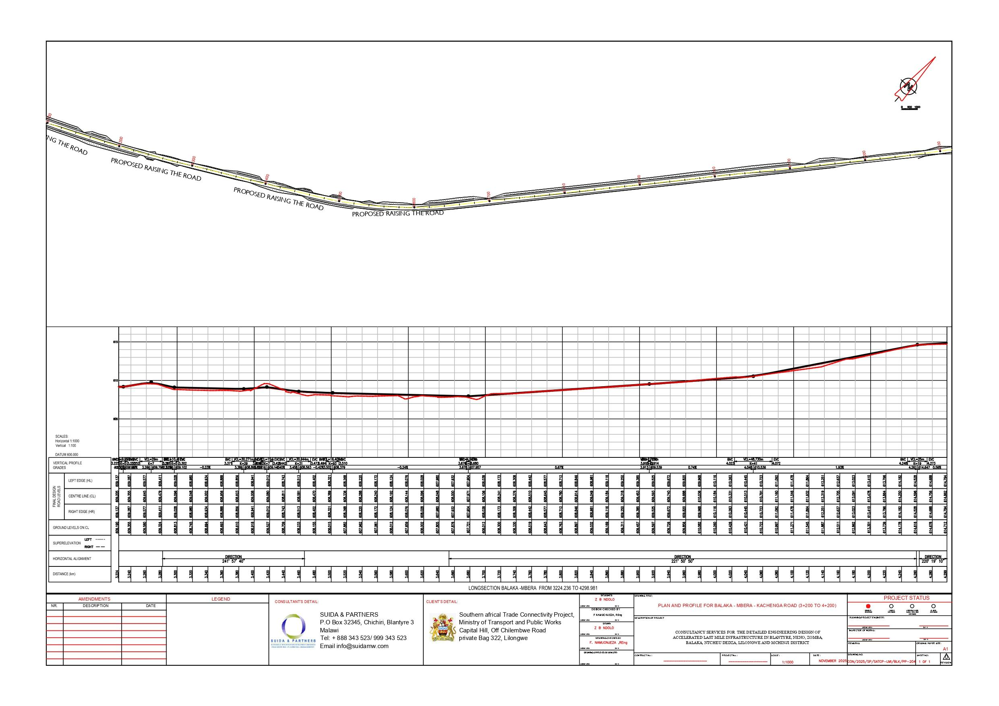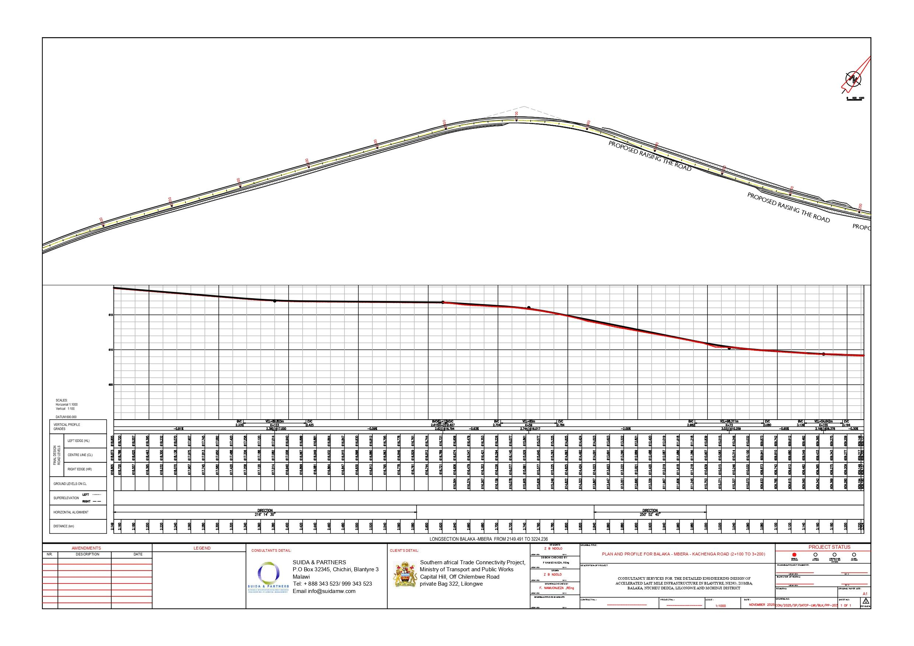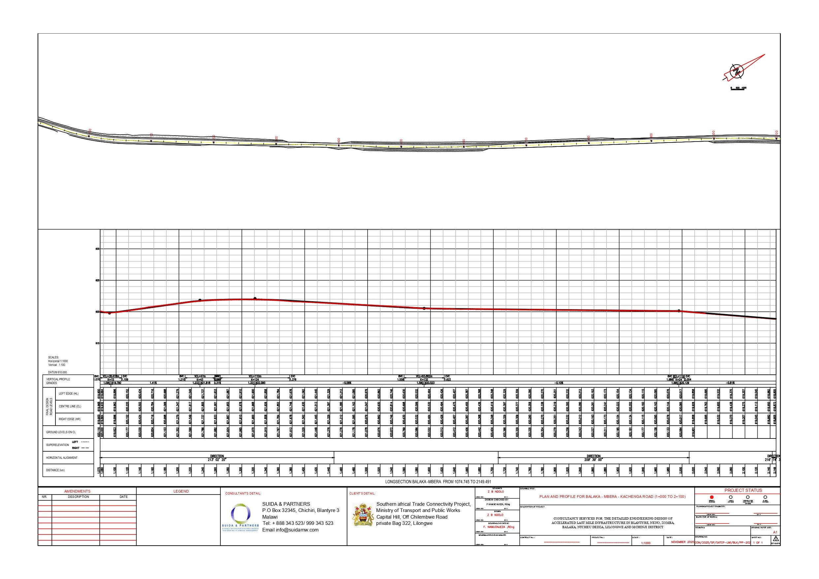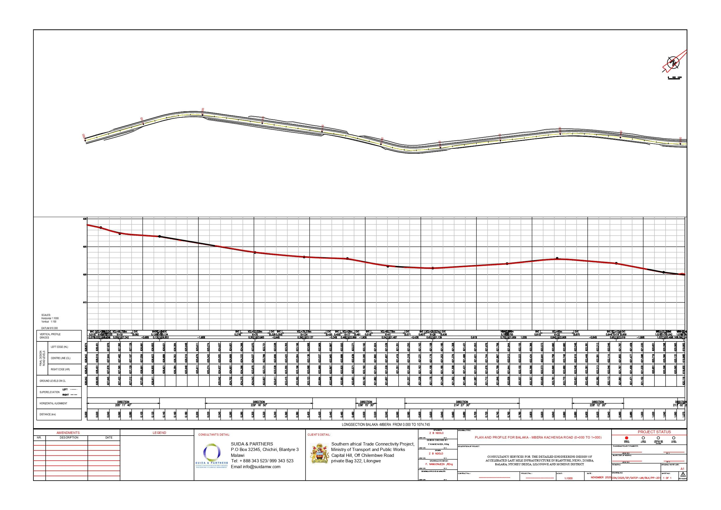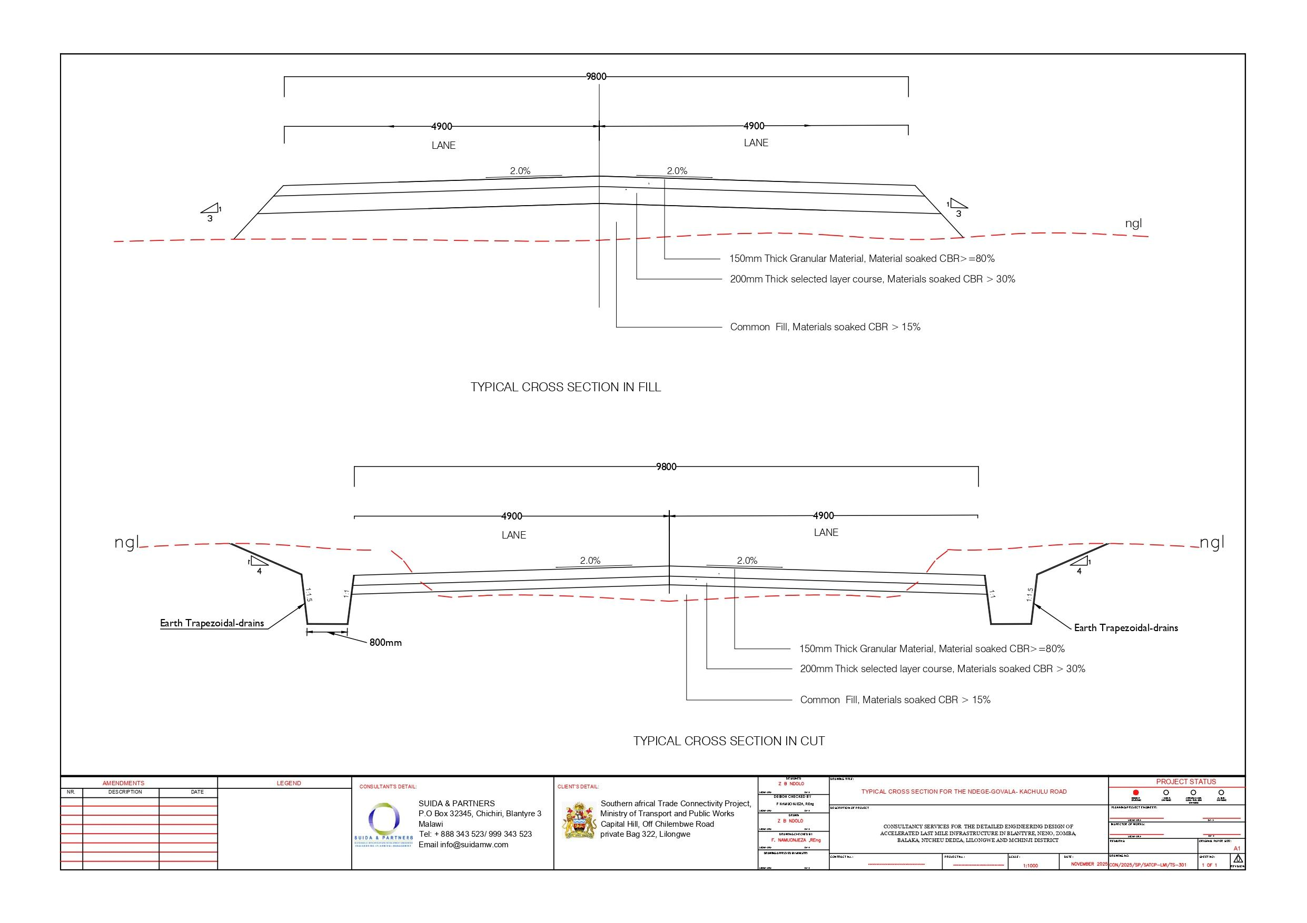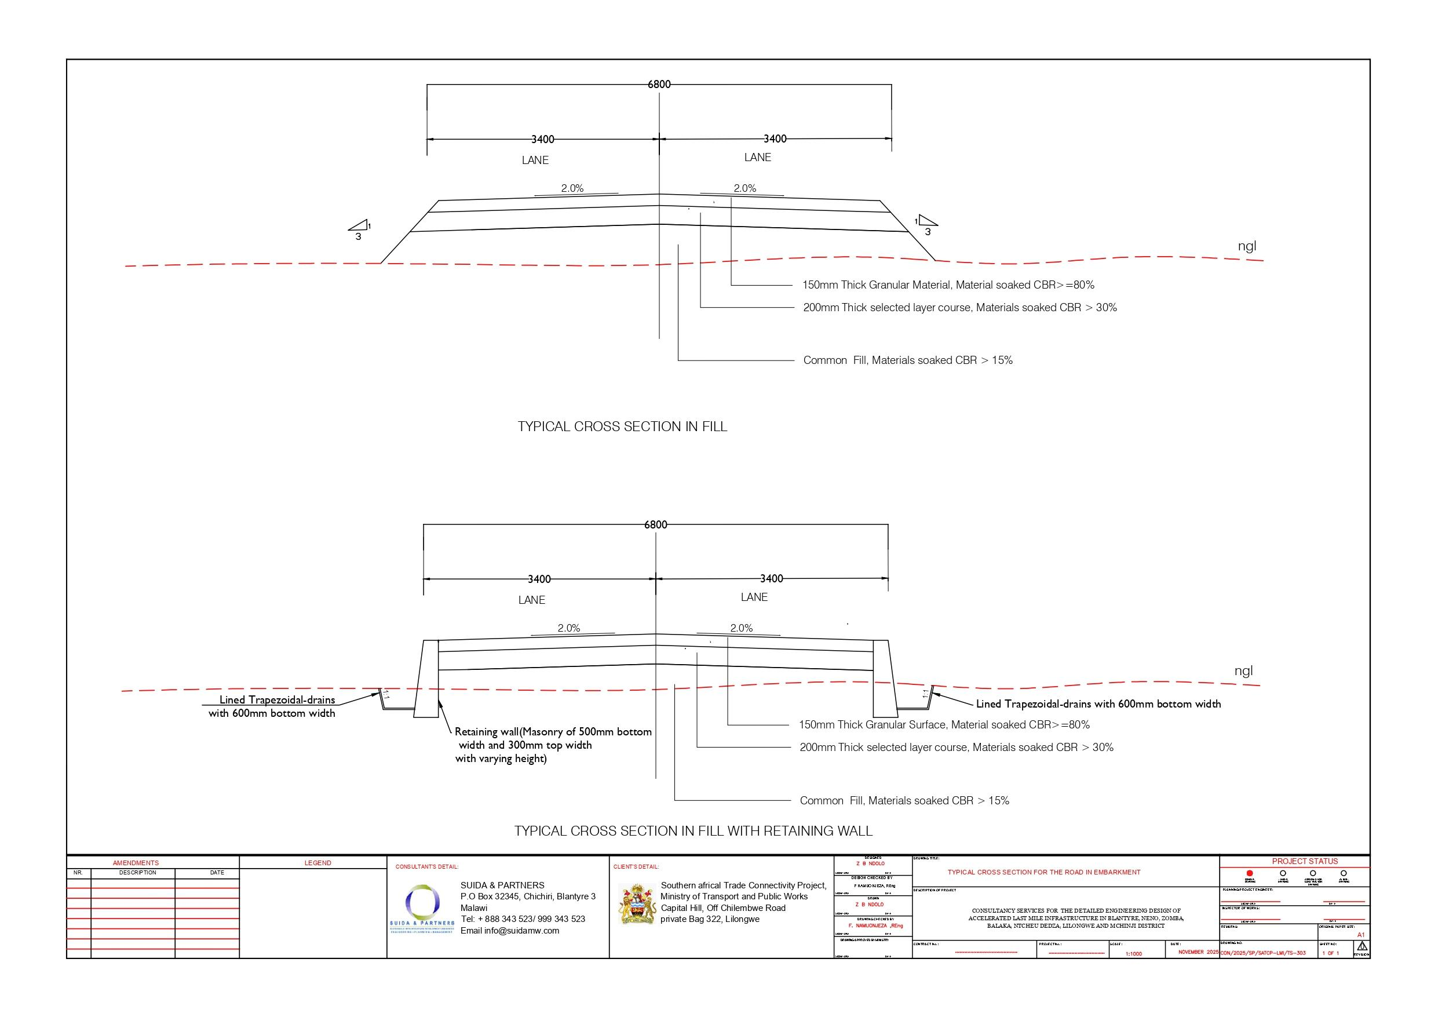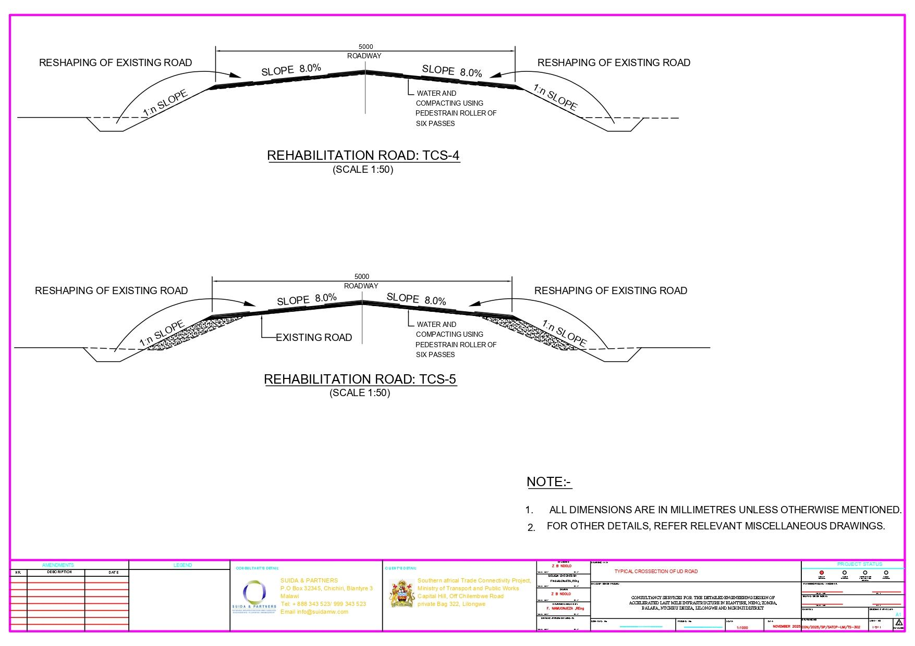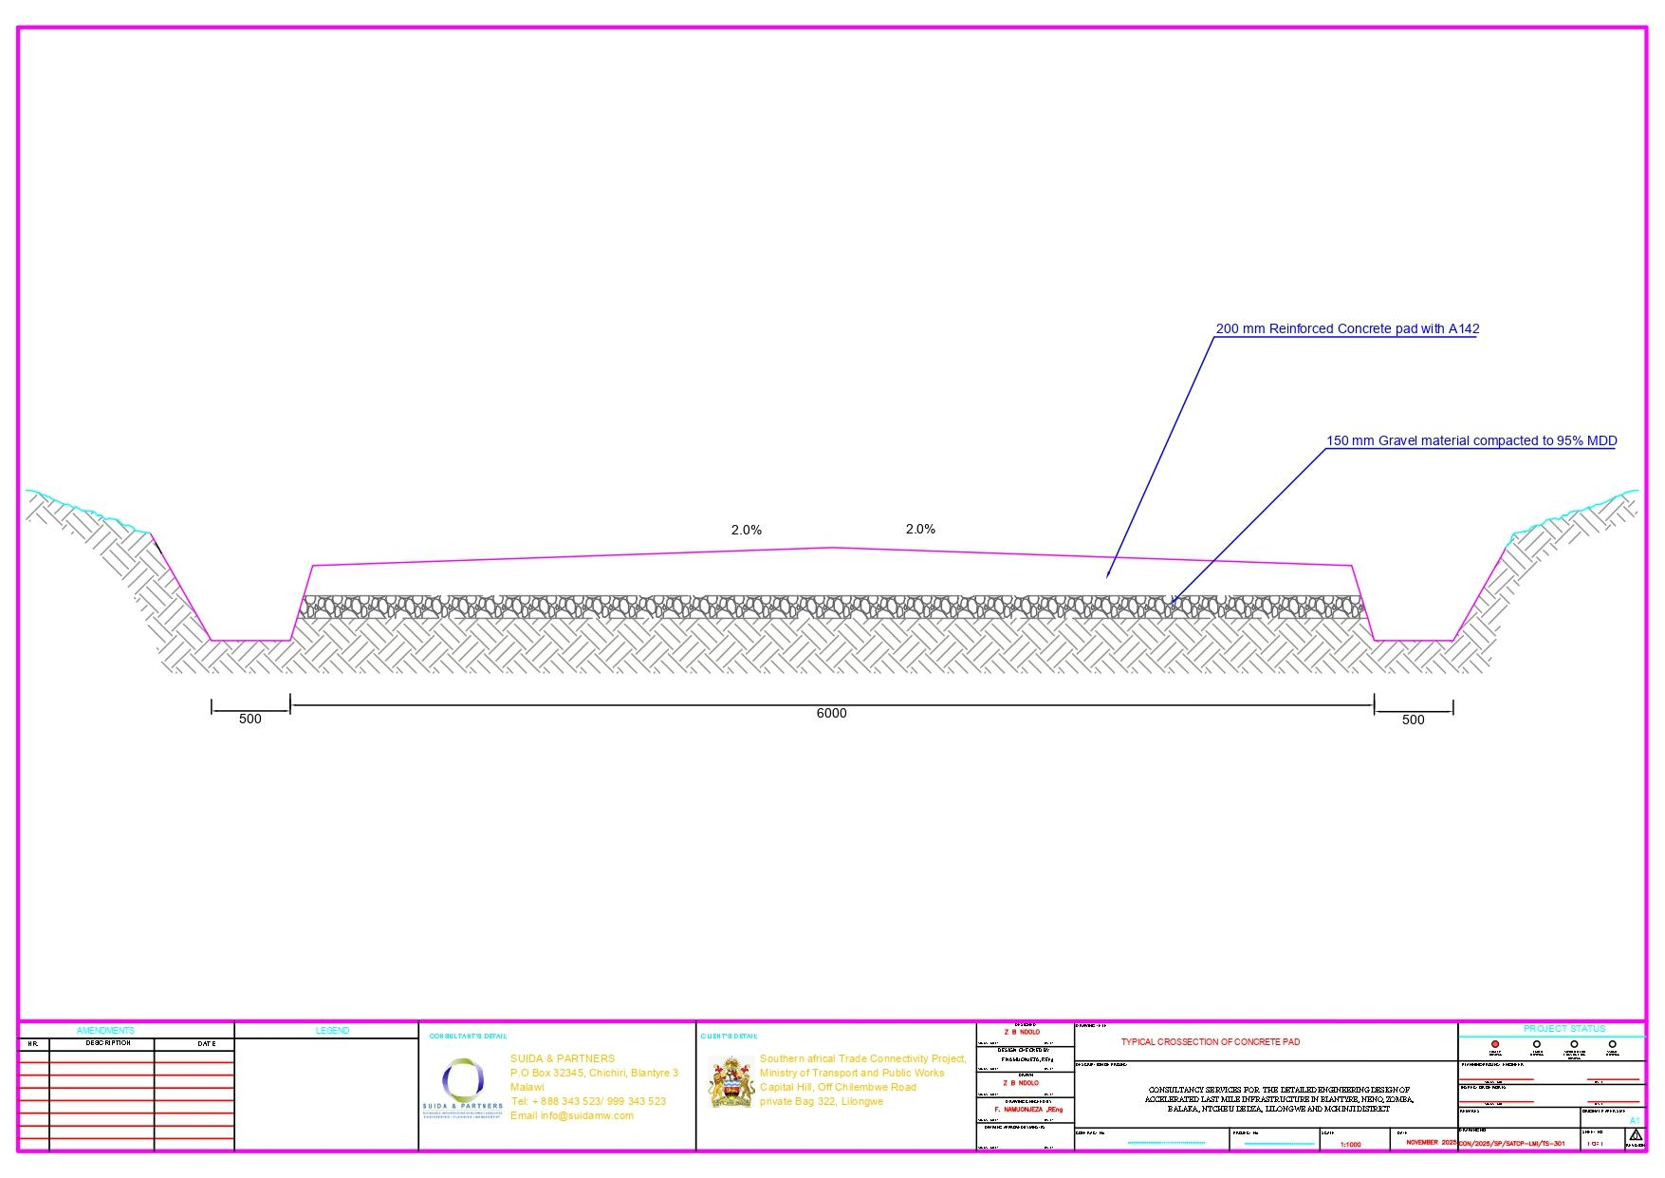

Note: All photographs included in this report were taken during stakeholder consultations and field activities with the informed consent of the individuals concerned.
The road reserve and road centre line shown in this figure are indicative only and may not be spatially accurate due to the map scale, basemap limitations, and coordinate system/projection used. They are included for illustrative purposes only and must not be relied upon for surveying, land demarcation, or construction setting out

