
Government of Malawi
Ministry of Transport & Public Works

ENVIRONMENTAL AND SOCIAL MANAGEMENT PLAN (ESMP) FOR THE PROPOSED UPGRADING OF ZOMBA - KACHULU ROAD TO GRAVEL STANDARD IN ZOMBA DISTRICT

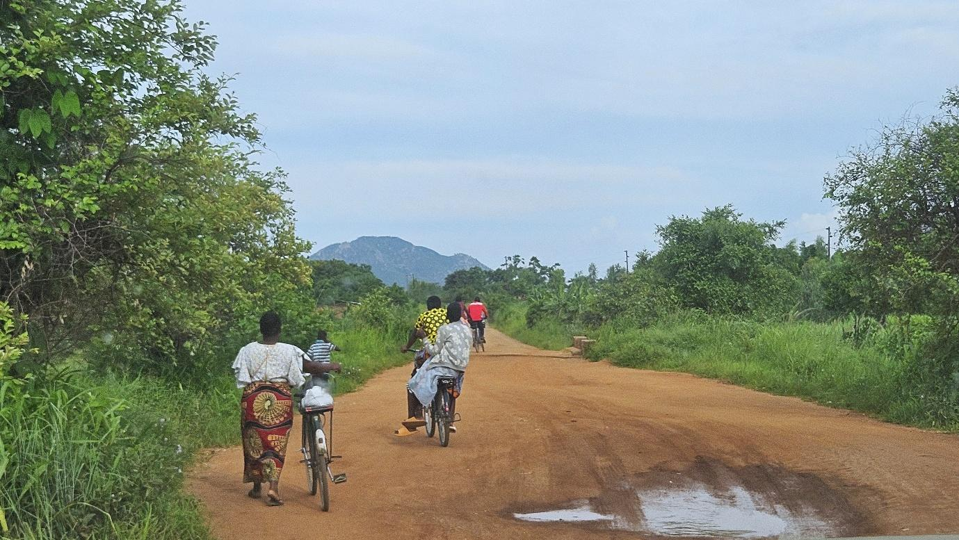

Ministry of Transport and Public Works
Southern Africa Trade and Connectivity Project
Private Bag 322
Lilongwe 3

18 JUNE, 2026

EXECUTIVE SUMMARY
1.0 Project Background
The proposed upgrading of the Govala–Mpyupyu section of the Zomba–Kachulu Road (S143) is a priority intervention under the Southern Africa Trade and Connectivity Project (SATCP), financed by the World Bank and implemented by the Ministry of Transport and Public Works. The project is located in Zomba District in the Southern Region of Malawi, within Traditional Authority Mwambo and Sub-Traditional Authority Nkagula, and forms part of the classified S143 road corridor linking Govala Trading Centre, Mpyupyu Trading Centre, surrounding agricultural settlements, and onward connections toward Kachulu/Lake Chilwa and Zomba.
The road plays a critical role in supporting agricultural production, petty trading, local transport services, and access to schools and essential services. However, the current condition of the road is characterised by inadequate drainage structures, erosion-prone sections, dust-generating gravel surfaces, and stream crossing vulnerabilities at Dambolanyanga stream and an unnamed stream near Linyama. During the rainy season, overtopping and localized flooding reduce road reliability, while in the dry season, dust emissions affect roadside settlements.
To address environmental and social considerations associated with the proposed rehabilitation works, an Environmental and Social Management Plan (ESMP) has been prepared in compliance with the Environment Management Act (2017), the MEPA Guidelines for Environmental Assessment (2025), and applicable World Bank safeguard requirements under SATCP.
The proposed works involve rehabilitation within an existing road reserve and are not expected to require land acquisition or result in physical displacement. The scope includes drainage improvements, sectional re-gravelling, culvert installation and rehabilitation, embankment strengthening, localized shaping, and installation of safety features.
Construction is expected to take approximately 6–9 months, with peak labour demand during earthworks and drainage installation. The workforce will be predominantly locally sourced, providing short-term employment opportunities for youth and households within Govala and Mpyupyu. No permanent employment is anticipated during operation, as maintenance will be undertaken under existing Roads Authority arrangements.
2.0 Nature and Scope of the Proposed Project
The project involves rehabilitation of the existing Govala–Mpyupyu road section to improve safety, drainage efficiency, and all-weather reliability. Key components include:
- Improvement of the road formation and gravel running surface;
- Construction and rehabilitation of culverts and drainage structures at Dambolanyanga stream and the unnamed stream near Linyama;
- Installation of side drains and erosion protection measures;
- Sourcing of gravel and construction materials from approved sites; and
- Progressive rehabilitation of borrow pits and material sources.

3.0 Rationale of the Proposed Project
The road serves predominantly rural communities whose livelihoods depend on agriculture, petty trade, and mobility between villages and trading centres. Poor road conditions constrain access to markets, increase transport costs, and reduce reliability during heavy rainfall events.
Rehabilitation is necessary to:
- Improve year-round connectivity and resilience to rainfall;
- Reduce travel time and vehicle operating costs;
- Strengthen agricultural market linkages toward Zomba and Lake Chilwa areas;
- Enhance safety for pedestrians and cyclists; and
- Improve drainage performance at stream crossings.
4.0 Justification of the Study
Preparation of the ESMP is a statutory requirement under the Environment Management Act (2017) and MEPA Guidelines (2025), including the World Bank Operational Policies. The project involves rehabilitation of an existing rural road within a settled and agricultural environment. Anticipated impacts are site-specific, largely temporary, and manageable through structured mitigation measures.
A stand-alone ESMP is therefore considered the appropriate safeguard instrument. The ESMP functions as a binding implementation tool to ensure environmental, social, labour, occupational health and safety, and community risks are systematically identified, mitigated, monitored, and reported.
5.0 Objectives of the ESMP
The ESMP seeks to:
- Identify environmental and social risks across project phases;
- Define practical mitigation and enhancement measures;
- Ensure compliance with national and World Bank safeguard requirements;
- Protect workers and communities;
- Establish monitoring and reporting mechanisms; and
- Promote transparency and accountability through stakeholder engagement and GRM processes.
6.0 Methodology Used to Prepare the ESMP
The ESMP was prepared through:
- Review of national legislation, MEPA guidelines, and project design documents;
- Field assessments along the Govala–Mpyupyu corridor;
- Stakeholder consultations with community leaders and district authorities;
- Identification of phase-based environmental and social risks; and
- Development of site-specific mitigation and monitoring measures.
7.0 Summary of Key Positive Impacts and Enhancement Measures
7.1 Improved Flood Resilience and Drainage Efficiency
Rehabilitation will improve cross-drainage functionality at Dambolanyanga and Linyama stream crossings.
Enhancement Measures:
- Apply hydrological modelling for culvert sizing;
- Monitor drainage functionality during operation;
- Maintain culverts and side drains routinely.
7.2 Improved Transparency and Community Ownership
Structured consultations and operational GRM strengthen trust.
Enhancement Measures:
- Maintain corridor-wide GRM;
- Continue community engagement during construction.
7.3 Local Employment and Income Generation
Short-term employment will increase household liquidity.
Enhancement Measures:
- Prioritize local recruitment;
- Ensure transparent labour selection;
- Promote fair labour practices.
7.4 Local Economic Stimulation
Local procurement will stimulate Govala and Mpyupyu businesses.
Enhancement Measures:
- Source materials from licensed suppliers;
- Encourage local SME participation.
7.5 Enhanced Market Access and Connectivity
Improved road surface reduces travel time and transport costs.
Enhancement Measures:
- Maintain gravel thickness and grading;
- Support safe roadside economic activity.
8.0 Summary of Key Negative Impacts and Mitigation Measures
8.1 Settlement Proximity Disturbance Risks
Construction near Govala and Mpyupyu may increase dust and vibration.
Mitigation Measures:
- Implement dust suppression;
- Restrict noisy works to daytime hours;
- Maintain community communication.
8.2 Soil Erosion and Sedimentation
Earthworks may affect stream crossings.
Mitigation Measures:
- Install sediment control measures;
- Stabilize exposed slopes;
- Rehabilitate disturbed areas promptly.
8.3 Water Contamination Risks
Hydrocarbon spills could affect soils and surface water.
Mitigation Measures:
- No on-site fuel storage;
- Fuel to be procured directly from nearby service stations;
- Prohibit washing in streams;
- Implement spill response procedures.
8.4 Borrow Pit Degradation
Unrehabilitated pits may pose hazards.
Mitigation Measures:
- Approve borrow sites in advance;
- Rehabilitate progressively;
- Prevent stagnant water formation.
8.5 Dust and Traffic Safety Risks
Construction and improved surface conditions may increase accident risk.
Mitigation Measures:
- Implement Traffic Management Plan;
- Install signage and speed calming;
- Conduct road safety awareness.
8.6 GBV/SEA/SH Risks
Worker influx may create social tension.
Mitigation Measures:
- Enforce Code of Conduct;
- Conduct awareness training;
- Maintain confidential reporting channels.
8.7 Climate Vulnerability
Extreme rainfall may affect embankments.
Mitigation Measures:
- Monitor drainage systems;
- Strengthen weak sections;
- Maintain routine inspection.
9.0 Conclusion and Recommendations
9.1 Conclusion
The rehabilitation of the Govala–Mpyupyu Section will generate significant socio-economic benefits, including improved drainage resilience, enhanced market connectivity, and increased economic mobility. Identified environmental and social risks are manageable through structured implementation of the ESMP.
With effective supervision, monitoring, and institutional coordination, the project is environmentally and socially acceptable.
9.2 Recommendations
- Allocate adequate financial and human resources for ESMP implementation;
- Integrate mitigation measures into contractual obligations;
- Approve site-specific plans prior to mobilization;
- Operationalize GRMs at community and worker levels;
- Obtain all statutory approvals prior to commencement;
- Deploy qualified Environmental and Social personnel;
- Maintain coordination between MoTPW (SATCP PIU), Roads Authority, Zomba District Council, and MEPA.

ACRONYMS AND ABBREVIATIONS

AIDS | Acquired Immune Deficiency Syndrome
DED | Detailed Engineering Design
DESC | District Environment Sub-Committee
EHS | Environmental, Health and Safety
EMA | Environment Management Act
ESHS | Environmental, Social, Health and Safety
ESIA | Environmental and Social Impact Assessment
ESMMP | Environmental and Social Mitigation and Monitoring Plan
ESMP | Environmental and Social Management Plan
FGD | Focus Group Discussion
GBV | Gender-Based Violence
GIIP | Good International Industry Practice
GRM | Grievance Redress Mechanism
HIV | Human Immunodeficiency Virus
IEC | Information, Education and Communication
IUCN | International Union for Conservation of Nature
LC | Local Council
LMI | Last Mile Infrastructure
MEPA | Malawi Environment Protection Authority
OHS | Occupational Health and Safety
OP/BP | Operational Policy / Bank Procedure (World Bank)
PPE | Personal Protective Equipment
RA | Roads Authority
RHS | Right-Hand Side
SATCP | Southern Africa Trade and Connectivity Project
SEA | Sexual Exploitation and Abuse
SEA/SH | Sexual Exploitation and Abuse / Sexual Harassment
SEP | Stakeholder Engagement Plan
SH | Sexual Harassment
STA | Sub-Traditional Authority
WMP | Waste Management Plan

TABLE OF CONTENTS

EXECUTIVE SUMMARY i
TABLE OF FIGURES x
LIST OF TABLES xi
1 CHAPTER 1: INTRODUCTION AND BACKGROUND 1
1.1 Introduction 1
1.2 Project Background 1
1.3 Developer Details 2
1.4 Nature and Scope of the Project 2
1.5 Project Objectives 2
1.6 Justification of the Project 3
1.7 Objectives of the ESMP Study 3
1.8 Rationale of the ESMP 3
1.9 Methodology 4
1.9.1 Literature and Document Review 4
1.1.1 Field Investigations and Site Verification 4
1.1.2 Stakeholder Consultations 4
1.10 Project Location 5
1.11 Land Tenure and Land Requirement for the Project 11
1.12 Potential Users of the ESMP 11
1.13 Introduction 13
1.14 Project Components and Activities 13
1.15 Spatial Distribution of Works by Chainage 15
1.16 Labour Requirement 15
1.17 Material Requirements and Sources 16
1.18 Waste Generation and Management 17
1.19 Borrow Pit Rehabilitation 19
2 CHAPTER 3: POLICY AND LEGAL FRAMEWORK 20
2.1 Introduction 20
2.2 National Policies and Strategies 20
2.2.1 Policy Framework 20
2.2.2 Legislative Framework 21
2.3 World Bank Safeguard Policies and Procedures 24
2.3.1 World Bank Operational Policy OP/BP 4.01: Environmental Assessment 24
2.3.2 Environmental, Health and Safety (EHS) Guidelines 25
2.4 Institutional Framework 26
2.5 Summary of Main Statutory Approvals/Licenses to be obtained for the project 26
3 CHAPTER 4: ENVIRONMENTAL AND SOCIAL SETTING 28
3.1 Introduction 28
3.2 Biophysical Environment 28
3.2.1 Topography 28
3.2.2 Geology 28
3.2.3 Soils 31
3.2.4 Climate and Climate Change Risks 33
3.2.5 Water Resources 35
3.2.6 Flora and Fauna (Biological Environment) 37
3.2.7 Ecological Significance of Vegetation 41
3.2.8 Fauna 41
3.2.9 Ecological Sensitivity and Baseline Implications 43
3.3 Socio-economic environment 43
3.3.1 Demographic Characteristics 43
3.3.2 Education and Literacy 44
3.3.3 Health 44
3.3.4 Cultural Heritage 45
3.3.5 Agriculture 45
3.3.6 Economic Activities and Livelihoods 45
3.3.7 Transport 46
3.3.8 Security 46
3.3.9 Land Use 46
3.3.10 Vulnerable and Marginalized Groups 47
3.3.11 Communication 47
3.3.12 Energy Sources 47
4 CHAPTER 5: ENVIRONMENTAL AND SOCIAL MITIGATION AND MONITORING PLAN 48
4.1 Introduction 48
4.2 Framework instruments for contractor implementation 48
4.3 Environmental and Social Mitigation and Monitoring Plan 50
4.4 Institutional Arrangements and Implementation Capacity 61
REFERENCES 63
ANNEXES 65
Annex 1. Feedback Letter from MEPA 65
Annex 2. Terms of Reference from MEPA 66
Annex 3a. List of Stakeholders Consulted 68
Annex 3b Issues raised by stakeholders and how they have been addressed in ESMP 70
Annex 4. Sample Code of Conduct for Contractors 72
Annex 5. Barrow Pit Rehabilitation Framework 76
Annex 6. Traffic Management Framework 80
Annex 7. Chance Find Procedure for Last Mile Infrastructure under SATCP 84
Annex 8: Labour Management Guidelines for Contractor Compliance and Preparation of Labour Management Plans (LMPs) 86
Annex 13. SATCP LMI Grievance Redress Mechanism (GRM) Protocol 90
Annex 14. Spatial Distribution of Works by Chainage 97
Annex 15. Project Design Drawings 100

TABLE OF FIGURES
Figure 1-1. Consultation with Zomba DESC 5
Figure 1-2. Location of Zomba – Kachulu Road (Govala – Mpyupyu Section) 6
Figure 1-3. Arial view of Govala – Mpyupyu Road Section of the Zomba – Kachulu Road 7
Figure 1-4. Detailed view of the starting point (Chainage 6+670) on Zomba – Kachulu Road 8
Figure 1-5. Detailed view of the estate area (approx. Chainage 7+700 -8+000 m) 9
Figure 1-6. Detailed view of Mpyupyu Section 10
Figure 4-1. Geological Map of the Govala – Mpyupyu section of the Zomba – Kachulu Road 30
Figure 4-2. Soils along the Govala - Mpyupyu Road 32
Figure 4-3. Mean monthly temperature pattern for Govala – Mpyupyu Road 33
Figure 4-4. Mean monthly rainfall pattern for the project area 34
Figure 4-5. Hydrological map of the proposed project area 36
Figure 4-6. Typical Vegetation along the Govala–Mpyupyu Section Showing grass and cultivated fields 37
Figure 4-7. Observed Invasive Species Gmelina arborea on roadside margins 41
Figure 4-8. Saint Michaels FP School alomg the Govala – Mpyupyu Road 44
Figure 4-9. Yankho Private Clinic along Govala – Mpyupyu Road 45
Figure 4-10. A normal day at Mpyupyu Trading Centre 46

LIST OF TABLES
Table 1-1. Potential Users of the ESMP and Their Roles 12
Table 2-1. Project Components and Activities 14
Table 2-2. Expected Number of People to be Employed (Peak Workforce) 16
Table 2-3. Materials required, estimated quantities, and potential sources 17
Table 2-4. Waste Streams and Waste Management 18
Table 3-1. Policies Guiding the Project 20
Table 3-2. Legislation Guiding the Project 22
Table 3-3. World Bank Environmental and Social Operational Policies Triggered by the Project 25
Table 3-4. E&S Institutional Framework and Mandates 26
Table 3-5. Summary of Statutory Approvals and Licences Required 27
Table 4-1. Recorded Flora Species, Growth Form, Origin, and Conservation Status – Govala–Mpyupyu Section 38
Table 4-2. Invasive Plant Species Recorded and Associated Ecological Risk – Govala–Mpyupyu Section] 40
Table 4-3. Recorded fauna Species and Conservation Status – Govala–Mpyupyu Section 42
Table 5-1. Institutional responsibilities for ESMP implementation and oversight – Govala–Mpyupyu Section 62

CHAPTER 1: INTRODUCTION AND BACKGROUND

Introduction
The rehabilitation of the Govala–Mpyupyu section of the Zomba–Kachulu Road in Zomba District is part of the Last Mile Infrastructure (LMI) Roads Rehabilitation Initiative under the Southern Africa Trade and Connectivity Project (SATCP), aimed at improving rural accessibility, connectivity, and climate resilience.
The proposed works involve rehabilitation of the existing road within TA Mwambo and Sub-TA Nkagula, including drainage improvements, culvert installation and rehabilitation, embankment strengthening, re-gravelling, and road safety enhancements. The road is a key local access route linking Govala and Mpyupyu Trading Centres, surrounding agricultural areas, and wider connections to Kachulu and Zomba City.

Project Background
The subproject involves the upgrading of approximately 8 km of existing road to gravel standard, including drainage improvement works such as culvert installation and rehabilitation. The total estimated project cost is USD 450,000, with an anticipated implementation period from May 2026 to December 2026.
The road serves a predominantly rural population within TA Mwambo and Sub-TA Nkagula in Zomba District, linking agricultural communities to Govala and Mpyupyu Trading Centres, and providing onward connectivity to Zomba City and the Lake Chilwa economic zone. An estimated 71,000–72,000 people are directly dependent on this corridor for mobility, market access, and service delivery.
At peak construction, the contractor is expected to employ approximately 80–100 workers, with priority given to local recruitment for unskilled and semi-skilled roles. Indirect beneficiaries include farmers, traders, and transport operators, with women forming a significant proportion of smallholder farmers and informal traders along the corridor.
Currently, the road is in a deteriorated condition due to inadequate drainage, eroded embankments, and damaged culverts, particularly at Dambolanyanga stream and the unnamed stream near Linyama, resulting in seasonal inaccessibility, increased transport costs, dust emissions, and safety risks.
The proposed rehabilitation focuses on restoring the functionality of the existing alignment through improved drainage, strengthened road structure, and enhanced safety measures, while minimising environmental and social impacts. The project is classified as Category B, reflecting that impacts are site-specific and manageable through mitigation measures.

Developer Details
Name of Developer: | Ministry of Transport and Public Works
Physical Address: | The Project Manager  Southern Africa Trade and Connectivity Project  Private Bag 322  Lilongwe 3
Contact Person: | The Project Manager  Southern Africa Trade and Connectivity Project  Ministry of Transport and Public Works  Private Bag 322  Lilongwe 3.  Cell: 0999088044  Email: hastingsngoma@gmail.com

Nature and Scope of the Project
The scope of works focuses primarily on drainage improvement, pavement rehabilitation, and embankment stabilisation. Drainage interventions include cleaning and reshaping of side drains, construction of mitre and earth drains, installation of lined drains in selected sections, and provision of scour protection and erosion control at discharge points. Existing culverts will be cleaned, repaired, and in some cases replaced or upgraded with higher-capacity reinforced concrete structures, including box culverts at identified drainage crossings. In low-lying and erosion-prone sections, embankment formation and stabilisation measures will be undertaken to raise the road profile, improve hydraulic performance, and reduce overtopping risks during periods of intense rainfall.
Road formation works include regrading of the carriageway, reinstatement of shoulders, correction of crossfall, and placement of gravel wearing course material in accordance with Low Volume Road (LVR) design standards. Spot improvements will address areas affected by surface distress, erosion, and moisture damage. Material sourcing will utilise approved borrow areas and commercial sources identified in the DED, with rehabilitation measures implemented following extraction.

Project Objectives
The objective of the proposed upgrading of the Zomba–Kachulu Road (Govala–Mpyupyu Section) is to improve all weather accessibility and safety of the road users.
Specifically, the project aims to:
- Improve all-weather accessibility through rehabilitation of the road surface and drainage structures.
- Enhance connectivity between Govala and Mpyupyu Trading Centres, surrounding settlements, and agricultural production areas.
- Improve road safety for all users, including pedestrians, cyclists, and motorised traffic.
- Strengthen resilience of the road to rainfall, flooding, and erosion through appropriate drainage and structural improvements.
- Support agricultural and local trade activities by improving transport efficiency for goods and services.
- Ensure environmentally and socially responsible implementation in line with the Environment Management Act (2017) and MEPA Guidelines (2025).

Justification of the Project
The rehabilitation is justified on technical, socio-economic, and climate resilience grounds. Technically, the road has deteriorated due to inadequate drainage, culvert failure, embankment erosion, and runoff impacts, resulting in reduced passability, increased transport costs, and safety risks during rainy seasons. Socio-economically, the road supports surrounding communities engaged in agriculture and trade who rely on it for access to markets, schools, and health services. Poor road conditions limit mobility and economic activity. From a resilience perspective, recurrent erosion and drainage failures indicate vulnerability to intense rainfall events. Rehabilitation will improve drainage performance and reduce maintenance requirements. The project is consistent with rural road development objectives under national infrastructure programmes.

Objectives of the ESMP Study
The primary objective of this ESMP is to provide a practical framework for managing environmental and social risks associated with the rehabilitation works.
Specifically, the ESMP seeks to:
- Identify and assess environmental and social impacts.
- Define mitigation measures using the mitigation hierarchy.
- Establish institutional responsibilities for implementation and supervision.
- Provide monitoring indicators and reporting mechanisms.
- Ensure compliance with the Environment Management Act (2017) and MEPA Guidelines (2025).
- Integrate occupational health and safety, labour, and community risk management measures.
- Support stakeholder engagement and grievance redress mechanisms.
The ESMP serves as an implementation tool guiding environmental and social performance during project execution.

Rationale of the ESMP
Preparation of this ESMP is required under the Environment Management Act (2017) following MEPA determination that the project requires an Environmental and Social Management Plan prior to works.
Although the project involves rehabilitation of an existing road, activities such as earthworks, drainage works, and borrow pit use may generate localized environmental and social impacts requiring management.
The project follows the requirements of applicable environmental assessment procedures for Category B-type projects, ensuring that risks are site-specific, manageable, and reversible through mitigation measures

Methodology
The study used in preparation of the ESMP used combined methods such as literature review, field investigations, and relevant stakeholder consultations to identify environmental, social, and OHS risks and translate them into mitigation and monitoring measures.

Literature and Document Review
Review included:
- Project documentation and engineering design drawings;
- MEPA feedback and Terms of Reference;
- National environmental, land, labour, water, and transport legislation;
- World Bank safeguard requirements (ESF / OP 4.01 principles).
This provided the regulatory and technical basis for impact assessment and mitigation development

Field Investigations and Site Verification
Field verification was conducted along the road to assess:
- Drainage crossings and low-lying sections;
- Settlement areas at Govala and Mpyupyu;
- Agricultural land use patterns;
- Road condition, erosion zones, and embankment stability.
Findings were used to validate design assumptions and identify environmental and social risks.

Stakeholder Consultations
Consultations were undertaken with Zomba District Council, DESC, and local community representatives from Govala and Mpyupyu areas.
Key issues raised included:
- Flooding and drainage problems;
- Road safety concerns;
- Access disruptions during construction;
- Livelihood dependence on agriculture and transport routes;
- Social risks including GBV/SEA/SH.
Inputs were integrated into the ESMP and monitoring framework.
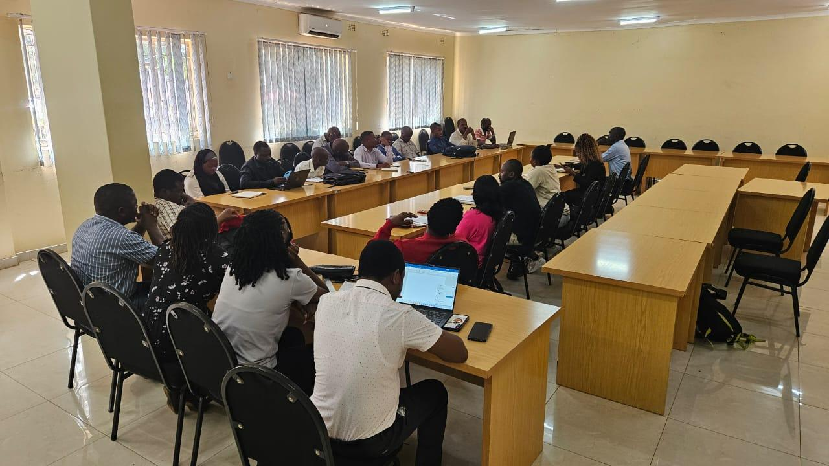
Figure 1-1. Consultation with Zomba DESC

Project Location
The Govala–Mpyupyu section forms part of the Zomba–Kachulu Road in Zomba District, connecting Govala Trading Centre, agricultural settlements, Mtengeranjiru Estate, and Mpyupyu Trading Centre.
The road section has an approximate length of 8.59 km. Based on surveyed spatial data (UTM Zone 36S, metres); the alignment commences at:
- Start Point (Near Govala Trading Centre):
770,161.65 mE; 8,295,491.82 mN
and terminates at:
- End Point (Near Mpyupyu Trading Centre):
761,721.66 mE; 8,296,466.15 mN
The alignment traverses rural agricultural landscapes, including maize fields, rice cultivation areas in dambos, scattered homesteads, and trading centres. It also crosses seasonal drainage lines prone to runoff during rainfall periods.
Figures provided in this ESMP illustrate the road alignment, settlement nodes, drainage features, and surrounding land use.
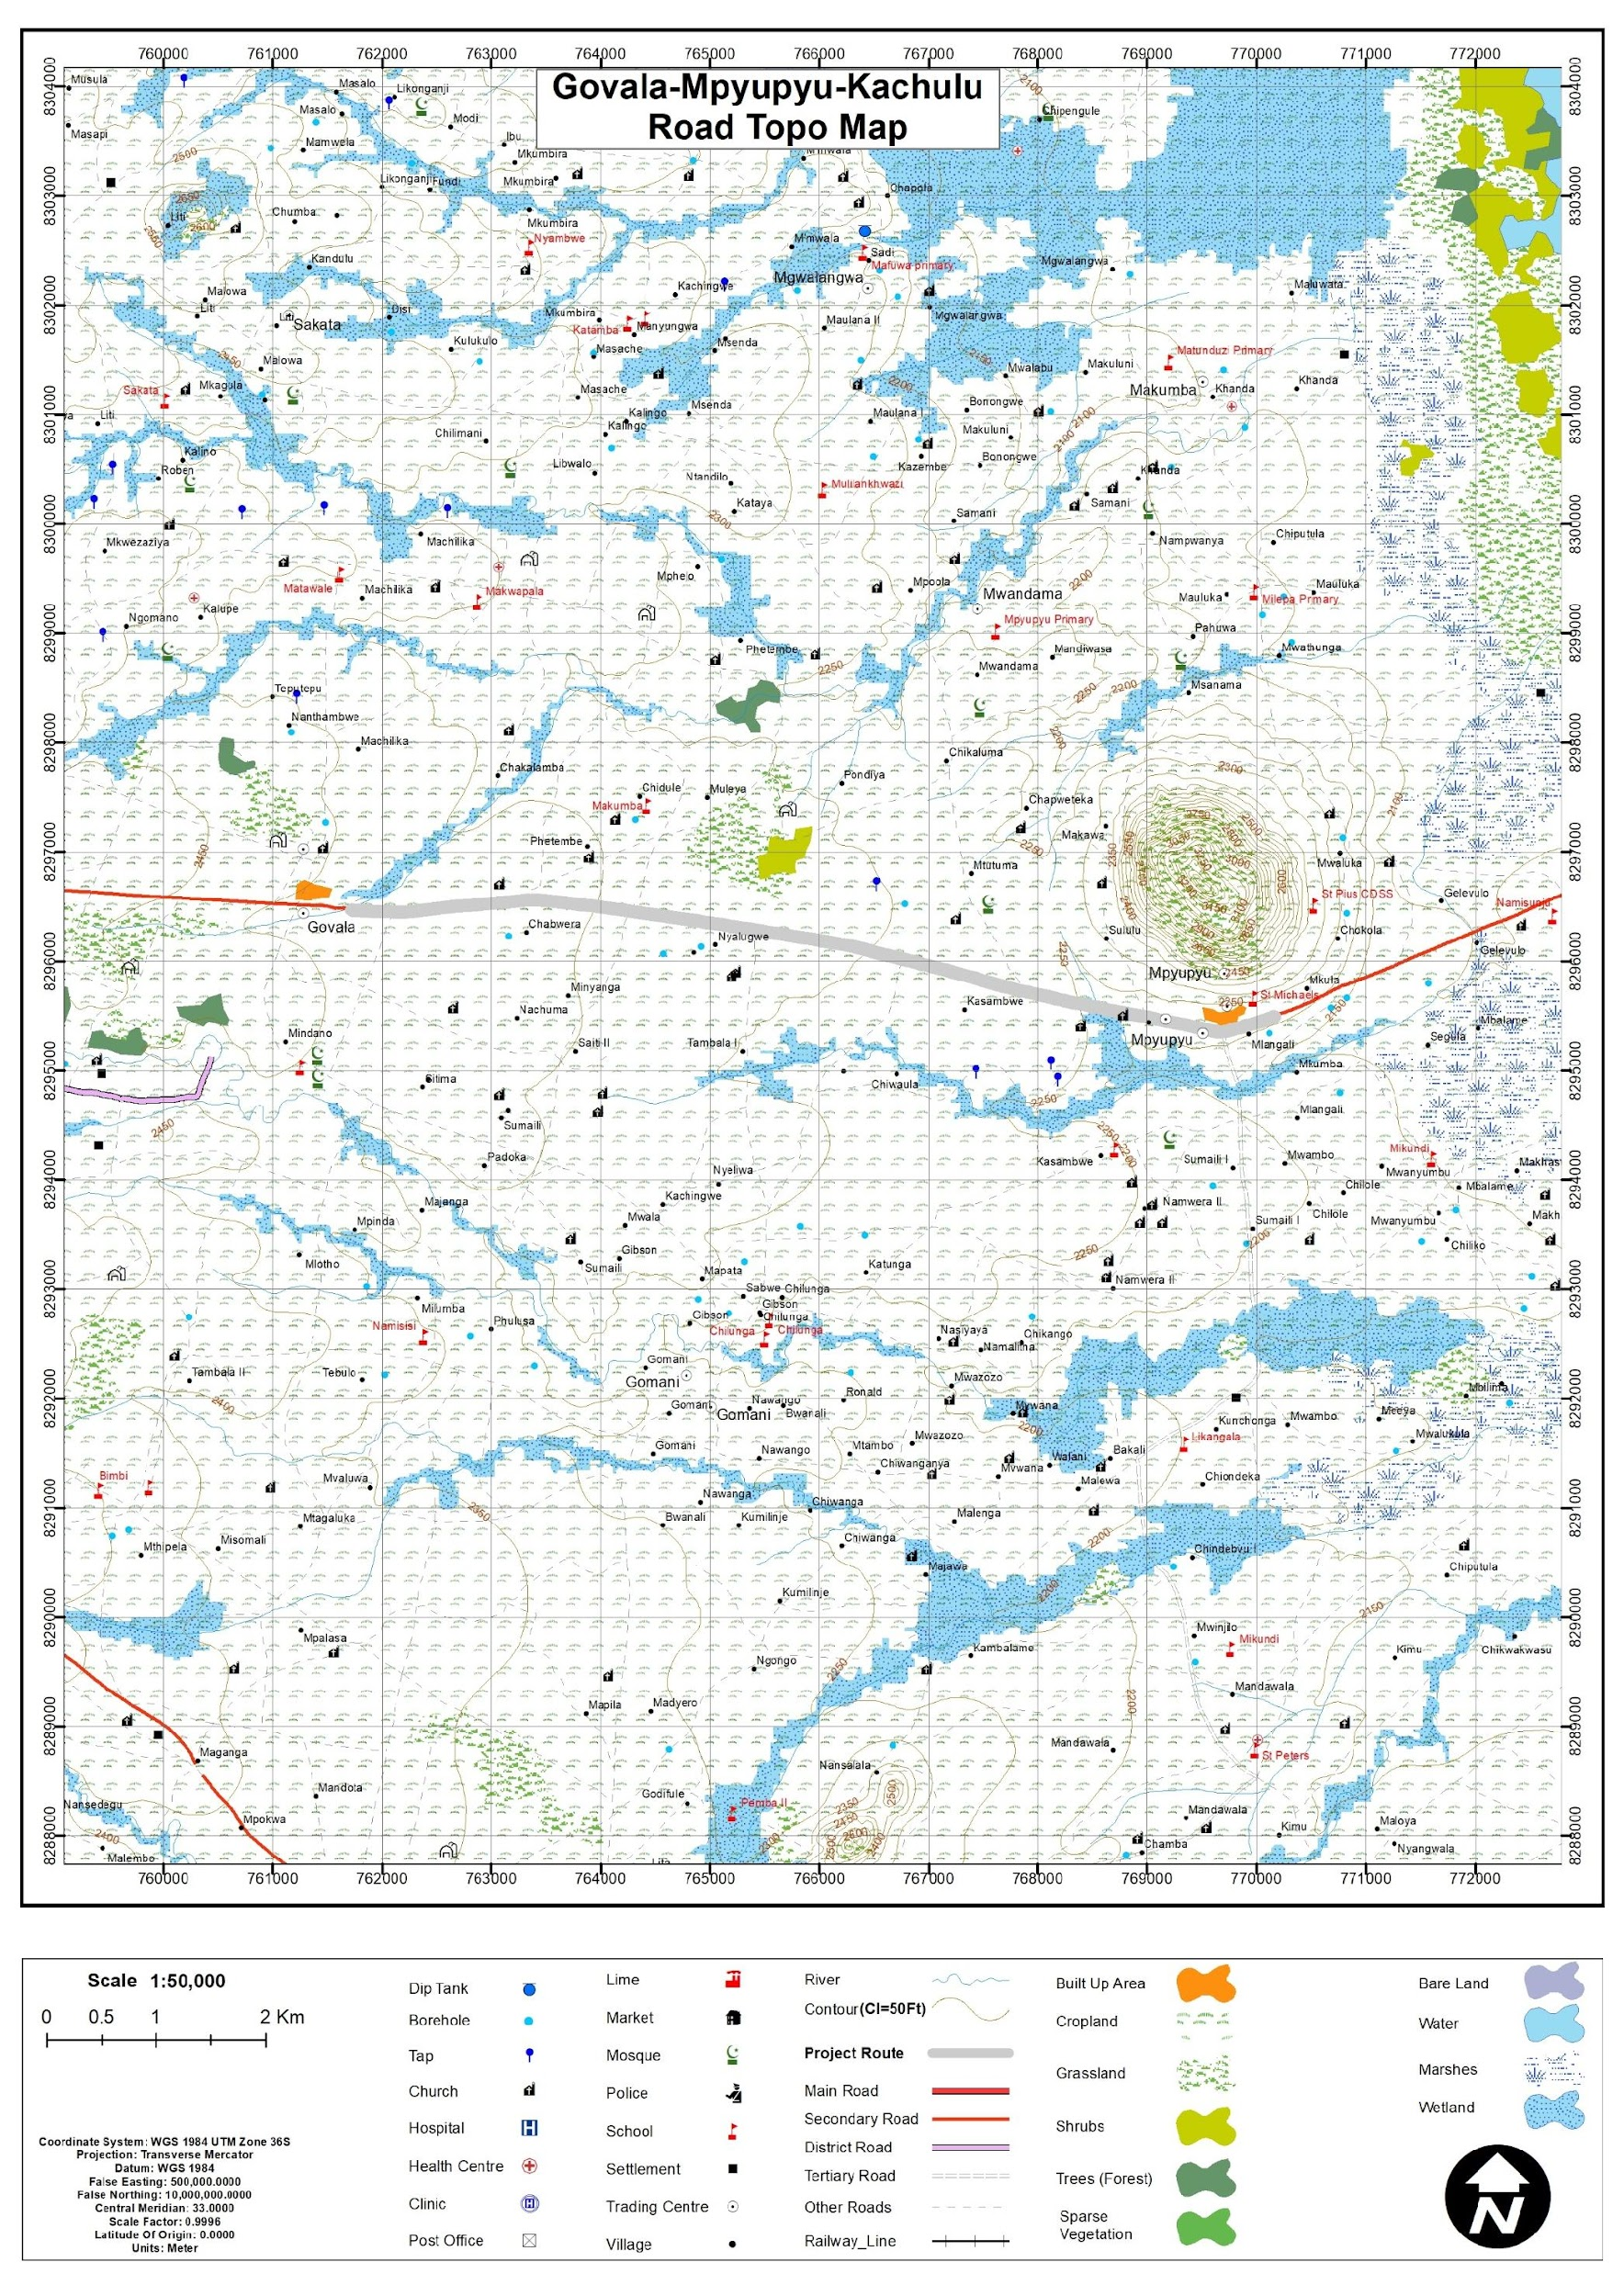
Figure 1-2. Location of Zomba – Kachulu Road (Govala – Mpyupyu Section)

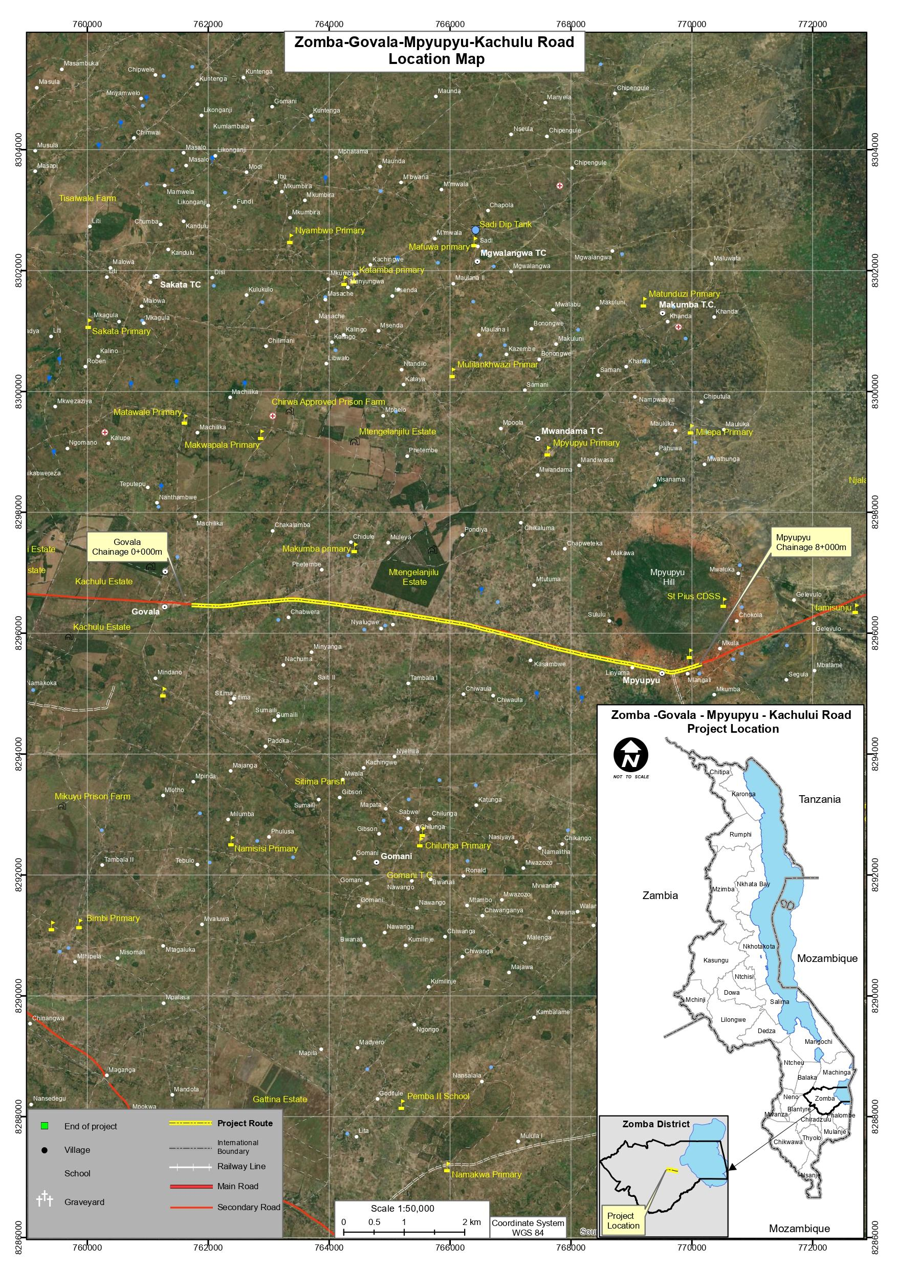
Figure 1-3. Arial view of Govala – Mpyupyu Road Section of the Zomba – Kachulu Road
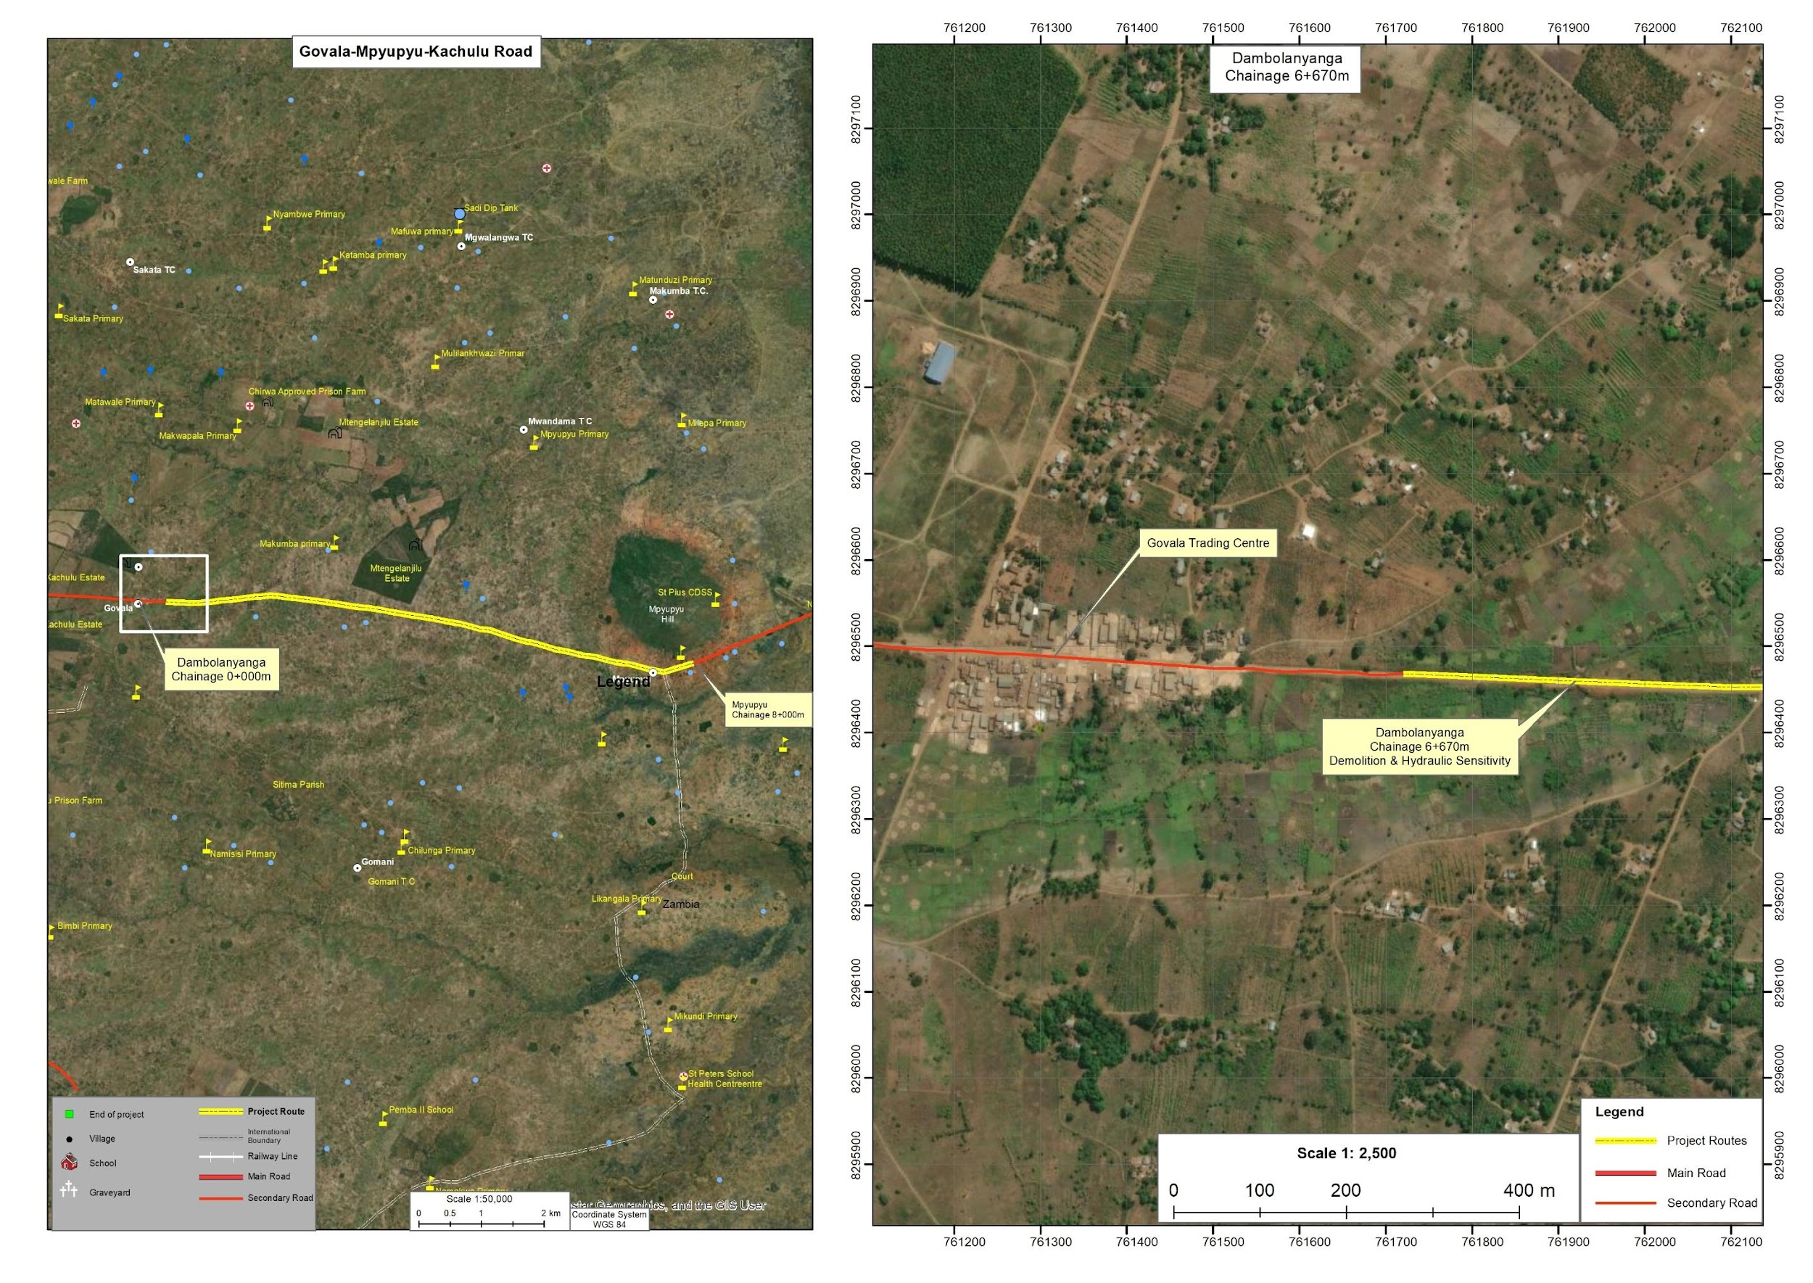
Figure 1-4. Detailed view of the starting point (Chainage 6+670) on Zomba – Kachulu Road

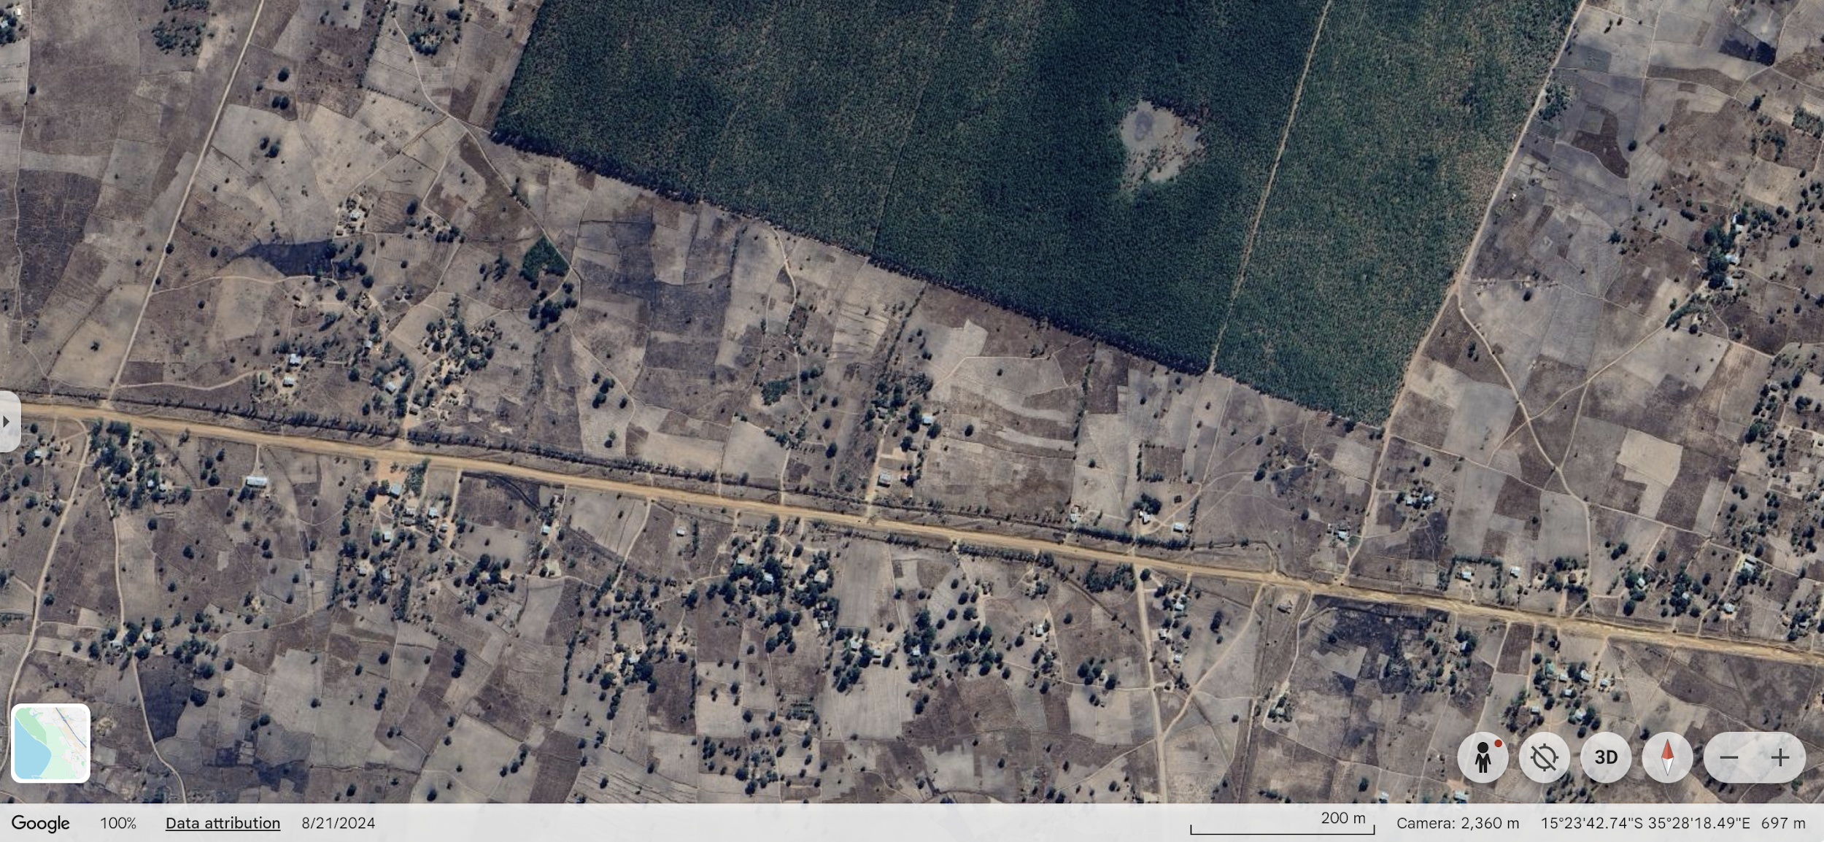
Figure 1-5. Detailed view of the estate area (approx. Chainage 7+700 -8+000 m)
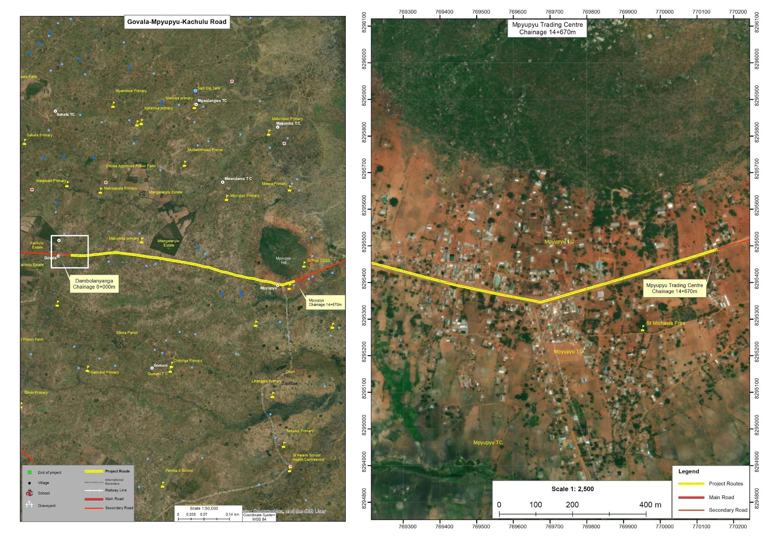
Figure 1-6. Detailed view of Mpyupyu Section

Land Tenure and Land Requirement for the Project
The Govala–Mpyupyu Section of the Zomba–Kachulu Road is located within TA Mwambo and Sub-TA Nkagula in Zomba District. Land within the project area is predominantly held under customary land tenure, administered through traditional authority structures in accordance with Malawi’s land governance framework. Residential plots, cultivated fields, and small trading areas adjacent to the road are generally occupied and used under customary rights, with land allocated and managed through local traditional leadership.
The existing road alignment constitutes a recognized public access corridor and forms part of the district road network. The proposed upgrading works will occur strictly within the existing road reserve and right-of-way, which has a width of 36 metres or 18 metres on both sides of the lane. This is in line with the Public Road (Amendment) Act Chapter 69:02 of 2023. In this respect, no expansion beyond the established footprint is anticipated. Informal temporary structures such as vending booths and groceries placed by their occupants within the public road reserve are not part of the project footprint. Where such items occur along the alignment, the corresponding sections have been deliberately excluded from the spot-based rehabilitation scheme during design, so that construction works avoid them altogether; any residual coordination needs around the immediate working area will be handled under the stakeholder engagement and GRM provisions of this ESMP. No permanent dwellings, agricultural fields or assets outside the road reserve are anticipated to be affected.
While agricultural fields and structures are located in proximity to sections of the road—particularly near Govala and Mpyupyu Trading Centres—these occur outside the functional carriageway and road reserve. The project design maintains the existing alignment and width, thereby avoiding encroachment onto adjacent customary land holdings (Figures 1-5 & 1-6; Annex 14).

Potential Users of the ESMP
This Environmental and Social Management Plan (ESMP) provides guidance for managing environmental and social risks associated with the rehabilitation of Zomba–Kachulu Access Road. The document serves as a practical tool for institutions responsible for project implementation, supervision, compliance monitoring, and stakeholder engagement throughout the project lifecycle.
Table 1-1 outlines the key institutions and stakeholders expected to use this ESMP and their respective roles in environmental and social management.

Table 1-1. Potential Users of the ESMP and Their Roles
Potential User | Potential Usage of the ESMP
Malawi Environment Protection Authority (MEPA) | Regulatory review, environmental compliance monitoring, and verification that project implementation aligns with the Environmental Management Act (2017) and MEPA requirements.
Ministry of Transport and Public Works (MoTPW) and PIU | Project owner and implementing authority responsible for overall coordination of the road rehabilitation works and ensuring that environmental and social safeguards are integrated into project implementation under the SATCP Last Mile Infrastructure component.
Zomba District Council (including DESC) | Local-level monitoring and coordination of environmental and social management measures, as well as facilitation of engagement with local communities.
Ministry of Labour and National Construction Industry Council (NCIC) | Oversight of labour standards, occupational health and safety compliance, and contractor adherence to national labour regulations.
Project Engineers and Supervising Consultants | Integration of environmental and social requirements into construction supervision, site inspections, and monitoring of mitigation measures during project implementation.
Contractors and Subcontractors | Implementation of ESMP mitigation measures, occupational health and safety provisions, labour management procedures, community health and safety measures, and GBV/SEA/SH prevention requirements during construction.
Local Communities and Road-Corridor Users | Awareness of project activities, potential impacts, mitigation measures, employment opportunities, and access to the project Grievance Redress Mechanism (GRM).
World Bank and Other Oversight Institutions | Safeguards due diligence, implementation supervision, and monitoring of compliance with applicable environmental and social safeguard policies.

CHAPTER 2: PROJECT DESCRIPTION

Introduction
This chapter describes the technical scope of the proposed upgrading of the Govala–Mpyupyu section of the Zomba–Kachulu Road (S143), covering approximately 8 km between chainages 6+000 and 14+000. It presents the main engineering works, project components, and implementation activities associated with upgrading the existing road alignment to gravel standard within the established road reserve.
It outlines the key activities to be undertaken during the planning and design, construction, contractor demobilisation, and operation and maintenance phases, including drainage improvement, culvert and drift works, embankment stabilisation, reshaping and gravelling of the running surface, material sourcing, labour requirements, waste management, and reinstatement of disturbed areas.

Project Components and Activities
The Govala–Mpyupyu Road Upgrading Project involves the upgrading and rehabilitation of approximately 8 km of the S143 Zomba–Kachulu Road between Govala and Mpyupyu in Zomba District. The works will be undertaken within the existing road reserve and are intended to restore road functionality, improve drainage performance, and reduce flood-related and erosion-related disruptions along this section of the corridor. The project focuses on improving road geometry and surface condition, strengthening embankments in low-lying or eroded sections, and rehabilitating drainage structures such as culverts, drifts, and side drains to ensure reliable all-weather access for surrounding communities.
Field investigations and engineering assessments identified several deteriorated road sections and drainage structures requiring repair, rehabilitation, or replacement. Particular attention was given to erosion-prone locations and flood-affected areas, including the approaches to Dambolanyanga Stream and other minor stream crossings, where drainage failures and poor formation have historically caused surface damage, overtopping, and transport disruptions. The proposed drainage design, including culvert capacities, mitre and earth drains, and stormwater management measures, has been developed to be adequate for expected runoff conditions. Detailed engineering drawings and specifications for the works are provided in the design annexes for the project. The main project activities will be implemented across four phases as summarised below.

Table 1-2. Project Components and Activities
Phase | Project activities
Pre-construction / Design phase | Prepare Detailed Engineering Designs (DED) based on field investigations, engineering surveys, traffic counts, and hydrological analysis. Verify existing road and drainage infrastructure (concrete pipe culverts, drifts, side drains). Identify erosion-prone and flood-prone sections and drainage deficiencies. Refine road geometry, gravel layer thickness, camber, embankment stabilisation needs, culvert sizing, and positions of mitre and earth drains. Define erosion and scour protection measures and confirm that proposed drainage openings are adequate for design storm flows within the existing road reserve.
Construction phase | Establish site offices and temporary facilities. Undertake limited vegetation clearing within the road reserve. Execute earthworks for reshaping and grading of the road formation. Excavate and stabilise deteriorated sections and reconstruct embankments in low-lying or eroded areas. Clean, repair, and replace culverts; construct new headwalls and wing walls; excavate or improve inlet and outlet drains. Install mitre and earth drains, scour checks, and outlet protection. Place, spread, and compact gravel wearing course. Maintain community and farm access as far as practicable and implement ESMP measures for erosion control, traffic management, OHS, community safety, stakeholder engagement, and GRM.
Contractor demobilisation phase | Remove construction machinery, temporary facilities, and surplus materials. Clear and reinstate temporary access tracks, laydown areas, and stockpile sites. Rehabilitate any borrow pits or material extraction areas through re-contouring, drainage, and stabilisation in line with approved rehabilitation plans. Collect and transport all remaining construction waste to designated, approved disposal sites in coordination with Zomba District Council. Remove temporary drainage diversions and restore flows to natural or designed channels.
Operation and maintenance phase | Open the upgraded Govala–Mpyupyu section of S143 to traffic and hand over to the Roads Authority / MoTPW. Undertake routine maintenance including periodic grading of the gravel surface, cleaning of culverts and drains, repair of localised erosion and scour protection, and maintenance of road safety features such as signage and marker posts. Manage residual environmental and social risks primarily related to road safety and drainage functionality through standard maintenance procedures and district-level oversight.

Spatial Distribution of Works by Chainage
Upgrading works along the Govala–Mpyupyu section are not continuous; instead, they are concentrated at discrete chainage sections where the Engineer has identified drainage, formation, and embankment defects requiring intervention. The chainage references therefore indicate where direct construction activities (earthworks, culvert and drift rehabilitation or replacement, grading, gravelling, embankment formation, earth drains, and scour checks) will occur, and where environmental and social receptors (households, fields, trading centres, watercourses, schools, and other community facilities) are most likely to experience disturbance.
The specific spatial distribution of works by chainage for the Govala–Mpyupyu section of the Zomba–Kachulu Road is presented in Annex 14, together with an aerial overview in Figure 1-3 (Aerial view of Govala–Mpyupyu Road Section). These show priority intervention points including the Dambolanyanga stream approaches, low-lying embankment sections, and locations with concentrated scour and drainage failure. Outside the chainage sections identified in Annex 14, only routine maintenance and minor touch-ups within the existing road prism are planned, such as local reshaping of side drains or pothole repair, with limited environmental and social disturbance.

Labour Requirement
The upgrading of the 8 km section will be implemented by civil workers comprising of employing skilled, semi-skilled, and unskilled labour. The workforce will be temporary and vary according to construction activities such as earthworks, drainage installation, and gravel placement. At peak, the contractor is expected to employ approximately 80–100 workers. Priority will be given to local recruitment for unskilled and semi-skilled roles including clearing, excavation, drainage works, material handling, and traffic control.
Specialised technical personnel such as engineers, surveyors, and equipment operators may be sourced externally where local capacity is limited.
The project will deploy 2 Environmental and Social Specialists responsible for safeguards oversight, coordination, and reporting on environmental and social compliance, including OHS monitoring support.
Employment will include supervision, surveying, earthworks, drainage construction, plant operation, traffic management, environmental and OHS compliance, and site security functions.

Table 1-3. Expected Number of People to be Employed (Peak Workforce)
SN | Employee Category | Local | External* | Total
1 | Civil Engineering and Supervision | 3 | 3 | 6
2 | Surveying and Setting Out | 2 | 2 | 4
3 | Masonry and Concrete Works | 8 | 0 | 8
4 | Carpentry and Formwork | 6 | 0 | 6
5 | Mechanical / Equipment Operators | 6 | 3 | 9
6 | Drainage Construction | 12 | 0 | 12
7 | Excavation and Earthworks | 15 | 0 | 15
8 | Manual Material Handling | 10 | 0 | 10
9 | Site Clearing and Preparation | 8 | 0 | 8
10 | Traffic Control and Safety | 6 | 0 | 6
11 | General Site Maintenance | 5 | 0 | 5
12 | Catering and Welfare Services | 2 | 0 | 2
13 | Security Services | 4 | 0 | 4
14 | Health and Safety Compliance | 2 | 0 | 2
15 | Environmental & Social Management | 2 | 0 | 2
 | Total (Indicative Peak) | 91 | 8 | 99

Material Requirements and Sources
The rehabilitation works will require construction materials for earthworks, drainage improvement, culvert installation, and gravel surfacing along the 8 km Govala–Mpyupyu section. The key material requirements, estimated quantities, potential sources, and intended uses are summarised in Table 2-3.
Water for construction activities such as concrete works, compaction, dust suppression, and site use will be sourced from approved boreholes, licensed suppliers, or authorised abstraction points, ensuring that usage does not adversely affect community supply or ecological flows.
Additional materials such as sand, aggregates, and selected fill will be obtained from licensed quarries or approved suppliers, while energy needs will primarily involve diesel and petrol for machinery and haulage vehicles. All sourcing will include appropriate environmental controls to prevent pollution, regulate extraction, and ensure site restoration after use.

Table 1-4. Materials required, estimated quantities, and potential sources
SN | Material required | Unit | Estimated quantity | Potential sources | Remarks (use in project activities)
1 | Lateritic gravel / selected fill | m³ | 8,500–9,000 (subject to final design and compaction factors) | Approved borrow pits within feasible haul distance | Gravel wearing course, embankment strengthening, reshaping of road formation and shoulders
2 | Sand | m³ | Moderate | Licensed river sand suppliers or approved extraction sites | Concrete and mortar for culverts, headwalls, drifts, and drainage structures
3 | Aggregates | m³ | Moderate | Approved stone quarries | Concrete works for culverts, headwalls, aprons, and other structural drainage components
4 | Water | m³/day | Moderate | Approved boreholes, community water points (where authorised), or licensed tankered supply | Concrete mixing, compaction of gravel layers, dust suppression, and general site use, without compromising community supply
5 | Cement | 50 kg bags | Moderate | Authorised building material suppliers | Binding material for concrete culverts, headwalls, aprons, and minor structural works
6 | Diesel | Litres | Moderate | Licensed fuel suppliers | Operation of construction machinery, haulage trucks, and plant
7 | Petrol | Litres | Low | Licensed fuel suppliers | Operation of light equipment and supervision vehicles

All material sourcing and extraction activities will be undertaken in compliance with national regulations and MEPA environmental safeguards, with specific measures for borrow pit approval and rehabilitation, pollution prevention, and protection of nearby communities and natural resources.

Waste Generation and Management
The contractor will implement a site-specific Waste Management Plan (WMP) that follows the hierarchy of avoidance, reduction, reuse, recycling, and safe disposal, consistent with MEPA requirements, the Environment Management Act (2017), and World Bank good practice. Waste will be segregated at source, stored temporarily in designated, clearly labelled areas, and transported to approved municipal or licensed disposal facilities. Liquid waste from welfare facilities will be managed through portable sanitation units or septic systems serviced by licensed operators, with no uncontrolled discharge to land or watercourses. Hazardous waste will be securely stored on impermeable, bunded surfaces and handled or removed only by licensed collectors.
The main anticipated waste streams and management measures are summarised in Table 2-4.

Table 1-5. Waste Streams and Waste Management
Waste stream | Possible sources | Key management measures
Excavated soil / spoil | Earthworks, drainage improvements, culvert and embankment works | Reuse suitable material for backfilling, embankment formation, and shoulder shaping; place stockpiles away from drains and watercourses; dispose excess spoil at council-approved sites, avoiding wetlands, fields, and settlement areas.
Construction rubble and concrete waste | Culvert rehabilitation, headwalls, drifts, minor structures | Minimise breakage and wastage; allow concrete wash water to settle in lined pits; reuse cured rubble as hardcore or erosion protection where appropriate; dispose remaining rubble at designated disposal sites.
Cleared vegetation and organic waste | Bush clearing within road reserve, grass cutting | Limit clearing to the defined footprint; chip or windrow vegetation for use as mulch or erosion control where feasible; remove unwanted woody material to agreed disposal locations; avoid open burning unless specifically authorised by the District Council and MEPA.
Scrap metal | Damaged culvert components, reinforcement off-cuts, metal signs | Collect in a secure, designated area; keep separate from general waste; sell or return to licensed scrap or recycling facilities; prohibit dumping in drains or borrow pits.
Packaging waste (cement bags, plastics, containers) | Material deliveries, concrete works, fuel and lubricant containers | Segregate at source into recyclable and non-recyclable fractions; reuse where practical; compact and store in covered bins; return reusable drums and containers to suppliers; dispose residual packaging via licensed waste handlers or municipal facilities.
Used oils, lubricants, filters, oily rags | Plant and equipment maintenance, servicing | Store in sealed, clearly labelled containers on bunded, impermeable surfaces; use drip trays during servicing; maintain spill kits; prohibit discharge, burial, or burning; hand over to MEPA-licensed hazardous waste or oil recycling companies.
Used batteries and other e-waste | Vehicles, equipment, small electronics | Store in secure, weather-proof containers; prevent leakage and damage; return to suppliers or licensed recyclers; no on-site disposal.
Domestic solid waste | Site offices, welfare facilities, workers’ day activities | Provide covered bins at work areas; ensure daily collection and central storage; transport to council-approved disposal sites; prohibit littering and open dumping along the road.
Sewage and sanitary wastewater | Portable toilets, welfare facilities, washing points | Use portable toilets or septic systems sized for workforce; contract licensed operators for regular emptying and off-site treatment; site units away from watercourses and wells; prevent direct discharge to soil, drains, or streams.
Concrete wash water | Cleaning of mixers, tools, and concrete equipment | Designate lined washout areas away from drains and water bodies; allow solids to settle and concrete to cure; reuse hardened residue as hardcore where suitable; prevent wash water from entering natural drainage lines.

Organic and domestic waste from welfare facilities will be collected regularly and transported to approved municipal disposal sites, while all liquid waste streams (sanitary wastewater and concrete wash water) will be contained and managed to avoid contamination of soil, surface water, and groundwater. Hazardous wastes such as oils, lubricants, filters, oily rags, and batteries will be kept separate from general waste, stored safely in labelled containers, and removed from site only by licensed hazardous waste handlers; on-site disposal, burial, or burning of hazardous waste will not be permitted.

Borrow Pit Rehabilitation
All borrow pits utilised for gravel extraction will be reshaped to stable slopes, drained where necessary to prevent stagnant water accumulation, and reinstated in accordance with agreed rehabilitation plans. Restoration may include backfilling, contouring, and re-vegetation to reduce erosion and safety risks.
Mitigation measures for risks and impacts associated with material sourcing and waste generation are detailed in Chapter 5.2 (Environmental and Social Mitigation and Monitoring Plan).

CHAPTER 3: POLICY AND LEGAL FRAMEWORK

Introduction
This chapter outlines the applicable policy, legal, and institutional framework for the proposed upgrading of the Zomba–Kachulu Road (Govala–Mpyupyu Section) in Zomba District. It identifies relevant national legislation, policies, and World Bank requirements governing environmental and social (E&S) management, and defines institutional roles for compliance, supervision, and monitoring throughout the project lifecycle.

National Policies and Strategies

Policy Framework
Table 3-1 presents key national policies and strategies that provide the strategic and regulatory framework for planning, implementation, and monitoring of the proposed project. These policies reflect Malawi’s development priorities and establish obligations relating to environmental protection, land administration, water resources management, climate resilience, gender inclusion, labour standards, waste management, and transport sector governance.
Table 2-1. Policies Guiding the Project
Policy / Strategy | Brief Description | Implications for the Project
Malawi 2063 (MW2063) and First 10-Year Implementation Plan (MIP-1, 2021–2030) | Malawi’s long-term national vision and medium-term implementation plan prioritising economic infrastructure, rural connectivity, trade facilitation, and climate resilience. | The road rehabilitation supports MW2063/MIP-1 by improving local connectivity, access to markets and services, and strengthening climate-resilient infrastructure within the existing corridor.
National Environmental Policy (2004) | Framework for integrating environmental sustainability into development planning, including safeguards, pollution prevention, and conservation. | Requires application of environmental management measures, pollution control, and adherence to MEPA requirements throughout implementation.
National Land Policy (2002) | Promotes orderly land administration, secure tenure, and safeguards in land-based development. | Requires respect for public road reserve status and surrounding customary land rights; land requirement considerations are addressed under Section 2.4.
National Water Policy (2005) | Promotes sustainable water resources management, protection of water bodies, and equitable water access. | Requires safeguarding of rivers/streams and responsible water abstraction for construction, with prevention of erosion and siltation from earthworks and drainage activities.
National Gender Policy (2015) | Promotes gender equality and equitable participation in development, including addressing GBV risks and barriers to inclusion. | Requires gender-inclusive consultations, fair access to employment opportunities, and integration of GBV/SEA risk prevention measures in contractor management.
National Climate Change Management Policy (2016) | Provides guidance for climate adaptation and mitigation across sectors; promotes climate-resilient infrastructure. | Requires climate-resilient drainage and erosion control measures, and integration of climate risk considerations in design and construction practices.
National Sanitation Policy (2008) | Provides a framework to improve sanitation and hygiene standards, including safe management of waste. | Requires proper solid and liquid waste management (including segregation, safe storage, and disposal) in line with the waste hierarchy.
National HIV and AIDS Policy (2022–2027) | Aims to reduce new infections and strengthen workplace systems and non-discrimination protections. | Requires workplace HIV and AIDS awareness measures and non-discriminatory practices for workers and communities.
National Transport Policy (2015) | Aims to develop a safe, efficient, sustainable transport system, emphasizing rural access, safety, and resilience. | Requires incorporation of road safety measures, access management during construction, and maintenance of connectivity for local communities and services.
National Labour and Employment Policy (2017) | Promotes decent work, fair labour practices, and inclusive access to employment. | Requires fair recruitment, decent working conditions, prevention of child labour, and promotion of local employment consistent with labour laws and OHS standards.
National Forest Policy (2016) | Promotes sustainable forest management and restoration. | Requires minimising vegetation clearing within the road reserve and applying erosion control/rehabilitation measures for disturbed areas.
National Decentralization Policy (1998) | Devolves planning and service delivery responsibilities to district councils and local structures. | Requires structured engagement with Zomba District Council and DESC for oversight, monitoring, and alignment with district priorities and by-laws.

Legislative Framework
Table 3-2 outlines the principal national legislation governing the implementation of the Proposed Upgrading of the Zomba – Kachulu Road. These statutes provide the legal basis for environmental protection, land administration, labour standards, occupational health and safety, public health, water resources management, and road infrastructure development in Malawi. Compliance with these laws is mandatory and informs the design, construction, and operation of the project, as well as the mitigation and monitoring measures set out in this ESMP.
Table 2-2. Legislation Guiding the Project
Act | Brief Description |  |  | Implications for the Project
Constitution of the Republic of Malawi (1995) | Supreme law guaranteeing environmental protection, human rights, gender equality, and sustainable development (Sections 5, 12(e), 13(d)). |  |  | Requires environmentally sound project implementation and adherence to constitutional principles through application of approved safeguards instruments.
Environment Management Act (2017) | Principal legislation for Environmental protection and sustainable resource use; mandates environmental assessment and compliance monitoring. |  |  | Requires preparation and implementation of an approved ESMP and compliance with conditions set by MEPA prior to and during construction.
Public Roads Act (2023) | Provides for classification, construction, maintenance, and management of public roads, including stormwater management, access control, and safety. |  |  | Requires adherence to road reserve management, drainage standards, safety provisions, and lawful execution of rehabilitation works within the public road.
Land Act (2016) and Customary Land Act (2016) | Establish the legal framework for land tenure, acquisition, and compensation across public, private, and customary land. |  |  | Confirms public road reserve status and safeguards surrounding customary land rights; no new land acquisition is required for this project (see Section 2.4).
Water Resources Act (2013) | Regulates water abstraction, pollution control, and protection of water resources. |  |  | Requires permits for water abstraction where applicable and implementation of measures to prevent pollution, siltation, and alteration of drainage patterns.
Occupational Safety, Health and Welfare Act (1997) | Provides for safe and healthy workplaces, registration of workplaces, and regulation of plant and machinery. |  |  | Requires registration of construction sites, implementation of OHS measures, provision of PPE, and safe working conditions for all workers.
Employment Act (2000) | Establishes minimum employment standards and prohibits forced labour, discrimination, and child labour. |  |  | Requires fair recruitment, prohibition of child labour, non-discrimination, and compliance with national employment standards.
Gender Equality Act (2013) | Promotes gender equality and prohibits discrimination and sexual harassment in workplaces. |  |  | Requires gender-inclusive employment practices and enforcement of workplace measures to prevent GBV/SEA/SH.
HIV and AIDS (Prevention and Management) Act (2018) | Protects rights of persons living with or affected by HIV and AIDS and guides workplace responses. |  |  | Requires non-discriminatory practices, workplace sensitisation, and adherence to national HIV and AIDS guidelines.
Public Health Act (1948) | Provides for public and environmental health, including sanitation, waste management, and drainage. |  |  | Requires provision of adequate sanitation, waste disposal facilities, and control of health risks during construction.
Environment Management (Waste Management and Sanitation) Regulations (2008) | Governs solid and liquid waste management, including hazardous waste handling. |  |  | Requires waste segregation, safe storage, and disposal through licensed facilities in line with the waste hierarchy.
Environment Management (Chemicals and Toxic Substances) Regulations (2008) | Regulates handling, storage, transport, and disposal of chemicals and toxic substances. |  |  | Requires controlled storage and disposal of fuels, oils, and chemicals using approved methods and licensed handlers.
Forestry Act (2020) | Provides for conservation and sustainable management of forest resources. |  |  | Requires minimisation of vegetation clearing within the road reserve and implementation of erosion control and site rehabilitation measures.
National Parks and Wildlife Act (2017) | Provides for protection of wildlife and biodiversity and regulates activities affecting habitats. |  |  | Requires avoidance of habitat disturbance and prohibition of hunting or wildlife exploitation by project workers.
Local Government Act (1998) | Empowers local councils to manage development, environment, sanitation, and community engagement. |  |  | Requires coordination with Zomba District Council and DESC for consultations, monitoring, and alignment with local by-laws.
Physical Planning Act (2016) and Physical Planning (Amendment) Act (2022) | Regulates orderly land development and requires development permission from local authorities. |  |  | Requires obtaining Development Permission from the relevant local authority prior to commencement of works.
National Construction Industry Act (1996) | Regulates the construction sector and mandates contractor registration and compliance with standards. |  |  | Requires contractor registration with NCIC and adherence to safety, quality, and environmental standards.
Data Protection Act (2024) |  | Provides for the protection of personal data and privacy, including collection, processing, storage, and sharing of person. | Requires that all personal data collected during stakeholder consultations, labour management, and grievance handling is processed lawfully, stored securely, and used only for intended project purposes. Confidentiality must be maintained, particularly for sensitive grievances such as GBV/SEA/SH cases.
Liquid Fuels and Gas (Production and Supply) Act (2004) and Regulations | Regulates storage and handling of liquid fuels and gas. |  |  | Requires licensing of any on-site fuel storage exceeding regulatory thresholds and compliance with MERA requirements.
Construction Industry Act No. 28 of 2025 (CIRA Act) | Establishes the Construction Industry Regulatory Authority (CIRA) to regulate, develop, and promote the construction industry in Malawi. The Authority oversees registration and licensing of contractors, consultants, material manufacturers and suppliers, enforces professional and ethical standards, promotes training and capacity development, and standardizes construction practices and procedures across the industry. |  |  | Requires that all contractors, consultants, and suppliers engaged in the proposed Road rehabilitation project be registered and licensed by CIRA, and that construction activities comply with approved industry standards, codes of ethics, and professional conduct requirements. The project must therefore ensure engagement of CIRA-registered entities, adherence to quality and safety standards, and compliance with regulatory oversight for construction works.

The contractor will develop and implement specific plans in line with the frameworks in annexes 4,5,6,7,8 and 13.

World Bank Safeguard Policies and Procedures

World Bank Operational Policy OP/BP 4.01: Environmental Assessment
In accordance with World Bank Operational Policy OP/BP 4.01 on Environmental Assessment, the project has been classified as a Category B intervention. This classification reflects the nature and scale of the proposed works. The primary safeguard instrument required under OP/BP 4.01 for such Category B projects is a stand-alone Environmental and Social Management Plan (ESMP), which provides a practical framework for managing identified Environmental and Social risks during project implementation.
The World Bank safeguard policies applicable to the proposed project are summarised in the relevant section of this ESMP, together with an explanation of their applicability. Through adherence to OP/BP 4.01 and associated safeguard provisions, the project seeks to ensure that the anticipated benefits of improved access, safety, and resilience are achieved without undue environmental or social harm and in a manner consistent with both national regulations and World Bank standards.
Table 2-3. World Bank Environmental and Social Operational Policies Triggered by the Project
Safeguard Policy | Key Requirements and Application to the Project
Environmental Assessment (OP/BP 4.01) | Requires environmental and social assessment for Bank-financed projects. This project is Category B, and a stand-alone ESMP has been prepared to manage site-specific, reversible impacts.
Physical Cultural Resources (OP/BP 4.11) | Requires protection of cultural heritage. No known resources identified; a Chance Finds Procedure is included in the ESMP

Environmental, Health and Safety (EHS) Guidelines
These EHS Guidelines are designed to be used together with the relevant Industry Sector EHS Guidelines, which provide guidance to users on EHS issues in a specific construction or industry sector. The EHS Guidelines are categorized as follows:
- Environmental Guidelines – provide framework for managing air emissions and ambient air quality; energy conservation; wastewater and ambient water quality; water conservation; hazardous materials management; waste management; noise and contaminated Occupational Health and Safety Guidelines - provide framework for managing general facility design and operation; communication and training; physical hazards; chemical hazards; biological hazards; radiological hazards; personal protective equipment; special hazards environment; and monitoring.
- Community Health and Safety Guidelines – provide framework for managing water quality and availability; structural safety of project infrastructure; life and fire safety; traffic safety; transport of hazardous materials; disease prevention and emergy preparedness and response; and
- Construction and Decommissioning Guidelines – provide framework for managing environment; occupational health and safety; and community health and safety, including relevant contractor instruments such as waste management plan, traffic management plan, stakeholder engagement plan, labour management plan, SEA/SH Prevention and Response Plan, biodiversity management plan, gender-action plan, and gender-based violence management plan among others.

Institutional Framework
The implementation of the ESMP is supported by a structured institutional arrangement reflecting regulatory hierarchy and functional responsibilities. At the apex is the environmental regulator, followed by the project client responsible for overall accountability, and supporting institutions that provide technical oversight, coordination, and local-level compliance monitoring. The key institutions and their ESMP-related mandates are summarised in Table below.
Table 2-4. E&S Institutional Framework and Mandates
SN | Institution | ESMP-Related Mandates
1 | Malawi Environment Protection Authority (MEPA) | Apex environmental regulator; reviews and approves ESMP; issues environmental authorisation; conducts compliance monitoring and inspections; enforces corrective actions for non-compliance.
2 | Ministry of Transport and Public Works (MoTPW) | Project Client and overall responsible authority; ensures ESMP implementation and compliance; integrates E&S requirements into project planning, procurement, and execution under SATCP.
3 | SATCP Project Implementation Unit (PIU) | Supports MoTPW in coordinating safeguard implementation; ensures alignment with World Bank requirements; consolidates E&S monitoring and reporting.
4 | Roads Authority (RA) | Provides technical oversight and monitoring of the implementation of the ESMP and upgrading works.
5 | Zomba District Council / DESC | Facilitates stakeholder engagement; participates in site inspections; monitors compliance with local environmental, health, and by-law requirements; supports GRM implementation and resolution.
6 | Ministry of Labour & National Construction Industry Council (NCIC) | Enforces labour laws and occupational health and safety (OHS) standards; monitors workplace compliance; ensures adherence to labour regulations and contractor registration requirements.

Summary of Main Statutory Approvals/Licenses to be obtained for the project
The implementation of the Upgrading of Zomba – Kachulu Road project requires compliance with several statutory approvals and licensing requirements to ensure adherence to environmental, labour, and community health and safety regulations as provided in table 3-6.

Table 2-5. Summary of Statutory Approvals and Licences Required
SN | Approval / Licence Required | Applicable Legal / Regulatory Framework | Issuing Institution | Responsible Party | Indicative Timeframe
1 | ESMP Approval / Environmental Clearance | Environment Management Act (2017) | Malawi Environment Protection Authority (MEPA) | MoTPW | Up to 3 months
2 | Approval for Waste Disposal | Environment Management Act (2017); Local Government Act (1998) | MEPA; Zomba District Council | Contractor | ~2 weeks
3 | Approval for Sand Extraction (where applicable) | Local Government Act (1998) | Zomba District Council | Contractor | ~2 weeks
4 | Quarrying / Borrow Pit Approval (if required) | Mines and Minerals Act (2018) | Department of Mines | Contractor | Up to 3 months
5 | Workplace Registration Certificate | Occupational Safety, Health and Welfare Act (1997) | Ministry of Labour | Contractor | ~2 weeks
6 | Water Abstraction Permit (if required) | Water Resources Act (2013) | National Water Resources Authority | Contractor | ~2 weeks
7 | Development Permission (where applicable) | Physical Planning Act (2016, as amended 2022); Local Government Act (1998) | Zomba District Council | MoTPW | ~2 weeks
8 | Fuel Storage Licence (where applicable) | Liquid Fuels and Gas (Production and Supply) Act (2004) and Regulations | Malawi Energy Regulatory Authority (MERA) | MoTPW / Contractor | Up to 3 months

CHAPTER 4: ENVIRONMENTAL AND SOCIAL SETTING

Introduction
This chapter describes the existing environmental and social conditions within the 8 km corridor of the Zomba–Kachulu Road between chainage 6+000 and 14+000. The baseline information establishes the reference conditions against which potential project impacts are assessed and mitigation measures defined.
The baseline description is informed by field reconnaissance, stakeholder consultations, secondary data sources, and observations along the approved alignment. It focuses on physical, biological, and socio-economic characteristics relevant to the scale and nature of the proposed upgrading works.

Biophysical Environment

Topography
The topography of the planned road section is characterized by gently to moderately undulating terrain with a gradual west–east decline in elevation. As illustrated in Figure 1-2 (Govala–Mpyupyu–Kachulu Road Topographic Map), the alignment descends from approximately 2450 ft around Govala to about 2250 ft across Chabwera, Nyalugwe, Kasambwe and toward Mpyupyu. This indicates an overall elevation drop of roughly 200 ft (approximately 60 m) along the 8 km corridor.
The road alignment follows this natural longitudinal gradient, resulting in a dominant west–east surface water flow direction during rainfall events. Contours along the western section are moderately spaced, indicating gentle slopes and stable terrain conditions. The central section traverses broad interfluves with limited relief, intersected by seasonal drainage lines and marshy areas mapped adjacent to the corridor. These features reflect a hydrologically active landscape, particularly during the rainy season.
Toward the eastern end of the corridor, the terrain becomes more variable. Mpyupyu Hill, located northeast of the road alignment, is defined by closely spaced concentric contours, indicating steeper slopes and significantly higher relief relative to the surrounding plains. The road itself remains at a lower elevation southwest of the hill and passes through Mpyupyu settlement. Runoff from the slopes of Mpyupyu Hill naturally drains south-westwards toward the road and associated wetland systems, interacting with the broader west–east longitudinal gradient.

Geology
The geological setting of the Govala–Mpyupyu section of the Zomba–Kachulu Road (Figure 4-2) is dominated by crystalline Precambrian basement rocks of the Malawi Basement Complex, overlain in places by superficial deposits. The mapped alignment (heavy grey line) traverses predominantly high-grade metamorphic lithologies with localized surface soil cover.
Approximately 95% of the proposed 8 km road section, extending eastwards from near Govala toward Mpyupyu, is underlain by Other Surface Soils (Q) comprising clay, sand, and weathered regolith derived from the underlying basement rocks. These unconsolidated to semi-consolidated materials represent deeply weathered profiles typical of tropical conditions. They form the immediate road subgrade along most of the corridor and are generally fine- to medium-textured, with moderate plasticity and variable strength depending on moisture content. During the rainy season, these materials are prone to softening and reduced bearing capacity, particularly in poorly drained depressions.
In contrast, the area around the starting point near Govala Trading Centre (Chainage 0+000) is underlain by Charnockitic gneiss and granulite (Xk). These high-grade metamorphic rocks are part of the crystalline basement and are typically massive and competent at depth. However, surface exposures are limited, and the rock is commonly overlain by a weathered mantle forming residual soils. The transition from Xk units near Govala into widespread Q surface soils eastwards reflects progressive weathering and sediment accumulation along the gently sloping terrain.
Isolated occurrences of other basement lithologies (including syenitic and granitic intrusives) are mapped in the broader area, particularly toward the Mpyupyu locality; however, these units do not form the dominant subgrade along the road alignment. No major fault structures are mapped intersecting the proposed road section. Although minor joints and structural lineaments are present regionally, the project area lies within a tectonically stable basement terrain with no evidence of active faulting or geologically induced instability.
From an engineering perspective, the predominance of clayey and sandy surface soils (Q) indicates that subgrade characteristics vary with moisture conditions, particularly in low-lying and poorly drained areas.
The localized occurrence of more competent charnockitic gneiss near Govala does not significantly influence the overall geological profile of the corridor, which remains dominated by weathered basement-derived soils.
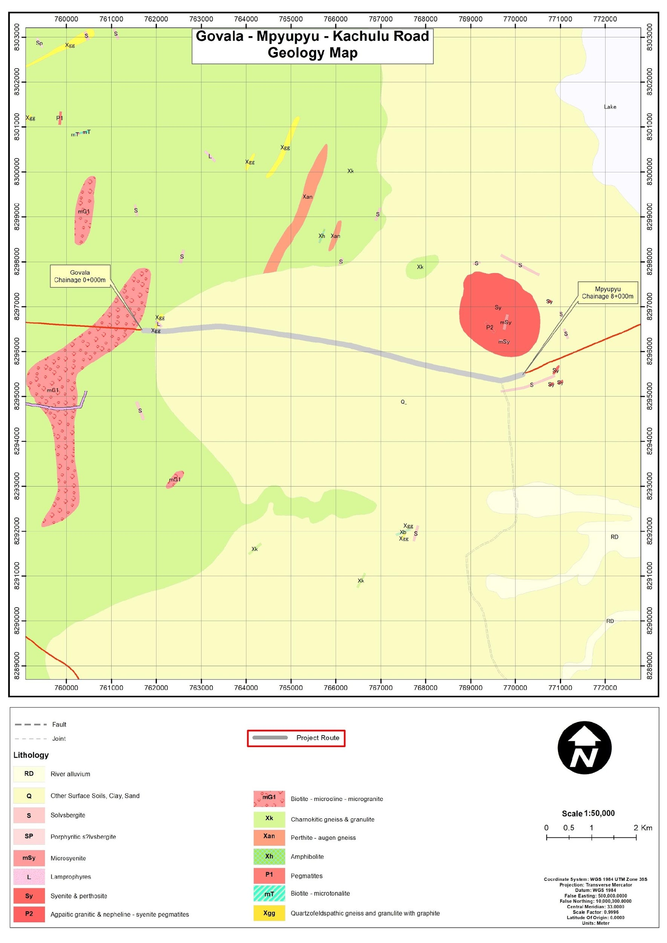

Figure 3-1. Geological Map of the Govala – Mpyupyu section of the Zomba – Kachulu Road

Soils
The soils underlying the Govala–Mpyupyu section of the Zomba–Kachulu Road (Figure 4-2) comprise three principal soil profiles, reflecting variations in parent material, topography, and drainage conditions along the corridor.
Around Chainage 0+000 near Govala Trading Centre, the alignment is underlain predominantly by sandy clay loam soils. These soils are moderately fine-textured, moderately well-drained under natural conditions, and derived from weathered basement rocks. They generally provide adequate bearing capacity during dry periods but exhibit moisture sensitivity during the rainy season. When drainage is inadequate, these soils tend to soften, leading to rutting, localized depressions, and loss of camber.
Toward the eastern end of the section, particularly around Chainage 8+000 in the Mpyupyu locality, the dominant soil type is clay loam. These soils are finer-textured and more plastic, with higher water retention capacity. Under saturated conditions, clay loam soils are susceptible to reduced shear strength and deformation under traffic loading. This characteristic increases vulnerability to water ponding, subgrade weakening, and surface deterioration where drainage outlets are insufficient.
Across the majority of the corridor—approximately 60% of the road section—the underlying soils are mapped as sand. These sandy soils are relatively well-drained and less plastic but are more prone to surface erosion, corrugation, and loss of fines if not adequately compacted and protected with appropriate gravel surfacing. In low-lying areas, sandy soils may also be subject to localized wash-outs during intense rainfall events.
Localized zones of rock outcrop are mapped near the Mpyupyu area but are spatially limited and do not form the dominant subgrade along the alignment. Marshy and variable soil units occur further north and east of the corridor but do not extensively intersect the proposed road section.
the soils along the Govala–Mpyupyu section are moderately moisture-sensitive and erosion-prone. Clay-rich sections exhibit reduced strength under saturated conditions, while sandy sections are more susceptible to surface erosion and loss of fines. These characteristics reflect typical soil behaviour within the corridor’s environmental setting.
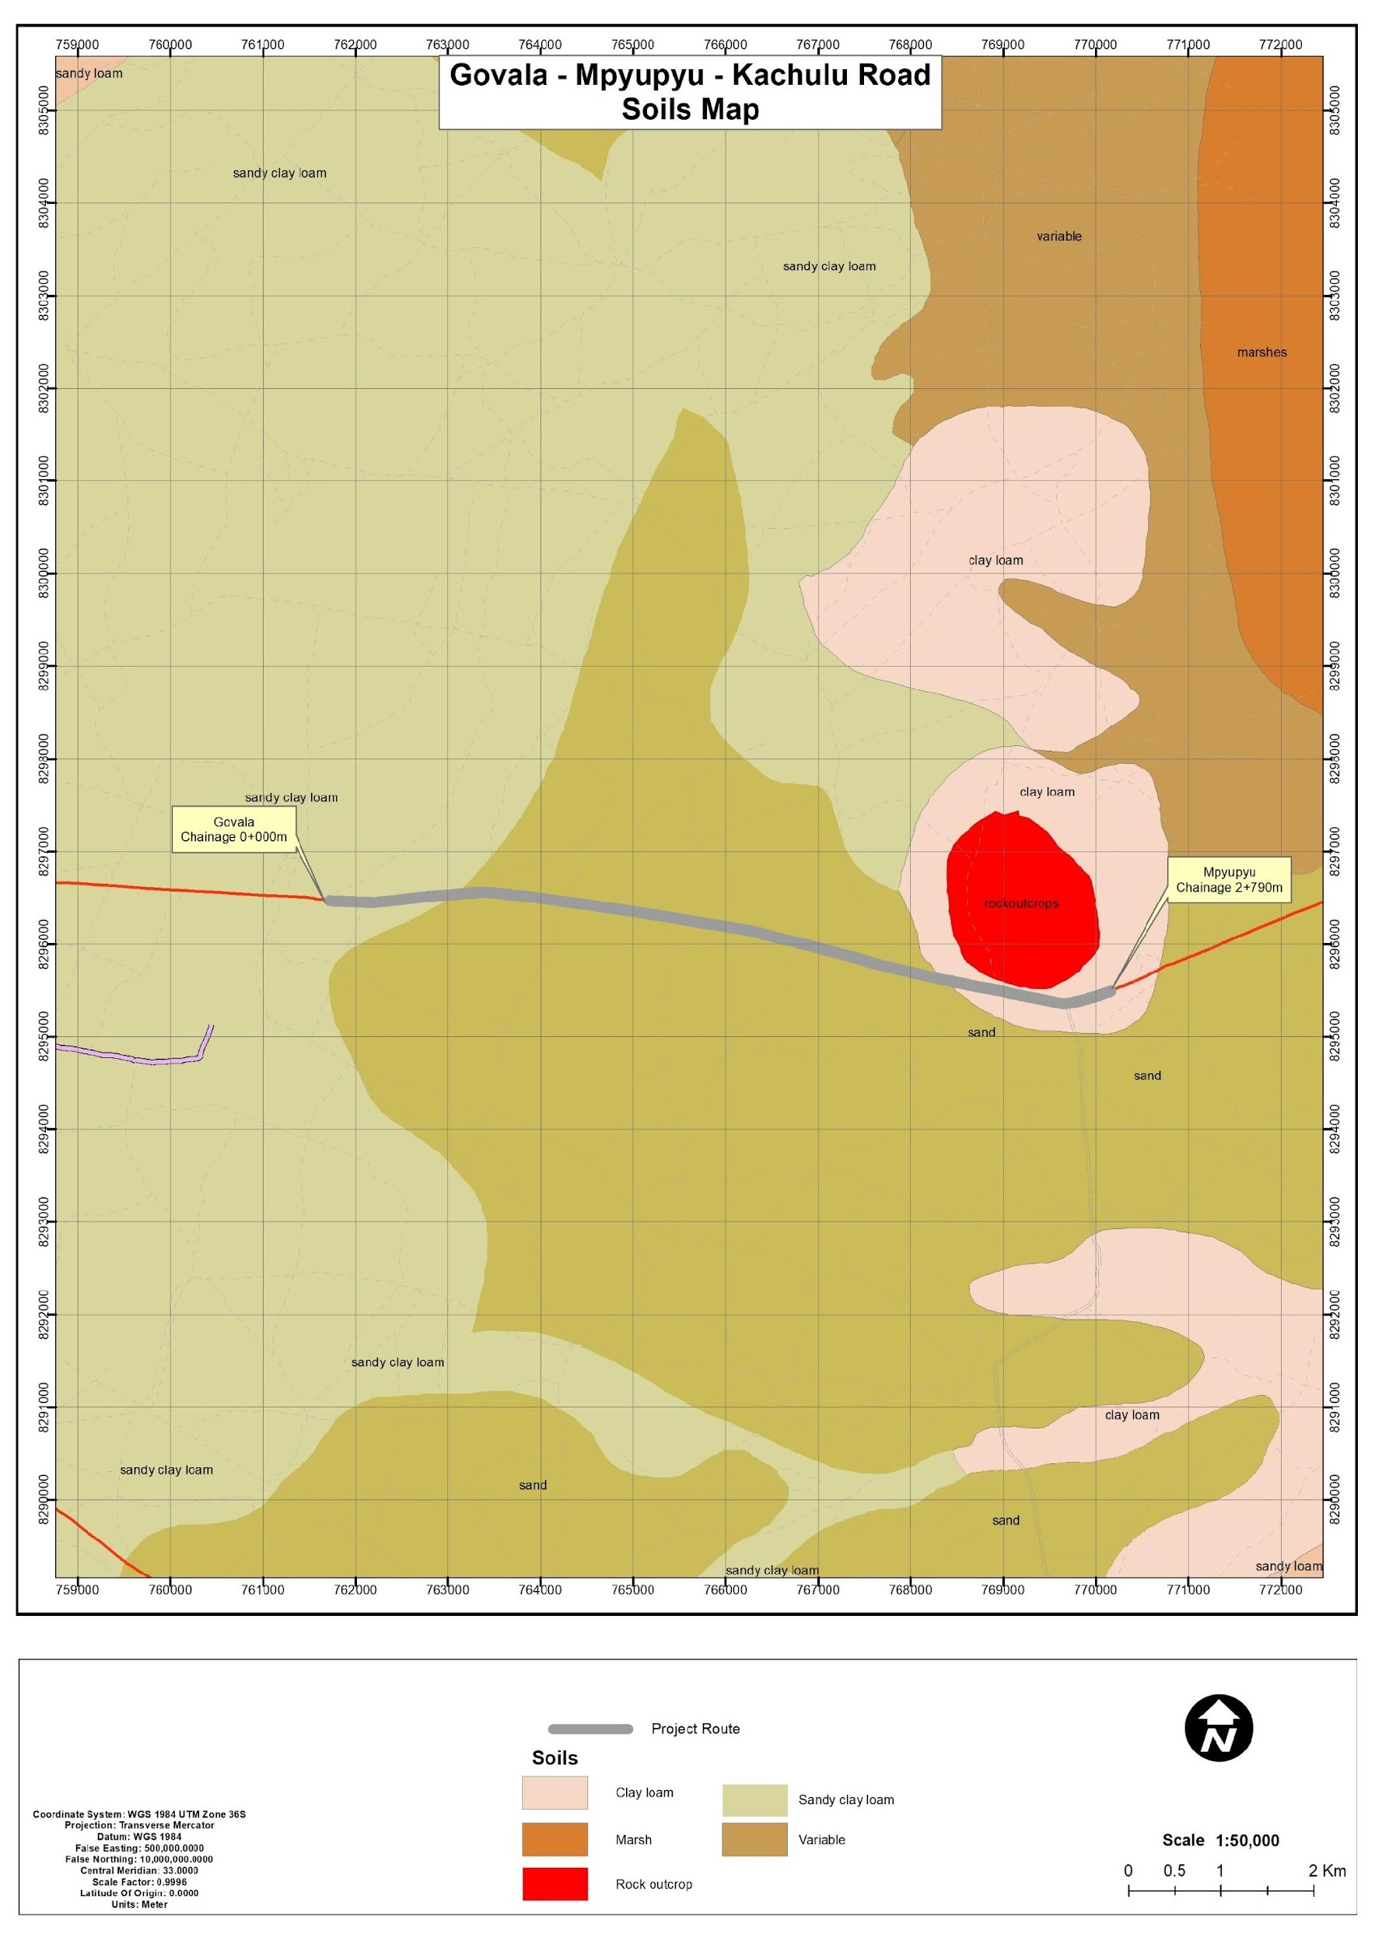
Figure 3-2. Soils along the Govala - Mpyupyu Road

Climate and Climate Change Risks

General Climate Conditions
The project area lies in a tropical climate zone with a distinct warm–wet season and a cooler dry season. Rainfall is strongly seasonal, with most precipitation occurring between December and March and annual totals typically ranging from about 600 mm to 1,500 mm, while the period from May to October is generally dry with only isolated showers. The eastern, windward slopes of the Zomba Plateau receive higher rainfall than the leeward western side, but runoff from the plateau sustains rivers and streams that are important for irrigation and domestic water supply across the wider district.
The temperature regime is relatively mild throughout the year. As illustrated in Figure 4-3 (Average Maximum and Minimum Temperature for Kachulu in Zomba), mean maximum temperatures are highest from September to November, reaching about 29–30 °C in October–November, and lowest in June–July at around 23 °C. Mean minimum temperatures follow a similar pattern, falling to approximately 12–13 °C in June–July and rising to about 19–20 °C in November–December. These moderate but seasonally variable temperatures, combined with the pronounced wet season, influence road surface performance, erosion potential and the scheduling of construction activities along the Govala–Mpyupyu section.

Figure 3-3. Mean monthly temperature pattern for Govala – Mpyupyu Road

Climatic Change
Zomba District is already experiencing observable impacts of climate variability and change, including more frequent flooding, intense rainfall events, dry spells, cyclones, hailstorms and strong winds. These climate-related hazards have contributed to recurrent disasters such as riverine flooding, drought, crop pest outbreaks (including armyworms and red locusts), and water-borne disease outbreaks such as cholera, particularly in areas around Ngwelero, Chingale, Likangala, Kachulu, Govala and the Lake Chilwa shoreline. The district is therefore considered highly prone to drought, floods, crop pests, cholera and storm damage.
The rainfall regime for Kachulu, used as a proxy for the project corridor, shows a pronounced concentration of rainfall in the early wet season. As illustrated in Figure 4-4 (Average Monthly Rainfall for Kachulu in Zomba), average monthly totals exceed 300–400 mm in January and February, decline sharply from March to May, and remain very low from June to September before increasing again in November–December. This pattern underscores the importance of designing the road to withstand short periods of very high runoff followed by extended dry spells.
Such seasonality is a critical determinant of gravel road performance. High-rainfall months increase the risk of rutting, loss of camber, shoulder erosion and overtopping of side drains and culverts where cross-drainage is inadequate, while prolonged dry periods promote surface loosening and high dust emissions.

Figure 3-4. Mean monthly rainfall pattern for the project area

Wind Speed and Direction
Although site-specific wind data were not analysed, regional climatology indicates generally moderate wind speeds, with slightly stronger winds during the late dry season (August–November). This period coincides with dry soils and heightened dust susceptibility.
Wind conditions influence dust dispersion during earthworks, hauling, and stockpiling. Dust suppression measures—such as controlled watering of exposed surfaces and careful siting of temporary facilities—will be necessary, particularly during the late dry season.

Water Resources
The Govala–Mpyupyu section of the Zomba–Kachulu Road lies within the southern Malawi highland drainage system, forming part of the broader Lake Chilwa Basin hydrological setting. The area is characterised by gently undulating terrain with seasonal, rainfall-driven surface drainage patterns rather than well-defined perennial river systems.
As confirmed through map analysis and field verification, there are no major or prominent rivers intersecting the Govala–Mpyupyu section. Hydrology within the corridor is therefore dominated by small seasonal streams and localised drainage lines that respond directly to rainfall events.
The road crosses two minor watercourses:
- Dambolanyanga Stream – located toward the western section near the start point shortly after Govala Trading Centre;
- An unnamed seasonal stream – located near Linyama village toward the eastern section approaching Mpyupyu Trading Centre.
Both watercourses exhibit seasonal flow regimes, with peak discharge occurring during the rainy season (November–April). During the dry season (May–October), flows reduce significantly and may cease entirely, reflecting the rainfall-dependent hydrological regime of the corridor.
The broader area map indicates the presence of scattered dambos and low-lying wetland pockets south of the alignment, particularly toward the Mpyupyu side. These features are associated with shallow groundwater tables and fine-textured soils that retain moisture during and shortly after rainfall events. However, the main road alignment itself remains outside any major perennial river channels.
Runoff within the corridor is therefore largely diffuse, with water draining west–eastward along the general topographic gradient, consistent with field observations. During high-intensity rainfall events, surface runoff may temporarily accumulate at stream crossings and low-lying sections, increasing susceptibility to:
- Localised water ponding,
- Drain overtopping,
- Side drain scouring,
- Subgrade softening in clay-rich areas.
Given the absence of major river crossings, hydrological risk is moderate and primarily associated with seasonal storm events rather than sustained fluvial flooding. Drainage performance at the Dambolanyanga crossing and the unnamed stream near Linyama will be critical to maintaining road stability during peak rainfall months.

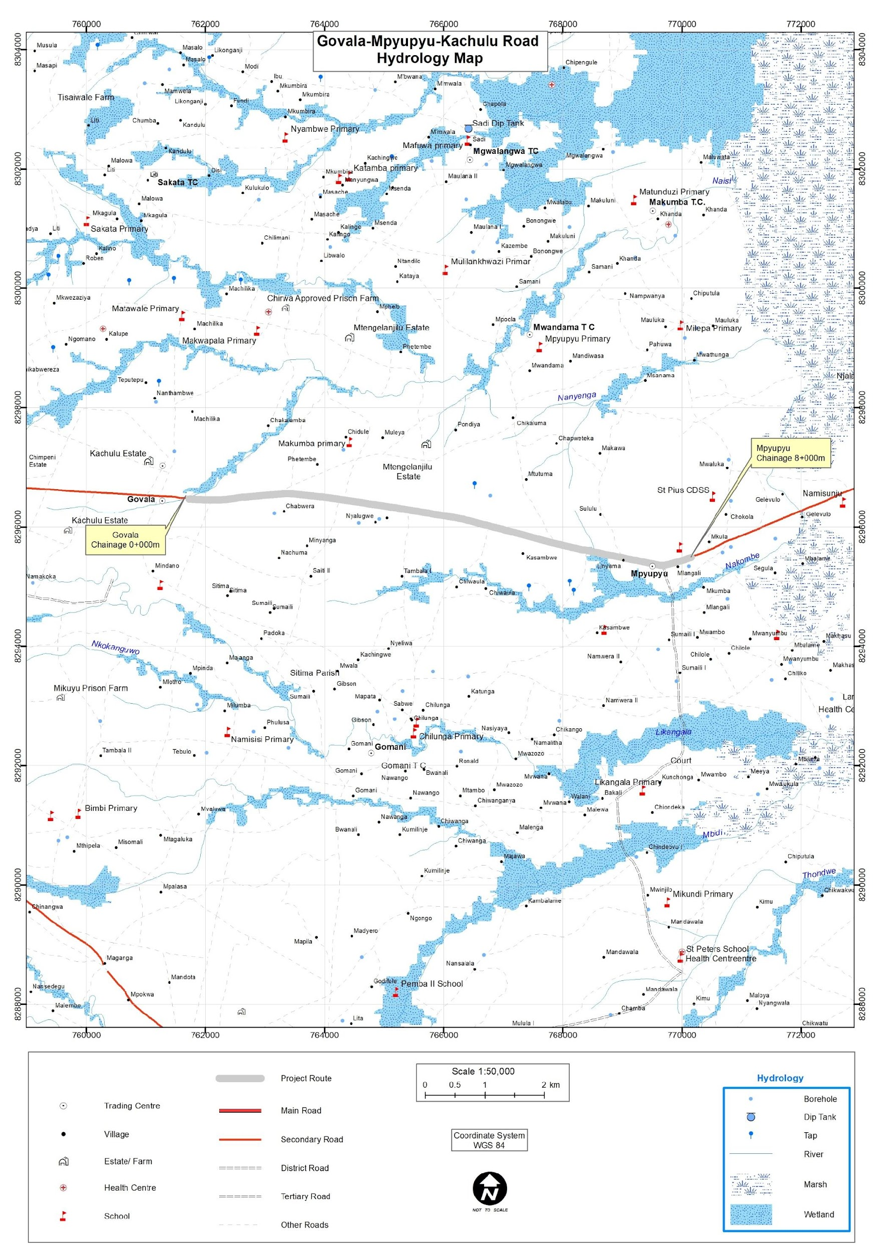
Figure 3-5. Hydrological map of the proposed project area

Flora and Fauna (Biological Environment)

Flora of the Area
The Govala–Mpyupyu section of the Zomba–Kachulu Road traverses a predominantly rural landscape characterised by a mosaic of mixed woodland and smallholder agricultural land within Sub-TA Nkagula (north of the alignment) and TA Mwambo (south of the alignment). The vegetation reflects moderate anthropogenic modification resulting from subsistence cultivation, fuelwood harvesting, settlement expansion, and periodic roadside clearing. Although fragmented, portions of the corridor retain elements of indigenous woodland structure typical of miombo-associated systems in the Zomba highlands.
Vegetation within and adjacent to the road reserve consists of scattered indigenous tree species, planted exotics, shrubs, grasses, and herbaceous plants. Cultivated crops—particularly Zea mays (maize)—dominate extensive sections of land adjoining the road. Woodland patches are discontinuous and vary in density, with relatively higher woody cover observed away from trading centres and settlement clusters.
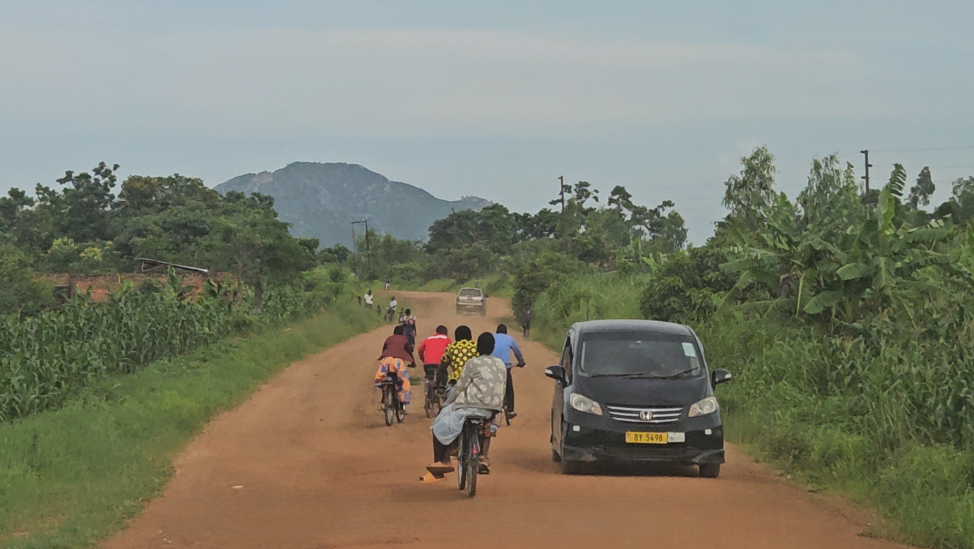
Figure 3-6. Typical Vegetation along the Govala–Mpyupyu Section Showing grass and cultivated fields

Species Composition
Baseline ecological surveys recorded twenty-eight (28) plant species along the Govala–Mpyupyu section. The assemblage comprises trees, shrubs, grasses, and herbaceous plants typical of disturbed woodland–agricultural transition zones. Common indigenous species recorded include Brachystegia spiciformis (Msasa), Piliostigma thonningii, Newtonia buchanani, and Terminalia sericea. Planted or naturalised exotic species such as Eucalyptus globulus, Senna siamea, and Gmelina arborea were also observed, primarily around homesteads and field boundaries.
The species inventory reflects a modified but functioning rural ecosystem rather than intact natural forest. No continuous canopy woodland or ecologically unique plant communities were identified within the direct project footprint.

Table 3-1. Recorded Flora Species, Growth Form, Origin, and Conservation Status – Govala–Mpyupyu Section
Species Name | Family | Form | English Name | National Plant Red Data List Conservation Status | IUCN Status
Adansonia digitata | Malvaceae | Tree | Baobab | Not Evaluated | Least Concern
Albizia lebbeck | Fabaceae | Tree | siris | Not Evaluated | Not Evaluated
Azanza garckeana | Malvaceae | Shrub | African Chewing Gum | Not Evaluated | Not Evaluated
Bambusa vulgaris | Poaceae | Grass (woody) | Common Bamboo | Not Evaluated | Not Evaluated
Bauhinia petersiana | Fabaceae | Tree | kalahari white bauhinia | Least Concern | Least Concern
Brachystegia spiciformis | Fabaceae | Tree | Msasa | Least Concern | Least Concern
Brachystegia taxifolia | Fabaceae | Tree | African mahogany | Not Evaluated/ Least concern | Least Concern
Cascabella tevetia | Apocynaceae | Shrub | Yellow oleander | Not Evaluated/ Least concern | Least Concern
Casimiroa eduris | Rutaceae | Tree | White Sapote | Not Evaluated | Not listed/Not evaluated
Eucalyptus globulus | Myrtaceae | Tree | Tasmanian blue gum | Least Concern | Least Concern
Ficus natalensis | Moraceae | Tree | Natal fig | Least Concern | Least Concern
Gmelina arborea | Lamiaceae | Tree | White teak | Least Concern | Least Concern
Jacaranda mimosifolia | Bignoniaceae | Tree | Blue jacaranda | Not Evaluated | Least Concern
Lantana camara | Verbenaceae | Shrub | Common lantana | Not Evaluated | Least Concern
Lonchocarpus capassa | Fabaceae | Tree | Apple-leaf | Not Evaluated | Data deficient
Mangifera indica | Anacardiaceae | Tree | Mango | Not Evaluated | Least Concern
Melia azedarach | Meliaceae | Tree | Chinaberry tree | Not Evaluated | Least Concern
Newtonia buchanani | Fabaceae | Tree | Forest Newtonia | Not Evaluated | Least Concern
Piliostigma thonningii | Fabaceae | Tree | Camel's foot tree | Not Evaluated | Least Concern
Psidium guajava | Myrtaceae | Herb | Guava | Not Evaluated | Least Concern
Senna siamea | Fabaceae | Tree | Siamese cassia | Least Concern | Least Concern
sida acuta | Malvaceae | Herb | broom weed | Least Concern | Not Evaluated
Solanum panduriforme | Solanaceae | Herb | Bitter apple | Not Evaluated/ Least concern | Not Evaluated
Tecoma stans | Bignoniaceae | Shrub | Yellow bells | Not Evaluated/ Least concern | Least Concern
Ziziphus mauritiana | Rhamnaceae | Shrub | Indian jujube | Not Evaluated | Least Concern
Zea mays | Poaceae | Grass | Maize | Least Concern | Least Concern

Endemic and Threatened Flora
Review of conservation status against the National Plant Red Data List (2002) and the IUCN Red List (latest available version) indicates that none of the recorded flora species are endemic to the project area. No species classified as Critically Endangered, Endangered, Vulnerable, or Near Threatened were identified within the road reserve or immediate area of influence. Most recorded species fall under the categories of Least Concern or Not Evaluated.
One nationally protected species, Terminalia sericea (Silver cluster-leaf), was observed at low density within the broader alignment area. This species is protected under the Forestry Act and associated regulations. Its occurrence does not elevate the corridor to high conservation value but requires compliance with national forestry legislation during any vegetation disturbance.

Invasive Alien Flora
Two invasive or potentially invasive species were identified along sections of the corridor: Lantana camara and Gmelina arborea. These species are known to colonise disturbed soils and may expand following vegetation clearance or earthworks. Their presence is localised rather than extensive, and no dense invasive thickets were recorded within the project footprint.
Table 3-2. Invasive Plant Species Recorded and Associated Ecological Risk – Govala–Mpyupyu Section
Scientific Name | Common Name | Growth Form | Invasive Status in Malawi | IUCN Status | Ecological Risk Description | Observed Distribution Within Project Section | Risk Level Within Project Area
Lantana camara | Common Lantana | Shrub | Widely recognized invasive alien species in Malawi (naturalised; aggressive coloniser of disturbed habitats) | Least Concern | Forms dense thickets; suppresses native regeneration; reduces grazing value; alters fire regimes; rapidly colonises disturbed soils | Localised roadside patches, especially near disturbed margins and settlement interfaces | Moderate (localised but capable of expansion following disturbance)
Gmelina arborea | Gmelina | Tree | Exotic species; locally invasive where naturalised outside plantation context | Least Concern | Fast-growing exotic; can outcompete indigenous species in disturbed or cleared areas; alters vegetation structure if unmanaged | Scattered planted individuals and occasional naturalised regeneration near settlements | Low–Moderate (limited occurrence but potential for spread in disturbed zones)

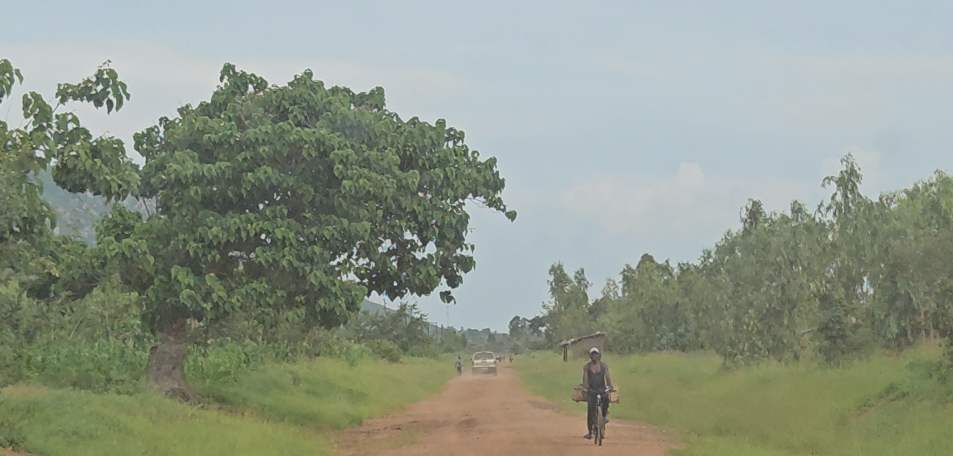
Figure 3-7. Observed Invasive Species Gmelina arborea on roadside margins

Ecological Significance of Vegetation
Despite moderate anthropogenic modification, vegetation within the Govala–Mpyupyu corridor provides important ecological functions. Woodland patches and scattered trees offer habitat and foraging resources for birds, reptiles, and small mammals. Root systems contribute to soil stabilisation, particularly in sloping terrain and near drainage crossings. Vegetation cover also supports nutrient cycling, microclimate regulation, and erosion control.
No protected areas, biodiversity hotspots, or legally designated conservation sites were identified within the rehabilitation footprint. Overall vegetation sensitivity within the project area is therefore classified as low to moderate.

Fauna
The main fauna species recorded (observed or reported) for the Govala–Mpyupyu road section include a mix of small and medium-sized mammals (such as yellow baboon, vervet monkey, scrub hare, pouched mouse, epauletted fruit bat and four-toed hedgehog), common farmland and woodland birds (including yellow bishop, common bulbul, speckled mousebird, tropical boubou, little bee-eater, doves and sparrows), several reptiles and amphibians (notably agamas, chameleons, skinks, black mamba, Mozambique spitting cobra and African clawed frog), and a variety of macro-invertebrates (butterflies, locusts, grasshoppers, bees, dragonflies and ants) as summarised in Table 4-3.

Table 3-3. Recorded fauna Species and Conservation Status – Govala–Mpyupyu Section
SN | Scientific Name | English Name | Taxa | National Red Data List Status (Malawi) | IUCN / Global Status
1 | Papio cynocephalus | Yellow Baboon | Mammal | Not Evaluated | Least Concern (LC)
2 | Chlorocebus pygerythrus | Vervet Monkey | Mammal | Not Evaluated | Least Concern (LC)
3 | Lepus saxatilis | Scrub Hare | Mammal | Not Evaluated | Least Concern (LC)
4 | Saccostomus capensis | Pouched Mouse | Mammal | Least Concern | Least Concern (LC)
5 | Epomophorus crypturus | Epauletted Fruit Bat* | Mammal | Least Concern | Least Concern (LC)
6 | Atelerix albiventris | Four-toed Hedgehog | Mammal | Not Evaluated | Least Concern (LC)
7 | Euplectes capensis | Yellow Bishop | Bird | Least Concern | Least Concern (LC)
8 | Pycnonotus barbatus | Common Bulbul | Bird | Least Concern | Least Concern (LC)
9 | Colius striatus | Speckled Mousebird | Bird | Least Concern | Least Concern (LC)
10 | Laniarius major | Tropical Boubou | Bird | Least Concern | Least Concern (LC)
11 | Merops pusillus | Little Bee-eater | Bird | Least Concern | Least Concern (LC)
12 | Passer griseus | Northern Grey-headed Sparrow | Bird | Least Concern | Least Concern (LC)
13 | Pogoniulus chrysoconus | Yellow-fronted Tinkerbird | Bird | Least Concern | Least Concern (LC)
14 | Streptopelia capicola | Ring-necked Dove | Bird | Least Concern | Least Concern (LC)
15 | Turtur chalcospilos | Emerald-spotted Wood-Dove | Bird | Least Concern | Least Concern (LC)
16 | Agama armata | Peter’s Ground Agama | Reptile | Least Concern | Least Concern (LC)
17 | Agama mossambica | Mozambique Agama | Reptile | Not Evaluated / LC | Least Concern (LC)
18 | Chamaeleo africanus | African Chameleon | Reptile | Not Evaluated / LC | Least Concern (LC)
19 | Chamaeleo dilepis | Flap-necked Chameleon | Reptile | Least Concern | Least Concern (LC)
20 | Dendroaspis polylepis | Black Mamba | Reptile | Not Evaluated / LC | Least Concern (LC)
21 | Naja mossambica | Mozambique Spitting Cobra | Reptile | Not Evaluated / LC | Least Concern (LC)
22 | Trachylepis striata | African Striped Skink | Reptile | Not Evaluated / LC | Least Concern (LC)
23 | Xenopus laevis | African Clawed Frog | Amphibian | Not Evaluated | Least Concern (LC)
24 | Acanthacris ruficornis | Garden Locust | Insect | Not Evaluated / LC | Not Evaluated (NE)
25 | Acraea natalica | Natal Acraea | Insect | Least Concern | Least Concern (LC)
26 | Acrida acuminata | Stick Grasshopper | Insect | Not Evaluated / LC | Not Evaluated (NE)
27 | Amauris niavius | African Monarch (Friar) | Insect | Not Evaluated / LC | Least Concern (LC)
28 | Apis mellifera | Western Honey Bee | Insect | Not Evaluated / LC | Data Deficient (DD)
29 | Nomadacris septemfasciata | Red Locust | Insect | Least Concern | Least Concern (LC)
30 | Orthetrum chrysostigma | Epaulet Skimmer | Insect | Not Evaluated / LC | Least Concern (LC)
31 | Orthetrum julia | Julia Skimmer | Insect | Not Evaluated / LC | Least Concern (LC)
32 | Pachycondyla tarsata | African Stink Ant | Insect | Not Evaluated / LC | Not Evaluated (NE)
33 | Zonocerus elegans | Elegant Grasshopper | Insect | Least Concern | Least Concern (LC)

Ecological Sensitivity and Baseline Implications
The Govala–Mpyupyu section of the Zomba–Kachulu Road is situated within a moderately modified woodland–agricultural landscape supporting common and widely distributed flora and fauna. No endemic species, no IUCN-listed threatened species, and no designated critical habitats were identified within the project footprint.
Ecological sensitivity is therefore assessed as low to moderate. The baseline indicates a modified ecosystem dominated by common and widely distributed species, with no designated conservation areas or critical habitats identified within the project footprint.

Socio-economic environment

Demographic Characteristics
The Govala–Mpyupyu corridor serves a predominantly rural population within TA Mwambo and Sub-TA Nkagula, with a combined administrative population of approximately 203,500 persons (National Statistics Office, 2025). An estimated 71,000–72,000 people (≈35%) are directly dependent on the road for access to markets, services, and mobility. Settlement patterns are semi-clustered around Govala and Mpyupyu Trading Centres, with dispersed homesteads across intervening agricultural and wetland areas, reflecting a typical rural feeder-road setting with low-to-moderate and uneven population density.
The population is predominantly youthful, with approximately 45% aged below 18 years, about 49% within the working-age group, and only 4–5% elderly, implying high pedestrian activity, particularly around trading centres and schools. The sex composition shows a slight female majority (about 94–95 males per 100 females), with female-headed households estimated at 30–35%, indicating potential vulnerability in labour availability and resilience to socio-economic shocks.
Average household size is approximately 4.4 persons, with an estimated 46,000 households across the two administrative areas. Housing is largely rural in character, with more concentrated and permanent structures near trading centres and more basic dwellings in dispersed sections. Mobility patterns are strongly agriculture- and market-driven, with daily movements centred on farm access, trading centres, and service points, and seasonal linkages extending to Lake Chilwa and Zomba. The corridor therefore functions as a critical socio-economic artery, supporting both routine livelihoods and broader market connectivity.

Education and Literacy

Education
Key educational institutions along the proposed Govala–Mpyupyu road are St. Michaels Primary School, Namisunju School, and Makumba School, which collectively serve an estimated 1,500+ learners from surrounding communities. These schools are located within settlement areas rather than directly within the road reserve, but are functionally linked to the road through footpaths and access tracks. The road is widely used by learners as a primary access route, particularly near trading centres and settlement clusters, making these locations important social receptors with heightened sensitivity to construction-related disturbances and road safety risks.
Literacy
Literacy levels within the corridor reflect district-level conditions, with an estimated overall literacy rate of approximately 67%, and notable gender disparities of about 74% for males and 60% for females. This moderate literacy profile, combined with rural settlement characteristics, underscores the need for inclusive stakeholder engagement approaches. Accordingly, project communication will utilise local languages, oral methods, and visual aids to ensure effective outreach, particularly for women and other vulnerable groups, in line with MEPA (2025) guidelines.
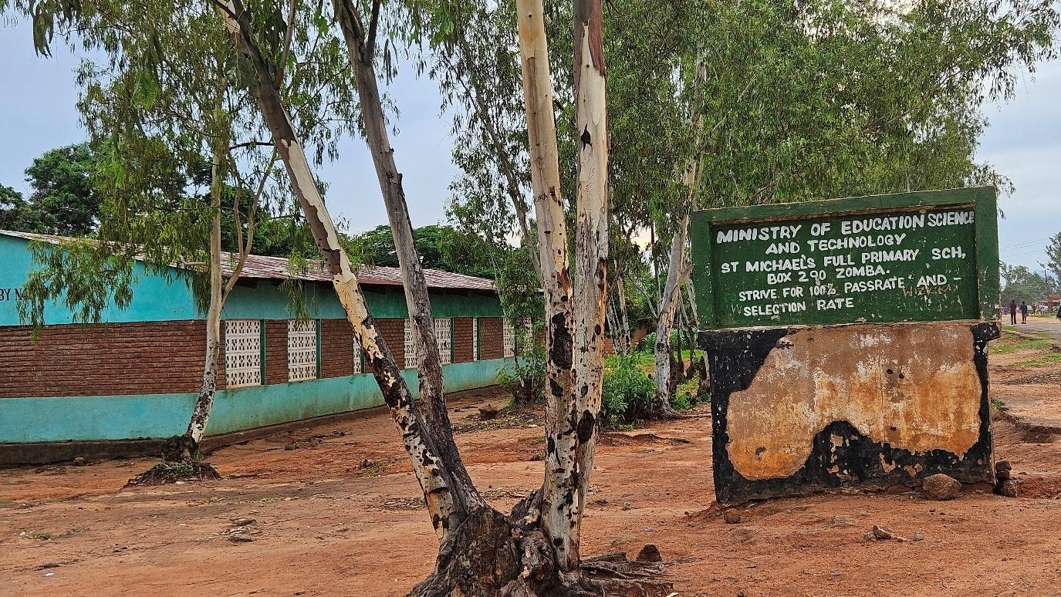
Figure 3-8. Saint Michaels FP School alomg the Govala – Mpyupyu Road

Health
Notable health facilities along this road include Yankho Private Clinic, which serves as one of the nearest primary healthcare providers for communities along the Govala–Mpyupyu corridor (Figure 4-9). Most residents access basic health services through such local facilities, while more advanced and specialised medical care is obtained through referral systems to higher-level health centres and hospitals located outside the immediate project area. The road therefore plays an important role in facilitating access to healthcare services, particularly for emergency referrals and routine medical visits.

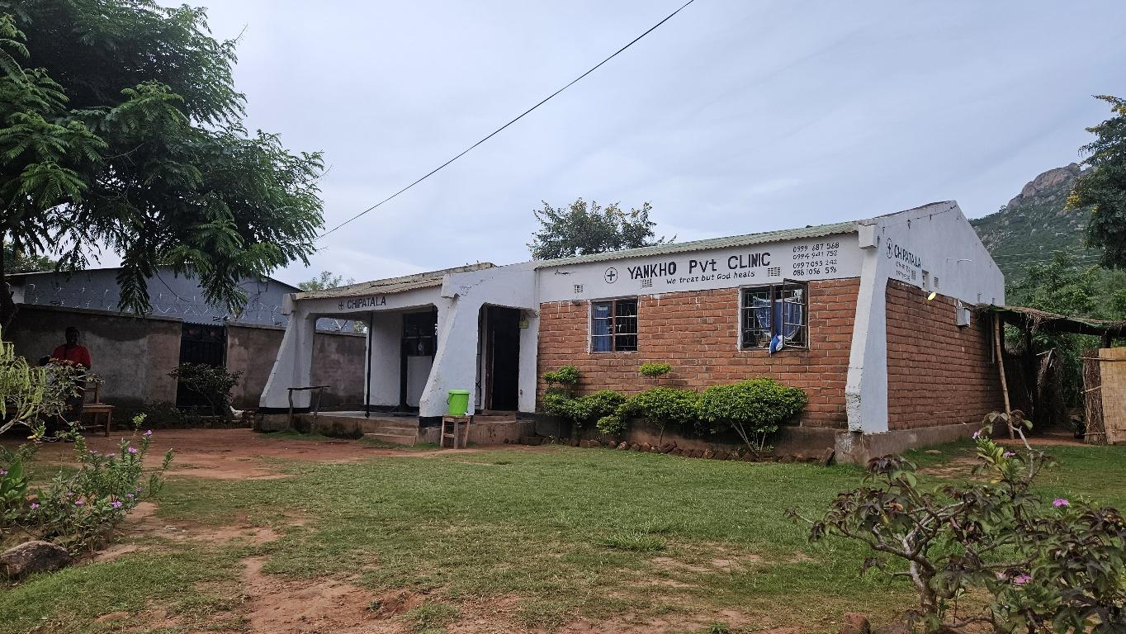
Figure 3-9. Yankho Private Clinic along Govala – Mpyupyu Road

Cultural Heritage
No known cultural heritage sites, sacred sites, shrines or archaeological resources were identified along the Govala–Mpyupyu section based on available secondary sources and community/DESC inputs. The alignment follows an established road reserve through agricultural and settlement landscapes without known cultural heritage sensitivities. Notwithstanding this baseline finding, the ESMP will maintain standard good-practice provisions for chance finds given the general possibility of encountering buried materials during excavation.

Agriculture
Agriculture is the dominant livelihood and land use along the Govala–Mpyupyu corridor, consistent with census-based workforce characterization indicating that agriculture accounts for approximately ~81.7% of the livelihood base (TA/district reference). Cropping is primarily smallholder and rain-fed, with rice and maize forming the key production base, and community evidence indicates localized rice aggregation and processing functions linked to Govala and Mpyupyu. The corridor therefore supports the movement of farm inputs and produce to trading centres and wider markets, including linkages associated with Lake Chilwa and Zomba, and the road’s function is closely tied to seasonal production cycles and market access requirements (Zomba District Socio-Economic Profile, 2017 – 2022).

Economic Activities and Livelihoods
Over 70% of the rural population in Zomba lives below the national poverty line of $1 per day. The Main economic activities along the corridor are predominantly agriculture-based, with communities engaged in smallholder production of crops such as maize and rice, particularly within dambos and wetland-fringe areas. These activities are complemented by small-scale informal trade and services concentrated at Govala and Mpyupyu trading centres, which function as local economic hubs. Secondary livelihood activities include petty trading, rice milling, and produce aggregation, with strong linkages to the Lake Chilwa economy, particularly in relation to fish trade and associated market chains (Zomba District Socio-Economic Profile, 2017 – 2022).

Transport
Transport within the Govala–Mpyupyu section is dominated by non-motorised and intermediate means, reflecting rural mobility patterns and reliance on walking, bicycles and motorcycles. Pedestrian activity is particularly concentrated around trading centres and settlement clusters where roadside trading and service access occur, reinforcing the corridor’s social function beyond vehicle movement. The road therefore supports mixed-use mobility linking farms, markets, schools and health service points, and its usability is a key determinant of day-to-day socio-economic functioning (Zomba District Socio-Economic Profile, 2017 – 2022).
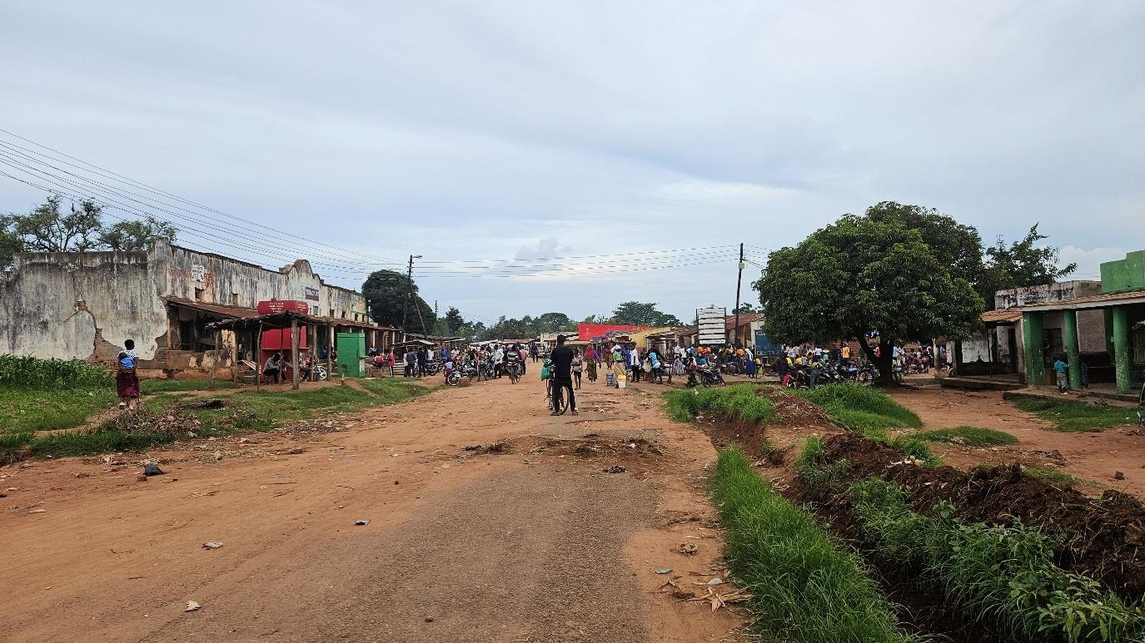
Figure 3-10. A normal day at Mpyupyu Trading Centre

Security
Security conditions along the corridor are generally stable, with no significant security threats reported aside from occasional petty theft and minor incidents, particularly within trading-centre environments. Security is primarily managed through community policing structures and traditional leadership systems. More serious or referral cases are handled through formal law enforcement institutions, notably Chinamwali Police Post and Zomba Police (Zomba District Socio-Economic Profile, 2017 – 2022).

Land Use
Current land use along the 8 km Govala–Mpyupyu section of the Zomba–Kachulu Road (S143) reflects a typical rural mixed-use corridor within an existing road reserve. The roadside is predominantly bordered by smallholder agricultural fields, with seasonal crops cultivated close to the carriageway, including within portions of the road reserve. In and around Govala and Mpyupyu trading centres, sections of the reserve are used for informal vending activities, temporary kiosks, produce display areas, and small market-related structures aligned along the road edge.
Scattered homesteads and associated household land uses (kitchen gardens, footpaths, and access tracks) intersect the road reserve at various points, particularly near settlements and social facilities such as schools, churches, and small shops. Informal pedestrian paths and local access tracks connect these homesteads and fields to the main road, often crossing or running parallel to the formation. Drainage lines, seasonal runoff pathways, and vegetated strips occur within and adjacent to the reserve, with some areas exhibiting encroachment by cultivation onto side drains and shoulders. Collectively, these patterns define the existing land use context within which the upgrading works will be implemented.

Vulnerable and Marginalized Groups
Vulnerable groups in the corridor include female-headed households (estimated at ~30–35%), older persons, ultra-poor households and households with limited literacy capacity. The youthful population structure also implies a high proportion of children who are particularly sensitive to road safety risks in settlement sections. These vulnerabilities reinforce the need for inclusive engagement approaches and practical access safeguards throughout project implementation.

Communication
Communication services in the corridor are primarily supported by mobile phone networks, with Airtel and TNM coverage generally more reliable in trading-centre and settlement nodes than in low-lying or sparsely settled sections. Radio and community meetings remain common channels for information dissemination, supported by traditional leadership structures. These communication pathways provide the principal means through which project-related information can be effectively shared with corridor communities (Zomba District Socio-Economic Profile, 2017 – 2022).

Energy Sources
Household energy use is dominated by traditional biomass fuels, particularly firewood. Electricity access is limited and largely confined to nearby service centres (Zomba District Socio-Economic Profile, 2017 – 2022).
Limited adoption of alternative energy sources such as solar reflects affordability and infrastructure constraints.

CHAPTER 5: ENVIRONMENTAL AND SOCIAL MITIGATION AND MONITORING PLAN

Introduction
This chapter presents the Environmental and Social Mitigation and Monitoring Plan (ESMMP) for the upgrading of the Govala–Mpyupyu section of the Zomba–Kachulu Road (S143). It sets out the mitigation measures, monitoring requirements, implementation responsibilities, and reporting arrangements for managing the environmental and social impacts identified during planning, construction, contractor demobilisation, and operation of the subproject.
The ESMMP provides the framework for implementing environmental and social safeguards in accordance with the Environment Management Act, 2017, the MEPA Guidelines for Environmental Assessment, 2025, and relevant World Bank safeguard and Environmental, Health and Safety (EHS) requirements. It forms part of the environmental and social obligations to be implemented by the Contractor, Supervising Consultant, the MoTPW PIUZomba District Council (including the DESC), and other relevant authorities during project execution.
Monitoring provisions are included to enable the PIU, Supervising Consultant, District Council, and MEPA to systematically track environmental and social performance, verify the effectiveness of mitigation measures, and ensure timely corrective action throughout implementation. Monitoring will focus on key risk areas including erosion and sediment control, drainage functionality and protection of stream crossings, pollution prevention, waste management, occupational health and safety, labour and working conditions, traffic and pedestrian safety (particularly at trading centres and social facilities), stakeholder engagement, and grievance management.
Monitoring reports will be prepared by the Contractor and submitted on a monthly basis to the PIU, Supervising Consultant, and District Environmental Office for review and follow-up in line with the short construction period (approximately three to four months).

Framework instruments for contractor implementation
To support effective implementation of the mitigation and monitoring measures set out in this chapter, this ESMMP includes framework instruments in the annexes that establish minimum procedures, standards, and compliance requirements for contractor implementation. Prior to commencement of works, the Contractor shall prepare site-specific plans and procedures based on these framework instruments for review and approval by the Supervising Consultant and PIU, with copy submission to the District Environmental Office where applicable.
At a minimum, the Contractor shall prepare and implement the following site-specific instruments before the relevant activities commence:
- Borrow Pit Rehabilitation Plan, based on Annex 5: Barrow Pit Rehabilitation Framework.
- Traffic Management Plan, based on Annex 6: Traffic Management Framework.
- Labour Management Plan, based on Annex 8: Labour Management Guidelines for Contractor Compliance and Preparation of Labour Management Plans (LMPs).
- Contractor Environmental and Social Management Plan (C-ESMP), based on Annex 9: Contractor Environmental and Social Management Plan (C-ESMP) Framework, integrating construction-method-specific environmental, social, health, and safety controls.
- Waste Management Plan, based on Annex 10: Waste Management Framework.
- Stakeholder Engagement Plan, based on Annex 11: Stakeholder Engagement Framework.
- GBV/SEA/SH prevention and response measures, consistent with Annex 8: Labour Management Guidelines and Annex 13: SATCP LMI Grievance Redress Mechanism (GRM) Protocol, as applicable to GBV/SEA/SH risk management.
In addition, the Contractor shall implement Annex 4: Sample Code of Conduct for Contractors, Annex 7: Chance Find Procedure for Last Mile Infrastructure under SATCP, and Annex 13: SATCP LMI Grievance Redress Mechanism (GRM) Protocol as mandatory instruments throughout the construction period. These instruments apply to all workers, subcontractors, suppliers, and other personnel engaged on the subproject.
All contractor-prepared plans shall demonstrate consistency with Malawi environmental and labour legislation, the Environment Management Act, 2017, MEPA environmental assessment requirements, relevant World Bank safeguard principles, and the mitigation and monitoring commitments set out in this ESMMP.

Environmental and Social Mitigation and Monitoring Plan

REF | Impacts & Risks | Enhancement/Mitigation Measures | Responsible Institution | Implementation Cost | Performance Monitoring Indicator | Frequency | Monitoring cost (USD)
5.3.1 Planning Phase – Positive Impacts and Enhancement Measures
5.3.1.1 | Improved flood resilience and drainage efficiency | Ensure culverts at Dambolanyanga and unnamed Linyama stream are sized using peak flow modelling; Validate hydraulic design; incorporate scour protection at outlets. | MoTPW, Design Engineer | Included in project design cost | Approved design report,  Consultations records | Once (Design Approval) | N/A
5.3.1.2 | Improved stakeholder acceptance | Conduct stakeholder consultations and disclose ESMP  Establish and operationalize a Grievance Redress Mechanism (GRM)  Ensure inclusion of women and vulnerable groups in consultations | MoTPW / Design Consultant | 500 | Number of consultations conducted  Availability of Functioning GRC along the road  Representation of vulnerable people in consultation groups and GRCs | Monthly | 500
 | Early planning of local employment opportunities. | - Include local labour provisions in procurement documents;  - Establish transparent recruitment procedures;  - Promote gender-inclusive employment to achieve 40% female employment | - MoTPW  - Contractor  - Contractor | 200 | Presence of labour and gender clauses in bidding documents | Once | 800
5.3.2 Planning Phase – Negative Impacts and Mitigation Measures
5.3.2.1 | Anxiety to loss of land and assets | Sensitize communities on the Project  No land take outside of the project area  Establish a grievance mechanism | Design Engineer | 200 | Number of sensitizations done | 3 times prior to comment of works | 50
5.3.2.2 | Inadequate capacity of contractors to identify and manage the potential environmental and social risks | Contractor to include an Environmental, Social, Health and Safety (ESHS) Officer in their staffing to be based at site.  Develop and implement Contractor-ESMP (C-ESMP) and associated management plans in line with the frameworks, Malawi regulations and WB EHS guidelines and policies covering;  - Waste Management Plan  - Code of Conduct  - Borrow Pit Rehabilitation;  - Stakeholder engagement  - Traffic Management Plan | Contractor | Contractor cost | EHSS officer On site  Availability of Management Implementation Plans | Monthly | 300
 | Poor early decisions on borrow pits and material sources. | Verify land ownership; obtain landowner consent; integrate borrow pit management obligations in contracts. | MoTPW, DCs | 1000 | Number of approved material sites with documented consent | Once | 500
5.3.3 Construction Phase – Positive Impacts and Enhancement Measures
5.3.3.1 | Local employment and income generation | Establish and implement transparent recruitment procedures;  Promote gender-inclusive employment to achieve 40% female employment. | Contractor | 1000 | % of local workers employed  Ratio of women to men employed (target is 40:60) | Monthly | 300
5.3.3.2 | Stimulation of local SMEs and traders | Procure materials locally where feasible; document local supplier engagement. | Contractor | Contractor material budget | Percentage and value of contracts awarded to local suppliers  (Over 60% should be Malawian) | Monthly | 250
5.3.3.3 | Skills Transfer | Provide on job trainings | Contractor | 300 | Number of workers trained in new skills | Monthly | 200
5.3.4 Construction Phase – Negative Impacts and Mitigation Measures
5.3.4.1 | Soil erosion and sedimentation into streams | Install erosion control measures (silt traps, drainage channels, slope stabilization) to manage impact during construction, while permanent measures are being constructed as per design | Contractor | 500 | Control measures (silt traps, drainage channels, slope stabilization) in place during construction | Every two months | 1000
5.3.4.2 | Water contamination from fuel and machinery | Store fuel in bunded areas; implement spill response plan; prohibit washing near streams. | Contractor | 500 | No hydrocarbon spills recorded | Weekly | 100
5.3.4.3 | Environmental degradation from uncontrolled material extraction. | Acquire permits for material extraction or procure from licensed suppliers  Restrict extraction to approved sites; prohibit riverbed and wetland extraction; demarcate borrow pits.  Rehabilitate Borrow pits and sand mining areas. Progressive rehabilitation should be implemented where possible. | Contractor | Include in contract | Permits available on site  Number of demarcated borrow pits  % area of borrow pit rehabilitated  and free of stagnant water | Once  Monthly  Monthly and prior to site handover by Contractor | Environmental degradation from uncontrolled material extraction.
5.3.4.4 | Dust emissions affecting settlements | Water exposed surfaces; cover haul trucks; enforce speed limits. | Contractor | 1000 | Number of grievance related to dust  Records of dust suppression activities | Weekly | 500
5.3.4.5 | Disruption of water flow | Provide temporary diversion channels during culvert installation and maintain environmental flows | Contractor | 500 | Diversion channels in place and records of flows (inspections) | Monthly | 500
5.3.4.6 | Soil and water contamination | Establish designated fuelling areas; provide spill kits; ensure proper storage of fuels | Contractor | 500 | Availability of spill kits and designated areas for fuelling and fuel storage areas | Monthly | 500
5.3.4.6 | Soil and water contamination | Provision of sanitation facilities for workers, | Contractor | 500 | Number of facilities provided | once | 200
5.3.4.6 | Soil and water contamination | Provide waste bins and train workers on waste management as part of inductions  Disposal of waste at disposal sites approved by the District Council | Contractor | 200 | Number of bins being used on site | Every two months | 100
5.3.4.7 | Occupational Health and Safety risks | Provide ESHS Personnel  Implement measures indicates SATCP’s OHS Management Framework  Carry out risk assessment and implement measures accordingly  Induct all workers on the OHS Plan and conduct toolbox talks on at least a weekly basis  Provide PPE to all workers and enforce it’s use.  Implement emergency preparedness procedures included in the OHS Management Framework | Contractor | 1000 | Number Accident, near miss and incident records  Availability of Risk assessment records for al activities  Number of Training records for workers on OHS plan available on site (Target is 100%) | Monthly | 250
5.3.4.8 | Climate-related risks: increased surface runoff, flash flooding, and accelerated soil erosion, particularly during high-intensity rainfall events | Store loose soil material, waste, concrete mix and fuel away from the river banks | Contractor | 1000 | Designated sites for waste, fuels and concrete mixing away from riverbank  Provide shelter/rest areas for workers | Monthly | 500
5.3.4.9 | Community Health and Safety risks | Implement dust suppression  Conduct awareness campaigns on HIV/Aids, Cholera and other communicable diseases  Provide safe diversion for safe movement of traffic (including signage, barriers and passable diversion) | Contractor | 500 | Traffic management plan developed and available on site | Monthly | 400
5.3.4.10 | Temporary loss of access to land due to use for ancillary facilities including diversions and storage area | Enter into negotiated agreements with clear alternatives and compensation modalities as needed  Contractor to restore land | Contractor | Project cost | Signed sale/lease agreements shared with PIU | Once | N/A
5.3.4.11 | Temporary disruption of access to farms and social services. | Maintain access to farms, social services etc as part of the Traffic Management Plan including signage, temporary crossings use of flag people etc. | Contractor | Costed above | Number of grievances related to issues with access | Monthly | N/A
5.3.4.12 | Labour influx risks including communicable diseases, SEA/SH and social tensions. | Ensure all workers are trained on and sign Worker Code of Conduct  Conduct HIV/AIDS and SEA/SH awareness training;  Establish and maintain a Community Grievance Redress Mechanism that is SEA/SH responsive | Contractor | 2,000 | % of workers signed the CoC against number employed  % of workers who received training on CoC against number employed  % of workers who received training on HIV/AIDS, SEA/SH against number employed  Number of Grievances received  % of grievances received against resolved within indicated timelines | Monthly | 200
5.3.4.13 | Labor exploitation, abuse (forced or underage), and discriminatory working conditions | Explain to all workers conditions of service, labour expectations and contract duration  Ensure all workers have a signed contract and given a copy  Implement age verification system using national identification to employ only those that are 18 years old and above  Establish and maintain a Worker Grievance Redress Mechanism that is SEA/SH responsive | Contractor | 1000 | - % of workers with signed contract against number employed  - No of underage workers  - Availability of functioning WGRC  % of grievances resolved against received within indicated timelines | Monthly | 200
5.3.4.14 | Impacts to Cultural Heritage | Implement a Chance Finds Procedure including the training of workers | Contractor | 200 | % of workers trained on chance finds procedure | Monthly | 200
5.3.4.15 | Damage to assets including crops and trees as a result of works | Establish a grievance redress mechanism  Payment of compensation for any losses/ damage to assets inadvertently caused as a result of contractor activities at replacement value | Contractor | Cost as per unintended damage. | Number of grievances related to lost assets received  % of grievances related to lost assets resolved in agreed timelines | Monthly | N/A
5.3.4.4 | Environmental degradation from uncontrolled material extraction. | Acquire permits for material extraction or procure from licensed suppliers  Restrict extraction to approved sites; prohibit riverbed and wetland extraction; demarcate borrow pits.  Rehabilitate Borrow pits and sand mining areas. Progressive rehabilitation should be implemented where possible. | Contractor | Include in contract | Permits available on site  Number of demarcated borrow pits  % area of borrow pit rehabilitated | Once  Monthly  Monthly and prior to site handover by Contractor | 500
5.3.5 | Demobilisation: Negative
5.3.5.1 | Residual contamination of waste after demobilisation | Remove all materials and waste; remediate contaminated soils; final site audit. | Contractor | 1000 | Site clearance certificate issued | Once | 350
5.3.5.2 | Occupational health and safety | • Follow proper decommissioning procedures and safety protocols.  • Provide PPE and training for workers involved in demobilization.  • Secure the site during equipment removal to prevent unauthorized access | Contractor | 2000 | Zero serious incidents recorded  Number of PPE provided against people exposed to risk conditions | Once | 150
5.3.6 | Operation & Maintenance: Positive
5.3.6.1 | Enhanced market access and economic mobility | Maintain road surface; ensure periodic grading and drainage maintenance. | District Council | 1000 | Reduced travel time and transport cost | Bi-annual | 900
5.3.6.2 | Reduced flood-related disruption | Routine desilting of culverts; pre-rainy season inspection. | District Council/Roads Authority | 1500 | Number overtopping events recorded | Quarterly | 800
5.3.7 | Operation & Maintenance: Negative
5.3.7.1 | Higher accident risk due to increased speed | Install speed calming measures; conduct road safety campaigns. | Roads Authority/DRTSS | 1000 | Number of road accidents recorded | Annually | 600
5.3.7.2 | Drain overtopping and embankment erosion (climate variability) | Inspect embankments after heavy rains; reinforce weak sections. | RA | 800/year | Erosion incidents recorded | After major storms | 700
5.3.7.3 | Seasonal dust generation during dry season | Periodic watering in settlement areas; plant roadside vegetation. | RA/DC | 2000/year | Reduced dust complaints | Seasonal | 500

Institutional Arrangements and Implementation Capacity
The District Environment Sub-Committee (DESC) for Zomba District is a key institutional body supporting implementation and monitoring of the Environmental and Social Management Plan (ESMP) for the Govala–Mpyupyu section of the Zomba–Kachulu Road. Consultations confirmed that the DESC has the mandate, technical awareness, and willingness to participate in environmental and social oversight throughout the project lifecycle. Its role will include conducting joint site inspections with the Contractor and Supervising Consultant, monitoring compliance with ESMP requirements such as occupational health and safety, waste management, drainage and borrow-pit management, and community safety measures, and participating in the Grievance Redress Mechanism (GRM) to review and resolve community complaints from settlements along the S143 corridor.
Despite this readiness, the DESC has highlighted several operational constraints that may affect its effectiveness, particularly limited access to transport and fuel, insufficient operational funding, and lack of allowances for field monitoring activities. These constraints may reduce the frequency and coverage of inspections unless supported by targeted project assistance. To strengthen institutional capacity, the DESC recommends logistical and technical support, including provision of fuel and transport for site inspections, allowances for monitoring teams, standardised ESMP monitoring checklists and reporting templates, and regular coordination meetings with the Contractor, Supervising Consultant, MoTPW PIU, and other district stakeholders. Early disclosure of the ESMP, Annex 14 (spatial distribution of works), and contractor work plans is also considered essential to enable proper planning of monitoring activities.
For short-duration upgrading works such as this subproject, the DESC has proposed monthly monitoring visits during the construction period, subject to availability of logistical support. For any extended works or follow-up activities, quarterly visits may be used to verify longer-term rehabilitation of borrow pits, drainage structures, and reinstated areas. Implementation of the ESMP will therefore require coordinated engagement among national, district, and site-level institutions through routine supervision, reporting, and consultation mechanisms. Detailed responsibilities for specific mitigation and monitoring actions are presented in the ESMP Implementation and Monitoring Matrices.

Table 4-1. Institutional responsibilities for ESMP implementation and oversight – Govala–Mpyupyu Section
Institution | Role in ESMP implementation
Ministry of Transport and Public Works (MoTPW) / SATCP PIU | Executing agency responsible for overall ESMP oversight; integrates ESMP requirements into bidding documents and contracts, supervises compliance, reviews monitoring reports, and ensures corrective actions are implemented and reported to development partners.
Roads Authority (RA) | Provides technical oversight for the S143 road section; ensures ESMP provisions are reflected in designs and contracts, participates in supervision and compliance monitoring, and verifies that drainage, embankment, and safety works are executed as specified, especially at Govala and Mpyupyu trading centres and stream crossings.
Contractor | Holds primary responsibility for implementing ESMP mitigation measures during construction; appoints an Environmental, Health and Safety (EHS) Officer, prepares and implements site-specific management plans (C-ESMP, OHS, traffic, waste, GBV/SEA/SH, borrow pits), maintains environmental and social compliance records, and submits regular performance reports to the Supervising Consultant and PIU.
Supervising Consultant (SC) | Provides day-to-day supervision of construction activities and verifies contractor compliance with ESMP requirements through regular inspections, monitoring checklists, non-conformance reports, and technical reporting to the PIU and RA.
Malawi Environment Protection Authority (MEPA) | Provides statutory environmental oversight, including review of the ESMP, issuance of environmental determinations, and periodic compliance inspections in accordance with the Environment Management Act (2017) and MEPA Guidelines (2025).
Zomba District Council / District Environment Sub-Committee (DESC) | Supports local monitoring, facilitates community engagement in TA Mwambo and Sub-TA Nkagula, participates in joint inspections, assists with environmental awareness and grievance handling at district level, and monitors sensitive locations such as stream crossings, borrow pits, and trading-centre sections.

REFERENCES
1. Policies and Strategies
Government of Malawi. (1994). National environmental action plan. Ministry of Natural Resources.
Government of Malawi. (2002). Malawi national land policy. Ministry of Lands, Housing and Urban Development.
Government of Malawi. (2004). National environmental policy. Ministry of Natural Resources.
Government of Malawi. (2015). National transport policy. Ministry of Transport and Public Works.
Government of Malawi. (2016). National climate change management policy. Ministry of Natural Resources, Energy and Mining.
Government of Malawi. (2016). National forest policy. Ministry of Natural Resources, Energy and Mining.
Government of Malawi. (2018). Malawi 2063: An inclusively wealthy and self-reliant nation. National Planning Commission.
Government of Malawi. (2022). National water policy. Ministry of Agriculture, Irrigation and Water Development.
Government of Malawi. (2025). National gender policy. Ministry of Gender, Community Development and Social Welfare.

2. Legislation and Regulations
Government of Malawi. (1995). Constitution of the Republic of Malawi. Government Printer.
Government of Malawi. (1948). Public Health Act. Government Printer.
Government of Malawi. (1997). Occupational Safety, Health and Welfare Act. Government Printer.
Government of Malawi. (1998). Local Government Act. Government Printer.
Government of Malawi. (2000, as amended). Employment Act. Government Printer.
Government of Malawi. (2010). Child Care, Protection and Justice Act. Government Printer.
Government of Malawi. (2013). Water Resources Act. Government Printer.
Government of Malawi. (2017). Environment Management Act. Government Printer.
Government of Malawi. (2017). Gender Equality Act. Government Printer.
Government of Malawi. (2017). Trafficking in Persons Act. Government Printer.
Government of Malawi. (2018). HIV and AIDS (Prevention and Management) Act. Government Printer.
Government of Malawi. (2020). Forestry Act. Government Printer.
Government of Malawi. (2017). National Parks and Wildlife Act. Government Printer.
Government of Malawi. (2019). Mines and Minerals Act. Government Printer.
Government of Malawi. (2022). Land Act. Government Printer.
Government of Malawi. (2023). Public Roads Act. Government Printer.

3. Guidelines, Standards, and Institutional Frameworks
Malawi Environment Protection Authority (MEPA). (2025). Guidelines for Environmental assessment (2nd ed.). Government of Malawi.
Malawi Environment Protection Authority (MEPA). (2008). environmental management (waste management and sanitation) regulations. Government of Malawi.
Government of Malawi. (2020). Chemicals and toxic substances management guidelines. Ministry of Natural Resources.
World Bank. (2004). Operational Policy OP/BP 4.01: Environmental Assessment. World Bank Group.
World Bank. (2017). Environmental and social framework. World Bank Group.
World Bank. (2018). Good practice note: Addressing gender-based violence in investment project financing. World Bank Group.

4. Project and Technical Documents
Suida & Partners. (2025). Detailed engineering design report (draft) for accelerated last-mile infrastructure in Blantyre, Neno, Zomba, Balaka, Ntcheu, Dedza, Lilongwe and Mchinji districts, Malawi (Contract No. MW-MTPW-454201-CS-QCBS). Ministry of Transport and Public Works, Government of Malawi; Southern Africa Trade and Connectivity Project (SATCP).
Government of Malawi, Ministry of Transport and Public Works. (2026). Inception report: Consultancy services for preparation of Environmental and social management plans for proposed last-mile infrastructure under the Southern Africa Trade and Connectivity Project (SATCP). Project Implementation Unit.

5. Statistical Reports and Other Literature
National Statistical Office (NSO). (2018). 2018 Malawi population and housing census report. Government of Malawi.
National Statistical Office (NSO). (2018). 2018 Malawi population and housing census: District analytical report – Zomba. Government of Malawi.
National Statistical Office (NSO). (2018). 2018 Malawi population and housing census: District analytical report – Zomba. Government of Malawi.
National Statistical Office (NSO). (2018). 2018 Malawi population and housing census: District analytical report – Zomba. Government of Malawi.
National Statistical Office (NSO). (2024). Malawi labour force survey report. Government of Malawi.

ANNEXES

Annex 1. Feedback Letter from MEPA
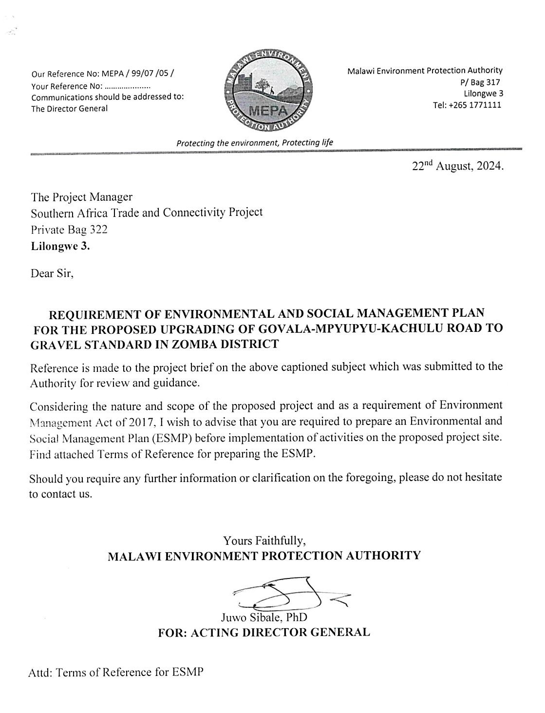

Annex 2. Terms of Reference from MEPA

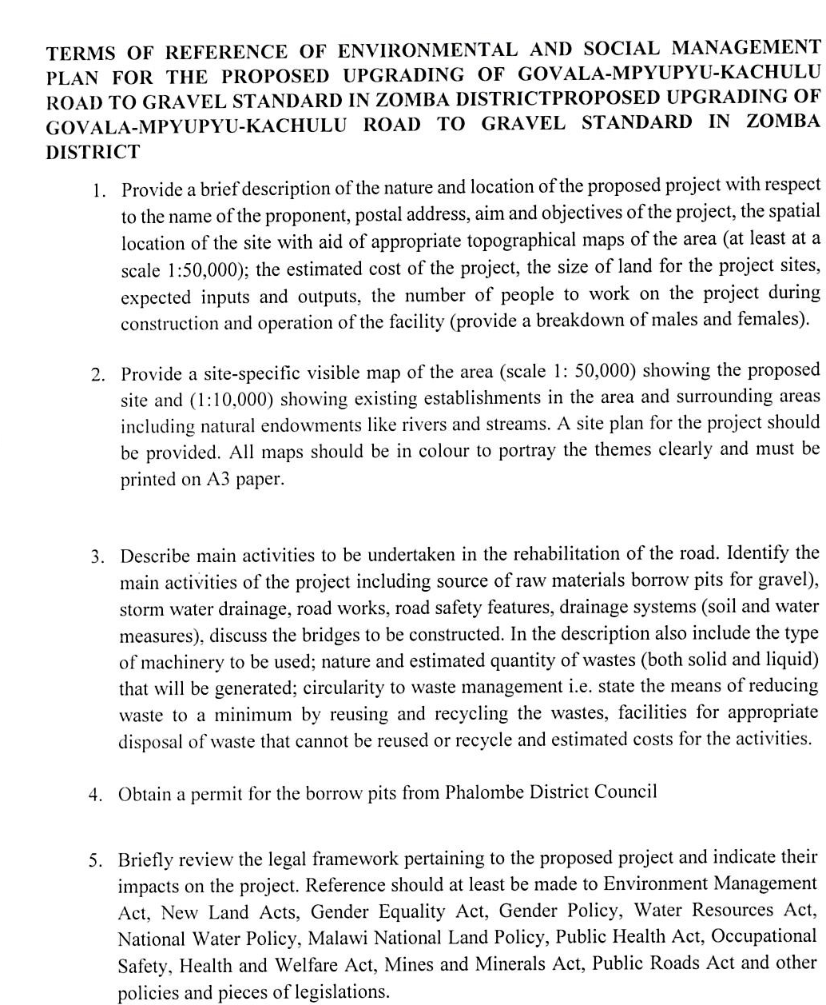
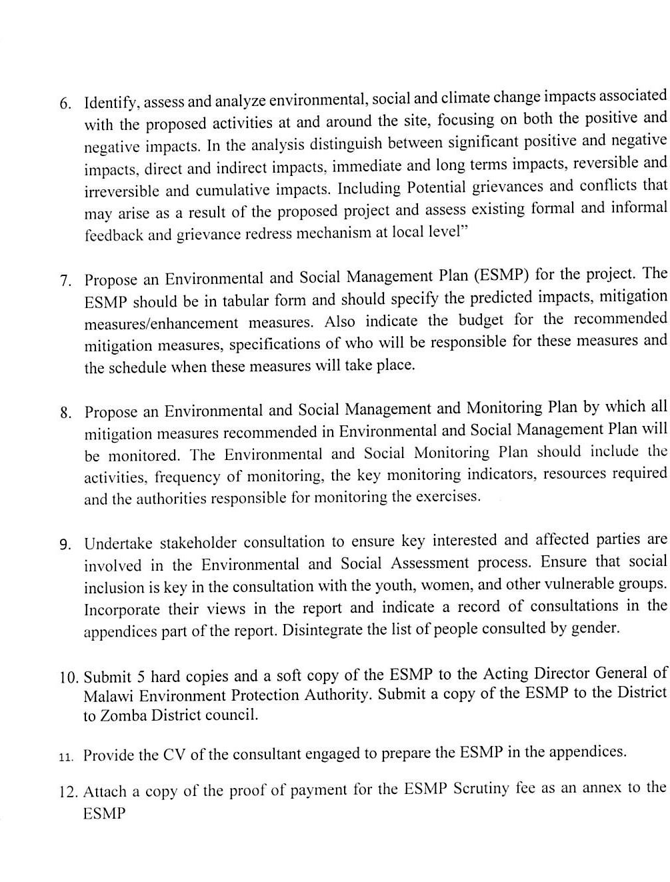

Annex 3a. List of Stakeholders Consulted
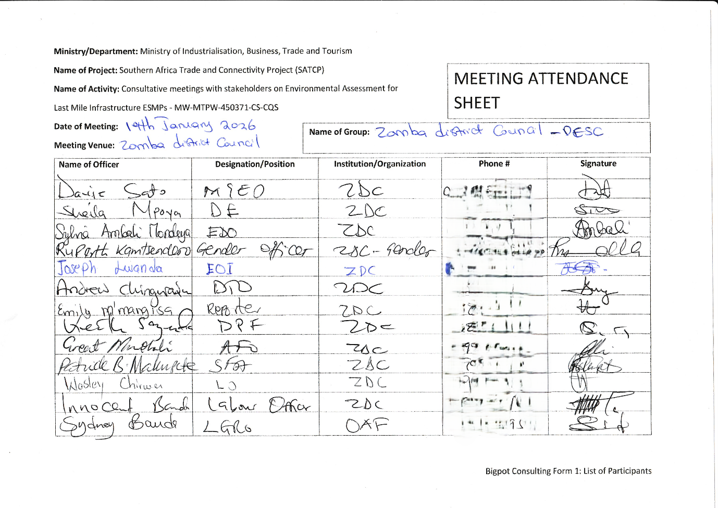
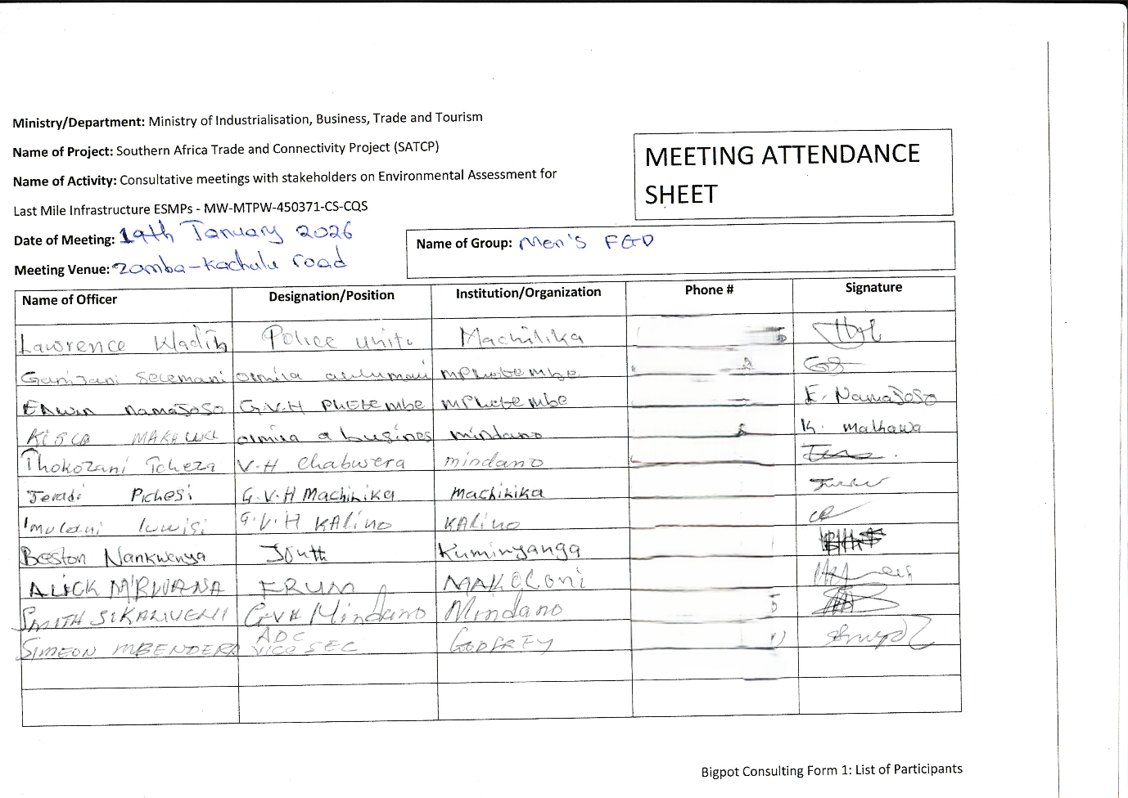
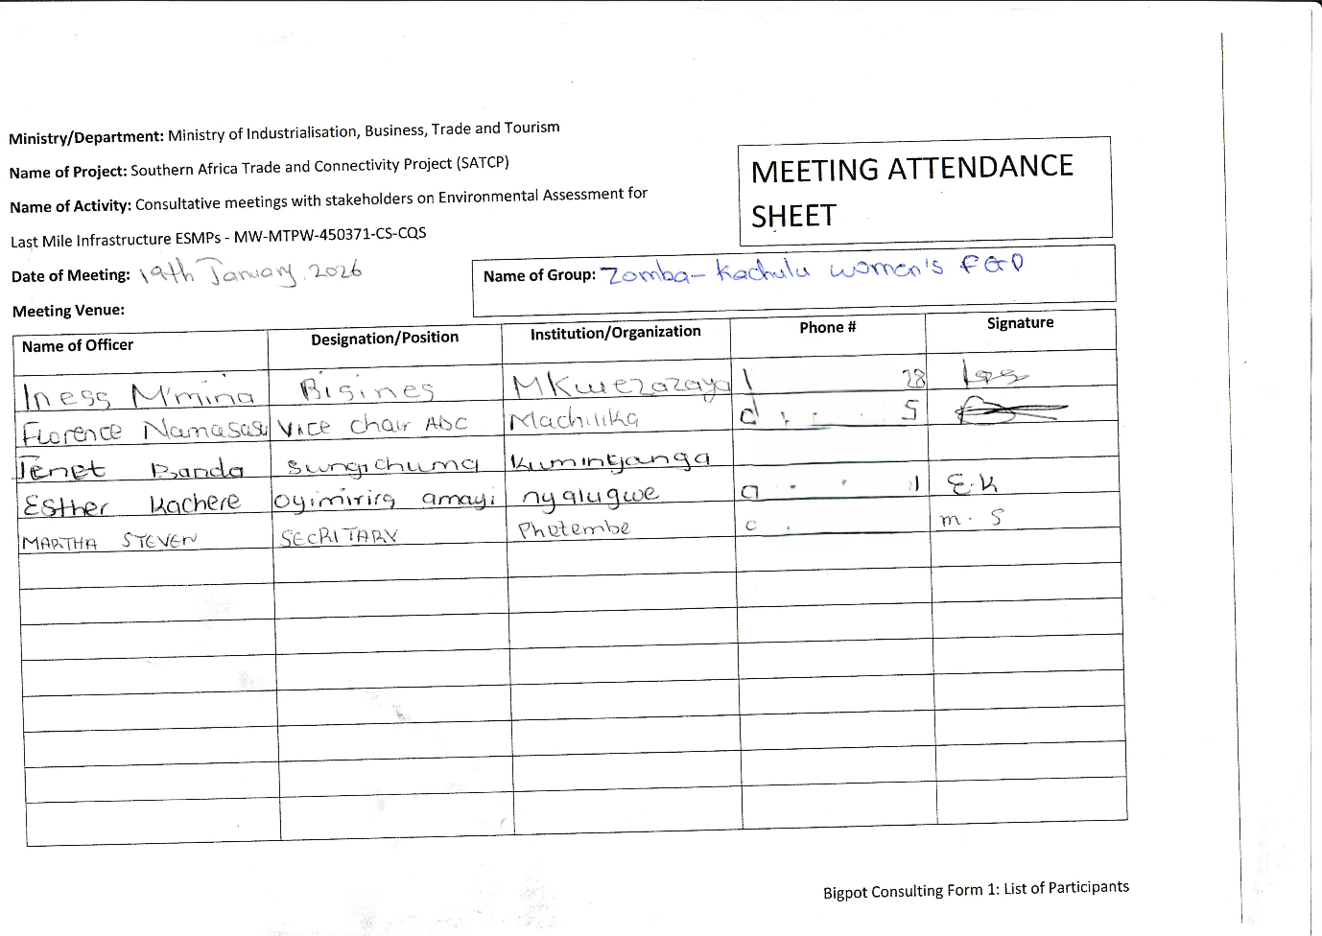

Annex 3b Issues raised by stakeholders and how they have been addressed in ESMP
SN | Issue Raised | Raised By | ESMP Response / Intervention | ESMP Reference (Section / Table / Annex)
1 | Road must remain within existing alignment; avoid widening and compensation | DESC, Women, Men | ESMP confirms upgrading confined to existing road reserve; no realignment or widening beyond established footprint; no physical displacement anticipated | Sec. 1.4 Nature & Scope; chap. 5 Impact Assessment (Land and Construction-Period Impacts); Executive Summary
2 | Need structured disclosure and district coordination | DESC | ESMP establishes formal institutional coordination with Zomba DESC; monthly monitoring and structured disclosure procedures included | Sec. 3.4 Institutional Framework; sec. 5.1 Monitoring Plan; Annex 3– Consultation Records
3 | Protection of irrigation canals and scheme areas from runoff/sediment | DESC | Climate-resilient drainage design; sediment control measures; culvert rehabilitation; sequencing works during dry periods | Sec. 1.4 Project Scope (Drainage Works); chap. 6 Construction Mitigation (Water Resources)
4 | Risk of contractor abstracting water from irrigation sources | DESC | Contractor required to obtain abstraction authorization; prohibition on using community water sources without formal agreement | chap. 6 Mitigation Matrix – Water Resources; Annex – Contractor E&S Clauses
5 | Cement runoff and water contamination | DESC | Controlled concrete works; prohibition of mixing near water points; sediment traps; wastewater containment procedures | Sec. 6 Mitigation (Soil & Water); Annex – Site-Specific Management Plans
6 | Drainage failure due to steep terrain | DESC, Men | Drainage structures sized for peak flows; check drains; erosion control measures incorporated | Sec. 1.4 Scope; Sec. 4.2 Baseline (Topography); Sec. 6.2 Drainage Mitigation
7 | Borrow pits may become hazardous | DESC, Men | Mandatory Borrow Area Management Plan; controlled excavation depth; rehabilitation and slope stabilization required | Sec. 6.2 Mitigation (Materials Sourcing); Annex 9 – Borrow Pit Management Requirements
8 | Spoil disposal and land restoration | DESC | Spoil Management Plan; approved disposal areas; site reinstatement after works | Sec. 6.2 Construction Phase – Waste & Spoil; Annex 6– Contractor Obligations under Waste Management Framework
9 | Waste management (cement bags, camp waste, wastewater) | DESC, Women | Contractor to implement Waste Management Plan; designated disposal sites; no open dumping | Sec. 6.2 Waste Management; Annex 6– Waste Management Framework
10 | Contractor camps and sanitation risks | DESC, Men | Camp Management Plan required; sanitation facilities; solid and liquid waste controls | Sec. 6.2 Social & OHS Mitigation; Annex – Camp Management Requirements
11 | Graveyard is strict no-go zone | DESC, Women, Men | Cultural heritage protection; buffer zones; no encroachment; monitoring supervision | Sec. 4 Cultural Heritage Baseline; Sec. 6 Cultural Heritage Mitigation
12 | Chance finds procedure required | DESC, Women, Men | Formal Chance Finds Procedure included; stop-work and notify authorities protocol | Sec. 6.2 Cultural Heritage Mitigation; Annex 12 – Chance Finds Procedure
13 | Protection of boreholes and wells | Women | Buffer zones; no stockpiling near water points; runoff diversion measures | Chap. 6 Water Resources Mitigation
14 | Dust affecting households and crops | Women, Men | Water spraying; speed control; material covering; community notification | Chap. 6 Air Quality Mitigation
15 | Vibration impacts on mud houses | Men | Controlled equipment operation; avoidance of heavy compaction near structures; monitoring | Chap. 6 Community Health & Safety
16 | Road safety risks to children; need humps/signage | DESC, Women, Men | Traffic Management Plan; signage; speed calming; awareness campaigns | Chap. 1.4 Scope (Safety Measures); Sec. 6 Traffic Management; Annex – Traffic Management Plan
17 | Maintain access for farmers and traders | DESC, Men | Staged construction; temporary diversions; pedestrian and farm access maintained | Chap. 6 Access & Mobility Mitigation
18 | High number of female-headed households | DESC, Women | Gender-responsive employment provisions; protection of vulnerable groups | Chap. 4 Social Baseline; Sec. 6 Social Mitigation Measures
19 | GBV/SEA/SH risks due to contractor presence | DESC, Women, Men | Mandatory GBV/SEA/SH Action Plan; Worker Code of Conduct; awareness and referral pathways | Chap. 6 Social Risk Mitigation; Annex – GBV/SEA/SH Action Plan
20 | Need formal GRM | Women, Men | Project-level GRM established; complaint log; district-level linkage; confidential handling of SEA/SH cases | Sec. 5.1 Grievance Redress Mechanism
21 | Prioritise local labour; gender inclusion | DESC, Women, Men | Local recruitment prioritised; equal opportunity provisions; gender inclusion targets | Chap. 6 Labour Management; Chap. 4 Social Baseline
22 | Delayed wages; no contracts; child labour concerns | DESC | Written contracts required; compliance with labour laws; prohibition of child labour; labour GRM included | Chap. 6 Labour & OHS; Annex – Contractor Labour Clauses
23 | Occupational health and safety; PPE | DESC | OHS Management Plan mandatory; PPE enforcement; toolbox talks; barricading | Chap. 6 OHS Mitigation; Annex 13– Labour Management Guidelines
24 | Monitoring constraints at district level | DESC | Joint monitoring schedule defined; roles and indicators clarified in ESMP | Chap. 5.1 Monitoring Plan
25 | Need climate-resilient design | DESC | Emphasis on resilient drainage, erosion prevention, stormwater management | Sec. 1.4 Scope; Chap. 6 Drainage & Erosion Mitigation
26 | Strong winds affecting housing | Men | Vegetative stabilization and slope protection measures incorporated | Chap. 6 Soil & Erosion Control
27 | Limited alternative vehicle routes | Men | Staged works; temporary access management; advance communication | Chap 6. Access Management

Annex 4. Sample Code of Conduct for Contractors
1. Purpose and Scope
This Sample Code of Conduct (CoC) provides the minimum mandatory standards of behaviour for all personnel engaged in implementation of SATCP Last Mile Infrastructure (LMI) subprojects, including contractors, sub‑contractors, supervising consultants, suppliers, and all categories of workers (permanent, temporary and day workers). The annex serves as a framework and template for preparation of a project‑specific Contractor’s Code of Conduct, which shall be adapted by each Contractor to reflect the scope, risks, workforce composition and community context of the subproject, and submitted to the Supervising Consultant and the PIU for review and approval prior to mobilisation.
The project‑specific CoC shall apply to all personnel working on or in connection with the subproject and shall be communicated in a language and format that workers understand. Each worker shall sign the approved Code of Conduct as a condition of employment and shall receive induction and periodic refresher training on its requirements, including sanctions for non‑compliance.
The Code addresses risks associated with the following:
- Environmental and social management.
- Occupational health and safety (OHS).
- Labour influx and labour relations.
- Spread of communicable diseases, including HIV and AIDS.
- Sexual harassment (SH), sexual exploitation and abuse (SEA), and gender‑based violence (GBV).
- Child labour and child protection.
- Illicit behaviour, crime and corruption.
- Community health, safety and road safety.
Compliance with the approved Code of Conduct is a contractual obligation for the Contractor and all associated personnel, and a condition of employment on the project. The Contractor shall be responsible for enforcement of the Code at worksites, worker accommodation areas, haul routes and all other project‑related locations, while the Supervising Consultant and PIU shall monitor compliance as part of ESMP and contract implementation.
2. General Obligations
The Supervising Consultant shall ensure that the Contractor and all associated personnel:
a) Legal Compliance
Comply at all times with the laws, regulations, and standards of the Republic of Malawi, including the Environment Management Act (2017), labour laws, occupational safety legislation, and applicable World Bank safeguard requirements.
b) ESHS Planning Instruments
Prepare, implement, and maintain site-specific instruments prior to commencement of works, including:
- Environmental and Social Management Plan (ESMP);
- Health and Safety Management Plan (HSMP);
- HIV and AIDS Awareness Programme;
- Occupational Health and Safety Awareness Programme;
- Road Safety and Traffic Management Plan.
c) Occupational Health and Safety
Provide a safe and healthy working environment, including:
- Provision and compulsory use of appropriate Personal Protective Equipment (PPE);
- Prevention of avoidable accidents and injuries;
- Immediate reporting and correction of unsafe acts or hazardous conditions.
d) Traffic and Road Safety
Implement traffic safety measures, including:
- Temporary speed calming devices and speed-limit signage;
- Warning signs in villages, trading centres, schools, health facilities, and construction zones;
- Enforcement of safe driving practices by all project drivers.
e) Environmental Protection
Avoid unnecessary clearance of trees and vegetation, prevent conflicts over water resources, and ensure sustainable use of natural resources in consultation with local communities.
f) Pollution Prevention
Take all reasonable measures to prevent pollution of air, water, and soil, land degradation, and environmental damage, and ensure compliance with good international industry practice.
g) Worker and Public Safety
Install standard safety signs, barricades, and road markings during construction and after completion to protect workers, communities, and road users.
h) Sanitation and Welfare Facilities
Provide adequate sanitation facilities, including:
- Safe drinking water;
- Decent toilets and washing facilities at worksites and camps;
- Prohibition of open defecation.
i) Site Rehabilitation and Restoration
Restore all disturbed areas after construction, including borrow pits, quarries, stockpiles, camps, access roads, batching plants, fuel storage areas, and waste disposal sites, through landscaping, tree planting, and erosion-control measures.
3. Labour, Ethics, and Social Conduct
j) Non-Discrimination
Prohibit all forms of discrimination in recruitment, employment, and working conditions on the basis of gender, age, ethnicity, disability, religion, marital status, political affiliation, or other protected characteristics.
k) Fair Labour Practices
Adhere to Malawi labour laws by issuing written contracts to skilled and unskilled workers, respecting working hours, wages, and conditions of employment.
l) Prevention of Sexual Harassment
Strictly prohibit sexual harassment, including abusive language, inappropriate gestures, sexually suggestive behaviour, or culturally offensive conduct, particularly towards women and children.
m) Prevention of SEA/GBV
Prohibit any form of sexual exploitation, abuse, or violence, including:
- Exchange of money, goods, services, or employment for sex;
- Exploitative or degrading behaviour;
- Any sexual activity with minors (persons under 18), regardless of consent.
n) Child Protection and Child Labour
Prohibit child labour and all forms of child abuse, exploitation, or endangerment, and ensure children’s safety in and around project areas.
o) Conflict of Interest and Corruption
Avoid conflicts of interest and prohibit bribery, favouritism, or preferential treatment based on personal, financial, or family relationships.
p) Protection of Property and Assets
Safeguard project equipment, materials, and property; prohibit theft, vandalism, misuse, or waste of resources.
q) Grievance Reporting and Non-Retaliation
Ensure that workers and community members can report violations of this Code through established grievance mechanisms without fear of retaliation, provided the report is made in good faith.
4. Enforcement and Accountability
r) Acknowledgement and Sanctions
All workers and contractor personnel shall:
- Read, understand, accept, and sign this Code of Conduct as a condition of employment;
- Attend mandatory induction and refresher training on ESHS and SEA/GBV prevention.
Any violation of this Code of Conduct may result in disciplinary action, including:
- Verbal or written warnings;
- Suspension or dismissal;
- Termination of contract; and/or
- Referral to relevant legal authorities.
5. Contractor Certification
I, the undersigned, confirm that I have read and understood this Code of Conduct and commit to ensuring full compliance by all personnel engaged under this contract.
I Agree /
Name of Authorized Representative: ____________________________
Signature: ____________________________
Name of Company: ____________________________
Physical Address: ____________________________
Company Stamp: ____________________________
Date: ____________________________

Annex 5. Barrow Pit Rehabilitation Framework
(SATCP Last Mile Infrastructure Projects)
1. Introduction and Purpose
This Borrow Pit Rehabilitation Framework applies to all borrow pits identified and utilised under the SATCP Last Mile Infrastructure (LMI) projects. It sets out mandatory procedures for environmentally sound material extraction, operation, rehabilitation and closure of borrow pits so that material sourcing does not result in permanent land degradation, public safety hazards, or adverse impacts on surrounding communities and ecosystems.
The Framework provides the standard requirements that Contractors must follow when preparing site-specific Borrow Pit Management and Rehabilitation Plans for each borrow source they intend to use. These site-specific plans shall form part of the Contractor’s Environmental and Social Management Plan (C-ESMP) and shall be submitted to the Supervising Consultant and the PIU for review and approval prior to opening or using any borrow pit. The Framework shall also be applied within the site-specific ESMP to guide oversight, monitoring and verification of borrow-pit performance throughout construction and post-closure.
2. Project Context
Borrow pits are identified during the design and pre-construction phases of LMI subprojects based on geotechnical investigations undertaken under the Detailed Engineering Design (DED). These borrow pits may supply lateritic gravel, fill material, or other construction materials required for road rehabilitation, drainage works, and ancillary infrastructure.
At the planning stage, borrow pits are considered indicative material sources. Final selection, approval, and use shall be subject to field verification, landowner consent, environmental and social screening, and approval by relevant authorities.
3. Regulatory and Safeguards Framework
Borrow pit development, operation, and rehabilitation under SATCP LMI projects shall comply with:
- Environment Management Act (2017)
- MEPA Guidelines for Environmental Assessment (2025)
- SATCP ESMF
- World Bank OP/BP 4.01 and OP/BP 4.04 (where applicable)
- Approved ESMPs and DEDs for each LMI subproject
4. Borrow Pit Planning and Site Controls
Before opening or using any borrow pit, the Contractor shall:
- Obtain written approval from the Supervising Consultant and the relevant District Council.
- Secure documented landowner consent and confirmation from the appropriate Traditional Authority.
- Verify land tenure status and agree on access, use, rehabilitation, and handover conditions.
- Clearly demarcate the borrow pit footprint and access routes.
- Strip and stockpile topsoil separately for use during rehabilitation.
- Install warning signage and temporary fencing, particularly where borrow pits are located near settlements, agricultural land, footpaths, or grazing areas.
5. Key Environmental and Social Risks
Typical risks associated with borrow pits under LMI projects include:
- Loss of productive agricultural land
- Open excavations posing injury risks to people and livestock
- Standing water leading to mosquito breeding
- Soil erosion and sediment runoff into nearby streams or wetlands
- Visual scarring of the landscape
- Community dissatisfaction where land is not adequately restored
6. Rehabilitation Objectives
Borrow pit rehabilitation under SATCP LMI projects shall aim to:
- Restore land to a safe, stable, and productive condition
- Prevent erosion, standing water, and slope instability
- Reintegrate rehabilitated sites into agricultural or community land use
- Eliminate public health and safety hazards
- Meet landowner, community, and District Council expectations
7. Rehabilitation Measures
7.1 Progressive Rehabilitation
- Implement rehabilitation progressively, commencing immediately after material extraction in each section.
- Phase excavation activities to minimise the total open area at any given time.
7.2 Backfilling and Reshaping
- Reuse overburden and unsuitable material for backfilling.
- Reshape excavated areas to stable slopes (maximum 1:3).
- Partially backfill deep excavations to eliminate water accumulation.
7.3 Topsoil Replacement
- Evenly spread stockpiled topsoil over rehabilitated surfaces.
- Ensure sufficient topsoil depth to support revegetation or agricultural reuse.
7.4 Drainage and Erosion Control
- Restore surface drainage to natural flow patterns.
- Apply erosion control measures such as contour shaping, grass strips, or stone pitching where required.
7.5 Revegetation
- Revegetate rehabilitated sites using indigenous grass species and locally appropriate tree species, subject to landowner preference.
- Prioritise vegetation that supports soil stabilisation, shade provision, and community utility.
8. Safety and Community Protection
- Secure active borrow pits using fencing, barriers, or warning tape.
- Install clear warning signage in English and local languages.
- Eliminate vertical faces and open pits upon closure.
- Formally hand back rehabilitated sites to landowners after completion.
9. Post-Use Land Options
Subject to agreement with landowners and District Councils, rehabilitated borrow pits may be converted into:
- Agricultural land
- Community woodlots
- Grazing areas
- Controlled water retention areas (only where approved, engineered, and safe)
10. Roles and Responsibilities
Actor | Responsibility
Contractor | Implement borrow pit management and rehabilitation
Supervising Consultant | Approve, supervise, and certify rehabilitation works
District Council / DESC | Community liaison and site verification
Landowners / Traditional Authorities | Accept rehabilitated land

11. Monitoring and Reporting
- Report borrow pit status in monthly ESMP compliance reports.
- Monitor indicators including number of rehabilitated sites, erosion evidence, water ponding, and vegetation establishment.
- Conduct final inspections prior to issuance of completion certificates.
12. Budgeting
- Fully include borrow pit rehabilitation costs in the Contractor’s BoQs and C-ESMP.
- Prohibit approval of any borrow pit without a costed and approved rehabilitation provision.
13. Completion and Handover
Consider borrow pits closed only when rehabilitation is complete, sites are safe and stable, and formal handover documentation is signed by relevant parties.
14. Conclusion
This Borrow Pit Rehabilitation Framework provides a consistent and enforceable approach for managing borrow pits across all SATCP Last Mile Infrastructure projects, ensuring Environmentally responsible material sourcing, protection of community interests, and full compliance with MEPA (2025) and World Bank safeguards.

Annex 6. Traffic Management Framework
1. Introduction
This Traffic and Access Management Framework (TAMF) has been prepared for the Southern Africa Trade and Connectivity Project (SATCP) – Last Mile Infrastructure (LMI) subprojects, including feeder road rehabilitation, drainage improvements, bridge/culvert works and associated construction activities. The Framework sets out the minimum requirements for planning, operating and monitoring construction-related traffic so that works are carried out safely and with limited disruption to local communities and road users.
The Framework provides mandatory guidance for the preparation and implementation of site-specific Traffic and Access Management Plans (TAMPs) by Contractors. For each subproject, the Contractor shall prepare a TAMP consistent with this Framework and submit it to the Supervising Consultant and the SATCP PIU/State Agency for Transport and Construction Projects for review and approval prior to commencement of construction works.
The TAMF aims to ensure that all construction-related traffic—vehicles, equipment and personnel—is managed safely, efficiently and in an environmentally and socially responsible manner, while minimising risks and disruptions to communities, vulnerable road users, businesses, and existing transport infrastructure.
2. Purpose and Objectives
Construction activities will increase vehicular and machinery traffic within worksites and along existing regional and community roads. Without effective management, such traffic may:
- Interfere with normal traffic and pedestrian movements;
- Increase risks of accidents and injuries to workers and the public;
- Damage existing road infrastructure;
- Generate dust, noise, congestion, and community nuisance.
The objectives of this Framework are to:
- Promote safe interaction between construction traffic, pedestrians, and local road users;
- Minimize environmental and social risks associated with construction traffic;
- Guide the planning, use, and rehabilitation of access roads and haul routes;
- Ensure site-specific traffic impacts are addressed through appropriate design, scheduling, signage, and controls.
3. Access Roads and Haul Routes
a) Planning and Approval
The Contractor shall prepare detailed layout plans for all proposed access roads and haul routes. These plans shall:
- Be submitted to the Supervising Consultant for approval;
- Be accompanied by written consent from affected landowners, Traditional Authorities, or village leadership where applicable.
b) Use of Existing Infrastructure
Existing roads shall be used wherever feasible. Construction of temporary access roads shall only be permitted where unavoidable and upon approval by the Site Manager and relevant stakeholders. Construction of temporary diversions, if required, will require approval of the District and the World Bank.
c) Environmental Considerations
Planning of haul routes shall consider:
- Vegetation and sensitive habitats;
- Watercourses and drainage patterns;
- Existing land use;
- Proximity to households, schools, markets, and health facilities.
d) Construction, Maintenance, and Rehabilitation
The Contractor shall be responsible for:
- Construction and routine maintenance of access and haul roads;
- Installation of drainage infrastructure at early stages to prevent erosion;
- Decommissioning and rehabilitation of temporary roads upon completion of works.
Topsoil shall be stripped and stockpiled prior to construction and reused during rehabilitation. Disturbed areas shall be revegetated using indigenous species where applicable.
e) Dust Suppression
Dust control measures shall be implemented, including:
- Regular watering of access and haul roads;
- Enforcement of speed limits (maximum 30 km/h near settlements);
- Use of dust palliatives where necessary.
Dust suppression activities shall be recorded and reported as part of Environmental compliance monitoring.
4. Traffic Management and Safety Measures
Each site-specific Traffic and Access Management Plan shall include, at minimum, the following components:
4.1 Traffic Control and Signage
- Clearly defined access routes within and around worksites;
- Advance warning signage along haul routes and near construction zones;
- Temporary traffic signs, barriers, and flag persons where required;
- Establishment and enforcement of speed limits and control points.
Where bridge or culvert works require road occupation, temporary bypasses or diversions shall be constructed prior to commencement of works to avoid full road closures.
5. Transport of Materials
The Contractor shall ensure that:
- Vehicles transporting fine or granular materials are fully covered with tarpaulins to prevent dust and spillage;
- Any spillage or pollution along transport routes is cleaned immediately at the Contractor’s cost;
- Delivery schedules are aligned with off-peak hours to reduce congestion and disturbance to communities.
6. Driver Requirements and Conduct
All project drivers and equipment operators shall:
- Hold valid licenses appropriate to the vehicles or machinery operated;
- Be trained and certified in defensive driving and road safety;
- Receive training in eco-driving to reduce fuel consumption and emissions;
- Undergo project induction covering pedestrian safety, fatigue management, and substance abuse prevention.
Driver working hours shall be managed to prevent fatigue, ensuring adequate rest periods. The Contractor shall maintain up-to-date driver registers and dust suppression logs.
7. Interaction with Communities and Sensitive Areas
High-risk interaction areas such as schools, markets, trading centres, and health facilities shall be identified and mapped. Site-specific mitigation measures shall be implemented, including:
- Temporary pedestrian crossings;
- Traffic calming devices (speed bumps, rumble strips);
- Warning lights, reflectors, and signage;
- Temporary bypasses where necessary.
Community engagement shall be coordinated with the Stakeholder Engagement Framework (Annex 11) to ensure awareness of traffic changes and safety measures.
8. Monitoring, Enforcement, and Reporting
The Contractor’s Traffic and Access Management Plan shall include:
- An accident and incident register with clear reporting procedures;
- Random alcohol and drug testing protocols for drivers;
- A penalty and disciplinary structure for non-compliance with traffic safety requirements;
- Regular monitoring of road conditions and prompt repair of damage caused by construction traffic;
- Monthly traffic management reports detailing:
  - Traffic incidents and near misses;
  - Dust and noise control performance;
  - Community complaints related to traffic;
  - Corrective actions undertaken.
The Supervising Consultant shall verify compliance and recommend corrective measures where deficiencies are identified.
9. Institutional Responsibilities
Actor | Key Responsibilities
Contractor | Prepare and implement site-specific TAMPs, ensure compliance
Supervising Consultant | Review, approve, and monitor TAMP implementation
SATCP / PIU | Oversight and enforcement
District Authorities | Local coordination and support
Traffic Police (where applicable) | Enforcement and incident response
10. Conclusion
This Traffic and Access Management Framework establishes mandatory requirements for safe, efficient, and environmentally responsible management of construction traffic under the SATCP Last Mile Infrastructure subprojects. Effective implementation of this Framework will reduce accident risks, protect communities, and ensure compliance with national legislation and World Bank safeguard requirements.
Site-specific Traffic and Access Management Plans shall be developed and approved prior to commencement of construction works and updated as necessary throughout project implementation.

Annex 7. Chance Find Procedure for Last Mile Infrastructure under SATCP

1. Introduction
This Chance Find Procedure sets out the protocol to be followed if previously unidentified cultural heritage is discovered during implementation of the SATCP Last Mile Infrastructure (LMI) subprojects. Cultural heritage may include, but is not limited to, archaeological materials, graves and burial sites, religious artefacts, sacred or ritual sites, and historical objects that were not identified during the initial environmental and social assessment. The procedure is to be applied by Contractors and Supervising Consultants on all worksites and along all associated project footprints, and ensures that any chance finds are managed in accordance with the Monuments and Relics Act (Cap 29:01) of Malawi and the World Bank’s OP/BP 4.11 on Physical Cultural Resources.
2. Purpose
The purpose of this procedure is to safeguard Malawi’s tangible cultural heritage by ensuring that any unexpected discoveries are handled with care and in accordance with legal and safeguard requirements. The procedure seeks to prevent unauthorized interference, preserve historical and cultural assets, and maintain respect for community traditions and sensitivities.
3. Scope
This procedure applies to all personnel involved in the project, including contractors, subcontractors, consultants, field workers, and any party engaged in construction, material sourcing, excavation, or related site activities. It is applicable to all locations along the project corridor, including campsites, borrow pits, material stockpiles, access roads, and working zones.
4. Definition of a Chance Find
A chance find is defined as any artifact, feature, structure, or site of cultural, historical, or religious significance that is discovered unexpectedly during the execution of project activities. Examples may include human remains, pottery fragments, stone tools, religious objects, altars, burial grounds, historical ruins, or sacred trees. These are typically items or sites not previously recorded or anticipated in the ESMP documentation.
5. Procedure to Follow in the Event of a Chance Find
If a chance find is encountered, the following steps must be followed:
- All work in the immediate vicinity must stop immediately. The affected area must be secured with a buffer zone of no less than 20 to 50 meters to prevent disturbance or looting.
- The Contractor must promptly inform the Supervision Consultant, the Project Implementation Unit (PIU) of the SATP, and the Department of Antiquities (DoA) within 24 hours.
- The DoA will dispatch a qualified cultural heritage or archaeological specialist to assess the nature, significance, and appropriate treatment of the discovery.
- Based on the expert assessment and consultations with relevant stakeholders, the cultural material may be preserved in situ, documented and relocated, or managed in accordance with traditional practices—such as holding customary ceremonies prior to relocating graves or sacred objects.
- No work should resume in the vicinity until the DoA has provided written clearance authorizing continuation. All findings must be properly recorded, photographed, and geotagged for documentation and reporting purposes.

6. Roles and Responsibilities
The Contractor is responsible for ensuring that all site personnel are trained in this procedure and for immediately halting work and protecting the area in the event of a discovery. The Supervision Consultant must verify contractor compliance and support the coordination of response efforts. The PIU is responsible for notifying the Department of Antiquities, facilitating expert engagement, and ensuring adherence to this procedure. The Department of Antiquities will lead assessments, determine the heritage value of the find, and authorize appropriate measures or clearance to resume work.
7. Training and Awareness
To ensure that all relevant personnel are aware of and can implement this procedure, pre-construction induction training will be provided to all workers and supervisors. This will include awareness of local cultural sensitivities and the importance of cultural heritage protection. Refresher training will be conducted every six months or upon the onboarding of new workers. On-site communication materials such as posters and briefing cards will be used to reinforce awareness.
8. Legal and Policy Basis
This procedure is grounded in the Monuments and Relics Act (Cap 29:01) of Malawi, which mandates the protection and reporting of archaeological discoveries and prohibits unauthorized disturbance of cultural resources. It is also aligned with the World Bank’s OP/BP 4.11 (Physical Cultural Resources), which requires Borrowers to avoid, minimize, or mitigate impacts on cultural heritage and to engage relevant communities and authorities in the process of managing heritage resources.
9. Reporting and Documentation
All chance finds must be documented in a standardized reporting format that includes the date and time of discovery, location coordinates (GPS), a physical description of the find, photographic records, and the actions taken. These reports must be submitted to the PIU, the Department of Antiquities, and included in the Contractor’s monthly E&S compliance reporting. Records of follow-up actions, assessments, and final clearance must also be retained.
10. Budget and Resources
A dedicated budget line will be included in the project’s Environmental and Social Management Plan (ESMP) to support implementation of the chance find procedure. This will cover costs associated with expert assessments, protective measures (e.g., fencing), documentation, stakeholder engagement, and cultural or ceremonial activities where required for the proper treatment of sacred or religious sites.

Annex 8: Labour Management Guidelines for Contractor Compliance and Preparation of Labour Management Plans (LMPs)

1. Purpose of these Guidelines
These Labour Management Guidelines are issued to guide Contractors in the preparation and implementation of project‑specific Labour Management Plans (LMPs) for SATCP Last Mile Infrastructure (LMI) road projects. They are not a standalone LMP; rather, they operationalise the project‑level Labour Management Procedures and relevant Malawi labour legislation for application at subproject and contract level.
Specifically, the Guidelines:
- Establish minimum labour and working‑conditions requirements that Contractors must meet on all SATCP LMI contracts.
- Clarify statutory obligations under applicable Malawi labour legislation (including the Employment Act, Occupational Safety, Health and Welfare Act, Gender Equality Act, Child Care, Protection and Justice Act, and Trafficking in Persons Act).
- Define the scope, structure and content expected in Contractor LMPs, including provisions on terms and conditions of employment, OHS, worker accommodation, Code of Conduct, SEA/SH and GBV, child labour, and grievance mechanisms.
- Provide direction on labour‑risk identification, mitigation and monitoring consistent with national law and World Bank requirements for managing social risks (OP/BP 4.01 and the Labour Management Procedures for SATCP).
All Contractors engaged under SATCP shall prepare a site‑specific Labour Management Plan (LMP) consistent with these Guidelines and the project‑level Labour Management Procedures, and submit it to the Supervising Consultant and PIU for review and approval prior to mobilisation. The approved LMP will form part of the Contractor’s C‑ESMP and will be monitored throughout implementation.
2. Legal and Policy Framework
Contractors must ensure their LMPs demonstrate compliance with:
- Employment Act (2000, as amended)
- Occupational Safety, Health and Welfare Act (1997)
- Gender Equality Act (2013)
- Child Care, Protection and Justice Act (2010)
- HIV and AIDS (Prevention and Management) Act (2018)
- Trafficking in Persons Act (2017)
- Public Health Act (1948)
- Applicable minimum wage regulations
- Relevant World Bank safeguards (OP/BP 4.01)
The LMP must clearly reference these instruments and describe how compliance will be operationalised.
3. Categories of Workers to be Covered
The Contractor’s LMP shall cover all categories of project workers, including:
- Direct workers (Contractor employees)
- Subcontracted workers
- Security personnel
- Primary supplier workers
The LMP must describe how labour standards will be applied to subcontractors and suppliers.
4. Minimum Content Requirements for Contractor LMPs
Each Contractor’s LMP must include, at a minimum, the following components:
4.1 Workforce Planning and Recruitment Procedures
The LMP must describe:
- Anticipated labour numbers by category and phase;
- Recruitment procedures;
- Local hiring strategies;
- Non-discrimination measures;
- Age verification procedures;
- Prohibition of forced labour and child labour;
- Record-keeping systems for employees.
Recruitment must comply with Sections 4, 5, 21, and 23 of the Employment Act.
4.2 Employment Conditions
The LMP shall demonstrate how the Contractor will ensure:
- Written contracts for all workers;
- Clear specification of wages, hours, and benefits;
- Compliance with statutory working hours and rest days;
- Provision of annual, sick, and maternity leave;
- Equal pay for equal work;
- Proper termination procedures and severance entitlements.
4.3 Occupational Health and Safety (OHS)
The LMP must include:
- Site-specific OHS risk assessment;
- Hazard identification and control measures;
- PPE provision policy;
- Toolbox talks and safety training plan;
- Accident and incident reporting procedures;
- Emergency response plan;
- First aid and medical arrangements;
- Special protection for young workers (14–18 years).
OHS provisions must comply with the Occupational Safety, Health and Welfare Act (1997).
4.4 Worker Welfare Facilities
The LMP must outline provision of:
- Adequate sanitation facilities (segregated by gender);
- Potable water;
- Waste management systems;
- Rest areas and shelters;
- Medical and first aid facilities;
- Safe worker accommodation (where applicable).
4.5 Gender, GBV, SEA/SH and Child Protection
The LMP shall include:
- A mandatory Code of Conduct;
- GBV/SEA/SH awareness training programme;
- Zero tolerance policy;
- Confidential reporting pathways;
- Sanctions for misconduct;
- Measures to prevent exploitation of minors.
The LMP must align with the project’s GBV Management Framework.
4.7 Workers Grievance Redress Mechanism (WGRM)
The Contractor’s LMP must establish a Workers Grievance Redress Mechanism that:
- Is free and accessible;
- Protects confidentiality;
- Prohibits retaliation;
- Provides defined timelines for resolution;
- Maintains grievance records;
- Allows escalation procedures.
4.8 Monitoring and Reporting
The LMP must describe:
- Internal compliance monitoring procedures;
- Monthly labour reporting requirements;
- OHS statistics reporting;
- Training records;
- Grievance reporting;
- Supervision Consultant oversight arrangements.
5. Key Labour Risks in LMI Road Projects
Contractors shall assess and manage risks including:
- Workplace injuries and accidents;
- Exposure to dust, noise, and hazardous materials;
- Spread of communicable diseases;
- Child labour and forced labour risks;
- Gender-based violence;
- Labour disputes;
- Discrimination and exclusion of vulnerable groups;
- Resource competition due to labour influx.
Mitigation measures must be integrated into the Contractor’s ESMP and Construction Environmental and Social Management Plan (C-ESMP).
6. Review and Approval
No Contractor shall mobilise to site until:
- A project-specific Labour Management Plan has been prepared;
- The LMP has been reviewed and approved by the Supervision Consultant and SATCP;
- The Code of Conduct has been signed by all personnel;
- Induction training on labour standards and GBV has been conducted.
7. Enforcement
Failure to comply with these Guidelines and approved LMP provisions may result in:
- Suspension of works;
- Withholding of payment;
- Contractual penalties;
- Termination of contract.

Annex 13. SATCP LMI Grievance Redress Mechanism (GRM) Protocol

1. Introduction
This Grievance Redress Mechanism (GRM) Protocol has been developed for the Southern Africa Trade and Connectivity Project (SATCP) – Last Mile Infrastructure (LMI) subprojects, including feeder road rehabilitation, drainage improvements, culvert/bridge works and associated construction activities. The GRM provides a structured, project-wide system for receiving, recording, assessing and resolving concerns, queries and complaints from communities, workers and other stakeholders.
The GRM serves as the first line of response to stakeholder concerns, complementing statutory and other grievance channels (e.g. courts, police, labour authorities). It aims to resolve issues as close as possible to the point of impact, using dialogue and collaborative problem-solving, and thereby maintain constructive relations between the project, affected communities and workers.
Construction activities under SATCP LMI are expected to generate grievances related to, among others, land and assets, labour and working conditions, occupational and community health and safety, environmental impacts, and gender-based violence / sexual exploitation and abuse / sexual harassment (GBV/SEA/SH) and trafficking in persons (TIP). Contractors are required to develop and implement site-specific GRM Management Plans consistent with this Protocol.
The GRM will use two complementary modes of recording grievances:
- Manual submission (e.g. verbal, paper forms, grievance boxes, community meetings); and
- Electronic recording in a central database to allow tracking, escalation, and consolidated reporting across SATCP LMI.
Electronic recording will be promoted to support timely management oversight, automatic flagging of overdue cases, and real-time analysis of grievance trends.
2. Categories and Types of Grievances
The GRM will receive and register all grievances related to SATCP LMI activities, whether from community members, workers or institutions. Grievances may be submitted:
- In person to GRM committee members or project staff.
- By phone, SMS, WhatsApp or project-designated hotlines.
- Via grievance boxes at key locations.
- Through written letters or emails to the PIU, Supervising Consultant or Contractor.
The following categories and examples guide classification (non-exhaustive):
2.1 Construction-related Community Concerns and Livelihood Continuity
- Reinstatement disputes – Disputes about reinstatement of inadvertently damaged crops, structures or roadside assets during construction.
- Access disruption – Concerns about temporary loss of access to homes, services, schools or markets during construction.
- Livelihood continuity – Alleged negative impacts on income sources (e.g. crop damage, disruption of business).
2.2 Health and Safety (Workers and Community)
- Safety violations – Inconsistent handling of safety breaches, inadequate enforcement of rules.
- Accidents and injuries – Workplace or traffic accidents, concerns about the response, or perceived unfair dismissal following an accident.
- Health and safety hazards – Exposure to hazardous materials or unsafe conditions, lack or poor quality of PPE.
- Community safety complaints – Dust, noise, blocked accesses to schools/health centres/markets, speeding construction vehicles, unsafe detours, open borrow pits or excavations.
2.3 Labour / Contractor Issues
- Payment disputes – Delayed payment, underpayment or non-payment.
- Working conditions – Poor accommodation, sanitation, unsafe or unhealthy work environments.
- Wage disputes – Wage rates, overtime, non-payment of benefits.
- Discrimination and harassment – Workplace discrimination, bullying, harassment.
- Contract interpretation – Disagreements about terms, duration, or conditions of contracts.
2.4 Gender and Social Inclusion (GSI)
- Gender discrimination – Unequal treatment of women and men in recruitment, pay or opportunities.
- Social exclusion – Exclusion of youth, persons with disabilities or vulnerable groups from employment or consultations.
- Cultural insensitivity – Disrespect for local customs, norms or religious practices.
2.5 Environmental
- Pollution and waste management – Improper waste disposal, dust, noise, spills, or other pollution.
- Community environmental impacts – Perceived damage to water sources, agricultural land, forests or communal resources.
- Natural resource damage – Deforestation, degradation of wetlands, unsustainable material extraction.
2.6 General Project Issues
- Project delays and disruptions – Concerns about prolonged construction or schedule slippage affecting access.
- Communication gaps – Lack of information, unclear messages about project scope, timing and impacts.
- Stakeholder engagement – Inadequate consultation, lack of feedback, or perceptions of exclusion.
2.7 GBV / SEA/SH and TIP (Special Handling)
GBV/SEA/SH and TIP-related grievances require special, survivor-centred handling. These cases will:
- Be received through any GRM entry point, but not investigated by community or project committees.
- Be immediately and confidentially referred (with consent) to trained focal points and survivor service providers/police, in line with the project’s GBV/SEA/SH Action Plan and referral protocol.
- Not be discussed in open committee meetings; only anonymised statistics may be reported.
3. Objectives of the GRM
The GRM seeks to:
- Provide accessible, responsive and demonstrably fair channels through which communities and workers can raise grievances and complaints and obtain timely resolution.
- Maintain open, two-way communication between the project and stakeholders and serve as an early-warning system for emerging risks.
- Resolve most grievances locally and amicably at site or community level, reducing escalation to courts or disruptive conflict.
- Manage expectations and reduce negative perceptions by offering clear information on what the project can and cannot do.
- Prevent accumulation of unresolved grievances that could lead to protests, work stoppages, sabotage or reputational damage.
- Ensure that the rights, dignity and safety of all complainants are respected, including vulnerable and marginalised groups.
- Generate lessons on recurrent issues to support continuous improvement of ESMP and C-ESMP implementation.
4. Principles of the GRM
The SATCP LMI GRM is guided by the following principles:
- Human dignity and rights – All complainants are treated with respect, without discrimination.
- Equity and gender equality – Processes recognise different barriers faced by women, men, youth and vulnerable groups and proactively promote equitable access.
- Accessibility – Multiple, free-of-charge uptake channels (verbal, written, phone, SMS/WhatsApp, boxes, community meetings) are provided in local languages; illiterate complainants can lodge complaints verbally.
- Fairness and impartiality – Grievances are assessed objectively; members with conflicts of interest recuse themselves; complainants may appeal decisions.
- Transparency – Procedures, timelines and possible outcomes are clearly communicated; complainants are informed of progress and decisions.
- Accountability and responsiveness – Clear responsibilities for receiving, logging, processing and closing grievances; time-bound response standards; monitoring of overdue cases.
- Confidentiality and safety – Identity of complainants is protected where requested; anonymous grievances are accepted; special measures protect GBV/SEA/SH survivors.
- Predictability – Sequential steps (receipt, acknowledgement, assessment, resolution, appeal, closure) and associated timeframes are defined and publicised.
- Inclusivity and participation – GRM committees are gender-balanced and include community representatives; stakeholders participate in developing and reviewing solutions.
- Systematic record-keeping – All grievances are logged, tracked and reported (including anonymous ones), with capacity to attach supporting evidence.
- Right to appeal – Complainants can request reconsideration and, if unsatisfied, escalate to higher levels and/or formal legal systems.
- Rule of law – Outcomes are consistent with the Constitution and laws of Malawi and applicable international standards.
5. GRM Structure and Implementation Levels
The GRM operates at three main levels, plus specialised handling for GBV/SEA/SH and TIP:
- Community Level GRM Committee (CGRC) – For community grievances.
- Contractor / Workers’ GRM Committee (WGRC) – For worker-related grievances.
- District Grievance Redress Committee (DGRC) – For escalated and complex cases and oversight.
- Project-Level GRM Focal Point (PIU) – For further escalation, supervision and reporting to SATCP and the World Bank.
5.1 Community Level GRM Committee (CGRC)
Composition (6–10 members, ≥40% women):
- Community representatives (including women and youth).
- Community member(s) from affected villages.
- Community Development Assistant / case worker.
- Representative of community policing or community-based structures.
- Local NGO/CBO representative where available.
Chiefs and political leaders are not formal members, but are kept informed and may support outreach to ensure independence.
Key roles:
- Conduct community sensitisation on GRM procedures and rights.
- Receive grievances (verbal or written), assist complainants to record them, and log all cases.
- Screen and, where within mandate, investigate and facilitate resolution through dialogue with involved parties.
- Refer complex cases or those beyond community mandate (including all GBV/SEA/SH and criminal cases) to the Supervising Consultant and/or DGRC.
- Provide feedback to complainants and record outcomes.
- Submit monthly summaries to the DGRC and Supervising Consultant.
5.2 Contractor / Workers’ GRM Committee (WGRC)
Composition (6–10 members, ≥40% women):
- Worker representatives (skilled and unskilled, including women).
- Contractor’s ESHS/HR representative (secretariat).
- Supervising Consultant representative.
- Where relevant, service provider/GBV focal person.
Key roles:
- Sensitise workers on GRM, Code of Conduct and rights.
- Receive and log grievances from workers (including anonymously).
- Screen and address labour-related complaints within the Contractor’s mandate (wages, conditions, OHS, etc.).
- Refer unresolved or serious cases (e.g. GBV, criminal acts, systemic labour violations) to the DGRC and/or regulatory authorities.
- Provide feedback to complainants and ensure documentation of actions taken.
5.3 District Grievance Redress Committee (DGRC)
Typical composition (with ≥40% women):
- District Environmental Officer.
- Director of Public Works.
- District Social Welfare / Protection Officer.
- District Gender Officer.
- District Labour Officer.
- District Lands Officer.
- HIV and AIDS Coordinator.
- Police representatives (Victim Support Unit and Community Policing).
- District Education Officer (as needed).
- NGO / CSO representative.
- SATCP PIU representative.
- Supervising Consultant and Contractor representatives (as observers/resource persons).
Key roles:
- Receive cases escalated from CGRCs, WGRCs and Supervising Consultant.
- Verify facts (including site visits), mediate and decide on appropriate resolutions.
- Refer GBV/SEA/SH, TIP and other criminal matters to appropriate services/police while ensuring survivor-centred handling.
- Provide guidance, training and backstopping to CGRCs and WGRCs.
- Consolidate and submit quarterly GRM reports to the District Executive Committee and PIU.
- Monitor overall functioning of the GRM and recommend improvements.
5.4 Project-Level GRM Focal Point (PIU)
- Maintain the central GRM database and track status of all cases.
- Provide oversight and quality control of GRM implementation across LMI sites.
- Support resolution of cases escalated from the DGRC where necessary.
- Report GRM performance to SATCP management and the World Bank.
6. GRM Process and Timeframes
The standard process applies to all grievances except GBV/SEA/SH and other sensitive cases, which follow separate confidential protocols.
- Receipt and Registration (Day 0–2)
  - Grievance received via any channel (verbal, written, phone, box, etc.).
  - Logged in the GRM register (paper and/or electronic) with unique ID, date, category, location, and brief description.
  - Complainant receives acknowledgement (receipt, SMS or verbal confirmation).
- Screening and Assignment (Day 2–5)
  - CGRC or WGRC reviews the grievance to confirm whether it falls within their mandate.
  - If yes, they handle it at their level; if not, it is referred to DGRC or appropriate authority (e.g. police, labour office) with documentation.
- Investigation and Proposed Resolution (Day 5–21)
  - Committee gathers information from relevant parties, may conduct site visits, review documents or consult experts.
  - A proposed resolution is formulated (e.g. corrective action, compensation within project rules, explanation, and/or referral).
- Communication of Decision (By Day 21)
  - Decision communicated to the complainant in a language and format they understand.
  - If accepted, the case is implemented and closed.
  - If not accepted, the complainant may appeal to the next GRM level (e.g. from CGRC/WGRC to DGRC, from DGRC to PIU or formal legal system).
- Implementation and Closure (Within agreed timeframe, typically 30–45 days total)
  - Responsible party implements agreed actions.
  - Committee verifies completion and records closure details in the register/database.
- Appeal
  - If unsatisfied, complainants can escalate sequentially (CGRC/WGRC → DGRC → PIU → courts/other formal mechanisms).
  - Appeals and outcomes are logged and reported.
7. Special Protocol for GBV / SEA/SH and TIP
- Any GRM entry point may receive a GBV/SEA/SH/TIP disclosure.
- The receiver must prioritise survivor safety, confidentiality and consent, thank the survivor, avoid probing questions, and not attempt to investigate.
- With the survivor’s consent, the case is referred within 24 hours to a designated GBV Focal Point (e.g. Social Welfare Officer or specialised NGO) and, where appropriate, the police.
- The case is recorded without personal identifiers in the GRM system for statistical and monitoring purposes only.
- No details are discussed in GRM committee meetings; only anonymised numbers and types of cases are reported.
8. Information, Training and Monitoring
- GRM information (process, contacts, timelines, anonymity options) will be disclosed through community meetings, posters, radio spots and worker inductions in accessible languages.
- All GRM committee members receive initial and refresher training on GRM procedures, record-keeping, conflict resolution and GBV-sensitive handling.
- The PIU consolidates monthly/quarterly GRM reports (number of cases, categories, resolution rates, average closure time, outstanding cases) and uses this information to improve ESMP and C-ESMP implementation.

Annex 14. Spatial Distribution of Works by Chainage

Chainage |  | DESCRIPTION
FROM | TO | DESCRIPTION
0+000 |  | NDEGE
0+500 |  | Provide mitre drain - RHS
0+700 |  | Provide mitre drain - RHS
0+900 |  | Provide mitre drain - RHS
1+430 |  | Provide mitre drain - RHS
1+500 |  | Provide mitre drain - LHS & RHS
1+570 |  | Provide mitre drain - RHS
1+650 |  | Provide mitre drain - RHS
1+660 |  | Provide mitre drain - LHS
1+700 |  | Provide mitre drain - RHS
1+800 |  | Provide mitre drain - LHS
2+100 |  | Provide mitre drain - LHS & RHS
2+200 |  | Provide mitre drain - LHS & RHS
2+300 |  | Provide mitre drain - LHS & RHS
2+540 |  | Provide mitre drain - LHS & RHS
2+590 |  | Provide mitre drain - RHS
2+600 |  | Provide mitre drain - LHS
2+680 |  | Provide mitre drain - LHS
2+700 |  | Provide mitre drain - LHS
2+900 |  | Provide Mitre drain - LHS & RHS
3+000 |  | Provide Mitre drain - LHS & RHS
3+100 |  | Provide mitre drain - RHS
3+160 |  | Provide Mitre drain - LHS & RHS
3+200 |  | Provide mitre drain - LHS
3+280 |  | Provide mitre drain - LHS
3+330 |  | Provide Mitre drain - LHS & RHS
3+400 |  | Provide mitre drain - LHS
3+500 |  | Provide mitre drain - RHS
3+520 |  | Provide Mitre drain - LHS & RHS
3+700 |  | Provide mitre drain - RHS
3+750 |  | Provide mitre drain - LHS
3+850 |  | Provide mitre drain - LHS
3+980 |  | Provide mitre drain - LHS
4+000 |  | Provide mitre drain - LHS
4+230 |  | Provide Mitre drain - LHS & RHS
4+300 |  | Provide mitre drain - LHS
4+340 |  | Provide Mitre drain - LHS & RHS
4+400 |  | Provide mitre drain - LHS
4+490 |  | Provide mitre drain - LHS
4+550 |  | Provide mitre drain - LHS
4+600 |  | Provide mitre drain - LHS
4+640 |  | Provide mitre drain - LHS
4+700 |  | Provide Mitre drain - LHS & RHS
6+200 |  | Provide mitre drain - LHS
7+200 |  | Provide mitre drain - LHS
7+300 |  | Provide mitre drain - RHS
7+600 |  | Existing Concrete Pipe culvert (600mm Dia 3 lines)
7+700 |  | Provide mitre drain - LHS
7+730 |  | Provide mitre drain - LHS
7+800 |  | Provide mitre drain - RHS
8+100 |  | Provide Mitre drain - LHS & RHS
8+200 |  | Provide mitre drain - LHS
8+300 |  | Provide mitre drain - LHS
8+400 |  | Provide mitre drain - LHS
8+480 |  | Provide mitre drain - LHS
8+600 |  | Provide mitre drain - LHS
8+640 |  | Provide mitre drain - LHS
8+700 |  | Provide mitre drain - LHS
8+800 |  | Provide mitre drain - LHS
8+840 |  | Provide mitre drain - RHS
8+860 |  | Provide mitre drain - LHS
8+920 |  | Provide mitre drain - RHS
9+000 |  | Provide mitre drain - RHS
9+080 |  | Provide mitre drain - LHS
9+200 |  | Provide mitre drain - LHS
9+240 |  | Provide mitre drain - LHS
9+300 | 9+520 | Embankment Formation, Provide earth drains - LHS & RHS
9+300 |  | Existing Concrete Pipe Culvert - (600mm Dia 1 Line) - remove and replace with a Box culvert 1.5 x 1m - 2 Cells, provide erosion protection works at the approaches
9+300 | 9+380 | Masonry retaining wall
9+380 |  | Existing Concrete Pipe Culvert - (600mm Dia 1 Line) - remove and replace with a Box culvert 1.5 x 1m - 1 Cell, provide erosion protection works at the approaches
9+520 | 10+000 | Section requires grading in (heavy grading)
9+900 |  | Provide mitre drain - LHS
10+000 | 12+500 | Embankment Formation
10+300 |  | Provide mitre drain - LHS
11+000 |  | Provide mitre drain - LHS
12+100 |  | Provide mitre drain - RHS
12+200 | 12+400 | Embankment Formation and Lined drains required
12+460 |  | Katanda Bridge
12+860 |  | Existing Concrete Pipe Culvert - (600mm Dia 2 Line) - requires 2No. Head walls, cleaning and erosion protection works -
12+930 |  | Existing Concrete Pipe Culvert - (600mm Dia 2 Line) - requires 2No. Head walls, cleaning and erosion protection works -
13+060 |  | Existing Concrete Pipe Culvert - (600mm Dia 2 Line) - requires 2No. Head walls, and cleaning
13+180 | 13+220 | Provide earth drains - LHS, Fill eroded section
13+220 | 13+240 | Provide earth drains - LHS
13+220 |  | Existing Concrete Pipe Culvert - (600mm Dia 1 Line) - requires 2No. Head walls, Repair inlet structure, cleaning and provide erosion protection works -
14+000 |  | Mpyupyu

Annex 15. Project Design Drawings

